
A TECHNICAL REPORT
STUDENT INDUSTRIAL WORKING EXPERIENCE SCHEME
(SIWES)

HELD AT DAAR COMMUNICATIONS PLC

BY
AJIBOYE BOLUWATIFE EMMANUELLA
ND/23/MAC/PT/0552

SUBMITTED TO
THE DEPARTMENT OF MASS COMMUNICATION
INSTITUTE OF INFORMATION AND COMMUNICATION TECHNOLOGY

KWARA STATE POLYTECHNIC, ILORIN KWARA STATE.
IN PARTIAL FULFILMENT OF THE REQUIREMENT FOR THE AWARD OF NATIONAL DIPLOMA (ND)
IN
MASS COMMUNICATION

AUGUST - NOVEMBER 2024.
DEDICATION
I dedicate this technical report to the almighty God.

ACKNOWLEDGEMENT
All thanks and adoration goes to almighty God for giving me the opportunity to begin my siwes and ended it successfully, my gratitude goes to my parents Mr. and Mrs. AJIBOYE for their support, I pray God will bless you for me.

ABSTRACTS
The Students Industrial Work Experience Scheme (SIWES) is an accepted skills acquisition programme which forms part of the approved academic standard in the degree programme for Nigeria University. In 1974, the federal government of Nigeria introduced the national policy on industrial training, called the Students Industrial Work Experience Scheme (SIWES).This programmes is under the umbrella of the ministry of education through the industrial training fund (ITF), was designed to help students acquire the necessary practical education/experience in their field of study and other related professions. This is an effort which was created on order to bridge the existing gap between the theory taught in the classroom and practice of science, agriculture, medicine, engineering, technology and other professional programmes in the Nigeria tertiary institution. The programme was established basically to impact elaborate practical understanding to students with respect to their various disciplines. This report is a summary of the experience I acquired during my Students' Industrial Work Experience Scheme (SIWES) in Radio Kwara.

TABLE OF CONTENT
TITLE PAGE I
DEDICATION II
ACKNOWLEDGEMENT III
Abstract IV
TABLE OF CONTENT V
CHAPTER ONE
1.0 INTRODUCTION 1
1.1 BACKGROUND OF SIWES 1
1.2 AIMS AND OBJECTIVES OF SIWES 1-2
1.3 HISTORICAL BACKGROUND OF THE ORGANIZATION 2
1.4 ORGANIZATIONAL CHART 3
1.5 MAJOR ACTIVITIES OF THE ORGANIZATION 3
CHAPTER TWO
2.1 WHAT IS NEWS 4
2.2 JOURNALISM 4-5
2.3 QUALITIES OF A GOOD JOURNALIST 5-7
2.4 STUDIO MICROPHONE 7-8
CHAPTER THREE
3.1 TELEVISION STUDIO 9-12
3.2 QUALITIES OF A GOOD PRESENTER 12-13
3.3 RADIO MEDIA 13-14
CHAPTER FOUR
4.1 CONCLUSION 15
4.2 RECOMMENDATION 15

CHAPTER ONE
1.0 INTRODUCTION
These reports provide details of the experience and challenges I had during my four months of the Student Industrial Working Experience Scheme (SIWES) acquired at Radio Kwara, Ilorin, Kwara State.
1.1 BACKGROUND OF SIWES
The Industrial Training fund established by decree 43 was introduced in 1971, vis-à-vis the birth of the Students Industrial Work Experience Scheme (SIWES) the same year by the Federal Government of Nigeria (FGN).
It is an integral part of the requirements for the award of Certificates, Diplomas and Degrees in institutions of higher learning, e.g Colleges of Education, Polytechnics, Universities, etc.
Student Industrial Work Experience Scheme (SIWES) exposes students to industry based skills necessary for a smooth transition from the classroom to work environments. It accords students of tertiary institutions the opportunity of being familiarised and exposed to the needed experience in handling machinery and equipment which are more often than not, found in such an educational institutions.
My four months Industrial Training was observed at Network Operations Centre, Kwara state Polytechnic Ilorin, Kwara State, Nigeria.
1.2 AIMS AND OBJECTIVES OF SIWES
Students Industrials Work Experience Scheme (SIWES) Program designed to expose and prepare students of universities, Polytechnic, colleges of technology, colleges of agriculture and Education for Industrial Work situation which they are likely to meet after graduation. It is a skills training program that affords students the opportunity of familiarizing, acquiring and exposing themselves to the needed experiencing in handling industrial equipment and machinery that are not usually available in their institutions. Considering all the facts of production, the human factors of production, management, distribution, marketing and supervision among others the objectives for which industrial policy has been drawn become unachievable. The aim SIWES plan to achieve as follows:
- To expose and each students to work methods and technique in handling equipment that may not be available in the university of institution.
- To make students have a smooth transition from the university to the workforce of the world.
- To give students the ability to try and apply the given knowledge and experience in any industry they find themselves in.
- To afford student of tertiary institution the opportunity of being familiarized and exposed of the needed experience in handling Machinery, Equipment and Measuring which are usually not available in the educational institution.
- To improve the technology development in the country.
- To expose the student and broaden their knowledge on the practical aspect of the course they are pursuing in their various schools ahead of their future.
- To enlarge student performance when he/she graduated from school for the world to be proud of his/her school in life time.
1.3 HISTORICAL BACKGROUND OF THE ORGANIZATION
DAAR Communications plc is an independent privately owned broadcasting organization in Nigeria. It was established on 31 August 1998, by Raymond Dokpesi. On 23 April 2007, it was converted into a public liability company. It pioneered Africa Independent Television (AIT), Faaji 106.5 FM and Raypower 100.5 FM. The company is listed on the Nigerian Stock Exchange.
The DAAR communication Plc was penalized with a fine of ₦500,000 in July 2018 with two weeks optimum. The fine was imposed by the National Broadcasting Commission as a result of alleged infringement on the provisions of the Nigeria Broadcasting Code. The Director-General of NBC, Mallam Is’haq Modibbo Kawu, claimed that the fine was imposed "following the persistent and flagrant infringement of the provisions of the Nigeria Broadcasting Code through the use of provocative, inflammatory and divisive comments by anchors on the Raypower programme, Political platform.

1.4 ORGANIZATIONAL CHART
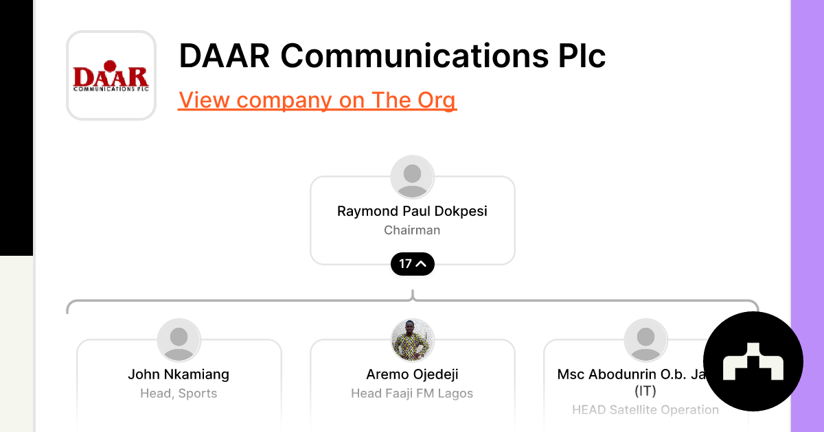

1.5 MAJOR ACTIVITIES OF THE ORGANIZATION
DAAR Communications Plc is a Nigerian media and Entertainment Company that develops, produces, and markets radio and television programs.

Their activities include:
- Radio: Broadcasting on Raypower 100.5 FM, which covers news, music, sports, and more
- Television: Broadcasting on Africa Independent Television (AIT), which covers news, sports, and more
- Pay-TV: Providing DAARSAT, a digital streaming service
- Corporate services: Providing services to corporations
- Printing: Printing and related support activities
- Telecommunications: Providing wireless telecommunications carriers
- Multimedia: Providing multimedia services

CHAPTHER TWO
2.1 WHAT IS NEWS
News is information about current events. This may be provided through many different media: word of mouth, printing, postal systems, broad casting, electronic communication, or through the testimony of observers and witnesses to events. News is sometimes called "hard news" to differentiate it from soft media.
Report writing is a formal style of writing elaborately on a topic. The tone of are port and report writing format is always formal. The important section of occasion is the target audience. For example – report writing about as school event, report writing about a business case, etc.

2.2 JOURNALISM
Journalism is the profession of gathering, processing, and disseminating news and information to the public through various media channels. It involves researching and reporting on current events, trends, and issues, with the goal of informing, educating, and engaging the audience.
Types of Journalism
1. Investigative Journalism: In-depth reporting on complex issues, often involving research and analysis to uncover hidden truths.
2. Broadcast Journalism: Reporting for radio, television, or online video platforms, often involving live coverage and interviews.
3. Print Journalism: Reporting for newspapers, magazines, or online publications, often involving in-depth feature articles and analysis.
4. Online Journalism: Reporting for online news websites, blogs, or social media platforms, often involving breaking news and real-time updates.
5. Sports Journalism: Reporting on sports events, teams, and athletes, often involving live coverage and analysis.
6. Entertainment Journalism: Reporting on the entertainment industry, including movies, music, and celebrities.
7. Business Journalism: Reporting on business and economic news, often involving analysis and commentary on market trends.
8. Environmental Journalism: Reporting on environmental issues, including climate change, conservation, and sustainability.
9. War Journalism: Reporting from conflict zones, often involving live coverage and analysis of military operations.
10. Citizen Journalism: Reporting by non-professional journalists, often involving community-based reporting and social media.
2.3 QUALITIES OF A GOOD JOURNALIST
Do you get inspired by famous journalists and the righteous persona the represent? What are those qualities that make them stand out of the crowd? From courage to honesty, integrity to determination, there are some essential qualities that a professional journalist possesses. If you are aspiring to make a career in journalism, you should have these qualities.

A Way with Words
How do you distinguish between an average news story and an enthralling news piece? Effective writing skills can make all the difference. A writer should know how to play with words and should be able to produce an error-free, grammatically correct and concise article with factual information that would pique the interest of the audience.

Thorough Knowledge
For being a good journalist, you need to be aware of the current events. Read a wide range of both print and digital medium of news sources to stay updated on the happening events. Also, you need to have some background knowledge before you go out to cover a story and write on it. Your ability to research to find out the important details of a story is quite helpful.

Investigative Skills
A journalist relies on facts and evidence, not on emotions while working on a story. An ideal journalist should be observant and possess strong analytical skills to assess a situation if there is something more to it. Whether it is about confirming the credibility of sources or assessing an incident, a journalist should know how to weight a situation critically. Sound judgment to verify the information before drafting the story is equally significant.

Effective Communication Skills
Like any other field, effective communication skills are essential for an ideal journalist. If you know your way with people, you can understand them then you can extract relevant information for a story. An ideal journalist should also know how to take control of a situation if the interview goes wrong. Journalists should be proficient in English and be well-versed to file a story that would attract the target audience.

Professionalism and Confidence
Even if you are a fresher and in your internship phase, you should consider yourself a professional. What professionalism means in the journalism field is meeting deadlines, ready to take up work before regular working hours and have the courage to accept criticism from the editors. Also, journalists should reflect confidence in order to succeed. However, you should always be eager to learn from your limitations and enhance your skills.

Persistence and Discipline
The profession of journalism requires hard work and persistence. Sometimes you might be chasing a story for months to get a lead and hit the newspapers. During such times, an ideal journalist should not give up following on a story and must remain disciplined. The ultimate motive of any journalist should be to find the truth and seek justice in all matters even if he or she has received recognition for their efforts.

Ethics are Important Too
With so much of competition to move ahead in the race, sometimes journalists abandon their ethics for money and fame. A good journalist should always behave ethically and never follow illegal measures even if it helps in uncovering the secrets behind a story. Accuracy and honest should be more important while writing a new piece.
From print to electronic, from newspapers to magazines, the profession of journalism requires some important personality traits and significant skills to succeed. If you are planning to pursue a career in journalism, you should question yourself if you have these essential skills.
2.4 STUDIO MICROPHONE
Studio microphones can be dynamic, condenser, or ribbon microphones. The type of microphone you choose depends on your recording needs.
Dynamic microphones Durable and versatile, Can handle high sound pressure levels, Good for live performances and podcasts, and Examples include the Shure SM57 and Rode Podmic.

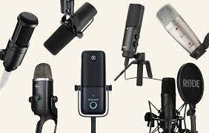
Features
- Polar pattern: Describes how well the microphone picks up sound from different directions
- Frequency response: Indicates the sound frequencies the microphone can reproduce
- Sensitivity: How well the microphone captures sound
- Diaphragm: The type of diaphragm affects the microphone's frequency response and how it handles sound pressure

Types of studio microphones
- Condenser microphones
Use capacitance instead of moving coils, making them sensitive and ideal for vocals and instruments
- Dynamic microphones
Have heavier diaphragms that can handle higher sound pressure levels, making them suitable for drums and other loud instruments
- Ribbon microphones
Sensitive and delicate, with a low-end frequency response that adds warmth to the sound.

CHAPTER THREE
3.1 TELEVISION STUDIO
A television studio, also called a television production studio, is an installation room in which video productions take place, either for the production of live television and its recording onto video tape or other media such as SSDs, or for the acquisition of raw footage for post-production. The design of a studio is similar to, and derived from, movie studios, with a few amendments for the special requirements of television production. A professional television studio generally has several rooms, which are kept separate for noise and practicality reasons. These rooms are connected via 'talkback' or an intercom, and personnel will be divided among these workplaces.
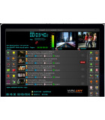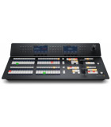Broadcast Video Mixer
Broadcast Video Route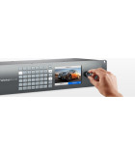Broadcast-Tv-And-Video- Playout- Automation-Software

STUDIO FLOOR
The studio floor is the actual stage on which the actions that will be recorded and viewed take place. A typical studio floor has the following characteristics and installations:
Decoration and/or sets
Professional Video Camera (sometimes one, usually several), typically mounted on pedestals
Microphones and fold back speakers
Stage Lighting rigs and the associated Lighting control console, although it is often located in the production control room (PCR)
Several video monitors for visual feedback from the PCR
A small public address system for communication
A glass window between the PCR and studio floor for direct visual contact is often desired, but not always possible
While a production is in progress, people composing a television crew work on the studio floor.
The on-screen presenters themselves, and any guests - the subjects of the television show.
A floor manager, who has overall charge of the studio area stage management, and who relays timing and other information from the television director.
One or more camera operators who operate the cameras, though in some instances these can also be operated from the PCR using remotely controlled robotic pan tilt zoom camera (PTZ) heads.
Possibly a teleprompter operator, especially if this is a live television news broadcast.

PRODUCTION CONTROL ROOM
The production control room is the place in a television studio in which the composition of the outgoing program takes place. The production control room is occasionally also called a studio control room (SCR) or a "gallery" – the latter name comes from the original placement of the director on an ornately carved bridge spanning the BBC's first studio at Alexandra Palace, which was once referred to as like a minstrels' gallery.
The vast majority of devices in a PCR are interfaces for rack-mounted equipment that is located in the Central Apparatus Room (CAR).

CENTRAL APPARATUS ROOM
The central apparatus room (CAR) houses equipment that is too noisy or runs too hot to be located in the production control room (PCR). It also makes sure that coax cable, SDI cable, Fibre optic cable or other wire lengths and installation requirements keep within manageable lengths, since most high-quality wiring runs only between devices in this room. This can include the actual circuitry and connections between:
Character Generator (CG)
Camera Control Units (CCU)
Digital Video Effects (DVE)
Video Routers
Video Servers
Vision Mixer (video switcher)
VTRs
Patch Panels

MASTER CONTROL
Master control is the technical hub of a broadcast operation common among most over-the-air television stations and television networks. Master control is distinct from a PCR in television studios where the activities such as switching from camera to camera are coordinated. A transmission control room (TCR) is usually smaller in size and is a scaled-down version of central casting.
The master control room in a US television station is the place where the on-air signal is controlled. It may include controls to play out pre-recorded television programs and television commercials, switch local or television network feeds, record satellite feeds and monitor the transmitter(s), or these items may be in an adjacent equipment rack room. If the program is broadcast live, the signal goes from the PCR to MCR and then out to the transmitter.

3.2 QUALITIES OF A GOOD PRESENTER
A good presenter possesses qualities like confidence, strong communication skills, passion for the topic, clear and concise delivery, adaptability to the audience, thorough preparation, effective use of visuals, the ability to engage the audience, and a deep understanding of their listeners' needs.

KEY QUALITIES OF A GOOD PRESENTER

- Confidence: Projecting self-assurance and belief in their message, which helps to capture the audience's attention.
- Audience Awareness: Thoroughly understanding the audience's background, interests, and level of knowledge to tailor the presentation accordingly.
- Clarity of Communication: Delivering information in a clear, concise, and easily understandable manner.
- Passion and Enthusiasm: Demonstrating genuine excitement about the topic to engage the audience.
- Engaging Delivery: Using effective body language, eye contact, and vocal variation to keep the audience interested.
- Adaptability: Adjusting presentation style based on audience feedback and reactions.
- Preparation and Organization: Having a well-structured presentation with clear flow and supporting materials.
- Storytelling Skills: Using narratives and anecdotes to connect with the audience on a personal level.
- Visual Aids Proficiency: Utilizing slides, graphics, and multimedia effectively to enhance understanding.
- Empathy and Connection: Showing genuine interest in the audience and their concerns.

3.3 Radio Media
Radio is the technology of using radio waves to carry information, such as sound and images, by systematically modulating properties of electromagnetic energy waves transmitted through space, such as their amplitude, frequency, phase, or pulse width.

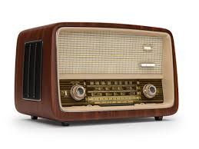
The Radio media is the largest in Africa but a kind of the oldest broadcasting network of Nigeria. It was gotten from radio-Nigeria operate as a network Kaduna State Media Cooperation (KSMC) news rooms give timely information of the program from the program unit which is the heart beat of the media.

TIPS IN MAKING A GOOD RADIO PRESENTATION
- Aim to create
- Understand how, when, why and what the listener is saying
- Know your listeners
- Make your listener care

CHAPTER FOUR
CHAPTER FIVE
5.1 CONCLUSION
The Student Industrial Work Experience Scheme (SIWES) plays a significant role in human resource development, it helps students develop new skills and enlightens them of what the present society holds for them after graduation and helps them adapt accordingly.
5.2 RECOMMENDATIONS
I put forward the following recommendations for future improvement of the scheme;
- Organizing workshops, seminars and symposium for students in various faculties in other to keep the student abreast of new technologies and innovations.
- Posting of students for SIWES should be done by the scheme to ensure conformity with course of study.
- A mass enlightenment campaign should be carried out, to enable industries and establishments to know the importance of SIWES to the future of the student and the society at large.
- The scheme should also try to enforce the act guiding the establishment of the scheme, to serve as a deterrent to those establishments who reject student for IT.
- School Curriculum should be organized in such a way that the SIWES exercise be carried out at a stretch of six months and not the intermittent arrangement of three months twice.

