

KWARA STATE POLYTECHNIC, ILORIN
TECHNICAL REPORT
ON
STUDENT INDUSTRIAL WORK EXPERIENCE SCHEME (SIWES)

HELD AT

OLAIYA METAL WORKS NIG LTD
ORILOWO AVENUE ILORIN, KWARA STATE

PRESENTED BY
SULYMAN ABIODUN MUHAMMED
ND/23/wed/FT/0025

SUBMITTED TO
THE DEPARTMENT OF WELDING AND FABRICATION, INSTITUTE OF TECHNOLOGY, KWARA STATE POLYTECHNIC ILORIN

AUGUST 2024-DECEMBER 2024
DEDICATION
This report is dedicated to Almighty Allah, the creation of all universe, the one only to be worship, for giving me this privilege and understanding knowledge and protection.
I also give thank to my adorable parents Mr and Mrs Sulyman for their support in my financial activities in my studies.

ACKNOWLEDGMENT
My adoration goes to Almighty Allah of all human and every one in heaven and earth. All glory and praise unto Him. I would like to express my special thanks of gratitude to my parent for their abundant effort and uncountable support as well as my lecturers and my student of industrial works experience.
I also thank the entire staff of my department of welding and fabrication, Kwara State Polytechnic, Ilorin.
My appreciation also goes to my brothers and my sisters of the same blood for their financial support, may God Almighty always bless you all.
There will be no significant effect in the treatment if I refuse to appreciate all my friends and colleague in my department, I thank you, all pray goals shall not be jeopardized.
To all I say a big thanks to you.

PREFACE
The introduction of the student industrial work experience scheme (SIWES) is to prepare student to have practical experience of what has been taught in school. The report activity took place at attachment with the reference of the SIWES log book. The period of attachment is four (4) month.

TABLE OF CONTENT
Title page
Dedication
Acknowledgement
Preface
CHAPTER ONE
1.1 Introduction 1
1.1 definition of Siwes 1
1.2 Function of SIWES Unit 1
1.3 Aims and objectives of SIWES 2
CHAPTER TWO
2.0 Historical Background Of The Organization Attachment table of content of the role of enzymes in fermentation reaction
3
2.1 Organization Chart Of The Organization 3
CHAPTER THREE
3.0 Fabrication Of A Burglary 4
3.1 Material Stools And Equipment Used In The Fabrication Of Burglary 4
CHAPTER FOUR
4.0 Bech shearing machines 13
4.1 Sliding gate 14
CHAPTER FIVE
Conclusion 16
Recommendation 16

CHAPTER ONE
- INTRODUCTION
The student industrial works experience scheme (SIWES) was established by the industrial training fund (I.T.F) in 1973 and control by the national board for technical education (NBTE). The aims and objectives is to develop student skill and to expose students in the school of engineering, technology, environment, science and agriculture and medical science to the working experience in which they will found themselves in future.
It is integral part of degree and National Diploma programme institute of higher learning in Nigeria. This privilege programme would definitely broaden student chance of learning and would empower his/her academic efficiency.
During my four months Industrial Working Experience Scheme (SIWES) at Federal Ministry of Agricultural and Rural Development, the usefulness of maintenance in Tractor was proved and lot of experience was gained.
1.1 Definition of Siwes
Student industrial Working Experience (SIWES) is a skill acquisition training programme set up by the Federal and State government across the Nation in collaboration with the body known as Industrial Training Fund (I.T.F) for student to have a working experience and a feel of what it takes to be genius in one discipline before challenges ahead.

1.2 Function of SIWES Unit

By the directive of National Universities Commission (NUC) and IndustrialTraining Fund (ITF), the Unit is mandated to carry out the following functions.
i. Supervision of the students placed in the industries located within our ITFzone.
ii. Processing of students’ logbooks, ITF forms and industrial
attachment reports upon which is based on the Federal Government fundingof supervision and
students’ allowances.
iii. Fostering of close links between the university and industries participating inSIWES programme.
iv.Provision of advisory guidance to participating students on careeremployment opportunities.
v. Monitoring of compliance with the requirements of SIWES on the part ofstudents in eligible disciplines as a condition for graduation.

1.3 AIMS AND OBJECTIVES OF SIWES
1. It exposes the prepare students of higher institution for the industrial working situation they can likely to meet in the future.
2. It enables student to apply what they have learn theoretically in class into practice in the real world.
3. It makes student to understand the technical implication of their profession.
4. It helps student to express their initiatives, competence and standard in task they have chosen.
5. It enable student to be technically and morally oriented
6. It helps to make transition from school to the working environment easier and to enhance students contact for later job placement.

CHAPTER TWO
2.0 HISTORICAL BACKGROUND OF THE ORGANIZATION ATTACHMENT
Olaiya metal works was first established in 1992 at Kabala West, in Kaduna State, and later in the year 2000 they relocated to Ilorin and having their head office besides Kwara State A.D.P gate by then and later moved to Orilowo Avenue behind bay-star filling station as their present head office.
The company was a limited liability company by then in the year 2003, but their staff today is over forty, among them are university and polytechnic graduates, the company has nearly constructed and commissioned ultra modern plaza along old Jebba road Sango Ilorin in the year 2011. Another giant factory is under construction and will soon be commission soon.

The company also engages in other activities which differ from its academics activities, this includes:
- The fabrication of burglary
- The fabrication of sliding gate
- The production of a door frame

2.1 ORGANIZATION CHART OF THE ORGANIZATION
Manager
Engineers
Apprentice
Surface Finishing & Dressing
Casting Section
Moulding Section

CHAPTER THREE
3.0 FABRICATION OF A BURGLARY
Design of burglary: This involves detail calculation and drawing of the burglary to be fabricated.
Measuring of Mild Steel: This involves the measurement of the sixteen MM mild steel iron to prescribed lengths as shown in the detailed diagram. It is done with the aid of a measuring tape.
Cutting of Mild Steel: Mild steel were cut in accordance with the prescribed measurement and designed values using hand saw.
Welding: Arc welding it is welding process whereby coalescence is produced by heating the work piece with an electric arc set up between a flux coated electrode and the work piece.



Diagram of steal burglary

3.1 MATERIAL STOOLS AND EQUIPMENT USED IN THE FABRICATION OF BURGLARY
1. Pipe
2. Welding Machine
3. Electrode
4. Chipping Hammer
5. Hack Saw
6 Measuring Tape
7 Try Square
8 Plier
9 Venier caliper
10 Steel chalk and marker

- Welding Machine: This machine is coupled with the electrode holder and the return current cable known as earth by non engineers. It is made up of primary coil and the secondary coil, with the two hands of the primary coil connected to the electric source bringing current into the welding machine and the two hands of the secondary coil connected to the electrode holder and the return current cable. From private study and literatures on welding, it was realized that the welding machine is working like a transformer because it convert electric current from the primary coil into electromagnetic field sent into the secondary coil used in welding the mild steel iron together

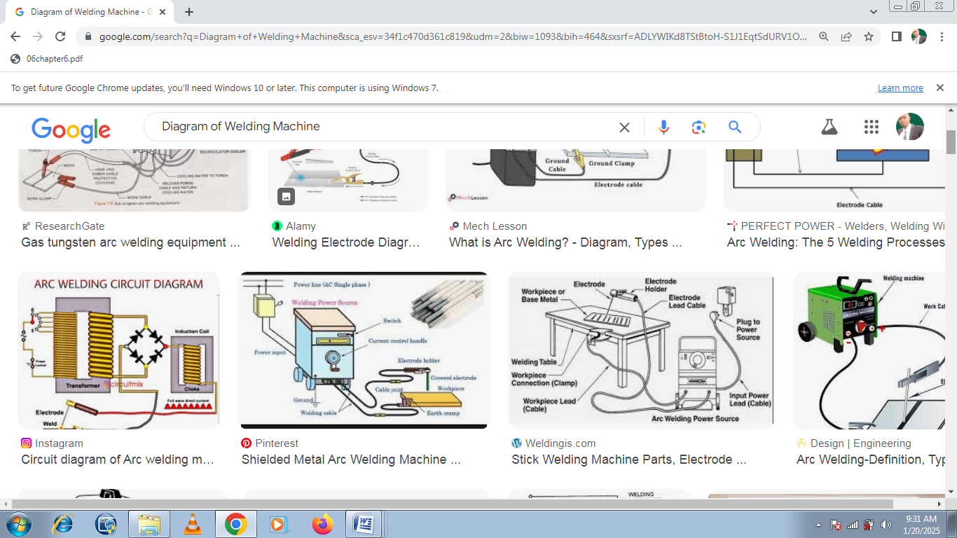

Diagram of Welding Machine
3.2 GAS WELDING
Gas welding, also known as oxy-fuel welding, is a process that uses a flame produced by burning a mixture of oxygen and a fuel gas to join metals. This technique has been widely used in fabrication, repairs, and manufacturing.

Components of Gas Welding
- Fuel Gas: Common gases include acetylene, propane, hydrogen, or natural gas. Acetylene is the most commonly used due to its high flame temperature.
- Oxygen: Combines with the fuel gas to intensify the flame and achieve the necessary heat.
- Welding Torch: Mixes oxygen and fuel gas and directs the flame onto the welding area.
- Regulators: Control the pressure of the gases from the cylinders.
- Hoses: Transport the gases from the cylinders to the torch.

Steps in Gas Welding
- Preparation:
  - Clean the metal surfaces to remove contaminants.
  - Assemble and inspect the equipment for leaks or damage.
- Adjust the Flame:
  - Light the torch, adjust the fuel gas and oxygen mixture to produce the desired flame (neutral, carburizing, or oxidizing flame).
- Welding:
  - Melt the edges of the metals and use a filler rod if needed.
  - Ensure proper control of heat and filler material to create a strong weld.
- Cooling: Allow the welded joint to cool gradually to minimize distortion.

Types of Flames
- Neutral Flame: Equal oxygen and fuel gas ratio; suitable for most welding applications.
- Carburizing Flame: Excess fuel gas; used for applications where the metal requires additional carbon.
- Oxidizing Flame: Excess oxygen; suitable for materials like brass.

Applications
- Joining thin metals like sheets and pipes.
- Repairing damaged or broken parts.
- Brazing and soldering.

Advantages
- Portable and versatile.
- Can weld a variety of metals.
- Simple and inexpensive equipment.

Disadvantages
- Limited to thin materials.
- Slower compared to modern welding methods like MIG or TIG.
- Potential fire and explosion hazards due to combustible gases.

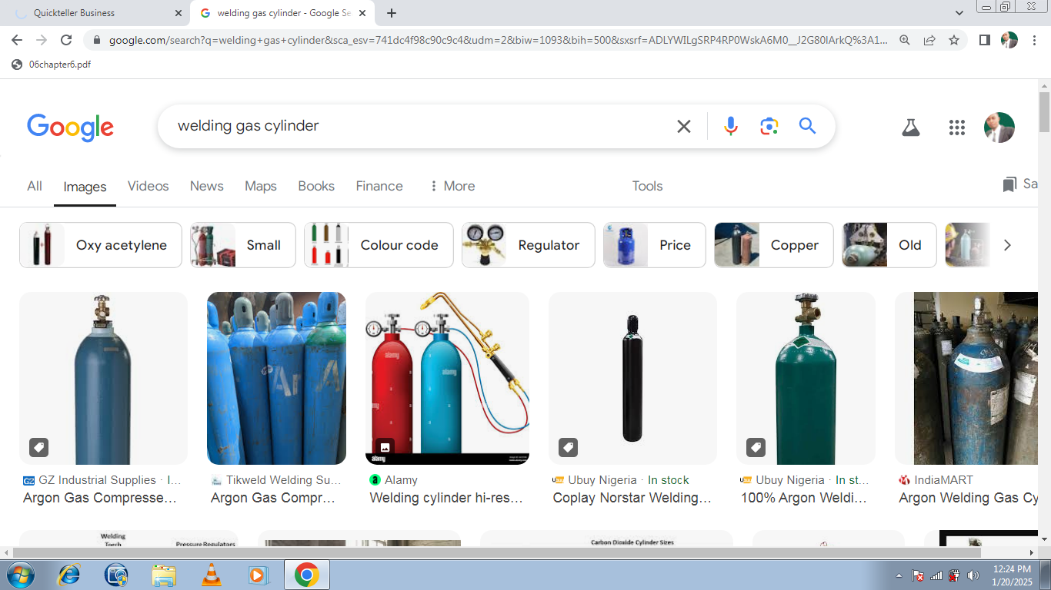
Diagram of gass Welding Machine

- Pipe: For the frame of the burglary bar, cut twelve pieces of pipe horizontal, and two pieces of pipe vertical. Make sure the pipe arc cut properly. Make the end of the pipe straight and bend appropriately. Weld the pipe in position as the mark determined, make sure that the vertical and horizontal bar touches each other.

- Chipping Hammer: The Chipping hammer is used to remove some dark portion called slag or carbon that covers the welded portion and also using this hammer makes the welded portion to look like real metal. The chipping hammer was not available, locally improvised chipping hammer was made by welding two metals together to look like the chipping hammer.
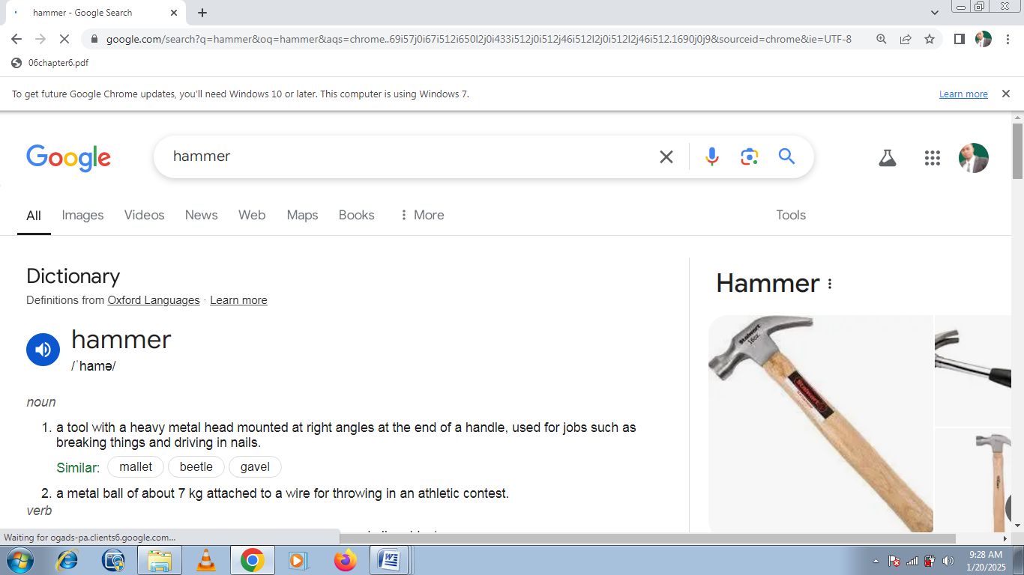
Hammer
4. Hack saw: The arc saw blade was fixed to its frame and was used in cutting the mild steel iron. Arc saw is of different teeth/ blade i.e. the 18 or 24 teeth. Selection is based on type of work.

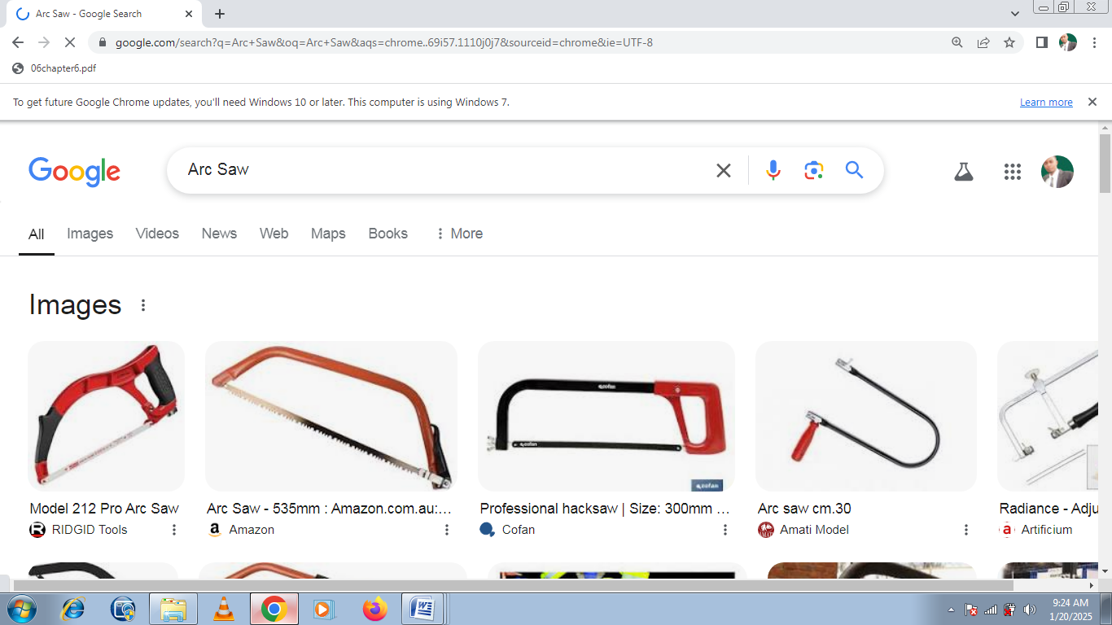

Arc Saw
Electrode: In arc welding an electrode is used to conduct current through a work piece to fuse two pieces together. Electrodes are of different gauges but for the assembly process, gauge 12 was used and it’s of 2.5 mm thickness. If the electrode is positively charged, the base metal will be hotter, increasing weld penetration and welding speed. Alternatively, a negatively charged electrode results in more shallow welds

6. Paint for beautification: The burglary was then painted so as to beautify it and at the same time, to prevent corrosion.

7 Measuring tape
A tape measure, also called measuring tape, is a type of flexible ruler. Tape measures are made from a variety of materials, including fiber glass, plastic and cloth. They are among the most common measuring tools used today.
Generally speaking, the term “tape measure” refers to a roll-up, self-retracting style tape measure that’s designed for carpentry. The actual tape potion of the measure, called the ‘ribbon,’ is usually constructed from a stiff metallic material that can stiffen when needed but can also roll up for simple use and storage. However, the term covers all types of tape measures – even tailor’s tape.

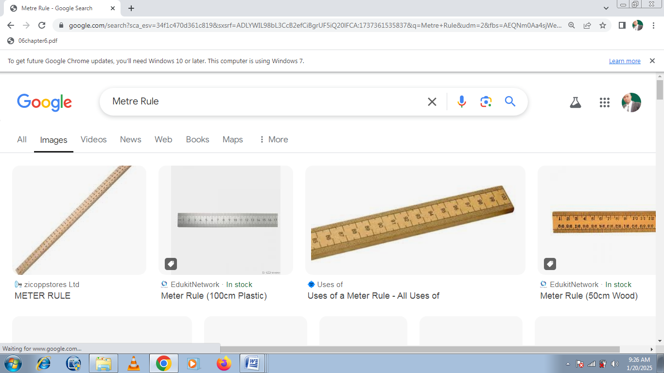
Metre Rule

8 Try square
A try square is special purpose square in wood- and metalworking used to mark or measure material. The name ‘try square’ comes from the concepts of ‘trying a surface’ (to check a surface’s straightness or correspondence to an adjacent surface) and ‘square’ (a 90°, or right, angle).Try squares generally consist of two parts. The ‘blade’ is the longer portion, usually made of metal. The ‘handle’ (or ‘stock’) is usually made of wood, plastic or metal. Try Squares from Johnson Level feature blades with hash marks for measuring shortdistances.

How to Use a Try Square
- Place the try square blade across the material you want to test or mark. The thicker part of the handle should extend over the edge of the surface, allowing the blade to lie flat across the surface.
- Hold the handle against the edge of the material. The blade is now positioned at a 90° angle compared to the edge.
- Find where you want to mark the material by adjusting the blade. Using the blade’s edge, draw a line across the material. To check the board’s square, align the blade with the end of the material. Make sure the corner of the material lines up with the corner of the try square. If there’s a gap between the try square and the material, the material isn’t square.

Try square

9 Plier
This is a hand-operated tool for holding and gripping small articles or for bending and cutting wire. Slip-joint pliers have grooved jaws, and the pivot hole in one member is elongated so that the member can pivot in either of two positions in order to grasp objects of different size in the most effective way. On some pliers the jaws have a portion that can cut soft wire and nails.
For bending wire and thin metal, round-nose pliers with tapering, conical jaws are used. Diagonal cutting pliers are used for cutting wire and small pins in areas that cannot be reached by larger cutting tools. Because the cutting edges are diagonally offset about 15 degrees, these can cut objects flush with a surface.

Plier

10 Venier Caliper
This is an instrument for making very accurate linear measurements introduced in 1631 by Pierre Vernier of France. It uses two graduated scales: a main scale similar to that on a ruler and an especially graduated auxiliary scale, the vernier, that slides parallel to the main scale and enables readings to be made to a fraction of a division on the main scale. Vernier calipers are widely used in scientific laboratories and in manufacturing for quality control measurements.
In the figure, the vernier scale has 25 divisions, whereas the main scale has 24 divisions in the same length. This means that the divisions on the vernier scale are shorter than those on the main scale by ¹/₂₅ of a division on the main scale. In the figure, line 8 on the vernier coincides with line x on the main scale. To align lines 7 and y, the vernier would have to be moved to the left by ¹/₂₅ of a main-scale division; to align lines 6 and 40, the movement would be ²/₂₅, and so on. By similar reasoning, the 0 line on the vernier would have to be moved a distance equal to ⁸/₂₅ of a main-scale division to align it with the 8.50 line (before the 40 line, therefore this is the 38.50 line) on the main scale. This means that in the position shown in the figure the 0 line is ⁸/₂₅ of a main-scale division to the right of the 8.50 line. The reading of the vernier is therefore 30 + 8.50 + 0.08 = 38.58.
11 Steel chalk and Marker
This is mainly used for marking Metal & Steel with a clear, wax-like mark.

12 Wrench
A wrench or spanner is a tool used to provide grip and mechanical advantage in applying torque to turn objects—usually rotary fasteners, such as nuts and bolts—or keep them from turning.
13 Wire brush
Wire brushes are an excellent choice for the removal of rust and oxidations, paint, slag, weld splatter and other unwanted surface contaminants with angle grinders, bench grinders or drills.

3.3 FACE WELD
A face weld is when the miter joint between the head and jamb faces is welded on the exterior of the frame face. The weld will be ground, finished smooth, and prime painted so the seam does not show. The remaining elements of the frame profile such as the soffit, stops, and rabbets are not welded.

3.4 BACK WELD
Back welding is weld placed on the miter of the frame where the head and jamb meet, but on the back side. This type of welding requires less grinding.

3.5 FULL WELD
Also specified as “fully welded” or “continuously welded”, a full profile weld is when the joints between all elements of the head and jamb profiles are completely welded. The faces and returns may be welded internally or externally. All other frame elements shall be welded internally

3.6 PREPARING TO WELD
1. Properly setting up the frame before welding is critical for ensuring the finished frame is square.
2. Lay the head and the two jambs down on a level work surface with the non-door side down.
3. Assemble the door frame and bend the tabs on the jamb to lock the jambs to the head.
4. Clamp the frame to the table for stability. Confirm the frame is square and adjust as needed.
5. Tack weld a shipping bar into the door side of the frame to guarantee the opening width of the welded frame. For example, if the door opening is 3 feet, then the spreader bar should be exactly 3 feet.
6. Now the frame is ready for welding. Using the minimum amount of weld necessary, apply the face weld, back weld, or full profile weld as specified.
- File the edges smooth.
- Grind until the weld is level with the face of the frame.
- The frame is ready to be painted after it is painted, a proper weld will give the frame a seamless appearance.

CHAPTER FOUR
4.0 BECH SHEARING MACHINE
A bech shearing machine appears to be a typographical error, likely intended to refer to a bench shearing machine or sheet shearing machine. Here's some information about both possibilities:

1. Bench Shearing Machine
- A bench shearing machine is a mechanical or manual device mounted on a workbench and used to cut or shear metal sheets or plates with precision.
- Commonly used in small workshops and fabrication units.
- Features include:
  - Compact size for easy installation on a bench.
  - Ability to cut thin sheets, rods, and strips of metal.
  - Leverage mechanism for efficient manual cutting.
  - Blades made of hardened steel for durability.

2. Sheet Shearing Machine
- A sheet shearing machine is designed to cut large sheets of metal or other materials into desired shapes or sizes.
- Operates manually, hydraulically, or pneumatically, depending on the type and scale of the machine.
- Features include:
  - High precision in cutting metal sheets.
  - Adjustable blade gaps to accommodate different material thicknesses.
  - Safety guards for operator protection.

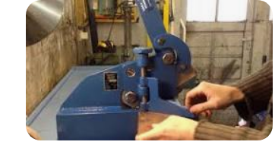
Bech shearing machine
4.2 SLIDING GATE
Welded sliding gates normally have a metal frame regardless of the cladding. The frame is made from either Aluminium Square Hollow Section (SHS) or Square Steel Rolled Hollow Section (RHS). The bottom rail is normally wider to provide better bracing and support for a sliding gate.
The Centre Mullions are only necessary for gates with timber pickets, hardwood slats, metal slats or metal sheets fitted to the front of the gate. The centre mullions help stiffen the gate up as well as provide something for horizontal timber or metal sheeting to be screwed to.
For gates with metal tubing welded to the frame center mullions are NOT necessary.
Middle rails are only necessary for gates higher than 1.2m (4') and have either vertical pickets, slats or sheeting fitted to the front.
If a Guide rail and Block Guide system is used then a guide rail needs to be welded or screwed to the back of the top or middle rail of the gate.
The closed end mullion butts onto the end of the bottom rail so it caps the bottom rail as well is provides good bracing.
Mitred corners for the top rail are neat, require no caps and provide good bracing. The open end mullion should butt onto the top of the bottom rail as the bottom rail needs to extend out an extra 400mm (16") normally to allow for an automatic gate operator.
For Bi-Parting Gates you make two frames the same but the extended bottom rail on opposite sides and half the width of a single panel gate.

4.3 WIDTH OF THE GATE FRAME
Normally a sliding gate should be wide enough so it will overlap the posts by 50mm (2") each side, which looks the nicest and fills in the gap on each side to some degree although how much depends on how far the gate sits behind the posts, which depends on the guide system used.
Height of the Gate Frame
For gates with vertical timber palings or slats fitted to the front the frame should have the top rail lower than the palings or slats, otherwise the top rail is at the very top of the gate. The gate will sit about 50mm (2") off the ground allowing for the gate track and wheels set up into the bottom rail.
4.4 WELDING THE FRAME TOGETHER
Tack the gate together first don't do full welds to start with because the heat will pull the whole frame out of shape, always tack weld in the middle of the join first as this will be strong enough to hold the frame together to begin with and allows the full weld to be done neatly after. It’s important to make sure the frame is sitting flat.
If your gate will have round tubing fitted for cladding and you have a middle rail don't weld the bottom rail in to begin with otherwise you won't be able to slide the tubes in place.
If your gate has NO rake make sure the diagonal measurements are the same so your frame will be square. Also check the width and height.

CHAPTER FIVE
5.0 CONCLUSION
The SIWES programe is an efficient an effective program which has bring much improvement to my field of study. I have gained a lot of experience from the various works done on field such as construction of sliding gate, solar street light and production of a particular project. It is a programe that bridges the gap between theory and practical aspect, so therefore it has made me to have technical knowledge about what I have learnt theoretically in class.
My three months SIWES program has equipped me the knowledge of metallurgical engineering design in terms of fabrication and production of a project. I here appreciate the effort to the Federal Government and Industrial Training Fund (I.T.F) for improving the technological development of this country.
5.1 RECOMMENDATION TO THE ORGANIZATION CONCERNING THE SIWES PROGRAMME
I would recommend that the organization should appeal to the federal government to make provision for necessary equipment for the effectiveness of the programme.
I will like to implore the organization to continue in their well accommodative standard.
I would recommend that the organization should provide transport facilities for SIWES students so as to move/carry them from the office to the site off construction.

REFERENCE
www.google.com
www.wikipedia.com
My training log book
Machines and laboratory manuals

