
A TECHNICAL REPORT

STUDENT INDUSTRIAL WORK EXPERIENCE SCHEME (SIWES)

HELD AT

CHI LIMITED.
14 Chivita Ave, Oshodi-Isolo, Lagos 102214, Lagos

WRITTEN BY
AYOOLA AMIDAH OPEYEMI
ND/23/BAM/PT/0613

SUBMITTED TO THE

DEPARTMENT OF BUSINESS ADMINISTRATION
INSTITUTE OF FINANCE AND MANAGEMENT STUDIES,
KWARA STATE POLYTECHNIC, ILORIN

AUGUST - NOVEMBER, 2024
DEDICATION
This report is dedicated to Almighty Allah, the Creator of whole universe who has bestowed His infinite mercy and wisdom upon to successfully accomplish of this great academic work.

ACKNOWLEDGEMENTS
All acknowledgement goes to my Allah because without Him, it would have been hard for me to be among the participant of this opportunity, He gave me strength, heart of concentration, stable memory, love, throughout the training praise and adoration back to Him.
Also using this great opportunity to thank my lovely parent Mr. and Mrs. Ayoola for their great support, love and understanding, because if not for them I would have be a victim of those people that are not educated, I want to say thank you.
My appreciation goes to my institute director for making this to happen and also thanking them for the good record that they are given to this institute, God bless you all.
Also I want to appreciate and thank you all staff in Chi Limited for your love and great support during the time I spent with you, thank you all.
TABLE OF CONTENTS
TITLE PAGE
DEDICATION
ACKNOWLEDGEMENTS
TABLE OF CONTENTS
CHAPTER ONE
1.0 Background of SIWES
1.1 Aim and Objectives of SIWES
CHAPTER TWO
2.0 Brief History of Chi Limited Company
CHAPTER THREE
3.0 Inspection to Chi Limited Company
3.1 To Convince the Client to Buy
CHAPTER FOUR

4.0 How to Create a New Product
CHAPTER FIVE
5.0 Summary
5.1 Conclusion
5.2 Recommendations

CHAPTER ONE
1.0 BACKGROUND OF SIWES
SIWES was established by industrial training fund (ITF) in 1973 to solve the problem of lack of adequate practical skills in preparatory for employment in industries by Nigeria graduates of tertiary institutions.
The scheme exposes student to industry based skill necessary for a smooth transition from the classroom to the world of work. It affords student of tertiary institutions the opportunity of being familiarized an exposed to the needed experience in handling machinery and equipment which are usually not available in the educational institutions.
Participation in SIWES has become a necessary precondition for the award of diploma and degree certificates in specific disciplines in most institutions of higher learning in the country in accordance with the educational policy of government.
OPERATORS: the ITF, the coordinating agencies (NUC, NCCE, NBTE) employers of labour and the institution funding the Federal Government of Nigeria.
BENEFICIARIES: undergraduate students of the following: agriculture engineering technology, environmental science education, medical science and pure and applied science.
DURATION: four months for polytechnics and colleges of education, six months for the universities.
Highlight number of participating institutions
Universities = 59
Polytechnics = 85
Colleges of education = 62
Total = 206

1.1 AIM AND OBJECTIVES OF SIWES
- To provides avenue for students to acquire industrial skill and experience in their approved course of study.
- To prepare students for their industrial work situation which are likely to meet after graduation.
- To bridge the identified gap and practice of engineering and technology in tertiary institutions.
- To expose student to working methods and techniques in handling equipment and machinery that may not be available in educational institution.
- To prepare student for employment in industries.
- Provide opportunity for students to apply their knowledge in real work situations bridging the gap between theory and practical.

CHAPTER TWO
2.0 BRIEF HISTORY OF OLU AYODELE & CO.
Chi Limited, incorporated in 1980, is a fast-moving consumer goods company that provides consumer products in the dairy, beverages, and snacks sectors. The company's headquarters are in Lagos, Nigeria, and it is primarily owned by The Coca-Cola Company. Chi Limited's major manufacturing facility is located in Lagos. The flagship products of the firm are Capri-sonne and Chivita; it holds the Nigerian license to market Caprisun.
Incorporated in Nigeria in 1980 by Dutch entrepreneur Cornelis Vink, it began operations in March of the same year. The company became part of the Tropical General Investment (TGI) conglomerate, which has diverse business interests in food, healthcare, agriculture, engineering, and other industries. The company began distribution of Capri Sonne in 1982, which later emerged as one of its flagship brands. In 1990, it introduced CHI juice, which was originally sold in cans, but after a couple of years, it was packaged in Tetra Pak. In 1996, the firm introduced Chivita orange flavoured juice to the market, and like the previous drink, it was originally sold in cans until 1997, when a paper carton packaging machine was installed. The firm later launched three new flavurs in Tetra Brik: pineapple, mango, and apple, and in 1999 it introduced blends of orange and pineapple.
CHI Limited was a pioneer in the industry in the use of Tetra Pak packaging for its dairy product, Hollandia.
On 30 January 2016, Coca-Cola announced a binding agreement for The Coca-Cola Company to acquire an initial minority equity shareholding in Chi Limited. Within the agreement, Coca-Cola made an initial 40 percent equity investment in Chi Limited and intends to increase ownership to 100 percent within three years, subject to regulatory approvals, while working on other long-term commercial structures. On January 30, 2019 The Coca-Cola Company announced that it now has a 100 percent ownership stake in CHI Limited after acquiring the remaining 60% it did not already own.

CHAPTER THREE
3.0 INSPECTION TO CHI LIMITED COMPANY
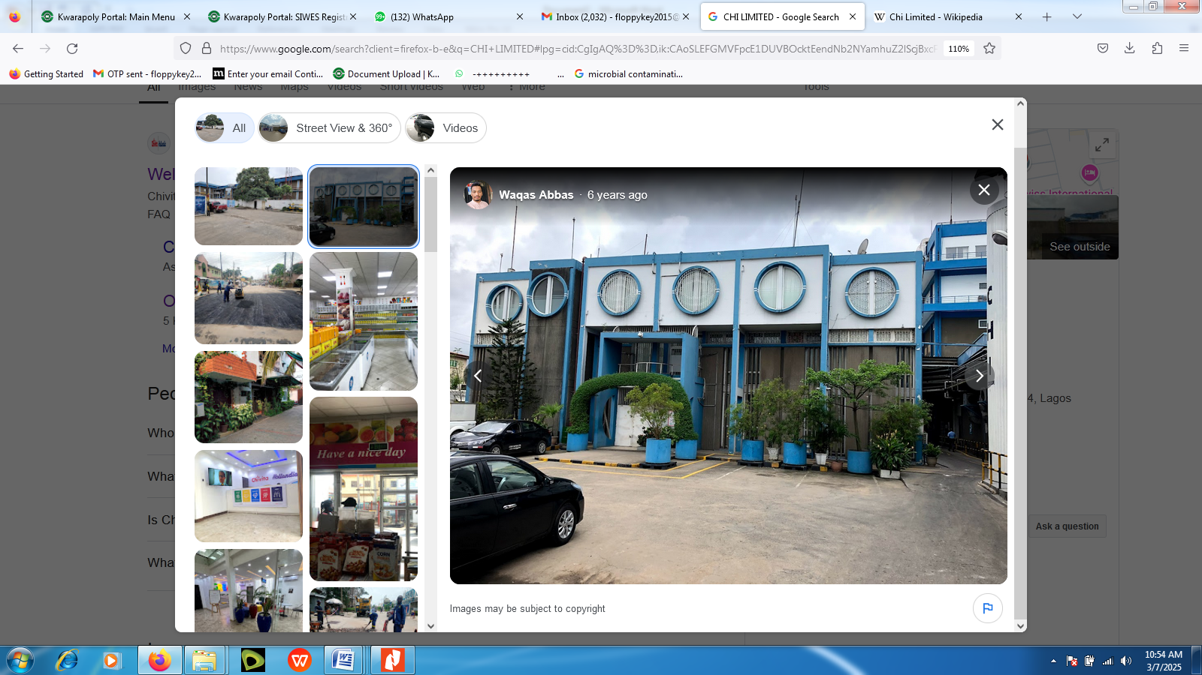
Fig. 1: Front view of Chi Limited Company
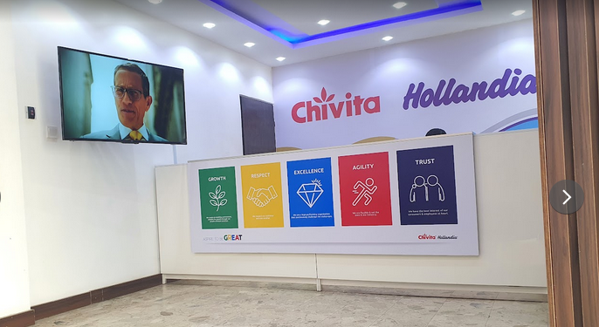
Fig. 2: Inside view of Chi Limited Company

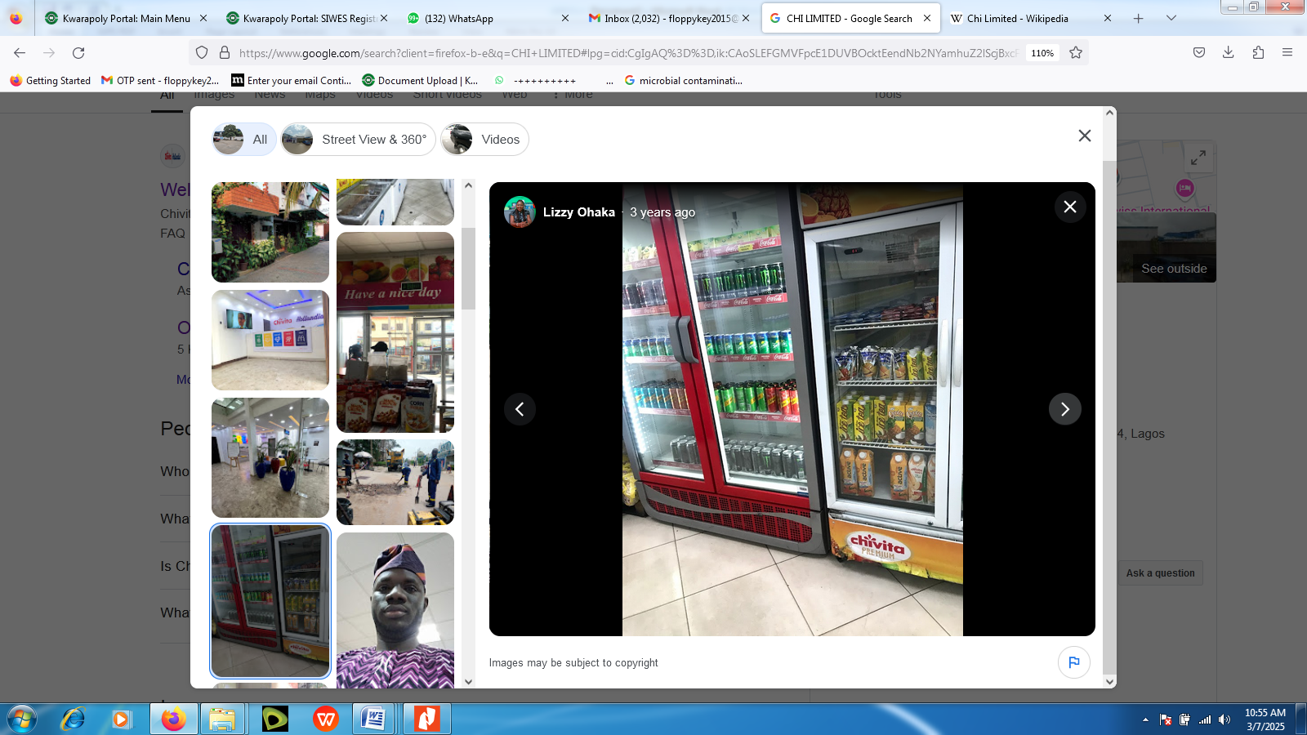
Fig. 3: Some of Chi Limited Company Products
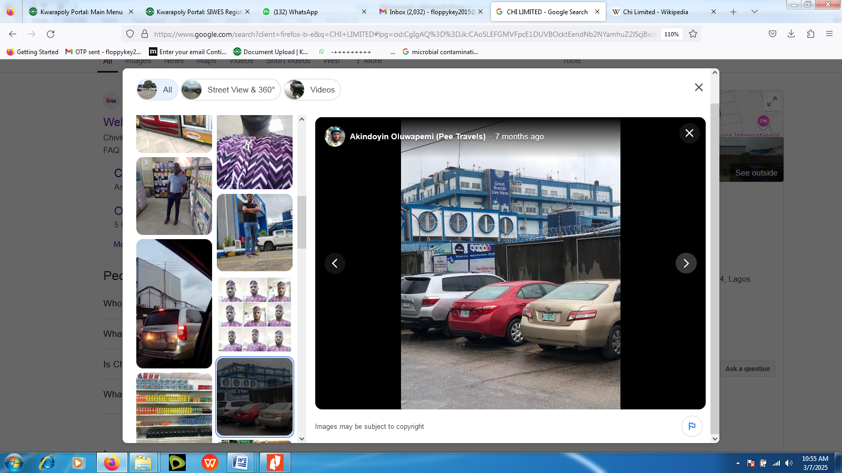
Fig. 4: Over view of Chi Limited Company

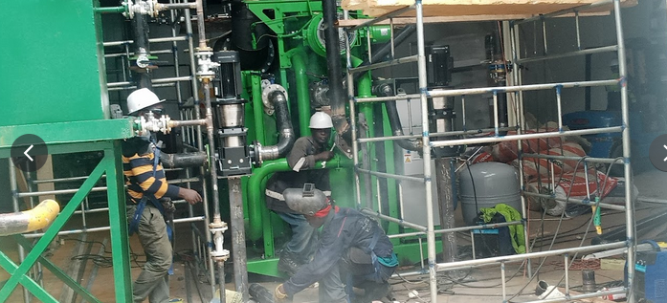
Fig. 5: Engineer work on production Machine when visit Chi Limited Company

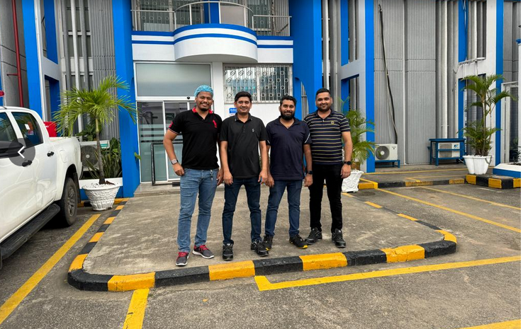 Fig. 6: Front view with some of the Top Executives of Chi Limited Company

3.1 TO CONVINCE THE CLIENT TO BUY

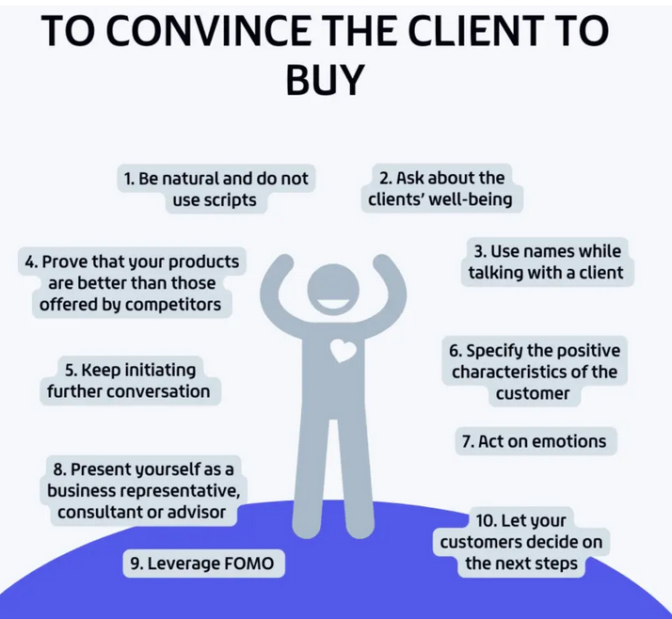

1. Be natural and do not use scripts
Customers choose to call because they want to have a conversation with a real person, who will respond to their inquiries and answer their questions, even the unusual ones. If it were otherwise, clients would keep on browsing the website. For this reason, you should never use readymade conversation scripts. These kinds of prewritten replies sound unnatural to the client and create a feeling of an unwanted sale process. Customers are more willing to buy if they establish an emotional relationship with a consultant.

2. Ask about the clients’ well-being
If you want to convince people to buy your product, at the beginning of the conversation, while introducing yourself, ask the customer about his/her well-being.
Research revealed that sales increase significantly within the group of customers, who were asked about their well-being. You can also start a conversation on a positive note.
An experiment conducted among waiters showed that positive comments increased the tip by 27%! During the telephone conversation, it works too.

3. Use names while talking with a client
Find out your client’s name and use it from time to time. Psychological research shows that people like to hear their names and are much more likely to make a friendly relationship when the other side uses it. In English, you can address the client by name without fear of committing a faux pas. However, it’s not that easy in some languages. For example, while having a conversation in Polish, pay attention to proper forms.
4. Prove that your products are better than those offered by competitors
Highlighting the advantages of a product or service offered by your company is very important. Often, customers call companies to ask questions about the product to investigate the market. Therefore, if you have an opportunity, emphasize that your offer is better (because it gives access to some special functions, it enables personalization, it is technically superior) and/or cheaper than the competitor (it is worth using specific values here, e.g., at 20%). If the offer is not cheaper – it is harder, but you can always mention that for a slightly higher price, the customer receives a better product.

5. Keep initiating further conversation
Lead and initiate a conversation, ask open questions, and give the interlocutor a chance to develop the topic. If you don’t know how to convince a client, try this: instead of saying: "So our product has this function,” say: "Yes, (name of the client), our product has such a function, and I will gladly tell you how it works.”

6. Specify the positive characteristics of the customer
Psychologists have proven that if we mention some clients’ positive aspects during the conversation, and our attitude to them, they will try to act accordingly. How does this affect incoming calls and phone sales? When you talk to the client, try to highlight the importance of one, by saying: “You are one of our best clients” or ”It’s a pleasure to do business with you.” In this way, you encourage the client to be the best customer!

7. Act on emotions
We all like to think that our decisions are rational, but let’s face it – our emotions influence most of it. When talking with a client, emphasize what positive emotions your product or its purchase will cause. You will see that it will work more effectively than an objective argument!

8. Present yourself as a business representative, consultant, or advisor.
If you are still wondering how to convince customers to buy your product, here’s our next tip. Just to clarify – we are not suggesting that you should introduce yourself as a business consultant if you are not working as one, or manipulate and lie about your position. However, there is a huge difference between acting like a professional who represents a company and behaving like a typical, pushy sales representative.
9. Leverage FOMO
Even undecided buyers often find it difficult to resign from a great opportunity – especially if they are aware of what they will lose by giving it up. In marketing, this phenomenon is called FOMO (Fear of Missing Out Fear). This term means a fear of losing the opportunity to buy/do something.
You can use this psychological trick in situations when you truly don’t know how to encourage a customer to buy your product – example of this could be as follows: present your offer as something that a potential customer will miss if they don’t make a purchase, rather than just emphasizing the added value of the product.

Summary
Incoming calls can be a great sales channel, and you need to know how to convince a customer to buy and how to move from questions about the product to a commercial offer. The psychological tricks above will help you establish a good relationship with the client.

CHAPTER FOUR

4.0 HOW TO CREATE A NEW PRODUCT
The entire product creation process can be boiled down to eight primary steps.

1. Document what your potential customer wants
No one wins if you are the only one who knows what the customer wants. Someone has to write it down so everyone is on the same page. This step is not about documenting features. It is about capturing your product’s benefits. Don’t worry about the “how”—that comes later.

2. Research your target market and your target customers
The next step requires you to stop, look, and listen.
The worst place to learn about your market, especially your competition, is when you already have a warehouse full of boxes. You may have heard the term R&D applied to product development. It stands for research and development. The research part is first because you need to know about your market, competition, and past successes in the early stages of your product development process. Until you do market research, you are only making assumptions.
As with every step in this process, experts, often freelancers, specialize in conducting research and presenting the results. Some of the common tactics used in product development research are:
- Customer profiles: Define your target audience and what they prioritize.
- Consumer interviews: Talk to people in your target demographic, explain the benefits of your product concept, and listen to what they think.
- Competitive analysis: Find products that do what you plan to do and document their strengths and weaknesses.
- Comparison analysis: Determine what customers can do instead of using your product. Then capture the advantages and disadvantages of those alternatives.

3. Design your product
Now it is time to define the “how” for your product. This is where your napkin sketch, some new disruptive technology, or the idea you had in the shower turns into something tangible — you start to develop the features of your product. Other terms for the design step are conceptual design, preliminary design, product design, or industrial design.
The best way to start this process is with ideation, an interactive process where you create quick sketches of both what the product looks like and what it does. A good product, and especially a great product, balances look and feel with functionality. When done correctly, aesthetics deliver functionality.

4. Engineer a Manufacturable new product that works
Up to this point, your product development team has been defining things at a higher level and not worrying about details—now it is time to worry about details. This step aims to fully define a manufacturable product with all of the desired features and functions. Some people call this step detailed design. It’s also a great place to apply the principles of lean product development.

5. Find your manufacturing partners
Around the time you start engineering, you also need to search for your new best friends, your manufacturing partners. This company, or companies, will take your design and turn it into something you can sell. You need to find them at this point because they need to help drive the design for manufacturing.

6. Build a product prototype, test, and iterate
Your team should start building prototypes when your product definition is solid enough. Having a physical product model will help answer questions about the design and take your market research to the next level. You can see how it looks, test its performance, get opinions from potential customers, and explore different solutions.

7. Plan the production of your new product
The production planning step starts in the final stages of the engineering and prototyping iteration process. Production planners, manufacturing engineers, quality engineers, and supply chain people take the complete product definition and turn it into a supply chain map, production plan, and quality system. All off-the-shelf components are sourced, custom tools like injection molds are designed and ordered, each step in manufacturing is laid out in detail, and an inspection and tracking system is put into place to ensure quality.

8. Manufacture your new product
After completing these previous steps, it’s finally time to start manufacturing. But your job and the job of your product development team is not over. Production, when done right, is also an iterative and interactive process.

CHAPTER FIVE
5.0 SUMMARY
In a period of my fifteen (15) weeks spent in Chi Limited Company, I will say the programme has really exposed me to various aspects of activities as sales, managing products, production process and wholesale representative, there are certain best practices to follow and good characteristics to cultivate. Business experts we interviewed say that the most successful company shares these traits.
I also leant about the maintenance and operation of various scientific instructions as related to the sales in Chi Limited Company.
The fifteen (15) week training programme has also enable me to correlate the theoretical experience I learnt from school to the practical knowledge I just acquired during the period of attachment.
5.1 CONCLUSION
In any company there must be A.Q.C department is the heart beat of the manufacturing company that produces product.
- They are after quality not a quantity.
- They monitor and correct error in a company.
- They carryout analysis of a raw materials granules, finished product and prepare chemicals.
- They carryout different types of test on each products e.g. moisture content test, weight variation.
Student Industrial Work Experience Scheme is a vital opportunity from which student should be able to utilize this great chance given to them in order to prepare themselves for the future challenges and more practical in their various field.
5.2 RECOMMENDATIONS
The Student Industrial Work Experience Scheme (SIWES) is a perfect scheme already. The scheme has been planned perfectly alright but my few recommendations include: To provide a forum for student taking part in the scheme, to participate in various seminar and workshop so as to broaden their understanding. This forum will also serve as an avenue for student to file complaints on difficulties they might be facing.
Finally, the scheme should improve on their supervisory role like every month’s supervision of each of their establishment and pay the appropriate allowance for the student at the end of the programme.

