A REPORT ON

STUDENTS INDUSTRIAL WORK EXPERIENCE SCHEME

(S.I.W.E.S)

AT

EDU LOCAL GOVERNMENT SECRETARIATE,LAFIAGI

BY

NDAKO ABDULLAHI

ND/23/BAM/FT/0019

DEPARTMENT OF BUSINESS ADMINISTRATION

INSTITUTE OF FINANCE AND MANAGEMENT STUDIES

KWARA STATE POLYTECHNIC, ILORIN

DECEMBER,2024
DEDICATION
This report is dedicated to my interest I have for the higher value of education.
Another dedication to my humble parent for their financial support during my programmed and also to the entire staff of Edu local Government secretariat staffs, especially those in Treasury/ Main account department, may all mighty God be with you all every time (amen).
ACKNOWLEDGMENT
I seize this glorious opportunity to express my gratitude unto Almighty God who is the beginner of every life and who made it possible for me to live to this day by his mercy, enable me to successfully see through this concluded academic work. I at this point expressed my warmest appreciation to a number of people who have contributed to the success of this report work in one way or the other.
I express my profound gratitude to my able and capable supervisor, in person of Mr. Mohammed Baba Ahmed who render fatherly assistance and also spare his time to go through this script. May Almighty God continue to show his infinity mercy on him(Amen?〕
I also appreciate the effort of the co-staff of Treasure/Main Account department of Edu local Government secretariat Lafiagi. As well as my college supervisor.May Almighty God to bless you all (Amen)
At the end, my biggest thanks and honour goes to almighty God once more for sparing my life and grant s me ability to go through the program and also gave me the strength to finish my program successfully and for his protection throughout the program
3.0 Summary, Conclusion and Recommendation.______________________________12

TABLE OF CONTENT
CHAPTER ONE
1.0 Introduction_______________________________________________________1
1.1 Background to the program, Students Industrial Work Experience Scheme (SIWES〕_____________________________________________________1
1.2 Purpose of Student Industrial Work Experience Scheme (SIWES)to Business Student______________________________________________________2
1.3 Identification of my Area of Attachment for Student Industrial Work Experience Scheme (SIWES)______________________________________________2-3
1.4 Brief of the Historical Background of Edu Local Government_____________3-5
1.5 The Chart of Local Government Treasury Department____________________5
CHAPTER TWO
2.1 The meaning of P.V _______________________________________________6
2.2 Requirement of Payment Voucher ____________________________________6
2.3 How a Voucher is Used in Account __________________________________6-7
2.4 Cash book______________________________________________________7
2.5 The main parts of the Typewriter are ________________________________7-8
2.6 Typewriter Sketch Diagram ________________________________________8
2.7.1 Department Vote Account Book ___________________________________9
2.7.3 Application Method of Impress Advance Ledger _______________________10
2.7.2 Impress Advance Ledger …………………______________9
2.7.4 Personal Emolument Register (PER)__________________________________10
2.7.5 Daily Abstract of Revenue Expenditure.....................______......10

2.8 Cheque...............................................____.........11
2.9 Budget............................................._____...........11
2.10 Edu Local Government Kwara State ___________________________________11
CHAPTER THREE

3.1 Summary____________________________________________________________12
3.2 Conclusion__________________________________________________________.12
3.3 Recommendation_____________________________________________________13
CHAPTER ONE
1.0 INTRODUCTION
1.1 BACKGROUND TO THE PROGRAM, STUDENTS INDUSTRIAL WORK EXPERIENCE SCHEME (SIWES)
The students Industrial Work Experience Scheme (SIWES) was established by the Industrial Training Fund (ITF) in 1973 to solve the problems of inadequate practical skills prepared for employment in industries or any forms of the organization by Nigeria graduates of tertiary institutions.
Participation in SIWES has become a necessary precondition for the award of NCE in specific discipline in most institution of higher learning in the authority in accordance with the Education policy of government.
Operation: The ITF,-the co-coordinating agencies (NCCE, NBTE, NUC)employers of labours and institutions.
Funding: The federal Government of Nigeria, beneficiaries undergraduate students of vocation, Technical and other related courses.
Duration: The period of the program is as follows: Four months foe College of Education, Polytechnic, College of Health and Six months for Universities.
In recognition of the shortcomings and weakness in the formation of SET Graduates, particularly with respect to acquisition of relevant production skills (RPSs], the industrial Training fund established the students; Industrial Work-Experience Scheme (SIWES) In 1973 The scheme was designed to expose students to the industrial environment and enable them develop occupational competencies so that they can readily contribute their quota to national economic and technological development after graduation.
Consequently, SIWES is a planned and structured program based on stated and specific career objectives which are geared towards developing the occupational competencies of participants.
1.2 PURPOSE OF STUDENT INDUSTIRAL WORK EXPERIENCE SCHEME (SIWES)TO BUSINESS STUDENT
The aims and objectives of SIWES to Business Students are:
1. To provide an individual with an understanding of the nature of business activities and environment within they function.
2. It provides individual with knowledge of theoretical and practical aspects of the operation of the various types of explore and deal with these problem

3. To develop in people an understanding of the role and integrated nature of business problem and an ability to explore and deal with these problem.
4. To develop in people the skills of analysis, synthesis and evaluation in the context of business.
5. To develop people the competencies and attitudes in playing the various roles in the business world.

1.3 IDENTIFICATION OF MY AREA OF ATTACHMENT FOR STUDENT INDUSTRIAL WORK EXPERIENCE SCHEME (SIWES)
My area of attachment is know and called Edu Local Government Secretariat, Lafiagi at the Department of Treasury/Main Account section.
In these organization, the following officers are seen and regarded as principal or management of this organization, they are: The Chairman, The Directorate of Personnel Management (DPM) and Treasurer.
The Treasurer also has many officers under him/her whose join their hands together with him/her in order to pilot the affair of the treasury unit or department. The officers are H.O.D, Principal Accountant, Senior Accountant,Executive Accountant, Revenue Officers, Store Officers, Pension Officers and Checking Officers. Each every officer has their own duties performing in the organization.
The treasury department is very important to every business organization because it is this department that keep proper record of income


and expenditure account of the organization. Not only this, but other are also listed below:
This department also view tax revenue control and generate revenue to the organization (Government).
It is through this department, books are open to every transactions been made in the organization.
It controls excess of expenditure in an organization.
It controls fraud and error in the account of an organization.
It prepares either daily m, weekly, monthly or annual budgetary allocation for the organization.
Been received or payment done to the customer.

1.4 BRIEF OF THE HISTORICAL BACKGROUND OF EDU LOCAL GOVERNMENT
My place of attachment is know and addressed Edu Local Government Secretariat, Lafiagi, Department of Treasury, Main Account unit.
Edu local Government as a whole is one of the oldest Local Government not only in Kwara State but also in northern Nigeria. Edu Local Government initially called Lafiagi Native Authority and it was created among other before the independent of 1960 by the premier of northern Nigeria, Late Sir. Ahmadu Bello, The Sar-dauna of Sokoto.
There were a total number of 104 (one hundred and four) Native Authority in the defunct north and 8 (eight) their number where in the former Ilorin province, namely Lafiagi, Borgu, Kabba Okene, Lokoja, Igala and Idah native Authorities.
In December 1968, the state Government under Governorship of Colonel Lasis Bamigboye announced a reform of its Local Government System. This reform amongst other things split the five largest Native Authority in Ilorin and Igala respectively. The Ilorin native authority was spilt into new Ilorin and Igboina/ Ekiti and Oyun Local Government Authority with headquarters at
Ilorin, Omu-Aran and Offa respectively. While the Igala native authority was split into new Okeni and Anka respectively.
The name authority was established and replaced by local Government authority, the authority aimed at bringing administration closer to the people of grass root level. In all eleven (11) Local Government authority were created comprising Idah, Kabba, Igbomina, Ekiti, Oyun, Kogi, Okene, Ankpa,Borugu and Lafiagi/Patigi. At a glance it would be agreed that the former native authority and its sub-office at Patigi were merged together to become aLocal Government in the new systemn with headquarter at Lafiagi its sub-office at Patigi were merged together to become a Local Government in the new system with the headquarters at Lafiagi.
This arrangement was on, until 1976 when another local Government reform was put in place that gave birth to Edu local Government with headquarter at Lafiagi. EDU meaning a River Niger that combines all the Nupe's In the Local Government Area together. The position remained unchanged until 1997 when Late Gen. Sani Abacha considers it imperative to create more Local Government across the country.Consequently Edu Local was spilt into two,giving birth to Patigi Local Government.
The first chairman who rules in the new Edu Local Government Area was Late Alhaji Baba Bello others include: Alhaji Mohammed Jibril Likpata, Late Mall. Aliyu Ndalubasa, Late Alhaji Abdullahi Jibril Ndaman, Alhaji Usman Ndalolo, Late Mall. Aliyu Ndadoko Tetengi Tsonga, Mr. Ogundiyun (SA). Alhaji Alfa, Alhaji Musa B.O Umar, Alhaji Ndamusa Mohammed Guyegi, Mr. James Wangwa Kolo Mr. Bayo Akpaguntan (SA), Late Mallam Mohammed Jiya Abubakar Kpatako, Mallam Nma Husseni Mohammed, Alhaji Abubakar M. Audu,A dynamic energetic and God fearing gentlemen Late Alhaji Mohammed Lerama Dubba who was sworn in as the sixteenth errand man of Edu Local Government,Issa Ndache Manuga, Hon. Tsado, Late Alhaji Idris Ibrahim, Mall. Abubakar Saiyeed Egichitso,Alhaji Abubakar Alfa Tsonga, Alh. Moh'd G. Belle, Mallam
Yakubu Sha'aba and last but not the list in person of Alhaji Umar Sanda Belle and Alh. Mohammed Aliyu as a TICChairman, the newly elected Chairman in person of Alhaji Abdullahi Bello up till date.

1.5 THE CHART OF LOCAL GOVRNMENT TREASURY DEPARTMENT
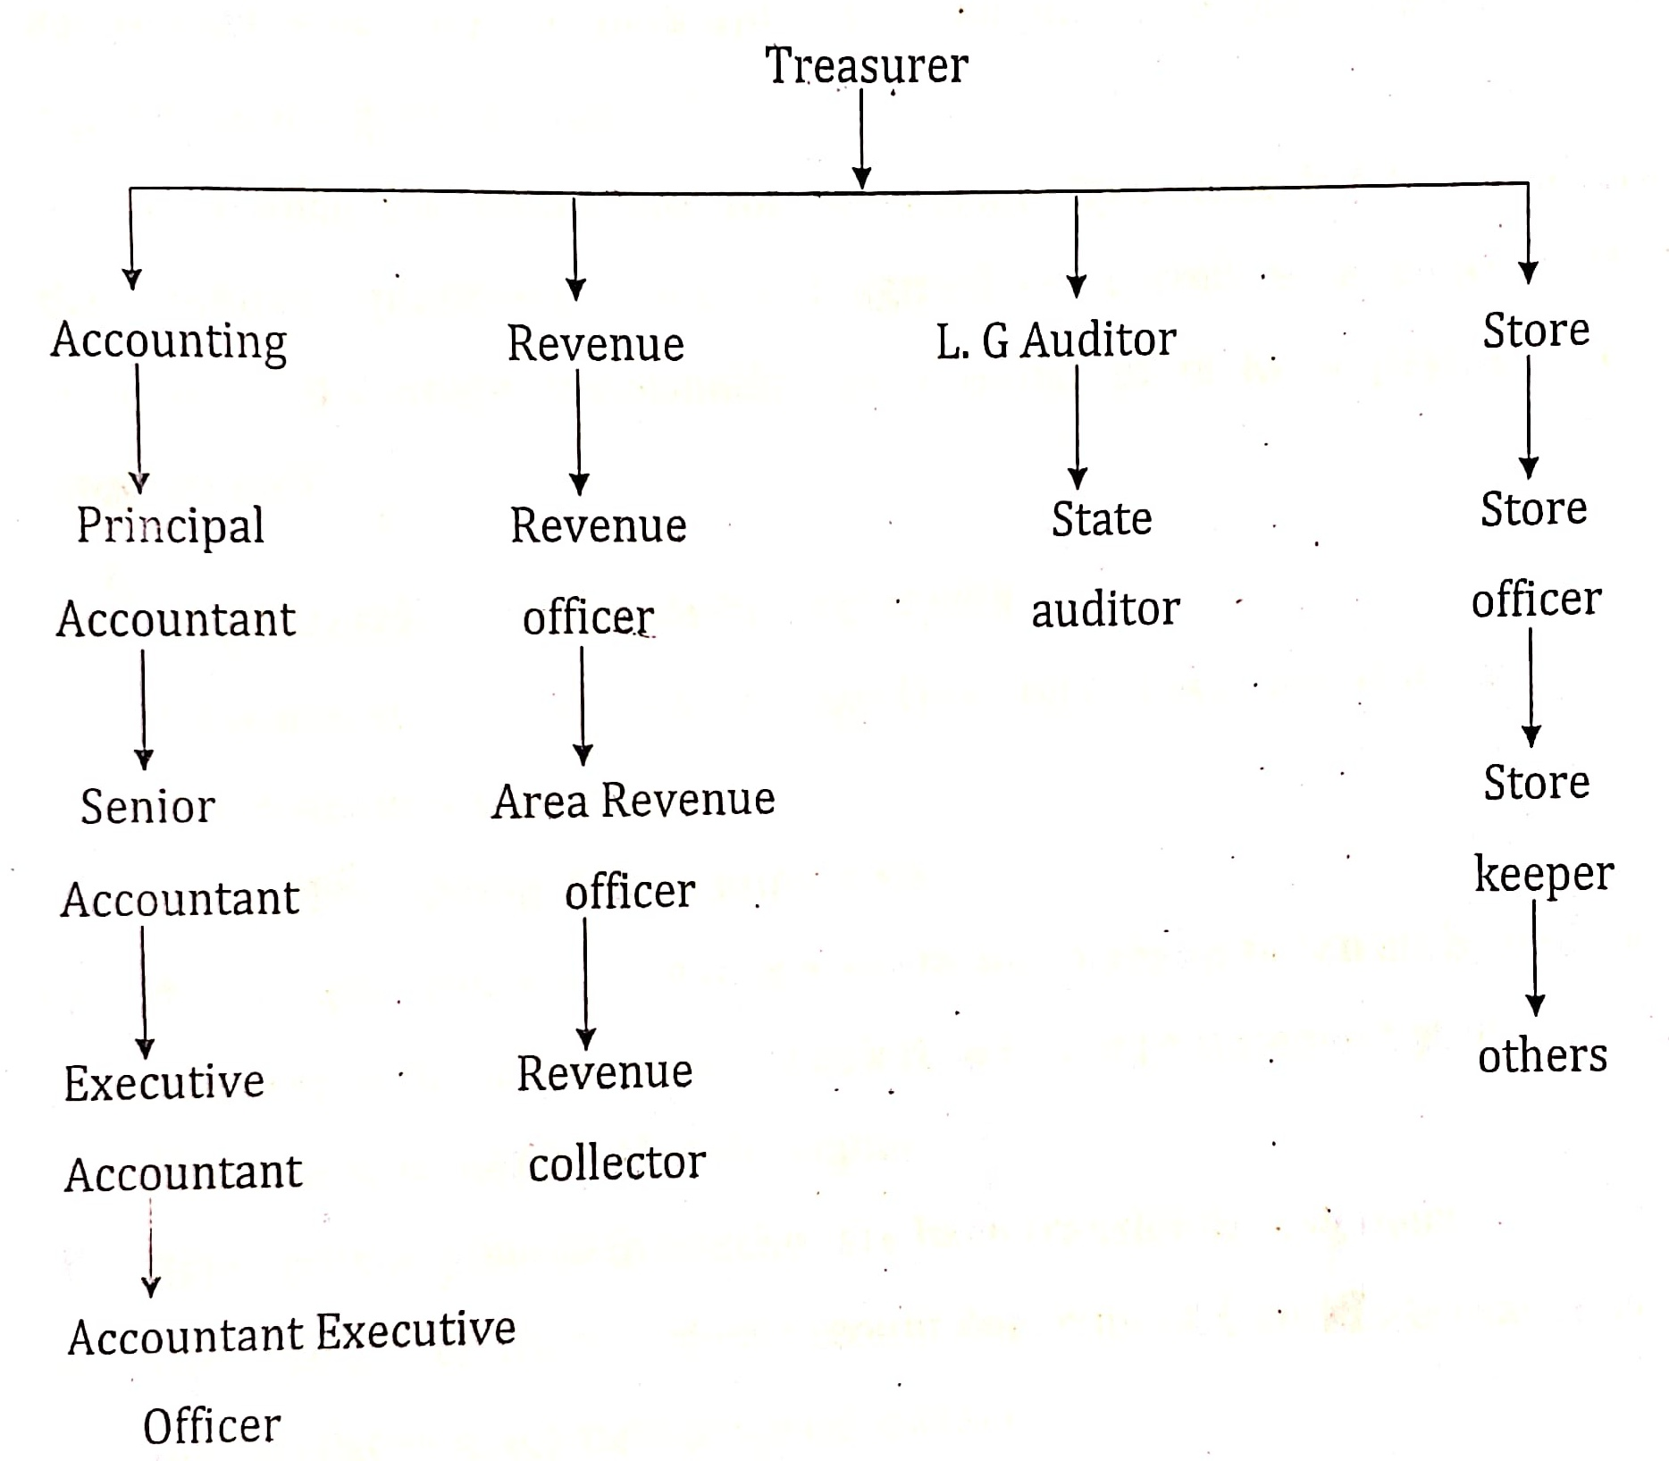
CHAPTER TWO
2.1 THE MEANING OF PAYMENT VOUCHER (P.V)
The full meaning of P.V is Payment Voucher. Payment voucher is documents wvhich support payment to their employer for their work done in the organization E.g. an invoice.
An invoice is a commercial document issues by a seller to buyer, indicating the products quantities, price and agreed on therefore, a voucher is an accounting document representing an internal to make a payment to an external entity.

2.2 REQUIREMENT OF PAYMENT VOUCHER

i. All issued vouchers should be under look and key. It is not open to everybody in the organization.
ii. All vouchers should be pre-numbered.
iii. We stamped voucher paid to prevent future representation of the voucher
iv. It is used in the preparation of bank reconciliation statement at the end of financial year usually 31of December
v. Every payment made in voucher are been transfer to cash book.
vi. Government Treasury/ Main Account department, L conclude that I can perform 80% in my field of specialization.

2.3 HOW A VOUJCHER IS USED IN ACCOUNT
a. A voucher is often a pre-number from used in the accounts payable department to standardize and enhance a company to its vendors and service providers a document which can be used as a proof that a monetary transaction has occurred between two parties in business.
b. It can also be use for a variety of purposes,sometime tacking the place cash in transaction acting as a receipt that invoice has been approved for payment.
It is a receipt in the sense that, the writing acknowledgement of have received an items of as specific value or specified article or some of money which have Environment settings that they operate, with a special emphasis on local needs and interest.
Head No: Sub-Head No:
It should also seek to develop in people a capacity for dealing with the diverse Technical and Business problem, a capacity which will enable to make sensible decision in their subsequent life throughout the course, people are to think effectively about Technical and vocational particularly business as a whole and to appreciate the interdependence of the various of their field of endeavors activities.

2.4 CASH BOOK
Month:

Date | Name of  payer | Particular  of receipt | TR.  No | PV.  NO | Head | Sub  Head | Cash |  | Bank
 |  |  |  |  |  |  | N | K | N | K
2.5.1 DEPARTMENT VOTE ACCOUNT BOOK
Description of Sub-Head:
EXPENDITURE

Line  No: | Date | Voucher No:  Dept.  Treasury | Particular | Annual |  | OCVS  Sign | Total Exp.  to Date |  | Balance of  fund Avail.
 |  |  |  | N | K | OCVS  Sign
 |  |  |  |  |  |  | N | K | N | K

2.5.2 IMPRESS ADVANCE LEDGER
Impress: is a sum of money advance to an officer to meet expenditure under the current estimatesfor which vouchers cannot be presented immediately to sub-accounting officer impress ledger is used for advance payment of estimates expenditure.
Accountant makes use of the ledger during preparation of annual budget impress should made through accounting officer to the accountant general.Impress is been authorized by accountant general. It is an authority which is conveyed by an impress warrant to impress holder, no impress money may be issue until.that authority has been received an impress must be used only for the specific purpose for which issued.
The operation of impress advance ledger should be made or done by accounting officer in charge, after the impress might have been issued for reference purpose when giving annual financial report.

2.5.3 APPLICATION METHOD OF IMPRESS ADVANCE LEDGER
An adjustment voucher is to transfer money from government account to another. It makes the account staff to know the total sum of income per month
expenditure controls; it is an indication that expenditure can be incurred public fund as approved in the estimate.
total
head

2.5.4 PERSONAL EMOLUMENT REGISTER (PER)
This is a ledger used in evaluating of every staff salary and allowance.This is a document or ledger used by accountant in knowing the total number of staff working in the organization.
The ledgers make the management to know the actua payment of salary to the staffs during the twelve (12) calendar months. This ledger is very important in every organization and is prepare by account staff.

2.5.5 DAILY ABSTRACT OF REVENUE EXPENDITURE
Daily abstract of revenue expenditure is a ledger used in entering daily expenditure of an officer sent out of an organization from cash book. It shows head,sub-head of various expenditure of department and office equipment. It is used during preparation of annual budget by account staff in preparing budget. The total amount budget for each head is shown in daily abstract of revenue expenditure.
It makes the work of budgeting fast for an account officer when presenting or preparing budget.

Head | Sub-  head | Voucher  No: | Amount |  | Sub-head |  | Total of
Head | Sub-  head | Voucher  No: | N | K | N | K | N | K

2.6 CHEQUE
A cheque is direction to a banker to pay or transfer a sum of money to a named payee. A cheque is dated and to be signed by the drawer. Two parallel transfers line are drawn across the cheque as a safety precaution.
In a cheque amount to be pay to drawer in indicated in the cheque book before banker made the payment to the drawer. Every check is credited in a ledger of a bank because; it is expenditure to the bank.
MONIES
Monies refer to funds or sums of money that can be easily converted to cash. It can also refer to asses that are invested on traded as commodity e.g.liquid money,jewayies and worths of an assets.

2.7 BUDGET
A financial and a quantitative statement prepare d and approved prior to a defined period of time usually a year.
Basic budget is based on a long time plane and used for current budget.Current budget is establishes for use over a short period of time usually one year or sometime less.
The budget composes of all ledger used by accountant to know income and expenditure for preparation of another financial year.
Budget officer is generally as senior member of the accounting staff responsible for preparation and presentation of budget to the mnanagement.
2.8 EDU LOCAL GOVERNMENT KWARA STATE
ESTIMATES OF CAPITAL EXPENDITURE

Sub-  head | Details of  Expenditure | Dev.Plan  Allocation | Proposed  Appropriation | Approved  Estimate | Actual  Expenditure
1. | Construction of  Market Staffs
2. | Construction of  Motor Park
3. | Construction of  Road
4. | Salary
5. | Staff Allowance
 | Total

Money is an element that has a strong power in human and purchases activities. Money came in existence to settle the difference of in balance between two or more people, in term of purchases and settlement of debts.
Money also have three (3) zils motive why people hold money.
i. Transaction purpose
ii. Speculative purpose
iii. Precaution purpose
People hold money for the purpose of buying and selling (businesses)economic recycling growth. While speculative is our day today needs which give satisfaction by money.
Money by it motive of persecution, it reduce the pains on sudden issues,like death, sickness ,legal issues etc.
Money as a good qualities, by it formula is known as D.D. SHAP
a. Durability
b. Divisibility
c. Scarce

d .Homogeneity
e. Portability
CHAPTER THREE
3.0 SUMMARY, CONCLUSION AND RECOMMENDATION
3.1 SUMMARY
The study began with the introduction of whole students industrial work experience scheme (SIWES) report under which Edu local Government,Treasury/Main Account Department was looked at briefly.
In this department we are taught about different books accounting such as cash book, payment voucher, departmental vote expenditure allocation book impress advance ledger, personnel emolument register, transcript daily transcript weekly transcript monthly and transcript yearly made in an organization.
All in all these books speak, communicate, in different direction but ended in the same direction just to maintain and control error, fraud, excess expenditure and to keep track.

3.2 CONCLUSION
Basically Edu Local Government staff of Treasury/Main Account department function in order to bring about development in the society as a whole.This made the treasury/main account staff to engage in general crucial to the attainment of the development some project or assignment and activities are carried out as to assisting to bring about development in the community.
Therefore, any theoretical knowledge given without practical is just like half knowledge,but with the little I derived at Edu Local Government.

3.3 RECOMMENDATION
A concerted effort towards an effective Edu local Government development necessitates the following recommendation:
i. Management of Edu local Government should listing and give adequate attention staff of Treasury/Main Account department, because the present
staffs of this department are ready to work towards the development of the society as a whole.
ii. Edu local Government should be resourceful and creative to realize the concepts of self reliance less dependent on the state and federal government for funds. The state and federal government should give a continue assistance and support to Edu local government in area of revenue generation.
iii. Conclusively, it is our hope and belief that all Edu citizens will take up challenges of fashioning our way of live that can lead us to great contentment and happiness. To attain development, therefore the structure values attitude of society should be the desire goal and objective of the development which need to be embarking upon

