

TECHNICAL REPORT ON STUDENT INDUSTRIAL WORK EXPERIENCE SCHEME (SIWES)

SIWES REPORT
UNDERTAKEN AT

OSBC ILE-AWIYE, OKE-BAALE OSOGBO OSUN STATE
Osogbo, Osun State

By:
IBRAHIM OBASANJO AREMU
ND/23/MAC/PT/0073

SUBMITTED TO:
DEPARTMENT OF MASS COMMUNICATION, INSTITUTE OF INFORMATION AND COMMUNICATION TECHNOLOGY (IICT) KWARA STATE POLYTECHNIC, ILORIN
IN PARTIAL FULFILMENT OF THE REQUIREMENT FOR THE AWARD OF NATIONAL DIPLOMA (ND) IN MASS COMMUNICATION

AUGUST – NOVEMBER, 2024

TABLE OF CONTENTS
TITLE PAGE i
CERTIFICATION ii
DEDICATION v
ACKNOWLEDGEMENTS v
TABLE OF CONTENTS ii
CHAPTER ONE 1
1.1 Introduction to SIWES 1
1.2 Background to the SIWES 1
1.3 Objectives of SIWES 2
CHAPTER TWO 3
2.1 History of the Organization 3
2.2 Vision And Mission Statement 3
2.2.1 Vision 3
2.2.2 Mission Statement 3
2.2.3 Organisation Structure And Department 3
2.2.4 Departments In OSBC, ILE AWIYE 4
2.3 Station Running Activities 6
CHAPTER THREE 7
INVOLVEMENT IN THE ORGANIZATION 7
3.1 Experienced Acquired 7
3.2 Work Done 7
3.3 Importance of Paper in News 7
3.4 Instrument Used in the News Room 8
3.5 What is Editing? 9
3.6 Who is a Reporter? 9
3.6.1 Types of Reporter 9
3.7 Sources of News 9
3.8 What is Line-Up? 9
3.9 Rule of Engagement in News Department 10
3.10 What is a Newscasters? 10
3.11 Duties of a Newscaster 10
CHAPTER FOUR 10
EXPERIENCED GAINED IN THE ORGANIZATION 10
4.1 What is Microphone 10
4.2 Types of Microphone 10
4.2.1 What Is A Condenser Microphone? 11
4.2.2 What Is A Dynamic Microphone? 11
4.2.3 What Is A Ribbon Microphone? 12
CHAPTER FIVE 13
CHALLENGES ENCOUNTERED, CONCLUSION AND RECOMMENDATION 13
5.1 Challenges Encountered 13
5.2 Conclusion 13
5.2 Recommendation 13

CERTIFICATION
This is to certify that this SIWES was carried out by IBRAHIM OBASANJO AREMU with Matric Number: ND/23/MAC/PT/0073 in the Department of Mass Communication, Institute of Information and Communication Technology (IICT), Kwara State Polytechnic, Ilorin.

DEDICATION
I dedicate this report to the Almighty God for his guidance, strength, and protection throughout and protection throughout my industrial training. I also dedicate it to my parents for their constant support and encouragement, as well as to my mentors and supervisors whose guidance helped me succeed during this period.

ACKNOWLEDGEMENTS
First and foremost, I appreciate Almighty Allah for giving me the privilege to partake in the Students Industrial Work Experience Scheme (SIWES).
I acknowledge my amiable and dynamic parents MR. AND MRS. IBRAHIM, for their financial, moral and spiritual caring and support during the course of my SIWES program.
I also appreciate my Industrial based supervisor for their patient, endurance, courage and kind support during the course of my stayed in OSBC ILE-AWIYE, OSOGBO OSUN STATE
I wish to also acknowledge my school based supervisor, for their support, encouragement and kind during their visitation to OSBC ILE-AWIYE, OSOGBO OSUN STATE
Finally, I appreciate my colleagues in the same industrial based training; I pray Almighty Allah will grant us success in our entire endeavor (Amen).

CHAPTER ONE

1.1 Introduction to SIWES
The Student Industrial Work Experience Scheme (SIWES) exposes students to industry based skills necessary for a smooth transition from the classroom to the world of work. It affords students of tertiary institutions the opportunity of being familiarized and exposed to the needed experience in handling machinery and equipment which are usually not available in the educational institutions and seeing firsthand the practical experience of some theoretical knowledge gained in the course of study.
Participation in SIWES has become a necessary pre-condition for the award of Diploma and Degree certificates in specific disciplines in most institutions of higher learning in the country, in accordance with the education policy of government.

1.2 Background to the SIWES
The Student Industrial Work Experience Scheme (SIWES) is an initiative which was established in 1973 by the Industrial Training Fund (ITF) to help bridge the gap between acquired classroom education and skills necessary for work in the industry.
Before the inception of the scheme in 1973, there was glaring evidence that inadequate practical exposure of students in tertiary institutions posed serious challenges to both the quality and standard of engineering and technological education in our nation. This resulted in half-baked engineering graduates who needed to undergo a form of training (Industrial Training) to be suitable for employment in industries and firms.
In order to forestall this threat that could bring about industrial regression, the Federal Government through the Industrial Training Fund (ITF) which was established by decree 47 of 1971 introduced the Student Industrial Work Experience Scheme (SIWES) in 1973.
SIWES exposes students to machines and equipment, professional work methods and ways of safe guarding the work areas and workers in industries and other organizations. It helps the student to know the link between what is learnt in the university and what is actually practiced on site. It further helps students to appreciate their field of study better, thereby also determining which area of specialization to go into to contribute to technological development of this nation.
The scheme involves the students, the universities and the industry (employers). It is funded by the Federal Government of Nigeria and jointly coordinated by the National Universities Commission (NUC) and the ITF.
SIWES orientation is usually done to intimate students with the rudiments of industrial training before they are being employed. At the end of the industrial training (IT), successful students whose log books were verified and approved by ITF officials are paid SIWES severance allowance.

1.3 Objectives of SIWES
- Provides the student with an opportunity to apply their theoretical knowledge in real work situation thereby bridging the gap between theory and Practical.
- Provides an avenue for students in tertiary institutions to acquire industrial skills and experience in their course of study.
- Expose students to work methods and techniques in handling equipment and machinery that may not be available in universities.
- Familiarizing the student for the working conditions they are likely to meet after graduation; and
- Make the transition from the university to the world of work easier and thus enhance student’s contacts for later job placement.

CHAPTER TWO

2.1 History of the Organization

The Osun State Broadcasting Corporation (OSBC) Ile-Awiye studio in Osogbo, Nigeria has been digitized and is now equipped with new transmitters. The OSBC was founded in 2001 and has a mission to inform, educate, and entertain listeners in Southwest Nigeria.
Early history
- The OSBC's television arm began in 1992 in Ibokun, a town 17 km from Osogbo.
- The OSBC's radio station transmitted on 89.5 FM from Ile Ife.
- In 1993, the radio station moved from Ile-Ife to Ita-Akogun in Osogbo.
- The OSBC's permanent headquarters were built at Oke-Baale, Ibokun road, Osogbo in 1995.
- The OSBC's radio and television services moved to their permanent headquarters in 1999.

Recent Upgrade
- The state government approved new transmitters and studio digital equipment for the OSBC.
- The OSBC's Ile-Awiye studio was digitized.
- The state government also approved permanent status for 66 freelancers who had been waiting for over 15 years



2.2 Vision and Mission Statement

2.2.1 Vision
Crafting stories that captivate and inspire your go-to- destination for unforgettable visual experience. Let’s turn your vision into reality.

2.2.2 Mission Statement
Our mission is to revolutionize radio by integrating advance technology, ensuring seamless compatibility with new media.

2.2.3 Organisation Structure And Department
OSBC is well structure radio station which all running and management is been fully control under the following step structure.
- Board of Trustees
- General Manager
- Station Manager
- Program Manager
- Administration Manager
- Marketing/ Finance Manager
- Studio Operators and Engineers

2.2.4 Departments In OSBC Station
- Administrative Department
- Programme Department
- Marketing Department
- Engineering Department
- Finance Department
- News and Current affairs
- Audit Department
Administrative Department: This department is in charge of all staffs matters, ranging from the code of conduct for all staffs, moral behavior, rules and regulation and scheme of services for all staffs. The department caters for personal matters training, training of staffs, and employment of new staffs, discipline and promotion. The department handles record keeping, takes care of matters relating to insurance of man and materials, survey of corporations land matters, dealing with contracts, provides clerical and secretariat duties for all department.
News and Programme Department: This department handles the entire programs as well as news section. Various Artists, freelancers as well as in house presenter are manage by this department. The Programme manager is responsible for the initiation of programs, and this idea must serve the purpose of informing, educating, persuading and entertaining.
Marketing Department: This is the department where the financial aspect of the organization is discussed and settled, not only that, the department deals with any jingle or advert rate and payment before going on air once verified by the programme department.
Engineering Department: This department is indebted with the task of supervising the equipment procurement, installation and maintenance of such equipment. He (producer/engineer) must be conversant with the broadcasting technology state.
Finance Department: The finance department is a service department that deals with the inflow and the outflow of the organization finances. It is in charge of budget preparation and budget control. It offers advice on financial matters to the chief director at all times. This department discharge duties ranging from billings, debt collection and payment of all fees for all channel, account reconciliation.
Editing Department: This is the department where we have experienced computer operator, their ingenuities is being task with the burning of disk, editing of recorded Audios, Jingles and Advert , and also keep the records.

ORGANOGRAM OF OSBC ILE-AWIYE, OSOGBO OSUN STATE

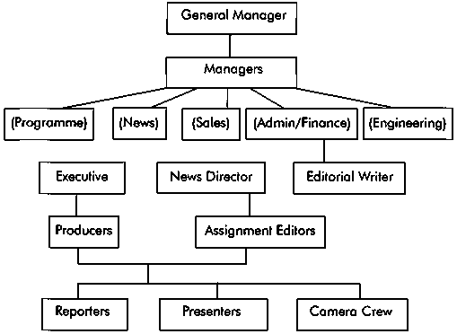

2.3 Station Running Activities
OSBC Ile-Awiye runs Uninterrupted hours of transmission for 19hours of quality and quantitative broadcast to our audience between 5:00am to 12:00am on daily basis making it one of our strength.
Our Programming Strength: We have distinctive programs with flexible but firm schedule.
News and current affairs: Our news hours are unique with accurate, balance and objective contents that attract high listeners.
Qualified and seasoned on air personalities that are young, vibrant and adding values to the broadcast industry.
OSBC Ile-Awiye also transmit and stream on all social media platforms which includes Facebook, Twitter, Instagram as well as Radio Garden as recognized worldwide radio streamers

CHAPTER THREE

INVOLVEMENT IN THE ORGANIZATION

3.1 Experienced Acquired
I started my SIWES program at OSBC Ile-Awiye Corporation the 10th of August 2024 in the news and current affairs department (English), under the supervision Mrs Oyegoke Alao.
My supervisor explained how Yoruba program works the time and tittle of each programs.
During my stays at OSBC Ile-Awiye, news department, I observed how the equipment in the studio are been use the mixer the first, second, third and fourth microphone are been use by the presenters.
I was able to know how to produce a programs and also given an explanations on how to control the console, operating system while recording, music ethics to play on a schedule programs and so on.
I participated on a program by 10:00am to 11:00am in the morning in which I broadcast a news.

3.2 Work Done
I was persuaded to do so many tasks at OSBC Ile-Awiye, which despite the fact that I was opportune to go on Air.
I carry out a task transcribing English briefs news to Yoruba which is called (IROYIN LEREFE) I also voice it out.
I was asked to go record a Jingleadvert.
I learnt how to read news, present news, how to write promotion and also how to write news about a particular event that happen especially at Ona-baba
There are numerous of my work done in which experienced a lot at OSBC Ile-Awiye, Osogbo Osun State

3.3 Importance of Paper in News
The following are the importance of paper in news.
- Available of news
- It will help the producer for the particular day to know which news will go for their time
- It help the producer alignment of a news story

3.4 Instrument Used in the News Room
The following are the instrument used in the news room.
- Table and chair


- Consoler
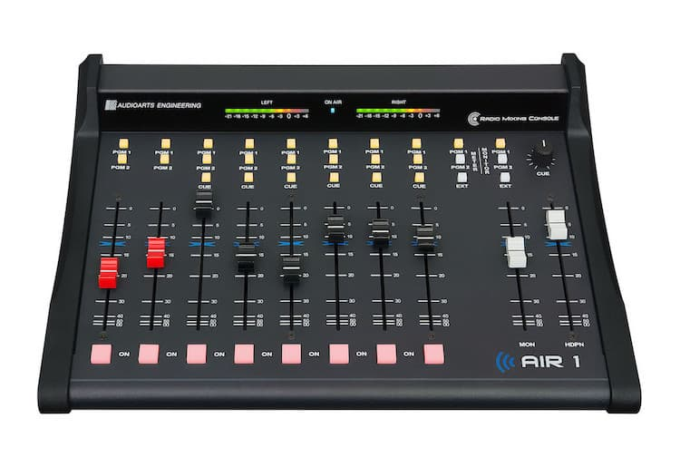

- Camera
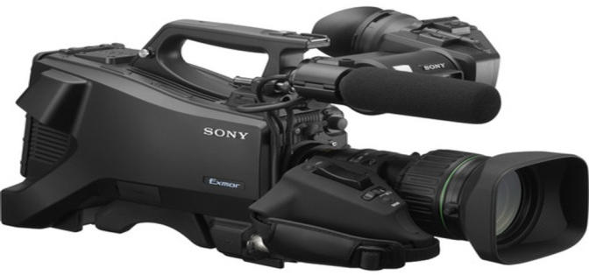
- Processor
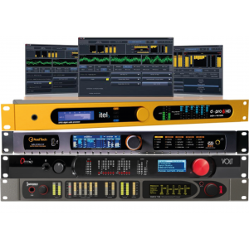

- Computer
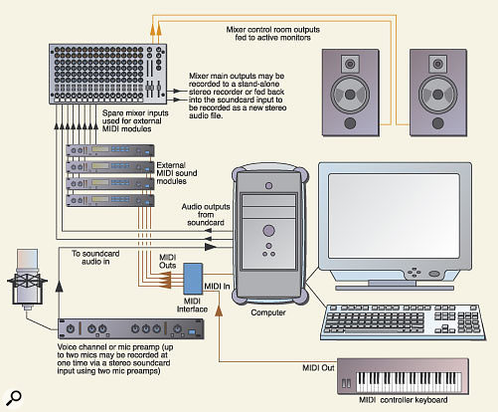

- Microphone
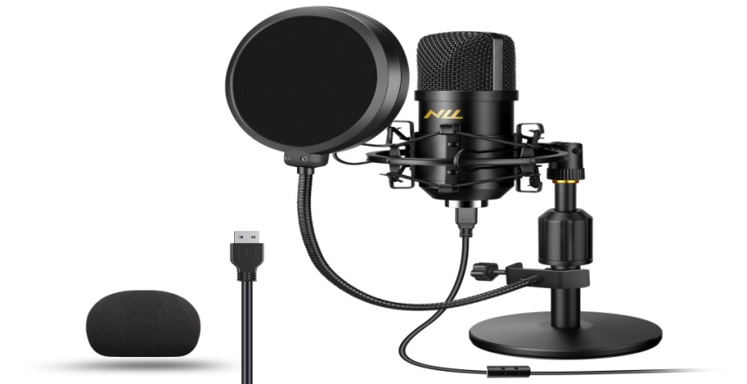

3.5 What is Editing?
Editing means doing all graphics. As a communicator you must know how to handle the system very well.

3.6 Who is a Reporter?
A reporter is also known as journalist who gather information and news to keep public informed.

3.6.1 Types of Reporter
There are three types of reporter know to me.
i. Judicial reporter ii. Education reporter iii. Health reporter

3.7 Sources of News
There are different ways of sourcing for news.
i. Rooting ii. Schedule assignment iii. Searching

3.8 What is Line-Up?
A line-up refers to a list of sequence individual on topic that will be featured on discussed in a news program or publication.

3.9 Rule of Engagement in News Department
The following are the rules of engagement in the news department.
i. Responsibilities of reporter ii. Alignment to responsibility
iii. Ability to work at any time iv. You must have a good news for news

3.10 What is a Newscasters?
A newscaster's job involves presenting current information and news via live radio, television or web broadcasts. While some newscasters may report on a variety of subjects, others specialize in areas like weather reporting, sports, politics, or general news, depending on the size of their news organization and the city in which they work.

3.11 Duties of a Newscaster
A newscaster is both a journalist and a broadcast specialist who communicates the news to a viewing or listening public. Depending on the location and the size of the station for which you work, you may report on international, national or local news.

CHAPTER FOUR

EXPERIENCED GAINED IN THE ORGANIZATION

4.1 What is Microphone
A microphone is a device that translates sound vibrations in the air into electronic signals and scribes them to a recording medium or over a loudspeaker.

4.2 Types of Microphone
There are three primary types of microphones. Those include cardioid, dynamic, and ribbon microphones.
Ideally, they all work the same but are designed to capture different elements. For example, if you're a singer, you may want your microphone to capture your voice while reducing the instruments in the background.

4.2.1 What Is A Condenser Microphone?
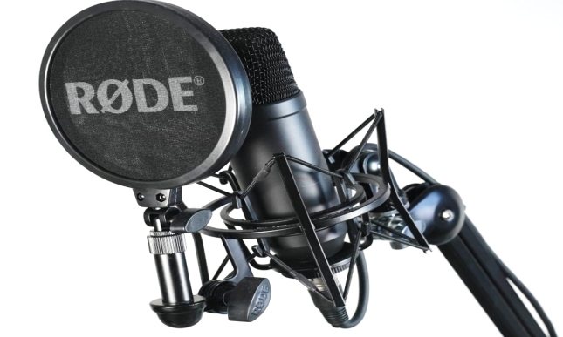
A condenser microphone uses a capacitor to convert sound into an electrical signal. These mics are typically used in studio recordings because they have a higher quality sound than dynamic microphones and are often best for vocals and higher frequencies.

4.2.2 What Is A Dynamic Microphone?

Another type of microphone to consider is a dynamic microphone. They are more rugged and can handle high volumes, making them ideal for live performances.
Some popular dynamic microphones are the Shure SM58, Shure SM7B, the Sennheiser e935, and the Audix i5.
Dynamic microphones are less sensitive than condenser microphones, meaning they can handle more sound without distorting the audio. This also makes them better for capturing louder sounds.

4.2.3 What Is A Ribbon Microphone?
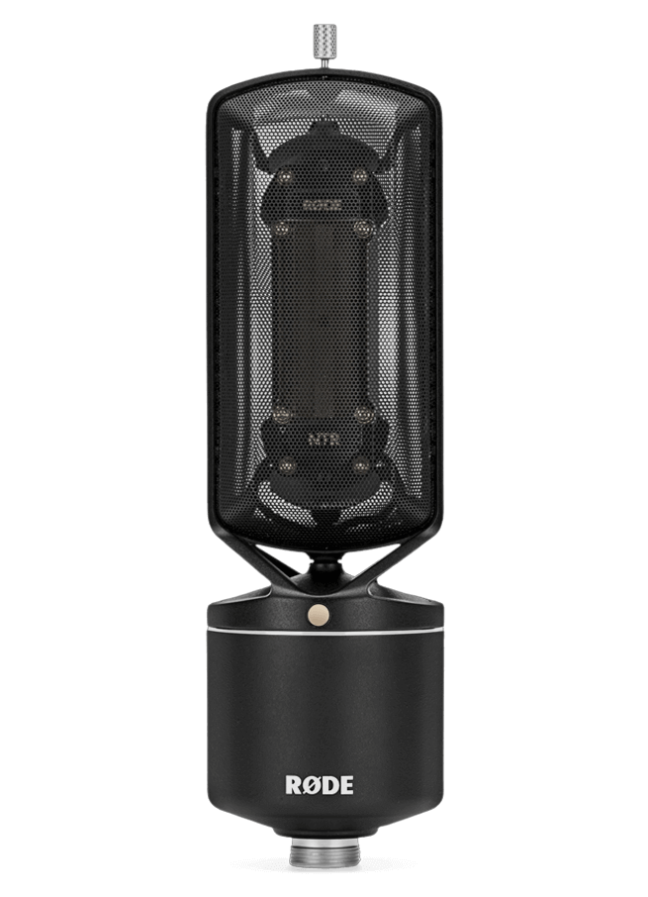
Ribbon microphones are less common but offer a unique sound that can be well-suited for certain genres of music. They use a ribbon of metal to convert vibrations into an electrical signal, and they typically have a figure-8 pattern.
There are a few different types of ribbon microphones available on the market.
Ribbon microphones are not as common as condenser or dynamic mics. However, they often produce a mellower sound than other microphone types, making them well-suited for certain genres of music. They can also be used for studio recordings for capturing the sound of vocals and acoustic guitars or capturing the sound of a choir or band.

CHAPTER FIVE

CHALLENGES ENCOUNTERED, CONCLUSION AND RECOMMENDATION

5.1 Challenges Encountered
There is nothing on earth that is free on challenges, life itself is full with different kinds of challenges and despite the fact that OSBC Ile-Awiye staff at news department are not friendly, because of the last spot of student that did then SIWES programme at OSBC Ile-Awiye, better still I tried my best to cope and cooperate with their activity.
Firstly, there are many insults been placed on it’s by some of the staff in the organization. In the first week of observing the industrial training in newsroom where I was posted, some of the staff in the newsroom do ask us if we have data in our mobile phone and if not, they will see us as an incompetent in the field or an unserious element. And at that time, they belittle us by not treating us anything.
Another challenge was that, there were many students from different school doing their SIWES programme also. And we neded to shift period for each other which they divided us into groups.

5.2 Conclusion
Frankly speaking, I will say that during my four (4) months in the SIWES programme at OSBC Ile-Awiye, Osogbo Osun state that I gained a lot of experience, which are:
- I can now understand the different between the theoretical and practical aspects of Mass Communication and other related courses.
- I gained how to present news, edit news, search for news, interrogate people and also know the differences in microphones and other studio gadgets.

5.2 Recommendation
SIWES is an important program that needs to be encouraged because, it provides from for practical knowledge to students in their areas of discipline.
It is important to ensure that student take the programme seriously and the government is to ensure strict supervision and monitoring of both the student and the school and the industry based supervision for better results.

