

A TECHNICAL REPORT ON
STUDENT INDUSTRIAL WORK EXPERIENCE SCHEME (SIWES)

BY
MOSHOOD KHALID OPEMIPO
ND/23/BAM/PT/0269

HELD AT
EDEN HOTEL AND RESORTS, KM 11, IDIROKO ROAD CHELSEA BUS-STOP OTA OGUN STATE

SUBMITED TO
DEPARTMENT OF BUSINESS ADMINISTRATION AND MANAGEMENT

INSTITUTE OF FINANCE AND MANAGEMENT STUDIES (IFMS)

IN PARTIAL FULFILMENT OF THE REQUIREMENT
FOR THE AWARD OF NATIONAL DIPLOMA (ND)
IN BUSINESS ADMINISTRATION AND MANAGEMENT

DECEMBER, 2024

DEDICATION
This report is dedicated to Almighty God, the Supreme Being and also to my loving parents, Mr. & Mrs. Moshood

ACKNOWLEDGEMENT
Firstly, with every sense of humility, I give my sincere appreciation to Almighty God from whom all knowledge, wisdom and intelligence is given to humanity for making it possible for me to accomplish my SIWES programme.
Education is an instrument of change, for human emancipation from ignorance, superstition and enslavement. My parents made sure they planted this in me. I am grateful to my parents, Mr. and Mrs. Moshood for their love, care, encouragement and financial support. I pray that Almighty God will grant them long life and hearty health to reap the fruit of their labour.
Words alone cannot express my enthusiasm to my SIWES supervisor and departmental lecturers for their paternal advice and tutelage. May God almighty continue to bless you all.

FOREWORD
This report contains all the work done and the experience gained during my two months of industrial programme which I had at Eden Hotel and Resorts in Ota Ogun State and it is written in chapters according to how the training goes.
The five chapters report is arranged as follow. Chapter one unveils a brief background of the advent of SIWES programme into Nigeria tertiary institution academic calendar. Chapter two reveals the major sections and units in the host organization and student’s specific involvement in the organization during training. Chapter four elucidates on work done by the intern in the organization, the relevance of the experience gained as it is in-line with the kernel of Hospitality management.
The last chapter of the report elucidates on conclusion, recommendation and suggestion for institution and organization.

- INTRODUCTION
The Student Industrial Work Experience Scheme (SIWES) is a skill training programme designed to expose and prepare students of universities and other tertiary institutions for the industrial work situation they are likely to meet after graduation. It is also a planned and structured programme based on stated and specific career objectives which are geared towards developing the occupational competencies of participants.
Sequel to the instruction relayed by the school authority and as allotted in the academic school calendar that every student should proceed on industrial training scheme at any organization of choice rendering service(s) related to course of their study, Kwara State Hospitality and Tourism Board under the supervision of the Ministry of Communication in Ilorin Kwara Statewas chosen as my place of attachment of which I had my three months internship as part of the requirements towards the award of National Diploma in Leisure and Tourism.

- DEFINITION AND CONCEPT OF SIWES.
Student industrial work experience is a training program established by I.T.F (Industrial Training Fund) in 1976 to bridge the gap between theory and practical aspect of learning in a tertiary institution in Nigeria and also to alleviate the challenges faced by young graduates in Nigeria labour market and beyond.
SIWES was established in Nigeria to help student develop on their practical aspect of learning expose them to various techniques in the industry and also aid their cohabitation with industrial staff, equipment and machineries.
The program was established with various coordinating agencies respect to each tertiary institution in the country. These agencies are:

- NBTE (National Broad for Technical Education)
- NUC (National University Commission) for University
- NCCE (National Commission of College of Education) for colleges of education.

- BRIEF HISTORY OF SIWES
Student industrial work experience scheme (SIWES) was established by Industrial Training Fund (ITF) in 1973/1974 to solve the problem of lack of adequate practical skills preparatory for employment in industries by Nigerian graduate of tertiary institution.
Prior to the establishment of the schemes, there was a concern among our institution of higher learning lacked practical background studies preparation for employment in the industries.
The student industrial work experience scheme (SIWES) is a skill training program designed to expose and prepare student of agriculture technology, environmental science, medical science and pure & applied science for the industrial work situation one is likely to meet after graduation.

- OBJECTIVES OF SIWES
- To provide an avenue for students in institution of higher learning to acquire industrial skills and experience in their approved courses of study
- Prepare students for the industrial work situation which they are likely to meet after graduation
- Expose students to work methods and techniques in handling equipment and machinery not available in their institution
- Provide students which they are likely to meet after graduation
- Expose students to work methods and techniques in handling equipment and machinery not available in their various institutions.

- OVERVIEW OF BUSINESS ADMINISTRATION AND MANAGEMENT
Introduction
Business Administration and Management are fundamental disciplines that focus on the organization, planning, and operation of businesses to achieve their goals efficiently and effectively. These fields involve decision-making, leadership, and the coordination of resources to ensure business success.
Definition of Business Administration and Management
- Business Administration refers to the process of organizing and overseeing business operations, including finance, marketing, human resources, and production.
- Management is the act of planning, organizing, leading, and controlling an organization’s resources to achieve specific objectives.
Key Functions of Business Administration and Management
- Planning – Setting business objectives and determining the best course of action to achieve them.
- Organizing – Allocating resources, assigning tasks, and structuring the organization to operate efficiently.
- Leading – Motivating and directing employees to work towards organizational goals.
- Controlling – Monitoring progress, evaluating performance, and making adjustments to improve efficiency.
Core Areas of Business Administration and Management
- Human Resource Management – Managing employee relations, recruitment, training, and performance.
- Marketing Management – Developing strategies to promote and sell products or services.
- Financial Management – Handling budgeting, investments, and financial planning.
- Operations Management – Ensuring efficient production and delivery of goods and services.
- Strategic Management – Setting long-term goals and competitive strategies for business growth.
Importance of Business Administration and Management
- Ensures efficient resource utilization.
- Helps organizations achieve their objectives.
- Improves decision-making and leadership skills.
- Enhances business competitiveness and sustainability.
Business Administration and Management are essential for the success of any organization. They provide the foundation for businesses to operate effectively, adapt to changes, and achieve long-term growth. Understanding these principles is crucial for entrepreneurs, managers, and business professionals.

- HOTEL
The word hotel according to Yayuk Sri Purwani, came from the France’s word ‘hostel’’, which means a lodging for people who make a trip. In the development of this word, people prefer call hotel to hostel. The word hotel was introduced to the public in 1979. (Yayuk Sri Purwani, 1993:2) The definition of hotel according to business dictionary is “commercial establishment providing lodging, meals, and other guest services.
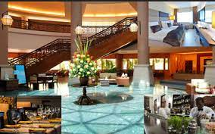
The Housekeeping Hotel Book defines hotel as “the building serving accommodation, food and beverages also the other facilities needed by the guest and managed professionally to get profit.” (Rumekso, 2002 : 2)
In conclusion, it can be said hotel is commercial establishment providing room, food and beverages and other supporting facilities for the guests during their stay in the hotel.

- STRUCTURAL ORGANIZATION OF HOTEL
Hotel is a big company which needs many departments to operate the business. Each department cooperates with each other to reach the goals. The structural organization of hotel according to Rumekso are as follows:
- General Manager: General Manager is the executive manager responsible for the overall operation of hotel or resort. The General Manager of a hotel always reports directly to a corporate office or hotel owner. General Manager has duty to manage of a management team, create operational budget, set business objectives, respond the issues involving guests, employees, or the facility. General Manager also maintains relations to companies or department, local governments, and many additional duties.
- Executive Secretary Manager: Executive Secretary has an administrative assistant in business office administration. Executive Secretary is responsible for assisting general manager’s activity. Some duties of Executive Secretary are to manage budgets and bookkeeping, maintain websites, and make travel arrangements. Executive Secretary also arranges meeting minutes and prepares meeting documents.
- Front Office Division: Front office is a division which deals with the guests directly. This department has a duty to handle the guests reservation and provide information about the hotel’s facility.
- House Keeping Division: House Keeping division has responsibility for maintaining the condition of hotel area especially hotel room. The duty is keeping the tidiness, cleanliness and beauty of hotel room.
- Human Resources Division: Human Resources division is a framework which helps employees develop their personal and organizational skills, knowledge, and abilities. This department has a duty to provide opportunities such as employee training, employee career development, performance management, coaching, succession planning, salary, and employee recruitment and organization development.
- Sales and Marketing Division:Sales and Marketing Division has responsibility to sell hotel room and promote about hotel facility to the customers.
- Engineering Division: Engineering division has responsibility to repair and maintain the hotel’s facility, such as electricity.
- Accounting Division: Accounting Division has responsibility to make note everything related to hotel’s financial, such as transaction activities in the hotel.
- Food and Beverage: Division Food and Beverages Division has duty to prepare food and beverage product. The activities of food and beverage division are usually worked in kitchen, banquet, pastry, bar and lounge, room service and pastry shop. (Rumekso, 2005:6)
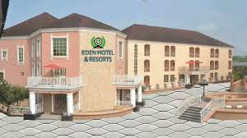
- ABOUT EDEN HOTEL AND RESORT
Eden hotel and resorts feels truly residential, like a home away from home. With guests at our individual rooms and suites having access to our pools, lounge areas and shaded pavilions. It is situated at the heart of Eden Avenue by Bells Secondary School, Ota, Ogun State with its plush, peaceful and beautiful ambience.
Photo Credit: web
Eden Hotel and Resort has well-furnished rooms of different categories. These categories include: the Single Room, Standard Room, Superior Standard, Deluxe Standard, Exclusive Standard, Super Exclusive Rooms, Family Suite, Diplomatic Suite and Presidential Suite. These rooms have air-conditioners with a king-size bed, flat screen TV, sofa, work table and an en-suite bathroom. Breakfast is served to guests at an extra charge.
It has facilities which include: free Wi-Fi, an outdoor swimming pool, a parking space, 24-hour power supply, restaurant where guests can choose from a list of both local and continental dishes and a bar where both alcoholic and non-alcoholic drinks are served. Guests can enjoy swimming sessions at the outdoor pool. Security personnel guard the premises at all times to ensure the safety of its guests.
Eden Hotel and Resort offers additional services like: laundry/dry cleaning, airport shuttle and car hire, a business centre, 24-hour room service, concierge, ironing services, housekeeping and an event facility.
- ORGANOGRAM OF THE ORGANIZATION
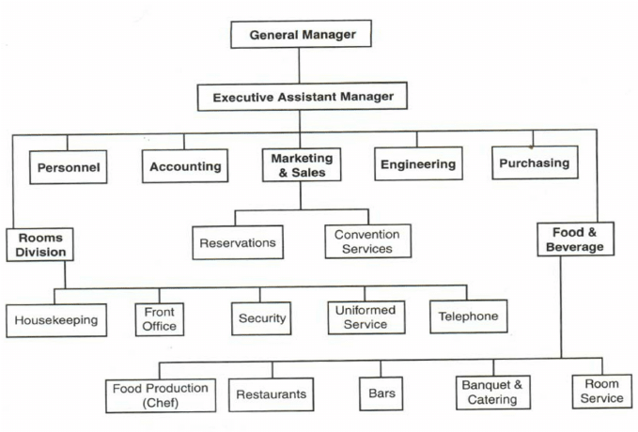

- MAJOR ACTIVITIES IN THE ORGANIZATION
Hotel activity is considered as a hospitality accommodation activity, which involves renting accommodation capacities to travelers, tourists and other guests for a short period of time, usually on a daily or weekly basis.
Hotels and similar accommodation facilities offer accommodation in rooms or apartments, sometimes including a cooking area. They offer accommodation in furnished rooms, daily cleaning of rooms. Additional options and services are offered to guests: supply with food and drinks, parking spaces, swimming pools, gyms, recreational areas, conference and meeting areas.
The facility, where hospitality activity is implemented, must be appropriately marked, has an appropriate operating permit, considers the minimum spatial conditions and has appropriately arranged outdoor areas. The minimum scope of services must be ensured for a specific hospitality facility, and it must operate regularly so that it is approved by the municipality. When implementing your activity, you need to consider the limitations of selling tobacco products and the restrictions of selling and offering alcohol beverages.
No preliminary decision on the fulfilment of conditions for carrying out a hospitality activity is required, but all conditions must be fulfilled, which will be supervised by competent inspectorates.

- SOME OF THE ACTIVITIES IN EDEN HOTEL AND RESORT ARE NOT LIMITED TO

- Food and Beverages
The food and beverage sector which is professionally known by its initials as F&B is the largest segment of the hospitality industry. The F&B department is estimated to provide 95% of all meals eaten in hotel today. It comprises of establishments primarily engaged in preparing meals, snacks, and beverages for immediate consumption on and off the premises. When a restaurant is part of a hotel, services it renders can enhance the guest experience by providing excellent food and first-class customer service. It can symbiotically function as part of other businesses, such as in bowling alleys or movie theaters.
- Restaurant and Dining
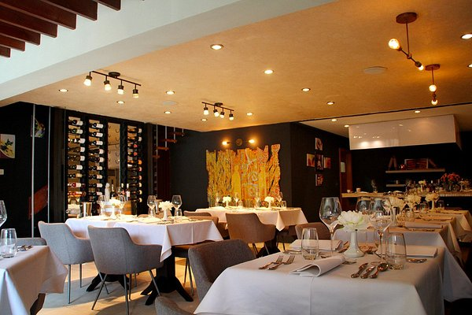
Restaurants and dining play a crucial role in the hospitality industry, providing food and beverages to customers in various settings. A restaurant is an establishment where meals are prepared and served to customers, either on-site or for takeout and delivery. Dining, on the other hand, refers to the experience of consuming food, often in a social or formal setting.
Restaurants come in different types, including fine dining, casual dining, fast food, buffets, cafés, and food trucks. Each type offers a unique atmosphere, menu, and service style. Fine dining restaurants provide an upscale experience with gourmet meals, elegant décor, and exceptional service, while fast food establishments prioritize quick service and affordability.
The success of a restaurant depends on several factors, such as food quality, customer service, ambiance, and pricing. Effective management, including inventory control, hygiene standards, and staff training, is essential for smooth operations.
Dining experiences vary from casual meals with family and friends to business dinners and special celebrations. Cultural influences, dietary preferences, and culinary trends also shape the restaurant industry. With evolving consumer preferences, many restaurants are now incorporating sustainable practices, healthier menu options, and digital ordering systems to enhance customer satisfaction.
- Lodging
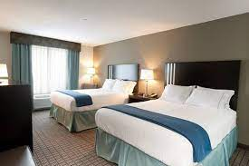
Lodging means accommodation for a period or a place to sleep for one or more nights. Fancy hotels, youth hostels, elder hostels, campgrounds, motels and other businesses that provide a place for people to sleep overnight are all in the lodging industry. Lodging businesses markets to other market segments such as business travelers, leisure travelers, long-stay travelers, budget travelers, and special travelers like people working with the government, airlines, and military.

Gym and Spa
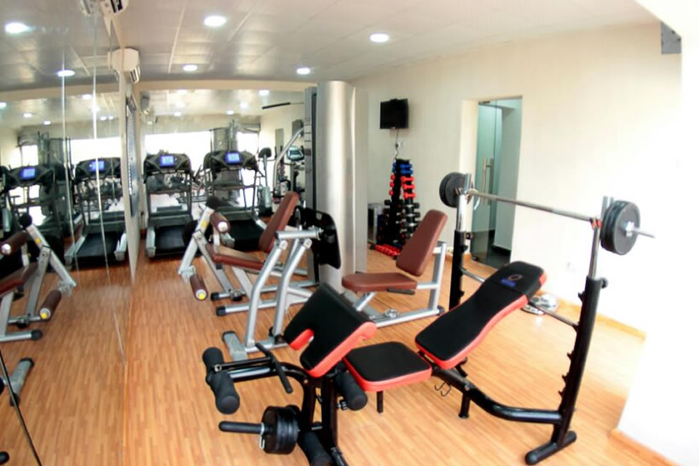
Gyms and spas are essential wellness facilities that promote physical fitness and relaxation. A gym is a fitness center equipped with exercise machines, free weights, and training areas where individuals engage in physical activities to improve strength, endurance, and overall health. It offers services such as personal training, group workouts, and specialized fitness programs like yoga, aerobics, and weightlifting. Regular gym workouts help in weight management, muscle building, and enhancing cardiovascular health.
On the other hand, a spa is a relaxation and wellness facility that provides treatments such as massages, facials, body scrubs, and hydrotherapy. Spas focus on stress relief, skincare, and holistic well-being, offering a peaceful environment to rejuvenate the mind and body. Some spas also provide advanced therapies like aromatherapy, hot stone massages, and detox treatments.
Many modern gyms incorporate spa services, creating a comprehensive wellness experience. This combination allows individuals to work on their fitness goals while also benefiting from relaxation and recovery treatments. The increasing awareness of self-care and healthy lifestyles has made gyms and spas popular destinations for those seeking overall well-being. Whether for fitness or relaxation, both facilities contribute significantly to physical and mental health.

- DEPARTMENT IN THE ORGANIZATION AND THEIR SPECIFIC FUNCTIONS
1. Front Office Department
This department performs various functions like
- Reservation
- Reception
- Registration
- Room assignment
- Settlement of bills of a resident guest
The department is considered as the nerve centre of a hotel. The front-office staff welcome the guests, carry their luggage, help them register, give them their room keys and mail, answer questions about the activities in the hotel and surrounding area, and finally check them out. In fact, the only direct contact most guests have with hotel employees, other than in the restaurants, is with members of the front-office staff.
2. Housekeeping Department
The housekeeping department is responsible for the cleanliness, maintenance, and aesthetic upkeep of rooms, public areas, back areas, and surroundings in a hotel and for the immaculate care and upkeep of all guest rooms and public spaces at all times. The staff members who excel in the Housekeeping Departments have an eye for detail and a commitment to the training, development and motivation of a diverse group of talented employees. It is the service and cleanliness that really make an impact on our guests and determine whether they will return and also recommend the hotel to others.
3. Food and Beverage Service Department
This department looks after the service of food and drinks to guests. The Food which is made in the Kitchen and Drinks prepared in the Bar to the Customers (Guest) at the Food & Beverage premises. Some examples of the food and beverage outlets are Restaurants, Bars, Hotels, Airlines, Cruise Ships, Trains, Companies, Schools, Colleges, Hospitals, Prisons, and Takeaway etc.
4. Kitchen or Food Production Department
All the food and beverages that are served to the hotel guest is prepared in the kitchen. Culinary preparation, as an art and science in the modern kitchen, required more than just a knowledge of food being prepared and the methods of preparation. It is through a knowledge of basic skills, terminology, and rules of the kitchen that a final goal, preparation and service of quality is achieved in the hotel kitchen.
5. Engineering and Maintenance Department
The engineering department is responsible for repairing and maintaining the plant and machinery, water treatment and distribution, boilers and water heating, sewage treatment, external and common area lighting, fountains and water features etc. Also, It looks after the maintenance of all the equipment, furniture and fixture installed in a hotel.
6. Accounts and Credits Department
This department maintains all the financial transactions. Accounting departments typically handle a variety of important tasks. Such tasks often include invoicing customers, accounts receivable monitoring and collections, account reconciliations, payables processing, consolidation of multiple entities under common ownership, budgeting, periodic financial reporting as well as financial analysis. Also common are setting up adequate internal controls for all business processes (to prevent theft/misappropriation of assets), handling external audits and dealing with banks in order to obtain financing. Taxes are sometimes handled by accounting departments in house, but this work is often contracted to outside tax accountants.
7. Security Department
The security department of a hotel is responsible for the overall security of the hotel building, in-house guests, visitors, day users, and employees of the hotel, and also their belongings.
8. Human Resources (HR) Department
Human Resource department is responsible for the acquisition, utilization, training, and development of the human resources of the hotel.
The role of the HR department also has to do with the administration of an impartial and internal justice system which will promote transparency and openness in organizational communication. The Human resources department also serves as a progressive voice in a common system and strives to ensure competitiveness in the conditions of service for staff.
9. Sales and Marketing Department
The major role of the sales and marketing department is to bring in business and also to increase the sales of the hotel’s products and services is the major task of the department.
10. Purchase Department
The purchase department is responsible for procuring the inventories of all the departments of a hotel.
11. Information Technology (IT)
The Information Technology department is responsible for the day-to-day support of all IT systems, business systems, office systems, computer networks, and telephony systems throughout the hotel/resort.
Additionally responsible for Information Technology issues, products, and services at the property. Provides user training and support of all property/site systems, network enhancements, hardware and software support etc.

- DISCUSSION
RELEVANCE OF THE EXPERIENCE GAINED BY STUDENT DURING THE PROGRAMME
Without mincing fact, Student Industrial Work Experience Scheme (SIWES) sustains a great relevance for tertiary institution students during internship. Besides exposure to the technical Know-how of things are been done in industrial setting which far differs from what is being taught within the four walls of classroom. This will undoubtedly unravel completely or at least lessen the demarcation and prevailing contrast in terms of work force and output between industrial staff and newly employed graduates.
Unlike an intern, I was given a warm welcome on my first day at Eden Hotel and Resorts. This was followed by my introduction to other staff and orientation on the activities/ functions of the organization.
In sequel to that, I was also introduced to other departments’ i.e. Food and beverages department, Housekeeping department, Frontline department, Kitchen and food Production department amongst others.
During my internship, I functioned relatively in some of the departments/units in the organization such as: Restaurant and bar unit, Kitchen department, Housing department, Laundry unit, Store keeping unit, front office department and I was able to gathered several hospitality management experience which will abet my academic career and pursuit.

- CHALLENGES ENCOUNTERED
- Financial scar
- Starkness of industrial staff
- Proximity of industrial location
- Limited internship period

- SUMMARY
During my period at Eden Hotel and Resort, Eden Avenue by Bells Secondary School, Ota, Ogun State. I was attached in the accountant department which consists of the Maintaining accurate financial records of income and expenses. I was taught how to prepare financial statements, including profit and loss reports, balance sheets, and cash flow statements. The period of this program has enabled me to combine the theoretical aspect learnt in four walls of class with the technical know-how of how things is being done in industry.

- CONCLUSION
The industrial training program has offered me opportunity to gain insight and more comprehensive understanding about the real industrial working condition and practices and it has actually exposed me to working experience and challenges that might be faced after school. I hereby conclude that government should make it compulsory for all tertiary institutions in Nigeria to making sure their school curriculum in designed in such a way that the academic calendar will vividly give all student irrespective of faculty and institute the opportunity to partake in the exercise of Student Industrial Working Scheme (SIWES)

- RECOMMENDATIONS
In other to achieve most of the objective of the student, industrial work experience scheme which are most specially to expose and give students opportunity to inculcate the theoretical knowledge to practical

- The SIWES official should try to liaise with private sector so that it will be easy for student for easy placement.
- The federal government should make sure that the industrial training fund official endeavor to visit several establishments where SIWES student are
- All institutions or bodies involve in the scheme should make sure that each organization make provision of incentives for the interns.

References
Google.com
Rumesko. B.O (2005:6) Production of Food and Beverages
Wikipedia
www.bovinaview.com
Yayuk Sri Purwani, (1993:2) Conceptual analysis of Hotel

