

A TECHNICAL REPORT
ON:
STUDENT INDUSTRIAL WORK EXPERIENCE SCHEME (SIWES)
HELD AT:
whyte kitchen
Opposite Ibukuoluwa besides genesis hotel iree road, osun state

PRESENTED BY:

SONIBARE HIKIMOT OMOWUMI
ND/23/HMT/PT/0046

SUBMITTED TO:
DEPARTMENT OF HOSPITALITY MANAGEMENT
INSTITUTE OF APPLIED SCIENCE (IAS)
IN PARTIAL FULFILLMENT OF THE REQUIREMENT FOR THE AWARD OF NATIONAL DIPLOMA (ND) IN HOSPITALITY MANAGEMENT

AUGUST - nOVEMBER, 2024

DEDICATION
This SIWES report is dedicated to Almighty God. I also dedicate it to my parent Mr. and Mrs. Sonibare for their support on this programme.

ACKNOLEDGEMENT
First and foremost, my enormous gratitude goes directly to Almighty God who made things possible to whom he will with easy hand. My profound gratitude goes to my lovely parent MR. & MRS. Sonibare may God continue to shower his perpetual blessing upon them.

INTRODUCTION
The scheme is designed to take place outside the school in every different environment rather than the one they are use to student environment. Students are allowed to choose a reputable organization of their choice. The lucky one will have to go in ministries of their place decided but the school SIWES offer, a lots of time students that fall into this categories complain a lots of skills and experienced are lost rather than unlike in private business where more gained.
SIWES was established by ITF in 1973 to solve the problem of lack of adequate practical skills preparatory for employment in industries by Nigerian graduates of tertiary institutions.
The Scheme exposes students to industry based skills necessary for a smooth transition from the classroom to the world of work. It affords students of tertiary institutions the opportunity of being familiarized and exposed to the needed experience in handling machinery and equipment which are usually not available in the educational institutions.
Participation in Industrial Training is a well-known educational strategy. Classroom studies are integrated with learning through hands-on work experiences in a field related to the student’s academic major and career goals. Successful internships foster an experiential learning process that not only promotes career preparation but provides opportunities for learners to develop skills necessary to become leaders in their chosen professions.
One of the primary goals of the SIWES is to help students integrate leadership development into the experiential learning process. Students are expected to learn and develop basic non-profit leadership skills through a mentoring relationship with innovative non-profit leaders.
DEFINITION OF SIWES
SIWES can be defined as an important program organized by the Industrial Training Fund (I.T.F) in order to impact and promote understanding practical for the experience gained in school. SIWES allows the students to acquire deep knowledge about what is taught in school.
AIMS AND OBJECTIVES OF SIWES
The following are the aims and objectives of SIWES.
- It gives students extra-ordinary experience on it field of study.
- It widen students experience on practical aspect.
- It enable student to know much about the importance of its field
- The application of their course and field are gained
- It also gives students ideas of interaction and acquires knowledge on small scale business.

RELEVANT OF EXPERIENCE GAINED
OBJECTIVE OF THE ESTABLISHMENT
- Its kitchen provides food and other edible substances for human consumption
THE VARIOUS DEPARTMENT OR SECTIONS IN THE ESTABLISHMENT AND THEIR FUNCTIONS
1. Kitchen
2. Restaurant

- KITCHEN:
The Kitchen is the place where all kinds of dishes like fried rice, boiled yam egg sauce, Afang Soup, Egusi Soup, Vegetable Soup etc are produced. The restaurants do the serving of the dish to the guest, while the bars serve drinks to the guest, alcoholic and non alcoholic drinks are sold there as well.
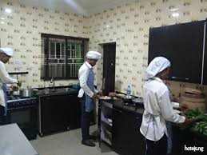
KITCHEN
- RESTAURANT
A restaurant is a business establishment that prepares and serves food and drinks to customers. Restaurants vary widely in terms of cuisine, ambiance, and pricing. They may offer a casual dining experience, such as fast food or a café, or a more formal setting with fine dining options. Restaurants can specialize in specific types of cuisine, or they may offer a diverse menu with various dishes from different culinary traditions. The dining experience at a restaurant typically involves customers ordering from a menu, being served by waitstaff, and enjoying their meals in the restaurant's dining area.
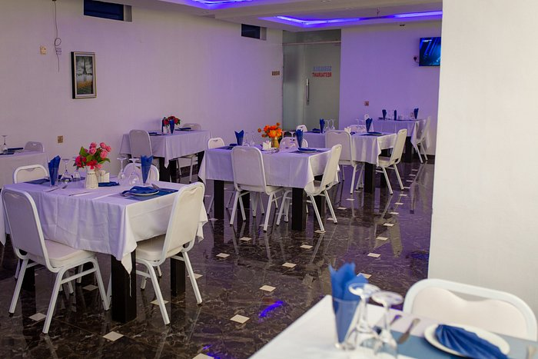
RESTAURANT
GENERAL EXPERIENCE ACQUIRED
Kitchen
- We where taught how to prepare sunset egg with vegetable oil
- jollof rice preparation was taught
- Fried rice and omelet egg preparation was done
Restaurant
- Welcoming of the guest and showing them the menu list to check wat he/she needs
- Wait around to take or write bills of the guest
MAKING OF DISHES
BOILED YAM EGG SAUCE RECIPES:
4 slices of yam, 2 fresh eggs, 5 seeds of fresh tomatoes, 2 seeds of pepper, ¼ teaspoonful of salt, a cube of maggi, ½ onions, carrots, green beans, groundnut oil, some quantity of water.
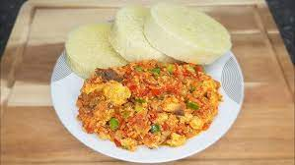
BOILED YAM EGG SAUCE
METHODS OF PREPARATION
Peel the slices of yam, wash and boil. Slice the tomatoes, onions, and pepper. Cut the carrot and green beans. Then put the groundnut oil on fire, allow to heat, add the salt, put the onion and allow to fry a bit then pour the tomatoes, and allow to fry, then put the carrot and green beans and allow to fry then pour the beated egg into it and stir, then add the maggi and allow to fry for 2 minutes, then remove from the heat dish into a flat plate with the boiled yam.
WHITE RICE WITH STEW
Recipes:
3 cups of Rice, a tin of tomatoes, 8 seeds of fresh tomatoes, 4 seeds of pepper, 1 onion, groundnut oil, 11/2 teaspoonful of salt, ½ kilogram of meat, curry leave, curry powder, thyme, 2 cubes of maggi, some quantity of water.
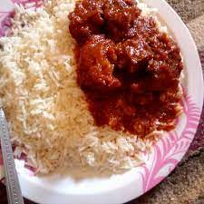
WHITE RICE WITH STEW
METHODS OF PREPARATION:
Wash the rice and parboil it, the boil finally put the groundnut oil on fire and add salt, onions and allow to fry, then put the grinded tomatoes and pepper and allow to fry, then add the tin tomatoes and allow to fry, then spice the stew with curry and thyme, after that you add the stewed meat, and add the curry leave and allow to boil, dish into a plate with white rice.
JOLLOF RICE
Recipes:
3 cups of rice, a tin of tomatoes, 4 seeds of fresh tomatoes, 2 seeds of pepper, 1 onions, groundnut oil, 1 teaspoonful of salt, ¼ kilogram of meat, curry powder, thyme, 2 cubes of maggi cube, carrot, green beans, and some quantities of water.
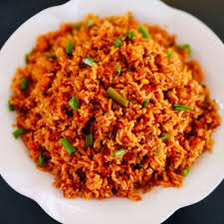
JOLLOF RICE
METHODS OF PREPARATION:
Wash the rice and parboil it, then heat the groundnut oil and add salt, onion and allow to fry. put the grinded tomatoes and pepper and allow to fry, then add the tin tomatoes and allow to fry, spice the stew with curry and thyme, maggi cube after pour the stew and rice with the stock (meat water) and stir, then allow it to boil, then fry the stewed meat, dish the rice with meat.
FRIED RICE
Recipes:
3 cups of rice, carrot, green beans, green pepper, 1 onions, ¼ nutmeg grinded, groundnut oil, butter, 2 cubes of maggi cube, thyme, ginger, curry, ½ kg of meat, and 1 teaspoonful of salt, some quantity of water, green peas, cabbage.
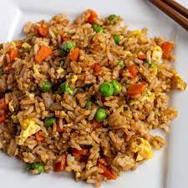
FRIED RICE
METHODS OF PREPARATION
Wash and parboil rice, wash and cut the carrots, green beans, green pepper, cabbage, ginger, onions, stewed the meat, with the liver. Then pour the parboiled rice into the stock (meat water) and allow to boiled, then heat the butter and groundnut oil add the carrot, green beans, green peas, green pepper, onion, ginger and allow to fry, then add maggi cube, curry and thyme, pure the cooked rice and stir then add the liver and cabbage and stir, dish in a plate.

YAM AND PLANTAIN CHIPS
Recipes:
2 slices of yam, 2 plantain, groundnut oil, ¼ onion, ¼ teaspoonful of salt, some quantity of water
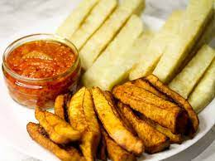
YAM AND PLANTAIN CHIPS
METHODS OF PREPARATION:
Peel the sliced yam and plantain, cut the yam in a small rectangular shape and cut the plantain in cylindrical shape, salt the plantain and yam the heat the groundnut oil and pour the onions allow to fry and pour the yam after frying the yam, then fry the plantain, then dish in a plate and serve with Egg sauce.
YAM PORTAGE:
Recipes:
5 slices of yam, pumpkin leave, 1 onion, 1 dry fish, a seed of fresh tomatoes, 2 seeds of flesh pepper, red oil, small quantity of Cray fish, 1 teaspoonful of salt, a cube of maggi, some quantity of water, ½ cut of ripe plantain.

YAM PORTAGE

METHODS OF PREPARATION:
Peel the sliced yam and put in a pot and put on fire, then add water onions, fresh tomatoes, salt, Cray fish, pepper and allow to boil, then cut the ripe plantain and add to the boiling yam after 20 minutes cut the pumpkin leaves and add to the yam, then remove from heat and dish.
UNRIPE PLANTAIN PORTAGE:
Recipes:
4 unripe plantain, pumpkin leave, 1 onion, 1 dry fish, a seed of fresh tomatoes, 2 seeds of fresh pepper, red oil, small quantity of Crayfish, 1 teaspoonful of salt, a cube of maggi, some quantity of water.
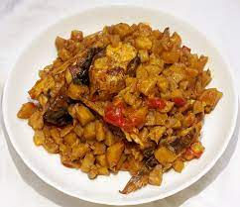
UNRIPE PLANTAIN PORTAGE
METHODS OF PREPARATION:
Peel the plantain, put in a pot and add heat to it, then add water onions, tomatoes pepper, red oil, maggi, salt, Crayfish, dry fish, and allow to boil for 30 minutes then cut the pumpkin leave and add to the boiling plantain, then remove from heat and dish in a plate.
GARNISHED INDOMIE WITH PLAIN OMELETTE
Recipe:
2 Sachet of indomie, 1 fresh tomato, 1 fresh pepper, ¼ onion, groundnut oil, 2 Eggs, carrot, green beans, water.
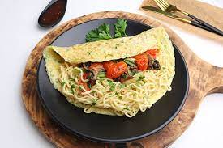
GARNISHED INDOMIE WITH PLAIN OMELETTE
METHODS OF PREPARATION:
Add water to the pot and apply heat, then allow it to heat very well, then add the indomie and allow to boil, then sieve it and put the empty pot on fire and add groundnut oil, onions, tomatoes, pepper, carrot, green beans, then the spices off the indomie and allow to fry then add the parboiled indomie and stir, then fry the Egg an remove from heat dish the garnished indomie with the plain omelette in a plate.
COSLOW SALAD
Recipes:
Cabbage, carrot, fresh tomatoes, green pepper, mayonnaise.
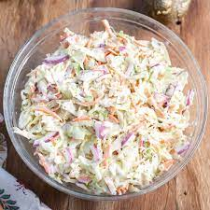
COSLOW SALAD
METHOD OF PREPARATION
Wash the cabbage, carrot, fresh tomatoes, green pepper in salty water. Then cut the cabbage, the carrot will not be cut in cubes but will be grated (sliced with grater), the fresh tomatoes will be sliced and the green pepper cut in cubes. Then the cabbage, carrot, fresh tomatoes, green pepper will be mixed together with the margarine and stir, then serve with either, Jellof rice or Fried rice
VEGETABLE SALAD
Recipes:
Mayonnaise, sweet corn, carrot, cabbage, cucumber, baked beans peas, green pepper, tomatoes.
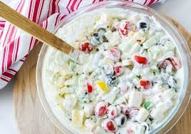
VEGETABLE SALAD

METHODS OF PREPARATION
Wash your vegetable with little salt and slice into small sizes then after slicing arrange it finely by putting green peas, sweet corn, cabbage, green beans, green pepper, tomatoes, cucumber and mayonnaise and mix it properly so that it will be together.

SUMMARY OF ATTACHMENT ACTIVITIES
The Industrial attachment programme also known as Student Industrial Work Experience Scheme (SIWES) is an appreciable skills acquisition programme designed to expose students to the real life working experience. The programme exposes students to the practical oriented aspects of their chosen professions so as to achieve the much needed technological advancement for the nation.
The report explains the details of the events and activities with each project been involved and outlined under each chapter. It started with an introduction, objectives of the programme of the programme. Section Two talks about the establishment and the different sections and their functions. Section three/four explains the activities been carried out during the programme, finally Section five being the last chapter highlighted problems, then the report was concluded with summary.
PROBLEMS ENCOUNTERED DURING SIWES
I encountered numerous problems during my Industrial Training programme at E-Phoenix Hotel.
1. PROBLEM OF LIGHT: light is the major thing an establishment needs for proper running, and also for comfort of the guest and functioning of the facilities and equipment in an establishment but the absent of light bring about discomfort of guest and poor management of the establishment.
2. INADEQUATE FACILITIES: The establishment didn’t provide any accommodation for the SIWES students.
3. COMMUNICATION: There was poor and ineffectual information dissemination due to complex links in the establishment.
5. PROBLEM OF SECURING A PLACE OF ATTACHMENT: I had most of problem searching for a place of attachment for my Industrial Training because most establishments refused my placement request.
CONCLUSION
Industrial Training is important, Educative and Interesting, it is a programme that exposes undergraduate to world of paid. It makes an individual to have as sense of responsibility and be diligent to work.
Extending the programme to more than six months will be better for the student to have more time to learn and gain all the practical experiences needed.

RECOMMENDATIONS
1. The establishment should provide a very good security in the establishment for the comfort of the SIWES students, the guest and their main staffs.
2. The establishment should provide adequate light for the establishment, for the comfort of guest, SIWES students, staffs and for proper functioning of equipments and facilities.
3. The establishment should make sure that before the end of each month that the salary should be paid, so that the SIWES student will be care of their transportation to work.
4. The establishment should provide a good accommodation for the SIWES students in their establishment.
5. The Industrial Training Fund should compile list of employers and available training places for industrial attachment and forward such lists to the coordinating agencies.
6. The Federal Government should make it mandatory for all Ministries, companies and government parastatals to provide attachment places for students.

