A TECHNICAL REPORT

ON

STUDENTS INDUSTRIAL WORK EXPERIENCE SCHEME
(SIWES)

UNDERTAKEN
AT

AROWOLO VENTURE
BY
OYETAYO SEKINAT BOLUWATIFE
MATRIC NO: ND/23/BAM/PT/0516

SUBMITTED TO

THE DEPARTMENT OF BUSINESS ADMINISTRATION
INSTITUTE OF FINANCE AND MANAGEMENT STUDIES
KWARA STATE POLYTECHNIC, ILORIN

IN PARTIAL FULFILMENT OF THE REQUIREMENTS FOR THE AWARD OF NATIONAL DIPLOMA IN BUSINESS ADMINISTRATION

AUGUST TO DECEMBER, 2024
DEDICATION
I dedicate this report write up to Almighty Allah who gives me strength and inspiration in the course of this work. Special dedication also goes to my ever supportive parents Mr. and Mrs. OYETAYO, and other family members for their relentless, financial and moral support towards the success of my four (4) months SIWES programme.

ACKNOWLEDGEMENT
I have taken effort in this Siwes. However, it would not have been possible without the kind support and help of some individuals and this organization. I would like to extend my earnest thanks to all of them.
I would and in Respect like explicitly express my gratitude to the Managing Director of AROWOLO VENTURE, in person of Mr Lukman, and the staff for their kind co-operation and their professional guidance and instruction during my Siwes which assisted me in completion of this Siwes.
I would like to express my special gratitude and thanks to industry persons for giving me such attention and time.
My thanks and appreciations also go to my colleagues in developing the Siwes Report and people who have willingly helped me out with their abilities. I am highly indebted to you all.

TABLE OF CONTENTS
TITLE PAGE
Dedication 1
Acknowledgement 2
Table Of Contents 3
CHAPTER ONE: INTRODUCTION 5 - 10
1.1 History Of Siwes
1.2 Objectives Of Siwes
CHAPTER TWO: DESCRIPTION OF THE ESTABLISHMENT OF ATTACHMENT 11-17
2.1 Location And Brief History Of Establishment
2.2 Objectives Of Establishment
2.3 Organization Structure
2.4 The Various Departments/Unit In The Establishment
CHAPTER THREE 18
3.0 Reporting On Work Actually Carried Out And Gained
CHAPTER FOUR: SUMMARY, CONCLUSTION AND RECOMMENDATION 19
4.0 Summary Of Attachment Activities
4.1 Problems Encountered During The Program
4.2 Suggestions For The Improvement Of The Scheme

CHAPTER ONE
INTRODUCTION
1.1 HISTORY OF SIWES
SIWES (Student Industrial Working Experience Scheme) was established by ITF in 1973 to solve the problem of lack of adequate practical skills preparatory for employment in industries by Nigerian graduates of tertiary institutions.
The Scheme exposes students to industry based skills necessary for a smooth transition from the classroom to the world of work. It affords students of tertiary institutions the opportunity of being familiarized and exposed to the needed experience in handling machinery and equipment which are usually not available in the educational institutions. Participation in Industrial Training is a well-known educational strategy. Classroom studies are integrated with learning through hands-on work experiences in a field related to the student’s academic major and career goals. It also expose the student to the practical aspect of some course being offer in the school.
Successful internships foster an experiential learning process that not only promotes career preparation but provides opportunities for learners to develop skills necessary to become leaders in their chosen professions.
One of the primary goals of the SIWES is to help students integrate leadership development into the experiential learning process. Students are expected to learn and develop basic non-profit leadership skills through a mentoring relationship with innovative non-profit leaders.
By integrating leadership development activities into the Industrial Training experience, we hope to encourage students to actively engage in non-profit management as a professional career objective. However, the effectiveness of the SIWES experience will have varying outcomes based upon the individual student, the work assignment, and the supervisor/mentor requirements.
It is vital that each internship position description includes specific written, learning objectives to ensure leadership skill development is incorporation.
Participation in SIWES has become a necessary pre-condition for the award of Diploma, Degree and NCE certificates in specific disciplines in most institutions of higher learning in the country, in accordance with the education policy of government.
1.2 OPERATORS OF SIWES
Operators - The ITF, the coordinating agencies (NUC, NCCE, NBTE), employers of labor and the institutions.
Funding - The Federal Government of Nigeria
Beneficiaries - Undergraduate students of the following: Agriculture, Engineering, Technology, Environmental, Science, Education, Medical Science and Pure and Applied Sciences.
Duration - Four months for Colleges of Education and Polytechnics, and Six months for the Universities.
1.3 OBJECTIVES OF SIWES
1. SIWES will provide students the opportunity to test their interest in a particular career before permanent commitments are made.
2. SIWES students will develop skills in the application of theory to practical work situations.
3. SIWES will provide students the opportunity to test their aptitude for a particular career before permanent commitments are made.
4. SIWES students will develop skills and techniques directly applicable to their careers.
5. SIWES will aid students in adjusting from college to full-time employment.
6. SIWES will provide students the opportunity to develop attitudes conducive to effective interpersonal relationships.
7. SIWES will increase a student's sense of responsibility.
8. SIWES students will be prepared to enter into full-time employment in their area of specialization upon graduation.
9. SIWES students will acquire good work habits.
10. SIWES students will develop employment records/references that will enhance employment opportunities.
11. SIWES will provide students the opportunity to understand informal organizational interrelationships.
12. SIWES will reduce student dropouts.
The four (4) months Students Industrial Work Experience Scheme (SIWES) which is a requirement for the completion of my course of study, was undertaken at AROWOLO VENTURE
The Industrial Training was based on working with Personal Computers, laptops, installation and maintenance, spreadsheet and word processing.

CHAPTER TWO
DESCRIPTION OF THE ESTABLISHMENT OF ATTACHMEMT
2.1 Location and brief history of AROWOLO VENTURE
AROWOLO VENTURE is a brain child of Lukman, a non-governmental organization (NGO) which was established 5years ago to assists in tackling basic societal problems, promotes education for indigent children and empowering youths through the provisions of various opportunities to be self-reliant.
This Institute is a skill acquisition centre which was established to compliments the state governments’ efforts at finding lasting and sustainable solution to the menace of unemployment through the provision of an enabling environment for youths to function effectively in the society.
The centre is also designed to eradicate unemployment in the society and to ensure that graduates of the institute could be gainfully employed in the state, nationally and internationally through the provision of a recognized qualification.
The venture is also giving efficient services to individual in the following areas as well:-
- Sales supply, sales of different provisions etc

2.2 Objectives of Establishment
The company’s core value offers include:-
- As part of its cooperate social responsibility, the company offers the most affordable prices on its service rendered
- It also provides unmatched after sales service to its numerous customers.
- The brand named AROWOLO VENTURE. is known for providing quality services, prompt service and excellent customer relations.
- Building strong reputation in the community through trust, honesty and transparency
- To satisfy both retail and wholesale customers’ need
- Continuously improving processes and services to meet evolving customer needs.
2.3 Organization Structures/Departments
AROWOLO VENTURE is divided into the following departments:-
- Store Center
- Customer service department
2.4 The various departments in the establishment and their functions
AROWOLO VENTURE
The service rendered by AROWOLO VENTURE are selling of goodies, noodles, provisions, etc. These departments also educate clients on the type of product that will be suitable for their usefulness.

CHAPTER THREE
SKILLS AND KNOWLEDGE ACQUIRED
2.0 INTRODUCTION OF PROVISION
A provision store is a retail outlet where goods such as food items and other consumer goods are sold. It is one of the lucrative businesses you can engage in out there and make you some money. It involves the game of buying in bulk, that is at wholesale and sell at a retail price which is a bit higher compared to the wholesale price you bought the goods at.
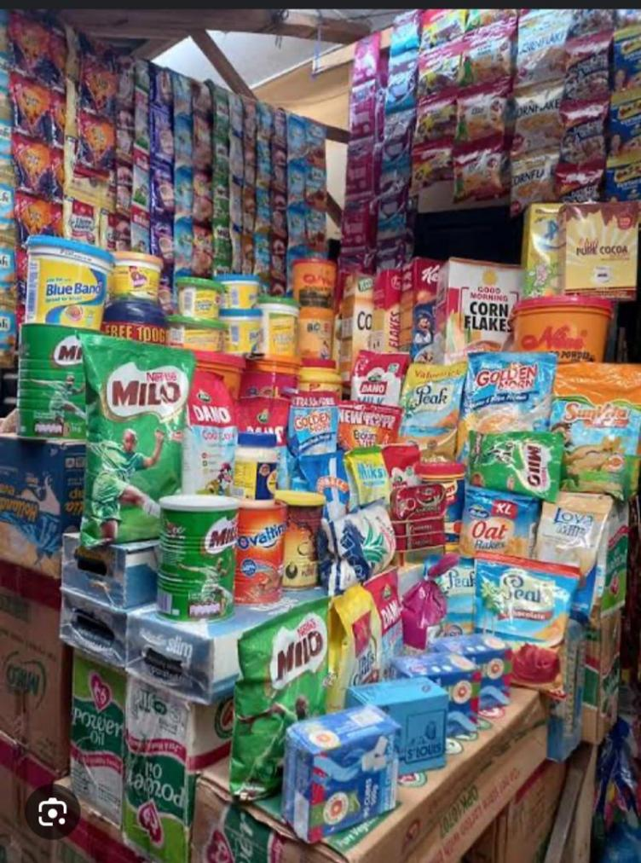
A provision store, also known as a convenience store, is a type of retail outlet that primarily sells a variety of common consumer products and necessities. Setting up a provision store is a commitment to serve the local community. It is a source of convenience, a repository of daily essentials, and a hub of community interaction. A provision store provides a place to engage, meet neighbors, share stories, and connect with the essence of local existence.

FOOD AND BEVERAGE
- Snack: As a small amount of food eaten between meals or as a quick energy boost. Such as chips, nuts and candies.


- Baked goods: These are sweet food product made from flour, sugar. Such as, cakes, cookies, pies and tarts.

BEVERAGES: These are liquid consumed for hydration, nutrition or pleasure. It can be classify into non-alcoholic and alcoholic beverage.
- Non-alcoholic: These are drinks that do not contain alcohol. E.g hot beverage, cold beverage and fresh juice.
- Alcoholic beverages: These are drinks that contain alcohol e.g bear, wine, spirit, and liquers.
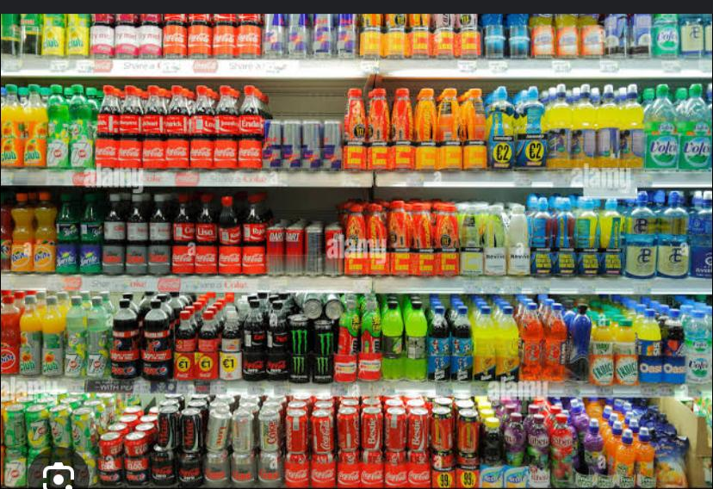

COFFEE AND TEA: These are two of the most popular beverages globally, offering various flavour aromas and benefits
TYPES OF COFEE:
- Arabia (mild nuanced)
- Robusta (bold, bitter)
- Dark roast (rice, bitter)

TEA
- Tea is a beverage made by infusing leaves, flower, root or fruits of plant in hot water.
TYPES OF TEA
- Black tea: Farmented robust
- Green tea: Streamed, antioxidant
- Oblong tea: Partially fermented

TEA CATEGORIES
Tea can be classify into two which are:
- Traditional tea
- Fruit and floral

INSTANT NOODLES AND SOUPS
Instant noodles are pre-cooked, dried noodle made from wheat flour, water, and seasoning.
TYPES OF INSTANT NOODLES
- Ramen
- Udon
- Soba
- Instant rice noodles
- Cup noodles
BENEFITS OF INSTANT OF NOODLE AND SOUP
- Convience
- Quick preparation

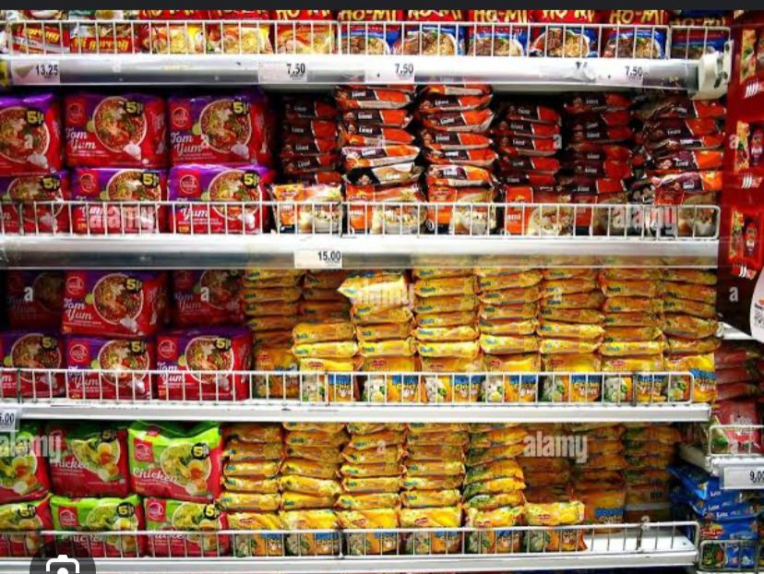

HOUSEHOLD ESSENTIALS
Household essentials: It refers to the basic necessities required for maintaining a comfortable and functional home.

Kitchen Essentials refers to must have item for cooking, food, preparation and storage.

Toiletries: Is know as personal care product, are essential items used for personal hygiene, grooming and health.
- Oral care: Such as tooth brush
- Skin care: Such as soap, body wash conditioner, moisturizer, lotion etc.


Shaving and gromming: It refers to the practices of maintaining and caring for one’s appearance, focusing on facial hair, body hair.

Cleaning supplies: are product used to maintain cleanliness and hygiene in home, offices and public spaces. Eg. all purpose cleaner, glass cleaner, vaccum cleaner, dusting spray etc.

Tools for cleaning
- Mop handles
- Broom handle
- Sponge
- Bucket, cleaning cart, microfiber etc.
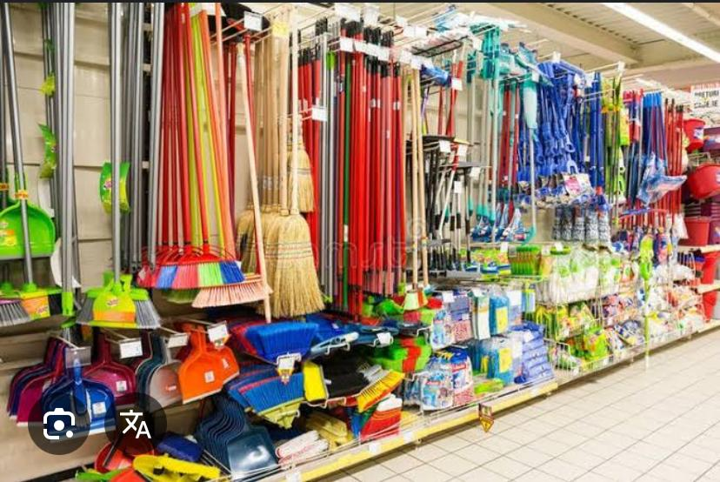

Personal Care: It refers to the practices and product use to maintain and promote physical and emotional well-being in relation to hygiene.

Cosmetics and Skincare product: These are use to maintain, protect and enhance the appearance of skin, hair and nails. Eg, makeup, hair care, nail care, lip product and so on.



CHAPTER FOUR
SUMMARY, CONCLUSION AND RECOMMENDATION
5.1 SUMMARY OF ATTACHMENT ACTIVITIES
This report contained and gives the details explanation of all activities carried out at AROWOLO VENTURE, Challenge Area, Ilorin, Kwara State, Nigeria.
The report explains briefly the details of all the activities with each Siwes been involved in outlined under each chapter. Chapter 1 started with the general introduction knowledge and objectives of the SIWES programme, Chapter 2 gives detailed of the skills and knowledge acquired during the programme, contained the activities at Laundry department and gives detailed of the skills and knowledge acquired during the programme, Chapter 3 explained the problems encountered during SIWES programme and Recommendations, Chapter 4 contained the summary of the whole report and the conclusion.

5.2 PROBLEMS ENCOUTERED DURING THE PROGRAM
There are numerous problems I encountered during my SIWES program at AROWOLO VENTURE.
Some of the major problems are as follow:-
- Problem of searching a place of attachment:- I had so many problems when searching for a place of attachment for my SIWES because most organization rejected my request giving one reason or the other that they do not want SIWES student.
- Cost of transport:- Also encountered challenges in the aspect of transport fair during the course of my training due to the distance of my place of attachment.
- Finance: - The organization do not make any provision to pay SIWES student nor do they draft any allowance package for s so as to less the expenses during the course of the program.
5.3 SUGGESTIONS FOR THE IMPROVEMENT OF THE SCHEME
- The establishment should provide the adequate facilities to make the programme enjoyable for the students.
- Government should motivate partners from the private sector through granting tax relief for companies that accept Students on SIWES.
- The company should be willing to accept and encourage students that are seeking for SIWES placement in their company without requesting for any money.
- Institutions should be encouraged to create financial autonomy for Institution based SIWES Units/Directorates.
- The establishment should provide the adequate facilities to make the programme enjoyable for the SIWES Students.
- SIWES should be properly presented to potential sponsors, such as Banks, multinational companies and other corporate institutions for Support in creating placement opportunities, training, equipment, Facilities, as well as direct funding of SIWES.

