


A TECHNICAL REPORT

ON

STUDENTS’ INDUSTRIAL WORK EXPERIENCE SCHEME
(SIWES)

UNDERTAKEN AT

ADEMUMSHO AGRO ALLIED GBAGBA PHASE 2,KWARASTATE

BY

ELEGBEDE RIDWAN OLUWAGBENGA (ND/23/AGT/PT/0084)

SUBMITTED TO:

THE DEPARTMENT OF AGRICULTURAL TECHNOLOGY

FEBRUARY 2024

CERTIFICATION

This is to certify that ELEGBEDE RIDWAN OLUWAGBENGA with matriculation number ND/23/AGT/PT/0084 carried out this report of Student Industrial Work Experience Scheme (SIWES) at ADMUMSHO AGRO ALLIED and has been prepared in accordance to regulations guiding the preparation of SIWES reports in the Department of Agricultural Technology

…………………………….. …………………………

Supervisor’s Signature Date

…………………………….. …………………………

H.O.D’s Signature Date

MR.BANJOKO IBRAHIM KAYODE

ABSTRACT

Student Industrial Work Experience Scheme (SIWES) is a skill development programs established by Industrial Trust Fund (ITF) in 1973 to provide a link opportunity for students to participate in the real world of work, benefit from practical exposure at various institutions offering services relevant to their field of studies and it is aimed at exposing students to the realities of world of work by matching the theoretical classroom knowledge with current practices in the work environment.

This report has attempted to give the overview of all that was done during the sixteen (16) weeks Industrial Training and the experience gathered during the training at ADMUMSHO AGRO ALLIED.

ADMUMSHO is a non-governmental organization specialized in the production of fish feed and breeding of catfish

Section one contains the introduction to Students’ Industrial Work Experience Scheme, brief history of Industrial Fund, objectives of Students’ Industrial Work Experience Scheme and objectives of the report.
Section two contains all the information about the organization I was attached to.

Section three contains all the activities, participation and experience gained during the period of training and

Section four contains conclusion and recommendations made based on challenges encountered and work experience.

DEDICATION

I dedicate my dissertation work to the Almighty God my creator, my strong pillar, my source of inspiration, wisdom, knowledge and understanding. He has been the source of my strength throughout the period of my industrial training attachment. A special feeling of gratitude to my loving parents, MR and MRS ELEGBEDE whose words of encouragement and push for tenacity strengthened me all through the period of SIWES.

ACKNOWLEDGEMENT

My deepest gratitude goes to God who has provided all that was needed to complete this project and the program for which it was undertaken for. There was never lack or want. Throughout this entire study, He took care of everything that would have stopped me in my tracks and strengthened me even through my most difficult times.

Also, I would like to express my profound gratitude to the directors at ADMUMSHO AGRO ALLIED, for their relentless effort in investing on me and giving their time to put me through this training process despite their tight schedules, I was still supported and encouraged in a lot of industrial responsibilities and tasks to improve my performance level. I would also like to appreciate all the staff at Admumsho Agro Allied who contributed their quota by welcoming and imparting in me with necessary knowledge.

I also appreciate the management of this great citadel of learning, the Kwara State Polytechnic (KP), the SIWES coordinators, my Head of Department, and my lecturers for the effort, support, and such an opportunity given to me to go outside the confine of the Institution and gain field experience and their contribution to the success of the training.

My utmost regard also goes to my parents, Mr and Mrs Elegbede who painstakingly laid the foundation for my education giving it all it takes and also my supportive siblings for their physical, spiritual and material support throughout my training period. God bless you all. You all won’t lose your reward Amen.

Lastly, I acknowledge all my colleagues at Admumsho Agro Allied for their love and support towards the success of my training. God bless you all Amen.

TABLE OF CONTENTS

TITLE PAGE i
CERTIFICATION ii
ABSTRACT iii
DEDICATION iv
ACKNOWLEDGEMENT v
TABLE OF CONTENTS vi
LIST OF FIGURES ix
LIST OF PLATES x
CHAPTER ONE 1
  - INTRODUCTION 1
  - STUDENTS INDUSTRIAL WORK EXPERIENCE SCHEME (SIWES) 1
  - HISTORICAL BACKGROUND OF SIWES 2
  - ORGANIZATION AND OPERATION OF SIWES 2
  - AIMS AND OBJECTIVES OF SIWES 3
    - OBJECTIVES OF REPORT 3
CHAPTER TWO 4
  - BRIEF HISTORY OF THE ORGANIZATION 4
  - OVERVIEW OF THE ORGANIZATION 4
  - OBJECTIVE OF ORGANIZATION 4
  - ORGANIZATIONAL STRUCTURE OF ESTABLISHMENT 5
  - VISION STATEMENT 5
  - MISSION STATEMENT 5
2.6. MAJOR ACTIVITIES OF THE ORGANIZATION 6

CHAPTER THREE 7
  - WORK DONE AND EXPERIENCE GAINED 7
  - CATFISH CULTURE 7
    - CULTURABLE FISHES 7
    - CATFISH GROWTH STAGES 8
    - WATER SOURCE FOR CATFISH CULTURE 10
  - ACTIVITIES INVOLVED IN CATFISH CULTURE 10
    - FISH FARM SITE SELECTION 10
    - FISH POND CONSTRUCTION 11
      - CONSTRUCTION OF AN EARTHEN POND 11
      - CONSTRUCTION OF CONCRETE POND 11
      - PLASTIC TANK FISH PONDS 12
    - PREPARATION OF POND 12
    - PURCHASING OF POST-FRY 14
    - SORTING OF CATFISH 15
    - STOCKING OF CATFISH 15
    - FEEDS AND FEEDING SYSTEM 17
    - SAMPLING OF CATFISH 19
    - HARVESTING OF CATFISH 20
    - FISH FEED PROCESSING…………………………………………………………………..21
    - FISH FARM RECORDS KEEPING 22
  - FISH PROCESSING AND VALUE ADDITION 22
    - ADVANTAGE OF FISH PROCESSING 22
    - SMOKING TECHNIQUES 22
CHAPTER FOUR 25
  - SUMMARY, EXPERIENCE GAINED, CONCLUSION AND RECOMMENDATION 25
  - SUMMARY OF ATTACHMENT ACTIVITIES 25
  - EXPERIENCED GAINED 25
  - CONCLUSION 26
  - RECOMMENDATION 26
    - DEPARTMENT 26
    - ADMUMSHO AGRO ALLIED 27
    - INDUSTRIAL TRAINING UNIT 27
    - RECOMMENDATION TO THE STUDENTS 27
REFERENCES 28

LIST OF FIGURES
Figure 2.1: organizational structure of Admumsho Agro Allied 5

LIST OF PLATES
Plate 3.1: An image of Clarias-gariepinus 8
Plate 3.2: Post-Fry Growth Stage 9
Plate 3.3; Stocking of the Catfish 16
Plate 3.4: Image showing (a) spot feeding with sinking (b) spot feeding with floating feed 19
Plate 3.5: Packaging of smoked fish 24

CHAPTER ONE

INTRODUCTION

Students Industrial Work Experience Scheme (SIWES)

The Student’s Industrial Work Experience Scheme (SIWES) is a program that is facilitated by the industrial Training Fund (ITF) to stop inadequate training among the students. This program is part of the academic curriculum of the students and forms part of the approved Minimum Academic Standards in the various degree program for all the Nigerian Universities. The introduction and entrenchment of the law that gave birth to Industrial Training Fund has done a great deal in training and retraining students to meet and provide effective services needed to produce high quality goods and services There is no doubt that technological advancement is one of the main key factors that must be considered to guarantee economic growth and improved manpower (Omonijo et al., 2019).

Economic recession and low productivity are the challenges facing most developing countries, in which Nigeria is one of those developing countries. In view of this and the fact that the knowledge acquired by students in the higher institutions of Nigeria are limited and mostly theoretical, the Federal Government of Nigeria through the Federal Ministry of Education considered it essential to establish a scheme through which students in the higher institutions will have the opportunity to apply the knowledge gained in the four walls of their lecture rooms, without affecting their academic program (Omonijo et al., 2020).

Consequently, the Students Industrial Work Experience Scheme (SIWES) was established by the government with a view to exposing students to industrial applications of their respective fields of study at some point of their academic program. This program is also set up in partial fulfilment of the award of Bachelor of Technology (B. Tech) or Bachelor of Sciences (BSc) depending on the nature of the institution. This scheme is managed and funded by the Industrial Training Fund, with branches across the higher institutions and states in Nigeria. It covers all areas of studies in the higher institutions, colleges of education, polytechnics, and universities across the country. It is a custom of every institution to require each of their students to prepare a report and give an oral presentation of their daily activities during the program (Omonijo et al., 2019).

Historical Background of SIWES

The Students’ Industrial Work-Experience Scheme (SIWES) was established in the year 1973 by the Industrial Training Fund (ITF) to expose students of the higher institution in Nigeria to practical applications of their various fields of knowledge. Statistics showed that 748 students from 11 institutions with 104 eligible courses participated in the scheme at its inception in 1964. By 1978, the scope of participation in the scheme had increased to about 5,000 students from 32 institutions. The Industrial Training Fund, however, withdrew from the management of the scheme in 1979 owing to problems of organizational logistics and the increased financial burden associated with the rapid expansion of SIWES (Mafe, 2010).

Consequently, the Federal Government funded the scheme through the National Universities Commission (NUC) and the National Board for Technical Education (NBTE) who managed SIWES for five years (1979 – 1984). The supervising agencies (NUC and NBTE) operated the scheme in conjunction with their respective institutions during this period. The scheme gained momentum in 2008 and the number of enrollments increased to 210,390 students from
219 distinct institutions with over 112 eligible courses. By this virtue, the scheme can be regarded as a general one, with its impacts on over 60 programs in the universities, over 40 programs in the polytechnics and about 10 programs in the colleges of education in Nigeria (Oyeniyi, 2012).

Organization and Operation Of SIWES

The organization of the Students’ Industrial Work-Experience Scheme (SIWES) involves many stakeholders as follows:

- Federal Government (Federal Ministry of Commerce & Industry)
- Industrial Training Fund (SIWES Division)
- Supervising/Regulatory Agencies (NUC, NBTE, NCCE)
- Industry/Employers (NECA, NACCIMA, MAN, Government Establishments)
- Tertiary Institutions (Universities, Polytechnics, Colleges of Education) and
- Student Trainees (Engineering, Science, Technology, NCE Technical).

Aims and Objectives of SIWES

The industrial Training fund’s Policy Document No.1 of 1973 which established SIWES outlined the objectives of the scheme as follows:

- Prepare student for industrial work situations that they are likely to meet after graduation.
- Make the transition from school to the world of work easier and enhance students’ contacts for later job placements.
- Provide students with the opportunities to apply their educational knowledge in real work situations, thereby bridging the gap between theory and practical.
- Enlists and strengthens employer’s involvement in the entire educational process of preparing university graduates for employment in industry.
- Provide an avenue for students in institution of higher learning to acquire industrial skills and experience during their courses of study.
- Expose student to work methods and techniques in handling equipment and machinery that may not be available in their institution.
- Maintain a balance between theoretical and practical knowledge.
- Advancing relationship between educational and industrial sectors.

Objectives of Report

The objective of the report includes the following:

      - It serves as a guide and reference material to other studies and research in various institution.
      - It broadens the student view in relation to their course of study.
      - To provide a work document effectively.
      - To produce students that is responsible for their work by providing enough evidential documents that related to work.
      - To expose the students on how to provide a proper document.
      - To build self-confidence in the student while providing the document.

CHAPTER TWO

Brief History of the Organization

Admumsho Agro Allied was founded in 2018 as a Non- Governmental Organization operating in Kwara State of Nigeria. Over the years, the organization has spread its tentacles to the areas of agriculture and community development, creating job employment for the youth, as well as equipping them to be creative and innovative. Admumsho Agro Allied is an aquaculture farm that is based on rearing and harvesting of fish in water environment using artificial pond, they deal with catfish (Clarias gariepinus). Catfish are sources of food for human beings. It is very rich in protein and vitamins A (Retinol). They are source of animal protein.

Overview of The Organization

Admumsho Agro Allied emerged few years ago, to provide employment opportunity for the people. It is located at Admumsho Agro Allied, Gbagba Phase 2, Sango, Kwara State. It was created to train and work with student leaders from tertiary institutions in Nigeria, advocating for quality education, healthy environment, and healthy food for children and students in all levels of Nigerian education, as well as ensure a peaceful co-existence between the management and its host community.

Objective of Organization

The organization was established to achieve the following objectives:

    - To ensure that youths are transformed to become creative and innovative.
    - To provide employment opportunities for youths.
    - To reduce the level of poverty within underdeveloped communities and raise sustainable communities out of them.
    - To emphasize and promote healthy living and environments.
    - To increase the intake of fish in Kwara state and the whole of Nigeria at large.
    - To ensure the fish is of low calories and low cholesterol.

Organizational Structure of Establishment

The professional workers include one Farm manager, one secretary, two supervisors, three stockkeepers, and six pond assistants. While the non-professional staff includes four feed distributors and eleven pond feeders.

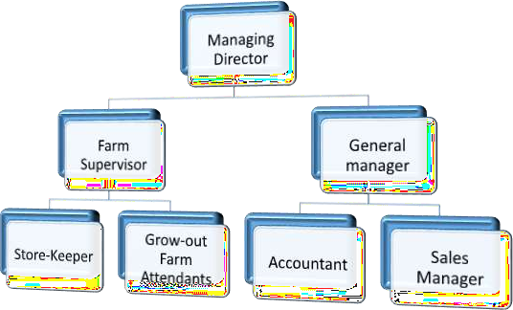

Figure 2.1: organizational structure of Admumsho Agro Allied.

Vision Statement

The vision statement of Admumsho Agro Allied is to be the prime training development organization in Nigeria and one of the best in the world.

Mission Statement

The mission statement of Admumsho Agro Allied is to set and regulate standard and offer direct training intervention in industrial and commercial skill training to motivate and transform graduates to become creative and innovative.

Major Activities of The Organization

Activities of the organization include;

    - Culturing of fish and the various activities involved.
    - Fish processing and value addition.

CHAPTER THREE

WORK DONE AND EXPERIENCE GAINED

The various activities carried out Admumsho Agro Allied involved culturing of catfish either at fry, fingerling, juvenile, jumbo, mélange, table size, brood stock stages ,various activities involved in successful establishment of a fish farm, fish processing and value addition.

Catfish Culture

Catfish culture is the growing of fish in a controlled environment concrete or earthen ponds. Aquaculture has the potential to become sustainable practice that can supplement capture fishes, eliminate fish importation, and significantly contribute to feeding the worlds.

Culturable Fishes

Fishes that can be raised in tank or ponds. Examples include:

- Clarias-gariepinus (African mudfish) – Has a flat head and an eel-like shape. They are without scales. They have extremely long dorsal fins (nearly reaching or reaching the caudal fin) Clariasgariepinus are the most farmed species in Nigeria. They constitute over 80 % of the total farmed fish in Nigeria.

- Heterobranchus spp: an oval and has a rectangular dorsum (upper side of the catfish), the snout is round and the eyes are lateral, with half lateral fin.
- Heteroclarias: This is a hybrid of Clariasgariepinus andheterobranchus.
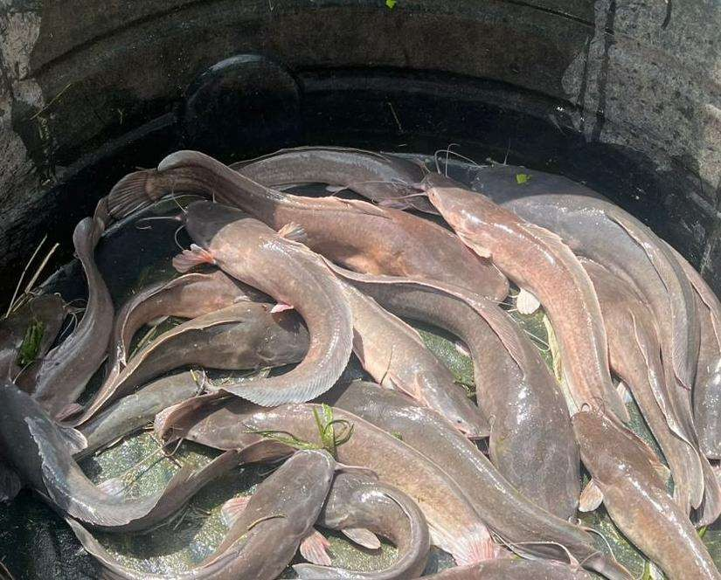

Plate 3.1: An image of Clarias-gariepinus

Catfish Growth Stages

Fries: Fries are fish that are born out of artificial insemination which happen between a period of 24 hours. Fish called fries when they are from three days to around two weeks, newly hatched fish fries that are yet to engage in feeding are called larvae.

Post-Fry: It is a period between fries and fingerlings. They are usually within 2 weeks to 4 weeks. They are still fragile at this stage and are prone to death if care is not taken or if hit by an outbreak.

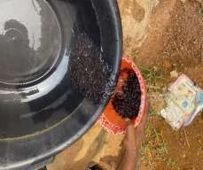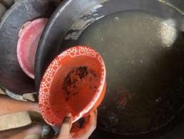

Plate 3.2: Post-Fry Growth Stage

Fingerling: Fish are called fingerlings when they are 3-4 gram in weight. A good fish depends on the parent stock use to hatch the fish. This is the common fish that is being stocked by farmer all over the world.
Post-Fingerling: This is the size between fingerlings and juveniles. Post-fingerling fish weigh from 4-6 grams.

Juvenile: Fish are called juvenile when they are (6-10 gram).Juvenile fish are the second common size of fish that is stocked by most farmer.

Jumbo: Jumbo fish is the biggest size of fish among the smaller catfish .Very few farmer purchase jumbo sizes, people who purchase jumbo are student that want to use it for practical or farmer that does not know how to care for younger catfish. Jumbo fish weight 10 gram

Melange :Fish attain the melange sizes at 3 month of stocking the fingerling or juvenile. Melange weigh between (400-600 gram) in size, this is what is called smokable-size of fish

Table Size: This is the size most famer want to achieve when they stock their fish at the fingerling or juvenile stage. Table sizes are fish that weigh 800 gram and above. This can be achieved within 5-6 month depending on the types of catfish.

Broodstock: Brood stock is parent stocked fish that is being used for hatching catfish. Fish should be referred to as brood stock when it meets two criteria:

It is 8 month and above from the date of production ( 8 month for male fish,1 year for female fish). It weighs 1kg and above.

Water Source for Catfish Culture

Water quality management is the most important aspect of management practices in fish farming. This is because fish cannot survive without water. Well and Springs, Ground water, Streams, rivers, and lakes water is the medium in which fish live.

Activities involved in Catfish Culture

At Admumsho Agro Allied the following various activities involved in catfish culture.

Fish Farm Site Selection

The selection of a suitable site for aquaculture is important for the success of the fish farm. The species to be cultured and the technology to be used determine site selection. Site conditions determine whether the fish farm will competitively produce, correct selection of the site and correct design of the fish farm is essential important.

Factors to be considered for selection of fish farm site include:

- Water availability (adequate quantity and good quality)

- Land topography.

- Accessibility.

- Soil type.

- Proximity and size of market.

- Availability of inputs.

- Biosecurity.

Fish Pond Construction

Fishpond is referred to as an artificial fish pond, at Admumsho Agro Allied artificial pond are used which is a great alternative to natural water reservoirs in which fish can be breed in a controllable environment. There are different types of artificial fish pond which include:

- Earthen pond
- Concrete pond
- Plastic tank fish pond

Construction of an earthen Pond

Construction of an earthen pond is a process that involves the digging of a hole in the ground, which is about 1m deep at the shallow end and 2m deep where the fish is bred.An earthen fish pond is a culture media where fishes are inside the earth, where fishes were cultured in an environment close to theirs. Fishes in this pond mature faster than those in the concrete pond. Its features were dykes, outlet, and inlet pipe. The source of water is from a natural water body.

Typically, earthen ponds are round or square, but you are free to choose any shape you like. You should be sure to have had a stable clean water supply that connects to the pond.

Construction of Concrete Pond

Concrete ponds are better in terms of hygiene. Construction of concrete pond is probably the simplest construction that requires only a less effort.

Steps Involved in Concrete Pond Construction includes:

        - Clearing of proposed site
        - Setting out which involves pegging and lining with the rope
        - Topsoil stripping to form strong basement
        - Surface blinding with concrete mixture (sharp sand, cement& gravel/ granite)
        - Block laying and stuffing of holes with concrete mixture
        - Placement of water inlet and outlet pipes

Plastic Tank fish Ponds

This is a type of fish pond that requires less capital, little energy is invested, it saves time and space as well. A plastic fish pond is a constructed plastic tank pond which is carved out of a full tank.

Steps involved in installing plastic tank fish pond include:

- The tank is usually ready-made or constructed by fabricators given specific requirements like size.
- Installation of constructed tanks will be done by plumbers who align units to the farms' water system (plumb).

Preparation of Pond

At Admumsho Agro Allied earthen pond is mainly used. The fish housing which is the pond must be of good shape before preparing the pond. Assuming the pond is a dug pond all that is needed is to prepare the pond for stocking. To prepare the pond for stocking, there are various step to follow in preparing the pond namely:

- DEMUDDING: This basically means the removal of mud present in the pond to make it more suitable for the fishes to reside. When a fish pond is being used the soil sand from the dike of the pond are being washed back into the pond during the rain and as a result of this mud will start to accumulate in the pond. In other to make things easier during the harvest time, de mudding of pond is essential.

De mudding of pond can be done in two different ways which are:

  - Removing the mud by throwing it to the edge of the pond.
  - Digging the pond at 1ft deep will remove the mud automatically.
  - If it is a pond that has been used before, big fishes of about 1 to 2kg can be found inside the mud hiding. These big fishes are potential predator to the juvenile fish.

- ENSURE YOUR DIKE/EMBANKMENT IS VERY HIGH: Catfish farmers often have to deal with a lot of problem and the most common problem during the raining season is flooding due the running water which can carry away the fish in a blink of an eye. It is advisable to locate

your pond near a stream/river, it is very important to make sure that the dike/embankment is a little bit higher than the water level, it must be at least 2 to 3ft Higher than the water level

- DIKE /EMBANKMENTS If the dike is taller than the water level, it will be very difficult for the water to carry away the fishes. To make the dike/embarkment taller can be done in two different way, when de mudding the pond the mud removed from the pond can be thrown at the various sides often pond to make it more higher and the other way is the use of sand bags.

- ENSURE THERE IS AN INLET AND OUTLET: water inlet and water outlet enable movement of water in and out of the pond respectively. Materials used to construct pond outlets and inlets at Admumsho Agro Allied is PVC pipe.

WATER INLET

The inlet can be placed slightly higher than the outlet to ensure maximum water inflow. If there is a 24/7 water supply into the pond then the inlet can be place at the same level with the outlet or even lower. Procedure for designing and constructing an inlet include:

- Place the inlet at the shallow end of the pond.
- Make sure that the bottom level of the inlet is at the same level as the bottom of the water feeder canal and at least 10 cm above the maximum level of the water in the pond.
- Design the inlet structure to be horizontal, without a slope.
- Make it wide enough to fill the pond completely in reasonable time.
- Make it such that water splashes and mixes as much as possible when entering the pond.
- Provide a screen to keep unwanted fish and other organisms out of the pond.

WATER OUTLET

Water Outlets are built in ponds for the following reason:

- Keep the water in the pond at its optimum level.
- Allow for the complete draining of the pond and harvesting of the fish.
- The flow of the draining water is as uniform as possible to avoid disturbing the fish excessively.
- Fish are not lost even during the draining period.
- Water can be drained from any pond levels.
- Allowance is made for overflow of excess water.

- It can be cleaned and serviced easily.

- Liming (Neutralization): Liming is the process of application of agricultural/industrial limes to fish ponds for example, Cao, Ca(OH)2, and CaCO3. Agricultural lime is the best liming material for fish pond. It is applied by broadcasting or sacking.

Advantage of liming

  - It corrects the acidity of pond water to the suitable PH range(Hydrogen Ion Concentration).
  - It makes available phosphorus added in fertilizer for plant use.
  - It acts as disinfectants of pond bottom, especially in newly constructed ponds or ponds in fallow.
  - It helps in reducing water turbidity that is in settling soil particles in muddy ponds.

- Pond Fertilization (Manuring):Application could be done before or after impoundment, it could be done through broadcasting or sack method. Fertilizer helps in enriching water nutrients for plankton production on which fish feed.

Types of fertilizer

- Organic fertilizer: Cow dung, Poultry dropping, Pig manure.
- Inorganic fertilizer: NPK, Triple Super Phosphate.

vi. Pond Netting: The pond netting is very important; it protect the fish from harmful predators such as frog and snakes and also keep the water free from leaves and debris. Choose net that has a hole size small enough to prevent any type of leaf in the area from getting into your pond. Pond should be fenced to avoid that theft and entry of predatory animals.

Purchasing of Post-Fry

Admumsho Agro Allied does purchase post-fry which are catfish offspring between2weeks to 4 weeks. They are still fragile at the stage and are prone to death if care is not taken or if hit by an outbreak.10 percent of purchase post-fry are given at the hatchery. Poor husbandry can result in high mortalities or diseased fish, proper monitoring and checking of their movement are really needed.

Factor to considering selecting catfish breed

- Hardy and easy to manage
- Resistant to disease and parasite infections
- Fast growing fish
- High market value
- High feed conversion rate
- High survival rate
- Acceptability to locality

Sorting of Catfish

Sorting which should be done before stocking (introducing the fish into the new home), Sorting means stocking of the same size of fish together while the shooters are removed. Sorting could be done preferably in the morning (8-10am) and Sorted fish should not be fed for 2 hours minimum or 3 hours maximum. This will help to relieve the fish of handling stress and regain lost energy.

Advantage of sorting

- Sorting is very important to avoid different size being stock together.
- To reduce cannibalism
- To reduce competition amongst the fish where the big fish would eat first leaving little or nothing for the smaller ones.

Stocking of Catfish

This is the process of introducing desired fish seeds into a prepared fish pond. The fish seed could be either fingerlings or juveniles from a reputable source. The stocking rate/density is determined by the space available, management practices for example feed, water quality. After sorting, the next thing is to introduce the fish into the new home. When stocking the fishes, you should make sure that the fishes are placed gently into the pond to avoid injury.

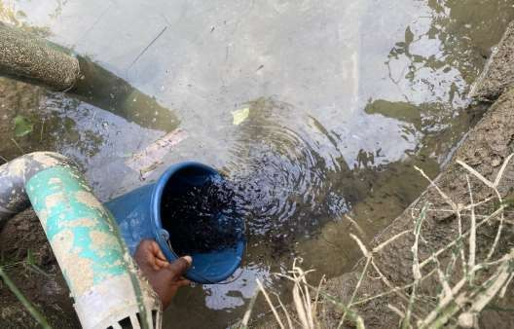

Plate 3.3; Stocking of the Catfish

Guideline for stocking catfish

Stocking of catfish require much knowledge therefore the following will guide when stocking the fishes.
- Do not stock in an unprepared pond: Stocking in an unprepared pond can greatly affect catfish production. Many things may be wrong with the pond you fail to prepare. Excess of mud affect the survival rate of the newly stockfish it makes them less resistant to disease and makes the turbidity level of the pond water to rise thereby causing high rate of mortality.

- Never attempt to stock an unsorted Juvenile fish: It will be an abundant profit if juveniles of sizes within the same range are stock together. Do not stock outgrow fish with the smaller fishes in the same pond, it is dangerous you might not be able to predict what will be left at the end of the process.

- Do not stock Catfish of different species in the same pond except you want to experiment: The feeding pattern in different species of cat fish is not the same, this might make one specie to Out-grow the other. If one specie outgrows the other, then it will result to problem of cannibalism.

- Do not overstock except you have other plans: It is more expensive and less profitable when you overstock your catfish pond.

- Never stock in an unprotected pond: You should put nets and bird line on juvenile pond to avoid predators like snakes, bird, and alligator feeding on them.

Feeds and Feeding System

Fish feed is one very important aspect in fish farming. In fish farming, feed represents about 70%
- 80% of the production cost so a well-balanced diet is important to achieve good growth and high profit margin. The amount of feed fed depends on size and nutritional need of the fish. It should be ensured that feed contains balanced proportions of protein, carbohydrate, fats, vitamins and mineral salts. Fish do best when fed right quality and quantity at fixed time and position and must be fed at a particular time interval daily and at a particular spot. Feed should be given gradually to avoid food wastage and water pollution.

Types of feed

- Natural Feeds: They are produced through pond fertilization using organic manure (cow, pig and poultry droppings) and inorganic fertilizers such as NPK and other natural foods include maggot, insects and earthworm.

- Artificial Feeds: Artificial feeds are compounded feeds. They could be in mesh, crumbles or pellets (sinking or floating).Two types of artificial feed include:

  - Floating feed.
  - Sinking feed.

- Floating feed: Floating feed is also known as extruded feed. This type of feed is the early fish feed given to fish in their early stage. This is the best feed for fishes for 7-8 weeks, it is recommended giving catfish floating feed at the early stage because they are more fragile at their early stage. You can put the feed on the pond gradually and let them eat it. The risk of overfeeding is significantly reduced, thereby ensuring there is no water pollution that can lead to high mortality in the very fragile juveniles. Furthermore, due to their fragile nature, giving the juveniles feed that is not rich and not containing the right nutrients can affect their long- term growth.

- Sinking feed: Sinking Feed is also known as non-extruded feed.Catfish are mostly bottom feeder, so by their very nature, they are designed to be eating non-extruded (or sinking) feed. This type of feed is the employed feed after the 8 weeks of feeding your fishes with Floating (Extruded) feed.

FEED GRADE

Fingerlings (3 to 4 grams): 1.5mm feed size. Post- Fingerlings (4 to 6 grams):1.8mm feed size Juvenile (6 – 10 grams): 2mm feed size
Post-Juvenile (10 grams): 2mm feed size

FEEDING METHOD OF CATFISH

There are the two types of feeding method; broadcast feeding and spot feeding.

  - Broadcast Feeding: This basically involves going around the ponds by spreading floating feed all over the pond to ensure the circulation of feeds for all the fishes in the pond

Advantage of broadcast feeding

- This is the easiest ways for feeding fishes from post-fry to the post-juvenile stage. This should be done because they just got introduced into a large quantity of water, often from somewhere significantly smaller and not all the fishes can come to the same spot to eat.

- By spreading the extruding (or floating) feed across the pond, it will ensure they all get to eat.

  - Spot Feeding: Spot feeding is basically the feeding of fishes in one single spot. Less time-consuming and it is more effective since it is less stressful and carefully monitor how the fishes are eating. At first, if they are used to eating using the broadcast style most of the fishes will not come to a particular spot to eat. However, by only feeding them on that spot for a few days, they’ll be conditioned to come to that spot and eat.

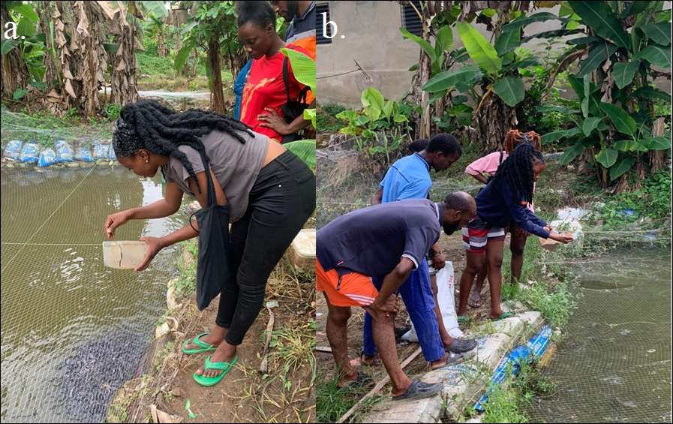
Plate 3.4: Image showing (a) spot feeding with sinking (b) spot feeding with floating feed

Feeding period

Fingerlings (3 to 4 grams): twice daily Juvenile (6 – 10 grams): once or twice daily Anything above post-juvenile: once daily.

Sampling of Catfish

The sampling of catfish is the act of knowing the average weight of the fish by weighing them either monthly or bi-monthly. The sampling is done by weighing the minimum of 200 fishes from the pond. Monthly sampling is to be implore to avoid both over feeding and under feeding when feeding the catfish, there are two factors to consider which are;

- Under feeding: This may result to less weight gain and increase the rate of cannibalism among them.

- Over feeding: Since you have known the percentage of feed to be given to them per day, then you should not overfeed the fishes because it may lead to overweight gain and also cause water pollution, increasing the ammonia level of the water and also cause the ultimate death of the fish due to overweight.

Harvesting of Catfish

Harvesting involves the parking and picking of fishes out of the pond for customers to select their desire size. Harvesting is conveniently done by drag netting (partial harvesting) or by draining the pond (total harvesting).The bigger the drag net will determine the number of people that will drag the net. Fishes are sold in weight and a proper record must be taking during the harvesting.

Some preparation of harvesting

- Stop feeding the fish two days before harvesting

- Setting up all harvesting equipment well in advance

- Making market arrangement well in advance of the harvest date

- Preparing of manpower as it’s a big task

- Fishes are best to harvest early in the morning

Fish Feed Processing

Fish feed processing involves the conversion of raw materials into a nutritious and palatable feed for fish. The process involves several stages, including raw material selection, grinding, mixing, extrusion, drying, cooling, pelleting, packaging, and storage.

Raw Material Selection

Raw materials used in fish feed processing include:

1. Protein Sources

- Fishmeal

- Soybean meal

- Corn gluten meal

- Wheat gluten meal

2. Energy Sources

- Fish oil

- Soybean oil

- Wheat flour

3. Vitamin and Mineral Sources

- Vitamin premixes

- Mineral premixes

- Amino acids

Grinding and Milling

Grinding and milling involve reducing the particle size of the raw materials to increase their surface area and improve digestibility.

1. Grinding

- Hammer mills

- Roller mills

- Pin mills

2. Milling

- Ball mills

- Vibratory mills

- Jet mills

Mixing

Mixing involves combining the ground raw materials with other nutrients and additives.

Extrusion

Extrusion involves forcing the mixed ingredients through a die to create a uniform pellet shape.

Drying

Drying involves removing excess moisture from the extruded pellets.

Cooling

Cooling involves reducing the temperature of the dried pellets to prevent overheating and improve storage stability.

Pelleting

Pelleting involves forming the cooled pellets into a uniform size and shape.

Packaging and Storage

Packaging and storage involve protecting the pellets from moisture, light, and pests.

Fish Farm Records Keeping

- It is important to keep records in order to

- Afford evaluation of the profitability and general economic of fish farm investment

- Provide vital management information for future planning, improvement and development of the farm

- Provide necessary grounds to obtain credit or funding support from financial institution.

Fish Processing and Value Addition

Fish is one of the proteins that need careful handling. This is because fish spoils easily after capture due to the high tropical temperature which accelerates the activities of bacteria, enzymes and chemicals oxidation of fat in the fish. Preservation of fish does not just increase its shelf life, the taste differs and also make the fish to be used in different way.

Advantage of Fish Processing

- Fishes available all year round in preferred taste to the consumer.

- .Provides quality nutrients

- An opportunity for potential investors

Smoking Techniques

Smoking is the method of preservation or a way to add deliciously smoky flavor and darker color. The process involved in catfish smoking include

Gutting

Gutting is the removal of the intestines of the fish. Gutting should be carried out on fish no matter what method of preservation is going to be applied. Gutting of fish helps to prevent bacterial attack before and during processing, preservation and storage.

Washing

Washing is the act of using water to remove dirt or debris of any size from an object. The intent is to make the product dirt/debris free. The importance of washing cannot be over emphasized. Washing helps to reduce the presence of physical, chemical and biological contaminants.

BRINING (Treating with salt)

Brine is simply salt and water.100g of salt should be added in 1litre of clean water to make brine. Soaking fish in brine will achieve the following;
- It will firm up the flesh and make fish to be less slippery.

- Old blood will be drawn out, improving taste of the fish.

- It will add saltiness to fish taste.

- Preserves fish for longer period by killing and reducing bacterial growth for a longer period.

- Adding additional flavor to fish.

SMOKING

  - The heating chamber is filled with charcoal and charged by fire. If you're using gas or electric oven just light it up.
  - Place fish, skin side down on oiled smoker rack and feed into the smoking oven.
  - Keep the fire low, for the first two hours and increase the heat after the first two hours
  - The length of time of smoke-drying will depend on the size and thickness of the fish, and on your preference for dry or moist smoked fish.
  - Continue smoking until fish is flaky and cooked through.
  - There are many advantages for smoking fish. It prolongs the “shelf life” of the fish. Many people believe it enhances the flavor when used in sauces and soup.

WEIGHING INTO UNITS

The fishes should be weighed into 250g, 500g and 1Kg packs.

PACKAGING

After smoke drying, the fishes are packaged in branded transparent cellophane or polythene bags and sealed to prevent dust and germs from getting into the fish. The fishes should be packaged in 250g, 500g and 1Kg packs. As at the time of writing this report, 1Kg of packaged smoke-dried catfish is N3000 while half Kg, 500g is N1500.
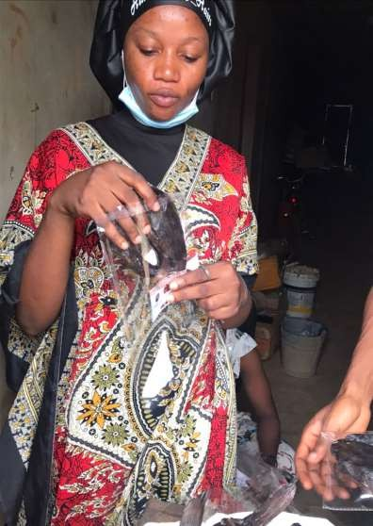

Plate 3.5: Packaging of smoked fish

CHAPTER FOUR

SUMMARY, EXPERIENCE GAINED, CONCLUSION AND RECOMMENDATION

Summary of Attachment Activities

During the period of my Industrial Training in the Department of Fishery, Al-Furqaan fish and aquatics, I engaged in several activities which helped me to developed problem solving skills and interaction with others. Below are some of the basic activities involved in during the Industrial Training:

I was assigned to the manager of the department, a person of Mr. Ibrahim Mutapha, with him, I was able to learn various fishing techniques which can yield a lot of profit without much stress.

During the period of my Industrial Training, I used the knowledge of mathematics to know the feed conversion ratio of the fish, with this, I was able to predict the number of possible fishes that will be harvested at the end of the production. Through the knowledge of mathematical science, they were able to know how to reduce the cost of production and maximize profits.

Experienced Gained

- Problem identification and solving

- Ability to work under pressure with little or no supervision

- It was a real experience for me as I developed the ability to work effectively under pressure with little or no supervision.

- Leadership: During my SIWES program, I was able build more leadership skills. I also learnt how to relate and work with different people.

- Time management and multi-tasking

- I was well built on time management and multitasking in which I met up with projects deadline while I multitasked.

- Communication: I interacted with people both skilled and mostly unskilled workforce, public speaking and overtime I became better at communicating with people.

Conclusion

The Student Industrial Work Experience Scheme has been a very educative, inspiring, and vision conceiving experience for me as an individual. This 16-week training has increased my faith in the agricultural sector of our nation’s economy. I have seen many possibilities that exists in the agricultural field of study from the outside world.

As such, I’m convinced beyond doubt that the past 5years of rigorous study in my field is not a waste because there is a world on the outside that needs what I have been learning and will still learn, and fortunately, my Industrial Training has made me know this experientially.

On a final note, I will say conclusively that this industrial training was worth the energy and resources invested by the government, the school management and individual student.

Recommendation

Department

      - The Government should improve the annual plan of action and disbursement of fund (budget) as timely as possible on Agriculture to promote agricultural research and increase food production for economic growth and stability and improve food security in Nigeria.
      - University through the Industrial Training Unit (ITU) do not just visit students at the organization where they are attached but ensure they see what students do and interact with their industry-based supervisors, to be certain the aim of the scheme is accomplished.
      - The Department of Agricultural Extension and Communication Technology (AEC) should consider reaching out to their students during their industrial training through calls and text as it would foster a more cordial relationship.
      - Students should consider practical skill acquisition as their utmost priority while seeking and choosing Industrial training placement rather than pay. They should not look down on anybody irrespective of their level or qualification because the lowest esteemed staff might add the most tangible and indispensable value to your life.

Admumsho Agro Allied

      - The management should utilize the large expanse of land and inculcate new technological methods.
      - They should try as much as possible to repair and use the earthen ponds that have been abandoned in order to boost their productions.
      - They should work towards improving their functional fish farming system i.e. cage culture, in order to increase their productivity.
      - They should improve on their marketing strategies by getting more sales for their products.
      - FECA still make use of bamboos for the construction of their cage fish farm which is still local. They should make use of other better planks instead of bamboos.

Industrial Training Unit

- The Industrial Training Unit of KP should improve on their effort in visiting students in their respective training sites so as to encourage them and to monitor their activities.
- Industrial Training stipend should not be delayed and should be paid to accredited students at when due.

Recommendation to the Students

-They should see the scheme as a skill acquisition scheme and embrace it by following its rules and regulation
-The students should be open minded to learning during the training period.

-Students should be highly inquisitive.

-They should focus on learning new skills and methods to solving upcoming challenges at their various fields of specialization.

REFERENCES
Mafe, O. A. . (2010). †Invited Paper presented at the Workshop on “Achieving the Necessary Professional Standards in Chemical Engineering in our Universities” organized by the Nigerian Society of Chemical Engineers, Afe Babalola Hall, University of Lagos, 29. 1–38.
Omonijo, D. O., Anyaegbunam, M. C., Adeleke, V. A., Nnatu, S. O., Ejoh, S., Oluwunmi, A. O., Olowookere, E. I., & Agubo, C. (2019). The review of the student industrial work experience Scheme (SIWES) in four selected countries. Academic Journal of Interdisciplinary Studies, 8(3), 158–169. https://doi.org/10.36941/ajis-2019-0014
Omonijo, D. O., Anyaegbunam, M. C., & Nnatu, S. (2020). Vision 2020 : Sustainable Economic Development and Application of Innovation Management Exploring Social Problems Associated With Citations to Ensure Academic Integrity Exploring Social Problems Associated With Citations to Ensure Academic Integrity. July 2019.
Oyeniyi, A. A. (2012). Students ’ Industrial Work Experience Scheme ( SIWES ) and the Incidence of Occupational Misfit in Nigeria By Aderonke Agnes Oyeniyi , PhD Industrial Training Fund ( ITF ). Eric, 1–16. https://files.eric.ed.gov/fulltext/ED533330.pdf

