

A
TECHNICAL REPORT ON INDUSTRIAL ATTACHMENT FOR STUDENT INDUSTIRAL WORK EXPERIENCE SCHEME (SIWES)
HELD AT
SOBI FM ILORIN KWARA STATE

BY

SHEU SAWI ZAINAB
ND/23/MAC/PT/0392

DEPARTMENT OF MASS COMMUNICATION
INSTITUTION OF INFORMATION AND COMMUNICATION TECHNOLOGY
KWARA STATE POLYTECHNIC, ILORIN.

IN PARTIAL FULFILLMENT OF THE REQUIREMENT FOR THE AWARD IN NATIONAL DIPLOMA CERTIFICATE IN MASS COMMUNICATION.

DECEMBER 2024

CERTIFICATION

This is to certify that this report is original to the author, SHEU SAWI ZAINAB of matric number ND/23/MAC/PT/0392 of the Department of Mass Communication, Institute of Information and Communication Technology, Kwara State Polytechnic, Ilorin and was supervised accordingly by;

………………………….. …………………………...
SIWES COORDINATOR DATE & SIGNATURE

……………………….. ..………………………..
SIWES SUPERVISOR DATE & SIGNATURE

…………………………… …………………………
HEAD OF DEPARTMENT DATE & SIGNATURE

PREFACE

This is a report of four months industrial training which was done as part of the requirement needed for the award of National Diploma Certificate which was embarked upon by the technical student after their first year of stay in school.
It is also done to enable the student’s to be exposed the practical aspect of their course of study and write down what he/she has gained during the training.
The program is aimed at correcting the incompetence in the school leaving the scientific and technical in country.

DEDICATION
This report is dedicated to the Almighty God, the Beneficent, the Merciful, the Cherisher of the Universe, the Uncreated Creator of all creatures, and the Most Knowledgeable, who seeks knowledge from Himself alone, for granting me the opportunity, privilege, and understanding to participate in the Student Industrial Work Experience Scheme (SIWES).
I also dedicate this report to my amiable parents, Sheikh Muh Jamiu Babasawi and my mother, Alhaja Lateefat Babasawi, for their unwavering financial and moral support throughout the course of this program. May Allah continue to bless them abundantly (Amin).
Additionally, I extend my heartfelt dedication to Mrs. Olatorera Abdulkareem, whose guidance and mentorship played a crucial role in my learning journey. May Allah reward her abundantly.

TABLE OF CONTENT
Title
Preface
Dedication
Acknowledgement
Table content
CHAPTER ONE
  - Introduction
  - Background
  - Objective of SIWES
CHAPTER TWO
2.0 Brief History of the Establishment
2.1 Organizational structure
2.2 The various Department/Units in the Establishment
CHAPTER THREE & FOUR
3.0 Experience gained during the SIWES program
3.1 Interactive relationship within the organization
CHAPTER FIVE
4.0 Summary
4.1 Recommendations
4.1 Conclusion
CHAPTER ONE
INTRODUCTION OF SIWES
The Students Industrial Work Experience Scheme (SIWES) for the 2023 /2024 academic session kicked off the month of in August 2023 and was concluded (4) months in the month of December, 2024. The industrial attachment program is solely aimed at improving in working skills of students in tertiary institutions as well as effecting, learning, participation and observation into proactive invariable fields with respect to grasp very useful practical knowledge which not only makes them employable but also aids in the perfect understanding of theories and operation in their different profession. It is a corporative industrial internship program that involves industries, the Federal Government of Nigeria, Industrial Training Fund (ITF), and Nigeria Universities Commission (NUC). The program is of very high importance considering the lack of adequate practical equipment for learning in most Nigeria tertiary institutions and itself proven as it has been part and parcel of the countries system of education for over 28 years.

AIMS OF SIWES
The Industrial Training Funds Policy document Number 1 of 1973, which established SIWES outline the objective of the scheme. The objectives are to:-
- To provide an avenue for Students in Nigerian Tertiary Institutions to acquire Industrial Skills and Experience during their course of Study.
- To prepare Students for the work they are likely to meet after graduation.
- To expose students to work methods and techniques of handling equipment and machinery that may not be available in their Institutions.
- To allow the transition phase from school to the world of working environment easier and facilitate students contact for later job placement.
- To provide students with an opportunity to apply theoretical knowledge in real work situation there by bridging the gap between theory and practice.

Historical Background of SIWES
SIWES (Student Industrial Work Experience Scheme) was set up by the federal government of Nigeria to close the gap between theoretical learning and practical work experience. It was first kicked off and funded by the Industrial Training Fund ITF) in 1973 the scheme has gone through series of reforms. Its management has changed hands from the ITF in 1978 to various regulatory agencies such as National Universities (NUC) and National Board for Technical Education (NBTE) and board to the ITF again in 1985. These are the major stake holders in SIWES. Consequently, SIWES program was introduced into the curriculum of tertiary institution in the country as far back as 1974 with 948 students from two institution of higher earning and the scheme has over the year contributed immensely to the personal development and motivation of their academic programs and what knowledge and skill will be expected of them on professional practice after graduation.

DEFINITION OF TERMS
- SIWES: Student Industrial Work Experience Scheme. The Scheme was established by the Industrial Training Fund (ITF) in 1973 to solve the problem of lack of adequate preparatory for employment in Industrial by Nigeria graduates of tertiary Institution.
- Industrial Training Fund: The fund was established in 1971 and has operated consistently and painstakingly within the context of its.
3. CONSOLE: It is considered as the center piece or the very heart of Radio station Hasan (2013) in Adoyi (2020:54) Says, professionally, a mixing console is an electronic device for combining (Mixing) ,routing, and changing the level, tone and/ or dynamics of audio signals
CHAPTER TWO
DEPARTMENTS IN SOBI FM (101.9) ILORIN, KWARA STATE AND THEIR FUNCTIONS
GENERAL MANAGER/CEO
Hired by the Board, the general manager is responsible for the overall operation of the company as a media outlet. As the station’s leader, the general manager provides the vision to ensure Sobi FM grows and improves and the needs of the staff and listeners are met. Specifically, the general manager’s duties are to:
- ▪ Coordinate and manage all aspects of the station in compliance with NBC regulation
- ▪ Schedule and conduct regular meetings for all staff.
- ▪ Establish and evaluate annual goals with each management staff member.
- ▪ Represent Sobi FM at all external engagements.
- ▪ Be available for assistance regarding any aspect of station operation.
- ▪ Serve as the final authority on any decision internal to station operations.
- ▪ Approve all expenditures in accordance with the approved budget and develop the annual budget
- to present to the BOT.
- ▪ Operates the station in accordance with the policies approved by the board
- ▪ Provides leadership, discipline and motivation to all staff.
- ▪ Meet weekly with the management staff and submit monthly reports to the Board regarding
- station operation, including progress towards annual goals; income/expense projections and
- progress; personnel notes including training efforts, recruitment/retention, morale and staff
- vacancies; long-range planning; technology implementation; any legal issues; and any other
- matter.
CHIEF FINANCIAL OFFICER
- ▪ Prepare reliable, accurate and retrievable Certificate of Broadcast to all advertising agencies
- ▪ Develop and maintain timely and accurate financial statements and reports that are appropriate
- in accordance with IFRS
- ▪ Develop, implement, and ensure compliance with internal financial and accounting policies and
- procedures as approved by the board
- ▪ Prepare all supporting information for the annual audit and liaise with the Board's Audit
- Committee and the external auditors as necessary
- ▪ Document and maintain complete and accurate supporting information for all financial
- transactions
- ▪ Develop and maintain sound financial accounting system
- ▪ Ensure monthly reconciliation of all bank and other account statement
- ▪ Manage the cash flow and prepare cash flow forecasts in accordance with policy approved by
- the board
- ▪ Develop and implement policies and procedures to ensure that personnel and financial
- information is secure and stored in compliance with current legislation
- ▪ Lead and manage payroll preparation and administration, budget preparation, project
- management accounting and risk management
- ▪ Render tax and other statutory returns to the government
- ▪ Ensure prompt payment of all rates, charges and returns and maintain good relations with
- financial institutions
HEAD, PROGRAMMES
- ▪The Head of Programmes (HOP) is responsible for all material broadcast over the airwaves and
- online. The HOP is on-call 24 hours a day for programming issues.
- ▪ The HOP is responsible for recommending the hiring and firing for all on-air staff and
- programming department members.
- ▪ The HOP serves as the adviser to the on-air staff regarding NBC and station on-air rules and
- regulations.
- ▪ The HOP is responsible for enforcing the rules and regulations regarding the programming of
- the station. The HOP generates programme logs and oversees scheduling of all on-air elements.
- ▪ The HOP is responsible for providing guidance to freelance artistes who add value to the station
- HEAD, MARKETING
- ▪ The Head of Marketing (HOM) works closely with the General Manager and the Head of
- Programmes to develop exciting and interesting on-air contents and activities to keep listeners
- interested in Sobi FM.
- ▪ The HOM promotes the station’s image, programmes and activities in the stations immediate
- and remote communities. Duties include planning and executing station events, overseeing
- giveaways, engaging and liaising with advert agencies, corporate stakeholders, retail and
- commercial stakeholders and ensuring that the company’s marketing and publicity targets are
- well met.

HEAD, NEWS & CURRENT AFFAIRS
- ▪ The Head News and Current Affairs is responsible for generating news and current affairs programs and providing leadership to the unit team
CHIEF ENGINEER
- ▪ The chief engineer is responsible for the maintenance of all broadcast equipment at the station.
- ▪ The chief engineer works closely as an adviser to the general manager regarding the purchase
- of any broadcast equipment at the station.
- ▪ The chief engineer is responsible for enforcing the rules and regulations regarding broadcast equipment at the station.
INTERNAL CONTROLLER
- ▪ Directs the Internal Audit function.
- ▪ Responsible for establishing and maintaining an effective Internal Audit Program with a primary
- focus on internal control, compliance and IT audits.
- ▪ Provides reasonable assurance that risk management, control, and governance systems are
- functioning as intended and will enable the company’s objectives and goals to be met.
ON-AIR OPERATOR/HOST (OAP)
- The on-air host strictly follows the programming format and NBC regulations. The host is also responsible for the behavior of all in-studio guests and visitors.
ICT
- Responsible for updating and maintaining the station’ online presence
- Responsible for developing and managing the station’s social media platforms
- Responsible for using IT tools to promote the image of the station
- Responsible for generating and managing social media traffic
LIBRARIAN/PRODUCTION OFFICER
- ▪ The librarian maintains the station’s music library.
- ▪ The librarian works closely with the HOP to ensure that new music is available for use by on-air
- staff.
- ▪ Undertakes the packaging of promos, jingles and announcements.

DEPARTMENTAL ORGANIZATION
- Programs Department
- The Programs Department is responsible for coordinating all broadcast programs. The Head of
- Programs oversees the on-air studio, schedules all shows news, sports, and current affairs
- Programs as well as music and produces daily log sheets. The programs department is also
- Responsible for evaluating shows and making changes to the schedule.
Marketing Department
- The Marketing Department is responsible for developing new businesses as well as maintaining
- relationship with existing customers. It is responsible for promoting the station and its activities to its commercial stakeholders
Engineering Department
- The Engineering Department is responsible for ensuring that the station maintains leadership and
- qualitative edge through the effective deployment and maintenance of the latest broadcast equipment
Finance and Administration Department
- The Finance and Administration Department is responsible for the effective management of the station’s finance, accounting and human resource functions
News & Current Department
- The News and Current Affairs Department is responsible for generating, and developing high quality
- news and current affairs programs that will keep audiences hooked to the station
- Control, Audit and Compliance
- Reports to the Board and is responsible for ensuring that all activities in the station are effectively and
- efficiently undertaken based on the board’s approved policies.

BRIEF HISTORY OF SOBI FM
Sobi FM (101.9 MHz) is a radio station based in the city of Ilorin, Kwara State, Nigeria. It was established on 10 July 2017 and is located on top of the Sobi Hill, off Shao Road, about 390 metres above sea level. Sobi 101.9 FM Ilorin is an indigenous radio station, based in Ilorin, the capital city of Kwara State, in the North Central region of Nigeria.
Its ownership/management structure is a purely Nigerian affair. Our contents are Pan-Nigerian, with a Corporate Content Direction (CCD) being “Engendering Social Rebirth among the Youths”.
It was established in July 2017; and between that time and now, it has won many awards, such as the Nigeria Media Nite-Out – 2019 and 2021; YOMAFA Best Radio Station of the year, 2018.
We are the most listened-to radio station in our areas of coverage, with Kwara State and its environs being our primary area. We parade some of the most captivating contents to our teeming audience, in both English and indigenous languages (Yoruba, Hausa, Fulfude, Nupe and Batonu). We are the only radio station doing that in our geopolitical region.
We have the most popular Sports programs – Sports Base and Sports Vibes (English); Lori Papa, L’agbo Soccer and Ṣe ó lè S’ọtẹ (Yoruba) among other flagship sociopolitical programs, like Ọrọ̀-Ìlú (Multilingual); Perspectives, Home Front (English) among others. We also have youths-captivating programs like “Campus Gist”; Children Half hours and a host of other box office programs.
With all these, we believe, we are advertisers’ delight, and ideal partner that gives value for money.
Meanwhile Sobi FM had won series of national awards in its short but eventful years of existence; including two-time-in-a-row, Nigeria Media Nite-Out “best Radio Station of the year in the North Central Region of Nigeria” (2019 and 2021), as well as producing the, Nigerian Media Niteout’s “Next-rated OAP of the Year”, in person of Oluwafemi Oparinde.
Our News is a “Box office”, to our teeming listeners across our areas of coverage, due to its timeliness, reliability and accuracy, as a result of our widespread network of correspondents across the state and beyond.
It would interest you to know that, Sobi 101.9 FM Ilorin is the only traditional media outfit in Kwara State that does “Breaking News”. This is also down to the vibrancy of our staff, scattered across the nation.
We give extensive, live coverage to landmark events like annual National festivals(Durbar, Ileya, Christmas, Independence Day,, Democracy Day, among others), local and international event days, National elections, among other events.
STRUCTURE OF SOBI FM
. 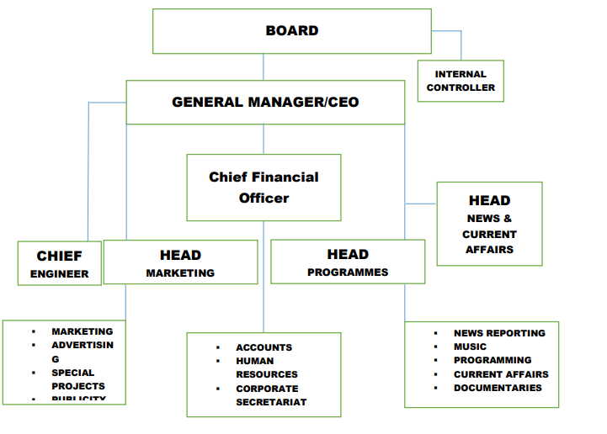

CHAPTER THREE & FOUR
SIWES EXPERIENCE AT SOBI FM (101.9) ILORIN KWARA STATE
My SIWES commenced officially on the 5th of August 2024. And I resumed at SOBI FM on the 5th August 2024. SIWES experience can be regarded as plus, because I learnt a lot of things which includes the practical and theoretical aspects of Mass Communication and made me to have more experience.
On the first week of my SIWES training I was introduced to the Radio station and I was introduced to various department in SOBI FM/ orientation.
We started by attending online classes, purposely for us to be familiar with how to schedule online meetings as a communicator in training.
I was taught the words that is not meant to be broadcast, which is called NTBB.
NTBB means NOT TO BE BROADCAST.
I learned how to operate different equipment in SOBI.
I was taught how to handle the microphone, Head Phone, Mixer, Audio Processor, active monitor speaker,

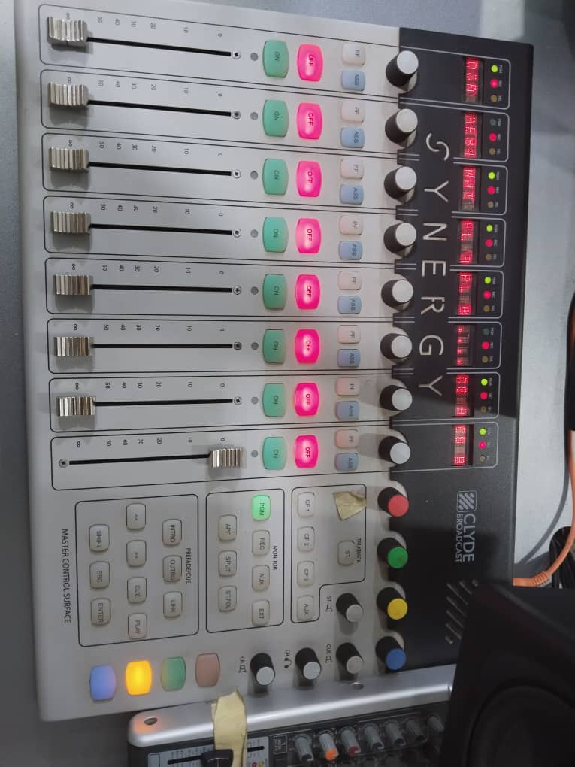
CONSOLE MIXER
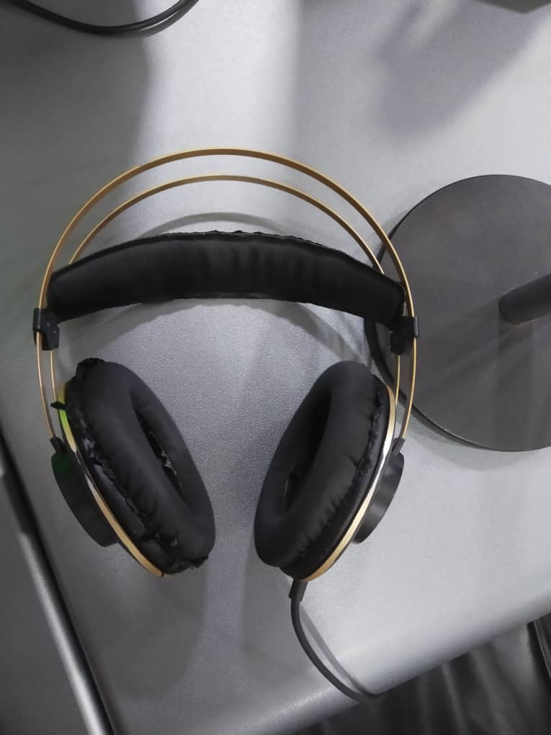
HEADSET

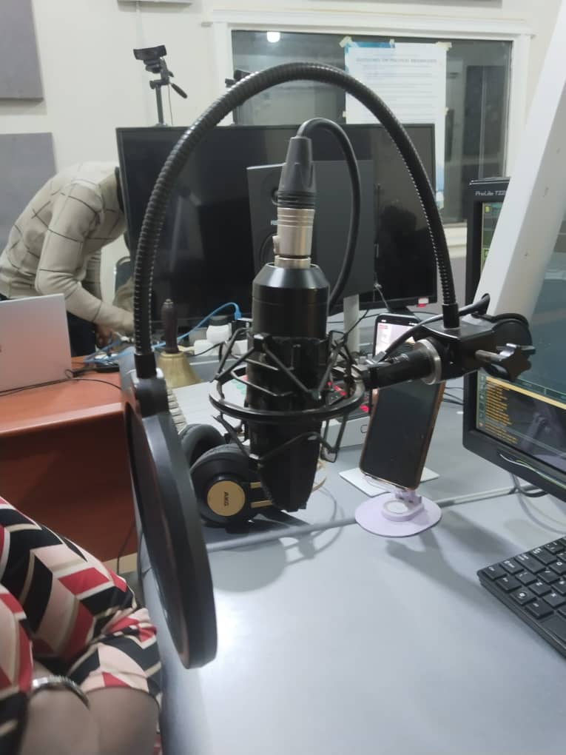
MICROPHONE
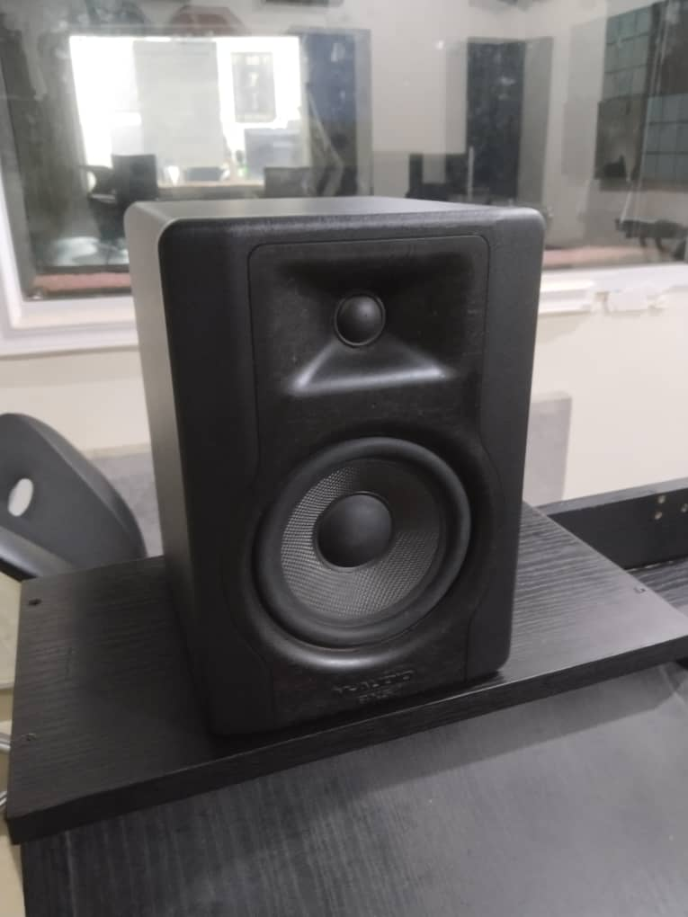
SPEAKER

NEWS WRITING IN SOBI FM
News writing is one of the things I learnt in SOBI FM, learning news writing includes how to source for news, how to write and edit news, and how to identify a news worthy event.

What I basically learnt from News Writing
- Introduction to News
- Definition and purpose.
- Characteristics of News writing
- The inverted pyramid structure
- Elements and News story
- Writing Styles
- Tips for effective News writing

Introduction to News Writing

News writing is the art and craft of presenting current events or information to an audience through written formats, typically for newspapers, online platforms, or broadcast media. It is a cornerstone of journalism, requiring a balance of accuracy, clarity, brevity, and audience engagement. Below is an overview of key aspects of news writing.
Definition and Purpose
- Definition: News writing is the process of gathering, organizing, and presenting factual information about recent events, issues, or trends in a clear and concise manner.
- Purpose:
  - To inform readers or listeners.
  - To educate the public on significant issues.
  - To provoke thought or stimulate discussions.
  - Sometimes, to entertain or inspire.
Characteristics of News Writing
- Accuracy: All information must be verified and factual.
- Objectivity: Avoid bias and present all sides of a story.
- Clarity: Use simple and straightforward language.
- Brevity: Write concisely, avoiding unnecessary words.
- Timeliness: Focus on recent or upcoming events.
- Relevance: Address topics that matter to the target audience.
The Inverted Pyramid Structure
- This is the standard structure for news writing:
  - Lead (or Lede): The first paragraph summarizes the most critical information—answering the “5Ws and H” (Who, What, Where, When, Why, and How).
  - Body: Expands on the details provided in the lead, adding context, quotes, and supporting evidence.
  - Conclusion: Contains background information or less essential details, often designed to be cut off if necessary for space.
Elements of a News Story
- Headline: A concise and engaging summary of the story to attract readers.
- Byline: Indicates the author of the article.
- Lead Paragraph: The hook that provides the main point of the story.
- Body Paragraphs: Offers supporting details, data, quotes, and analysis.
- Ending: Sometimes a kicker or quote to leave an impression.
Writing Style
- Active Voice: Prefer active over passive constructions (e.g., "Police arrested the suspect" vs. "The suspect was arrested by police").
- Plain Language: Avoid jargon unless relevant and explained.
- Third-Person Perspective: Maintain neutrality by writing in the third person.
Tips for Effective News Writing
- Know Your Audience: Tailor content to meet the interests and reading level of your target demographic.
- Verify Facts: Cross-check all data and sources to maintain credibility.
- Use Quotes: Direct quotes from credible sources enhance authenticity.
- Proofread: Ensure the absence of grammatical or factual errors.

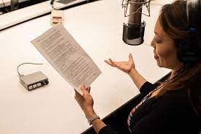

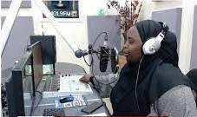
News Room
A newsroom is the central hub where news organizations, such as newspapers, television stations, radio stations, or online media platforms, coordinate and manage their news-gathering and production activities. It serves as both a physical space and a metaphorical center for collaboration among journalists, editors, and producers.
ARMS OF RADIO PROGRAM
Radio program consist of three arms, which are;
- Informative
- Educative
- Entertainment
The Role of Advertisement in Mass Communication
During my Students Industrial Work Experience Scheme (SIWES) placement, I had the opportunity to gain practical experience in the field of mass communication, particularly in the area of advertisement. Advertisement plays a crucial role in mass communication, serving as a bridge between businesses and their target audiences. It is an essential tool for creating awareness, promoting products or services, and influencing consumer behavior. This experience exposed me to the dynamics of advertising and its importance in the communication process.
Advertisement in Mass Communication
Advertisement, as a core aspect of mass communication, involves the dissemination of persuasive messages to large audiences through various media channels. These channels include television, radio, newspapers, magazines, billboards, and digital platforms. The primary objective of advertising is to inform, persuade, and remind the public about a product, service, or idea. It also helps organizations build their brand image and maintain relevance in a competitive market. At my SIWES placement, I observed and participated in various advertising campaigns, which gave me a deeper understanding of how messages are crafted and delivered to achieve specific goals.
My SIWES placement was at a media-focused organization where I worked closely with the advertising department. During this period, I witnessed the end-to-end process of creating and executing advertisements. This included:
- Research and Planning: I participated in brainstorming sessions where market research was conducted to understand the target audience. This step is essential to develop strategies that align with the audience's needs and preferences.
- Content Creation: I learned how to design advertising content, including headlines, slogans, visuals, and scripts. I gained hands-on experience using tools like Canva and Adobe Photoshop to create engaging visuals for print and social media platforms.
- Media Selection: I observed how media platforms were chosen based on the nature of the product and target audience. For example, products aimed at young people were promoted heavily on social media, while services targeted at older demographics utilized radio and newspapers.
- Execution and Monitoring: I contributed to scheduling advertisements and tracking their performance. This involved analyzing audience engagement metrics to determine the effectiveness of the campaigns.
Skills Acquired
The SIWES experience significantly improved my knowledge and skills in advertisement and mass communication. Some of the key skills I acquired include:
- Creative Content Development: I learned to write compelling advertising copy and design eye-catching visuals to attract and retain audience attention.
- Strategic Thinking: I developed the ability to analyze market trends and audience behavior, which are critical for planning successful advertising campaigns.
- Media Literacy: I gained insight into how different media channels operate and how to select the most appropriate medium for a campaign.
- Teamwork and Collaboration: Working with a team of professionals taught me the importance of collaboration and effective communication in achieving organizational goals.
- Technical Skills: I acquired proficiency in tools such as Canva, Adobe Photoshop, and social media analytics tools, which are essential for designing and monitoring advertisements.

CHAPTER FIVE
SUMMARY, RECOMMENDATION AND CONCLUSION
My experience at SOBI FM Ilorin, was a wonderful experience and I have come to say that studying Mass Communication without practical, could be regarded as a waste of time, resources and energy because the training has helped me a lot.
I was taught how to write News basically, how to cast a news, how to handle different equipment in Radio Station, writing of News story, how to edit news and identify a news worthy event. I was also exposed to different equipment that are used in the radio station.

RECOMMENDATION
- I would recommend that the Kwara State polytechnic should improve the school by assisting the SIWES student with computer and modern technology and it would lead to create development of the school
- I would recommend that the department of Mass Communication in Kwara State Polytechnic should expose student to practical skill and allow them to practice until they understand it perfectly well.
CONCLUSION
Student Industrial Work Experience Scheme is very Essential for all student to be able to understand what their cause of study will present to them after graduation and also learn beyond what they will be able to learn in school.
SIWES really helps student a lot by also allowing student to connect with people that are already practicing in the field. All thanks to the Government, SOBI FM, Kwara State Polytechnic and my Department.

