

A TECHNICAL REPORT OF STUDENTS’ INDUSTRIAL WORK EXPERIENCE SCHEME (SIWES) REPORT

HELD AT:
KWARA STATE BUREAU OF STATISTICS
6, Saadu Alanamu Road, GRA, Ilorin, Kwara State

PREPARED BY:

ADEBAYO FELICIA FIKAYOMI
ND/23/STA/FT/0022

SUBMITTED TO

THE DEPARTMENT OF STATISTICS, INSTITUTE OF APPLIED SCIENCE, KWARA STATE POLYTECHNIC, ILORIN

IN PARTIAL FULFILMENT OF THE REQUIREMENT FOR THE AWARD OF NATIONAL DIPLOMA (ND) IN STATISTICS

AUGUST - DECEMBER, 2024
PREFACE
The writing of this SIWES report is manufacture by the school authority that before attaining the certificate of National Diploma (ND) in Statistics. Each student must undergo the four (4) months SIWES programme.
The SIWES record therefore contains the work done within the four months.

TABLE OF CONTENTS
Title page
Preface
Table of contents
CHAPTER ONE
1.1 Introduction
1.2 Brief History of SIWES
1.3 Aims and Objectives of SIWES
CHAPTER TWO
2.1 Brief history of the Organization
2.2 Organizational chart of the company
2.3 Various Department and their functions
2.4 Vision and Mission of the Organization
CHAPTER THREE
3.1 Experience Acquired
3.2 Work Done
CHAPTER FOUR
3.1 Executive Summary
CHAPTER FIVE
5.1 Problem Encountered during the Attachment and Solution
5.2 Conclusion
5.3 Recommendations

CHAPTER ONE
1.1 INTRODUCTION
Student Industrial Work Experience (SIWES) is a three months programme setup by the federal government for professional student in Mass Communication and other elected courses which is controlled, in which the headquarter is in Kaduna State in affiliation with Industrial Training Fund (ITF) at Jos.
However, the government introduced the programme in other to assist students to be familiar with the practical aspect of their profession i.e. Mass Communication.
Student Industrial Work Experience (SIWES) is a programme setup by National Board of Technical Board (NABTEB) for its practical improvement of mass communication. The programme is setup during the period of three months which is corresponding with a body known as Industrial Training Fund (ITF).

1.2 BRIEF HISTORY OF SIWES
Prior to the establishment of the scheme, there was growing concern among our industrialists that graduates of our institutions of higher learning lacked adequate practical background studies preparatory for employment in industries. Thus, the employers were of the opinion that theoretical education going on in higher institutions was not responsive to the need of the employers of labour.
It is upon this background that the rationale for initiating and designing the scheme by the Industrial Training Fund, during its formative years- 1973/1974- was introduced to acquaint students with the skills of handling employers’ equipment and machinery.
The ITF solely funded the scheme during its formative years. But as the financial involvement became unbearable to the fund, it withdrew from the scheme in1978. In 1979, the Federal Government handed the scheme over to both the National University Commission (NUC) and the National Board for Technical Education (NBTE). Later the Federal Government in November 1984, reverted the management and implementation of the SIWES programme to ITF and it was effectively taken over by the Industrial Training Fund in July 1985 with the funding being solely borne by the Federal Government.
1.3 AIMS AND OBJECTIVES OF THE PROGRAMME
The aims and objectives are as follows:
- To provide wide practical experience of the industrial Student in Various Studies.
- To give inspiration, commitment and dedication to the student
- To enlighten the student about various aspect of their course of study
- To hasten the level of understanding and studying since they had been exposed to practical aspect of their course.

CHAPTER TWO
2.1 BRIEF HISTORY OF THE ORGANIZATION
Kwara State was created on 27th May, 1967, when the federal Military Government of General Yakubu Gowon broke the four regions that then constituted the Federation of Nigeria into 12 states. At its creation, the state was made up of former Ilorin and Kabba provinces of the Northern Region. Kwara State has since 1976 reduced considerably in size as a result of further creation of state in Nigeria on 13th February, 1976.
Prior to the creation of the Bureau, the statistical system in the state has suffered serious setbacks in terms of structural and infrastructural facilities. It was also constrained by both statistical processes and activities of the state. All statistical units in the various MDAs were either not properly defined or subsumed in other mainly unrelated departments. Hence, data from such units or departments lack integrity, professional touch and negate rather than propagate statistics development.
The Federal Government International Organizations, Policy Makers, Researchers and other data users are concerned about the non-availability and of course poor quality of data particularly those measuring performance indicators in Governance e.g. KWASEEDS, poverty and corruption levels. There is also dearth or poor quality of data available for planning at the micro and macro-levels. The creation of the Statistical Bureau is actually intended to provide an outfit which responds to the observed gaps in the Statistical System of the State. The Bureau is a by-product of a National Statistical Master Plan with State component tagged State Statistical Master Plan. This Master Plan is weaved around five thematic areas;
- Organizational Development
- Human Resources Development
- Data Development
- Data management Dissemination and Access
- Infrastructure and Equipment

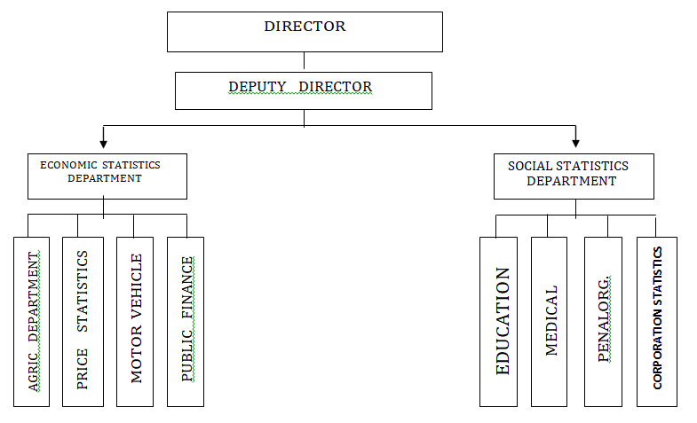
2.3 ORGANOGRAM OF THE ORGANIZATION

2.4 VISION AND MISSION OF THE ORGANIZATION
VISION STATEMENT
The long-term vision for the State Statistical System "is of a proactive; coordinated, well-managed and resourced system capable of meeting Statistical data and information needs of the State towards sustainable development of the state and poverty reduction of the inhabitants.
MISSION STATEMENT
The mission of the State Statistical System will be to:
- raise public awareness about the importance and role of statistical information to society
- collect, process, analyze and disseminate quality statistical data and information in a coordinated and timely manner.
- promote the use of statistical data and information at individual, Local Government Area, State, institutional and national levels, especially for evidence-based policy design and decision-making, and build sustainable capacity for the production and use of statistical data and information in the State.

STRUCTURE OF ORGANIZATION
State Bureau of Statistics (SBS) Structure
An organizational structure can improve or hinder efficiency in an organization. The structure plays a crucial role in an organization. It defines the allocation of responsibilities and powers, reporting relationships and processes, hierarchy levels and value added, allocation of resources and determining skills requirements and affordability. The current structure of SSS.
is inappropriate and needs to change. In any case, a change in strategy often requires change in the organizational structures to make it support strategy. Accordingly, a new structure based on function has been proposed for the new agency, taking into account its expected role, status and challenges that lie ahead.

Board of Directors
The Statistics Edict provides for the establishment of a Board of Directors (the Board) as the governing body of the Bureau. The Board will be responsible for ensuring that the Bureau fulfills its mission and that its profile is commensurate with its new role in State development. In particular, the Board will be responsible for:
- Advice to the Government on the state statistics policy, procedures, methods and regulations relating to the development of statistics
- Formulating and monitoring the implementation of policies for more effective coordination of the State Statistical System
- Monitoring the technical quality of official statistics and promoting adherence to good practice and international recommendations and standards, with a view to ensuring that the statistics are integrable to national statistics.
- Formulating and monitoring the implementation of policies pertaining to the organization and management of the Bureau.
- Promoting and protecting the integrity of official statistics and the professional independence of the statistical Bureau
- Appointing, promoting and disciplining senior staff of the Bureau except the State Statistician-General.
- Setting guidelines for the recruitment, discipline and promotion of junior staff
- Providing the Government with a Quarterly Progress Report on activities of the Bureau and the entire State Statistical System every quarter
- Reviewing the structure of the Bureau as necessary and Proving the corporate plans, work plans and budgets of the Bureau.

CHAPTER THREE
3.1 EXPERIENCE ACQUIRED
My Media Attachment Program at KWARA STATE BUREAU OF STATISTICS has been a successful one as I was exposed to the practical aspect of my syllabus.
The following are the knowledge gained during the SIWES;
- I learnt on how to set up a desktop computer
- I was introduced to Microsoft word (MS-WORD)
- I was introduced to Microsoft Excel (Spread sheet)
- I was introduced to road density (field work on traffic flow)
- I learnt on how to create users account and password on the operating system
- I learnt on how to observe appropriative shutting down as a computer system to avoid surge on the computer system.
- I learnt some controls/ shortcut keys through the keyboard
- I learnt about the use of computer
Finally, my perception about office profession has been greatly widely broaden. It gives me the opportunity to gain first experience of the profession even though it was not easy.

RETAIL PRICE OF PROCESSED FOOD ITEMS

CHAPTER FOUR
4.1 EXECUTIVE SUMMARY
SIWES means Student Industrial Work Experience. Students are out annually to professional organization relevant to their course of study with the help of the institution based. Coordinator and the scheme takes up at the end of the first year during the ND programme for science oriented courses studied in institutions. The scheme was established by the ITF (Industrial Training Fund) to solve the problem of lack of adequate practical skills. During this programme, students are expected to get technical assistance and acquire more experience scheme in their chosen field of study.

CHAPTER FIVE
5.1 PROBLEMS ENCOUNTERED DURING THE ATTACHMENT AND SOLUTION
I didn’t face or encounter any difficulty or problem during my attachment except that my place of attachment is far away from my house.
But the general problems that students encounter before and during the attachment are as follow:
- Lack of available industry in the location of some students
- High cost of transport fare from the students resident to the attachment
- Laziness of some students during the attachment
SOLUTION
- Government should increase their investment on establishing companies for science oriented students.
- There should be a certain amount to be paid to the students during the attachment
- There should be monthly check on the students during the attachment
5.2 CONCLUSION
Student Industrial Work Experience (SIWES) is a scheme that improves the technical knowledge of students in the Nigeria institutions. The scheme exposes students to working method and techniques in handling equipment’s and machinery that may not be available in their institutions. It is a good process that every science oriented courses must undergo.
As for me, the SIWES I did at SBS exposed me to the practical aspect of my syllabus. It widens my knowledge and skill on the discipline. The scheme equips students properly to face future challenges.
Lastly, big thanks to the Industrial Training Fund (ITF) for the establishment of SIWES which now serves as an opportunity for we students of the Nigeria institution.
5.3 RECOMMENDATIONS
Federal government, as a matter of responsibilities has to contribute immensely to the uplifts of this programme by putting in place a considerable compensation for the students who embarked on this kind of stressful and deadly programme. The federal government has a lot of role to play in building up a brighter future for us in order to maintain the peace and stability of the state.
Secondly, a lot of task also lies on the school authority to orientate and enlighten their students on the expected things they are going to face or encounter pleasantly or in the other hand when they get to their various placements of works before the commencement of the programme.
Thirdly, there should be rigorous inspection and supervision as some students count and envisage this programme as a mere task and they should as well enhance their strength and bestow and hefty mark on it.
Lastly, students need money for their upbringing and sponsorship, so I will urge the Federal Government to make the allowance more attractive to boost the students’ morale.

