A

REPORT OF THE STUDENTS’ INDUSTRIAL EXPERIENCE SCHEME (SIWES) REPORTS

OMO-SAM GLOBAL LIMITED, AT OJUDUN BERGER, LAGOS STATE

FROM SEPTEMBER 2024 TO DECEMBER 2024

BY
OLAYIWOLA RAGHBEEBAT ROLAKE
ND/23/MKT/FT/0009

SUBMITTED TO:
THE SIWES COORDINATOR
DEPARTMENT OF MARKETING
INSTITUTE OF FINANCE AND MANAGEMENT STUDIES

KWARA STATE POLYTECHNIC, ILORIN
KWARA STATE

IN PARTILA FULFILLMENT OF THE REQUIREMENT FOR THE AWARD OF NATIONAL DIPLOMA (ND) IN MARKETING
CERTIFICATION PAGE
I hereby certify that this report of Student Industrial Work Experience Scheme (SIWES) was prepared and complied by IBRAHIM NOFISAT ONAOLAPO with the Matriculation number; ODLNDMAC0566 from the department of Mass Communication, Kwara State Polytechnic, Ilorin, Kwara State for the successful completion of SIWES undertaken at Radio Kwara 99.1fm, Ilorin.

_____________________________ _____________________________
Head of Department (HOD) SIWES Supervisor
Mass Communication Department

_____________________________
Student

ACKNOWLEDGEMENT
I thank GOD almighty and I give all the glory, honour and adoration for His mercy over my life during the course of my study and when undergoing my Industrial Training.
My appreciation also goes to my Industrial Based lecturer; MR. MUSA MURITALA BADA whose accessibility, untiring effort, patients, guidance and suggestions fabulously contributed to the completion of this report, may GOD continue to guide and protect her and her family.
Lastly, my appreciation goes to the Director of Administration in person of Alhaji Sikiru for accepting me into the organization and support, may GOD almighty be with him and his household.

DEDICATION
I dedicate this report to GOD almighty for His unlimited grace, consistent love, immeasurable faithfulness and for sparing my life throughout the period of my SIWES programme.

TABLE OF CONTENTS
Title page
Certificate page
Dedication
Acknowledgements
CHAPTER ONE
1.0 Introduction
1.1 History Background of Students Industrial Work Experience Scheme (SIWES)
1.2 Objectives of SIWES
CHAPTER TWO
2.1 Background of the organisation
2.2 Vision
3.3 Mission
3.4 Organogram of the organisation
3.5 Policies/programmes
3.6 Public service departments
CHAPTER THREE
CHAPTER THREE
3.0 My experience at Omo-Sam Global Limited
CHAPTER FOUR
Conclusion
Recommendation
Reference

CHAPTER ONE
1.0 INTODUCTION
The origin of Industrial Training could be traced to the advent of industrial revolution which ushered in steam engines, power driven machines and a new system of production in Europe. The function satisfactorily then, workers needed to deport from their craft capabilities and embrace knowledge and understanding which the new technologies offered in work – settings via practical training. Therefore, the need prompted higher citadels of learning to commence application of practical and technical affairs.
The concept thrived between 1824 and 1830 extensively to warrant the creation of technical and engineering courses. These courses where established for at Reasselea. Polytechnic institute, USA, and secondly at Colombia University to on the new scientific curriculum that necessitated the Greek or latin language indusu, the effect of this concept has been argued and it lead to the spread or escalation of science, engineering and technical education in several tertiary institutions in American and Europe towards the end of 19th century.
The products of these instructions were trained through systematic instruction with a body of knowledge in engineering and science which was theoretical and universal. Hence, they had broad ideas on fundamental knowledge to the workability of various engineering systems but lacked an indepth foundation on practical knowledge needed for effective production in certain jobs.
The gap between theoretical knowledge and practical training was therefore noticed for bridging and it necessitated, science and engineering students complementary their theoretical knowledge with practical training in industries so as to become productive in their career after graduation. This prompted the innovation that later took place in the 20th century with the introduction of cooperative education through Herman Schneider, the Dean, college of engineering, university of Cincinnat.
Therefore, engineering students started attending classes to acquire theoretical knowledge and also engaged in trainings with the same duration in companies for practical experiences.
Although studies have shown some variations in cooperative education in work settings across the globe till date, but it is still a striking fact that Schneider’s innovation of 1906 serves as the foundation for all training in science, engineering and technology in developed nations such as North America and Western Europe, with little impacts in some developing countries.
1.1 HISTORY BACKGROUND OF STUDENTS’ INDUSTRIAL WORK EXPERIENCE SCHEME (SIWES)
Students’ Industrial Work Experience (SIWES) is a programme designed that exposed and prepare student of Universities, Polytechnics, Colleges of Technology, College of Agriculture and Education for industrial work situation which they are likely to meet after graduation. It is a skill training programme which affords students their opportunity of familiarizing, acquiring and exposing themselves with the needed experiences in handling industrial equipment and machinery that are not usually available in their institutions.
Students’ Industrial Work Experience Scheme (SIWES) is a human capital formation programme through industrial attachment for which student are experienced to have a practical experience on the basis of theories and principles acquire in the teaching – learning process. However, the prevalence of inability of participant of SIWES to secure employment after the programme casts doubt on the continuing relevance of SIWES to the contemporary industrial development drives in Nigeria.
Human resources development constitutes the most critical factor in the development process and the quality must therefore be inherent in the productive capacity of people. Human societies in the quest for development have identified and developed institutional as well as structured training and educational programmes as major avenues for processing human beings to acquire the necessary skills and technical competence for their roles in the development of the society.
In this context, it is observed that, it is not only in advanced nation that science and technology and spreading, but that, they are increasingly valued. Whenever people value their nation’s independence, prosperity, power and prestige, and also, where nations seek a high standard of living, improved health or better education in most discussions on human resources management, training and development represent the most significant.
SIWES was established by ITF (Industrial Training Fund) in the year 1973 to solve the problem of lack of adequate proper skills for employment of tertiary institution graduates by Nigeria. SIWES was founded to be a skill training programme to help expose and prepare student of universities, polytechnics and colleges of education for the industrial work situation to be met after graduation, this scheme serve as a smooth transition from the classroom to the world of work and further help in the application of knowledge. The scheme provide student with the opportunity of acquiring and exposing themselves to the experience required in handling and managing of equipment and machinery that are usually not made available in their institutions.
In Nigeria, SIWES was introduced in 1973 to enable undergraduate student in science and engineering acquire practical skills needed to function satisfactorily in work-setting. Industrial training commenced in the country due to the reliance of companies or industries on technical proficiencies, for production process and preservation of company resources.
In practice, it is said to originated from then Yaba Technical Institute, now Yaba College of Technology. At that point, students were being sponsored by various government owned institutions and other private forms. The practice permitted students to return to work with their employers during long vacations. Through this, students were having work – related experience and the training available in companies then must have been responsible for the quality of graduates in organizations in those early days.
However, it could be observed that the quality of the Nigerian graduates began to diminish afterwards due to the death of faculties to impact quality education on students in tertiary institutions. As military imperialists began to unleash terror on social critics, most of which were faculty members were recruited into the academics. To worsen the situation, most of the expatriates left Nigeria for their countries of origin, the vacuum created could not be filled satisfactorily with the skills of fresh graduates from the nation’s educational systems.
Given this, multinational companies in Nigeria such as Flour Mill Plc Nigeria, Bagro Plc, Nigerite, Nigerian Breweries Plc, Unilever Nigeria Plc, Texaco Over Seas (TO), Cheuron Nigeria Limited (CNL) established training schools; also call skill acquisition through hands on experience.
Since independence, the issue that has attracted the interest of succeeding Government in Nigeria has been that of human resource development from the beginning of Nigeria’s nationhood, it was eminent that the pace of national development through technological advancement devolved not so much on the availability of mine or resources, rather, on the articulation and effective utilization of the vast human and material resources. It is on this basis that investment on training of the human factor becomes a serious challenge as science and technology related courses are requisite for national development.
Therefore, it is observed that, initial efforts aimed at achieve rapid national development were concentrated on the expansion of formal exceptional institutions, through acquire the skilled, knowledge and varied chorological expertise required to meet the needs the needs of special and vital sectors of the economy. However, the fundamental role of education in human resources development is a matter of priority for any developing country to involve functional education policy. This is necessary because only through such priority can a country lay a solid foundation for a future, stable and res-oriented human resource development. Thus, growth and development, which the result from effective organizational change, depend on a well – educated and a quality skilled human capital that is capable of applying vision, knowledge and creativity to their economic activities. Thus, industrial education which can be achieved through the formal or / and informal educational approach(es) attract the attention of Government and individuals, in contemporary development environment.
1.2 OBJECTIVES OF SIWES
The core objectives of the scheme are as follow:
- To expose the students to work method and techniques
- To provide an avenue for students to acquire industrial skills.
- Enhancing student contract with potential employers while on training.
- To help students appreciates the role their professional play in society.

CHAPTER TWO
CHATPER TWO
2.1 BACKGROUND OF THE ORGANISATION
2.2 VISION
To sustain a reformed Public service, proficient in professionalism, effective and transparent service delivery.
3.3 MISSION
To create quality and objective Public Service through adherence to rules and regulations.
3.4 ORGANOGRAM OF THE ORGANISATION
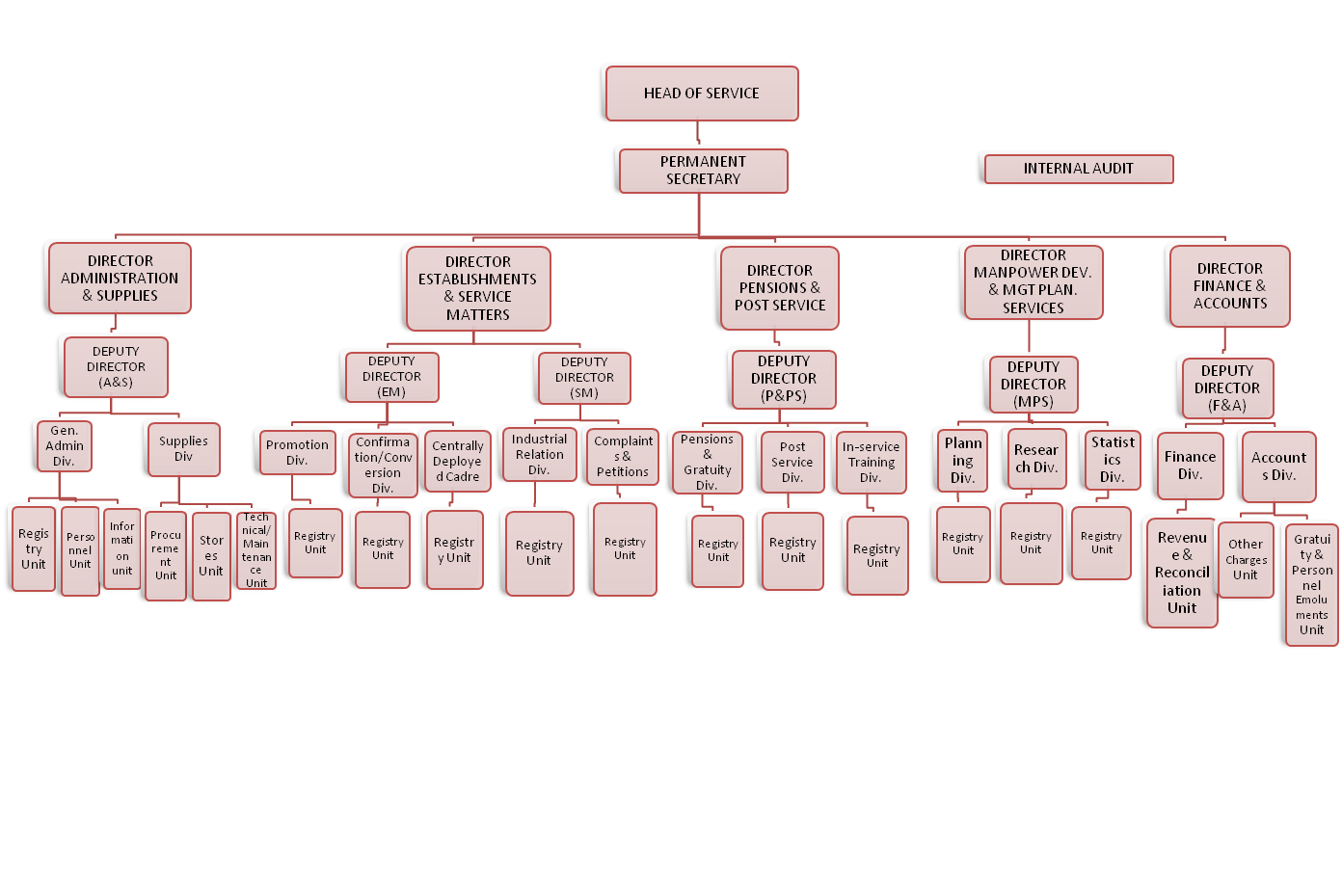

3.5 POLICIES/PROGRAMMES
- Monthly payment of pension and gratuities
- Biometric verification of pensioners
- Distribution of welfare packages to pensioners (every quarter of the year)
- Visitation
3.6 PUBLIC SERVICE DEPARTMENTS
The Commission has the following departments:-
- Administration Department: This Department is responsible for the General Administration of the Commission. It takes charge of staff Welfare and Maintenance of Vehicles.
- Finance Department: This department deals with all matters of Finance and Budget Estimates.
- Planning, Research and Statistics: This Department is charged with the responsibility of collating, collecting and keeping records of Public Servants. The data collected are used for the preparation of the Commission's Annual Reports, Achievements and Quarterly Reports. The Department is also responsible for providing information/data for Gazette publications of promotions, transfers, secondment, new appointments, withdrawals, resignations and retirements from service on request.

CHAPTER THREE
TECHNICAL TRAINING EXPERIENCE
WEEK 1: I learnt the processing of supply chain, receiving and protecting of goods, we are also giving task to perform such as receiving of good, recording of inventory and checking of purchases
WEEK 2: We were given the company price tag record books to study and copy for us to know the actual amount each good cost.
WEEK 3: We are also thought how to repackage goods, basics concept on how to market goods, I was also asked to list out the goods supplied to the company, we were also asked to rearrange the goods.
WEEK 4: I were asked to supply goods of 100bags to a customer, I were also asked to issue an invoice for them and record them on the company record book. Also I were asked to supply another customer the goods they bought. We were also attached with accountancy students for inventory calculation.
WEEK 5: Stock taking; we were asked to count all the available stock in the store. We supply good to the customers and issued invoice to them.
WEEK 6: Purchasing of goods: we were given invoice to purchase some good from other companies. Other students were asked to checkmate the goods we bought and we were asked to arrange them in the store.
WEEK 7: Purchasing of goods: we were given invoice to purchase some good from other companies. Other students were asked to checkmate the goods we bought and we were asked to arrange them in the store.
WEEK 8: Stock taking; we were asked to count all the available stock in the store. We supply good to the customers and issued invoice to them
WEEK 9: we were asked to supply goods of 100bags to a customer, I were also asked to issue an invoice for them and record them on the company record book. Also I were asked to supply another customer the goods they bought. We were also attached with accountancy students for inventory calculation.
WEEK 10: We are also thought how to repackage goods, basics concept on how to market goods, I was also asked to list out the goods supplied to the company, we were also asked to rearrange the goods.
WEEK 11: We were asked to prepare account from the invoice issued
WEEK 12: We reversed all we have being doing

CHAPTER FOUR
RECOMMENDATION AND CONCLUSION
Going through some of the experience gained during the programme, I will recommend that there is need for improvement on some of the activities, both in the marketing department where I served and the school.
The time duration for the programme should be extended for more than three (3) months.
Media organization should create more practical knowledge for the student for them to acquire more knowledge from their versatile staff.
CONCLUSION
SIWES was established to provide opportunities for students to be involved in the practical aspect of their respective disciplines in the industries working environment. During my four (3) months industrial training, I gained a wide range of experience from the various assignment undertaken such as; purchasing, supplying of goods, stock taking. All the experience gained help to fulfill the objectives of SIWES.

