

TECHNICAL REPORT ON STUDENT INDUSTRIAL WORK EXPERIENCE SCHEME (SIWES)

HELD AT:
SAMTUNDE ELECTRICAL NIGERIA LIMITED
99 EMIRS ROAD ILORIN KWARA STATE

WRITTEN AND SUBMITTED BY:

INAWOLE GODWIN EMMANUEL
MATRIC NO: ND/23/EEE/PT/0079

SUBMITTED TO:
DEPARTMENT OF ELECTRICAL/ELECTRONIC ENGINEERING
INSTITUTE OF TECHNOLOGY (I.O.T)
KWARA STATE POLYTECHNIC, ILORIN
P.M.B. 1375 ILORIN, KWARA STATE

IN PARTIAL FULFILLMENT OF THE REQUIREMENT FOR THE AWARD OF NATIONAL DIPLOMA (ND) CERTIFICATE IN ELECTRICAL AND ELECTRONIC ENGINEERING

FROM AUGUST – DECEMBER 2024

DEDICATION
This report work is dedicated to the Almighty God, the Alpha and Omega. The one who make me whom I am today, also dedicated to my parents Mr. and Mrs. INAWOLE, And to all the staffs of SAMTUNDE ELECTRICAL NIGERIA LIMITED. Lastly, to my brothers and sisters.

ACKNOWLEDGMENT
What I am now is by the grace of the almighty God who is able to do all things and make me to excel abundantly above in all I ask and think, according to the power that works in me unto him the glory and domination.
The success of this report however would not have been possible without the invaluable support, assistance and encouragement of a large number of people who are too numerous to mention.
My thanks goes to my lovely parents Mr. INAWOLE for their words of encouragement and to my brothers and sisters. And to those whose names did not appear who at one point or the other contributed to the success of this write-up.
I say thank you and GOD BLESS YOU

PREFACE
Student industrial work experience scheme is geared towards educating and giving the participant i.e. the student to the practical aspect of the academic discipline and course he or she is pursuing.
This technical report is based on all the training acquired by me during the course of my industrial attachment the attachment lasted for four months (August – December 2024)
This program is organized for all engineering and technological students of higher institution of leaning, is a sure way of achieving the guest for technological and self reliance in a country like ours where the need for technological advancement cannot be over emphasized.
My acquired experience on this industrial work which I did at has given me SAMTUNDE ELECTRICAL NIGERIA LIMITED insight into the course of my study. It has exposed me and given me the knowledge about the various types of electrical and some work techniques, whose operational techniques work only, but theoretically explained in our lectures in class. I want to appreciate the national board of technical education for the introduction of the student industrial work experience scheme programme to the higher institution to prepare us for a better future.

ABSTRACT
This report cover the systems of electrical installation the types of electrical installation system, such as surface wiring system and conduit wiring system, the tools and instruments used and their uses, various types of materials used in electrical installation including the cable to be use and various things to consider before the electrical installation of a building.
SAMTUNDE ELECTRIAL NIGERIA LIMITED.

TABLE OF CONTENTS
Title i
Dedication ii
Acknowledgment iii
Preface iv
Abstract v

CHAPTER ONE
1.0 Introduction 1
1.1 Specific Aims of SIWES 1
1.2 Objective 2

CHAPTER TWO
2.0 Brief History of the organization 3
2.1 Organization chart 3

CHAPTER THREE
3.0 Electrical Tools and Instruments 4
3.1 Uses of the above tools and instruments 5
3.2 Maintenance of the tools 8
3.3 Some safety precaution in the electrical installation 8
3.4 Wiring system 9
3.5 Material needed in electrical installation 10
Materials used in electrical installation 10
3.6 Types of wiring system 13
3.7 surface wiring system 13
Block diagram for connection of lighting point and switch for
Surface wiring 13
3.8 Conduit wiring system 14
3.9 Types of conduit wiring system 14
3.9.1 Half conduit system wiring 14
3.9.2 Full conduit system wiring 14
3.10 Laying of conduit pipe 15

CHAPTER FOUR
4.0 Relevance of the experience gained at students field of study 18

CHAPTER FIVE
5.0 Conclusion and Recommendation 19
5.1 Conclusion 19
5.2 Recommendation 19

CHAPTER ONE
1.0 INTRODUCTION
Student industrial work experience scheme (SIWES) programmed, it was establish in year 1973 by Federal Government of Nigeria through the Industrial Training Fund (ITF) under the NTBE (National Board for Technical Examination). It has it’s headquarter in Jos Plateau State. The major reason behind the establishment of SIWES programmed and the importance of the student to display their talents and also learn the practical aspects of their fields of study. After their graduation, they will have something valuable to contribute to the society. They will also be able to face future challenges in their respective field of study.
1.1 SPECIFIC AIMS OF SIWES.
- To introduce trainee to the industrial atmosphere and discipline.
- To provide opportunity for the trainee student to apply knowledge obtained in form of lecture and practical to industrial reality.
- To provide an opportunity for the trainee student to assess their own suitability for carriers.
- It enable the industrial to be able to recruit graduates to the post appropriate to their background, training and the orientation during the change over from student to work status.
- To be introduced to as wide a range of industrial skills as much as possible.
- To enable trainee student become familiar with the organization and control of the industries similar to where they are likely to work after graduation.
1.2 OBJECTIVES
Specifically, the objectives of the students industrial Work Experience Scheme are to provide an avenue for students in Nigeria Tertiary Institutions to acquire industrial skills and experience in their course of study.

CHAPTER TWO
2.0 BRIEF HISTORY OF THE ORGANIZATION
Samtunde Electrical Nigeria limited was established in year 2004 and it is compose of the highly technical.
Samtunde Electrical Nigeria Limited, No. 99 Emirs Road Ilorin Kwara State.
2.1 ORGANIZATION CHART
Director

Asst. Director

Supervisors

Student Workers Apprentice

CHAPTER THREE
3.0 ELECTRICAL TOOLS AND INSTRUMENTS
Electrical Engineering makes use of different instrument in performing different operations.
Some of the instruments used are listed below:
- Screw driver
- Bending spring
- Gloves
- Pliers
- Hammer
- Neo Tester
- Fixing tape
- Hack saw
- Centre punch
- Raw plug drill
- Cutting pliers
- Multi meter
3.1 USES OF THE ABOVE TOOLS AND INTRUMENTS
- Screw Driver - it is used for loosing and tightening screw.
- Bending Spring – it is made up of spring, it is used in bending PVC pipe when working on conduit wiring system.
- Gloves –it is used to guide against electrical and mechanical damages to the hands.
- Pliers – it is used for cutting, disconnecting or removing installation material like rubber from a conductor. It is also used to hold material firmly in order to couple the material.
- Hammer – it is used for clipping cable to a surface.
- Tester – it is used to check whether a conductor is live. It is also used to detect the flow of current in a conductor.
- Fixing Tape – it is used in passing wire into PVC pipe when working on conduit system wiring.
- Hacksaw – it is used for cutting metal and PVC pipe when working on conduit wiring system.
- Center Punch – it is used for making point in metal or concrete blocks before drilling.
- Cutting Pliers – for cutting conductors
- Raw plug Drill – for forming holes inside the block or concrete.
- Multi Meter – is an instrument designed to measure electric current, voltage and usually resistance, typically over several ranges of value.
DIAGRAMS ARE SHOWN BELOW




Neo Tester
Multi Meter
Bending Spring

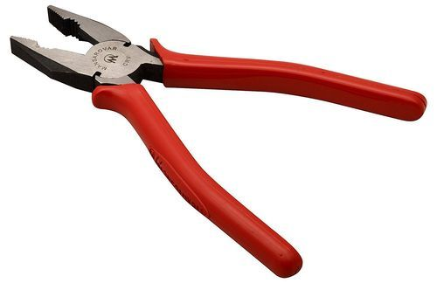
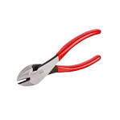


Nose plier
Combination Plier
Cutting Plier



Clipping Hammer
Hack Saw

3.2 MAINTENANCE OF THE TOOLS.
The maintenance are listed below.
- Keep the tools in cool and dry place.
- It should be check regularly.
- It should be kept away from rain.
- It should be taking away from in sting.
3.3 SOME SAFETY PRECAUTION IN ELECTRICAL INSTALATION.
- Always put on your overall when in workshop or any place of work.
- Always remove the fuse when carrying out installation on live cable.
- Test the conductor polarity by means of tester not by touching it ordinarily.
- It is dangerous to operate electrical machine you are not familiars with.
- Spark from switch cause serious burns.
- Always use correct tools for all jobs. Since incorrect tools used can result in accident.
- When using ladder, ensured that it is placed properly to avoid it from falling down.
- When working on concrete pole with ladder, ensure safety belt is used to hold the body when working.
3.4 WIRING SYSTEM.
When choosing a system of wiring from a building, the following point must be put into consideration:
- Neatness of the finished jobs:- To see if a particular wiring system if choosing a for a building will not be eyes sure.
- Time required to complete the wiring:- That is, if therefore length of time that is allocated for the completion will not fail, particularly urgent jobs being allocated by government .
- The durability of the installation:- If a particular wiring chosen withstanding the hazard condition of usage or will last long as expected of the installation. For Example, a surface PVC. Sheathed wiring will prove hazardous to a metal workshop.
- Future Extension and Alteration:- One must ensure that a system of wiring will give room for future addition. For Example, a concealed conduct wiring will not be suitable for factory installation which is often subjected to extension.
- Drainage to the fabric of the building by cut away:- For Example, it will be better to wire a completed multi-storey building in surface wiring than concealed conduct which may weaken the wall and pillars when chiseled to form channel.
- Special consideration like dampness:- Flammable in a situation which is either permanently damp or intentionally damb, damp proof fitting and wiring materials must be used to prevent ingress of moisture to the wiring and if flammable situation all accessories and apparatus to be used must be of flame proof type.
- Cost of installation:- Cost is one of the important aspect to be considered when deciding on a system of because a client may want to wire his or her building in fill conduit, because of the neat appearance but by the time he or she sees the estimated cost of the wiring he or she may not be able to afford the cost.
3.5 MATERIAL NEEDED IN ELECTRICAL INSTALLATION
- Cable:- A Length of insulated single conductor (Solid or stranded), or of two or more such conductor, each provided with its own insulation, which are laid up together.
- PVC Sheathed Cable:- A Cable of which the conductor insulation and mechanical protection is of polyving-chloride.
- Cable Trunking:- A cast for cables, constructed of metal sheet, wood or insulating materials and may be of rectangular or square cross section of which one side is removable or binged for the whole of its length for the purpose of laying cable therein.
- Circuit Breakers:- A mechanical device for making and breaking a circuit both under normal and abnormal condition, such as those of a short circuit being broken automatically.
- Consumers Control Unit:- It is a distribution board incorporation a main switch or main circuit breaker within its unit.
- Distribution Board:- This is an assemblage of parts including one or more fuses or miniature circuit breaker, arrange for the purpose of distribution of Electrical energy to final sub-circuit and to other distribution boards.
- Earth Electrode:-A metal rod or rods metal plate or mat having effectual connection with the general mass of the earth.
- Fuse:- It is a device for opening a circuit by means of a conductor designed to melt when an excessive current flows. Its consists of two parts, the base and the bridge.
- Installation of Conductor:- It is a suitable non-conductor material enclosing surrounding or supporting a conductor.

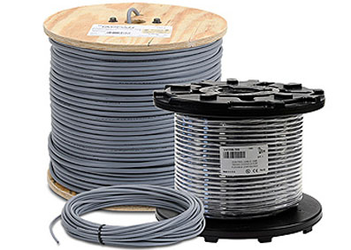
Lamp holder
13A Flush Socket
13A Double socket
Conductor Cable
Lamp holder and Bulb
3-way flush switch
2-way flush switch
1-way flush switch
Cables and Socket
ELCB
MATERIALS USED IN ELECTRICAL INSTALLATION
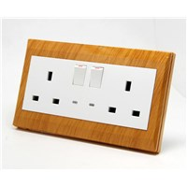
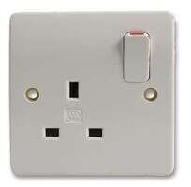


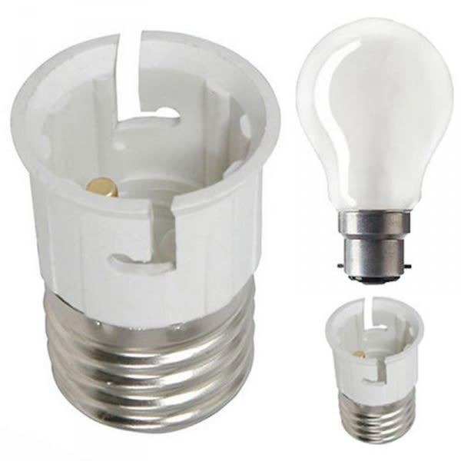
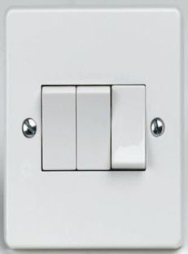
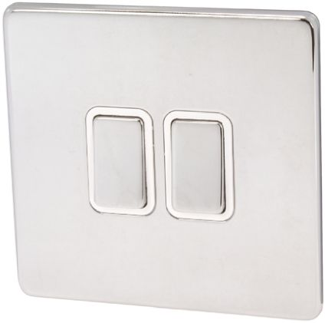
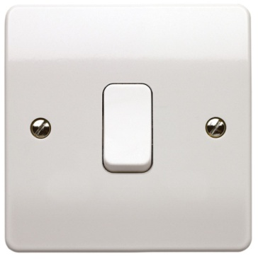

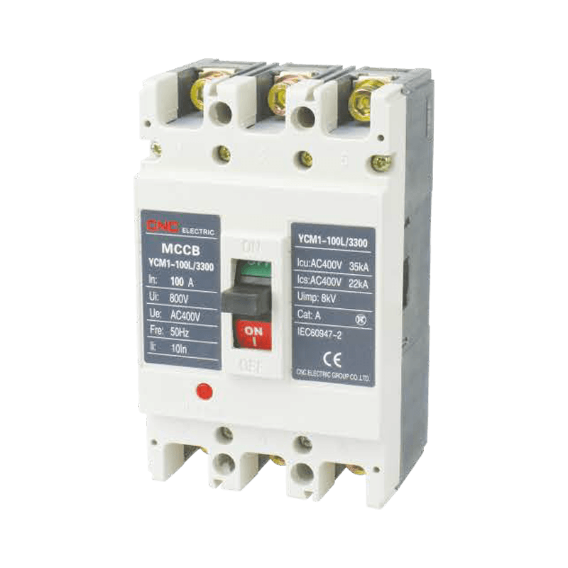
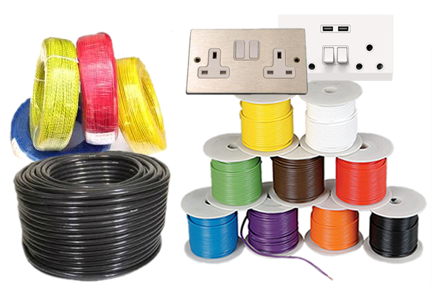

3.6 TYPES OF WIRING SYSTEM
- Surface wiring system
- Trunking wiring system
- Conduit wiring system
3.7 SURFACE WIRING SYSTEM
This is the system of wiring by which is called PVC sheathed wiring on surface, this involve the use of PVC insulated laid up in flat formation with a close covering of thought PVC as mechanical protection since there is no metal sheat. A bare conductor as in twin and earth cable will be enclosed in PVC sheat to serve as the earth continuity conductor.
SOME OF THE MATERIALS USED FOR SURFACE WIRING SYSTEM
- plastic box (3x3, 3x6)
- Joint box
- Ceiling ro
- Lamp holder
- Cable
- Clips and nails

BLOCK DIAGRAM FOR CONNECTION OF LIGHTEN POINT AND SWITCH FOR SURFACE WIRING

Lighting bulb
L

Supply cable
N
Junction box
L

Switch
L

N

L

3.8 CONDUIT WIRING SYSTEM
It is laying of PVC pipe inside the blocks for passing cables for conduit wiring.
SOME OF THE MATERIALS USED FOR CONDUIT WIRING SYSTEM
- Iron box (3x3, 3x6)
- Pipe (20mm, 25mm)
- Wall bracket box(“U” way, “end” way, and “four” way)
3.9 TYPES OF CONDUIT WIRING SYSTEM.
- Half conduit system wiring.
- Full conduit system wiring.
3.9.1 HALF CONDUIT SYSTEM WIRING
This system of wiring it require laying for PVC pipe inside the block and on the ground, it require less cost and less materials.
3.9.2 FULL CONDUIT SYSTEM WIRING.
This is the system of wiring by which it require laying of PVC pipe inside concrete blocks, on the ground and including the inside of the ceiling such as that there won’t be a space for cable to be showing or to be seen outside. It require more cost than the half conduit system of wiring, it is require more materials than the half conduit, its more well presentable for the well wise customers.

3.10 LAYING OF CONDUIT PIPE
Good conduit work can only be achieved when there is good PVC pipe laying.
The following points will assist Electricians in this field.
- PLANING THE LAYOUT:-The following point should be considered before starting the actual layout.
- The Building should be studied property (e.g if it is bungalow).Draw your layout.
- Make sure the consumer has a requirement clearly before started in the architects drawing.
- MARKING OUT:-During the marking out, the following procedure should be taking.
- Position of the boxes for Switches, Sockets, Cooker, etc. should be clearly marked.
- Position of the Distribution Board.
The laying cannot be done by using chalk to make marks and lines as following.
- Channeling and cutting bricks or concrete: After the marking out of the building, the next thing is to use chisel or hammer to cut or channel the bricks in order to put conduit pipes inside the bricks.
- Preparing the conduit:- Conduit comes in length, length should be cut to size with hacksaw having a fine tooth blade. It should be cut in a pipe vice. Preparing the conduit will also involve bending of the conduit depending on the type of conduit being installed which may heavy or light gauge conduit, full or half pvc pipe laying system.
Size and Cable Used in an Electrical Installation:

S/N | SIZE OF CABLE | USES
i. | 1.5mm | For lighting
ii. | 2.5mm | For Socket of 13Amps and 15A
iii. | 4mm | For AC and Cooker Control unit
iv. | 6mm | For Cooker Unit
v. | 10mm | For meter and distribution board
vi. | 16mm | For Servicing Building
TYPE OF SWITCH THAT WE HAVE:-
We have different type of switch as follow:
- We have One Gang Switch.
- We have Two Gang Switch.
- We have Three Gang Switch.
- And we also have Four Gang Switch.
TYPES OF SOCKET THAT WE HAVE:
- 13A (3X3 for one way, 3x6 for two way socket)
- 15A (3X3 for one way, 3x6 for two way socket)
3.14 SOLAR POWER SYSTEM.
Solar power system is the process by which we can generate heart of any solar photovoltaic system, is the solar of the photovoltaic module which transfers light energy to electricity. A standard module has a number of Silicone Crystalline/or amorphous cells connected in series/parallel configuration to get the required voltage/current.
A number of such modules are connected in series/parallel combination to get the required power out-put.
Photovoltaic systems use high efficiency modules for the best performance and value of money.
The uses of solar power system involve in used of dip charge battery through a charge control unit and the battery drive an inverter which acts as a centralized power generating unit, capacities range from 0.5KVA to 5KVA and above.

TYPE OF SOLAR SYSTEM
- Series solar system.
- Parallel solar system.

CHAPTER FOUR
4.0 RELEVANCE OF THE EXPERIENCE GAINED AT STUDENTS FIELD OF STUDY
In summary, this program has exposed me to some practical aspect in relation to my course of study (Electrical engineering) and I benefitted greatly from the grogram. What I learnt at various site involves the following
- Wiring installation system.
- Type of wire suitable for installation
- Types of wiring system
- Tools suitable for electrical installation

CHAPTER FIVE
- CONCLUSION AND RECOMMENDATION
5.1 CONCLUSION
The SIWES programmed has contributed positively to my exposure and training in the field of electrical and electronics engineering. It has also helped me to put into practice the knowledge gained in classroom with the actual industrial experience. Also to develop a critical and realistic approach to problems with their solution in the electrical field.
5.2 RECOMMENDATION
The polytechnics should make it compulsory for all students, since the programmed goes way in improving student’s practical and theoretical experience.
SIWES programmed is such a program that exposes student to the practical aspects of what he/she has been taught theoretically in the school.

