

KWARA STATE POLYTECHNIC
P.M.B 1375, ILORIN-NIGERIA
www.kwarapoly.edu.ng

A TECHNICAL REPORT OF STUDENTS’ INDUSTRIAL WORK EXPERIENCE SCHEME (SIWES) REPORT

HELD AT:
AJOKE FARMS, ILORIN

PREPARED BY

IBRAHIM ISLAMIAT OPEYEMI
ND/23/BAM/PT/0931

SUBMITTED TO

DEPARTMENT BUSINESS ADMINISTRATION AND MANAGEMNENT, INSTITUTE OF FINANCE AND MANAGEMENT STUDIES, KWARA STATE POLYTECHNIC, ILORIN.

IN PARTIAL FULFILLMENT OF THE REQUIREMENT FOR THE AWARD OF NATIONAL DIPLOMA

FROM
SEPTEMBER-DECEMBER 2024
DEDICATION

I dedicate this report first and foremost to the almighty God, my creator who has given me the strength to go through the period of this training. All glory and honor to him who lives forever and ever. Amen.

ACKNOWLEDGMENT
I would like to genuinely appreciate my parents for their high persistence, non-stop love, moral and financial support towards me. I would also like to appreciate my siblings and also to my supervisor.
Thanks to almighty God for making this possible, I am very grateful.

TABLE OF CONTENT
Title page
Dedication
Acknowledgment
Table of contents
Chapter One:
Introduction & History of SIWES
Objectives of SIWES
Chapter Two:
Description of the Establishment
Location and Brief History
Objectives of the Establishment
Organizational Structure
Various Department And Their Functions
Chapter Three
Works Carried Out
Chapter Four
Actual work done and Experience gained
Chapter Five:
Recommendations
Challenges Faced In the Industry

CHAPTER ONE
1.1 INTRODUCTION TO SIWES
The student industrial work experience scheme [SIWES] is the acceptable skill training program which forms part of the approval minimum academic standard in the various degree programs for all Nigerian tertiary institutions.
It is an effort to bridge the gap existing between theory and practical of Science, Engineering and Technology. Agriculture, Management and all other professional education program in Nigerian tertiary institutions.
It is aimed at exposing students to machine and equipment professional work methods and way of safe guarding other organization. The scheme is a tripartite program involving the polytechnics, Universities and Colleges of Education all going into the industries [employers of labor].
1.2 BACKGROUND OF SIWES
The students industrial work experience (SIWES) is a skill training program designed to expose and prepare students of higher institution for the working environment they are likely to meet after graduation. SIWES was established by Industrial Training Fund (ITF) in 1973 to solve the problem of lack of adequate practical skills, in preparation for employment in industries by Nigeria graduates.
The SIWES program runs in the Nigeria universities in conjunction with the Industrial Training Fund unit, to promote practical in tertiary institution. The aim of the program is to bridge the gap existing between theoretical aspect of what is being taught in the lecture rooms and what is actually obtained in the field it is aimed at exposing students to challenges they are likely to come across upon their graduation from the universities and to adequately expose students to professional work methods.
Participation in Industrial training is a well-known strategy. Classroom studies are integrated with learning through hands-on work experiences in a field related to the student's academic major and career goal. It enhances an experiential learning process that not only promotes career preparation but also provides opportunities for learning, to develop skills necessary to become leaders in their chosen professions.
Participation in SIWES has become a necessary pre-condition for the award of Diploma and Degree certification in specific discipline in most institutions of higher learning in the country, in accordance with the educational policy of government.
1.3 OPERATORS OF THE SIWES PROGRAM: The industrial training fund (ITF), employers of labour, the higher institutions and some coordinating agencies like Nigeria Universities commission (NUC). National Commission for civic Education (NCCE) and National Board for Technical Education (NBTE) are the operators of this program.
FUNDING: The Federal Government of Nigeria fund this program.
BENEFICIARIES: Undergraduate students of the following: Agriculture, Engineering Technology, Environmental, Science, Medical Science and pure and Applied Sciences.
DURATION: One year for Polytechnics, Four months for Colleges of Education, and six months for the Universities.
1.4 AIM AND OBJECTIVES OF SIWES
AIM:
The aims of the Student Industrial Work Experience Scheme (SIWES) are as follows:
- To expose students to industrial based skills necessary for smooth transition from classroom to the world and the applicability of work done in various schools to meet the industrial demand.
- To bridge the gap existing between theoretical aspects of what is being taught in the lecture rooms and practical aspect what is actually gained in the field.
- To expose students to the challenges they are likely to come across upon their graduation from the university and to adequately expose students to professional work methods.
OBJECTIVES:
- Expose students to work methods and techniques in handling equipment and machinery that may not be available in the universities.
- Prepare students for the work situations they are likely to meet after graduations.
- To provide an avenue for students in the Nigeria Universities to acquire industrial skills and experience in their course of study.
- To make the transition from the University to the world of work easier, and enhance students' contacts for later job placements.
- Provide students with an opportunity to apply their theoretical knowledge in real work situation, thereby bridging the gap between University work and actual practice.
- Enlist and strengthen employers' involvement in the entire education process of preparing University graduates for employment in industry.

CHAPTER TWO
2.1 DESCRIPTION OF THE ESTABLISHMENT OF ATTACHMENT
Ajoke Farms, Ilorin is a large-scale agricultural enterprise located in Kwara State, Nigeria. It was established in 2015. Ajoke Farms, Ilorin operates on a vast land area and is involved in various agricultural activities, including crop cultivation, animal husbandry, and agro-processing. The establishment of Ajoke Farms, Ilorin aimed to boost food production, create employment opportunities, and promote agricultural development in Kwara State and Nigeria as a whole. The farm is known for its integrated farming system, which involves the cultivation of crops such as maize, soybean, and cassava, as well as the rearing of livestock including cattle, poultry, and fish.
Ajoke Farms has been recognized as one of the successful agribusiness initiatives in Nigeria, contributing significantly to food security and economic growth in the region. It serves as a model for large-scale agricultural investment and has attracted attention from investors, policymakers, and agricultural experts both nationally and internationally.
Here's a brief history of Ajoke Farms:
Inception and Planning: The idea for Ajoke Farms, Ilorin was conceived in the early 2000s as part of efforts to diversify the economy of Kwara State and boost agricultural productivity. The Kwara State Government under Governor Bukola Saraki initiated discussions with private investors to develop a large-scale commercial farm project.
Establishment: In 2015, the Kwara State Government signed a Memorandum of Understanding (MoU) with the private investor group to establish Ajoke Farms, Ilorin. The project aimed to transform over 13,000 hectares of land in the Ara area, Ilorin into a modern agricultural enterprise.
Development: Development of Ajoke Farms began in earnest with the clearing of land, construction of infrastructure, and establishment of various agricultural operations. The project encompassed crop farming, livestock production, and agro-processing facilities.
Expansion and Diversification: Over the years, Ajoke Farms, Ilorin underwent expansion and diversification, with the addition of new crops, such as maize, soybeans, and rice, as well as the introduction of modern farming techniques and technologies to improve efficiency and productivity.
Impact: Ajoke Farms, Ilorin has had a significant impact on the agricultural landscape of Kwara State and Nigeria as a whole. It has contributed to food production, job creation, skills development, and rural development in the region. The project has also served as a model for large-scale commercial agriculture in Nigeria.
Challenges: Like many agricultural projects, Ajoke Farms, Ilorin has faced challenges, including issues related to infrastructure, access to markets, and fluctuations in commodity prices. However, efforts have been made to address these challenges and sustain the operations of the farm.
Vision Statement of Ajoke Farms:
"To be a leading and sustainable agricultural enterprise contributing significantly to Nigeria's food security and economic development while promoting environmental sustainability and social responsibility."
Mission Statement of Ajoke Farms:
- Sustainable Agriculture: Ajaab Farms, Ilorin aims to practice and promote sustainable agricultural practices that optimize productivity while preserving the natural environment and ecosystem integrity.
- Food Security: The mission involves contributing to Nigeria's food security by producing high-quality agricultural products efficiently and consistently, thus meeting the needs of local and national markets.
- Economic Development: Ajoke Farms, Ilorin seeks to play a pivotal role in the economic development of the region and the nation by creating employment opportunities, fostering entrepreneurship, and enhancing income generation for local communities.
- Community Empowerment: The mission includes a commitment to empowering local communities through various initiatives such as capacity building, education, healthcare, and infrastructure development.
- Innovation and Excellence: Ajoke Farms aims to continuously innovate and improve agricultural practices, processes, and products to maintain high standards of quality, efficiency, and competitiveness.
- Ethical Standards: The mission emphasizes upholding ethical standards and integrity in all aspects of operations, including business practices, environmental stewardship, and community relations.
2.2 STRUCTURE OF ORGANIZATION
Structure
An organizational structure can improve or hinder efficiency in an organization. The structure plays a crucial role in an organization. It defines the allocation of responsibilities and powers, reporting relationships and processes, hierarchy levels and value added, allocation of resources and determining skills requirements and affordability. The current structure of SSS is inappropriate and needs to change. In any case, a change in strategy often requires change in the organizational structures to make it support strategy. Accordingly, a new structure based on function has been proposed for the new agency, taking into account its expected role, status and challenges that lie ahead.
ORGANOGRAM OF AJOKE FARMS, ILORIN
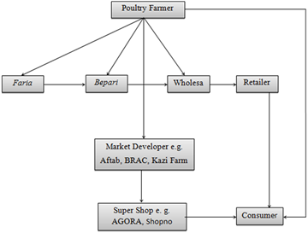
Fig 1: Organogram Of Ajoke Farms, Ilorin
CHAPTER THREE
POULTRY FARMING
Poultry Farming is raising of domestically or Commercially, primarily for meat and eggs but also for feathers, chickens, ducks and geese are of primary importance, While guinea fowl and squabs (young pigeon) are cheifly of local interest.
Classification of poetry animal/foul
- Broiler
- Layers
- Noilers
The above three set of poultry birds are either producing meat egg or both of them.
LAYER BIRD
Layers chickens are such a special species of hens, which need to be raised from when they are one day old. They start laying eggs commercially from 18-19weeks of age. They continue laying eggs continuously till their 73-88 weeks of age. They can produce about one leg of eggs by consuming about 2.5kg of food during their egg laying period.
According to the nature and color of the eggs layers hens are of two types; Short description of these two types are listed fellow.
WHITE EGG LAYING BIRD
This types of hen is comparatively smaller in Size. They eat less food and colour of the egg shell is white, havard white, Hi-line white, Bovanch white e.t.c are some popular white egg laying bird/chickens.
BROWN EGG LAYING HENS
Brown egg-laying hens are larger in size. They eat more food, compared to white egg layers, lay bigger eggs than other laying breeds. The shell is brown coloured. There are many types of brown layer available. Among those is a brown sever 579, Bablona Harko Havard brown e.t.c are very suitable for the commercial layer.
STEP INVOLVE IN SETTING OUT A LAYER FARM
- Location: The housing system is very important for rearing layers and effective keeping and management. As a new person to livestock business, you don’t want to invest all your capital into buying lands in an urban area which may turn out not being used because government policy is against setting up poultry farm near residential for health implication. Battery cage are best housing cages for laying birds because it creates comfort and stability for them.
- Setup Capital: With a location in Mind, you now have a clearer idea of the capital required of you. Write down your detailed capital and investment requirement For your farming in Nigeria venture and set out to source for it. Like every other farming project, the bigger you plan to start, the more investment required. You need to decide on the level of capital investments you are willing to commit to the business before starting.
- Get Chicks: Look for good hatchery where you can get healthy day-old chick to start with. Ensure they are well past and they are not mixed together with any species of day-old chick of layers bird request for.
- Feed and water management: You can buy feed from your local market or make the Feed at your own house. You can just make sure the one brought or made is enriched with protein and minerals which are very essential for laying hens.
- Give them at least 2%calcium for two weeks after birth.
- Feed them with starter feed for eight weeks.
- Serve them two or three times daily to their 18 weeks old
- Serve them layer poultry feed according to their age and weight.
- Don’t decrease increased while laying (even if their weight increases).
- Provide adequate water according to the demand of your laying hens. Supply cold water during hot weather and warm water in cold weather.
- Vaccination: This makes your hens disease assistance it helps to keep them free from infection and reduce the mortality rate. But before vaccination, take note that you don't need to vaccinate ill hen any more (separate ill birds to avoid spreading) and make sure vaccination equipment is washed with hot boiled water or antiseptic/germicide. Here are the vaccines that can be given to layers hens. Marex, Gambox, Salmonella e.t.c.
POULTRY EQUIPMENT
  - Battery chicken cage: this is one of the important equipment needed in rearing of layers. Battery cage provide them more comfortability and Suitability
  - Drinking equipment: This is also another equipment needed in poultry bird house for drinking. Water trough, bowl are commonly used.
  - Feeding equipment: Feeding trough are mostly essential to make them more satisfied with feeding themselves these equipment should be more than two in case there is need for change.
  - Manure cleaning equipment: In case they are in the day old level when they will still be feeding and walking around on a bedding material such as, sawdust, frequently changing of the bedding material should be done to avoid bad odor and dirty.
  - Lighting: at least 12 hours light should be provided for the birds for safety and feeding purpose.
  - Immunization Equipment: Vaccination equipment should be kept very well and safely.
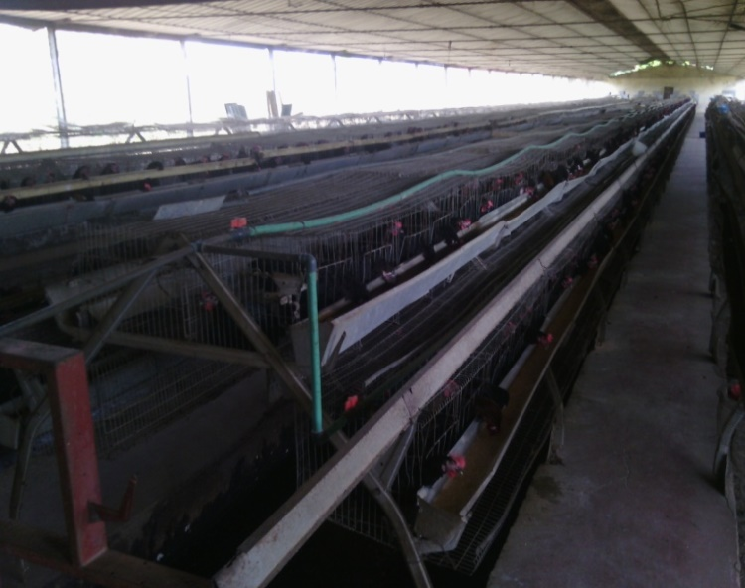
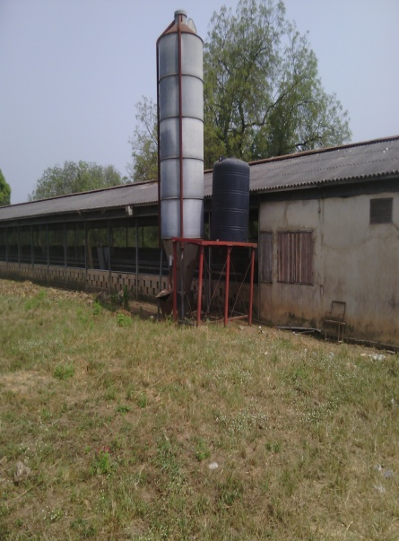

Fig 2: Battery Cage System Poultry
POULTRY HOUSE EQUIPMENT
- Water trough
- Feeding trough
- Shovel
- Broom
- LED lights
- Sawdust
- Water tank
- Create
- vaccine box
- Vaccine box
- syringe and needle
- Packer
- Foot dip
VACCINATION SCHEDULE FOR LAYERS
Age Name of Vaccine Date Route
5-7th days Lasota - 1/R
14-16days I.B.D - 1/0
24-26th day I.B.D (boster) - D/W
30th day Lasota (booster) - D/W
7th week Fowl Pox 0.2ml 1/M
9th week Deworming - -
10th week RCB 0.5ml 1/M
15th week Debeaking - D/W
17th Week Lasota - -
DAILY ROUTINE MANAGEMENT IN LAYER PEN
- Washing their feeding trough before giving them another.
- Washing their watering tank/trough and replace the water with new one
- Random check of the bed don’t know whether anyone of them is abnormal or ill
- Change their bedding material at least within 2 days
- Give them or add multivitamin to their feed or water to enhance their growth.

CHAPTER FOUR
4.0 ACTUAL WORK DONE AND EXPENRIENCE GAINED
The first day of my arrival into the Poultry Farm. It was an induction exercise. I was shared different sectors of department. The first week of resumption It was basically an induction week. I was exposed to different section of the department and various personnel. I was also shown the working environment comprises of various offices, toilets etc. And also the basic rules and regulations of the poultry farm.
The second week, I carried out some office duties like typing of document using the Microsoft word and excel I carried out cleaning routines of arrangement of files and errands for the manager.
The third week, I was taught some office ethic like attendance to work on time, good communication skills and appearance.
  - EXPERIENCE GAINED
- I gained a whole lot of experience at Ajoke Poultry farms. I was instructed to remain in the office clerk department. I performed duties like photocopies, scanning of document, recording of files reading data information.
- I also maintain and update filling, inventory, mailing and database system. Either manually or using a computer.
- I was assigned the duties of an administrative assistant, my duties are managing and distribution of information, sending and receiving correspondence, taking memos and maintaining files.
- I was posted to the Human Resource Department where I assisted in terms of planning and strategies management. I joined the workforce planning; we carried out recruitment, selection, orientation and exit process.
- I carried out training for new and old staffs, my involvement was in operating of the projector and errands.
- I was assigned the duties of a marketing assistant; I was under serious supervision and assisted to carry out duties of distributing financial and statistical information as budget spreads sheets, organizing and hosting presentation and customers visits.
- I was also in the department of digital marketing; we carried out the duty of co-coordinating all social media channel, media /website optimizations, marketing, reported and analyze results to improve performance using tools such as Google analytic

CHAPTER FIVE
5.1 SUMMARY OF ATTACHMENT ACTIVITIES
In all, I was able to carried out risk management, planning and strategic, management and also recruitment, selection and orientation process.
In conclusion, I worked in the entire department and carried out all my activities perfectly well.
5.2 SUGGESTIONS FOR IMPROVEMENT OF THE SCHEME
With a view to improving the student industrial work experience scheme, I suggest that the stakeholders in charge of the scheme should liaise with some companies and farms in the field of study of the courses offered in school such that students are sent to these companies for this program. This will help to reduce the length of time student spend in looking for placement.
5.3 PROBLEMS ENCOUNTERED
While giving kudos for the pros benefitted during the course of this program, I would also give some knocks as the programmed was without cons. The first issue I had was that I usually closed late. I couldn’t close the time I was expected to and there was nothing I could do about it.
The next was that there were no funds in the sense that the money I was getting from transport fare was not even enough compared to what I spend every day and this really affected me because I had to always rely on my parents for money every day.
Also, I was used as if I was a staff, I resumed when other staffs resume and I close even later than them. I did more work I was not even seen as a trainee but a worker so due to fatigue I almost fell off the Staircase.
5.4 SUMMARY, CONCLUSIONS AND RECOMMENDATIONS
SUMMARY
In summary, the student industrial work experience scheme program is very worthwhile one for students in the higher institui9tions. It bridges the gap between the theoretical knowledge impaired in me in school and the practical aspect of it.
The program also gave me an avenue to apply the prior knowledge I got from my lecturers in school in real life setting.
5.5 CONCLUSION
The student industrial work experience scheme was an educative and interesting one; it gave avenues for learning in all ramifications for me in the Organisation. The program exposed me to the relevance of self reliability
The four month SIWES program helped in making me achieve great things and has connected me with people of high substance, and lastly, the program is a welcomed idea and I strongly support that it should remain in the
5.6 RECOMMENDATION
- Industries should make sure well trained and experienced staffs are employed
- The industries should provide adequate facilities to make the program enjoyable and worthwhile for students.
- More so the industries should employ staffs that are read to prove their worth.

