
REPORT ON
STUDENT INDUSTRIAL WORK EXPERIENCE SCHEME (SIWES)

HELD AT;
TUNADEX VALUE CHAIN RESOURCES, 680 EKORO ROAD TOBAFEX COMPLEX VURGARIZER BUS-STOP ABULE EGBA, LAGOS STATE.

BY
ABDULRAZAK BARAKAT WURAOLA
ND/23/STA/FT/0049

SUBMITED TO
DEPARTMENT OF STATISTICS,
INSTITUTE OF APPLIED SCIENCES,
KWARA STATE POLYTECHNIC, ILORIN.

IN PARTIAL FULFILMENT OF THE REQUIREMENTS
FOR THE AWARD OF NATIONAL DIPLOMA (ND) IN STATISTICS.

August – November, 2024

DEDICATION
This report is dedicated to almighty God, the Supreme Being, the beneficent, the merciful, and the foundation of wisdom, knowledge and understanding to the prudent.

OUTLINE
Title Page 1
Dedication 2
Outline 3
Introduction to SIWES 4
Definition of SIWES 4
Aim and Objectives of SIWES 5
Introduction of Industrial Placement 5
Organization structure 6
Departments and their function 6
Statistical Work Done 7
Experiences Gained in the Industrial Place 9
Conclusion 10
Recommendation 11

INTRODUCTION TO SIWES
Student industrial work experience scheme (SIWES) was established by Industrial Training Fund (ITF) in 1973/1974 to solve the problem of lack of adequate practical skills preparatory for employment in industries by Nigerian graduate of tertiary institutions.
Prior to the establishment of the schemes, there was a concern among our institution of higher learning lacked practical background studies preparation for employment in the industries.
The student industrial work experience scheme (SIWES) is a skill training program designed to expose and prepare student of agriculture technology, environmental science, medical science and pure & applied science for the industrial work situation one is likely to meet after graduation.
The program was established with various coordinating agencies respect to each tertiary institution in the country. These agencies are:
- NBTE (National Broad for Technical Education)
- NUC (National University Commission) for University
- NCCE (National Commission of College of Education) for colleges of education.
DEFINITION OF SIWES
Student industrial work experience which is a program established by I.T.F (Industrial Training Fund) in 1976 to bridge the gap between theory and practical aspect of learning in a tertiary institutions in Nigeria.
SIWES was established in Nigeria to help student develop on their practical aspect of learning expose them to various techniques in the industry and also help them to know the ways of handling equipment and machineries.

AIM AND OBJECTIVES OF SIWES
The aim and objectives of SIWES are as follows;
- Provide an avenue for students in institution of higher learning to acquire industrial skills and experience in their approved courses of study.
- Prepare students for the industrial work situation which they are likely to meet after graduation.
- Expose students to work methods and techniques in handling equipment and machinery not available in their institution.
- Provide students which they are likely to meet after graduation.
- Expose students to work methods and techniques in handling equipment and machinery not available in their various institutions.

INTRODUCTION OF INDUSTRIAL PLACEMENT
TUNAdex Chain Resources Company, officially known as TUNAdex Global Venture, was established on September 29, 2017. It operates as a business specializing in manufacturers' representation, import, export, and general merchandise. The company is based at KM 261 Abeokuta Expressway, Ijaye-Ojokoro, Lagos, Nigeria. The registered proprietor of the company is Saheed Kareem Babatunde.
TUNADEX Nigeria Ltd, another branch of the company, specializes in the sale and supply of office stationery, office equipment, office furniture, and corporate gifts at wholesale prices. This branch is located at 1 Apostle Morakinyo Street, NNPC Bus Stop, Ejigbo Oke Afa Road, Isolo, Lagos​.
These business divisions indicate that TUNADEX is involved in both trade and corporate supply services, catering to various business needs across Nigeria.

ORGANIZATIONAL STRUCTURE

DEPARTMENT IN THE PLACEMENT AND THEIR FUNCTION
- Operations Department
- Manages logistics, supply chain, and inventory.
- Ensures smooth import/export and product distribution.

- Sales & Marketing Department
- Develops strategies to promote products and services.
- Handles customer acquisition and business growth.

- Finance & Accounts Department
- Manages financial transactions, budgeting, and reporting.
- Ensures financial compliance and profitability.

- Human Resources Department
- Oversees recruitment, staff training, and employee relations.
- Ensures compliance with labor laws and company policies.

- Customer Service & Support
- Handles client inquiries, complaints, and after-sales support.
- Ensures customer satisfaction and brand loyalty.

STATISTICAL WORK-DONE
Statistics can be said to be about collecting, organizing, summarizing, presenting and analysis of data and there are various method or techniques in which data can be analyze to make a valid and valid conclusion or interpretation of the analyzed data. During my stay at the TUNADEX, I was placed in the records department in which I input record in the system using MS Excel ad MS Word, and I was able to carry-out some statistical work.
Visa Applications Record – October (TUNADEX Chain Resources Company)
Date | Applicant Name | Visa Type | Country | Status
01-Oct-2024 | Applicant 1 | Business Visa | USA | Approved
03-Oct-2024 | Applicant 2 | Tourist Visa | UK | Pending
05-Oct-2024 | Applicant 3 | Work Visa | Canada | Approved
07-Oct-2024 | Applicant 4 | Work Visa | Canada | Approved
09-Oct-2024 | Applicant 5 | Student Visa | Australia | Rejected
10-Oct-2024 | Applicant 6 | Student Visa | Australia | Rejected
12-Oct-2024 | Applicant 7 | Business Visa | UAE | Approved
14-Oct-2024 | Applicant 8 | Business Visa | UAE | Approved
16-Oct-2024 | Applicant 9 | Tourist Visa | France | Pending
18-Oct-2024 | Applicant 10 | Work Visa | Germany | Approved
21-Oct-2024 | Applicant 11 | Work Visa | Germany | Approved
23-Oct-2024 | Applicant 12 | Student Visa | USA | Approved
25-Oct-2024 | Applicant 13 | Student Visa | USA | Approved
27-Oct-2024 | Applicant 14 | Business Visa | UK | Rejected
29-Oct-2024 | Applicant 15 | Business Visa | UK | Approved
30-Oct-2024 | Applicant 16 | Tourist Visa | Spain | Pending
31-Oct-2024 | Applicant 17 | Work Visa | South Africa | Approved
31-Oct-2024 | Applicant 18 | Student Visa | Italy | Approved
31-Oct-2024 | Applicant 19 | Work Visa | Japan | Rejected
31-Oct-2024 | Applicant 20 | Business Visa | Netherlands | Approved
Summary:
- Total Applications: 20
- Approved Visas: 11
- Pending Applications: 4
- Rejected Visas: 5

Out of 20 application for the month of October, 2024. 11 visas got approved, 4 are on pending while 5 was rejected and it is shown in the bar chart below.

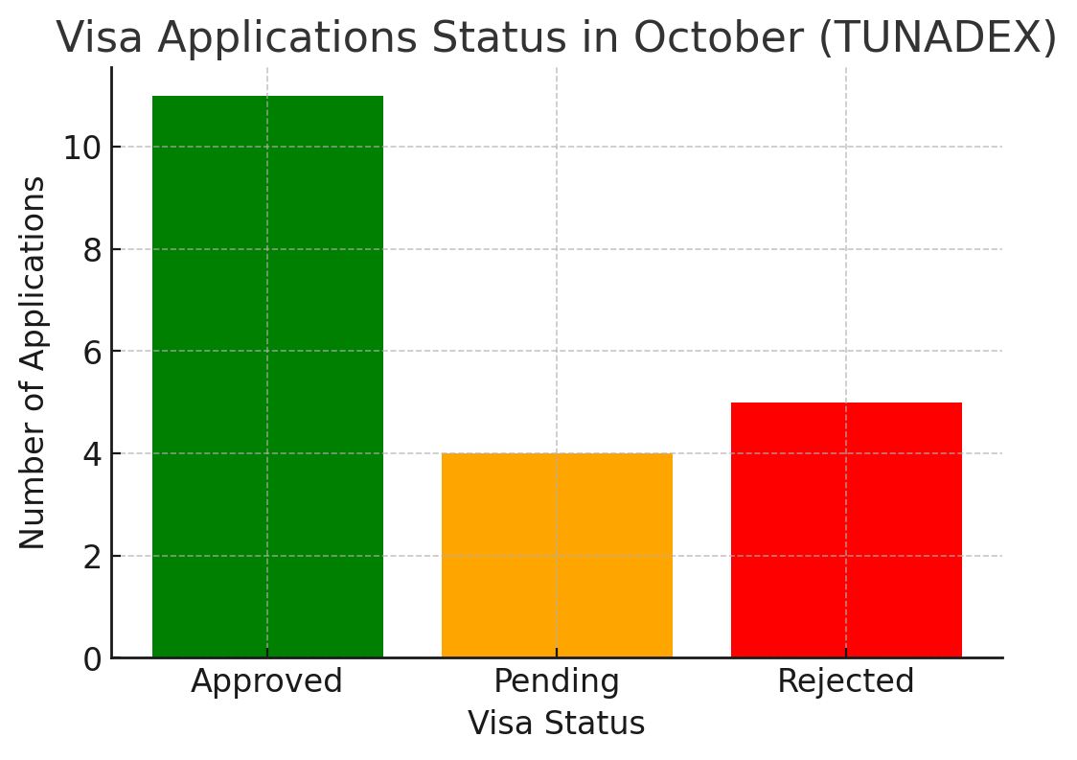

More explanation:
  - Approved Applications (11):
- The majority of visa applications were approved, indicating a high success rate.
- This suggests that most applicants met the visa requirements.
  - Pending Applications (4):
- A moderate number of applications are still under review.
- Further processing or additional documentation might be required.
  - Rejected Applications (5):
- Some applications were denied, likely due to incomplete documentation or failure to meet visa criteria.
- This highlights a need for better guidance and preparation for applicants.

EXPERIENCE GAINED IN SIWES PLACEMENT
Week 1: Introduction to the company staffs, the rules and regulation of the company.
Week 2: I was taught how to use MS Word and MS Excel.
Week 3: I assist in processing of visa application by collecting all necessary data and documents.
Week 4: I participated in a team meeting to discuss travel packages and pricing strategies.
Week 5: Field work: I did survey on how happy customer are with travel packages.
Week 6: I was taught how to draw table of records in Ms Excel, how to merge the lines, how to bold the records and how to add color.
Week 7: I obtained records of visas application (approved, pending and rejected visas) and it was recorded in a new created template in excel.
Week 8: I assisted in analyzing how long it takes to process visa applications
Week 9: I assisted in creating a summary of the processing time for international passport.
Week 10: I obtained records of visas application (approved, pending and rejected visas) and it was recorded in a new created template in excel.

CONCLUSION
After my stay at the SIWES placement, which I was placed in the records department in which I input the daily record in the system, and I was able to carry-out some statistical work by practical, I understand that solving the problem of skill acquisition by graduates of Nigerian technical / vocational education is a reason for the establishment of SIWES. It was planned to be a bridge between educational institutions and industrial employers with the latter providing general and specific occupational skills and knowledge. If the scheme is not adequately implemented it becomes difficult for graduates of the system to secure proper understanding of their choice of study and implementing into occupations or make smooth transition to the labor market world.
Incompetence in workplace is related to the kind or quality of training in the school. To improve on the scheme’s implementation students should be placed in industries relevant to their field s of study. There is need for greater cooperation between industries and educational institutions on how best to implement SIWES programme. It can thus be concluded that SIWES offers the students learning experiences which cannot be directly gained in the class room.

RECOMMENDATION
- All the institutions involved should be organizing orientation courses in collaboration with the ITF for their students prior to their attachment with the attendance made mandatory for the students accepted for SIWES and ITF staff.
- ITF should ensure the regular visitation of the ITF officers to supervising Agencies institutions, employers and students on attachment.
- ITF should be providing insurance cover to students on attachment and improve on paying students and supervisors allowances for motivation.
- The Banks should speed up their action at clearing of cheque issued to avoid unnecessary delay.

