
A TECHNICAL REPORT

STUDENT INDUSTRIAL WORK EXPERIENCE SCHEME (SIWES)

HELD AT

MIMI RESORT AND GARDEN LTD
No. 4, ACO Furniture Crescent Madalla, Abuja

PRESENTED BY

SANNI KHADIJAT ADBIODUN
MATRIC NO: ND/23/HMT/PT/0024

SUBMITTED TO THE

DEPARTMENT OF HOSPITALITY MANAGEMENT TECHNOLOGY
INSTITUTE OF APPLIED SCIENCES (IAS),
KWARA STATE POLYTECHNIC, ILORIN

IN PARTIAL FULFILLMENT OF THE REQUIREMENT OF AWARD OF NATIONAL DIPLOMA (ND) IN
HOSPITALITY MANAGEMENT TECHNOLOGY

SEPTEMBER – DECEMBER, 2024
DEDICATION
This report is dedicated to Almighty God, the embodiment of knowledge, wisdom and understanding.

ACKNOWLEDGEMENTS
Foremost, I am grateful to the most high for seeing me through this level of my SIWES report. I dedicate this work to Almighty God. He has been the wind beneath my wings. His grace, strength and mercy has brought me thus far and I am grateful.
My deepest appreciation and thanks go to my supervisor, Mr. Akeem for his guidance and tutelage and more importantly constructive criticisms that helped me to stay focused from the beginning of this work to the end.
I am equally grateful to all lecturers in the Department of Hospitality Management for their role in instilling in me the virtue of hard work.
I would remain externally indebted to my parent, benefactor, advisers friends and siblings for their love, concern and support.

TABLE OF CONTENTS
TITLE PAGE
DEDICATION II
ACKNOWLEDGEMENTS III
TABLE OF CONTENTS IV
CHAPTER ONE
1.1 Background of SIWES 1
1.2 Objective SIWES Programme 1
1.3 Philosophy of job specification for SIWES 2
CHAPTER TWO
2.0 Historical Background of the Company Organization of Attachment 3
2.2 Objectives of Establishment 3
2.3 Organization Structure 3
2.4 Department of the Establishment 4
2.5 Major Activities of the Organization Department 5
CHAPTER THREE
3.0 Section unit of the Organization and their specific function 5
CHAPTER THREE
3.0 Student Specific Involvement of the Various Section units 7
3.1 My Involvement at the Restaurant 7
3.3 My involvement at the Room Service 10
CHAPTER FOUR
4.0 Relevance of Experience Gained by Students in the front office 10
CHAPTER FIVE
5.1 Conclusion 13
5.2 My Advice 13
5.3 To the Polytechnic 13
5.4 Recommendation 13
CHAPTER ONE
1.0 BACKGROUND OF SIWES
SIWES was established by industrial training fund (ITF) in 1973 to solve the problem of lack of adequate practical skills in preparatory for employment in industries by Nigeria graduates of tertiary institutions.
The scheme exposes student to industry-based skill necessary for a smooth transition from the classroom to the world of work. It affords student of tertiary institutions the opportunity of being familiarized an exposed to the needed experience in handling machinery and equipment which are usually not available in the educational institutions.
Participation in SIWES has become a necessary precondition for the award of diploma and degree certificates in specific disciplines in most institutions of higher learning in the country in accordance with the educational policy of government.
OPERATORS: the ITF, the coordinating agencies (NUC, NCCE, NBTE) employers of labour and the institution funding. The federal government of Nigeria.
BENEFICIARIES: undergraduate students of the following: agriculture engineering technology, environmental science education, medical science and pure and applied science.
DURATION: four months for polytechnics and colleges of education, six months for the universities.
Highlight number of participating institutions
Universities = 59
Polytechnics = 85
Colleges of education = 62
Total = 206

1.2 OBJECTIVE OF SIWES PROGRAMME
The aims of this four month’s industrial training program undertaken in different places are states below:
- To exposed student into work methods and techniques in handling equipment and machinery that may not be available in the polytechnic.
- To develop in the student more skill in their various discipline as they actively participate in the activities on the site of their attachment.
- Prepare students for work situation they are likely to meet after graduation.
- To provide an avenue for student in Nigeria polytechnic to acquire industrial skills and experience in their course of study.
- To provide student the opportunity to apply their theoretical knowledge in real practical situation therefore bringing the existing gap.
1.3 PHILOSOPHY OF JOB SPECIFICATION FOR SIWES
It is essential to ensure the proper training of the polytechnics student in preparing them for the world so work, so as to facilitates the full realization of the objective of (SIWES) one important instrument for maintain uniformly high and consistent standards is the provision of polytechnics wide job specification for each programme.
Job specification is therefore, the breakdown of or packaging of a discipline into various tract elements, which would serve as a major guide not only for the student on industrial attachment but also for the industrialist.
The job specification involves the itemization of the tasks the polytechnics students are expected to perform while on industrial attachment the lines of the theoretical knowledge imparted in the classroom.

CHAPTER TWO
2.0 HISTORICAL BACKGROUND OF THE COMPANY ORGANIZATION OF ATTACHMENT
Location and brief history of establishment Mimi Resort and Garden Ltd; a purely Hospitality outfit located along Furniture Crescent, Madalla of Abuja was established about one and half (1^{1/2} ) decades ago.
The park sited on a serene environment covering about 2 hectares of land has functional facilities for recreation, events centre, rental services, restaurant, bar and accommodation
2.4 Department of the Establishment
Department of the Establishment and their functions various departments/units in the establishment are as listed below:
ORGANIZATION STRUCTURE
OPERATION MANAGER
FINANCIAL MANAGER
PLUMBER
ELECTRICIAN
SECURITY PERSONNEL
GARDENERS
CLEANERS
WAITERS
SECRETARY
MANAGING DIRECTOR
2.5 MAJOR ACTIVITIES OF THE ORGANIZATION DEPARTMENT
- Front Office: - the front office department deals with welcoming the guest and they also sell out the hotel accommodation.
- Food and Beverages Services: - The food and beverage section deal with production of food and services and provision of drinks and beverages to the guest.
- House Keeping Department: - The house keeping department deal with provision of accommodation, cleaning of room premises sweeping of the line clean and neat.
- Maintenance Department: - The department repair any faulty equipment and electronic in the hotel example is the engineer.
- Account Department: - This is in charge of the guest house incomes goals and take care proper record of the daily money or sales of the hotel.
- Administration Section: - The Administration sections take proper care of the staff welfare and employ new staff when needed.
CHAPTER THREE
3.0 STUDENT SPECIFIC INVOLVEMENT OF THE VARIOUS SECTION UNITS
The Department:
- RESTAURANT
- ROOM SERVICE
- BAR
As a Hospitality Management Student, I was posted to various units, in the guest house like the house keeping department, front office and food and beverages department.
I worked in the House Keeping and was taught the procedures for cleaning rooms how to lay beds and sweeping of the hotel premises.
I also worked in the food and beverages department, I worked at the bar where I was taught how to attend to different guest, served food and I also worked at the restaurant where I learnt how to use various equipment in the kitchen like the microwave machine, gas cooker, electrical stove, kerosene stove; I clean the kitchen and its surroundings.
I also worked with the laundry department where I washed the duve and bed sheet, pillow case, curtains with the washing machine and also drain it with the machine and then ironed it when due for ironing.
3.1 MY INVOLVEMENT AT THE RESTAURANT
3.1.1 Restaurant
Restaurant is a business which prepares and serves food and drinks to customers in exchange for money meals are generally served and eaten on the premises, but many restaurants also offer take-out or take-away and food delivery services and some offer only take-away and delivery when food is been order from the room is the waiter or waitress that will go and serve it, and they will be the one to collect the money from the guest.
The restaurant serves all the major meals such as, breakfast, lunch and dinner, when the waiter or waitress want to attend to the customer, he/she must go with the docket, where the items is been put down and they must know the price off hand.
- Serving high quality food and tasty will earn a restaurant a good reputation, causing customers to make return visits.
- It is very good to prepare meals using the best, high quality ingredients to ensure consistency, so that the customer can come back some other time
And the waiter/waitress must be responsible, honest, smart, well behave, record keeper, passionate, profitable thinking, systemized thinking.
You serve drinks by the right because wine glass cup is placed at the right-hand side on the table, you are also to serve the kids first and Host at the end which is the father. But in case of serving wine instead of water, it is necessary for the host to first of all have the taste of what you want to serve. i.e. when you bring the order (wine) show it to the guest to confirm whether that is what he ordered for, put it down on a table and open, remove the cook I mean the wine cover and place it on the side plate, put a little wine inside the wine glass cup and let the host have a taste, just to zeap after that you can serve the table round, but the host is to be serve at the end.

3.2 MY INVOLVEMENT AT THE ROOM SERVICE
Room service delivers food from the onsite restaurant to a guest’s room. Unlike other delivery services, the staff provides all dishes, cutlery and trays. This allows guests to enjoy their meals in bed or at the table. Room service also extends to alcoholic drinks. However, many hotels stock such beverages in the mini-fridge.

Why Do Guests Enjoy Room Service?
Room service is a convenience. It allows guests to eat in privacy or outside of regular restaurant hours. Most hotels take food orders throughout the day, accommodating late comers and early risers.
In many respects, room service also saves time. Guests can get ready in the morning while their food is prepared. This avoids restaurant waits and reduces the time between eating and starting the day.
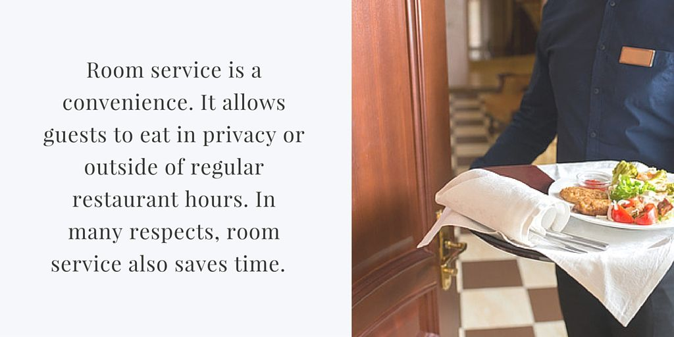

3.3.1 Why Hotel Should Offer Room Service
Room service can play a very important role in your guests’ experience at your hotel. Customers may seek out a hotel with room service out of necessity, for convenience, and even for a sense of luxury. Here are some reasons why room service may be essential for your guests.

3.3.2 Necessity
- Your hotel may be located in a remote area where accessing food 24 hours a day may be difficult.
- Guests may be traveling or working at odd hours, forcing them to depend on room service for meal options when other restaurants are closed.
- Some guests may feel unsafe venturing to find food at night on their own.
- International travelers may not feel comfortable enough with the language to order food from an outside establishment.
- Guests with disabilities may find it strenuous to go out to local restaurants.

3.3.3 Convenience
- Solo travelers may find it more comfortable to eat on their own within the privacy of their room.
- Business travelers are able to continue their work from their room without needing to pause and go out to eat.
- Guests who book meeting rooms may find it convenient to also have a food option delivered right to their meeting.
- Room service allows guests to receive food without having to wait for a table during a dinner rush.
- Guests won’t need to venture outdoors in inclement weather to locate food.
- Late comers and early risers are guaranteed access to a meal.
- Guests are able to save time by getting ready while a meal is being prepared and brought to them.
3.2 MY INVOLVEMENT AT THE KITCHEN DEPARTMENT
Kitchen is a room area or part of a room used for cooking and food preparation in a dwelling or in a commercial establishment when the food is been order from the restaurant, it will be prepare in the kitchen and when they are done with it, they with call to come and serve it to the customer.
And portion control is very important because it allows us to know and have a tight handle on how many calories you are presumably taking in. all the raw food and vegetable has its own measurement, before it been served to or cooked to the customer. It is there right to cook anything that is been order from the restaurant.
3.2.1 The Equipment in Kitchen
Cutting board, cast iron pan, stainless steel pots and pans, blender dutch oven, immersion blender, food processor, pressure cooker, microplane wooden spoon, rubber spatula, vegetable peeler, utensils and small wares.
More so, they posses good grooming and hygiene because grooming is one of the most important qualities of a kitchen department.
When working in the kitchen, one must cover his/her head must not put on jewelries, must not put on a high heel shoe and must be hygiene.

CHAPTER FOUR
3.3 MY INVOLVEMENT AT THE BAR DEPARTMENT
Bar is a place where drinks are been served, either in it original form cocktail or mocktail.
Cocktail: is the mixture of drinks with alcohol
Mocktail: is the mixture of drinks without alcohol. Normal and standard tots measures of alcohol is 2.5cl
There are two (2) classification of breweries;
- Nigeria Breweries 2. International Breweries
Including the coca-cola product and guiness product Nigeria breweries includes;
i. Goldberg ii. 33 beer
iii. Start beer iv. More
v. Life vi. Heineken
vii. Star lite viii. Maltina
ix. Gulder x. Power Horse
xi. Fayrouz xii. Climax
International Breweries Includes;
i. Trophy ii. Beta Malt iii. Grand Malt vi. Budweiser v. Eagle
Coca-cola Product;
i. Coke ii. Fanta iii. Sprit iv. Schweppess v. 5 Alive vi. Monster drink vii. Eva water
Guiness Product;
1. Star 2. Smirroff (ice) 3. Malta guiness 4. Origin 5. Harp
Equipment in the Bar
  - Chiller 2. Wine opener 3. Ice picker 4. Serving tray 5. Straw etc.

RELEVANCE OF EXPERIENCE GAINED BY STUDENTS IN THE FRONT OFFICE
- 4.0.1 The Front Office Department
- This is the unit department in the hotel that is concern with welcoming and receiving guest, they receive and welcome the guest checking and checking out, they also sell hotel rooms to the guest.
- The sections which consists the front office department are the reception, they also deal with advance reservation or booking of rooms and the conference hall and garden bar, they handle enquires or complain and provide information and so on. These are done by the receptionist.
- Therefore, reception section is considered as a centre of activities in the hotel, the efficiency and personality displayed by the receptionist is of permanent importance to the hotel because is the first person that will attend to the guest and the last person that will check the guest out. The reception have a direct contact with guest and also have any information concern about the hostel services.

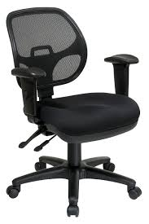
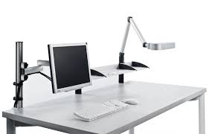
- Equipments in Front Office


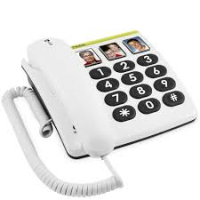
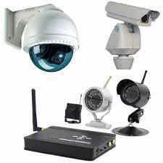
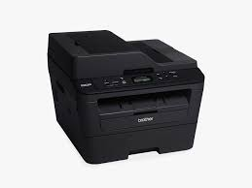

4.0.2 Quality of a Good Receptionist
1. Good Listening Skills: - Good receptionists listen closely as clients are talking so they can be efficient in solving their problems or answering their questions, the receptionist must be able to give the guest a good first impression.
2. Patience: - A good receptionist must be patience in carrying out his/her duty.
3. Tactfulness: - He/she must be able to get along with difficult guest, must be tolerant, diplomatic in handling guest etc.
4. Telephone Conversation: - A good receptionist must be able to handle telephone calls politely and must be able to operate the system due to the technology.
5. Manner: - A good receptionist must have to maintain personal hygiene, he/she must dress properly, neatness, the uniform must be well ironed in order to give the guest a good first impression.
4.0.3 Document Used in the Receptionist
1. Guest registration form
2. Tariff book
3. Daily chart
4. Bill form
5. Reservation book
6. Daily guest register
7. Monthly and daily file
8. Booking chart
9. Notice board
10. Cupboard/drawer

CHAPTER FIVE
5.1 CONCLUSION
My impressions about the Mimi Resort and Garden Ltd; have the necessary equipments which can aid easy learning and boost knowledge. The management is friendly; accommodative they give students the freedom to learn freely.
5.2 MY ADVICE
To the organization: - The hotel should please try to accept student who apply for SIWES programme.
5.3 TO THE POLYTECHNIC
The polytechnic should also guide student in choosing a standard hotel for their SIWES.
5.4 RECOMMENDATION
I hereby recommend students of Hospitality Management to carry out their Industrial Training Programme in Mimi Resort and Garden Ltd as they stand the chance to learning. The hotel helps them in achieve their aim with a good practical method rather than sitting in the class room always.

