
A TECHNICAL REPORT

STUDENT INDUSTRIAL WORK EXPERIENCE SCHEME (SIWES)

HELD AT

PRIMARY HEALTHCARE CENTER
3 Dispensary, Amukoko, Lagos State

WRITTEN BY
OGUNWUYI AYOMIDE ESTHER
ND/23/NAD/FT/0056

DEPARTMENT OF NUTRITION AND DIETETICS
INSTITUTE OF APPLIED SCIENCES (IAS),
KWARA STATE POLYTECHNIC, ILORIN

IN PARTIAL FULFILLMENT OF THE REQUIREMENT OF AWARD OF NATIONAL DIPLOMA (ND) IN
NUTRITION AND DIETETICS

SEPTEMBER – DECEMBER, 2024
DEDICATION
This report is dedicated to God Almighty, with whom all things are possible, who guide my life before during and after the SIWES.
Also to my dearest parent Ogunwuyi and my brother and sister for their support and moral towards the success of this program.

ACKNOWLEDGEMENTS
All honor and adoration belongs to God Almighty, the Author and Finisher of my soul for the grace given to me from the beginning and end of my SIWES. I return all glory to Him.
My profound gratitude goes to my lovely parent Ogunwuyi and my siblings for their support throughout the programme.
My appreciation also goes to my Head of Department (HOD) my supervisor & my replaceable lecturers.
And also to the Managing Director and staff of Pathology Department General Hospital Lagos.
Thank you all.

TABLE OF CONTENTS
TITLE PAGE
DEDICATION
ACKNOWLEDGEMENTS
TABLE OF CONTENTS
CHAPTER ONE
- Background of SIWES
1.1 Aim and Objectives of SIWES
1.2 Rules and Regulation of the Laboratory
CHAPTER TWO
2.0 Brief History of Primary Healthcare Center
2.1 Objective of the Establishment
2.2 Organogram of Primary Healthcare Center
CHAPTER THREE

3.0 Obstetric Examination

3.1 Preparation

3.2 General Inspection

3.3 Abdominal Inspection
CHAPTER FOUR

4.0 Care of the Mother and Newborn after Birth

4.1 Important issues to Discuss with Women and their Families, Immediately following Birth

4.2 Timing of Postnatal Visits

4.3 How to provide Information and Support for the Care of the Mother after Birth

4.4 Schedule of Postnatal Visits for Mother and Newborn

4.5 Sexuality Issues
CHAPTER FIVE
5.0 Summary and Recommendation and Conclusion
5.1 Summary
5.2 Conclusion
5.3 Recommendations
5.4 Problems Encountered during the Program

CHAPTER ONE
1.0 BACKGROUND OF SIWES
SIWES was established by industrial training fund (ITF) in 1973 to solve the problem of lack of adequate practical skills in preparatory for employment in industries by Nigeria graduates of tertiary institutions.
The scheme exposes student to industry based skill necessary for a smooth transition from the classroom to the world of work. It affords student of tertiary institutions the opportunity of being familiarized an exposed to the needed experience in handling machinery and equipment which are usually not available in the educational institutions.
Participation in SIWES has become a necessary precondition for the award of diploma and degree certificates in specific disciplines in most institutions of higher learning in the country in accordance with the educational policy of government.
OPERATORS: the ITF, the coordinating agencies (NUC, NCCE, NBTE) employers of labour and the institution funding the Federal Government of Nigeria.
BENEFICIARIES: undergraduate students of the following: agriculture engineering technology, environmental science education, medical science and pure and applied science.
DURATION: four months for polytechnics and colleges of education, six months for the universities.
Highlight number of participating institutions
Universities = 59
Polytechnics = 85
Colleges of education = 62
Total = 206
1.1 AIM AND OBJECTIVES OF SIWES
- To provides avenue for students to acquire industrial skill and experience in their approved course of study.
- To prepare students for their industrial work situation which are likely to meet after graduation.
- To bridge the identified gap and practice of engineering and technology in tertiary institutions.
- To expose student to working methods and techniques in handling equipment and machinery that may not be available in educational institution.
- To prepare student for employment in industries.
- Provide opportunity for students to apply their knowledge in real work situations bridging the gap between theory and practical.
1.2 RULES AND REGULATION OF THE LABORATORY
- Do not enter the laboratory without approval of the technologist.
- You must provide your own laboratory coat and you must wear it if you are in the laboratory.
- Except in an emergency, running or any over hurried activity should be forbidden in and around the laboratory.
- Additional protective equipment e.g. hand gloves, lightweight, mouth cover, cap, etc.
- All accidents should be report immediately.
- The laboratory must be keep clean and tidy all times.
- Do not use any equipment that appear faulty and repot unsafe equipment to the laboratory attendant.
- Reactions that produced off corrosive odour should be performing in the fume cupboard.
- Know the location of the nearest first aid box, firefighting equipment and fire alarm call point.
- No worker should ever eat, drink or smoke in the laboratory.

CHAPTER TWO
2.0 BRIEF HISTORY OF PRIMARY HEALTHCARE CENTER
Primary Healthcare Center – 3 Dispensary, Amukoko, Lagos State. The hospital is one of the several Healthcare Center in Lagos which is fully funded by Lagos State Government. It was established as a Primary Healthcare Center Hospital for the treatment of ill members of the society and its environment, it was one of the Primary Healthcare Center hospital in established by Lagos State Government.
2.1 OBJECTIVE OF THE ESTABLISHMENT
- To produce quality and effective drugs
- To save lives
- To foster and encourage a spirit of friendly cooperation among the members of the society and to promote favorable relatives between it and the medical, pharmaceutical hospital and related health professionals.

2.2 ORGANOGRAM OF PRIMARY HEALTH CARE CENTER
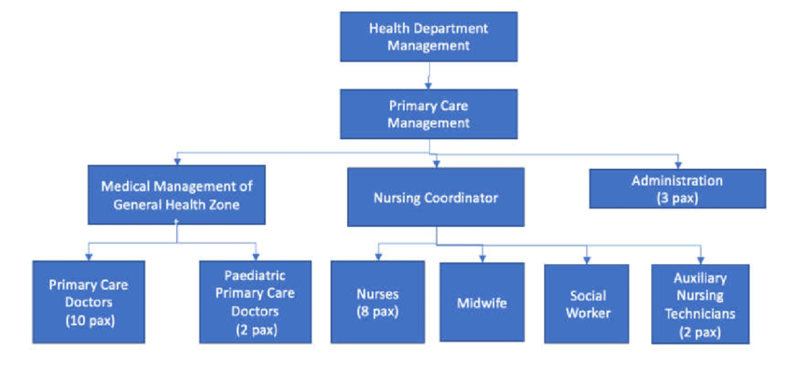

CHAPTER THREE

3.0 OBSTETRIC EXAMINATION
- Introduce yourself to the patient
- Wash your hands
- Explain to the patient what the examination involves and why it is necessary
- Obtain verbal consent

3.1 PREPARATION
- Measure the patient’s height and weight
  - In some of our Healthcare in Nigeria, this is performed at the booking appointment, and is not routinely recommended at subsequent visits
- Patient should have an empty bladder
- Expose the abdomen from the xiphisternum to the pubic symphysis
  - Cover above and below where appropriate
- Ask the patient to lie in the supine position with the head of the bed raised to 15 degrees
- Prepare your equipment: measuring tape, pinnard stethoscope or doppler transducer, ultrasound gel

3.2 GENERAL INSPECTION
- General wellbeing – at ease or distressed by physical pain.
- Hands – palpate the radial pulse.
- Head and neck – melasma, conjunctival pallor, jaundice, oedema.
- Legs and feet – calf swelling, oedema and varicose veins.

3.3 ABDOMINAL INSPECTION
In the obstetric examination, inspect the abdomen for:
- Distension compatible with pregnancy
- Fetal movement (>24 weeks)
- Surgical scars – previous Caesarean section, laproscopic port scars
- Skin changes indicative of pregnancy – linea nigra (dark vertical line from umbilicus to the pubis), striae gravidarum (‘stretch marks’), striae albicans (old, silvery-white striae)
Adapted from work by Indian Journal of Dermatology and James Heilman, MD [CC BY-SA 3.0], via Wikimedia Commons
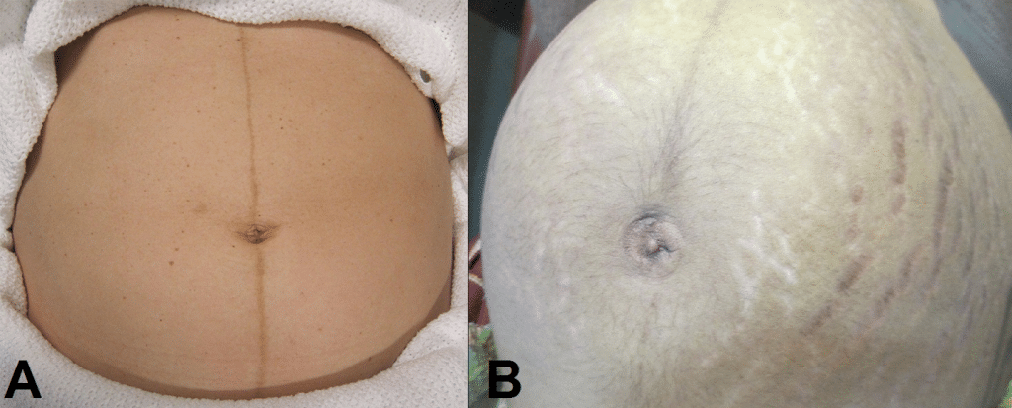
Fig. 1: – Skin changes in pregnancy. A) Linea nigra. B) Striae gravidarum and albicans.

Palpation
Ask the patient to comment on any tenderness and observe her facial and verbal responses throughout. Note any guarding.

Fundal Height
- Use the medial edge of the left hand to press down at the xiphisternum, working downwards to locate the fundus.
- Measure from here to the pubic symphysis in both cm and inches. Turn the measuring tape so that the numbers face the abdomen (to avoid bias in your measurements).
- Uterus should be palpable after 12 weeks, near the umbilicus at 20 weeks and near the xiphisternum at 36 weeks (these measurements are often slightly different if the woman is tall or short).
- The distance should be similar to gestational age in weeks (+/- 2 cm).

Lie
- Facing the patient’s head, place hands on either side of the top of the uterus and gently apply pressure
- Move the hands and palpate down the abdomen
- One side will feel fuller and firmer – this is the back. Fetal limbs may be palpable on the opposing side
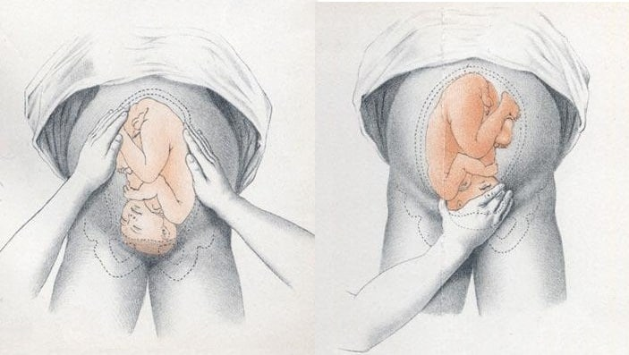
Fig. 2: – Assessing fetal lie and presentation.

Presentation
- Palpate the lower uterus (below the umbilicus) to find the presenting part.
- Firm and round signifies cephalic, soft and/or non-round suggests breech. If breech presentation is suspected, the fetal head can be often be palpated in the upper uterus.
- Ballot head by pushing it gently from one side to the other.

Liquor Volume
- Palpate and ballot fluid to approximate volume to determine if there is oligohydraminos/polyhydramnios
- When assessing the lie, only feeling fetal parts on deep palpation suggests large amounts of fluid

Engagement
- Fetal engagement refers to whether the presenting part has entered the bony pelvis
- Note how much of the head is palpable – if the entire head is palpable, the fetus is unengaged.
- Engagement is measured in 1/5s
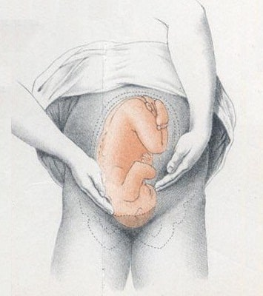
Fig. 3: – Assessing fetal engagement.

Fetal Auscultation
- Locate the back of the fetus to listen for the fetal heart, aim to put your instrument between the fetal scapulae to aim toward the heart.
  - Hand-held Doppler machine >16 weeks (trying before this gestation often leads to anxiety if the heart cannot be auscultated).
  - Pinard stethoscope over the anterior shoulder >28 weeks
- Feel the mother’s pulse at the same time
- Measure fetal HR for one minute
  - Should be 110-160bpm (>24 weeks)
CHAPTER FOUR

4.0 CARE OF THE MOTHER AND NEWBORN AFTER BIRTH
Some women will give birth in the home with a skilled attendant; others may not have a skilled attendant present. Some women who give birth in the facility will spend time there following childbirth. WHO recommends that a women not be discharged before 24 hours after birth. Regardless of the place of birth, it is important that someone accompanies the woman and newborn for the first 24 hours after birth to respond to any changes in her or her baby's condition. Many complications can occur in the first 24 hours. Following childbirth at home, it is important that the mother and baby receive a postnatal examination as early as possible, preferably within 24 hours of birth. If the birth was at a facility, mother and baby should receive a postnatal examination before discharge.
There are a number of important points to discuss with the woman and her family following birth to ensure that the woman has adequate care. See the WHO PCPNC for additional information.

4.1 IMPORTANT ISSUES TO DISCUSS WITH WOMEN AND THEIR FAMILIES, IMMEDIATELY FOLLOWING BIRTH
- The importance of having someone nearby for the first 24 hours.
- The importance and recommended timing of postnatal visits.
- The importance of the new mother eating more and healthier foods – discuss in the context of local practices and taboos to ensure women have access to good nutrition. The new mother should also drink plenty of clean, safe water.
- The importance of rest and sleep and the need to avoid hard physical labour.
- Discussion of normal postpartum bleeding and lochia – discuss with women how much blood loss they can expect, for how long. When bleeding is more than normal, they should seek care urgently.
- Discuss the danger signs for the woman and baby and the importance of seeking help quickly.
- Personal hygiene in the context of local practices and the environment. Discuss with women the type of pads they will use and their disposal, and care of episiotomy in the context of home conditions. Hand washing is particularly important to prevent infections. It is also important not to insert anything into the vagina.
- Talk to them about when they can resume sexual relations and the importance of condom use to prevent STI and HIV transmission. Sexual intercourse should be avoided until the perineal wound heals. Discuss the importance of birth spacing and counsel on the use of a family planning method.
- Discuss infant feeding and breast care and the importance of only taking prescribed medicines when breastfeeding.
- Discuss the importance of the home environment for promoting the health of the baby and recovery of the mother. For example, discuss the need for warmth, good ventilation and hygiene for both mother and baby.
- In an area with malaria, discuss the importance of mother and baby sleeping under an insecticide-treated bednet.

4.2 TIMING OF POSTNATAL VISITS
Following childbirth the woman and newborn should be examined within 24 hours by a health worker. At this time also discuss with the woman and family the timing of subsequent visits and the immunization schedule for the baby. WHO recommends that the mother and baby be visited at home by a trained health worker, preferably within the first week after birth. If your facility does not carry out home visits, discuss with the mother how she will come to the facility or local clinic for these scheduled visits. These visits early in the postnatal period are important for the mother and baby. It is also an important opportunity to ensure the establishment of breastfeeding and address any difficulties with attachment and positioning.

4.3 HOW TO PROVIDE INFORMATION AND SUPPORT FOR THE CARE OF THE MOTHER AFTER BIRTH
The PCPNC provides a list of practical tasks that need to be carried out following birth, if you do not have the PCPNC you should follow the norms and standards established in your facility. Explain the reasons behind the tasks you are carrying out and discuss with the woman any advice or recommendations you have for her to ensure appropriate care in the home during the postnatal period (refer to the points above). Encourage her to ask questions during the examination and use your active listening skills to reflect on and clarify what she is telling you. Help her to think of ways she can implement your advice. Sometimes, when women are unsure or hesitant they voice concerns in an indirect manner rather than directly raising an issue. Be aware of her body language and the non-verbal signs she may be showing you. Repeat back to her in different words what you think she is saying to see if you have understood.

4.4 SCHEDULE OF POSTNATAL VISITS FOR MOTHER AND NEWBORN
- First visit (could be a home visit) | within 1 week, preferably on day 3
- Second visit | 7-14 days after birth
- Third visit | 4-6 weeks after birth
Explain Subsequent Immunisation Schedule

4.5 SEXUALITY ISSUES
These visits are a good time to discuss sexuality issues. Often the woman will come to see you or be on her own at home with the baby. This can give you more privacy to discuss topics about which she may feel ‘shy’. The timing of when a couple resume sexual relations after childbirth is often guided by local sexual practices. Different communities and religious groups have different suggested periods of abstinence after childbirth. It would be useful to be aware of this and to be respectful of these practices. A woman is often embarrassed to ask when she can resume intercourse and may already be pressured by her husband or partner. In some cases, the partner may have had sexual intercourse outside the relationship during the period of abstinence following childbirth and hence the woman may be at risk of contracting STIs and HIV.
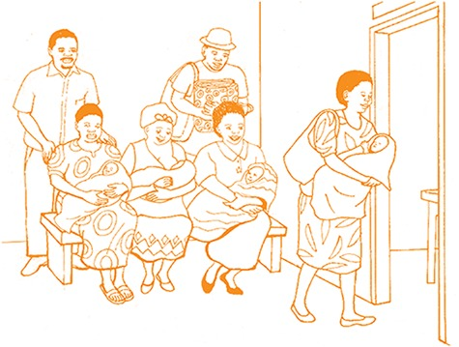

Fig. 4: Make women aware that a health worker may come for a home visit for postnatal care three days after birth
Encourage women to return to the health facility with their newborn babies for routine health checks or if any danger signs are present

CHAPTER FIVE
5.0 SUMMARY, CONCLUSION AND RECOMMENDATIONS
5.1 SUMMARY
Having passed through my four months of Industrial Training at Primary Healthcare Center – 3 Dispensary, Amukoko, Lagos State. One could see that thousands of souls have lost due to lack of knowledge, beliefs, unhygienic and superstition.
As a student that had undergo the Industrial Training mainly on Primary Healthcare Center which had a lot of experiences and knowledge concerning pregnant woman and childcare, I therefore conclude that, primary healthcare center help in saving lives in the whole world.
Moreso, I wish to state here that this training has been a memorable one for me.
5.2 CONCLUSION
The Training is a great privilege for student to know more about his course and also know practically the handing of the practical aspects of his course.
5.3 RECOMMENDATIONS
I want to appeal to the SIWES directorates that they should include transport allowance so that people that are coming for this program will be motivated.
The school can go into agreement with well known industry to take care SIWES student to avoid delayed placement
5.4 PROBLEMS ENCOUNTERED DURING THE PROGRAM
Few problems were encountered during the program this includes: Financial Problem.

