
A TECHNICAL REPORT

STUDENT INDUSTRIAL WORK EXPERIENCE SCHEME (SIWES)

HELD AT

DELRAM CONSTRUCTION COMPANY
N0. 3, MUAZU MOHAMMED ROAD, MINNA.

WRITTEN BY
SHAIBU ASETU AFUSAT
ND/23/BAM/PT/0208

SUBMITTED TO THE

DEPARTMENT OF BUSINESS ADMINISTRATION
INSTITUTE OF FINANCE AND MANAGEMENT STUDIES,
KWARA STATE POLYTECHNIC, ILORIN

AUGUST - NOVEMBER, 2024
DEDICATION
This report is dedicated to Almighty Allah, the Creator of whole universe who has bestowed His infinite mercy and wisdom upon to successfully accomplish of this great academic work.

ACKNOWLEDGEMENTS
All acknowledgement goes to my Allah because without Him, it would have been hard for me to be among the participant of this opportunity, He gave me strength, heart of concentration, stable memory, love, throughout the training praise and adoration back to Him.
Also using this great opportunity to thank my lovely parent Mr. and Mrs. Shaibu for their great support, love and understanding, because if not for them I would have be a victim of those people that are not educated, I want to say thank you.
My appreciation goes to my institute director for making this to happen and also thanking them for the good record that they are given to this institute, God bless you all.
Also I want to appreciate and thank you all staff in Delram Construction Company for your love and great support during the time I spent with you, thank you all.
TABLE OF CONTENTS
TITLE PAGE
DEDICATION
ACKNOWLEDGEMENTS
TABLE OF CONTENTS
CHAPTER ONE
1.0 Background of SIWES
1.1 Aim and Objectives of SIWES
1.2 Introduction to Chemical Laboratory
1.3 Rules and Regulation of the Laboratory
CHAPTER TWO
2.0 Brief History of Delram Construction Company Nigeria Limited
CHAPTER THREE
3.0 Introduction to Production Sector
Directives-Driven Production
Product Development Process
CHAPTER FOUR
4.0 Construction vs Manufacturing Supply Chains
Two Part Implementation Strategy
CHAPTER FIVE
5.0 Summary
5.1 Conclusion
5.3 Recommendations

CHAPTER ONE
1.0 BACKGROUND OF SIWES
SIWES was established by industrial training fund (ITF) in 1973 to solve the problem of lack of adequate practical skills in preparatory for employment in industries by Nigeria graduates of tertiary institutions.
The scheme exposes student to industry based skill necessary for a smooth transition from the classroom to the world of work. It affords student of tertiary institutions the opportunity of being familiarized an exposed to the needed experience in handling machinery and equipment which are usually not available in the educational institutions.
Participation in SIWES has become a necessary precondition for the award of diploma and degree certificates in specific disciplines in most institutions of higher learning in the country in accordance with the educational policy of government.
OPERATORS: the ITF, the coordinating agencies (NUC, NCCE, NBTE) employers of labour and the institution funding the Federal Government of Nigeria.
BENEFICIARIES: undergraduate students of the following: agriculture engineering technology, environmental science education, medical science and pure and applied science.
DURATION: four months for polytechnics and colleges of education, six months for the universities.
Highlight number of participating institutions
Universities = 59
Polytechnics = 85
Colleges of education = 62
Total = 206

1.1 AIM AND OBJECTIVES OF SIWES
- To provides avenue for students to acquire industrial skill and experience in their approved course of study.
- To prepare students for their industrial work situation which are likely to meet after graduation.
- To bridge the identified gap and practice of engineering and technology in tertiary institutions.
- To expose student to working methods and techniques in handling equipment and machinery that may not be available in educational institution.
- To prepare student for employment in industries.
- Provide opportunity for students to apply their knowledge in real work situations bridging the gap between theory and practical.

CHAPTER TWO
2.0 BRIEF HISTORY OF DELRAM CONSTRUCTION COMPANY NIGERIA LIMITED
Delram Construction Company Nigeria Limited was incorporated in MINNA, Nigeria with Registration Number 778349. It was registered on 13 Oct 2008 and it's current status is unknown. Company's registered office address is No.5, Zarumai Road, Minna, Minna. The company started its manufacturing operations in 1997 with a few nail cutting machines at a noble location on No.5, Zarumai Road, Ilorin with three members of staff as operators. At the inception, the incumbent Vice Chairman/CEO, Musa Saidu Kolo and Jonathan Salau Kolo was the company’s Engineer. From its humble beginning as a manufacturing company, Delram Construction Company has grown into one of the largest privately owned steel production company in Nigeria. Subsequently, company added new products profiles such as Black and Galvanized EM8, EM10, A142, PP packaging such as woven sacks, shopping bags and Nylons. Delram Construction Company (Nigeria) Limited is the only 100% indigenous steel and allied manufacturing company in Nigeria.
In 2011, the company established its First Hot Deep Galvanizing Line of 36,000mtpa for galvanized roofing sheets accompanied with a Colour Coating Line of 50 RPM for coloured and aluminium roofing sheets complete with all the facilities of Profile Forming and Cut to Length machines. The following year, Delram Construction Company commenced the construction of the Phase II of an Ultra Modern Steel Cold Rolling Mill Complex of 150,000mtpa comprise of 6-High Reversing Cold Rolling Mill, Push-pull Pickling Line, CNC Roll Grinding, Rewinding Line, 2 Ultra Modern Galvanizing Lines of 120 RPM, Cut to Length, Corrugating Station, Water Complex etc.
In 2014, the 150,000mtpa capacity Cold Roll Steel Mill Complex was completed as designed producing finished products for Roofing, Headpans, Shovels, and Trowels etc. The company completed installation of production line for Gerrard and Shyingle Stone Coated Roofing Sheets. The product is for Premium High End Roofing Sheets.
Company commenced exploration activities towards the construction and development of world class 1.5million MTPA Integrated Liquid Steel Complex in Oshokoshoko, Kogi State, Nigeria. Relevant permits for mines exploration have been obtained. All necessary laboratory analysis are currently on-going in Australia and Bureau Veritas laboratories, Canada in line with global rated JORC standard. EPC contractor has been secured. Funding arrangement is in progress. Completion of the integrated Mill is scheduled for December 2018.

CHAPTER THREE
3.0 INTRODUCTION TO PRODUCTION SECTOR
In a construction company, the "production sector" refers to the department responsible for the on-site execution of a construction project, encompassing all activities involved in transforming raw materials into a finished structure, including site preparation, excavation, foundation laying, framing, installation of utilities, finishing work, and final inspections, essentially managing the entire building process to deliver the project on time and within budget; it involves coordinating labor, materials, equipment, and subcontractors to ensure smooth operations on the construction site.
Key aspects of the production sector in construction:
- Planning and Scheduling:
Creating detailed project plans with timelines for each construction phase, including task sequencing and resource allocation.
- Site Management:
Overseeing daily operations on the construction site, ensuring compliance with safety regulations, quality standards, and project specifications.
- Material Management:
Managing the procurement, delivery, and storage of construction materials to avoid delays and waste.
- Labor Management:
Coordinating the work of different trade contractors and ensuring adequate skilled labor is available for each task.
- Equipment Management:
Maintaining and utilizing construction equipment efficiently.

- Quality Control:
Implementing quality checks throughout the construction process to ensure adherence to design standards. Important points to remember about the production sector:
- Interdependence with other departments:
The production sector heavily relies on input from design, engineering, and procurement teams to ensure project details are accurate and materials are readily available.
- Focus on efficiency:
The goal is to optimize resource utilization and minimize delays to achieve project goals within budget and time constraints.
- Lean construction principles:
Many construction companies adopt lean practices to streamline workflows, reduce waste, and improve overall productivity.
TYPES OF MANUFACTURING
There are at least three different ways to categorize types of manufacturing. The first uses product mix and process pattern as variables in a rectangular coordinate system with projects, job shops, batch flow, line flow and continuous flow as types along the diagonal (Figure 1). In this categorization, construction belongs to the project type and is characterized by a “very jumbled flow; process segments loosely linked” and also by the relative uniqueness of its product.
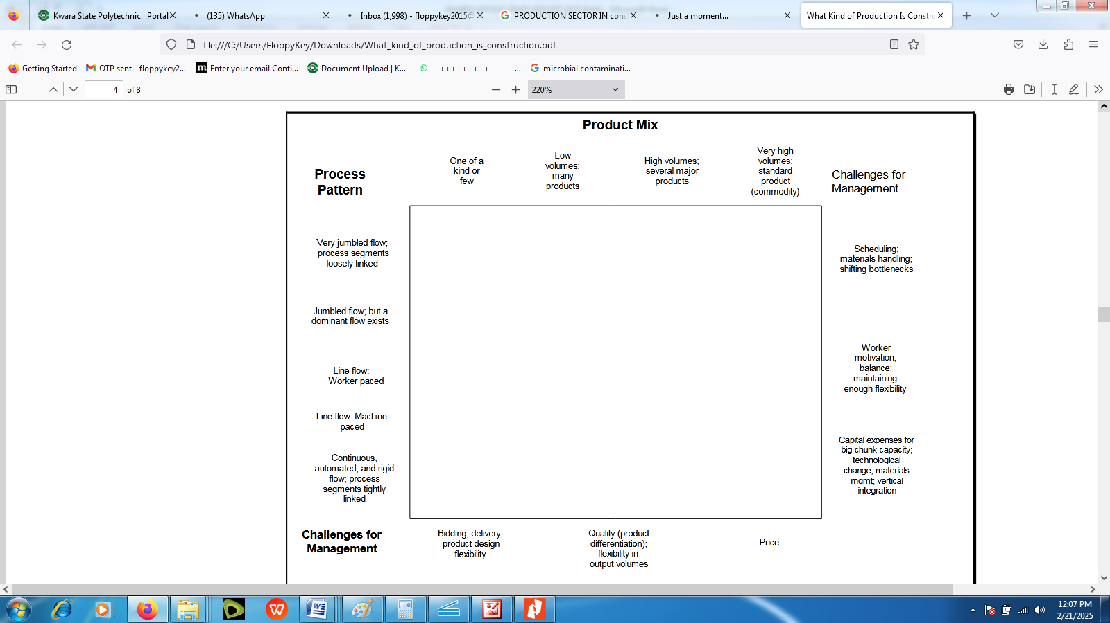
Fig. 1: Types of Production
A second method differentiates types of manufacturing in terms of the primary determinant of flow through the process. Factories that produce one or a few products have flows designed specifically for those products. A paper machine is a prime example and obviously is very inflexible. It would be difficult and perhaps economically impossible to adapt a paper machine to produce cans or bottles. Indeed, paper machines are designed to produce specific types of paper; e.g., linerboard, newsprint, or fine paper. By contrast, process-based flow would be found in factories organized to perform certain types of operations (grinding, milling, boring, etc.) on many different products. The third type identified by this method is fixed position manufacturing, in which the product being manufactured eventually becomes too large to be moved through work stations, so the work stations (work crews) have to move through the product.
Construction, ship building, and airplane manufacturing belong in this category. Unfortunately, there appears to be little written on fixed position manufacturing.
Types of manufacturing are also sometimes categorized as extraction, fabrication or assembly; i.e., collecting materials, shaping materials, or joining materials together. Job shops and batch flow shops tend to be fabricators, while line flow and continuous flow shops tend to be assemblers, although the alignment of these different typologies is far from perfect.
DIRECTIVES-DRIVEN PRODUCTION
Yet a fourth categorization might be useful; i.e., the division of production types between those in which flow is governed primarily by the alignment of machines and those in which flow is governed primarily by directives. This distinction somewhat parallels that made between product and process-based flows. However, construction poses some subtleties. Construction operations can be conceived in terms of assembly chains; e.g., excavate-form-rebar-pour-cure-strip-finish-backfill. In tightly coupled assembly chains, the work to be done by the next work station (e.g., rodbusters) is released to them by the upstream work station. They have little or no discretion about what work to do next.
However, not all assembly chains are tightly coupled. Consider the relationship between installing piping and electrical materials in a unit of an industrial plant. The completion of piping work in a subarea can be deemed to release that subarea to the electricians, but the sequence of electrical work in that subarea is not predetermined simply by that release.
One might argue that rod busters also can decide on which end of a trench to begin installing rebar, but the typical sizing of rebar releases requires that all the rebar for that trench be on hand when installation begins. That is not the case for the electrical work because the size of its releases is usually greater and because there is less structural integrity of the electrical installation itself as opposed to the rebar.

PRODUCT DEVELOPMENT PROCESS
We have long advocated that construction look to manufacturing’s product development process rather than to the factory for its inspiration and analogies. An automobile manufacturer does not only make cars, it also designs them. Product development begins with a decision to modify an existing model or create an entirely new one. It ends when factory production begins. This exactly parallels the scope of industrial construction. When Chevron decides to upgrade or expand a refinery, the ‘construction’ process begins. When ‘construction’ ends, the upgraded/expanded refinery is ready to go into production. So, far from construction being like factory production, it is actually parallel to product development. Admittedly, this is a best fit for industrial construction, whose customers are themselves manufacturers. However, it works also for the building and infrastructure sectors. Indeed, lean production itself is best conceived as including lean design and lean supply, and perhaps the lean enterprise as well.

CHAPTER FOUR
4.0 CONSTRUCTION VS MANUFACTURING SUPPLY CHAINS
Think of supply chains as concentric rings (Figure 2), in which raw material suppliers occupy the outer ring, fabricators occupy the middle ring, and the designer-constructor occupies the innermost ring. When you use 30% (and perhaps as little as 10%) of a raw material supplier’s output, you can influence his product specifications, product delivery, and product price. With the possible exception of the very largest construction companies, none occupy such a position with any of their raw materials suppliers, those who produce lumber, steel, cement, or aggregate, not to mention trees, iron ore, or rubber.
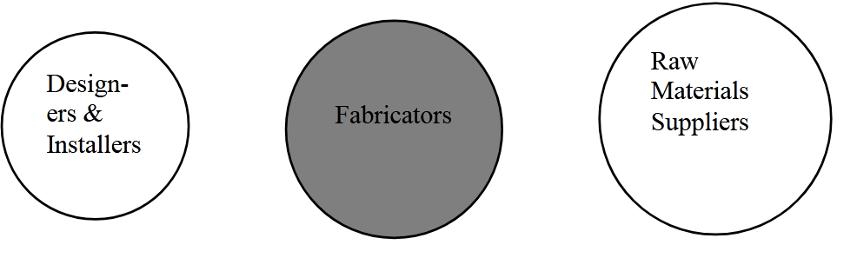
Figure 2: Supplier Integration
TWO PART IMPLEMENTATION STRATEGY
What kind of production is construction? In summary, construction is essentially the design and assembly of objects fixed-in-place, and consequently possesses, more or less, the characteristics of site production, unique product, and temporary teams. Making construction lean has at least two parts: (1) Claiming from construction what actually belongs to contemporary product manufacturing and minimizing construction’s peculiarities in order to take advantage of lean techniques developed in manufacturing, and (2) Developing lean techniques adequate to dynamic construction, the remainder that resists the first approach. A shared challenge for both is coordination of the specialist installers who occupy the front line, and through whom engineering and fabrication expertise is best applied.

CHAPTER FIVE
5.0 SUMMARY
In a period of my fifteen (15) weeks spent in Delram Construction Company Nigeria Limited, I will say the programme has really exposed me to various aspects of laboratory activities such as maintaining a wearing laboratory machine. Also, I was exposed to the area of experimental analysis and suspection control.
I also leant about the maintenance and operation of various scientific instruments as related to the construction aspect of company.
The fifteen (15) week training programme has also enable me to correlate the theoretical experience I learnt from school to the practical knowledge I just acquired during the period of attachment.
5.1 CONCLUSION
In any manufacturing company there must be A.Q.C department is the heart beat of the manufacturing company that produces product.
- They are after quality not a quantity.
- They monitor and correct error in a company.
- They carryout analysis of a raw materials granules, finished product and prepare chemicals.
- They carryout different types of test on each products e.g. moisture content test, weight variation.
Student Industrial Work Experience Scheme is a vital opportunity from which student should be able to utilize this great chance given to them in order to prepare themselves for the future challenges and more practical in their various field.
5.3 RECOMMENDATIONS
The Student Industrial Work Experience Scheme (SIWES) is a perfect scheme already. The scheme has been planned perfectly alright but my few recommendations include:
The purpose of the scheme should not merely be for acquiring knowledge only but also, to develop personal attribute and behavior so as to undertake the responsibility of preparing student for life outside school.
To provide a forum for student taking part in the scheme, to participate in various seminar and workshop so as to broaden their understanding. This forum will also serve as an avenue for student to file complaints on difficulties they might be facing.
Finally, the scheme should improve on their supervisory role like every month’s supervision of each of their establishment and pay the appropriate allowance for the student at the end of the programme.

