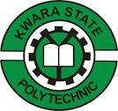

A TECHNICAL REPORT
ON
STUDENT INDUSTRIAL WORK EXPERIENCE SCHEME (SIWES)
UNDERTAKEN AT
MARK POLY INDUSTRIES LTD
NEW SITE, DADA CHURCH, OBASANJO ROAD, OTA, OGUN STATE

BY

ABDULROHEEM ROKIBAT OLADEJI
ND/23/STA/FT/0081

SUBMITTED TO THE DEPARTMENT OF STATISTICS,
INSTITUTE OF APPLIED SCIENCES,
KWARA STATE POLYTECHNIC, ILORIN
IN PARTIAL FULFILLMENT OF THE REQUIREMENTS FOR THE AWARD OF NATIONAL DIPLOMA IN STATISTICS
2024-2025 Academic Session
DEDICATION
This report is dedicated to Almighty God for its successful completion.

Acknowledgements
Foremost, special thanks go to Almighty God for the successful completion of this report.
My appreciation goes to the Management of Kwara State Polytechnic who had given me the privilege to have gone for this programme.
Lastly, my appreciation goes to all those who had been supportive in one way or the other.
Thanks to you all!

TABLE OF CONTENTS
Title page i
Dedication ii
Acknowledgements iii
Table of Contents iv
CHAPTER ONE
1.1 Background of SIWES 1
1.2 Objectives of SIWES 2
CHAPTER TWO
2.1 Company Profile 4
2.2 Organizational Structure 5
CHAPTER THREE
3.1 Work Done During SIWES 6
3.2 Skills Acquired During SIWES 7
CHAPTER FOUR
4.1 Challenges Faced During the Programme 10
CHAPTER FIVE
5.1 Conclusion 12
5.2 Recommendations 12

CHAPTER ONE
1.1 Background of SIWES
The Student Industrial Work Experience Scheme (SIWES) was established in 1973 to bridge the gap between theoretical classroom learning and real-world industrial practices. Before its introduction, many graduates faced difficulties in securing employment due to their lack of practical experience. The scheme was designed to expose students to hands-on training in industries related to their field of study, enabling them to apply theoretical knowledge in real work environments.
SIWES was initiated by the Industrial Training Fund (ITF) to address skill deficiencies among graduates of technical, engineering, and science-related courses in Nigeria. Over time, the program has expanded to include students from other disciplines such as business administration and mass communication. This initiative ensures that students acquire the necessary industrial exposure and professional competence required to excel in their chosen careers.
A key objective of SIWES is to familiarize students with modern technologies and industrial operations that may not be covered within their school curriculum. By participating in this program, students develop essential workplace skills such as problem-solving, teamwork, communication, and adaptability. These skills not only prepare them for the workforce but also boost their confidence in handling real-world challenges.
Beyond benefiting students, SIWES also strengthens the relationship between academic institutions and industries. Many companies use this scheme as an opportunity to train and evaluate potential employees, thereby reducing recruitment costs. Additionally, organizations contribute to the educational system by providing mentorship, structured training programs, and a conducive learning environment for students.
The collaboration between industries and higher institutions through SIWES ensures that students are trained in line with current industry standards. As industries evolve with advancements in technology, this partnership helps to keep academic curricula relevant to market needs. This reduces the gap between theoretical learning and practical applications, making graduates more employable.
Moreover, SIWES is a vital program that enhances students' practical competence and employability. Since its establishment in 1973, it has played a crucial role in preparing students for the labor market by equipping them with relevant industrial skills and experience. Through this program, students gain valuable exposure, develop professional networks, and become well-prepared to contribute to national development.
1.2 Objectives of SIWES
The Student Industrial Work Experience Scheme (SIWES) was established with the primary goal of bridging the gap between classroom learning and practical industrial experience. It aims to equip students with relevant skills and knowledge that will enhance their technical competence and prepare them for future employment. The objectives of SIWES include the following:
- Exposure to Industrial Work Environment: One of the key objectives of SIWES is to provide students with firsthand experience in a real work setting.
- Skill Development and Competence Building: SIWES helps students acquire and develop practical skills that are necessary for their professional careers.
- Enhancement of Employability: The program is designed to make students more employable by providing them with relevant industry experience.
- Familiarization with Modern Technology and Equipment: Industries are constantly evolving with new technologies and innovations. SIWES enables students to work with modern machines, tools, and software, giving them an advantage in adapting to technological advancements in their field.
- Encouragement of Industry-Academia Collaboration: SIWES fosters a strong partnership between academic institutions and industries. This collaboration ensures that the curriculum remains relevant to industry needs and provides opportunities for students to be mentored by professionals in their respective fields.
- Development of Entrepreneurial Mindset: By working in industrial settings, students gain insights into business operations, procurement, production management, and marketing strategies. This exposure encourages innovation and entrepreneurship, helping students develop business ideas and strategies for self-employment.

CHAPTER TWO
2.1 Company Profile
Mark Poly Industries Ltd is a leading manufacturing company located in Ijagba Industrial Area, Sango, Ogun State, Nigeria. The company began its operations in 2005 with the vision of producing high-quality polymer-based materials for various industries, including packaging, construction, and consumer goods. Since its establishment, Mark Poly Industries Ltd has grown into a reputable name in the manufacturing sector, known for its commitment to excellence and innovation in polymer production.
The company specializes in the processing and production of polypropylene, polycarbonate, and polystyrene, which are essential materials in industrial and commercial applications. Over the years, Mark Poly Industries Ltd has continuously upgraded its machinery and techniques to meet market demands and improve production efficiency. By utilizing modern technology and skilled personnel, the company ensures that its products meet both local and international standards.
Since its inception in 2005, Mark Poly Industries Ltd has expanded its operations to include various departments such as Production, Quality Control, Procurement, Packaging, and Marketing. The production facility is equipped with advanced machines that handle different stages of manufacturing, including material treatment, additive mixing, molding, and final finishing. The company also prioritizes environmental sustainability by implementing waste management strategies to minimize pollution and material wastage.
Quality control is a core aspect of the company’s operations. The Quality Control Department is responsible for inspecting and testing products to ensure they meet industry specifications before being released to the market. Mark Poly Industries Ltd also places a strong emphasis on customer satisfaction, ensuring timely product delivery and effective communication with clients. By maintaining strong relationships with its customers, the company continues to expand its market reach and improve its service delivery.
With nearly two decades of experience in the polymer industry, Mark Poly Industries Ltd remains committed to innovation, cost-effective production, and continuous research and development. The company’s goal is to further expand its production capacity, explore new product lines, and maintain its position as a trusted supplier of high-quality polymer-based materials in Nigeria and beyond. Through dedication and excellence, Mark Poly Industries Ltd continues to contribute to the growth of the manufacturing sector in Nigeria.
2.2 Organizational Structure
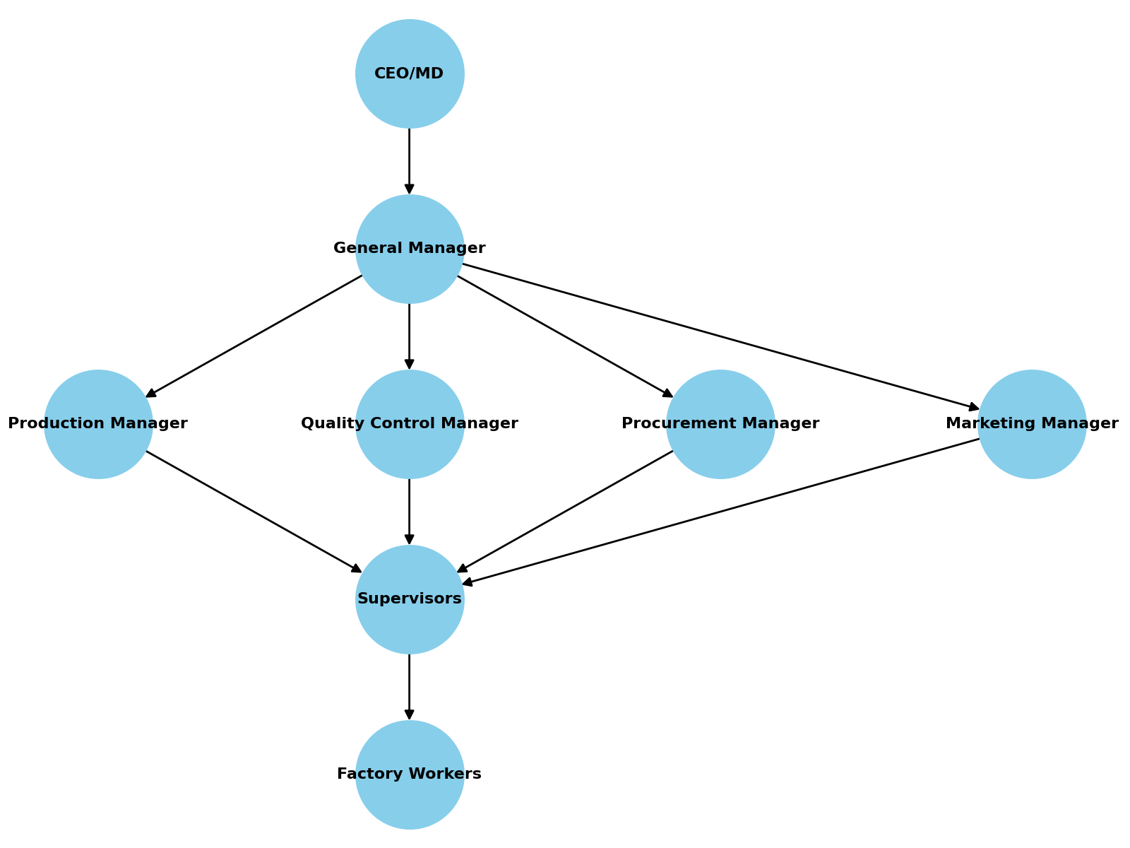

CHAPTER THREE
3.1 Work Done During SIWES
During my Student Industrial Work Experience Scheme (SIWES) at Mark Poly Industries Ltd, Ijagba Industrial Area, Sango, Ogun State, I was exposed to various aspects of industrial operations. My training began with an introduction to the factory premises, where I was familiarized with the different departments and their functions. I was also introduced to the factory workers, including the production team, quality control officers, procurement staff, and marketing officers. This orientation helped me understand the company's workflow and the roles played by each department in ensuring smooth operations.
A significant part of my training involved learning about the materials used for production, particularly different types of polymers such as polypropylene, polycarbonate, and polystyrene. I was taught how to identify these materials and their specific uses in manufacturing. Additionally, I was introduced to the processes involved in material procurement, treatment, and storage, ensuring that the raw materials were properly handled before being used for production.
I was also exposed to various production machines used in processing polymer materials. I observed how the machines were operated and assisted in feeding materials into the production units. My duties included scaling materials, mixing additive components, and supplying treated materials to different machines for production. Through this experience, I gained insight into how different machines functioned and how to calculate the required quantity of materials needed for a specific production process.
Another important aspect of my training was working with the product packaging unit. I was actively involved in packaging finished products and ensuring they met the required quality standards before being distributed to customers. Additionally, I participated in meetings on how to reduce production costs, where discussions focused on minimizing material wastage, improving production efficiency, and maintaining product quality.
I also worked closely with the quality control officers, where I learned about the importance of monitoring production quality. My responsibilities included inspecting finished products, identifying defects, and making recommendations for improvements. I also assisted in calculating the wages of casual workers, which gave me practical experience in salary computation and workforce management.
Lastly, my SIWES experience extended to the marketing and supply department, where I was involved in delivering products to customers and understanding sales processes. I had the opportunity to visit customers with marketing officers, gaining insight into customer relations, negotiation, and product distribution. This exposure broadened my understanding of the business side of manufacturing, emphasizing the importance of effective marketing strategies in sustaining a company's operations. Overall, my SIWES at Mark Poly Industries Ltd was an invaluable learning experience that enhanced my practical knowledge and prepared me for future career opportunities.
3.2 Skills Acquired During SIWES
The Student Industrial Work Experience Scheme (SIWES) at Mark Poly Industries Ltd, Ijagba Industrial Area, Sango, Ogun State, provided me with hands-on experience and helped me acquire several essential skills relevant to my field of study. One of the first skills I developed was industrial workplace adaptation, where I learned how to function effectively in a structured work environment. This included understanding workplace ethics, professional conduct, and the importance of teamwork in achieving organizational goals.
A crucial technical skill I acquired was the identification and handling of polymer materials, including polypropylene, polycarbonate, and polystyrene. I learned how to differentiate these materials based on their physical and chemical properties and their specific applications in manufacturing. Additionally, I gained knowledge about material treatment processes, ensuring that raw materials were properly processed before being used for production.
I also developed machine operation awareness, as I was exposed to different production machines used in polymer processing. Although I was not directly involved in operating the machines, I observed how they were handled and learned about their functions in production. I assisted in scaling materials, mixing additives, and feeding raw materials into machines, which gave me practical insights into industrial manufacturing processes.
Working with the product packaging and quality control teams enabled me to acquire quality assurance skills. I was trained on how to inspect finished products, identify defects, and ensure that only high-quality goods were sent for distribution. This experience helped me understand the significance of maintaining product standards and how companies implement quality control measures to prevent losses and ensure customer satisfaction.
Another important skill I gained was cost analysis and financial computation. I participated in meetings on reducing production costs, where I learned strategies for minimizing material wastage and improving efficiency. Additionally, I was involved in calculating the wages of casual workers and computing the salary structure of the company, which provided me with practical experience in payroll management and financial documentation.
My involvement in the procurement and supply chain department allowed me to develop procurement and inventory management skills. I learned about the processes involved in sourcing raw materials, negotiating with suppliers, and ensuring that materials were delivered on time for production. Furthermore, I assisted in keeping track of inventory records, ensuring that stock levels were adequately maintained to prevent shortages or overstocking.
I also acquired marketing and customer relations skills during my interaction with the marketing team. I was part of the product distribution process and had the opportunity to visit customers alongside marketing officers. This experience taught me the importance of good customer service, negotiation skills, and how to maintain positive business relationships to enhance sales and customer retention.
Lastly, my experience at Mark Poly Industries Ltd helped me improve my problem-solving and decision-making skills. Through my exposure to different industrial challenges, I learned how to analyze situations, develop solutions, and contribute to discussions on improving production efficiency. This skill is crucial for professional growth, as it enables me to think critically and make informed decisions in a work environment. Overall, my SIWES experience significantly enhanced my technical, financial, and interpersonal skills, preparing me for future career opportunities.

CHAPTER FOUR
4.1 Challenges Faced During the Programme
During my Student Industrial Work Experience Scheme (SIWES) at Mark Poly Industries Ltd, Ijagba Industrial Area, Sango, Ogun State, I encountered several challenges that affected my learning experience and overall efficiency. These challenges provided valuable lessons on how to adapt to real-world work environments and improve professional skills.
One of the major challenges I faced was limited practical involvement in machine operations. While I was exposed to different production machines, I was not allowed to operate them directly due to safety concerns. This restricted my hands-on experience in polymer processing and machine handling, making it difficult to fully understand some aspects of the production process.
Another challenge was inadequate supervision and guidance at certain points during my training. Due to the busy nature of the factory, workers were often preoccupied with their tasks, leaving little time to properly guide interns through the learning process. As a result, I had to rely on personal observations and occasional instructions to understand the workflow.
Additionally, workplace safety concerns posed a challenge during my internship. Although the company had safety measures in place, some workers did not strictly adhere to safety protocols. This made certain areas of the factory hazardous, requiring extra caution when moving around or handling materials.
The lack of proper documentation and structured learning materials also affected my learning process. Most of the knowledge I acquired was through verbal instructions and direct experience rather than through structured training manuals. Having a well-documented guide for interns would have made it easier to understand processes and follow standard procedures.
Another difficulty was adjusting to the demanding work schedule. The manufacturing industry operates under strict timelines, and I had to adapt quickly to the fast-paced nature of the work environment. This required physical endurance and mental alertness, as mistakes could lead to material wastage or production delays.
Finally, communication barriers between interns and some factory workers were a challenge. Some employees were reluctant to explain their tasks in detail, making it difficult to fully grasp certain technical aspects of the job. Over time, I learned how to approach different individuals and ask the right questions to get the information I needed.
Despite these challenges, the experience was highly rewarding. Overcoming these difficulties helped me develop problem-solving skills, adaptability, and resilience, which are essential qualities for professional growth in any industry.

CHAPTER FIVE
5.1 Conclusion
My Student Industrial Work Experience Scheme (SIWES) at Mark Poly Industries Ltd, Ijagba Industrial Area, Sango, Ogun State, was an invaluable learning experience that provided me with both practical and professional skills. I gained hands-on knowledge in polymer identification, material treatment, machine operations, quality control, procurement, packaging, financial computation, and marketing strategies. The exposure to real-world industrial operations helped me bridge the gap between theoretical learning and practical application. Additionally, I developed essential workplace skills such as teamwork, problem-solving, and decision-making, which will be beneficial in my future career. This experience has significantly enhanced my understanding of the manufacturing industry, making me more prepared for future opportunities in my field.
5.2 Recommendations
Based on my experience during the Student Industrial Work Experience Scheme (SIWES) at Mark Poly Industries Ltd, I recommend the following:
- The company should provide a more structured training program for interns to enhance their learning experience.
- Interns should be given more hands-on tasks in operating machines under supervision to gain deeper practical knowledge.
- The company should reinforce workplace safety training to ensure all employees and interns understand how to handle equipment and materials safely.
- Investing in modern production machines will improve efficiency, reduce waste, and enhance product quality.
- Implementing more frequent quality assessments can help identify production defects early and ensure higher customer satisfaction.
- Management should continue exploring ways to minimize production costs without compromising product quality.

