

A TECHNICAL REPORT ON
STUDENT INDUSTRIAL WORK EXPERIENCE SCHEME
(SIWES)
HELD AT:
KWARA STATE TELIVIAUTHORITY
Apata yakuba Kwara State

WRITTEN BY:
OBASA FATHIA ABIDEMI
ND/23/MAC/FT/0026

SUBMITTED TO
DEPARTMENT OF MASS COMMUNICATION, INSTITUTE OF INFORMATION COMMUNICATION TECHNOLOGY (IICT)
KWARA STATE POLYTECHNIC, ILORIN

IN PARTIAL FULFILLMENT OF THE REQUIREMENT FOR THE AWARD OF NATIONAL DIPLOMA (ND) CERTIFICATE IN MASS COMMUNICATION

AUGUST-NOVEMBER, 2025

DEDICATION
I dedicated this work to my dearest parents Mr. & Mrs. Obasa whom through their advice, love, care, and financial assistance have made me be where I am today, I pray to Almighty God continue to keep and guide them. Amen.

ACKNOWLEDGEMENT
I thank God Almighty for his Grace Honor, Mercy and adoration I received during the cause of my standing and when undergoing my Industrial Training Experience.
My appreciation also goes to my Industrial based Supervisors, Dr. Abdulrasaq. who accessibility, untiring effort over me, my parents and guidance and suggestion fabulously contributed to the completion of this report. May god continue to guide and protect them and their families at large.
Mostly also my appreciation goes to the director of Administration for accepting me into the organisation and his support, may Almighty God be with him and his entire house hold.

ABSTRACT
The student industrial work experience scheme SIWES is a program designed to give students practical industrial training while still undergoing their undergraduate studies.
Under the preview to enhance theoretical knowledge accumulated at school and requirement to obtain practical knowledge in a related course of study.
I did my 4 months SIWES program at the Kwara statState television Authority, Apata yakub Where I was introduced to all forms and categories of communication regulation, policy enactment, standard agreement, frequency management, transmission policy and management of all communication activities throughout the country.

TABLE OF CONTENTS
i TITLE PAGE
ii CERTIFICATION
iii DEDICATION
iv ACKNOWLEDGEMENT
v ABSTRACT
vi TABLE OF CONTENTS

CHAPTER ONE
1.0 INTRODUCTION OF SIWES 1
1.1 HISTORY OF SIWES 1
1.2 IMPORTANCE AND OBJECTIVES OF SIWES 2

CHAPTER TWO
2.0 BRIEF HISTOY OF ORGANIZATION 4
2.1 OBJECTIVES OF ESTABLISHMENT 4
2.1.1 VISION STATEMENT 4
2.1.2 MISSION STATEMENT 5
2.3 VARIOUS DEPARTMENTS IN THE ORGANISATION 6
2.4 OTHER SUPPORTIVE DEPARTMENTS INCLUDE 6
2.5 MATERIALS USE IN THE BROAD CAST STUDIO 6
CHAPTER THREE
3.0 TECHNICAL TRAINING EXPERIENCE 9

CHAPTER FOUR
4.0 EXECUTIVE SUMMARY 11

CHAPTER FIVE
5.0 CHALLENGES ENCOUNTERD 12
5.1 RECOMMENDATION 12
5.2 CONCLUSION 13

CHAPTER ONE
1.0 INTRODUCTION TO SIWES
Siwes is an acronym for student industrial work experience scheme. Siwes is an effective instrument used for exposing students to the realities of the working environment in Nigeria especially and the world generally.
In their various professions, so as to achieve the needed technological advancement for the nations.
The scheme is a participating activities /programme involving universities, polytechnics, and technical colleges. For students in various institution in Nigeria. It is run jointly by industrial training fund (I.T.F)
Some of the Aims of SIWES
To provide for the students to the opportunities to be involve in the practical aspect of their respective disciplines, thus bridging the gap between theatrical aspects taught in class and the real world situation.
To prepare student for industrial working environment they are likely to meet after graduating.
To expose students to latest development and technological innovation in their chosen professions.
1.1 HISTORY OF SIWES
Student industrial work experience scheme was initialed by industrial training fund (I.T.F) in 1975 so as to compliment the theological knowledge studies in the higher institution with practical experience. It is coordinated by I.T.F and N.V.E and under the umbrella of the ministry of education. It gives unique opportunities for students to be introduced to the industrial environment and obtain the technical knowledge while still studying.
It was established as a result of realization by the federal government in 1971, The need to introduce another dimension to the quality and standard of education obtained in the country in other to achieve the much needed technological advancement, because it has been shown that a coordination exist in a country level of economy technological development and its level of investment in man power.
It is founded by the federal government of Nigeria and operated by the (I.T.F) and coordinated agencies are (NVC, NCCE, NBTE). Employers of labour and the institution. The industrial training funds (I.T.F) funded the scheme during its formation years in 1973 /1974 to both the national and became unbearable to fund it withdrawal from the scheme in 1979 the federal government handed over the scheme in 1979 to both National and University commission (NVC) and the National Board Technical Education (NBTE) later in Nov, 1984 the federal government revert the management and implantation of the SIWES programme to the I.T.F and it was effectively taken over by the industrial fund in July 1985 with the funding being solidly borne by the federal government.
1.2 IMPORTANCE AND OBJECTIVES
In regards to the SIWES handbooks the specific objective and important is SIWES are to:
- To enable students to access interest suitable for chosen profession.
- To satisfy accreditation requirement set by NBTE.
- To provide students an opportunity to see the real world of their discipline and consequently bridge the gap between the classroom and real work situation.
- To provide an avenue for students in institute of higher learning to acquire industrial skills and experience in their course of study.
- To provide student with an opportunity to apply their knowledge in real work situation bridging the gaps between the theory and practical
- Prepare students for the industrial work experience they are to undergo after graduation.
The objective of the SIWES programme is all about strangulating the future employer. This programme is a successful attempt to help students to understand the under lying principles of their feature work after passing through the programme. The student would be able to know the really necessary aspect of his or her work.
CHAPTER TWO
2.0 BRIEF HISTOY OF RADIO NIGERIA HARMONY
RAY POWER 95.1F.M. Located at Oke Pupa Abere Osogbo, Osun State

AIM AND OBJECTIVES
1. To educate
2. To enlighten
3. To inform and to promote the state government policies and programmes.
MISSION
To broadcast efficiently and effectively throughout RAY POWER 95.1F.M Osogbo and beyond to attract and sustain maximum viewership and listenership to Foster co-existence amongst the different ethnic groups in Osun State and project Delta State and her people in line with our motto "Beaming signals of unity" for radio and television arm.
VISION
To inform, educate and entertain using the concept of transmission and reception.

2.1 VARIOUS DEPARTMENTS AND THEIR FUNCTION
There exist established ethics guiding the administration and operation of RAY POWER 95.1F.M.
DEPARTMENT AT RAY POWER 95.1F.M
Programming Department: Its ensures quality content towards fulfilling the satisfactory duties of the situation.
- News and Current affairs departments: They are responsible for information management news production and reporting it to inform and educate the topics.
- Engineering Department: They are saddled with the responsibility of providing uninterrupted technical support service to guaranty steady broadcast and ensure regular maintenance of all operational facilities including the I.C.T. units.
- Marketing Department: They provide a formidable, robust and resort oriented media campaigns on various products and services. The marketing department is into advertising, breading and promotional activities for any commercial items to boost acceptance and patronage in the market.
2.4 OTHER SUPPORTIVE DEPARTMENTS INCLUDE
- Administrative Department – for staff and general welfare
- Financial Department – Ensures products management of available resources.
- The audit, moderates financial regulations based on the principles of transparency and accountability.

2.5 MATERIALS USE IN THE BROAD CAST STUDIO
Some of the instrument used in the studio are :
Satellite
Microphone
Speaker
Head set
Mix engine
- Satellite :
Satellite television is a service that livers television and a low-nois.
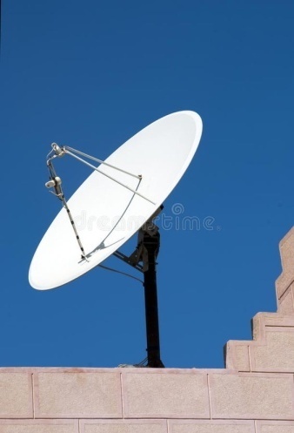

Microphone
Broadcasting microphones are an important part of any audio setup, whether for live events or recording. They help to capture and amplify sound, making sure that your audience can hear clearly.
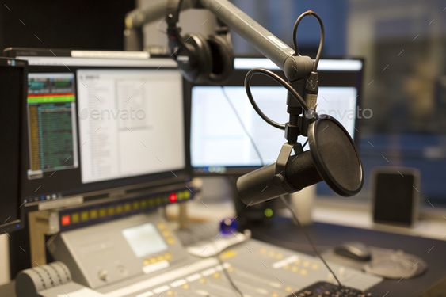

- Speaker
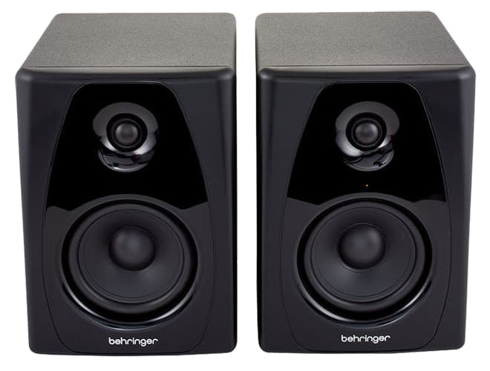
Studio monitor speakers are indispensable tools in radio studios because they provide a reliable reference for audio quality, enable precise audio production and mixing, and contribute to maintaining the professional standard of radio broadcasts

- Headset
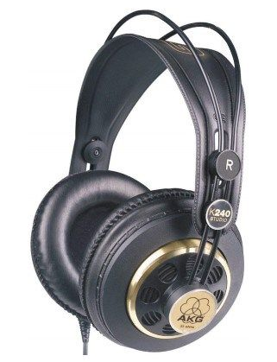
Radio hosts and producers use headphones to monitor the audio being recorded or broadcasted. They allow the hosts to hear their own voice, the voices of the other participants, and any background music or sound effects clearly.

- Mix engine
Its primary purpose is to control and manipulate audio signals from various sources, such as microphones, musical instruments, and playback devices, and combine them into a coherent audio output.
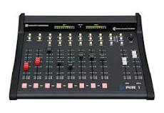

- Computer System
Computers have become an essential part of many types of journalism. From writing a breaking news story to hosting a TV show, the computer is involved in many ways. In broadcast journalism, computers are used for everything from writing scripts to live television
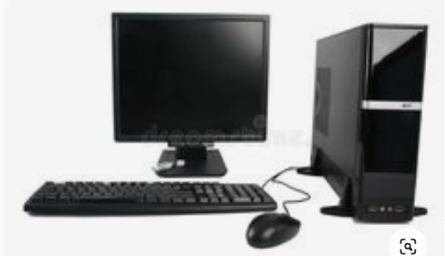

CHAPTER THREE
3.1. TECHNICAL TRAINING EXPERIENCE/WORK DONE EXPERIENCE
Speaking of achievement and the knowledge acquired I make sure that I learnt something; coming to work everyday was an experience to learn from. Everyday is opening me to one opportunity or the other.
PROGRAMMING
I was under programs department in the station, so I learnt how to produce live event. Like talk show and so on.
I learnt about interview: (about vox, the studio interview and the mixed interview).
I also learnt about the quality control: (opening montage, and end credit).
I learnt all production processing: (pre production, production, post production stage).
I learnt about the different types of camera shot.
I gained a wide range of experience from the various Assignments undertake such news writing and reporting news enlightenment, and editing process. And the experience gained help to fulfill the objectives of Siwes.
CONTROL ROOM
- I experience how to edit a programs and how to preview a programs.

CHALLENGES
Noticeable challenges facing Siwes students include finance, student’s placement as a result of non acceptance of students by some employers into their establishment, in adequate supervision of trainee as well as irregularity in academic.
SUGGESTION
- The students should be taught and show the proper way to do.
- pay, collect and submit their receipts, forms and logbooks.
- write and forward their Siwes application letters.
- fill in their logbooks.
- write their reports.

CHAPTER FOUR
4.0 EXECUTIVE SUMMARY
The student industrial experience scheme (SIWES) is a training found in 1973 to bridge the gap between the theory and practical oriented among students of engineering, technological social science and medical science in Nigeria institution of learning.
Its provide the job practical experience for student as they are expose to work method and mach inanes that may not be available in their institution.
At inception in 1974, the scheme started with 784form II institution and 104 eligible courses by 2008, 210. 390 students from 219 institution participated in the scheme with over 112 eligible courses.
However, the rapid growth and exposition of SIWES has occurred against the smooth operation and ministration of the scheme. Most industries are operating below in storage capacity whole other completely shutdown in Nigeria. This has impacted negatively on the scheme as higher institution of learning find it increasingly difficult to secure placement for studies industries where they could acquire the much practical experience.

CHAPTER FIVE
5.0 CHALLENGES ENCOUNTERED
There are some challenges encountered during my SIWES programme. Some of the problems are:
- Lack of Concentration: Most students lack concentration due to supervisor refusal to give full attention to the student by impacting and explaining things to them claiming that students already known this things and their schedule is tight despite being on duty.
- Another Challenge Was the Problem of Transportation: The increase and scarcity of fuel cause increase in transportation fee. My place of attachment was a bit far from my place in some way it affected me during the cause of the programme.
- Lastly the Issue of Industrial Based Supervisor: I was unable to get in touch with my supervisor till I almost ended my programme which gave me a lot of worries and concern because some other students has met with their supervisors.
So many challenges was faced but to mention a few
5.1 RECOMMENDATION
I want to say a very big thank you to the government for introducing the SIWES programme which helps in motivating students in the course of study and also to increase the knowledge and understanding of students in their future endeavor.
Going through some of the experience gained during the programme, I will recommend that there is a need for improvement on some of the activities both in the media organization where I served and the school.
- The time duration of the programme should be extended more than three month
- Media organization should create more practical knowledge for the student for them to acquire more knowledge from their versatile staffs.
5.2 CONCLUSION
SIWES was established to provide opportunities for students to involve in the practical aspect of their respective disciplines in the industrial working environment. During my Four (4) month Industrial Training, I gained a wide wage of experience from the various assignments undertaken such as news commentary, audio transcribing, page numbering and editing process.
SIWES has already and really helped to improve my educational morals and physical career in becoming a better journalist. In a nut shell the programme (SIWES) has really helped me and it has also served as an eye opener for me to be able to differentiate between the theoretical and the practical aspect of journalism.

