

A TECHNICAL REPORT ON
STUDENT INDUSTRIAL WORK EXPERIENCE SCHEME (SIWES)
HELD AT
FEDERAL AIRPORT AUTHORITY OF NIGERIA,
ILORIN, KWARA STATE

BY
ALATA SHAKIRAT TITILAYO
ND/23/TMT/FT/0012
SUBMITTED TO

DEPARTMENT OF TOURISM MANAGEMENT TECHNOLOGY

INSTITUTE OF APPLIED SCIENCES

KWARA STATE POLYTECHNIC ILORIN KWARA STATE.

IN PARTIAL FULFILMENT OF THE REQUIREMENT FOR THE AWARD OF NATIONAL DIPLOMA (ND) IN TOURISM MANAGEMENT TECHNOLOGY

SEPTEMBER – DECEMBER, 2024
DEDICATION
This SIWES report is dedicated to almighty ALLAH for HIS protection and mercy over me. I also dedicate this SIWES report to my supportive parent MR AND MRS ALATA for their all-round support

ACKNOWLEDGEMENT
Thank ALLAH Almighty for HIS glory, honour, adoration and mercy received during my course of study and when undergoing my SIWES.
My appreciation goes to my Industrial Based Supervisor, MRS BUNMI whose accessibility uniting effort patriot and guidance and suggestion fabulous by contributed to the completion of this report, may ALLAH continue to guide and protect him and his family.

TABLE OF CONTENT
- Title page
- Certification
- Dedication
- Acknowledgment
- Preface
- Table of content

CHAPTER ONE
1.1 Meaning of SIWES
1.2 History of SIWES
1.3 The scope and the importance of SIWES
1.4 Aims and objective of SIWES

CHAPTER TWO
2.1 Brief history of the organization
2.2 Vision of the organization
2.3 Mission of the organization

CHAPTER THREE
3.1 Siwes Technical Experience
3.2 Work done

CHAPTER FOUR
4.1 Student Primary Assignment

CHAPTER FIVE
5.1 Recommendation
5.2 Conclusion

CHAPTER ONE
1.1 MEANING OF SIWES
The Student's Individual Work Experience Scheme (SIWES) is a programme that is controlled by the industrial training fund(ITF) in conjunction with the university.
SIWES is designed to engage student in various degree programme in order to provide the student with adequate practical experience in various field of study and to expose them to working conditions.
This programme involves the ITF, students and industries. It's meant to bridge the gap between theory and practical work, sharpen student's skills and understanding of actual works processes and also provides an avenue to gain more knowledge

1.2 HISTORY OF SIWES
The early phase of science and technology in Nigeria was characterized by the theoretical lectures in polytechnic and universities which have proven to be an ill method to teaching students in universities and polytechnic, graduate with little or no technical experience in the course of study.
All the same, students inability to contribute to the society happening, growth and development of the country, it was then SIWES was introduced to the industrial and education section.
SIWES is the acronym for Students Industrial Work Experience Scheme. SIWES was established in early stage, SIWES was found by ITF (Industrial Training Fund), it was difficult to continue for the economic stress, the responsibility was shared between industrial training funds federal government

1.3 THE SCOPE AND THE IMPORTANCE OF SIWES
SIWES is created to expose to industrial based skills necessary for smooth transition from classroom to labour mandate.
It affords student of tertiary institution the opportunity to be familiar and expose to the needed experience in handling machinery equipment which are usually not available in the education institution.
Also it's an avenue for students in higher learning institute to acquire skill and experience in their various field of study that would prepare them for work after graduation.
The student industrial work experience scheme (SIWES) is a skill training programme design to expose and prepare student of mass communication for the Industrial work situation while they are likely to meet after graduation.

1.4 AIMS AND OBJECTIVES OF SIWES
1. It provides students with an opportunity to apply their knowledge in real work situation. Thereby bring the gap between theory and practical learning.
2. Expose students to work methods and techniques required in handling equipment and machinery not available in their institution
3. It provides an avenue for students in institution of higher learning to acquire industrial skills and experience in their academics discipline
4. It prepare students for the industrial work situation

CHAPTER TWO
2.1 BRIEF HISTORY OF FEDERAL AIRPORT AUTHORITY OF NIGERIA, ILORIN (FAAN)
Ilorin International Airport now General Tunde Idiagbon International Airport (IATA: ILR, ICAO: DNIL) is an airport serving Ilorin, a city in Kwara State of Nigeria. Ilorin International Airport is owned and operated by Federal Airports Authority of Nigeria (FAAN) and is located about 1.8 kilometers from downtown Ilorin. The airport has one runway, which is 3,100M X 60M, with an approach of 121.2MHz
Ilorin International Airport serves as a secondary airport to Lagos Airport and is situated approximately an hour's drive from Lokoja, the Kogi State capital. Recently, the terminal building of Ilorin International Airport has gone through renovations to accommodate up to 500 passengers at once. The commissioning of the airport was done by President Olusegun Obasanjo, who also laid the foundation of the airport's cargo shed projected to be completed in March 2007. The airport was initially commissioned on February 16, 1978, and is located in the Fili area of Ilorin, around 9km southwest of Ilorin town. ^{[4][5]} but it was upgraded to international status in 2012. Ilorin International Airport is the main airport serving Ilorin, the capital of Kwara State, Nigeria.
The most popular airlines that fly to Ilorin International Airport are Air Peace, Overland, and Green Africa. The most popular destinations from Ilorin International Airport are Abuja and Lagos. The airport is served by two airlines, Air Peace and Azman Air. They operate flights to Lagos, Abuja, and Port Harcourt.^{[6]} The airport is undergoing a number of improvements, including the construction of a new terminal building and the expansion of the runway. These improvements are expected to make the airport more efficient and able to handle more passengers, this is an increase of over 20% from the previous year.
The 1964 Civil Aviation Act saw the establishment of the legal framework for the regulation of aviation in Nigeria, which placed all aspects of aviation under firm government control. The statutory task of upgrading air transport infrastructure in the country to accommodate the growing number of flights and ever-larger aircraft thus fell directly to the Nigerian government.
In 1971 the Nigerian government appointed Netherlands Airport Consultants (NACO) to survey the existing international airports, prepare a master plan, and conduct feasibility and economic impact studies for the upgrading of Lagos airport and 13 other airports in the country. That was the start of the first wave of airport development that would take place during the 1970s

ORGANOGRAM
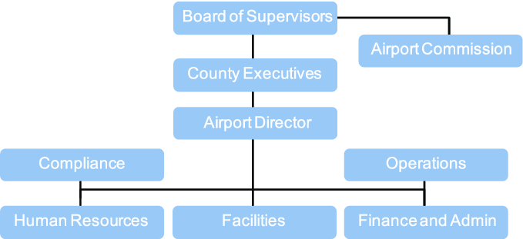

2.2 VISION STATEMENT
To be amongst the best airport groups in the world.

2.3 MISSION STATEMEN
To develop and profitably manage customer-centric airport facilities for safe, secure and efficient carriage of passengers and goods at world-class standards of quality.

CHAPTER THREE
SIWES TECHNICAL EXPERIENCE
3.1 EXPERIENCE GAINED
I started my SIWES programme at Federal Airport Authority of Nigeria, Ilorin (FAAN) on September 2024. under the supervision of Mrs Bunmi.
During my stay, I was taught many things pertaining to my course of study and everything relating to my work.

I learned about how Apron inspection was being conducted in which the surface area was okay for flight operations and the recording of the flight movement.
Registration of the flights movement was conducted in all aircrafts including the passengers it take off with.
The arrival of air peace flight with registration number 5N-BXF form DN-MM with 38pax and departed to DN-AA with 40pax.

I assisted the Airport duty office in programming the flight movement and amount of passenger traveling monthly.

In landside, Observed maintaining cleanliness from the terminal building to the airport entry gate, In airside I assisted in an inspection of the airside and the aircrafts are well parked and ready for operation.

Flight statistics computation was done and the monthly statistics record way done by the Airport duty officer and I assisted.

3.2 WORK DONE
Airport VIP lounge, protocol lounge and each offices were inspected and found cool and all systems working perfectly including the CCTV camera in which I was taught how to check everything and how to do minor repairing.

Runway inspection was conducted with the Marshallers and the ADO on duty and I was also taught how to perform Marshaller.

I observed trimming of grasses at the land side where vehicles are parked and was cleaning up by the cleaners on duty.

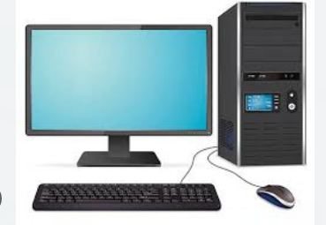

CHAPTER FOUR
4.1 STUDENT'S PRIMARY ASSIGNMENT

I was assigned to help for the inspection of taxi way and followed the marshallers to the airside for directing and parking aircrafts.

Free flow of traffic observed during operational hour, Entry and exit gate well managed by the aviation securities (AVSEC) and airforce personal.
Runway inspection conducted and found it okay for aircraft landing.
I observed free flow of traffic at the landside and vehicles are parked well and politely.
Terminal building was inspected it was found presentable and primary power supply and water supply were available.
The human resources department were inspected it was found clean and cool and operations were done.
Runway inspection was conducted and found surface area free and ready for operation.

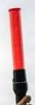

CHAPTER FIVE
RECOMMENDATION AND CONCLUSION
5.1 RECOMMENDATION
Going through some of the experience gained during the programme, I will recommend that there is need for improve on some of the activities both in the organization where I served and the school:
- the time duration for the programme is okay, three month
- the organization should create more practical knowledge for the student for them to acquire more knowledge from their versatile staffs
- the industrial training fund should provide a strong insurance policy covered for student on SIWES programme

5.2 CONCLUSION
SIWES was established to provide opportunities for student to be involved in the practical aspect of their respective disciplines in the industrial working environment. During my three months industrial training, I gained a wide range of experience form the various assignment undertaken such as how Apron inspection was being conducted in which the surface area was okay for flight operations and the recording of the flight movement.
Registration of the flights movement was conducted in all aircrafts including the passengers it take off with.
I assisted the Airport duty office in programming the flight movement and amount of passenger traveling monthly. All the experience gained help to fulfil the objective of SIWES.

