

A TECHNICAL REPORT
STUDENT INDUSTRIAL WORKING EXPERIENCE SCHEME
(SIWES)

HELD AT:
ROTANA HOTEL ALONG FATE ROAD ILORIN KWARA STATE

PREPARED BY:
ORIOLOWO VICTORIA JUMOKE
ND/23/TMT/FT/0019

SUBMITTED TO:

DEPARTMENT OF TOURISM MANAGEMENT
KWARA STATE POLYTECHNIC, ILORIN

IN PARTIAL FULFILLMENT OF THE REQUIREMENTS FOR THE AWARD OF NATIONAL DIPLOMA (ND) IN TOURISM MANAGEMENT

Sept., Nov., 2024
DEDICATION
I dedicate this technical report to the Almighty GOD, the giver of knowledge, wisdom and who is rich in mercy.

ACKNOWLEDGEMENT
I take this opportunity to express my profound gratitude and deep regards to the creator of heaven and earth, the one who knows the beginning and the end, the alpha and the omega. my sincere gratitude also goes to my guidance Mr. and Mrs. Oriolowo for their financial support and word of encouragement during my SIWES Programme and also to those who stood by me during my SIWES programme, thank you all. I also take this opportunity to express a deep sense of gratitude to compliment my supervisor at the place of my attachment for taking his time for my practical knowledge and for his cordially support, valuable information and guidance which helped me in completing my SIWES through various stages may Almighty God bless you abundantly.
TABLE OF CONTENT
Dedication
Acknowledgement
CHAPTER ONE
  - Introduction to SIWES
  - History of SIWES
  - Objectives of the Programme
  - Objectives of Establishment
CHAPTER TWO
2.1 Activities of place of Attachment
2.2. Precaution Taken in the Place of Attachment
2.3 Uses of the Organization Equipment
CHAPTER THREE
Reporting on Work Carried Out
3.1 Reporting on Daily Work Carried Out
CHAPTER FOUR
Challenges and Gain Encounter In Place of Attachment
CHAPTER FIVE
Summary, Conclusion and Recommendations
5.1 Summary
5.2 Conclusion
5.3 Recommendations
CHAPTER ONE
1.1 INTRODUCTION TO SIWES
Students Industrial Work Experience Scheme (SIWES) is a Skills Training Program designed to prepare and expose Students of Universities, Polytechnics, Colleges of Technology, Colleges of Agriculture and Colleges of Education for the Industrial Work situation they are likely to meet after graduation. The Scheme affords Students the opportunity of familiarizing and exposing themselves handling equipment and machinery that are usually not available in their institutions.

1.2 HISTORY OF SIWES
The Students’ Industrial Work Experience Scheme (SIWES) was initiated in 1973 by the Federal Government of Nigeria under the Industrial Training Fund (ITF) to bridge the gap between theory and practice among products of our tertiary Institutions. It was designed to provide practical training that will expose and prepare students of Universities, Polytechnics, and Colleges of Education for work situation they are likely to meet after graduation.
Before the establishment of the scheme, there was a growing concern among the industrialists that graduates of institutions of higher learning lacked adequate practical background studies preparatory for employment in industries. Thus the employers were of the opinion that the theoretical education going on in higher institutions was not responsive to the needs of the employers of labour.
As a result of the increasing number of students’ enrolment in higher institutions of learning, the administration of this function of funding the scheme became enormous, hence ITF withdrew from the scheme in 1978 and was taken over by the Federal Government and handed to National Universities commission (NUC), National Board for Technical Education (NBTE) and National Commission for Colleges of Education (NCCE). In 1984, the Federal Government reverted back to ITF which took over the scheme officially in 1985 with funding provided by the Federal Government.
1.3 OBJECTIVES OF THE PROGRAMME
The specific objectives of SIWES are to:
- Provide placements in industries for students of higher institutions of learning approved by relevant regulatory authorities (NUC, NBTE, NCCE) to acquire work experience and skills relevant to their course of study
- Prepare students for real work situation they will meet after graduation.
- Expose students to work methods and techniques in the handling of equipment and machinery that may not be available in schools.
- Make transition from school to the labour market smooth and enhance students’ conduct for later job placement
- Provide students with the opportunity to apply their knowledge in real life work situation thereby bridging the gap between theory and practice
- Strengthen employer involvement in the entire educational process and prepare students for employment in industry
- Promote the desired technological knowhow required for the advancement of the nation.
1.4 OBJECTIVES OF ESTABLISHMENT
The specific objectives of establishment are to:
- To deliver exceptional service to enhance guest experiences and ensure repeat visits.
- To achieve financial goals by optimizing revenue through effective pricing strategies and cost management.
- To build a strong brand identity that resonates with target markets, fostering loyalty and recognition.
- To explore opportunities for growth by entering new markets or expanding existing properties.
- To implement eco-friendly practices to minimize environmental impact and appeal to conscious consumers.
- To foster a positive workplace culture that attracts and retains skilled employees to enhance service quality.
- To stay ahead of industry trends by adopting new technologies and services that improve operations and guest experiences.
- To collaborate with local businesses and tourism boards to enhance offerings and promote the destination.
- To ensure the safety and well-being of guests and staff through robust security measures and health protocols.
- To actively participate in local community initiatives and support local economies.

CHAPTER TWO
2.1 ACTIVITIES OF PLACE OF ATTACHMENT
The experience, knowledge, skills and exposure acquired during the period of attachment in the industrial exercise cannot be over emphasized. I was exposed to certain areas in my course of study, such as:
- Analyzing Customer Preference
- Customer Behavior
- Customer Relation
- Pool Side and Field Bar
- The Lounges
- Hotel Policies and Procedure
- Sales of Beer, Goldberg, Trophy and Gin
- Sales of Non-Alcoholic Drinks
- Kitchen Utensils
- Hotel Bar
- Sanitation
- Cleaning of Guest Room
- Cashier
- House Keeping
- Industrial Software and System
- Hotel Management
- Industry Networking
- Budgeting and Cost Control
- Front Desk Operation
- Food and Beverages
2.2. PRECAUTION TAKEN IN THE PLACE OF ATTACHMENT
- Promote the use of eco-friendly materials and processes.
- Regular cleaning and disinfection of rooms and common areas.
- Implementation of health screenings for staff and guests.
- Installation of smoke detectors and fire alarms.
- Regular fire drills and training for staff.
- Development of emergency response plans for various scenarios (e.g., natural disasters, medical emergencies).
- Clear evacuation routes and signage throughout the property.
- Use of surveillance cameras and security personnel.
- Key card access systems for guest rooms and restricted areas.
- Compliance with food safety regulations in kitchens and dining areas.
- Regular inspections and training for food service staff.
- Secure handling of personal information in compliance with data protection laws.
- Training staff on maintaining guest confidentiality.
- Responsible alcohol service training for staff to prevent over-serving and ensure guest safety.
- Continuous training on safety protocols, emergency procedures, and customer service.
2.3 USES OF HOTEL EQUIPMENT AND ACTIVITIES
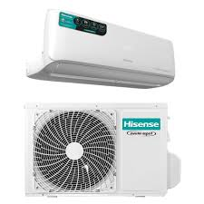
GUEST COMFORT


Beds and Linens: it provide a comfortable sleeping environment for guests.
Air Conditioning and Heating Units: it ensure a pleasant indoor climate.

FOOD AND BEVERAGE SERVICE

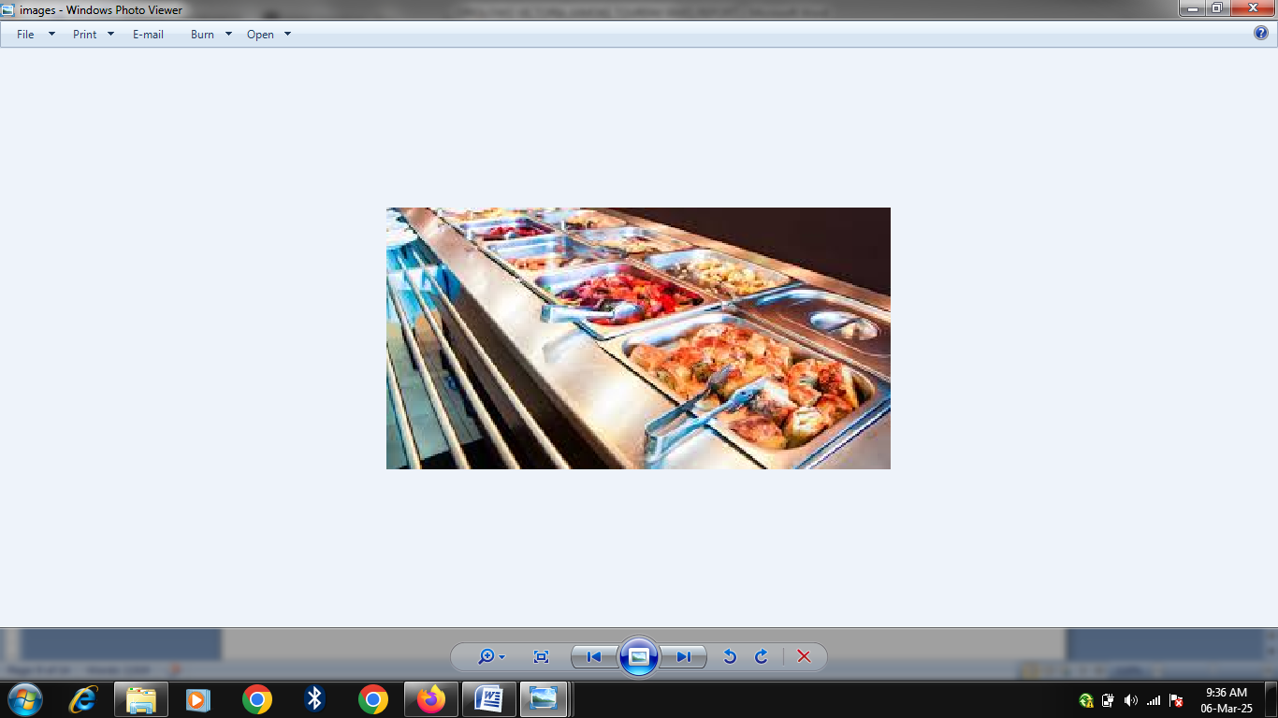

Kitchen Appliances (e.g., ovens, refrigerators): it facilitates food preparation and storage.
Dining Equipment (e.g., tables, chairs, utensils): it enhance dining experiences for guests.

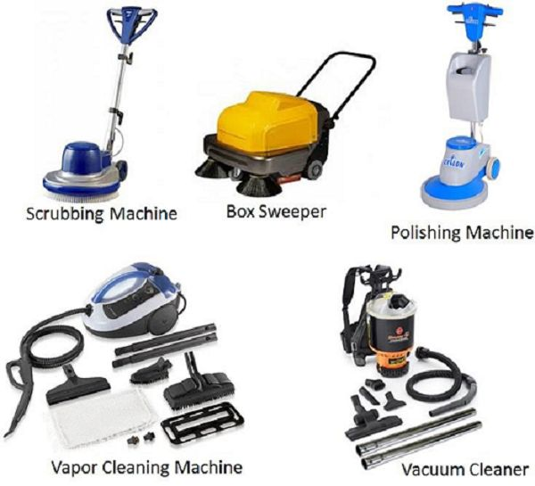
HOUSEKEEPING

Cleaning Tools (e.g., vacuums, mops): it maintain cleanliness in guest rooms and public areas.
Laundry Equipment: it manage the washing and drying of linens and uniforms.

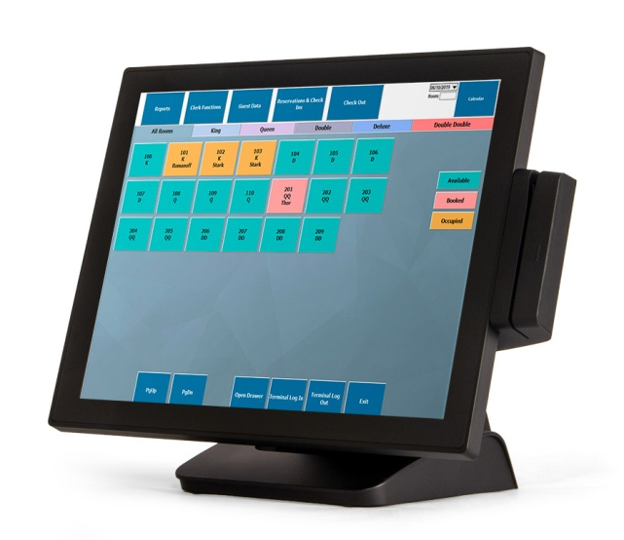
FRONT OFFICE OPERATIONS

Computer Systems: it manage reservations, check-ins, and check-outs efficiently.
Point of Sale (POS) Systems: it process payments and manage billing in restaurants and bars.

SAFETY AND SECURITY
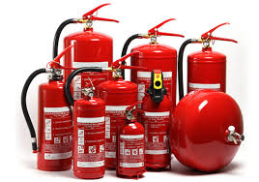
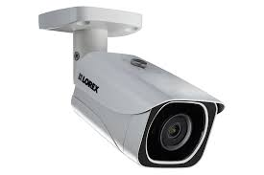

Surveillance Cameras: it monitors hotel premises for security purposes.
Fire Safety Equipment (e.g., extinguishers, alarms): it ensure guest and staff safety in emergencies.

RECREATIONAL FACILITIES
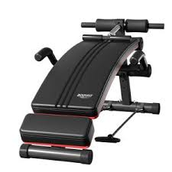
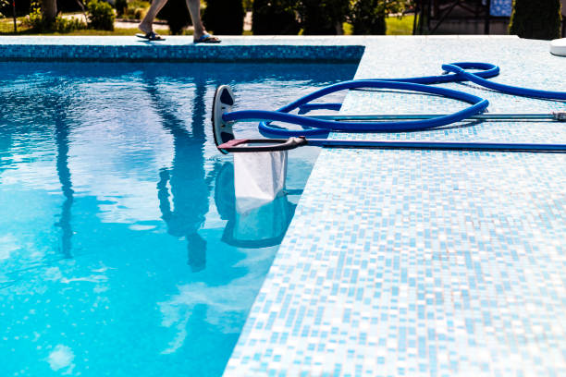

Fitness Equipment: it provides guests with options for exercise and wellness.
Pool Equipment: it maintain swimming pools for guest enjoyment.

CONFERENCE AND EVENT HOSTING



Audio-Visual Equipment: it supports presentations and events in meeting rooms.
Furniture (e.g., chairs, tables): it arrange spaces for various types of gatherings.


TELECOMMUNICATION

Telephone Systems: Facilitate communication between guests and staff.
Wi-Fi Equipment: Provide internet access throughout the hotel.

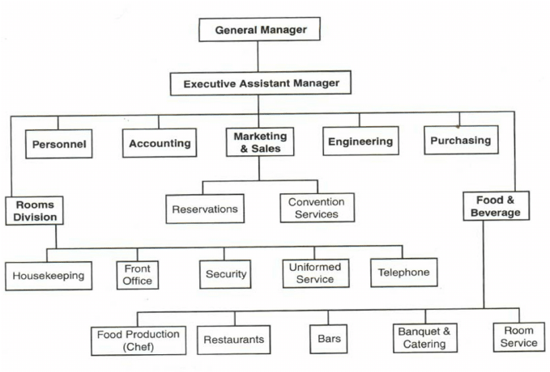
ORGANIZATION STRUCTURE/ORGANOGRAM
CHAPTER THREE
REPORTING ON WORK CARRIED OUT
3.1 Reporting on Daily Work Carried Out
WEEK 1: I was introduced to all members in the organization and I was given rules and regulation of the organization. Also, I learnt how to analyzed customer preference and customer behavior and their role of e-commerce in modern retail. I learnt on how to terminate machine as another means of payment
WEEK 2: I practicalize on how to booked a room at the receptionist. Also I learnt on how to be intact when customer make payment by transfer. I learnt on how to check-in and heck-out guest. Also, I practicalized on how to dusting surfaces, vacuuming carpets, and mopping floors to maintain cleanliness, replacing bed linens and towels to ensure hygiene.
WEEK 3: I practicalized on how to do replenishing toiletries, coffee, and other amenities for guest use. I learnt on how to checking smoke detectors, fire extinguishers, and emergency exits to ensure compliance with safety regulations.
WEEK 4: I learnt on how to build rapport with guest and ensuring satisfaction. Also, I learnt about front office and how to interact with guest to create a great experience from helping them check-in and creating personality on their interest.
WEEK 5: I learnt on how to arrange rooms for special events, such as anniversaries or business meetings, including decorations and seating. Also, I ensure that the internet connection is functional and providing assistance with connectivity issues.
WEEK 6: I learnt about providing information and assistance with local attractions, dining options, and transportation.
WEEK 7: I learnt about responding to guest complaints or emergencies promptly, such as noise disturbances or maintenance emergencies.
WEEK 8: I learnt about the importance of sales service in the hotel industry and also I work as receptionist to be able to attend to guest when coming in.
CHAPTER FOUR
CHALLENGES AND GAIN ENCOUNTER IN PLACE OF ATTACHMENT

GAINS
Practical Experience
Hands-On Skills: I gain practical skills and knowledge about the hotel management and assembly processes of hotel activities
Real-World Application: I apply theoretical knowledge from their studies in a real-world setting, and enhancing their understanding.
Industry Exposure
Understanding the Market: I learn about market trends, consumer preferences, and competition in the hotel industry
Networking Opportunities: Working alongside professionals allows me to build valuable industry connections.
Technical Knowledge
Learning Technology: Exposure to modern technologies used in hotel such as pools machine, modern furtinure
Quality Control Practices: Understanding quality assurance processes and standards in manufacturing.
Problem-Solving Skills
Real-World Challenges: I encounter and solve practical problems, enhancing their critical thinking and adaptability.
Project Management: Involvement in projects fosters skills in planning, executing, and managing tasks.

CHALLENGES
Adjustment to Work Environment
Workplace Dynamics: Navigating different personalities and team dynamics as been a difficulty.
Learning Curve: I faced a steep learning curve when dealing with complex machinery and processes.
Understanding Technical Jargon: Familiarity with industry-specific terminology.
Time Management
Balancing Responsibilities: I manage their time effectively between work responsibilities and personal commitments.
Meeting Deadlines: The pressure to meet production deadlines can be stressful.
Limited Scope of Work
Repetitive Tasks: I assigned to repetitive tasks, which that has been less engaging.
Pressure to Perform
Expectations: I felt pressure to perform at a high level, which can lead to anxiety.
Feedback and Criticism: Receiving constructive criticism can be challenging, especially for those not accustomed to it.
Safety Concerns
Working with Machinery: I experience inherent risks associated with working in a industrial environment, necessitating careful attention to safety protocols.
CHAPTER FIVE
SUMMARY, CONCLUSION AND RECOMMENDATIONS
5.1 SUMMARY
In the hospitality industry, hotel companies strive to create exceptional guest experiences while ensuring operational efficiency and profitability. Their objectives encompass customer satisfaction, brand development, market expansion, and sustainability. To achieve these goals, hotels implement various precautions, including health and safety protocols, security measures, and staff training.
Essential hotel equipment plays a crucial role in enhancing guest comfort and service quality, ranging from housekeeping tools to dining facilities and technology systems. Work carried out in hotel rooms includes routine housekeeping, maintenance and repairs, safety inspections, and setup for special occasions. Effective management of these tasks not only ensures a pleasant stay for guests but also maintains the hotel's overall quality and reputation.
In the competitive landscape of the hospitality industry, hotel companies prioritize creating memorable experiences for guests while maintaining operational excellence. A comprehensive approach involves several core objectives: enhancing customer satisfaction, building a strong brand identity, exploring opportunities for market expansion, and promoting sustainable practices that benefit both the environment and local communities.
5.2 CONCLUSION
The success of hotel operations hinges on a multifaceted approach that prioritizes guest satisfaction, safety, and operational efficiency. By focusing on the core objectives of enhancing customer experiences, maintaining high standards of cleanliness and safety, and utilizing essential equipment effectively, hotels can create inviting environments that foster loyalty and positive reviews. The ongoing commitment to staff training, proactive maintenance, and responsiveness to guest needs further solidifies a hotel's reputation in the competitive hospitality landscape.
5.3 RECOMMENDATIONS
- Siwes supervisors should make sure they visit the students in their place of attachment for proper monitoring, improvement and progress for the benefit of the societies as a whole.
- Employees should seek ongoing training and education to stay updated on industry trends and technological advancements.
- Engaging with industry professionals through workshops, trade shows, and online platforms can provide valuable insights and opportunities for career advancement.
- Implement eco-friendly practices, such as reducing water and energy usage, using biodegradable products, and promoting recycling programs to appeal to environmentally-conscious travelers.
- Implement regular training programs that focus on customer service, safety protocols, and emergency response to ensure all staff are well-prepared to meet guest needs.
- Upgrade technology systems for reservations, check-ins, and guest services. Consider mobile apps that enhance guest convenience, such as digital room keys and service requests.
- Establish a proactive maintenance plan to regularly inspect and address potential issues with plumbing, electrical systems, and furniture, minimizing downtime and enhancing guest comfort.

