

A TECHNICAL REPORT ON
STUDENT INDUSTRIAL WORK EXPERIENCE SCHEME (S.I.W.E.S)

UNDERTAKEN AT:

TRAOLZ FARM NIG. LTD
Zango Road Oke andi Ilorin Kwara State

BY:
ISSA ABDULBASHIT KOSEMANI
ND/22/AGT/PT/028

DEPARTMENT OF AGRICULTURAL TECHNOLOGY
KWARA STATE POLYTECHNIC, ILORIN

SUBMITTED IN PARTIAL FUFILMENT OF THE AWARD OF NATIONAL DIPLOMA (ND) IN AGRICULTURAL TECHNOLOGY

FROM:
AUGUST 2023 TO DECEMBER 2023

DEDICATION
This report is dedicated foremost to God Almighty for his favor, mercy and grace upon my life especially during my 4 months SIWES program at TRAOLZ FARM NIG. LTD.
I would also like to dedicate it to my parents and siblings for their love and support and everyone else that contributed towards making my SIWES training a fun and successful one.

ACKNOWLEDGEMENT
My appreciation goes to the Industrial Training Fund (ITF) for their foresight in putting this program in place and also to the Kwara State Polytechnic, for providing a platform on which I was engaged on the training.
Many thanks to my supervisor, Mr. Rasaq Adewale for taking time to supervise me during my training. I also express my profound gratitude to my and all members of staff of TRAOLZ FARM NIG. LTD who gave me training an exciting and blissful one. Also to my parents and siblings thank you all for your moral and financial support.
I am deeply indebted to God Almighty, the giver of all wisdom, knowledge and understanding without whom I would have achieved nothing at all.
Finally to my Institution based supervisor MR. Rasaq Adewale for his support and to my other friends and colleagues. Thank you all I am highly grateful.

CHAPTER ONE
INTRODUCTION
1.1 Background of Study
Student Industrial Work Experience Scheme (SIWES) is one of the Industrial Training Fund (ITF) programs which were introduced in 1974 due to the inability of students in Nigeria universities and polytechnics to meet the practical aspects of their training. That is, the needs to enable students match their theoretical school knowledge with the practical aspect of their training in industry.
The program was designed for students of tertiary institutions with the aim of exposing students that have acquired theoretical knowledge in the classrooms to the practical exposure and experience. The scheme is a tripartite program, involving the student, the university and the industry (Employer of labor). It is funded by the Federal Government of Nigeria and jointly coordinated by the Industrial Training Fund (ITF) and the National Universities Commission (NUC).
1.2 Brief history of SIWES
In recognition of the shortcomings and weakness in the formation of graduates, particularly with respect to acquisition of relevant production skills (RPSs), the Industrial Training Fund (which was itself established in 1971 by decree 47) initiated the Students’ Industrial Work-experience Scheme (SIWES) in 1973. The scheme was designed to expose students to the industrial environment and enable them develop occupational competencies so that they can readily contribute their quota to national economic and technological development after graduation. Consequently, SIWES is a planned and structured program based on stated and specific career objectives which are geared toward developing the occupational competencies of participants. Participation in SIWES has become a necessary condition for the award of degrees and diplomas
The main thrust of ITF program and services is to stimulate human performance, improve productivity, and induce value-added production in industry and commerce. Through its SIWES and Vocational and Apprentice Training Program, the Fund also builds capacity for graduates and youth self-employment, in the context of Small Scale Industrialization, in the economy.
1.3 AIMS AND OBJECTIVES OF SIWES
The program was specially designed to carry out the following;
- Bridge the gap between theory and practical thereby giving students the opportunity to apply their knowledge accurately.
- Expose students to what their professions entail.
- Improve inter-personal relationship skills of the students.
- Develop skills on practical knowledge

CHAPTER TWO
DESCRIPTION OF THE ESTABLISHMENT OF ATTACHMENT

2.1. Location and Brief History of the Establishment
The farm was established in the year 1990 with the aim of exposing the students of the faculty of agricultural science to practical field work and application of theoretical knowledge acquired so far in the Company. Traolz farm Nig. Ltd has over 50 hectares of land which is engaged in the production of sales of farm produce such as garri, chicken, pork, vegetables, fruits and also for planting and for research works.
The farm consist of 12 different units which includes; poultry unit, feed mill/pasture unit, farm mechanization/ crop processing unit, arable unit, crop type collection (CTC), piggery unit, cattle-sheep & goat unit, permanent crops unit, fishery unit, apiary unit, garri processing unit, rabbitry unit.
The farm is headed by the farm manager Mr. Rasaq Adekunle. The staff strength of the farm is above 30.

2.2 Organization chart
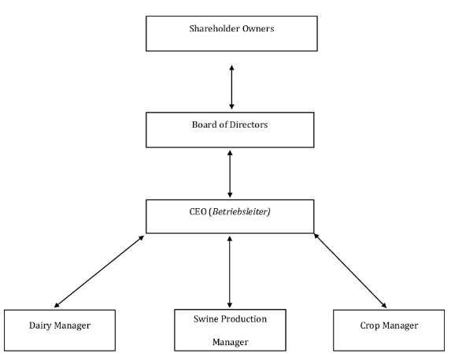

CHAPTER THREE
3.1 Wetting of Vegetables
Vegetables need to be wetted to support growth, but too much water can cause problems. Wetting vegetables can be done using drip irrigation, soaker hoses, or furrow irrigation.
3.1.2 Watering tips
- Water early: Watering in the morning reduces evaporation.
- Water slowly: Watering slowly helps water penetrate the soil.
- Water less frequently: Watering less often but more deeply allows water to seep into the ground.
- Avoid waterlogging: Waterlogging can cause rotting.
- Avoid excessive watering: Excessive watering can cause stunted roots.
- Avoid wetting leaves: Wet leaves can promote fungus and disease.
Watering methods
- Drip irrigation: Delivers water directly to the crop, reducing weed growth and evaporation.
- Soaker hoses: Gently water the soil without wetting the leaves.
- Furrow irrigation: Uses shallow ditches between rows to apply water.
Water needs
Root vegetables require moisture to develop properly. Some vegetables, like artichokes, have shallow root systems and need moist soil.
3.1.3 PIGGERY UNIT
Piggery unit deals with the rearing and breeding of pigs under intensive system of management. The unit houses a boar, three sows, five gilts, onesire, four growers and two in-soar.
The act of parturition in pigs is called FARROWING. Pigs are highly prolific and have a gestation period of 114days (3months, 3weeks, 3days) .
This unit is headed by Mr. Micheal Akinwale.
Routine management
- Clearing of the bushy areas surrounding the unit
- Feeding of pigs with Cassava peel, vegetables and pig feed
- Cleaning of the pen
Economics Importance of Pigs
- Sources of food
- Sources of income
- Research and scientific purpose
- Useful in medical and nutritional studies
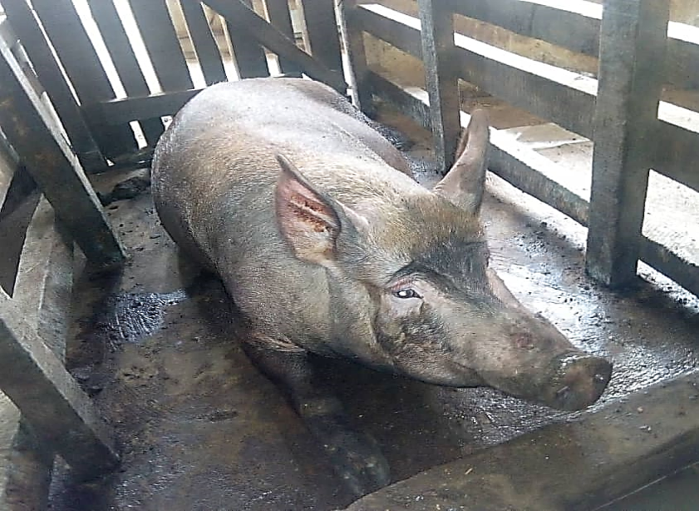
Fig 5; Pig in a pen

3.2 GARRI PROCESSING UNIT
This unit is involved in the processing of raw cassava into a dry granulated substance called garri. This is carried out by the various stages involved in the processing of cassava into garri ranging from peeling of the cassava to frying of the cassava flour.
This unit is coordinated by Mr. Alabi Samson.
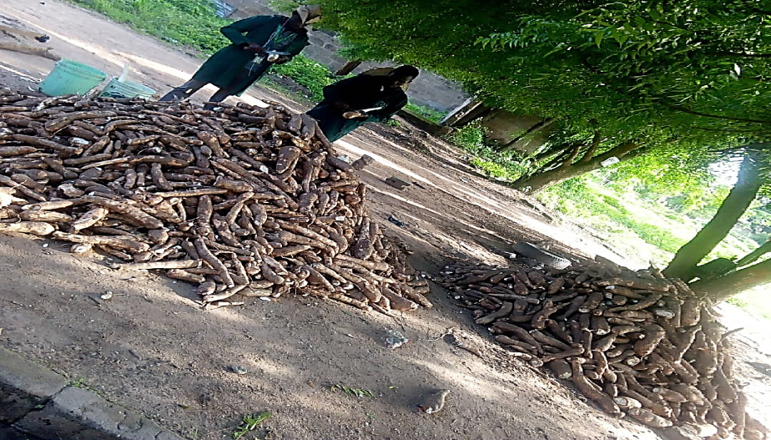
Fig 6; Cassava for Garri processing
Routine management
- Introduction to garri unit, terminologies and aspect of garri unit
- General cleaning of the processing unit and it surroundings
- Introduction to the processing machines
- Pulling of cassava, frying of garri and sieving of fermented cassava
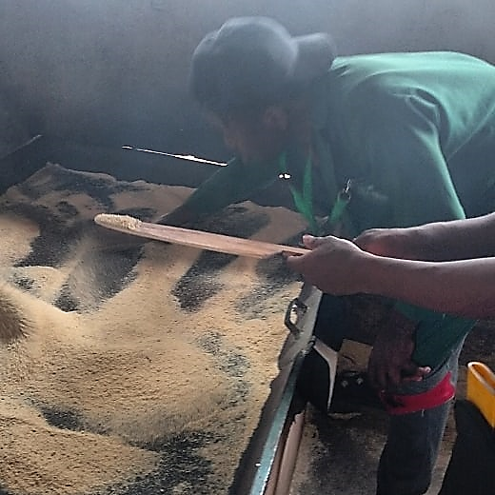
Fig 7; Frying of Garri
3.1.5 CROP TYPE COLLECTION UNIT
This unit is mostly concerned with growing of vegetables and species. It involves pre-planting to post planting operations. The land was cleared and tilled; beds are also made which are incorporated with organic manure to increase fertility before sowing of seeds.
Some of the vegetables planted at this unit are Amaranthus, Cucumber, Lettuce, Celosia spp. and pepper.
The unit headed by Dr S.O Akintaro.
Routine management
- Sowing of vegetables
- Regular wetting of the seedlings
- Making of vegetable bed
- Clearing of bush
- Rouging of weed from vegetable bed
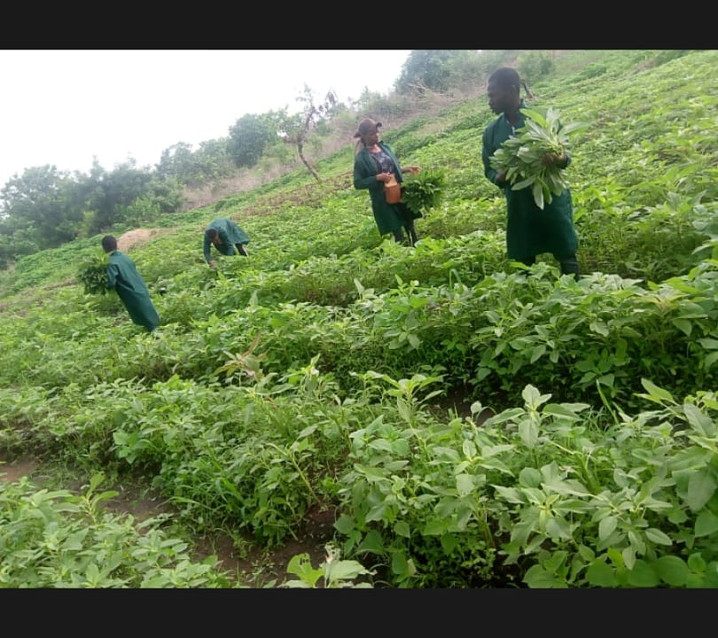
Fig 8; Vegetable Bed
3.1.6 FISHERY UNIT
The unit basically deals with rearing of fish in a conducive and confined environment, mainly in water body. Water body can classify into;
- Saline water
- Brackish water
- Fresh water
Importance of Fish
- Sources of food for man and animals
- Sources of income
- Source of protein
Routine practices carried out in this unit;
- Introduction to fishery unit, terminologies aspect of fishery
- Weeding of unwanted plant in cassava
- Making ridges around the fishery unit
- Feeding of fingerlings in the Earthen pond

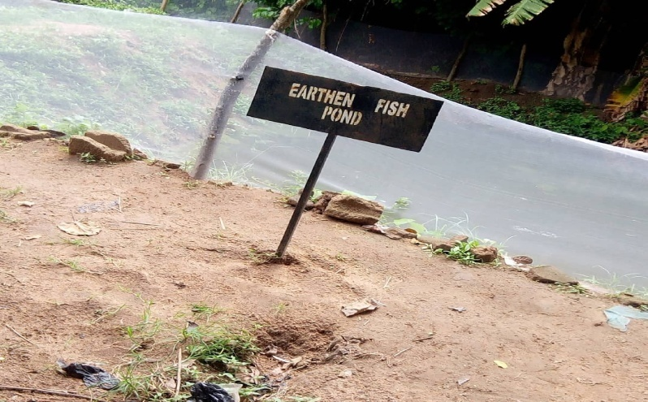
Fig 9; Earthen Fish Pond
CHAPTER FOUR
4.1 FORMULATE GOOD PIG FEEDS
Formulating a good feed will help to achieve the optimum growth of your piggery stock. Pigs' feeds should meet the animals' needs for maintenance of growth and reproduction, as well as vitamins.
Farm grains, such as maize, rice, and soya beans, are the most common and best sources of food to feed pigs on farms. Typically, corn-based feeds are used because they are high in digestible carbohydrates, low in fiber content, and cost-effective.
The feeds should be supplemented with other vitamins, proteins, and some anti-bacterial compounds for the feed to slow the growth of naturally occurring bacteria that may be harmful to the animals (pigs) or your livestock.
Feeds mixed with rice bran, broken rice, maize, soya beans, cassava, vegetables, and distillers' residues have shown positive results.
4.2 How to Feed Piglets (Under 40 Pounds/ 18 Kg)
Piglets have different dietary needs compared to adult pigs, and proper nutrition during this critical growth phase is essential for their health and development. Creep feeding is a common practice used to introduce piglets to solid food while they are still nursing from their mother.
Creep feeding involves providing specially formulated solid feed to piglets in a separate area from the sow. This allows piglets to access and consume solid feed without competition from larger pigs. Creep feeding is usually started when piglets are a few weeks old, and it helps to transition them from a milk-based diet to a solid feed.
The nutritional requirements of piglets are different from those of adult pigs. Piglets require higher levels of energy, protein, vitamins, and minerals to support their rapid growth and development. Creep feed should be formulated to meet these specific requirements, providing the necessary nutrients for optimal growth.
When introducing piglets to solid feed, it's important to do so gradually. Start by offering a small amount of creep feed, and then increase the amount as the piglets become accustomed to eating solid food. This gradual transition helps prevent digestive upsets and allows the piglets to adjust to the new diet.
As piglets grow, their dietary needs increase. Piglets gain weight quickly during the early stages of life, so it's crucial to monitor their growth and adjust their feed accordingly. The amount and composition of the creep feed should be adjusted based on the piglets' age, weight, and growth rate.
Creep feeding also plays a role in preparing piglets for weaning. By gradually introducing solid feed, piglets become accustomed to eating from a feeder, which makes the transition to a post-weaning diet smoother.
Proper nutrition during the pre-weaning and post-weaning phases is important for minimizing stress and promoting healthy growth.
Alongside creep feed, piglets also need access to clean and fresh water. Adequate water intake is essential for digestion, nutrient absorption, and overall health.
4.3 Growing and Finishing Pigs (40 Pounds and Above)
Pigs that are growing and weigh between 40-125 pounds, as well as finishing pigs that weigh 125 pounds to market weight (approximately 230 pounds or more), should transition from the grower feeds, which are nutrient dense with more protein, to the finisher feeds that are less dense.
4.4 Expected Growth Rates in Pigs
Piglets grow quickly throughout the early phases of their development, especially during the nursery stage. Although growth rates may vary throughout this time, on average, you should anticipate weight gains of 1.5 to 1.7 pounds every day, up to a maximum of about 110 pounds.
Later Growth: As pigs transition into the later stages of growth, typically after reaching a weight of around 110 pounds, their growth rate may increase. Weight gains ranging from 1.8 to 2.2 pounds per day can be expected. This growth rate is often achieved when pigs are in the finishing phase, and they are consuming a diet designed to maximize weight gain while ensuring their health and well-being.
4.5 Factors Influencing Pig Growth
Genetics: Different pig breeds and genetic lines have varying growth potentials.
Nutrition: A balanced diet that provides the necessary nutrients in the right proportions is crucial for optimal growth.
Health: Pigs that are healthy and free from diseases will grow more efficiently.
Environment: Adequate housing, ventilation, and space can positively impact pig growth.
Management: Proper care, regular monitoring, and appropriate management practices contribute to better growth.
The target market weight for pigs varies depending on the industry and market demand. Typically, pigs are sent to market when they reach a certain weight, which can vary from around 220 to 280 pounds or more. This variation depends on factors such as breed, market trends, and consumer preferences.

CHATPER FIVE
5.0 RECOMMENDATION AND CONCLUSION
5.1 CONCLUSION
The industrial attachment which lasted for three months has been able to help me to differentiate between theoretical work and practical. During this period I fully participated in poultry production, horticulture, cattle sheep and goat, feed mill, mechanization, fishery and piggery. Entrepreneurship in animal sciences were also carried out in poultry production this includes; transportation of old day chicks, installation of battery cages, house design
5.2 RECOMMENDATION
It is well known that the university system cannot provide all the technical knowledge and work experience needed by its students hence the opportunity provided through the SIWES. Nigeria students in higher institution should be encouraged to take the SIWES serious so as to enhance the opportunity of later job employment as well as self employment. Visitations should be made by supervisors from the institutions and representative from industrial training fund (ITF) in order to ensure students are getting the required and relevant training and exposure at their place of assignment.
I will also recommend prompt payment of Stipends by the establishments and payment of SIWES ALLOWANCE by the Industrial Training Fund (I. T. F.)during the period of attachment rather than after the program, so has to help the students solve minor needs such as feeding and transportation fare.

