

KWARA STATE POLYTECHNIC, ILORIN
INSTITUTE OF TECHNOLOGY
DEPARTMENT OF CIVIL ENGINEERING
Technical Report on Student Industrial Work Experience Scheme (SIWES)
2023/2024 SESSION

Held at
MINISTRY OF WORK AND TRANSPORT, ILORIN KWARA STATE

Presented

By

OMONIYI PELUMI SAMUEL
ND/23/CEC/FT/0018

DECEMBER, 2024

CERTIFICATION
This is to certify that SHAIBU IDAYAT MODUPEOLA with matriculation number ND/22/COM/PT/0142 undergoes her industrial training SIWES at MIKE-MAR MULTI CONCEPT. In partial fulfillment of the award of national diploma (ND) in computer science, kwara state polytechnic.

------------------------- ----------------------------
Student name Date & Sign

-------------------------- ----------------------------
Supervisor name Date & Sign

DEDICATION
This SIWES report is dedicated to Almighty Allah, Mr. & Mrs. OMONIYI for their spiritual and financial support during my SIWES program.

ACKNOWLEDGEMENT
My appreciation first goes to almighty Allah, the creator of Heaven and Earth for granting me the grace and privilege to be able to complete this SIWES program successfully and on schedule.
I am also grateful to my industrial based supervisors MRS. KUNLE-OJO MARY. and my tutors for their thorough supervision and useful advice which helped and also contributed to the success of the SIWES program. May the almighty God make their days on Earth longer to reap the fruit of their labor to the fullest in JESUS name.
Also I cannot but acknowledge my germane H.O.D, MR OYEDEPO F.S and all the lecturers in the department.
Thanks and GOD bless you all.

TABLE OF CONTENTS
Title page…………………………………………………………………......………… i
Certification ii
Dedication iii

Acknowledge ………………………………………………………………....………. IV
Table of contents…………………………………………………………….................. V-VI

CHAPTER ONE
1.0 Introduction..……………………………………………………………………… 1
1.1 Background of SIWES………..……….………………………………...…..…..…... 1
1.1.2 Brief history of SIWES ……….………..………………………….……....…….... 1-2
1.1.3 Mission statement of SIWES ……….………..…………………….…........…...… 2
1.1.4 Vision Statement of SIWES ……….………..…………………………....……...… 2
1.2 Aims of SIWES ……………….………..………………………….……....…...….. 2
1.2.1 Objectives of SIWES ………….………..………………………….……....…...…... 3
1.2.2 Importance of SIWES to Civil Engineering ……………………….…….......…........ 3
1.2.3 Justification for choice of industry……...………………………….……....……....... 3
1.3 History of establishment and profile…….….……………………...…...........…........ 4-5

CHAPTER TWO
2.0 Theoretical framework ……………………………………………...……….…… 6
2.1 Civil Engineering………………….………………………………...……….…… 6
2.1.2 Transportation Engineering System………………………………...……….…… 6
2.1.3 Origin of highway………...………………………………………………………. 6-7
2.1.4 Significance of highway…………………………………………...…………....... 7-8
2.2 Components of road structure…………………………………….……………... 8
2.2.1 Road and water ………………..…………………………….…………………... 9
2.2.2Crack sealing procedures…………………………………….………………….... 9
2.2.3 Roadway excavation…………………………………….……………………….. 10
- 2.4Filling and grading…………………………………….………………………….... 11
2.3 Spraying of water………………………………….……………………………….... 11
2.3.1Field compaction…………………………………….…………………………….. 12
2.3.2Blinding…..………………………………….……………………………………... 13
2.3.3Priming………...…………………………….…………………………………….... 14
2.3.4Asphalt overlaying …………………………………….……………..………... 14-15

CHAPTER THREE
3.0 Asphalt plant …………….…………………………...………………..……… 16
3.1 Materials …………...…………….…………………………….……..………. 17
3.2 Forms of Bitumen ………………………………………....………………… 17
3.3 Types of bitumen ……………….………………………………………………. 17
CHAPTER FOUR
4.0 Drainage system……………….………………………………..…………….... 19-21

CHAPTER FIVE
5.0 Summary ……………….…………………………..………...………………………. 22
5.1 Conclusion ……………….…………………………..……………………………… 22
5.2 Recommendation ……………….……………………………..……………………… 22
Reference
Appendix

CHAPTER ONE

1.0 INTRODUCTION

1.1 BACKGROUND OF SIWES
Students’ Industrial Work-experience Scheme (SIWES) is one of the Industrial Training Fund (ITF) programme which was introduced in 1974 due to the inability of engineering and technology students in Nigeria universities and polytechnics to meet the practical aspects of their training. That is, the needs to enable students match their theoretical school knowledge with the practical aspect of their training in industry. The Training lasts for six months. According to Ekpenyong (2011), one of the principles underlying any industrial work experience scheme for students in institutions of learning is the desire to marry the practical with the theoretical learning which characterizes conventional classroom situations with a view to striking a balance between theory and practice. The author stressed further that it was in realization of this that the ITF when it was established, set out to study the extent to which the theoretical knowledge that students in engineering technology and other allied fields in Nigerian institutions offering technology based courses related to the kind of work experience expected of them by employers. The result of the ITF survey showed a great disparity between students’ knowledge and their ability to apply it in relevant jobs. In order to bridge the gap between the two, the ITF in 1974 established a co-operative internship programme, which enabled students of technology to spend some part of their courses for relevant on the-job practical experiences in appropriate areas of the Nigerian industry (Ekpenyong, 2011). The author further stressed that the internship programme, SIWES, can therefore be seen as that which is intended to give Nigerian students studying occupationally related courses experience that would supplement their theoretical learning as a well of equipping the students with the needed skills to readily contribute their quota to national economic and technological development after function in the world of work. This need to combine theoretical knowledge with practical skills in order to produce results in the form of goods and services or to be productive is the essence and rationale for industrial training, and a basic requirement for the award of B.Eng.

1.1.2 BRIEF HISTORY OF SIWES
In recognition of the shortcomings and weakness in the formation of SET graduates, particularly with respect to acquisition of relevant production skills (RPSs), the Industrial
Training Fund (which was itself established in 1971 by decree 47) initiated the Students’ Industrial Work experience Scheme (SIWES) in 1973. The scheme was designed to expose students to the industrial environment and enable them develop occupational competencies so that they can readily contribute their quota to national economic and technological development after graduation. Consequently, SIWES is a planned and structured programme based on stated and specific career objectives which are geared toward developing the occupational competencies of participants. In spite of the challenges faced by SIWES in the four decades of its existence, the Scheme has not only raised consciousness and increased awareness about the need for training of SET students, but has also helped in the formation of skilled and competent indigenous manpower which has been manning and managing the technological resources and industrial sectors of the economy. Participation in SIWES has become a necessary condition for the award of degrees and diplomas to SET students graduating from higher institutions in Nigeria. It is therefore, not in doubt that SIWES is a veritable means or tool for National Economic Development. The main thrust of ITF programmes and services is to stimulate human performance, improve productivity, and induce value-added production in industry and commerce. Through its SIWES and Vocational and Apprentice Training Programmes, the Fund also builds capacity for graduates and youth self-employment, in the context of Small Scale Industrialization, in the economy.
The Industrial Training Fund is a grade ‘A’ parastatal operating under the aegis of the Federal Ministry of Industry, Trade and Investment. It has been operating for 45 years as a specialist agency that promotes and encourages the acquisition of industrial and commercial skills required for national economic development.

1.1.3 VISION STATEMENT
To be the prime skills training development organization in Nigeria and one of the best in the world.

1.1.4 MISSION STATEMENT
To set and regulate standards and offer direct training intervention in industrial and commercial skills training and development, using a corps of highly competent professional staff, modern techniques and technology.

1.2 AIM OF SIWES
The effort is aimed at helping/training students in the Nigerian tertiary institutions the practical aspect of their field of study by exposing students to machines and equipment, professional work methods and ways of safeguarding the work areas and workers in industries and other organizations.

1.2.1 OBJECTIVES OF SIWES
The Industrial Training Fund’s policy Document No. 1 of 1973 which established SIWES outlined the objectives of the scheme. The objectives are to:
- It provides an avenue for students in institutions of higher learning to acquire industrial skills and experience during their course of study.
- It expose Students to work methods and techniques in handling equipment and machinery that may not be available in their institutions.
- It makes the transition from school to the world of work easier and enhance students’ contact for later job placements and a chance to evaluate companies for which they might wish to work.
- It provides students with the opportunities to apply their educational knowledge in real work and industrial situations, there by bridging the gap between theory and practice.
- The programme teaches the students on how to interact effectively with other workers and supervisors under various conditions in the organization.

1.2.2 IMPORTANCE OF SIWES TO CIVIL ENGINEERING
- It exposes students to more practical work methods and techniques in civil engineering.
- It provides students in civil engineering with an opportunity to apply their theoretical knowledge to real life situations.
- It enables students in civil engineering to gain experience in handling equipment and machineries.
- It provides an environment whereby students in civil engineering can develop their creativity and interpersonal skills through software design techniques.
- It is one of the requirements for the award of Bachelor of Engineering Degree (B.Eng.) in Civil Engineering.

1.2.3 JUSTIFICATION FOR CHOICE OF INDUSTRY
Theoretical knowledge alone would not usually prepare and prepare an educated person for the world of work. The worker or productive individual must not only be knowledgeable but also be versatile in the application of skills to perform defined jobs or work. Both education and training are important; there cannot be effective education without some training input and there cannot be effective training without some educational input. The productive individual, particularly in this millennium, must be able to combine and utilise the outcomes from the two forms of learning (Know-How Ability and Do-How Capability) for production of goods and services which is crucial in pursuing careers in science, engineering and technology (SET) disciplines.

1.3 HISTORY OF ESTABLISHMENT AND PROFILE
The headquarters of Borno State Roads Maintenance Agency (BORMA) is located at Baga Road, Opposite Transmission Company of Nigeria (TCN) Office, Maiduguri, Borno state.
The Agency was established on the 2nd January, 2009 by (Dr.) Ali Modu Sheriff. The main function of the Agency is to establish, rehabilitate and maintain up to date road for the state for effective performance. The Governing Board of the Agency consist of the following members:-
- A chairman.
- One member from each of the three senatorial zones in the state.
- The General Manager of the Agency who shall serve as the Secretary of the Board.
- The commissioner of Works and Transport.
- The Director in charge of State Roads in the Ministry.
- A Representative of the Nigerian Association of Public Highways and Transportation officials, Borno State Chapter or any other similar body operating in the state. 7) One other person who shall be a woman to be appointed on personal merit.
The Chairman and Members of the Agency except ex-officio members shall be appointed by the Governor.
The Board shall have power to:-
- Provide the General policies and guidelines relating to the programmes of the Agency;
- Manage and supervise the affairs of the Agency;
- Subject to the provisions of the law, they make, alter, and revoke rules and regulations for carrying on the functions of the Agency;
- Fix terms and conditions of service, including remuneration of the employees of the Agency; and
- Do such other things which in the opinion of the Board are necessary to ensure the performance of the functions of the Agency.
The Chairman and other members of the Board, other than ex-officio members shall hold office for a term of 4-years and may be re-appointed for a future term of 4-years and no more, on such terms and conditions as may be specified in their letter of appointments.
The Agency ensures the efficient and effective maintenance of all existing highways and roads throughout the State.
Without prejudice to the generality of the foregoing, the Agency shall have power to:-
- Construct and maintain feeder roads in the State;
- Enter into road concession contract for the purpose of executing relevant road projects within the State;
- Set guidelines for the working of concession contracts;
- Plan and manage the development and implementation of the road safety standards; 5) Plan and develop strategies towards ensuring efficient and effective movement of traffic on State highways and roads and ensure their implementation;
- Make policy recommendations to the state government on matters relating to the maintenance of state highways and roads; and
- Carryout such other activities as appear to it necessary or expedient for the full and efficient discharge of its functions under the law.

CHAPTER TWO 2.0 THEORETICAL FRAMEWORK 2.1 CIVIL ENGINEERING
Civil engineering is a professional engineering discipline that deals with the design, construction, and maintenance of the physical and naturally built environment, including works like roads, bridges, canals, dams, and buildings. Civil engineering is the second-oldest engineering discipline after military engineering, and it is defined to distinguish non-military engineering from military engineering. It is traditionally broken into several sub-disciplines including architectural engineering, environmental engineering, engineering, control,structural engineering, earthquake engineering, transportation engineering, construction surveying, and construction engineering, etc. Civil engineering takes place in the public sector from municipal through to national governments, and in the private sector from individual homeowners through to international companies.

2.1.2 TRANSPORTATION ENGINEERING SYSTEM
Highway engineering is one of the most important branches of transportation system. (Gupta 2009), in his opinion defines Highway Engineering as the art of planning, design, construction and maintenance of road system. While Rogers (2003) defines Highway Engineering as the application of scientific principle to the planning, design, maintenance of a highway project or system of projects. We conclude that Highway Engineering is the science and technology dealing with road engineering. However, the term road or road ways was called Highway, which refers to a road way constructed on small embankments a little above the general ground level to avoid drainage and maintenance problems.
Its scope includes development, planning, alignment, geometric design and location, highway material, pavement design, maintenance and construction, traffic operation and its control, economic consideration, finance and administration, road architecture, arboriculture and landscaping.
On the other hand, Transportation Engineering involves planning, design and supervision of construction, maintenance and operational stages of the country’s infrastructure which is related to the movement of goods and people from their origin to destination (Hill, 2001).

2.1.3 ORIGIN OF HIGHWAY
The oldest mode of transportation was obviously on foot path. In those days, man travelled by watching stars or own shadows, or noting the direction of wind, so also felled trees were used to cross narrow streams and rivers were crossed by swimming or by rafts, and animals were used to transport men and materials.
However, man felt the necessity of easy transport, later wheel was invented and simple animal drawn wheeled vehicles were a common and popular mode of transportation for a long time. This gave birth to the necessity of a hard surface for easy movement of men and goods.
The first recorded road was the Assyrian Empire about 1900B.C, other developments include;
- ROMANS ROAD (312 B.C) 600 KM of road was constructed of stone blocks of considerable thickness.
- TREASAGUET CONSTRUCTION (1716-1796): a French man developed and improved road in 1764, he suggested that Thickness of road above 30CM does not contribute to the stability of the road. Considerations are given to the sub-grade moisture condition and compaction.
- METACALF (1717-1810) CONSTRUCTED 290KM of road in northern region of England, but he was blind much of his works were not recorded.
- MACADAM (1756-1836): he was Surveyor General of roads in England. His concepts are based on scientific basic and hence became very popular far and wide.

2.1.4 SIGNIFICANCE OF HIGHWAY
Highways are vitally important to a country’s economic development. The construction of a high quality road network directly increases a nation’s economic output by reducing journey time and cost, making a region more attractive economically. The actual construction process will have the added effect of stimulating the construction market.
A road is a thoroughfare, route, or way on land between two places that has been paved or otherwise improved to allow travel by foot or some form of conveyance, including a motor vehicle, cart, bicycle, or horse. Road network system in Nigeria has been classified into four categories these are:
- Trunk A Roads: - This form the major network around which other categories of roads are built. They run through the length and breadth of the country. They connect ports, capitals of various states and also provide international links with neighboring countries.
- Trunk B Roads: - These are the highway within the states, as they connect important towns and cities of the states. They also connect the cities of the states to federal highways end serve as the main arteries of traffic to and fro meet district roads.
- Trunk C Roads: - These are also called local government roads. They are constructed with nearly the same specifications as those of the state highways. They are intended to connect areas of production and market with state highways and railways.
- DFRRI Roads: - These are the least in Nigerian classifying system and they are connected to major district roads and railways. They are intended to serve the interior rural population of the district.

2.2 COMPONENTS OF ROAD STRUCTURE
Road Structure Cross Section is composed of the following components:
- Crown
- Camber
- Surface/Wearing Course
- Kerbs
- Shoulder
- Drainage
- Base Course
- Sub-base
- Formation level
- Sub Grade

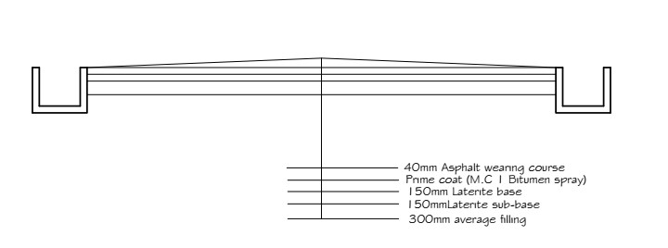
Plate 1.0: Road cross section

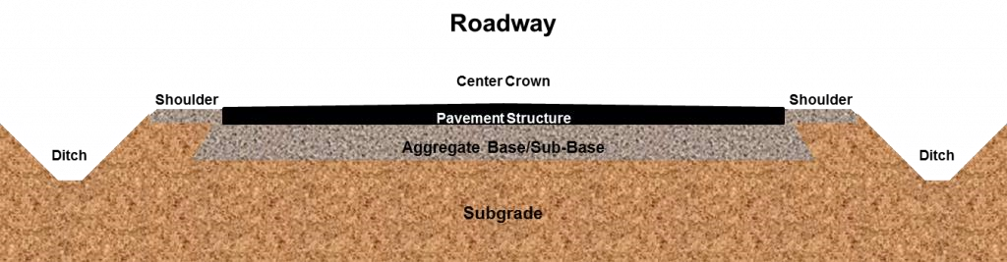
Plate 2.1: Road cross section

2.2.1 ROAD AND WATER
The greatest threat to an asphalt road is water. When a road is laid down, it flexes and moves slightly to accommodate changes in temperature and load. All this flexing eventually leads to cracking. Water penetrates those cracks and through processes like freezing, causes damage to the roadway. Crack sealing cleans debris from these cracks then fills them with an asphalt based polymer that adheres to the sides and bottom of the cracks, preventing the water from getting in.
Depending on the climate, the materials used, the pavement conditions and the technique used, crack sealing will last three to eight years.
Crack sealing has two primary purposes:
- To prevent the intrusion of water through the crack into the underlying pavement structure.
- To prevent extraneous materials from entering the crack and causing further deterioration as the pavement expands and contracts with temperature changes.

2.2.2 CRACK SEALING PROCEDURES
For crack sealing, the most important aspect of the procedure is the preparation of the crack for treatment. Also, the season when the crack sealing is done will affect its performance. If the cracks need to be routed or sawed to remove extraneous material, it should be done before cleaning the cracks. The routing or sawing is best accomplished using a vertical-spindle router, rotary- impact router, or a random-crack saw. After doing the routing or sawing, clean the cracks using high-pressure air, sandblasting, wire brushing, hot air blasting or high-pressure water. Cleaning the cracks is an essential step to ensure that the sealant will adhere to the sides of the crack. After cleaning, check the cracks for depth. A backer rod should be placed in large deep cracks to conserve sealant. The backer rod should be a compressible, non-shrinking, non-absorbent material with a melting point higher than the temperature of the sealant. The backer rod should be about 25 percent wider than the crack, to prevent slipping or floating out after placing the sealant. After the cracks are prepared, they are sealed with liquid asphalt. Equipment used for crack sealing or filling varies from truckmounted pressure applicators with hand wands to pour pots. No matter what type of equipment is used, the crack should be filled with sealant material from the bottom to the top of the crack to prevent air bubbles from forming bubbles create weak spots in the sealant.
Pour only the amount of material that will fill the crack. Don’t try to completely fill the crack because it is a waste of filler. Coat the vertical surfaces of the crack with a small excess of filler deposited in the bottom of the crack. To prevent tracking, the filler should be 1⁄8 to 1⁄4 inch below the top of the crack. If necessary, use a squeegee to remove excess sealant on the pavement surface, and then blot with sand or limestone dust

2.2.3 ROADWAY EXCAVATION
The work consist of all the required excavation within the limits of the right of way unless covered by other Sections of these Specifications. This shall include excavation of side ditches, where required, the removal, hauling and proper utilisation or disposal of all excavated materials and shaping of excavation and preparation of exposed surfaces of excavation on the entire length of the roadway, in accordance with these Specifications and to the lines, levels, grades, dimensions and cross sections shown on the Drawings or as required by the Engineer. The works specified shall also include operations in part widths and small areas of roadway where directed by the Engineer without any extra cost to the Employer.
Roadway excavation shall include the following:
- All excavation indicated on the Drawings within the limits of the cross sections and
excavation of all materials for side roads and intersections.
- The removal of existing pavement, sidewalks, kerbs and gutters within the limits of
construction.
- Excavation for stream and channel changes where not covered under Section 2.4, Channel Excavation.
- Excavation required in cuts under embankments below the lowest normal limit of
excavation indicated on the Drawings or below ground line and for the removal of unsuitable material. Materials from roadway excavations shall be classified as suitable or unsuitable as fill material, or as road pavement material, by the Engineer. To be suitable as fill material, soil must not contain roots, sods or other deleterious materials.
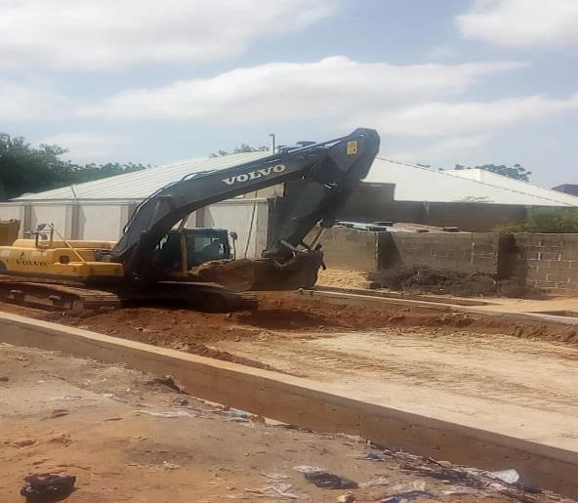
Plate 2.2: Roadway Excavation

2.2.4 FILLING AND GRADING
Laterite is filled into the cut portion of the road and compacted using sheep foot roller and smooth wheel roller. Laterite is a deep brown soil of cellular structure, easy to excavate, but gets hardened on exposure to air owing to the formation of hydrated iron oxides. The CBR (California Bearing ration) ratio of the laterite on our site is 85%. The laterite is brought form the borrow pit, the borrow pit is a hole dug to a certain depth where laterite of good CBR ratio can be obtained. There are three borrow pits where the laterite is been brought;
- Damaturu which is about 130km from Maiduguri,
- Nyaleri which is about 65km from Maiduguri, Gujubawo.
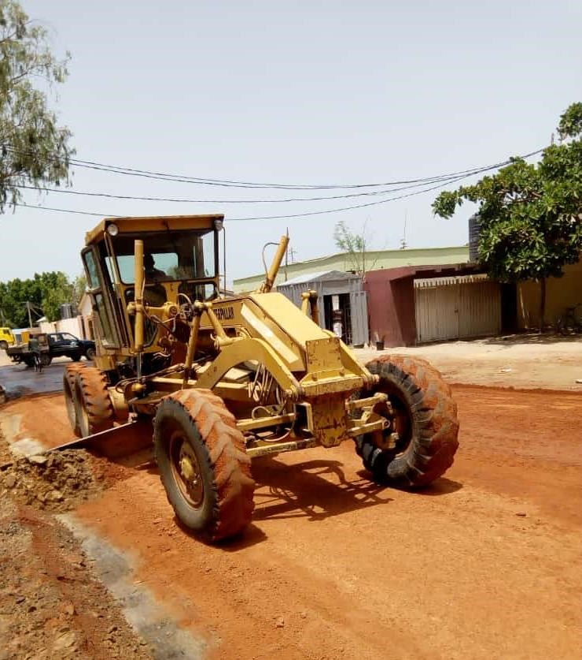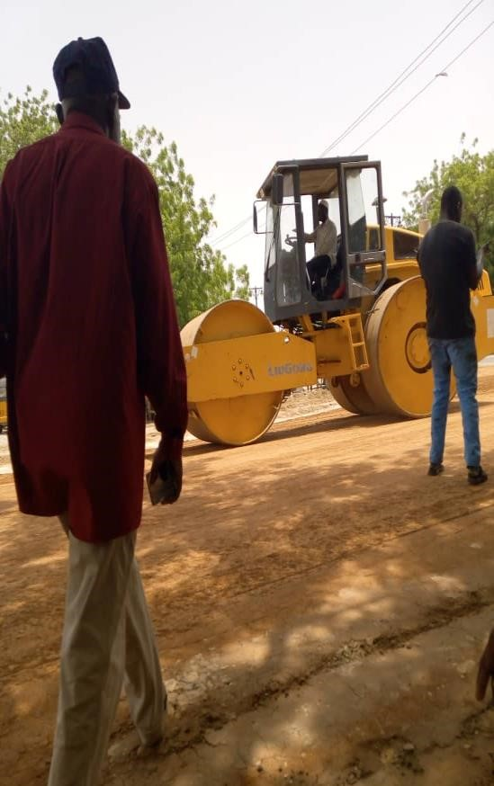

Plate 2.3: Road grading Plate 2.4: laterite compaction

2.3 SPRAYING OF WATER
Water is sprayed on the laterite to give it the required moisture just enough to allow maximum compaction. Also water is sprayed after compaction of laterite when there will be another layer of laterite to be laid on the current layer to create bond between the two layers.
This was done the water bauxer.
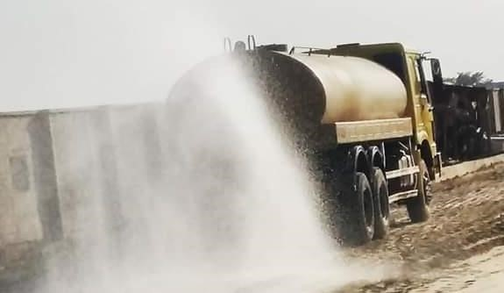
Plate 2.5: spraying of water by the water bauxer

2.3.1 FIELD COMPACTION
Most of the compa*ction in the field is done with the aid of compaction equipment such as rollers. The four most common types of rollers are:
- Smooth-wheel rollers: they are suitable for proof rolling sub-grades and for finishing operation of fills with sandy and clayey soils. These rollers provide 100% courage under the wheels, with the ground contact pressure as high as 310 to 380 KN/m². They are not suitable for producing high nit weights of compaction when used on the thicker layer.
- Pneumatic rubber tyre rollers: they are heavily loaded with several rows of tyres. The contact pressure under the tyre ranges from 600 to 700 KN/m², and they produce up to 70 to 80% courage. Pneumatic rollers can be used for sandy and clayey soil compaction.
- Sheep foot rollers: these are drums with large number of projections. The area of each projection ranges from 25 to 85 cm². These rollers are most effective in compacting clayey soils. The contact pressure under the projection ranges from 1400 to 7000 KN/m². These projections help in creating bond between the current layer of soil and the next layer of soil to be laid.
- Vibratory Rollers: they are extremely efficient in compacting granular soils. Vibrator con be attached to smooth-wheel, pneumatic robber type, or sheep foot rollers to provide vibratory effects to the soil. Factors affecting field compaction
- Soil type and moisture content
- Thickness of the layer of the soil
- The intensity of pressure applied by the compacting equipment
- The area over which the pressure is applied

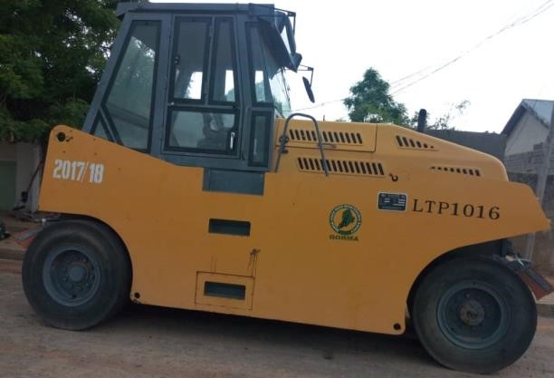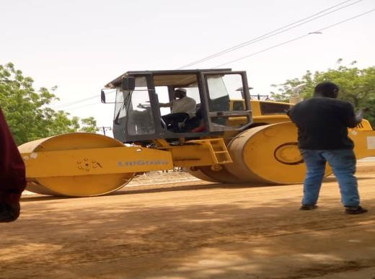

Plate 2.6: Pneumatic rubber tyre roller Plate 2.7: Drum wheel roller

2.3.2 PRIMING
This is the spraying of MC1 (Medium curing) on the surface of the prepared base course material e.g. laterite or stone base. After spraying the MC1, it should be allowed for about 1-hourto allow it penetrate into the base course material. It is recommended to spray
0.9 l/m², 1.o l/m² or 1.1l/m².
MC1 is one of the amongst the product of cutback bitumen. After applying MC1, it s hould be allowed to cure for a minimum of 48 to 72 hours before asphalt is placed, with no rain in the forecast. The temperature of MC1 during the application process should not be less than 150⁰C.The main purpose of priming is to;
- To coat and bond loose material particles on the surface of the base,
- To harden or toughen the base surface to provide a work platform for construction equipment,
- To plug capillary voids in the base course surface to prevent migration of moisture,
- To provide adhesion between the base course and the succeeding asphalt course. For the prime coat to be successful, it must be able to penetrate into the base course at least ½ inches.
-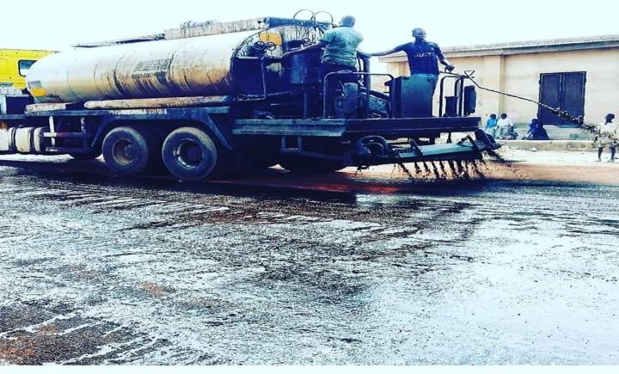
Plate 2.8: Bitumen Boiler

2.3.3 BLINDING
After application of MC1 (prime coat) to the base and the asphalt is not readily available from the Marini, blinding is done. This is the application of river sand OR Quarry dust after priming to;
- Remove the air voids in the MC1,
- To allow vehicles to use the roads immediately after priming and blinding,
- To prevent the MC1 from sticking to the tyres of vehicles thereby cleaning it away from the applied surface.
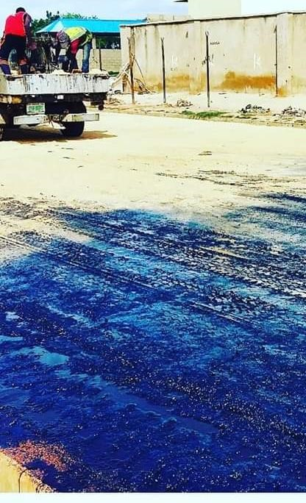
Plate 2.9: blinding of the primed surface using quarry dust

2.3.4 ASPHALT OVERLAYING
An asphalt overlaying is simply the process of installing a new layer of hot mix asphalt directly over the existing asphalt on roads. The main aim of overlay is to add structural support to the existing pavement. Overlaying existing asphalt is a good solution when the existing road is still in decent shape and the existing elevations will allow proper drainage without milling of the entire surface. To maximize the overlays useful life, failed sections of the existing pavement were cut, excavated and replaced. If the percentage of bitumen in the asphalt mix is high, it will result in folding of the road surface and if the percentage of the aggregates is higher in the mix, it will result in excessive cracking of the road. This not only results in poor surface, but it result in a surface that retains water, thereby reducing the life span of the road by accelerating the ravelling process.
Hot mixed asphalt is manufactured at temperatures between 270ºF and 325ºF, depending on the environmental conditions and the distance from the hot mix plant to the site, hot mixed asphalt can lose between 5ºF and 25ºF.After overlaying the hot asphalt, it is left for the temperature to cool to a temperature below 80ºc before compaction is started. The measurement of temperature at our site is done by the use of thermometer. If the compaction process is started at a temperature above 80ºc, it leads to development hairy crack which enlarges as time passes.
In the overlay process, if the hot mix asphalt pavement cools too quickly, the entire surface will ravel living a rough, rocky surface in a short period of time.
For the compaction of the newly over-laid asphalt, smooth wheel and pneumatic rubber tyre rollers are used. The smooth wheel roller compacts it first, water is sprayed to the wheel so that the asphalt does not stick to the wheel during the compaction process.
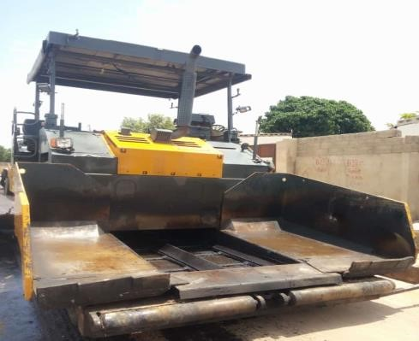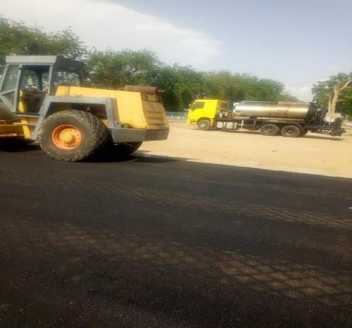
Plate 2.9.1: pneumatic finisher ready for use Plate 2.9.2: compaction of laid asphalt

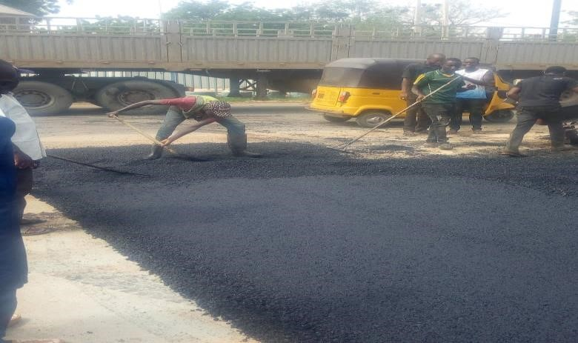
Plate 2.9.3: workers spreading asphalt

CHAPTER THREE 3.0 ASPHALT PLANT
This chapter discussed our visit to the drum mixing asphalt plant located along Gubio road. The main purpose of the asphalt plant is to produce Asphalt. We were shown the machines involved in the production of asphalt and the procedure involved was thoroughly explained to us. Some of the equipment used was:
- Hopper: there are about four hoppers at the Marini namely: hopper 1, hopper 2, hopper 3 and hopper 4. The hopper has a conveyor belt used for transporting the aggregates to another section of the production process. The aggregates fall onto the conveyor by gravity.
- Dryer: used to dry moist aggregate that enters it. Its temperature ranges between 150⁰c and 170⁰c.
- Bunner fan/Air Blower: this helps in pumping air into the dryer. It also sprays diesel to the dryer and flames it to create fire.
- Hot Elevator: this collects the hot aggregates and passes it to the mixer.
- Mixers: this is used to mixes the aggregates with bitumen by the use of Paddles. The mixture is then dumped into a bucket.
- Bitumen Storage Tank: this is used for heating the bitumen.
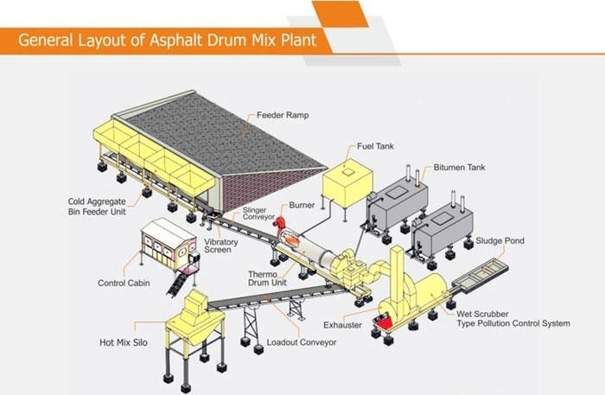
Plate 3.0: General layout of Asphalt drum mix plant

3.1 MATERIALS
- Aggregates: the main aggregates used in mixing asphalt at the Marini are  inch,
 inch,  inch, Quarry dust, river sand and Bitumen.
- Bitumen: Production of Bitumen:
Bitumen is the residue or by-product when the crude petroleum is refined. A wide variety of refinery processes, such as the straight distillation process, solvent extraction process etc. may be used to produce bitumen of different consistency and other desirable properties. Depending on the sources and characteristics of the crude oils and on the properties of bitumen required, more than one processing method may be employed.

3.2 FORMS OF BITUMEN

Cutback bitumen
Normal practice is to heat bitumen to reduce its viscosity. In some situations preference is given to use liquid binders such as cutback bitumen. In cutback bitumen suitable solvent is used to lower the viscosity of the bitumen. From the environmental point of view also cutback bitumen is preferred. The solvent from the bituminous material will evaporate and the bitumen will bind the aggregate. Cutback bitumen is used for cold weather bituminous road construction and maintenance. The distillates used for preparation of cutback bitumen are naphtha, kerosene, diesel oil, and furnace oil. There are different types of cutback bitumen: rapid curing (RC), medium curing (MC), and slow curing (SC). RC is recommended for surface dressing and patchwork. MC is recommended for premix with less quantity of fine aggregates. SC is used for premix with appreciable quantity of fine aggregates. Other forms of bitumen include Bitumen emulsion, Bitumen Primers, and Modified Bitumen.

3.3 TYPES OF BITUMEN
- 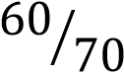
- 
III. | MC1
IV. | S125
The most preferred type of bitumen required for asphalting are: 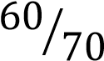 and
 while the most preferred type of bitumen required for priming is S125
and Mc1.
- Asphalt: This is the product gotten from the mixture of aggregates, river sand and bitumen. The mixture is done in percentage based on the required quality of asphalt needed. E.g. 33% of ½ inch, 33% of 3/8 inch, 36% of ¾ inch, 30% of river sand and 4.0% of bitumen.
Basically, when the entire aggregate particles (including the large aggregate particles) are coated with asphalt, the mix is said to be properly mixed.
- Oil: This is used together with the heater to heat the bitumen and it also helps in preventing the bitumen from flaming during the heating process.

PICTURES OF SOME PART OF THE PLANT
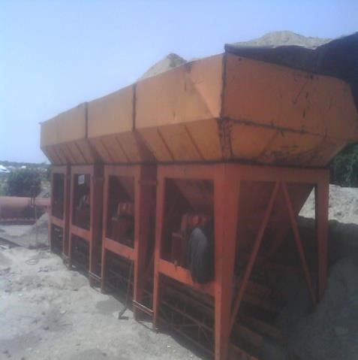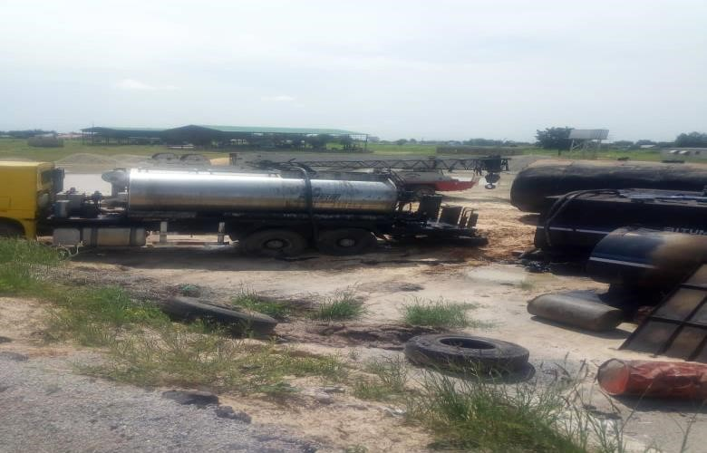
Plate 3.1: Hopper or cold bin feed Plate 3.2: Bitumen boiler supplying bitumen
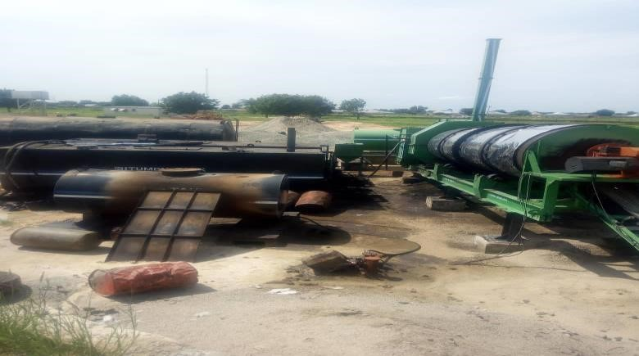
Plate 3.3: Arrangement of the mix plant

CHAPTER FOUR 4.0 DRAINAGE SYSTEM
One of the most important aspects of the design of a road is the provision made for protecting the road from surface water or ground water. If water is allowed to enter the structure of the road, the pavement will be weakened and it will be much more susceptible to damage by traffic. Water can enter the road as a result of rain penetrating the surface or as a result of the infiltration of ground water.
The road surface must be constructed with a sufficient camber or crossfall to shed rainwater quickly and the formation of the road must be raised above the level of the local water table to prevent it being affected by ground water.
Water can also have a harmful effect on shoulders, slopes, ditches and other features. High water velocities can cause erosion which, when severe, can lead to the road being cut. Alternatively, low velocities in drainage facilities can lead to silt being deposited which, in turn, can lead to a blockage. Blockages often result in further erosion.
A good road drainage system, which is properly maintained, is vital to the successful operation of a road. It has four main functions:
- To convey rainwater from the surface of the carriageway to outfalls
- To control the level of the water table in the subgrade beneath the carriageway
- To intercept ground and surface water flowing towards the road
- To convey water across the line of the road in a controlled fashion.
The first three functions are performed by side drains and the fourth by culverts, drifts and bridges.

4.1 SIDE DRAINS
The cost of side drains will normally be calculated as part of the cost of earthworks Side drains should be flat-bottomed if they are to be maintained by hand or 'v'-shaped if they are to be maintained by machine. Wide flat drains, known as 'meadow drains', can be used with advantage if there is room. The longitudinal gradient ofside drains should always exceed 0.5 per cent to reduce the possibility of silting up. In hilly terrain, providing side drains with the same gradient as the road may result in water velocities that are too high. It may therefore be necessary to reduce the maximum gradient to an acceptable level by the provision of shallow dams or scour checks. These are often constructed of masonry, but can also be constructed in concrete or even timber. Wide drains are preferred to reduce the velocity and so minimise erosion. The provision of turnouts or cut-off drains should also be considered to reduce or control the amount of water in the side drains. Costing may need to take account of these and the need to line drains with masonry or concrete in highly erodible soils.
Various stages of side drain construction can be see in the figures below;
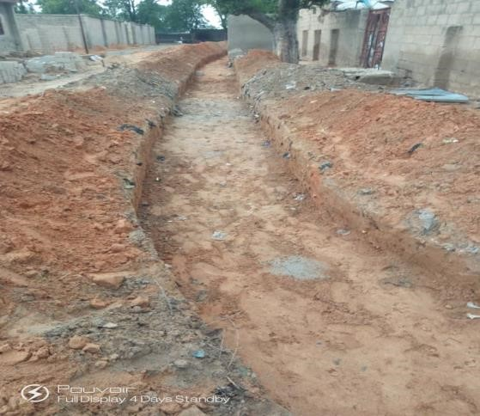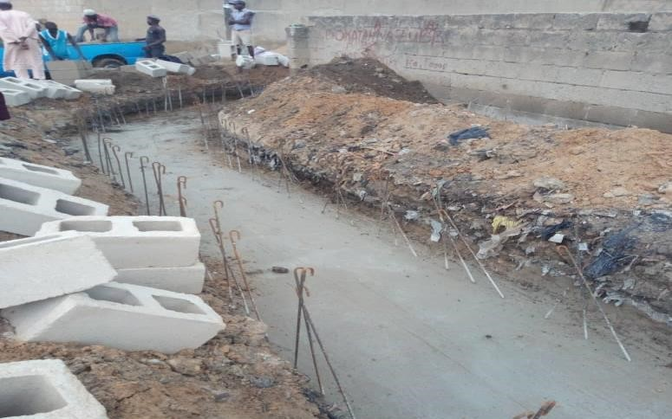

Plate 4.0: Excavated Drainage trench Plate 4.1: Blinding and concrete base
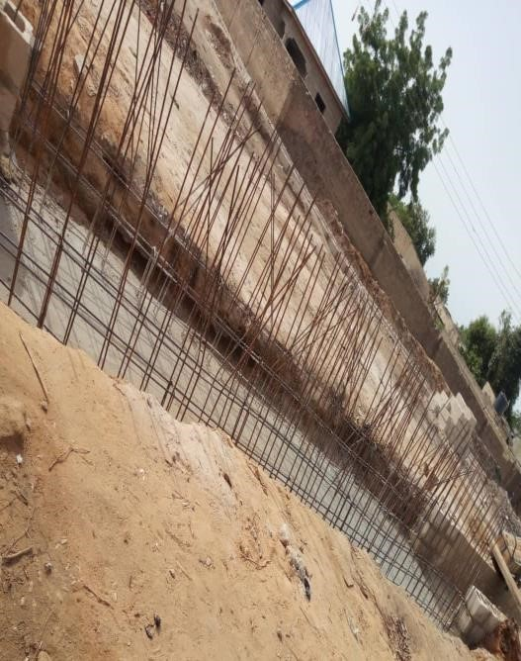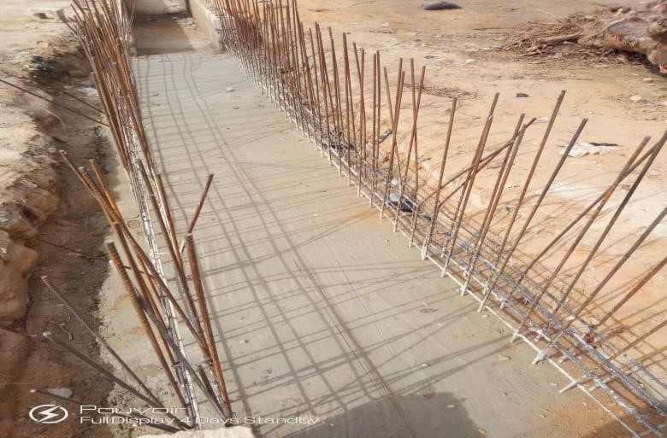
Plate 4.2: Arranged re-bars Plate 4.3:Arranged re-bars with concrete base
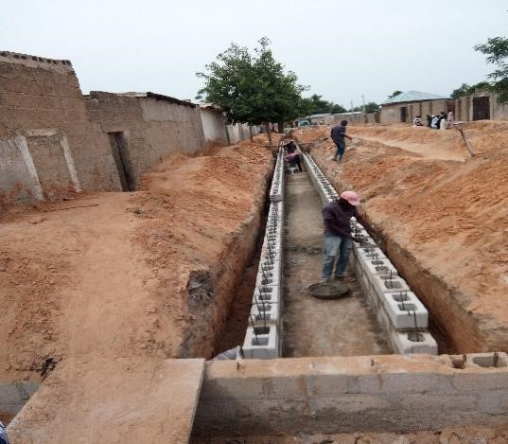
Plate 4.4: block drainage under construction
The use of culvert pipes to convey surface water under a road alignment is common, and provides a relatively cheap and durable solution. Most countries make concrete pipes of up to one metre diameter and these may be cost effective provided that they can be transported and handled. Corrugated galvanised steel pipes, often known by the trade name 'Armco', are available in larger diameters and are usually more expensive, but lighter and easier to handle. There should be little maintenance required for either material other than an annual inspection and clearing of accumulated silt or debris, although corrosion may occur to metal pipes in some circumstances. Culvert pipes require headwalls to protect the ends of the pipe and to direct water either towards or away from the culvert. The outfall of the culvert must be protected against scour and environmental damage downstream.
A culvert is an opening through an embankment used for the conveyance of water by mean of pipe or an enclosed channel, or it is a transverse and totally enclosed drain under a road or railway. It is typically embedded so as to be surrounded by soil. A culvert may be made from pipe, reinforced concrete or other material. A structure that carries water above land is known as aqueduct.
Culverts are commonly used both as cross-drains for ditch relief and to pass water under a road as natural drainage and stream. A culvert may be a bridge – like structure design to allow vehicle or pedestrian traffic to cross over the water way while allowing the adequate passage for the water.
The culvert type and shape selection is based on a number of factors including a) Requirement for hydraulic performance
- Limitation on upstream water surface elevation
- Roadway embankment height.

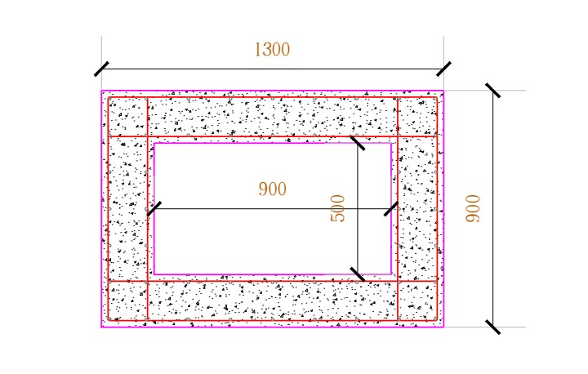
Plate 4.5: cross section of a culvert

CHAPTER FIVE 5.0 SUMMARY
I observed that Civil Engineers use their conceptual design method to build a structure for safety, stability, economy and durability. But at the same time supervising the project closely to make sure it is being executed exactly the way the design was and plan. they also accept material base on what the specification comes from the client to avoid using materials of poor quality that may alter their design calculation, for this may result in the failure of their structure.

5.1 CONCLUSION
This report has been able to x-ray an account of the entire work – experience garnered by me at the Borno State Road Maintenance Agency (BORMA) for the past 4 months, I had the oppoutunity to see practical application of what I learned in my classes that comprises of use of earth moving equipment’s use in excavation, grading earth spreading and piling, soil watering, compaction, spreading of MC₁ , asphalt laying. In structural work how scafolding places.
This experience made it possible for me to relate what I was taught in class with exactly what is happening on site.
I therefore concludes that SIWES is of great benefit to students in tertiary institutions. It therefore implies that the proper and effective administration of SIWES will go a long way in boosting and enhancing the competencies of the workforce of the country.

5.2 RECOMMENDATION
In view of the relevance of the SIWES program, it is important that it is sustained by the government through the Industrial Training Fund (ITF) as it exposes the student to work tools, facilities, and equipment that may not be available in their respective institutions in relation to their course of study. To this end, I recommend that the following under-listed points should be implemented:
1.Students’ Industrial Works Experience Scheme (SIWES) needs to be strengthened by all concerned stakeholder in order for its objectives to be fully realized.
2.Regular monthly allowances for students on attachment should be paid promptly.
3.Organizations should always accept students for SIWES and subsequently assign them to relevant jobs. Experience staff should always be made to train the students on attachment
4.There should be more funding of the scheme by the government in order for it to be more effective.

REFERENCES
- COREN (1991). Supervised Industrial Training Scheme in Engineering (SITSIE).
Formerly Council of Registered Engineers of Nigeria.
- Ekpenyong, L.E. (2011). Foundations of Technical and Vocational Education: Evolution and Practice for Nigerian Students in TVE and Adult Education, Policy Makers & Practitioners.
- Ekwue, K.C. & Eluro, D.C. (2002). Business Education for industry. The SIWES Experience. Business Education Journal, 11(5), 9-14.
- ITF (1973). Policy Document No 1. Industrial Training Fund, Jos, Nigeria. A lecture note on Highway Engineering by Engr. Ali Garga (unpublished)
- A lecture note on Soil mechanics by Engr. Prof. A.M kundiri (unpublished) The internet as an additional source

Appendix
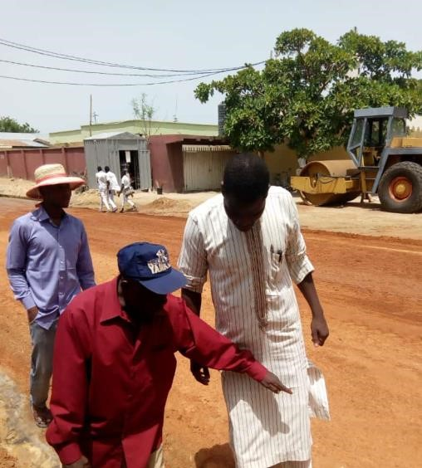
Plate 1: Image showing Engr, yakubu briefing on compaction

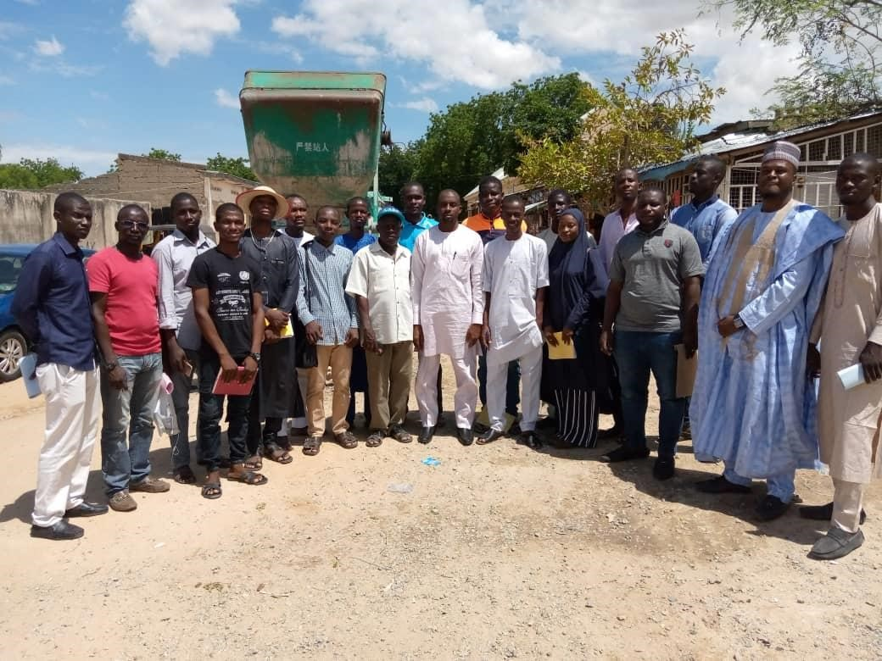
Plate 2: Image showing the group with Engr.Nura Mu’azu during his visit to the site
View publication stats

