

TECHNICAL REPORT ON STUDENT INDUSTRIAL WORK EXPERIENCE SCHEME (SIWES)
SIWES REPORT
UNDERTAKEN AT
WALI SUM HOUSE FM
OFF SOBI ROAD, ILORIN KWARA STATE
BY
IBRAHEEM SHEKINAT ALAKE
ND/23/MAC/PT/0079
SUBMITTED TO DEPARTMENT OF MASS COMMUNICATION TECHNOLOGY, INSTITUTE OF INFORMATION AND COMMUNICATION TECHNOLOGY, KWARA STATE POLYTECHNIC, ILORIN
IN PARTIAL FULFILMENT OF THE REQUIREMENT FOR THE AWARD OF NATIONAL DIPLOMA (ND) IN MASS COMMUNICATION,
AUGUST, 2024
TABLE OF CONTENTS
Title Page
Dedication
Acknowledgement
Abstract
CHAPTER ONE
  - Introduction
  - Historical Background Of The Organization
  - Objective of SIWES
  - Description of The Establishment Of Attachment
CHAPTER TWO
2.0 Introduction about the Company
CHAPTER THREE
3.0 Job Done/Experience Gain
Processes
Transmitter and modulation
Propagation
Resonance
Communication systems

Transmitters

CHAPTER FOUR
4.0 Problem Encountered and Possible Solution

DEDICATION
This report is dedicated to Almighty God for His divine mercy on me and my family who has given me the strength, wisdom, knowledge and understanding in working toward my success, I also dedicate this report to my parent and the family for their support and to my supervisor for the success of this report.

ACKNOWLEDGEMENT
To God who owns life, I wish to express my sincere appreciation and gratitude for serving me throughout my Siwes Report in Kwara State Polytechnic, and for making my vision come to reality, also for His Goodness, Mercy, Provision and Grace upon my life.
My profound gratitude goes to my sincere appreciation goes to my Dear Parent Mr. & Mrs. IBRAHEEM my God be with you.
My special thanks goes to the head of Department and the Entire staff of Mass Communication Department, Institute of Information Communication Technology, Kwara State Polytechnic, Ilorin for sharing wealth of Experience with me in my course of study.
Furthermore, thanks goes to my honorable and diligent supervisor for his advice, guidance and adequate encouragement relish from him which has contribute in no more small measure to the success of completion for this report.
Finally, my sincere gratitude also goes to my lovely friend both within and outside the institution.

ABSTRACT
This report gives a good account of the training and experience which exposed student during the Student Industrial Work Experience (SIWES) at all Information and Communication Institute.

CHAPTER ONE
INTRODUCTION
1.0 INTRODUCTION TO SIWE
The student industrial work experience scheme (SIWES) can be defined as a technical skill and acquisition of knowledge from the organization, industrial sector. It also serves as a motive that compliments the learning which student have acquired in the classroom or theoretically.
The student industrial work experience scheme is in practical fulfillment of TCS 210 of becoming a competent student in the field. It is a major work which is to expose student to the practical aspect of what they are been thought in class. During the course of study, I was posted to the programs department of the establishment.
1.1 BACKGROUND OF SIWES
The student industrial work experience scheme (SIWES) was established by ITF in 1973 to solve the problem of lack of adequate practical skill preparatory for employment in various industries by Nigerian graduates of tertiary institution.
The purpose of the scheme is to expose student to different kinds of industrial based skills necessary for a smooth transition from classroom to the world of labor. It afford the student of tertiary institution the opportunity of being engaged, familiarized and expose to the needed experience in handling various kinds of equipment and machine which are usually not available in the educational environment or institution.
However, participation in siwes has becomes a necessary pre-condition for the award of diploma in most institution of higher learning in the country, in accordance with the education policy of the government.
1.2 OBJECTIVES OF SIWES
The objectives of the student industrial work experience scheme (SIWES) as a follow:
It improves student’s knowledge about the industrial sector or organization.
It enable the student to practicalised different test form what they have learnt theoretical in the classroom. It relates the student to the labor market and how it’s being operated.
It also enlighten student to various division of industries or organization of work in which their course of study can be practicalised.
It enable student to know more the technological innovation in course of study, and some equipment which are or involved.
It enable student to know the practical aspect of chosen field of study.
1.3 Description of the establishment of attachment.
The Nigeria Television Authority, Ilorin was established in 1977. Its maiden transmission of programmed was from Lagos via satellite.
Between 1977 and date, the station has undergone tremendous changes which today have made it the toast of viewers and clients within and outside the state.
At present, the station has staff strength of ninety-one, headed by the General Manager T.R Gyang and it transmits 24 hours on weekdays.
Apart from contributing its quota in area of informing, educating and entreating it viewers, the station has produced several award winning programs in areas of drama transmission of programs from Lagos via satellite. The station had four transmitter stations and four link or relay station through which it was able to transmit to Kwara state, parts of Niger, Oyo, Ondo, Osun, Ekiti and Kogi state. NTA Ilorin hooks up with the NTA Network service to bring live news from all part of Nigeria and the world at large. The station has eihgt substantive General Mangers since its in caption in 1977. Engr. D.J Awoniyi was the first General Manager and his tenure was between 1977 and 1981;Mrs Chief Peter O. Olowo was General Manager between 6th may 1982 and October 1990; Mr J.D Angulu was General between 1990 and 1994; Mrs Vicky was General Meneger between November between 1st July 1994 and October 1994; Mrs. Araba A. Vincent was General Manager between November 2000 and February2004; Prince Adebimpe Idowu was General Manager between 2004 and 2005; Mr Dayo Salaeu was Genral Manager between December 2005 and septermber 2008 whilst Chief Thomas R. Gyang is the present Incumbent. Under the NTA Ilorin, we have two local government stations that are NTA Ogbomoso and NTA Patigi. NTA Obgomoso is fully operational and NTA Patigi is yet to take off operationally.
The present management team of NTA Ilorin includes:
Chief T.R. Gyang _______ General Manager.
T.A Olasehinsde ______ General Manager.
Hajia Moriliat T.O Adamu__ Manager. Administration.
Yinka Ajayi ___ Manager News and Current. Affairs.
Taiye Ogunderin ____ Manager programmes.
Yakubu G. Oladele _____ Marketing Manager.
Samuel Osawu ____ Chief Technical officer.
Engr. J.O Babajide __Manager-In-Charge, NTA Patigi.
Mrs Remi Awolola __ Manager-In-Charge, Ogbomoso.

CHAPTER TWO

2.0 ABOUT COMPANY
Although the idea of establishing a television station in kwara state was conceived as far back as 1971, some early teething problem did not make for its takeoff. Following a meeting in 1971 by a number of journalists who are indigenes of the state with military Governor Lieutenant-colonel Lasisi Bamigboye, the idea of establishing a newspaper and television station was conceived both of which was considered necessary for the state.
The then government gave its blessing to the immediate establishment of a newspaper, while accepting the idea of a television station in principle. The newspaper, known as “Nigeria Herald” started two years (1975) while feasibility studies for the television also started the same year. The change of Government in 1975 threatened the establishment of the station in Ilorin, but in view of the large sum of money already into the project, there could be no going back.
The final indication that the project will eventually take-off early in February 1977 when adverts for workers in the proposed station were placed in the newspapers. In may 19 77, Nigeria Television Authority Ilorin was finally given birth to, under the management of kwara state Ministry of information, however automatically became one of the stations took over by the Nigeria Television Authority following the Federal Government’s order under General Olosegun Obasanjo military administration announcement in 1975 of it’s intention to take over all television in Nigeria. The Nigeria Television Authority was finally inaugurated in May 1977 but took effect from April 1978. By that degree the Nigeria Television Authority became the only body empowered to undertake television broadcasting in the country.

CHAPTER THREE
3.0 JOBS DONE / EXPERIENCE GAINED
On my first day at the WALI SUM HOUSE FM station, I was first given a rundown of the studio safety rules and regulations. I took time to peruse through, and understand, this safety rules. I was also introduced to the management and various departments in the company, after which I was shown some transmission and broadcasting machines.
SAFETY RULES AND REGULATIONS
General Safety Rules When using the studios for broadcast or production.
Health & Safety
• REPORT ANY INJURIES TO THE TEACHER IMMEDIATELY!
• Learn the location of the nearest fire extinguisher
• NEVER MOVE ANYTHING HEAVY BY YOURSELF. Some of the equipment in the station is very large and heavy. Avoid back strain or other bodily harm by working with a partner.
• NEVER MOVE ANYTHING IF YOU HAVE PREVIOUS INJURIES. If you have preexisting back injuries, other physical injuries, or health issues that may be aggravated by moving an object, notify the Radio Operations Manager and/or your teacher, and do not move anything.
• Keep all food and drink out of all studios and the radio office area.
• Keep all exits free of obstruction and keep belongings in designated areas.
• Turn off (or airplane mode) all cell phones and other electronic communication devices before entering any radio broadcast or production studio.
• Never enter a studio above which the “onair” light is illuminated.
This studio is meant to accommodate 3 talent onmic.
The studio doors must always be closed when broadcasting.

Introduction
Broadcasting, Radio and Television, primary means by which information and entertainment are delivered to the public in virtually every nation around the world. The term broadcasting refers to the airborne transmission of electromagnetic audio signals (radio) or audiovisual signals (television) that are readily accessible to a wide population via standard receivers.
Broadcasting is a crucial instrument of modern social and political organization. At its peak of influence in the mid-20th century, national leaders often used radio and television broadcasting to address entire countries. Because of its capacity to reach large numbers of people, broadcasting has been regulated since it was recognized as a significant means of communication. (For more information, see the section "The Regulation of Broadcasting.")
Beginning in the early 1980s, new technologies–such as cable television and videocassette players–began eroding the dominance of broadcasting in mass communications, splitting its audiences into smaller, culturally distinct segments. Previously a synonym for radio and television, broadcasting has become one of several delivery systems that feed content to newer media.
II. The Emergence of Broadcast Communication
Throughout history, long-distance communication had depended entirely upon conventional means of transportation. A message could be moved aboard a ship, on horseback, by pigeon, or in the memory of a human courier, but in all cases it had to be conveyed as a mass through space like any other material commodity.
Radio
Radio is the radiation (wireless transmission) of electromagnetic energy through space. The biggest use of radio waves is to carry information, such as sound, by systematically changing (modulating) some property of the radiated waves, such as their amplitude, frequency, phase, or pulse width. When radio waves strike an electrical conductor, the oscillating fields induce an alternating current in the conductor. The information in the waves can be extracted and transformed back into its original form. Radio systems need a transmitter to modulate (change) some property of the energy produced to impress a signal on it, for example using amplitude modulation or angle modulation (which can be frequency modulation or phase modulation). Radio systems also need an antenna to convert electric currents into radio waves, and vice versa. An antenna can be used for both transmitting and receiving. The electrical resonance of tuned circuits in radios allows individual stations to be selected. The electromagnetic wave is intercepted by a tuned receiving antenna. A radio receiver receives its input from an antenna and converts it into a form usable for the consumer, such as sound, pictures, digital data, measurement values, navigational positions, etc. Radio frequencies occupy the range from a 3 kHz to 300 GHz, although commercially important uses of radio use only a small part of this spectrum.

A radio communication system sends signals by radio. The radio equipment involved in communication systems includes a transmitter and a receiver, each having an antenna and appropriate terminal equipment such as a microphone at the transmitter and a loudspeaker at the receiver in the case of a voice-communication system.

Processes
Radio communication. Information such as sound is converted by a transducer such as a microphone to an electrical signal, which modulates a radio wave sent from a transmitter. A receiver intercepts the radio wave and extracts the information-bearing electronic signal, which is converted back using another transducer such as a speaker. Radio systems used for communication have the following elements. With more than 100 years of development, each process is implemented by a wide range of methods, specialized for different communications purposes.

Transmitter and modulation
Each system contains a transmitter; this consists of a source of electrical energy, producing alternating current of a desired frequency of oscillation. The transmitter contains a system to modulate (change) some property of the energy produced to impress a signal on it. This modulation might be as simple as turning the energy on and off, or altering more subtle properties such as amplitude, frequency, phase, or combinations of these properties. The transmitter sends the modulated electrical energy to a tuned resonant antenna; this structure converts the rapidly changing alternating current into an electromagnetic wave that can move through free space (sometimes with a particular polarization).
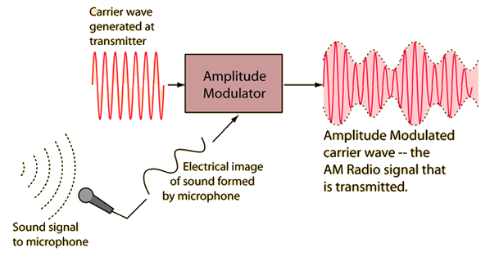

An audio signal (top) may be carried by an AM or FM radio wave.
Amplitude modulation of a carrier wave works by varying the strength of the transmitted signal in proportion to the information being sent. For example, changes in the signal strength can be used to reflect the sounds to be reproduced by a speaker, or to specify the light intensity of television pixels. It was the method used for the first audio radio transmissions, and remains in use today. "AM" is often used to refer to the medium wave broadcast band (see AM radio), but it is used in various radiotelephone services such as the Citizen Band, amateur radio and especially in aviation, due to its ability to be received under very weak signal conditions and its immunity to capture effect, allowing more than one signal to be heard simultaneously.
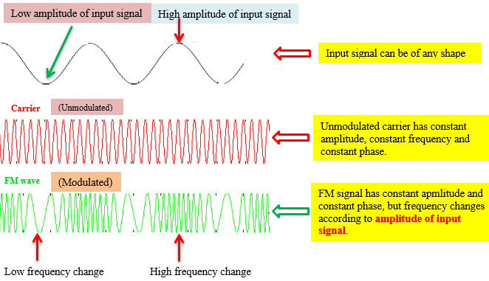
Frequency modulation varies the frequency of the carrier. The instantaneous frequency of the carrier is directly proportional to the instantaneous value of the input signal. FM has the "capture effect" whereby a receiver only receives the strongest signal, even when others are present. Digital data can be sent by shifting the carrier's frequency among a set of discrete values, a technique known as frequency-shift keying. FM is commonly used at Very high frequency (VHF) radio frequencies for high-fidelity broadcasts of music and speech (see FM broadcasting). Analog TV sound is also broadcast using FM.
Angle modulation alters the instantaneous phase of the carrier wave to transmit a signal. It may be either FM or phase modulation (PM).
Antenna.
Rooftop television antennas. Yagi-Uda antennas like these six are widely used at VHF and UHF frequencies.
An antenna (or aerial) is an electrical device which converts electric currents into radio waves, and vice versa. It is usually used with a radio transmitter or radio receiver. In transmission, a radio transmitter supplies an electric current oscillating at radio frequency (i.e. high frequency AC) to the antenna's terminals, and the antenna radiates the energy from the current as electromagnetic waves (radio waves). In reception, an antenna intercepts some of the power of an electromagnetic wave in order to produce a tiny voltage at its terminals, that is applied to a receiver to be amplified. Some antennas can be used for both transmitting and receiving, even simultaneously, depending on the connected equipment.

Propagation
Once generated, electromagnetic waves travel through space either directly, or have their path altered by reflection, refraction or diffraction. The intensity of the waves diminishes due to geometric dispersion (the inverse-square law); some energy may also be absorbed by the intervening medium in some cases. Noise will generally alter the desired signal; this electromagnetic interference comes from natural sources, as well as from artificial sources such as other transmitters and accidental radiators. Noise is also produced at every step due to the inherent properties of the devices used. If the magnitude of the noise is large enough, the desired signal will no longer be discernible; the signal-to-noise ratio is the fundamental limit to the range of radio communications.
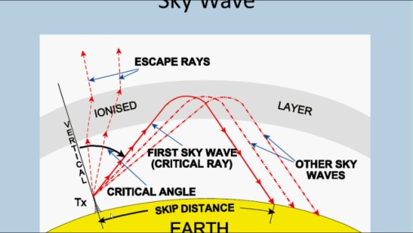

Resonance
Electrical resonance of tuned circuits in radios allow individual stations to be selected. A resonant circuit will respond strongly to a particular frequency, and much less so to differing frequencies. This allows the radio receiver to discriminate between multiple signals differing in frequency.

Receiver and demodulation
A crystal receiver, consisting of an antenna, adjustable electromagnetic coil, crystal rectifier, capacitor, headphones and ground connection.
The electromagnetic wave is intercepted by a tuned receiving antenna; this structure captures some of the energy of the wave and returns it to the form of oscillating electrical currents. At the receiver, these currents are demodulated, which is conversion to a usable signal form by a detector sub-system. The receiver is "tuned" to respond preferentially to the desired signals, and reject undesired signals.

Early radio systems relied entirely on the energy collected by an antenna to produce signals for the operator. Radio became more useful after the invention of electronic devices such as the vacuum tube and later the transistor, which made it possible to amplify weak signals. Today radio systems are used for applications from walkie-talkie children's toys to the control of space vehicles, as well as for broadcasting, and many other applications.
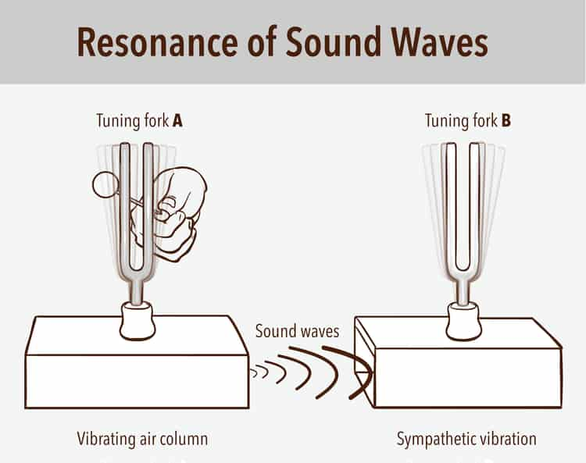

A radio receiver receives its input from an antenna, uses electronic filters to separate a wanted radio signal from all other signals picked up by this antenna, amplifies it to a level suitable for further processing, and finally converts through demodulation and decoding the signal into a form usable for the consumer, such as sound, pictures, digital data, measurement values, navigational positions, etc.

Radio band

Light comparison
Name | Frequency
Gamma ray | > 30 EHz (0.01 nm) | 124 keV - 300+ GeV
X-Ray | 30 EHz - 30 PHz (0.01 nm - 10 nm) | 124 eV to 120 keV
Ultraviolet | 30 PHz - 750 THz (10 nm - 400 nm) | 3.1 eV to 124 eV
Visible | 750 THz - 428.5 THz (400 nm - 700 nm) | 1.7 eV - 3.1 eV
Infrared | 428.5 THz - 300 GHz (700 nm - 1 mm) | 1.24 meV - 1.7 eV
Microwave | 300 GHz - 300 MHz (1 mm - 1 m) | 1.24 µeV - 1.24 meV
Radio | 300 MHz - 3 kHz (1 m - 100 km) | 12.4 feV - 1.24 meV

Radio frequencies occupy the range from a 3 kHz to 300 GHz, although commercially important uses of radio use only a small part of this spectrum.Other types of electromagnetic radiation, with frequencies above the RF range, are infrared, visible light, ultraviolet, X-rays and gamma rays. Since the energy of an individual photon of radio frequency is too low to remove an electron from an atom, radio waves are classified as non-ionizing radiation.

Communication systems
A radio communication system sends signals by radio. Types of radio communication systems deployed depend on technology, standards, regulations, radio spectrum allocation, user requirements, service positioning, and investment.

The radio equipment involved in communication systems includes a transmitter and a receiver, each having an antenna and appropriate terminal equipment such as a microphone at the transmitter and a loudspeaker at the receiver in the case of a voice-communication system.

The power consumed in a transmitting station varies depending on the distance of communication and the transmission conditions. The power received at the receiving station is usually only a tiny fraction of the transmitter's output, since communication depends on receiving the information, not the energy,that was transmitted.
Classical radio communications systems use frequency-division multiplexing (FDM) as a strategy to split up and share the available radio-frequency bandwidth for use by different parties communications concurrently.
Coverage
There are several factors influencing the coverage area:
· Location of the transmitter in relation to the desired coverage area
· Type and ‘pattern’ of the transmitting aerial
· Height of the transmitting aerial
· Power of the transmitter (and this is regulated in most countries)
· Terrain (how hilly is the area to be covered).

Transmitters
Transmitters are available with powers of a few Watts to several thousand Watts. A 50W transmitter may cover a small village or town
(if the aerial is high enough), whereas to cover a large city may require 5kW.
When selecting a transmitter the following parameters should be considered:
· Efficiency (there is no point paying for power which does not go into the aerial)
· Robustness (a modular design makes sense – a single failure will not render the whole unit inoperative)
· Remote control and diagnostics (often transmitters are sited in remote locations, difficult to get to)
What else is required?
In addition to the transmitter itself, several other components are required. An FM Processor is used to make your station sound ‘louder’ than its competitors, RDS allows data to be transmitted and displayed on suitably equipped receivers, a cavity filter reduces spurious emissions (and may be a regulatory requirement). Aerials need to be chosen carefully to ensure optimum coverage, connected with suitable ‘feeder’ cable to avoid losses.
More sophisticated systems will have back up transmitters with varying levels of change-over system. Dummy loads allow the transmitter to be tested independently of the aerial and feeder cable.
In situations where the transmitter is not located at the studio site, a Studio to Transmitter Link (STL) is required to get the signal from the studio to the transmitter.

CHAPTER FOUR
4.0 PROBLEMS ENCOUNTERED AND POSSIBLE SOLUTIONS
1. Difficulty in finding a place for industrial training is a big problem for students on the SIWES program. There are situations whereby you will write a company’s aptitude test, but because you do not know anybody within the company or that no one can speak on your behalf then you lose the placement.
Nigerian government in collaboration with SIWES should help students when it comes to securing a place for the training; or provide a policy that gives a Nigerian student right to be taken in any company he/she applied for the training. By so doing, the time wasted at home while searching for a place by the student will be minimized.

