

A TECHNICAL REPORT ON
STUDENT INDUSTRIAL WORK EXPERIENCE SCHEME (SIWES)

HELD AT
LAGOS STATE TELEVISION
PLOT 1 LATEEF JAKANDE ROAD, AGIDIGBA 101233, IKEJA LAGOS, NIGERIA

BY

LAWAL FATAI ABIODUN
MATRIC NO: ND/23/MAC/PT/0399

SUBMITTED TO
DEPARTMENT OF MASS COMMUNICATION,
INSTITUTE OF INFORMATION COMMUNICATION TECHNOLOGY (I.I.C.T)
KWARA STATE POLYTECHNIC, PMB 1375 ILORIN KWARA STATE

AUGUST – NOVEMBER, 2024.

DEDICATION
This report is dedicated to Almighty GOD for making everything easy for me throughout my Student Industrial Work Experience Scheme (SIWES) programme and to my parent Mr & Mrs LAWAL for their contribution to the success of this project. May Almighty God give you long life and prosperity (Amen)

ACKNOWLEDGEMENT
All praise, glory, honour and adoration to Almighty GOD, the author and the giver of wisdom, knowledge and understanding for the success of this programme.
I appreciate my parents which are my source to this world Mr & Mrs LAWAL for their parental and spiritual support because without their maximum understanding and support, this experience would have not come into existence including my brother and sister for their support.

PREFACE
The Student Industrial Work Experience Scheme (SIWES) is a National Diploma Curriculum of the Department of Mass Communication, Kwara State Polytechnic Ilorin. The programme was established by the Industrial Training Fund (ITF) in 1973 to 1974.
It is designed to acquire the student with life situation in industries as well as supplies in a more practical manner and their knowledge in practical activities and other practical field during their course of study.

TABLE OF CONTENTS
Title page
Dedication
Acknowledgement
Preface
CHAPTER ONE
1.0 INTRODUCTION
1.1 Background
1.2 Objectives of SIWES
CHAPTER TWO
2.0 Description of the Establishment of Attachment
2.1 Brief History of the Lagos Television Station
2.2 The Personnel’s of Lagos Television Station
CHAPTER THREE
3.0 TELEVISION STUDIO ROOM
3.1 Equipment’s used
CHAPTER FOUR
4.0 Work Experience
4.1 What is Television Programming?
4.2 Categories of Television Programs
4.3 Planning for Television Programming
4.4 Scheduling Strategies and Implementation
CHAPTER FIVE
5.0 RECOMMENDATION AND CONCLUSION
5.1 Recommendation
5.2 Conclusion
CHAPTER ONE
1.0 INTRODUCTION
1.1 Background
The Industrial Training fund established by decree 43 was introduced in 1971, vis-à-vis the birth of the Students Industrial Work Experience Scheme (SIWES) the same year by the Federal Government of Nigeria (FGN). It is against this background that the industrial training fund (ITF) initiated, designed and introduced SIWES Scheme in 1973 to acquaint students with the skills of handling employers’ equipment and machinery.
The Industrial Training Fund (ITF) solely funded the scheme during its formative years. However, due to financial constraints, the fund withdrew from the scheme in 1978. The Federal Government, noting the significance of the skills training, handed the management of the scheme to both the National Universities Commission (NUC), and the National Board for Technical Education (NBTE) in 1979. The management and implementation of the scheme was however, reverted to the ITF by the Federal Government in November, 1984 and the administration was effectively taken over by the industrial training fund in July 1985, with the funding solely boned by the Federal Government. It is an integral part of the requirements for the award of Certificates, Diplomas and Degrees in institutions of higher learning, e.g. Colleges of Education, Polytechnics, Universities, etc.
Student Industrial Work Experience Scheme (SIWES) exposes students to industry based skills necessary for a smooth transition from the classroom to work environments. It accords students of tertiary institutions the opportunity of being familiarized, exposed, and prepare students of universities, polytechnics, college of technology, college of agricultures and college of education for the industrial work situation they are likely to meet after graduation and to the needed experience in handling machinery and equipment which are not found in such an educational institution.
1.2 Objectives of SIWES
- To provide students with relevant practical experience.
- To satisfy accreditation requirements set by the Nigerian Universities Commission (NUC).
- To familiarize students with typical environments in which they are likely to function professionally after graduation.
- To provide student an opportunity to see the real world of their discipline and consequently bridge the gap between the University work and actual practice.
- To change the orientation of students towards labour market when seeking for job.
- To help students access area of interest and suitability for their chosen profession.
- To enhance students, contact for future employment
- To provide access to equipment and other facilities that would not normally be available in the University workshop
- To enlist and enhance industry involvement in university education.
- Summarily the objective of the Student Industrial Work Experience Scheme.
- To solve, the problem of inadequate practical skills, preparatory for employment in industries by Nigerian graduates of tertiary institution.
- To promote and encourage the acquisition of skills in industry and commerce, with a view of generating a pool of indigenous trained manpower sufficient to meet the needs of the economy.

CHAPTER TWO
2.0 DESCRIPTION OF THE ESTABLISHMENT OF ATTACHMENT
2.1 Brief History of the Establishment
The pioneer of the 1980 Lagos television station is the then commissioner for Information and Strategy Mr Dele Alake. It was the first television station to be established by a state government in October 1980 and it began transmission on November 9, 1980.
The purpose was for it to serve as a medium for the state government to disseminate information to the people. At the time, Alhaji Lateef Jakande was the first civilian administrator. Lekan Ogunbanwo, who was appointed Permanent Secretary in 2005 spearheaded the rejuvenation of the Station after its previous downfall.
This downfall was due to many reasons, some of which are; its switch from very high frequency VHF to ultra-high frequency UHF, the 1985 midnight inferno which consumed the entire legacy of the station. Today, Lagos television station serves as the pacesetter for state owned broadcast station in Nigeria.
2.2 THE PERSONELLES OF LAGOS TELEVISION STATION
- The Permanent Secretary: This role is headed by Mr Lekan Ogunbanwo. He can also be called the Chief Executive or the General Manager or the Chief Accounting Officer. He is responsible for the overall operation of a station. He has to be knowledgeable in the area of leadership and business and has to have a technical understanding of how the station operates. He works in association with other able personnel who form the managerial team. He controls both the material resources and financial resources of that station, also with the aid of these management bodies. The manager is responsible for both the failures and successes in any broadcasting station due to his responsibility to see to its smooth operation.
Some other important personnel not listed are, the receptionist, the news writer, the news reporter, the news anchor, maintenance engineers, master control/videotape engineer, the ENG editor, the Electronic News Gathering(ENG) crew, continuity writer, community relations director, assignment editor, they constitute the units available in every department.
- Director Administrator: It is headed by Mr Morakinyo Akinrinnade. He is in charge of the general administration, that is, he sees to staff promotion, staff welfare, staff employment, staff discipline, staff training, and coordination of transport facilities, supervision of purchase of stationary and the building of staff. He seeks the approval of the Permanent Secretary before granting certain provision, financial/material entitlement, to the staff.
- Director News: It is headed by Mrs Funke Moore. She supervises the news department and ensures that personnels and budgets are well managed and planned, respectively. She also sees to the acceptance of news contents that are informative and of great value to the local viewers. She assigns stories to reporters on staff and monitors the wire service. She is held responsible for all news coverage, reportage, production and transmission and also has a technical knowledge of how television operates. She sees to the approval of news stories that are not defamatory and therefore is strict in rendering professional guidelines and packaging of a news story. Under this body are other units which are;
The news reporter: These are the major people in the news department. They are usually found at any event and must be capable of writing news in a quick and accurate manner which would have in place the key elements of a news story in order to make it comprehensible to its audience.
The news writer: They research on latest news, what is new and current and they monitor news feeds. They book guests for live shows, write news feeds for the anchors, produce segments for the news program. They basically have the role of writing the news stories based on facts obtained from research and therefore must be capable of writing news effectively.
Assignment Editor: they are responsible for the gathering of the news that eventually goes into the program schedule. They set priorities for news coverage, the logistics of camera crew and reporters, they also prepare the satellite feeds in preparation for the live on-scene coverage of an event.
Executive Producer: He coordinates the content and presentation of broadcast programs and is supervised by the managing director and director news.
News anchor: They also possess the ability to write news stories, this is a unit in the news department that is actually seen by the viewers. The appear up-front on local newscast. They are complete journalist who are familiar with reporting live coverage.
- Director Programmes: He is responsible for the entire on-air product and has control over the production, talent, work schedule and programme schedule. He ensures that everything that goes on air is in accordance with the station's policy and is of high quality. He also governs the sound of the station and ensures that his programme objectives align with that of the general manager and general sales manager.
- Director Promotion: This department is not located within the organogram of Ltv station but is part of the personnel in a media house. They are responsible for the promotion of the station's image, program and activities. They work hand in hand with the programme department to produce on-air promotion. They also work with the sales department to secure new clients.
- Director Marketing: He helps convince investors to sponsor programmes, although the job of the director manager is limited because as a government owned station, advertisement is strictly rejected because it seeks to promote public affairs and is not driven by profit-making like private stations. It handles joint commercial ventures that drives national unity and not disintegration. It cooperates with the news department for commercial news. This department is primarily interested in sourcing for news for the station. He does this by marketing airtime, and through several other, but limited, revenue-yielding means.
- Director Current Affairs: His role is similar to that of the Director News. He is also the head of the editorial body and approves guests for all current affairs programmes.
- Director Production Service: He is basically in charge of every detail required in the actual production of the programming. He assigns announcers, schedules studio, arranges recording sections, produces commercials, and directs programs. In order to achieve these tasks, he supervises the producers, directors, floor directors and stage manager. He takes responsibility for a programme well done and one done otherwise.
Producer: He develops and organizes the program and is in charge of scripting, developing stories, booking guests to be showed on air, and overseeing the field production and editing.
Graphic Artist: He is involved in the production as well and is skilled in art and design and television production. He generally supports all production activities.
Director: He is responsible for the on-line execution of a program and serves as the producer for an entire program, in most cases, or for the production of a part of a larger program.
Production Assistant: He tries to help where necessary in the aiding of the production personnel.
Stage Manager: He is the representative of the director who takes his place on the studio floor and at the site of any live broadcast.
- Director Finance: It is headed by Mr Lawrence Ojo. He is responsible to the Permanent Secretary and handled the finance of the broadcast station. He plans budgets and controls the cash that flows out and that which flows in as well. He must be trustworthy and honest in the discharge of his duty.
- Director Engineering: It is headed by Mr Lakin Aina-Badejo. He heads the technical personnel and is the senior technical body at the broadcast station. He is also in charge of all broadcast equipment and their operations. He supervises the training of the engineering staff.
Maintenance Engineer: He installs and performs preventive maintenance on the station's control consoles, boards, and all electronic equipment. He is responsible for the repair, maintenance, installment and modification of all the electronic equipment in the station.
Master control/videotape Engineer: He is responsible for operating the videotape recording and playback equipment for live programs and also during commercial breaks in taped and network shows.
Studio Engineer: He operates all the equipment that would be used in the production of a program. They are the studio cameras, audio console, studio lighting, video switcher, the character generator and the electronic still-storage graphics display equipment.
Recording Engineer: they operate and maintain video and sound recording equipment. They also operate equipment that produce special effect such as a police siren.
All these are some of the personnel in Lagos Television Station. Others, as listed in the organogram, are;
- Internal Auditor
- Content Control Office
- Technical Public Directing Affairs
- Corporate Affairs Unit
- Agencies Parastatals and Ministries
- Director Marketing and Exhibition
- Studio and Floor Management
Others not listed in the Organogram are;
- Duty Officer
- Community Relations Director
- Director Sales Manager
- Continuity Writer
- Electronic News Gathering Editor
- Copy Writer
- Sports Director
- Sales Assistant
- Receptionist
- Security
CHAPTER THREE
3.0 TELEVISION STUDIO ROOM
Television Studio: A complex of rooms specifically designed for the origination of live television programs; in addition to the studio room in which the program takes place, there are three support rooms: the control room, equipment room, and prop room.
- A Television Studio, or Television Production Studio, is an installation room specifically equipped for video productions: live, or pre-recorded (which then go into post-production).
- A good television studio has several separate rooms, and members of staff communicate from one room to the other through the use of specific equipment. A television studio can be divided into two macro areas: the studio itself, and the technical area.
- The studio is where the program actually happens. This can be a news bulletin, a weather forecast, a talk show, a quiz show, an entertainment program, a sports program, etc.
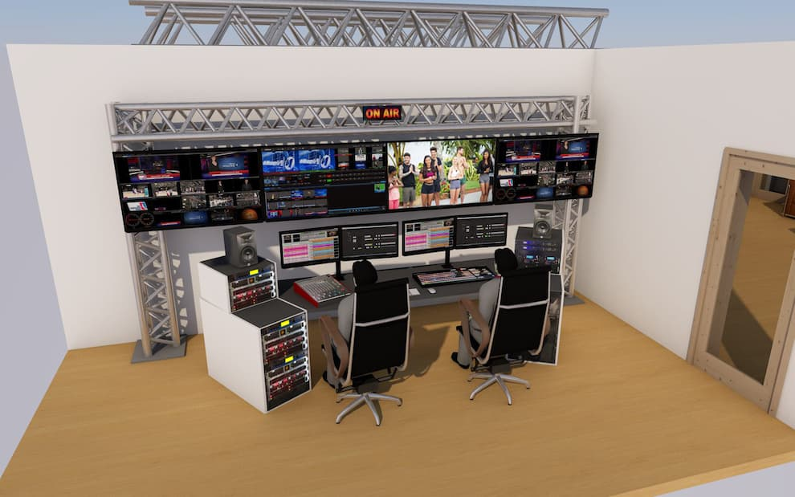

Depending on the number of spectators and on the type of activities involved, studios can be very big or small (as is the case for news and weather forecast programs). There are two types of studios:
  - real and
  - virtual.
3.1 STUDIO EQUIPMENT USED

Video Transmitter

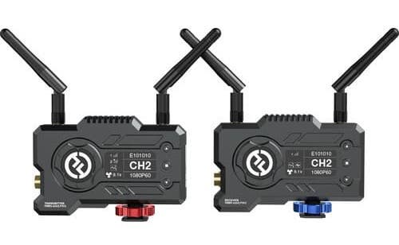
Video transmitters are designed to carry video and audio signals from one place to another. They normally come in pairs: a transmitter, or "sender", which is connected to an input signal - for example, a CCTV camera or a television set; and a receiver, which picks up the signal and sends it to a screen. A good video transmitter will be able to sustain wireless video transmission at a low latency and support connection to more than one receiver as well as monitoring of more than one mobile device.

Video Router


The video router - or matrix - is the sorting center for the signals of one or more studios. It has several inputs and outputs, allowing you to send SDI input signals to one or more SDI outputs.
It makes it possible, for example, to send the final signal of a video mixer to the whole chain of equipment that manages the DVT transmission, and, at the same time, to the encoders for the satellite transmission, or to the production studios for the recording and editing of the signal. Each router can be managed remotely via control panels or via software.

Converters

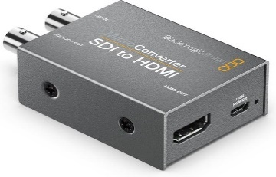
There are many different types of converters that can be used differently within a television studio. SDI-to-HDMI converters, for example, are necessary if you wish to send any SDI signal to the studio or direction monitors.
Then there are Audio-to-SDI converters, which allow you to embed the audio signal to the video one. SDI distributors can provide you with up to 8 identical outputs from just a single input, without having to get a very expensive matrix for that.
SDI-to-Fiber converters allow you to send SDI signals to greater distances than those supported by the SDI itself. There are also converters which allow you to edit the video format: when, for example, all the signals in the studio are in HD but the transmission system is in SD.

Studio Clock


As much as it may seem a trivial accessory, studio clocks are essential when it comes to timing the program's schedule, and they are a point of reference for all the members of the crew.

Video Wall



A video wall is a maxi screen composed of a variable number of modules. These can be combined to reach the desired dimensions of the screen. Each element can visualize just a part of the overall image, which is ultimately showed in its entirety by the combination of all the screens - much like in a mosaic.
Video walls are generally used in talk shows or news programs, to show multimedia and external signals (news or sports reporters) in the studio. It is not advisable to use them in virtual studios, where the background of the scene is managed via a chroma key.

PTZ Cameras
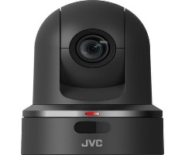

PTZ stands for: Pan, Tilt, Zoom - which means that these cameras can move horizontally, vertically, and zoom in or out.PTZ camera systems are becoming more and more popular and they are an essential part of video studio production nowadays. This is mainly due to the fact that having a cameraman behind each tripod-stand or handheld camera is a very expensive procedure: since several PTZ cameras may be managed by one person only, this dramatically reduces the costs.

Studio Cameras
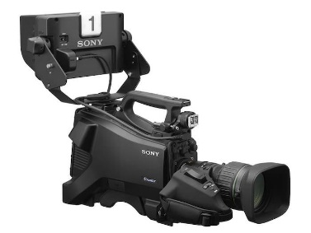

Is a camera used for electronic motion picture acquisition, initially developed for the television industry but now common in other applications as well. There are types of shots using the Zoom, the Close up Shot, Medium Close up (MC) and the Medium long shot (MLS). Professional cameras can be divided into three main categories:
i. Studio Cameras, ii. PTZ Cameras; iii. ENG Cameras
Originally designed specifically for video studios, these cameras have greatly evolved and become very popular, extending their potential to many other applications: music videos, news, sports, events, etc. They come with interchangeable lenses, so as to adapt to this wide variety of uses.

CHAPTER FOUR
4.0 WORK DONE
Television programming is the broadcast and management of television programs and software, which gives the TV Set its value and meaning, and without which the TV set would be ordinary hardware. TV programming is the major reason people use the set. It is the most vital selling point of the television.
Successful television programming is the duty of a station or network provider, and the success cannot be achieved without the inputs of satellite, cable, and telecommunications companies. It is a mutually beneficial relationship in which the companies need the networks and vice versa.
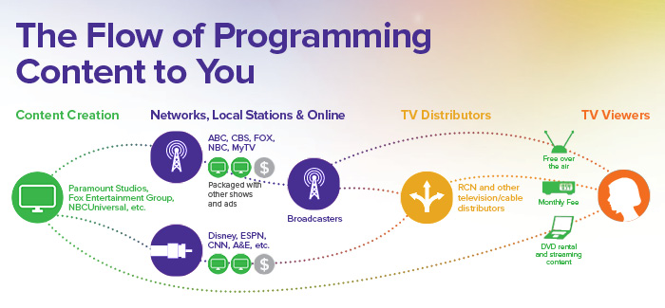

4.1 WHAT IS TELEVISION PROGRAMMING?
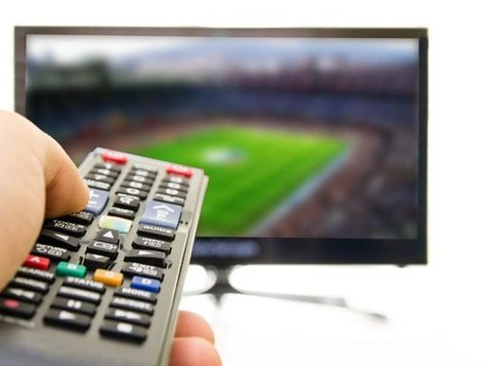
Basics and meaning of television programming

Television Programming is the organization of television programs into schedules that could be daily, weekly, or seasonal. It is the in-depth planning of the kind of programs to broadcast when to broadcast, and the audience targeted for the broadcast in order to ensure optimum usage of airtime.
Television programs, which are sometimes referred to as television shows, are content particularly prepared for broadcast on the television. It could be a one-time show or production, and it could also be a part of seasonally recurring programs.
4.2 CATEGORIES OF TELEVISION PROGRAMS
The common types of television programs
Programs prepared for television broadcast are in different categories, some of which are:

- News Program
- Reporting of Events Coverage
- Religious related program
- Documentaries
- Reality Shows
- Music Video shows
- Comedy shows
- Educational Programs
- Sports Programs
- General Entertainment programs
- Infomercials and promotional videos
- Game Shows
4.3 PLANNING FOR TELEVISION PROGRAMMING
Advertisement
Plans and scheduling strategies used in program implementation
Plans for television programming are made by television programmers. They decide on what show to broadcast and when to broadcast the shows.
However, it is not as straight-forward as selecting shows to be aired. A lot of marketing and planning strategies are involved in television programming.
However, before strategizing on what program to broadcast, the program has to be produced first. The production of television programs is in three stages.
- Pre-production stage: This stage involves everything prior to the actual shooting of the program. It includes research, ideas, writing, plans with crew and cast, costume organization, location hunting, and every other thing that would make for a successful shoot. This stage enables one to understand the kind of program that is expected as a finished product, the accompanying problems or complications, and solutions. It is the foundational stage.
- Production Stage: This stage involves the actual shoot to produce the program. It is the stage where the crew, cast, location, and equipment are managed in order to produce a perfect program.
- Post-Production: The final stage is where you obtain the concluded and perfected program. It involves cutting out any unnecessary details, editing, use of effects or music, arrangements of visuals to fit a proper and approved sequence. This is a stage where the program is finalized.
Program production is just one aspect of the planning for television programming. Once this is done, the networks would have to plan on how to select programs based on considered factors. They would have to decide which programs to continue and which to cancel.
This stage of planning involves two major aspects. One is development, which includes considered factors for selecting programs and producing them into television shows. The second aspect is known as scheduling, which involves planning the lineup of the programs to attract the audience and advertisers.
Some of the following factors are often considered for the development and scheduling of television programs:
- The target audience for the programming
- Appropriate day and time to air shows
- Audience flow to ensure that the audience is tuned in for the next program
- The appeal of the show for advertisers
- Production cost or cost of purchasing rights to a program
- Type of program and its general appeal
- Television ratings
- Cost to purchase rights to particular programs
- Type of program such as sitcom, drama, reality, and talk show
- Television ratings
The scheduling strategies employed for television programming are such that can give shows the ability to attract and retain an audience. They work to not only pull in the audience for the shows but to also deliver strategic audiences to the advertiser that would make their advertising have strong effects on their products.
4.4 SCHEDULING STRATEGIES AND IMPLEMENTATION
The newest and modern television programming strategies. Some of the common scheduling strategies for television programming are:
- Block programming: The strategy of scheduling a group of programs that are complementary in the same lineup. They are usually programs of the same category or genre and can be easily promoted together.
- Counterprogramming involves deliberate scheduling of programs to attract an audience away from another program. This usually occurs when both programs would typically attract contrasting audiences.
- Dayparting is a strategy of compartmentalizing the day into different segments in which a type of show or program appropriate for that time of the day would be broadcasted.
- Hammocking involves scheduling an unpopular show in between two popular shows with the hope that the audience would be tricked into watching it.
- Hot switching strategy eliminates commercial breaks in between two shows. The next show or program begins immediately after the previous show to give the viewers no chance to change channels.
The implementation of these strategies sometimes involves a combination of more than one strategy to achieve optimum results. The major aim of implementing any development or scheduling strategies for television programming is always to attract audiences, advertisers, and to increase ratings.
RSG Media Platform offers TV programmers and content producers audience data analytics that are useful in carrying out their functions. With modern intelligent software, programmers can have access to a large database of statistics about their target audience.

CHAPTER FIVE
5.0 RECOMMENDATION AND CONCLUSION
5.1 Recommendation
The recommendations arising from the foregoing appraisal of the effectiveness of SIWES in the formation of competent and productive technical manpower for the economy are summarized as follows;
- Funds earmarked for SIWES should be appropriated directly by the National Assembly in the same way for the National Youth Service Corps Scheme in order to remove the bottlenecks associated with release of fund for the operation of the scheme.
- The Federal Government should make adequate provisions in the annual budget for proper funding for SIWES in view of the potentials of the scheme to contribute to enhancing the quality of pool of technical skills available to the economy.
- The stipulation that employers should accept students for SIWES should be strengthened with stiffer penalties put in place for defaulters.
- A review of the policies that guide and regulate SIWES is necessary to ensure that the scheme complies fully with the tenants of cooperative education or work-integrated learning.
5.2 Conclusion
The Student Industrial Work Experience Scheme (SIWES) plays a significant role in human resource development, it helps students develop new skills and enlightens them of what the present society holds for them after graduation and helps them adapt accordingly.
As a result of the programme, I am now more confident to build my future My four (4) months industrial attachment has been one of the most interesting, productive and instructive experience in my life. Through this training, I have gained new insight and more comprehensive understanding about the television programming, condition and practice; it has also improved my soft and functional skills.
All these valuable experience and knowledge that I have gained were not only acquired through the direct involvement in task but also through other aspect of training such as work observation, interaction with colleges, superior and other people related to the field.

