

A TECHNICAL REPORT

ON

STUDENT INDUSTRIAL WORK EXPERIENCE SCHEME
(SIWES)

HELD AT

SUCCESS AUTOMOBILE WORKSHOP
ILORIN, KWARA STATE

PRESENTED BY:

OLADIRAN AMOS AYOMIDE
ND/23/MEC/PT/0148

SUBMITTED TO:

DEPARTMENT OF MECHANICAL ENGINEERING, INSTITUTE OF TECHNOLOGY (IOT) KWARA STATE
POLYTECHNIC, P.M.B 1375 ILORIN

IN PARTIAL FULFILLMENT FOR THE REQUIREMENT FOR THE AWARD OF NATIONAL DIPLOMA (ND) IN MECHANICAL ENGINEERING KWARA STATE POLYTECHNIC, ILORIN.

AUGUST – NOVEMBER, 2024.

DEDICATION
I dedicate this report to Almighty Allah, the beginning and the end of this programme, the giver of all wisdom, knowledge and understanding. If not for Him this programme would not have been possible.

ACKNOWLEDGEMENT
All praise goes to Almighty Allah for His wonderful work in completion of this SIWES report and also for giving me strength, knowledge and understanding in the course of the SIWES training.
Also to my humble parent, Mr. & Mrs. OLADIRAN for their financial and moral support and not forgetting my younger ones for their immense support throughout the days of my SIWES programme.
Also all my friends in person of Yakubu, Olugbon, Sholake and for their financial support. I pray that Allah will bless everyone of you (Amin).

PREFACE
This technical report covers the experience during the period of two months of Student Industrial Work Experience Scheme (SIWES). This industrial training is one of the requirements for the award of National Diploma.
It is aimed at giving engineering students exposure to their field, in term of practical and the industrial aspect of their field. It is to be gone by all engineering students. This report is necessary as it helps the lecturers to know where to tackle very well when lecturing then students in the classroom. To helps to test the knowledge of the students.

TABLE OF CONTENTS
Title page i
Dedication ii
Acknowledgement iii
Preface iv
CHAPTER ONE
- Introduction to SIWES 1
1.1 Aims and Objectives of SIWES 2
1.2 Workshop safety 2
CHAPTER TWO
2.0 History of the company 4
2.1 Organization chart of the company 4
CHAPTER THREE
3.0 Common Tools and Hand Tools With their Uses 5
3.1 Components of Automobile engine 7
3.2 Maintenance of motor vehicle 10
3.3 General Service of Automobile Engine 10
3.4 Brake Pad 10
3.5 Function of Brake Pads 11
3.6 Replacement brake pad 11
3.7 Brake Shoe 12
3.7.1 Function of Brake Shoes 12
3.8 Spark Plug 12
3.8.1 Parts of the Spark Plug 12
3.9 Gasket 13
3.9.1 Head Gasket 13
3.10 Shock Absorber 14
CHAPTER FOUR
4.0 Experience Gained 15
4.1 Suggestion for Improvement of the Programme 15
CHAPTER FIVE
5.0 Recommendation 16
5.1 Conclusion 16

CHAPTER ONE
1.0 INTRODUCTION TO SIWES
The Student Industrial Work Experience Scheme (SIWES) is an accepted skills programme which forms part of the approved academic standards in the degree programme for Nigerian Universities. In 1974, the Federal Government of Nigeria introduced the national policy on Industrial training, called the Students, Industrial Work Experience Scheme (SIWES). This programme is under the umbrella of the Ministry of Education through the Industrial Training Fund (ITF), was designed to help students acquire the necessary practical education/experience in their fields of study and other related professions.
This is an effort which was created in order to bridge the existing gap between the theory taught in the classroom and practice of science, agriculture, medicine, engineering, technology and other professional programmes in the Nigerian tertiary institutions. This programme is aimed at exposing the students to the use of various machines and equipment’s, professional work methods and ways of safeguarding the work areas in industries as well as other organizations.
The Students Industrial Work Experience Scheme (SIWES) programme involves the student, the Universities and the industries. This training is funded by the Federal Government of Nigeria and jointly coordinated by the Industrial Training Fund (ITF) and the National Universities Commission (NUC).

1.1 AIMS AND OBJECTIVES OF SIWES
The following are the major aims and objectives of SIWES program to the student
- To prepare students in skills development by participating in field works, particularly in report writing in their field of works.
- Provision of avenue for students to acquire industrial skills and experience during their course of study.
- To expose students to work methods and techniques in handling equipment and machineries that they may not be available in the universities
- To make the transition from the university to the world of work easier and thus enhance students contacts for later job placement.
- Exposure of the student to working methods and techniques in handling equipment and machineries that may not be available in their institutions.
1.2 WORKSHOP SAFETY
Safety is generally the preventive measure that are taken against hazards, accident or harm in day to day activities in the workshop, industry and there environment. Safety is an essential ingredient for existence. Workshop safety is particularly focusing on ways of preventing dangers, harm particularly accident, injury a times death to personnel, or others and things around the operator while doing work. The following are the basic workshop safeties that must be comply with. These include:
- Always use the right tools for the right job and damaged tools should be repair or do away with.
- Movement within the workshop should be normal and not hurry with proper watch out for projected materials, machine part, or materials in transit or slippery floor.
- Appropriate workshop clothing should be worn with all loose part properly secured
- Never walk under a load carried by crane or mechanical hoist
- Keep your work area tidy
- Clean up any spills immediately
- Wash hands after using equipment and materials

CHAPTER TWO
2.0 HISTORICAL BACKGROUND OF THE ORGANIZATION ATTACHMENT
Success Automobile Workshop is located along Oja tuntun Ilorin, Kwara state. It own and manage by the Individual. It majorly concerned about the welfare, construction and maintenance of roads, bridges and automobiles (like motor vehicle, motorcycle, tricycle) of the state.
2.1 ORGANIZATION CHART OF THE COMPANY
Success Automobile Workshop is so much organized like every other establishment, from the management level to the least in the organization. Below is the structural chart of the organization of the organization
MANAGING DIRECTOR
UNIT HEAD
MECHNIC
UNIT HEAD
PAINTING
UNIT HEAD
ELECTICAL
SUPERVISOR
APRENTICE
SIWES STUDENT
VULCANIZER

CHAPTER THREE
3.0 COMMON TOOLS AND HAND TOOLS WITH THEIR USES
There are various tools and hand tools in each workshop, they are highlighted below:

Spanner: Spanners are use in tighten and loosing bolt and nut, they are of different type like the flat, ring, socket, open ended
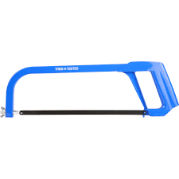
- Hacksaw:- This is one of the most common hand tools used for metal cutting. It comprises of a frame, handle, and blade. The saw cut on the forward stroke.

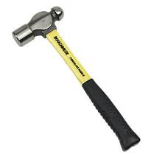
- Hammer:- Hammer head are made of carbon steel. The face are hardened and tempered, while the eye is left, soft to absorb shock. Handles are made from hickory or ash wood. The hammer is used for striking work.

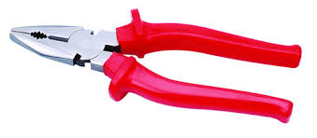
- Pliers:- These are used for gripping, and cutting small flat and round material and depressing of soft objects.

- Hand files:- These are used for reducing and smoothening of metal surfaces. They are available in different shapes and cutting teeth, depending on the type of work to be performed.
- Cutting tools:-These are tools that are mounted on the machine tool, such as lathe machine, drilling machine, milling machine etc to perform cutting operation. They are parting tool, knurling tool, end mill cutter, slab cutter, drill bits, side and face cutter etc
- Vernier caliper: it’s used to measure the internal and external diameter, and well as the depth of a material
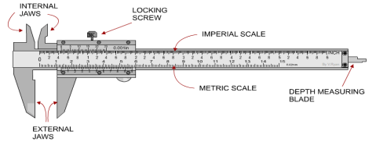

- Chisels: Chisels are ideal for trimming ends on bad cuts, shaping boards to fit or cutting rough holes. The most common chisel for rough work is 1 inch wide.
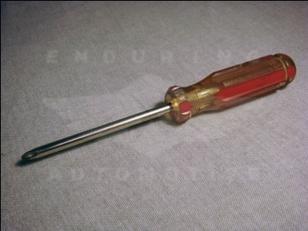

- Bench vice: is used to hold a workpiece for cutting or making any form of adjustment on the workpiece.
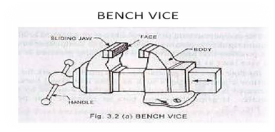

- Allen key: it is used in driving in or out Allen bolt i.e bolt of a hexagonal head
3.1 COMPONENTS OF AUTOMOBILE ENGINE
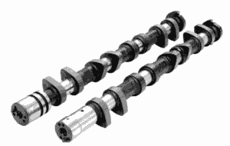
- Camshaft: is a type of rotating device used in piston engines propelling and operating the poppet valves. It works with the help of gears, chain and belt.

- Crankshaft: is a device which converts the up and down movement of the piston into rotary motion. It is present at the bottom of an engine.
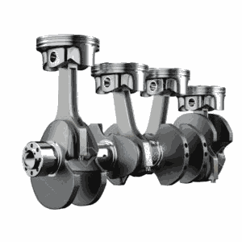

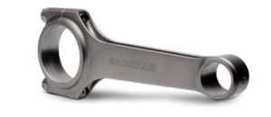
- Connecting rod: they are made of metals which are used for joining a rotating wheel to a reciprocating shaft it is also known as the con rod i.e it is used for joining the piston and the crankshaft.

- Engine/Timing belts: they are bands made of flexible material used for connecting or joining two rotating shafts or pulleys together.
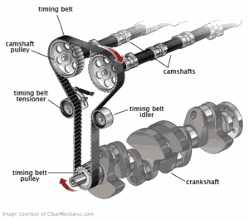

- Piston: is a cylindrical plug which is used for moving up and down the cylinder according to the position of the crankshaft in its rotation.
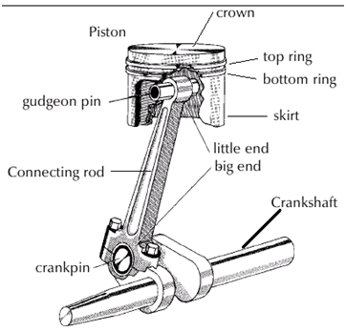

- Engine valve: are devices that regulate the flow of fuel mixture into the cylinder and assist in expelling exhaust gases.
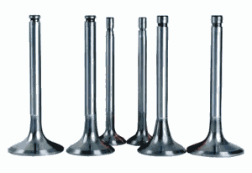

- Engine block: is a metal casting that serves as a basic structure on which other parts are installed.
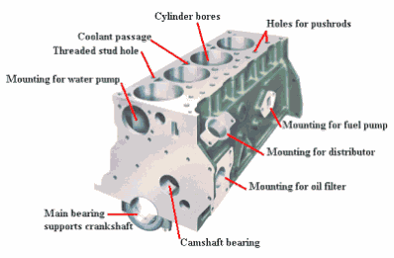

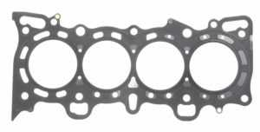
- Gasket: it a paper like sheet which is placed between the engine block and the engine head.

- Fuel pump: is a device that supplies the petrol to the carburetor sucking from the fuel tank
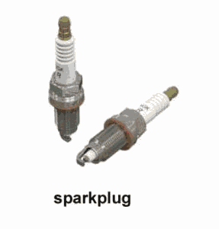
- Spark plug: this device is used in petrol engine only and ignite the charge of fuel for combustion

- Fuel injector: this device is used in diesel engine only and delivers fuel in fine spray under pressure.
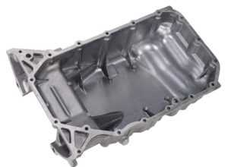
- Oil sump: It is use in retaining lubricating oil in which is pumped to different engine parts.

- Thermostats: This allows the passage of water to the engine (when the engine is getting hot) It releases water.
- Expansion tank: Store water in the tank.
- Radiator: This deals with the transfer of heat. It is also responsible for preventing the car engine from over-heating. When the engine is in use, it produces friction, heat and the radiator uses coolant to keep the engine running at a healthy temperature.
3.2 MAINTENANCE OF MOTOR VEHICLE
To extend the life span of a vehicle some certain procedures need to be considered
1. Checking of oil level (both engine oil and gear oil)
2. Ensure that the four wheel tyres are of equal size.
3. Always check the water level inside the radiator
4. replace/rebuild the burnt clutch disk with another for absolute gear efficiency.
5. Replace engine oil with the oil filter when certain kilometers are covered or merely every three (3) months interval.
3.3 GENERAL SERVICE OF AUTOMOBILE ENGINE
1. Changing of oil and its filter
2. Cleaning of air filter and fuel filter
3. Servicing of nozzle valve on injector
4. Changing of spark plug and replace it with new one.
3.4 BRAKE PAD
BRAKE PAD: are a component of disc brakes used in automobile and other application. Brake Pads are steel backing plates with frication material, bound to the surface that face the disc break rotor.
3.5 FUNCTION OF BRAKE PADS
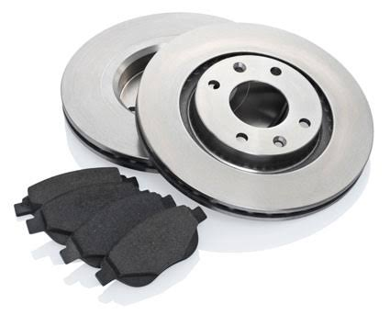
Brake Pads convert the kinetic energy of the car to thermal energy by friction the brake pads are contained in the brake caliper with their friction surfaces facing the rotor. When the brakes are hydraulically applied, the caliper clamps or squeezes the two pads together into the spinning rotor to slow or stop the vehicle when a brake pad is heated by contact with a rotor, it transfers small amounts of friction material to the disc, turning it dull gray. The brake pad and disc (both now with friction material) then stick to each other, providing the friction that stops the vehicle.

3.6 REPLACEMENT BRAKE PAD
- Loosen the front wheel nuts, slightly then raise the car and support on safety stand and remove the tire
- Remove the caliper bolt and pivot the caliper up out of the way.
- Remove the pad shims, pad springs and pads.
- Clean the caliper thoroughly remove any rust and check the grooves or cracks.
- Check the brake disc for damage or cracks.
- Install the pad springs.
- Push the piston so that caliper will fit over the pads. Make sure that the piston boot is in position to prevent damaging it when pivoting the caliper down
- Pivot the caliper down into position, then install caliper bolt and tighten it.
- Depress the brake pedal several times to make sure the brakes, then the road test.
- After installation check for leaks at hose and line.
3.7 BRAKE SHOES
Brake shoe is the part of a braking system which carries the brake lining in the drum brakes used on automobiles or the brake block in train brakes and bicycle brakes

3.7.1 FUNCTION OF BRAKE SHOES
The brake shoe carries the brake lining which is riveted or glued to the shoe, when the brake is applied, the shoe moves and presses the lining against the inside of the drum. The friction between lining and drum provides the braking effort. Energy is dissipated as heat.

3.8 SPARK PLUG
It’s a device for delivering electric current from an ignition system to the combustion chamber of a spark-ignition engine to ignite the compressed fuel/air mixture by an electric spark, while containing combustion pressure within the engine.
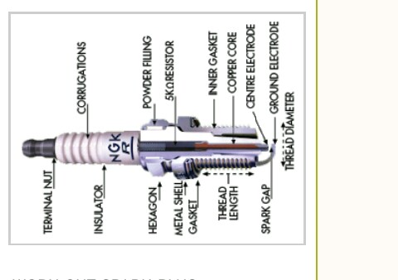
3.8.1 PARTS OF THE SPARK PLUG
- Terminal
- Insulator
- Ribs
- Seal
- Metal case/shell
- Central electrode
- Side electrode.

3.9 GASKET
The gasket is a mechanical seal which fills the space between two or more mating surfaces, which is then used to prevent leakage from or into the joined objects while under compression. Gaskets are typically made from asbestos graphite.
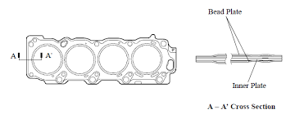
We have different kinds of gaskets

3.9.1 HEAD GASKET
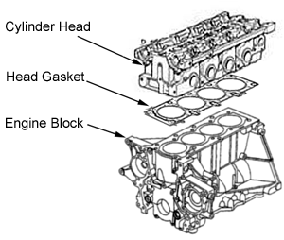
Head gasket is a gasket that sits between the engine block and cylinder head in an internal combustion engine. The purpose of the head gasket is to seal the cylinder to ensure maximum compression and avoid leakage of cooler or engine oil into the cylinders. It is the most critical sealing application in any engine.

3.10 SHOCK ABSORBER
Shock absorber: is to keep the car's tyres in permanent contact with the road, helping to provide optimum grip, when cornering and braking.
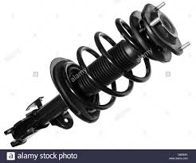

CHAPTER FOUR
4.0 EXPERIENCE GAINED
During the Seventeen weeks programme, I gained a lot especially in repairing a faulty car engine, changing of an automobile transmission System and suspension system like the shock absorber, control arm, tie rod, steering gears, and stabilizer linkage. Also repairing of an automobile Braking System like the brake pad, brake lining ,brake pedals
4.1 INTERPERSONAL RELATIONSHIP WITHIN THE ORGANIZATION
My Four months SIWES program has equipped me the knowledge of mechanical engineering especially in the automobile section.
During the course of staying with the coordinators in the various sections has turn a new moment in my course of study, like the company Manager in person of Ademola Joseph in automobile parts respectively.
4.2 SUGGESTION FOR IMPROVEMENT OF THE PROGRAMME
These are my few suggestions for the improvement of the SIWES program
- The industrial training fund should have up and hold committee on inspecting the student in their various organizations that they are attached to as this will improve the level of seriousness of the student to the program
- The Federal Government in collaboration with the industrial training fund (ITF) to increase the student allowance for the program as this will encourage them in active participation

CHAPTER FIVE
5.0 RECOMMENDATION
The experience I gained during my SIWES program cannot be over emphasized. I was practically oriented, I humbly recommend that the SIWES programme should be made compulsory for students of engineering fields in order to gain more experience in their course of study.
5.1 CONCLUSION
This SIWES programme has turn out to be more interesting, educative due to the nature of the program itself. I found it interesting and I fully participated in it which in turn yields a successful result, indeed it prepares me for future challenge in my chosen field.

