REPORT ON STUDENT INDUSTRIAL WORK EXPERIENCE SCHEME (SIWES)
HELD AT
FARYDHAK CONCEPTS
100, TOKUNBO STREET, OPP JAMAITUL CENTRAL MOSQUE, LAGOS ISLAND, LAGOS.

WRITTEN BY
AFOLABI SHUKURAT KEHINDE
ND/23/COM/FT/0011
SUBMITTED TO
DEPARTMENT OF COMPUTER SCIENCE,
INSTITUTE OF ICT,
KWARA STATE POLYTECHNIC, ILORIN

IN PARTIAL FULFILLMENT OF THE REQUIREMENT FOR THE
AWARD OF NATIONAL DIPLOMA (ND)
AUGUST – DECEMBER 2024

DEDICATION
This work is dedicated to the Almighty Allah, for his love, mercies, guidance and protection during and even after this work.
This work is also dedicated to my lovely and caring parents and wonderful brothers and sisters for their love, support and encouragement.

ACKNOWLEDGEMENT
I wish to acknowledge and thank everyone who contributed one way or the other towards the success of my industrial training.
My special thanks go to the management of company and my supervisor for their numerous contribution and effort to make this research a success. Also, my beloved parents and colleagues for giving me the great opportunity.
I want to say a big thanks to my siblings and my friends for their support and love also my friends for their encouragement and advice.

TABLE OF CONTENTS
DEDICATION i
ACKNOWLEDGEMENT ii
TABLE OF CONTENTS iii
ABSTRACT iv

CHAPTER ONE
  - Introduction
  - Definition of SIWES
  - Aims and objectives of SIWES
  - The role of the student and the institution

CHAPTER TWO
2.0 COMPANY’S PROFILE
2.1 UNDERSTANDING OF COMPUTER SYSTEM
2.2 SKILLS ACQUIRED DURING SIWES PROGRAM
2.3 Microsoft Word (MS -Word)
2.3.1. Starting Microsoft word
2.3.2. Microsoft word screen components
2.3.3. Creating a new document in word
2.3.4. Saving a document in word
2.3.5. To exit from Microsoft word
2.3.6. Relevant skills acquired in MS Word (Ms-Word)
2.4 Microsoft Excel (MS – Excel)
2.4.1 Starting Microsoft Excel
2.4.2 Microsoft Excel screen components
2.4.3 Creating a new document in excel
2.4.4 Saving a document in excel
2.4.5 To exit from Microsoft excel
2.4.6 Relevant skills acquired in MS Excel (Ms-Excel)
2.5 Microsoft Power Point (MS – Power Point)
2.5.1 Relevant skills acquired in MS Power Point (MS- Power Point)
2.5.2 Microsoft Powerpoint screen components
2.5.3 Creating a new document in Power Point
2.5.4 Saving a document in MS-Power Point
2.5.5 To exit from Microsoft Power Point
2.5.6 Relevant skills acquired in MS Power Point
2.6 Corel Draw
2.6.1. Starting Corel Draw
2.6.2. Corel Draw Screen Components
2.6.3. Creating A New Document In Corel Draw
2.6.4. Saving A Document In Corel Draw
2.6.5. To Exit From Corel Draw
2.6.6. Relevant Skills Acquired In Corel Draw
CHAPTER THREE
3.0. RELEVANT KNOWLEDGE CONT’D
3.1. HTML AND CSS
3.1.1. Basic Tags
3.1.2. Other Html Tags
3.1.3. Attribute Of Html
3.1.4. Example OF CSS
3.1.5. Relevant Skills Acquired In Html and CSS
3.2. INTERNET
3.2.1 Relevant Skills Acquired In Internet
3.3. TROUBLESHOOTING
3.3.1 Troubleshooting Techniques
3.3.2 Relevant Skills Acquired In Troubleshooting
CHAPTER FOUR
4.0 Conclusion and recommendation
4.1 Conclusion
4.2 Recommendation
4.3 Challenges and Problems Encountered

ABSTRACT
Student Industrial work experience scheme (SIWES) is a platform organized to train students in other to acquire practical knowledge to their theoretically understanding gained in the lecture room for them to be more useful to themselves and to the society and for them to be employable after graduation. With the help of Siwes program student are expose to the methods and techniques in handling equipment and machinery that may not be available in their institution and by doing this, it enhances the confidence of students in their course of study with the knowledge acquired already. It broadens the knowledge of the student on how works are being carried out on their field in an organization which makes them to be familiarized on the way and manner works are being accomplished. The Siwes program has help me to achieve better knowledge on how to use some application packages such as Microsoft word, Excel, Power Point, Corel draw, Html, CSS and many more confidently which will be used in any organization, industries, business and any office works.

CHAPTER ONE
  - INTRODUCTION
Student Industrial Work Experience Scheme also known as (SIWES) was established by Industrial Trust Fund (ITF) in the year 1973 to solve the problem of inadequate practical skills among students in tertiary institution in their course of study to make them employable after graduation. It is a period in which students undergoes training to acquire skills needed in their course of study in an establishment.
It exposes the student on the opportunity of being familiarized with the practical knowledge on their course of study for easy transition from academic environment to the world of employment. It also give students the privilege of being exposed to the needed skills required in handling machinery and equipment that are not usually available in most tertiary institution in Nigeria.
  - DEFINITION OF SIWES
Student industrial work experience scheme can be defined as a program designed to prepare students in tertiary institution to acquire practical knowledge in their course of study for smooth transition from academic environment to labor market. The scheme was funded by Federal Government of Nigeria and jointly coordinated by the National Universities Commission (NUC) and Industrial Training Fund (ITF).
  - AIMS AND OBJECTIVES OF SIWES
- To prepare students for the work situation they are likely to meet after graduation.
- To expose the students the methods and techniques in handling equipment and machinery that may not be available in their institution.
- It helps the students to understand better what has been taught theoretically in the class.
- To help student acquire industrial skills and experience during their course of study.
- To allow easy transition from academic environment to the world of working environment and facilitate students contact for later job placement.
1.4 THE ROLE OF THE STUDENT AND THE INSTITUTION
The role of the student is to partake in the program in such a way that he/she will achieve maximum benefit from the program. The student is advised to ask questions, be submissive, and adhere to all the rules and regulations of the organization where he is attached. Identification of placement opportunities, funding of SIWES supervisors and assessment of the student are some of the roles played by the institutions to ensure smooth running of the program.

CHAPTER TWO
2.0 COMPANY’S PROFILE
FARYDHAK CONCEPTS is located at 100, Tokunbo street, opp Jamaitul central mosque, Lagos island, Lagos. It is a company establish in rendering services to Tele-communication in other to provide high quality Mechanical Electrical and Civil services to telecommunication companies for smooth transmission of data. It’s also a verified CBT center for JAMB registration and others.
2.1 UNDERSTANDING A COMPUTER SYSTEM
What is a computer system?
A computer system can be defined as an electronic device that accepts data through the input devices such as keyboard, scanner etc, process it in the system unit known as CPU and give out accurate information according to data through output devices such as monitor, printer, speaker etc.
In other words, a computer system is a multipurpose device that consists of different electronic parts working together as a whole body towards achieving a certain goal.
2.2 SKILLS ACQUIRED DURING SIWES PROGRAM
- I learnt on how to use Microsoft word to type set document and many more. Details information below.
- I learnt on how to use Microsoft Excel to prepare quotation, calculate and many more. Details information below.
- I learnt on how to use Microsoft Power Point for presentation. Details information below.
- I learnt on how to use Microsoft Outlook to prepare document, send mails etc. Details information below.
- I was trained on how to use Corel Draw for designing of letter head, complimentary card, logo and many more. Details information below.
- I learnt on how to use the internet to create email account, send mails, save contacts on the internet and many more. Details information below.
- I learnt on how to troubleshoot a computer System with different techniques like reinstall and boot strap approach. Details information below.
2.3. MICROSOFT WORD (MS-WORD)
Microsoft Word is a word processing packages used in typing of letters, creating newsletter writing of reports and to prepare memo.
2.3.1. STARTING MICROSOFT WORD
How to activate Microsoft word in window 7 operating system
- Boot the computer
- Click on the start button.
- Click on “All Program”
- Click on Microsoft Office and locate Microsoft word
- Click on Microsoft word
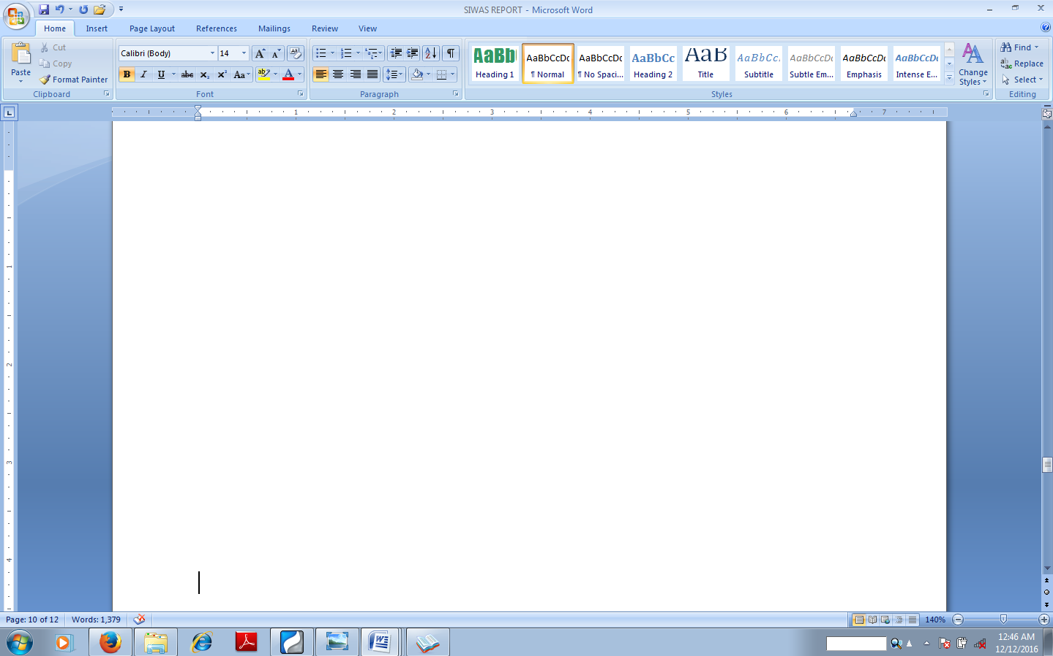
Figure 2: Microsoft Word Screen
2.3.2. MICROSOFT WORD SCREEN COMPONENTS
Microsoft word screen environment consists of the following components:
- Microsoft Office Button
- Quick Access Toolbar
- Title Bar
- Ribbon
- Ruler
- Text Area
- Word Help
- Status Bar
2.3.3. CREATING A NEW DOCUMENT IN WORD
- Click on Office Button
- Select New
- Select Blank document
- Click on create
2.3.4. SAVING A DOCUMENT IN WORD
- Click on Office Button
- Select save as
- Specify the location of the file
- Type the name of the document in the file name box
- Click save
2.3.5. TO EXIT FROM MICROSOFT WORD
- Save your documents properly
- Click on Microsoft Office Tab
- Select Close
2.3.6. RELEVANT SKILLS ACQUIRED IN MICROSOFT WORD ARE AS FOLLOWS:
- Mastering the keyboard to increase speed and accuracy.
- Type setting of document
- Insertion of tables
- Preparation of quotation in a table
- Scanning in Word
- Cropping of images etc.
2.4 MICROSOFT EXCEL (MS-EXCEL)
Microsoft Excel is a spreadsheet application software package that contains electronic worksheet for entering analyzing and reporting of data
2.4.1. STARTING MICROSOFT EXCEL
How to activate Microsoft Excel in window 7 operating system
- Boot the computer
- Click on the start button.
- Click on “All Program”
- Click on Microsoft Office and locate Microsoft Excel
- Click on Microsoft Excel
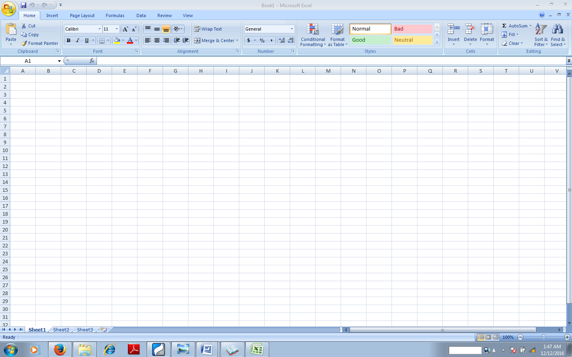
Figure 3: Microsoft Excel Screen
2.4.2. MICROSOFT EXCEL SCREEN COMPONENTS
Microsoft Excel screen environment consists of the following components:
- Microsoft Office Button
- Quick Access Toolbar
- Title Bar
- Ribbon
- Worksheets
- Formula Bar
- Scroll Bars
- Word Help
- Workbook
- Status Bar
2.4.3. CREATING A NEW DOCUMENT IN EXCEL
- Click on Office Button
- Select New
- Select Blank document
- Click on create
2.4.4. SAVING A DOCUMENT IN EXCEL
- Click on Office Button
- Select save as
- Specify the location of the file
- Type the name of the document in the file name box
- Click save
2.4.5. TO EXIT FROM MICROSOFT EXCEL
- Save your documents properly
- Click on Microsoft Office Tab
- Select Close
2.4.6. RELEVANT SKILLS ACQUIRED IN MICROSOFT EXCEL ARE AS FOLLOWS:
- Type setting a document
- Insertion of column and row
- Wrapping and shrinking of text to fit it to a cell
- Merging of cell
- Sorting of text in an ascending and descending order
- Insertion of tables
- Insertion of charts
- Formatting of cell
- Calculating in excel etc.
2.5. MICROSOFT POWER POINT (MS-POWER POINT)
Microsoft Power Point is an application package use for creating presentation.
2.5.1. STARTING MICROSOFT POWER POINT
How to activate Microsoft Power Point in window 7
- Boot the computer
- Click on the start button.
- Click on “All Program”
- Click on Microsoft Office and locate Microsoft Power Point
- Click on Microsoft Power Point 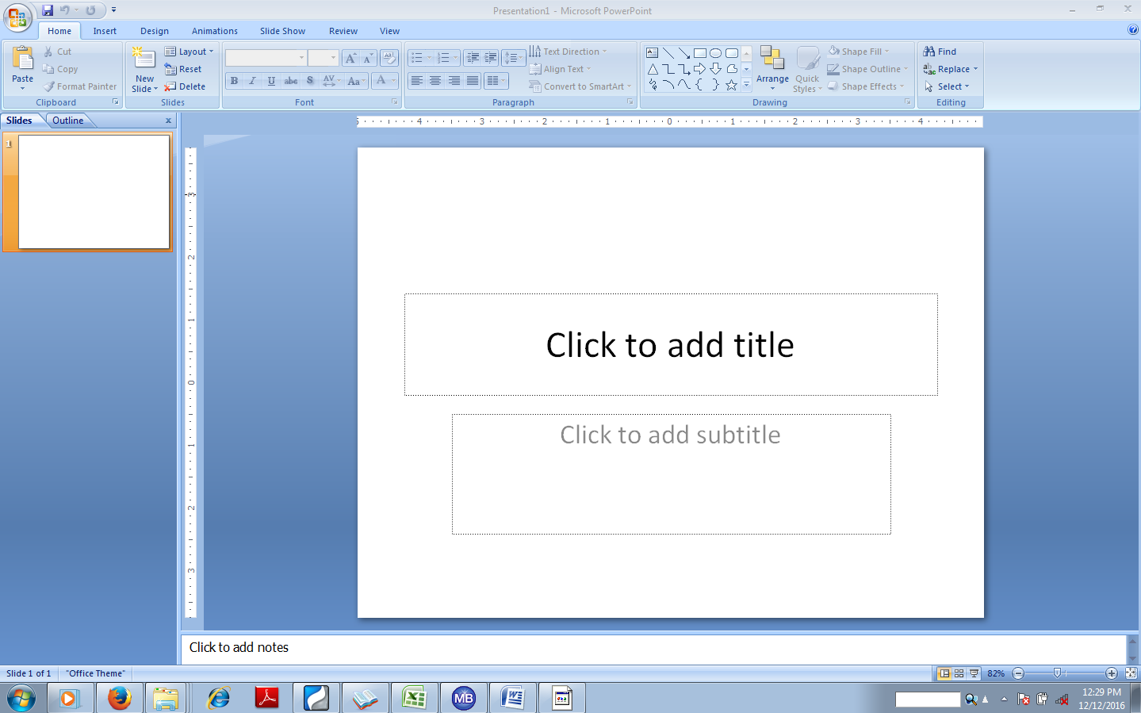
Figure 4: Microsoft Power Point Screen
2.5.2. MICROSOFT POWER POINT SCREEN COMPONENTS
Microsoft Power Point screen environment consists of the following components:
- Microsoft Office Button
- Quick Access Toolbar
- Title Bar
- Ribbon
- Ruler
- Slides
- Placeholders
- Notes
- Word Help
- Status Bar
2.5.3. CREATING A NEW DOCUMENT IN POWER POINT
- Click on Office Button
- Select New
- Select Blank document
- Click on create
2.5.4. SAVING A DOCUMENT IN POWER POINT
- Click on Office Button
- Select save as
- Specify the location of the file
- Type the name of the document in the file name box
- Click save
2.5.5. TO EXIT FROM MICROSOFT POWER POINT
- Save your documents properly
- Click on Microsoft Office Tab
- Select Close
2.5.6. RELEVANT SKILLS ACQUIRED IN POWER POINT ARE AS FOLLOWS:
- Creation of slides and applying some design on the created slide
- Cropping of images and insertion of photos and movies to a slide
- Applying animation to a created slide
- Insertion and deletion of table to a slide
- Insertion of page number and title on a slide
- Preparation of presentation for seminars etc.
2.6. COREL DRAW
Corel Draw is application packages design for graphics works.
2.6.1. STARTING COREL DRAW
How to activate Corel Draw on windows
- Boot the computer
- Click on the start button.
- Click on “All Program”
- Click on Corel Draw Graphics suits and locate Corel draw
- Click on Corel draw
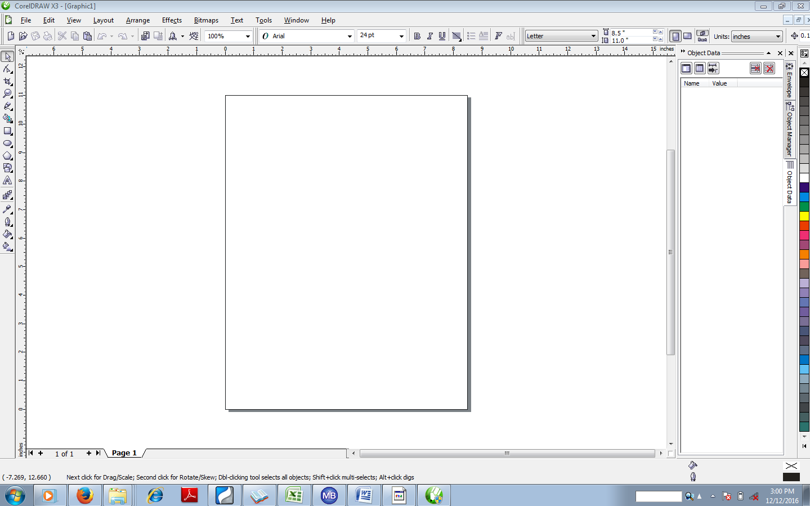
Figure 6.0: Corel Draw Screen
2.6.2. COREL DRAW SCREEN COMPONENTS
Corel Draw screen environment consists of the following components:
- Title bar
- Menu bar
- Standard Tool bar
- Property bar
- Tool box
- Color Palette
- Drawing Window
- Printable Page
- Horizontal and Vertical Scroll Bar
- Ruler
- Status Bar
2.6.3. CREATING A NEW DOCUMENT IN COREL DRAW
- Click on File on the menu bar
- Click on new
2.6.4. SAVING A DOCUMENT IN COREL DRAW
- Click on file on the menu bar
- Select Save as
- Specify the location of the document
- Type the name of the document in the file name box
- Click save
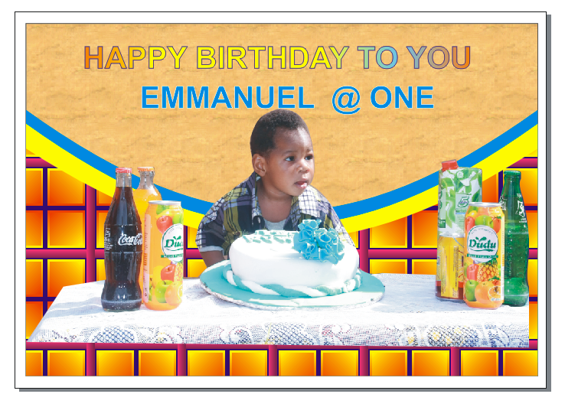
Figure 6.1: Design work in Corel draw
2.6.5. TO EXIT FROM COREL DRAW
- Save your work properly
- Click file from the Menu Bar
- Select Exit from the sub menus
2.6.6. RELEVANT SKILLS ACQUIRED IN COREL DRAW ARE AS FOLLOWS:
- Drawing of an object
- Coloring in Corel draw
- Scanner of document in Corel draw
- Importing of images in Corel draw
- Cropping of pictures
- Saving of design works to Pdf format
- Designing of borders
- Designing of Logo’s
- Designing of Barcodes
- Applying power clip in a design
- Designing of Letter Headings
- Designing of Complimentary cards
- Designing of Invitation and Wedding cards
- Designing of Banners
- Applying of Bitmaps colours and many more.

CHAPTER THREE
3.0. RELEVANT KNOWLEDGE CONT’D
3.1. HTML AND CSS
HTML (Hypertext Markup Language) is a markup language used to create static web pages and web applications.
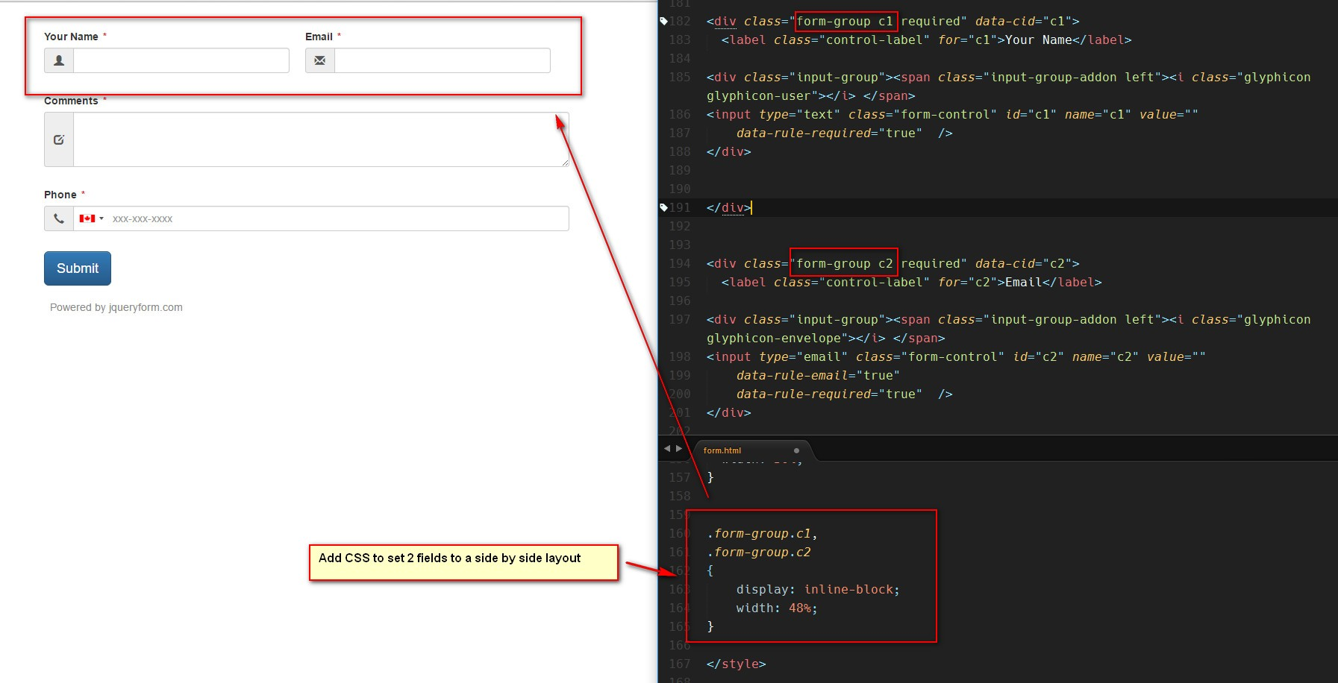
CSS (Cascading Style Sheets) is a style sheet language responsible for the presentation of documents written in a markup language.

Figure 6.1: HTML AND CSS WORK
BELOW IS AN EXAMPLE OF HTML USED TO DEFINE A BASIC WEBPAGE WITH A TITLE AND A SINGLE PARAGRAPH OF TEXT
The first line defines what type of contents the document contains. "<!DOCTYPE html>"
Means the page is written in HTML5. Properly formatted HTML pages should Include <html>, <head>, and <body> tags, which are all included in the example above.
The page title, metadata, and link to referenced files are placed between the <head> tags.
The actual contents of the page go between the <body> tags.
The web has gone through many changes over the past few decades, but HTML has always been the fundamental language used to develop webpages. Interestingly, while websites have become more advanced and interactive, HTML has actually gotten simpler.
If you compare the source of an HTML5 page with a similar page written in HTML 4.01 or XHTML 1.0, the HTML5 page would probably contain less code.
This is because modern HTML relies on cascading style sheets or JavaScript to format nearly all the elements within a page.
<!DOCTYPE html>
<html>
<head>
<meta charset =”UTF – 8”
<title></title>
</head>
<boby>
<p>This is a report written by Olowolafe Oluwadunsin Samuel </p>
</body>
</html>
3.1.1. BASIC TAGS
- <html>: The root element that begins and ends the document
- <head>: The document head that appears before the <body> tags
- <title>: The page title that appears within the <head> tags
- <body>: The page's content
- <h1>: A section heading
- <p>: A paragraph
- <a>: A link
- <img>: An image
3.1.2. OTHER HTML TAGS
- <main>: A semantic structural element
- <section>: A semantic structural element
- <article>: A semantic structural element
- <nav>: A semantic structural element
- <footer>: A semantic structural element
- <table>: Defines an HTML table
- <tr>: Defines a table row
- <th>: Defines a table header
- <td>: Defines a table cell
3.1.3. ATTRIBUTE OF HTML
- Form
- Table
- Image
- List
- Bold
- Boarder
- Class
- Color
- Placeholder
- Value
- Width
- Class
- Margin
- Style
- Lang

3.1.4. Example OF CSS
- Editor
- SYllABUS
- Study plan
- Bootcamp
- Website
- Snippets
3.1.5. RELEVANT SKILLS ACQUIRED IN HTML AND CSS ARE AS FOLLOWS:
- Understand HTML Basics
- Learn how to create Websites for clients and customers
- Work with core HTML Tags to build Modern Web Apps
- Separate Styling using Styles Sheets and Selectors
- Apply Styling using CSS
- Building and Style HTML Forms, Buttons, Tables and Lists
- Apply Gradient Styling and Images to Backgrounds
- Using Shadows and Glows on Text and Elements
- Building Menus and Dropdown Menus
- Build a complete Modern Day Website
3.2. INTERNET
Internet simply stand for International Network and can be defined as the global information system that provides, uses or make accessible either publicly or privately high level services layered on the communications and related infrastructure.
3.2.1 RELEVANT SKILLS ACQUIRED IN INTERNET ARE AS FOLLOWS:
- Ability to use the internet to search effectively
- Creation of yahoo account and other mails
- Composing and sending of mail on yahoo mail and other mail account
- Saving of contacts
- Searching of messages on mails
Creation of folder on mails etc.
3.3. TROUBLESHOOTING
Troubleshooting is logical, systematic search for the source of a problem so that it can be solved by Boot strap approach or by Reinstalled/Replaced the suspected hardware/software that are improperly installed, configured and defective.
3.3.1 TROUBLESHOOTING TECHNIQUES
There are two techniques to carry out the troubleshooting on a system namely:
- Reinstall or Replaced part
- Boot strap approach
1. Reinstall or replaced part: This is a process of reseating of any improperly installed hardware or replacing any defective hardware with a good part in order to identify the source of the problems.
2. Boot Strap Approach: This process whereby dead system parts will be strip down to the functional parts and then test to see whether it works.
3.3.2 RELEVANT SKILLS ACQUIRED IN TROUBLESHOOTING ARE AS FOLLOWS:
- Installing and uninstalling of software
- Coupling of computer system
- Maintenance of computer system by using disk cleanup and disk defragmentation
Upgrading of the system etc.

CHAPTER FOUR
4.0 CONCLUSION AND RECOMMEDATION
4.1 CONCLUSION

In conclusion, student industrial training (SIWES) is a great benefit to students because it enhances their knowledge practically to the things taught in school theoretically. It exposes the students in their field of the study which make the students to be confident of themselves. Siwes serves as a means of sharpening the student for smooth transition from class room to the labour market thereby making them to be familiarize and expose to the needed skill in handling machinery equipment that are not usually available in tertiary institution in Nigeria.
Before the SIWES program I only know the theoretical part of the computer system, but after this SIWES program, I gained knowledge about the practical aspect of computer system which gave room for me knowing how to use some application effectively like Microsoft Word, Excel, Power Point, Outlook, Corel Draw and many more.
The SIWES program should continue so that student will be practically sound in their field of study and to apply their theoretical knowledge gained in the class room to practically knowledge.
4.2 RECOMMENDATION
I want to recommend to KWARA STATE POLYTECNIC to pay attention to practical because anything taught theoretically is not enough for the student knowing full well that the country we are now is a country that want to see what you can do not your certificate only.
Available lecture room should be made for student because most of the department the number of people that stands outside is much because of lack of adequate lecture rooms. Provision should be made by providing enough lecture room to improve the learning of the student.
4.3 CHALLENGES AND PROBLEMS ENCOURTERED
The issue of transportation was a very challenging one making resuming to office every morning stressful. Lagos is populated State and with the people living in Lagos, it always make the road to be jam-packed with people every morning thereby causing traffic jam every morning which usually result to workers resuming late at the office. I always wake up very early in the morning so that I will beat the issue of traffic jam in the morning to enable me resume work early.

