

A TECHNICAL REPORT
STUDENT INDUSTRIAL WORKING EXPERIENCE SCHEME
(SIWES)

Held at
MONDO FOR AFRICA
Prepared by:
MURITALA LATIFAT OPEYEMI
ND/23/BAM/PT/0669

SUBMITTED TO

DEPARTMENT OF BUSINESS ADMINISTRATION
INSTITUTE OF FINANCE AND MANAGEMENT STUDIES
KWARA STATE POLYTECHNIC, ILORIN

IN PARTIAL FULFILLMENT OF THE AWARD OF THE REQUIREMENT OF THE AWARD OF NATIONAL DIPLOMA IN BUSINESS ADMINISTRATION

OCTOBER-NOVEMBER.2024
DEDICATION
I dedicate this technical report to the Almighty Allah, the giver of knowledge, wisdom and understanding.

ACKNOWLEDGEMENT
I am grateful to Almighty Allah, who granted me the grace, strength and knowledge to go through my period of Industrial attachment successfully. My sincere appreciation and heartfelt gratitude goes to my parents MR and MRS MURITALA and to all the staffs in MONDO FOR AFRICA for their precious advice during my Siwes program… Thanks to you all.

ABSTRACTS
The Students Industrial Work Experience Scheme (SIWES) is an accepted skills acquisition programme which forms part of the approved academic standard in the degree programme for Nigeria University. In 1974, the federal government of Nigeria introduced the national policy on industrial training, called the Students Industrial Work Experience Scheme (SIWES).This programmes is under the umbrella of the ministry of education through the industrial training fund (ITF), was designed to help students acquire the necessary practical education/experience in their field of study and other related professions. This is an effort which was created on order to bridge the existing gap between the theory taught in the classroom and practice of science, agriculture, medicine, engineering, technology and other professional programmes in the Nigeria tertiary institution. The programme was established basically to impact elaborate practical understanding to students with respect to their various disciplines. This report is a summary of the experience I acquired during my Students' Industrial Work Experience Scheme (SIWES) in NTA. I served as an intern in the News Department of the organization.

TABLE OF CONTENT
TITLE PAGE I
DEDICATION II
ACKNOWLEDGEMENTS III
ABSTRACT IV
TABLE OF CONTENTS V-VI
TABLE OF CONTENTS
CHAPTER ONE
  - INTRODUCTION TO SIWES 1
  - HISTORY OF SIWES 1
  - OBJECTIVES OF THE PROGRAMME 1-2
1.4 OBJECTIVES OF ESTABL ISHMENT 2
CHAPTER TWO
2.1 ORGANIZATIONAL CHART 3
2.2 SORTING PLASTIC FOR RECYCLING 3-4
2.3 HOW TO CRUSH PLASTIC USING THE CRUSHING MACHINE 4-6
2.4 BENEFITS AND APPLICATIONS OF CRUSHING PLASTIC 6
CHAPTER THREE
3.1 HOW TO HANDLE CUSTOMER INQUIRIES AND COMPLAINTS 7-8
3.2 LOGISTICS AND SUPPLY CHAIN 8-9
3.3 HOW TO ARRANGE RAW MATERIALS DELIVERY AND PRODUCT SHIPMENTS 9-10
3.4. INTRODUCTION TO MAINTENANCE AND ENGINEERING DEPARTMENT 11-12
3.5. HOW TO DEVELOP NEW PRODUCT AND IMPROVING THE EXISTING ONES 12
CHAPTER FOUR
4.1 INTRODUCTION TO MANAGEMENT AND STRATEGY 13-14
4.2 HOW TO RECORD PRODUCTION AND SALES DATA 14-15
4.3 HOW TO ENSURE ADHERENCE TO REGULATIONS 15-16
4.4 SIX SIGMA 16-17
CHAPTER FIVE
5.1 CONCLUSION 18
5.2 RECOMMENDATION 18

CHAPTER ONE
  - INTRODUCTION TO SIWES
Students Industrial Work Experience Scheme (SIWES) is a Skills Training Program designed to prepare and expose Students of Universities, Polytechnics, Colleges of Technology, Colleges of Agriculture and Colleges of Education for the Industrial Work situation they are likely to meet after graduation. The Scheme affords Students the opportunity of familiarizing and exposing themselves handling equipment and machinery that are usually not available in their institutions.

1.2 HISTORY OF SIWES
The Students’ Industrial Work Experience Scheme (SIWES) was initiated in 1973 by the Federal Government of Nigeria under the Industrial Training Fund (ITF) to bridge the gap between theory and practice among products of our tertiary Institutions. It was designed to provide practical training that will expose and prepare students of Universities, Polytechnics, and Colleges of Education for work situation they are likely to meet after graduation.
Before the establishment of the scheme, there was a growing concern among the industrialists that graduates of institutions of higher learning lacked adequate practical background studies preparatory for employment in industries. Thus the employers were of the opinion that the theoretical education going on in higher institutions was not responsive to the needs of the employers of labour.
As a result of the increasing number of students’ enrolment in higher institutions of learning, the administration of this function of funding the scheme became enormous, hence ITF withdrew from the scheme in 1978 and was taken over by the Federal Government and handed to National Universities commission (NUC), National Board for Technical Education (NBTE) and National Commission for Colleges of Education (NCCE). In 1984, the Federal Government reverted back to ITF which took over the scheme officially in 1985 with funding provided by the Federal Government.

1.3 OBJECTIVES OF THE PROGRAMME
The specific objectives of SIWES are to:
- Provide placements in industries for students of higher institutions of learning approved by relevant regulatory authorities (NUC, NBTE, NCCE) to acquire work experience and skills relevant to their course of study
- Prepare students for real work situation they will meet after graduation.
- Expose students to work methods and techniques in the handling of equipment and machinery that may not be available in schools.
- Make transition from school to the labour market smooth and enhance students’ conduct for later job placement
- Provide students with the opportunity to apply their knowledge in real life work situation thereby bridging the gap between theory and practice
- Strengthen employer involvement in the entire educational process and prepare students for employment in industry
Promote the desired technological knowhow required for the advancement of the nation.
1.4 OBJECTIVES OF ESTABLISHMENT
- To provide innovative and effective solutions
- To deliver exceptional customer service
- To drive business growth and expansion
- To build a strong brand reputation
- To develop and maintain a skilled workforce
- To promote a culture of innovation and continuous improvement
- To maintain high-quality standards and best practices
- To foster strategic partnerships and collaborations

CHAPTER TWO
2.1 ORGANIZATIONAL CHART
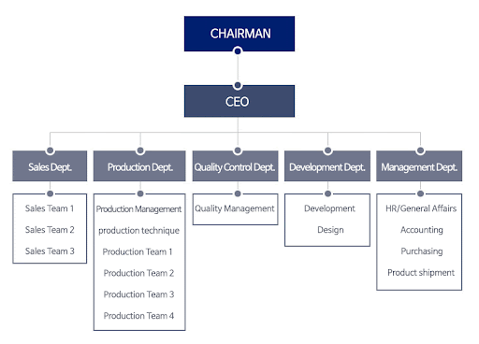
2.2 SORTING PLASTIC FOR RECYCLING
Plastic for recycling is sorted by type at home and at recycling centers using a variety of methods.

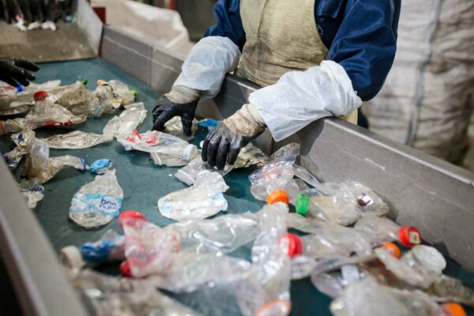

AT HOME
- Sort hard and soft plastics into the same container
- Clean plastic that has contained food or drink as much as possible
- Rinse containers with water if needed
- Don't put packaging that has been in contact with chemicals like paint or cleaning agents in the recycling bin

AT RECYCLING CENTERS
- Use optical sorters to identify and separate plastic bottles by polymer type
- Use other sorting methods to classify plastic by physical properties
Sorting methods
- Thermal-adhesion sorting
- Float-sink sorting
- Dry zig-zag sorting
- Electrostatic sorting
- Froth flotation sorting
- NIR spectrum sorting

Why sort plastic?
Sorting plastic by type ensures that each type of plastic can be recycled into the correct end product.

2.3 HOW TO CRUSH PLASTIC USING THE CRUSHING MACHINE
Crushing plastic using a crusher machine is a straightforward process that involves feeding plastic materials into the machine, which then breaks them down into smaller pieces. Step-by-step guide:
PREPARATION
1. Sort and clean the plastic: Separate the plastic materials by type and color, and remove any contaminants, such as labels, caps, or residue.
2. Check the crusher machine's specifications: Ensure the machine is designed to handle the type and quantity of plastic you want to crush.

CRUSHING PROCESS
1. Feed the plastic into the machine: Place the sorted and cleaned plastic materials into the crusher machine's feed hopper or inlet.
2. Adjust the machine settings: Set the machine's parameters, such as the rotor speed, screen size, and output size, according to the manufacturer's instructions and your desired output.
3. Start the machine: Turn on the crusher machine, and it will begin to break down the plastic into smaller pieces.
4. Monitor the process: Keep an eye on the machine's performance, and adjust the settings as needed to achieve the desired output.

SAFETY PRECAUTIONS
1. Wear protective gear: Use personal protective equipment (PPE), such as gloves, safety glasses, and a dust mask, when operating the crusher machine.
2. Ensure proper ventilation: Provide adequate ventilation in the work area to prevent inhalation of plastic dust and particles.
3. Follow manufacturer's instructions: Adhere to the manufacturer's guidelines for operating and maintaining the crusher machine.

POST-CRUSHING PROCESS
1. Collect and store the crushed plastic: Gather the crushed plastic materials and store them in a designated area for further processing or disposal.
2. Clean and maintain the machine: Regularly clean and maintain the crusher machine to ensure optimal performance and prolong its lifespan.

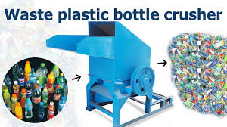

2.4 BENEFITS AND APPLICATIONS OF CRUSHING PLASTIC
Crushing plastic has many benefits, including recycling plastic waste and reducing environmental impact. Crushed plastic can also be used in construction materials.

BENEFITS
- Recycling: Crushed plastic can be recycled into new plastic products.
- Environmental impact: Crushing plastic reduces the amount of plastic waste in the environment.
- Construction: Crushed plastic can be used to make plastic lumber, bricks, and paving materials.
- Cost savings: Crushing plastic can save money and resources.
- Efficient disposal: Plastic crushers are an efficient way to dispose of plastic waste.
- Low energy consumption: Plastic crushers use relatively low amounts of energy.

APPLICATIONS
- Construction materials: Crushed plastic can be used to make plastic lumber, bricks, and paving materials.
- Recycling: Crushed plastic can be recycled into new plastic products.
- Reducing environmental impact: Crushing plastic reduces the amount of plastic waste in the environment.
- Efficient disposal: Plastic crushers are an efficient way to dispose of plastic waste.
- Low energy consumption: Plastic crushers use relatively low amounts of energy.

CHAPTER THREE
3.1 HOW TO HANDLE CUSTOMER INQUIRIES AND COMPLAINTS
Steps to handle customer inquiries and complaints:
- Listen attentively:
Pay full attention to the customer's concerns, ask clarifying questions to fully understand the issue, and avoid interrupting.
- Acknowledge the complaint:
Express understanding and validate their feelings by saying something like, "I understand your frustration regarding this issue."
- Apologize when appropriate:
Even if the issue isn't entirely your fault, a sincere apology can go a long way in de-escalating the situation.
- Gather information:
Ask necessary questions to gather details about the problem, including dates, times, and relevant product information.
- Investigate the issue:
Look into the problem to determine the root cause and possible solutions.
- Offer a solution:
Present a clear and feasible solution that addresses the customer's concerns, explaining the steps involved.
- Communicate clearly:
Explain the solution in simple terms and confirm the customer understands.
- Follow up:
Reach out to the customer after implementing the solution to ensure their satisfaction and address any remaining concerns.
Important considerations:
- Be timely:
Respond to customer inquiries and complaints promptly.
- Maintain professionalism:
Use polite language, avoid getting defensive, and remain calm even when dealing with an upset customer.
- Emphasize empathy:
Try to see the situation from the customer's perspective and show that you care about their experience.
- Document complaints:
Keep a record of all complaints to identify trends and areas for improvement.
- Escalate when necessary:
If you cannot resolve a complaint on your own, know when to involve a manager or higher-level support.

3.2 LOGISTICS AND SUPPLY CHAIN
What is Logistics?
Logistics refers to the planning, coordination, and execution of the movement and storage of goods, products, and resources from one place to another. It involves managing the flow of goods, information, and resources to meet customer demands.
What is Supply Chain Management?
Supply Chain Management (SCM) is the management of the flow of goods, services, and information from raw materials to end customers. It involves coordinating and integrating all activities, functions, and stakeholders involved in the production and delivery of a product or service.



Components of Logistics and Supply Chain Management:
1. Supply Chain: Network of organizations, people, activities, and resources involved in producing and delivering a product or service.
2. Logistics: Planning, coordination, and execution of the movement and storage of goods, products, and resources.
3. Transportation: Movement of goods, products, and resources from one place to another.
4. Inventory Management: Management of inventory levels, including storage, handling, and tracking.
5. Warehousing: Storage and handling of goods, products, and resources in a warehouse or distribution center.
6. Distribution: Delivery of goods, products, and resources to customers.
7. Supply Chain Visibility: Ability to track and trace the movement of goods, products, and resources throughout the supply chain.
3.3 HOW TO ARRANGE RAW MATERIALS DELIVERY AND PRODUCT SHIPMENTS
To effectively arrange raw materials delivery and product shipments, you need to carefully plan production schedules, coordinate with suppliers on delivery timings, utilize inventory management systems to track stock levels, and optimize transportation logistics to ensure timely deliveries and minimize costs; this includes considering factors like lead times, demand forecasting, storage capacity, and shipment distances.

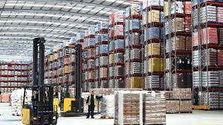

STEPS TO FOLLOW
Demand Forecasting:
  - Analyze historical sales data to predict future product demand accurately.
  - Use this information to plan raw material orders and production schedules accordingly.

Supplier Management:
  - Establish strong relationships with reliable suppliers who can consistently deliver quality raw materials on time.
  - Negotiate delivery terms, including lead times, minimum order quantities, and pricing.
  - Communicate production schedules and demand fluctuations to suppliers to optimize deliveries.

Inventory Management:
  - Implement a robust inventory management system to monitor raw material stock levels.
  - Set reorder points to ensure sufficient raw materials are available for production without overstocking.
  - Utilize Just-In-Time (JIT) inventory strategies where possible to minimize storage costs.

Production Scheduling:
  - Align production schedules with anticipated raw material deliveries to avoid disruptions.
  - Consider production lead times and batch sizes when planning schedules.
  - Factor in potential delays and buffer stock to mitigate production disruptions.

Transportation Logistics:
  - Choose appropriate transportation modes (truck, rail, air) based on product type, delivery distance, and urgency.
  - Negotiate favorable shipping rates with carriers.
  - Optimize delivery routes to minimize transportation costs.

Communication and Coordination:
  - Maintain clear communication with suppliers, production teams, and customers regarding delivery timelines and any potential changes.
  - Utilize technology like order management systems to track shipments and update stakeholders on delivery status.

- Sustainability:
Evaluate transportation options with lower environmental impact.
- Emergency Contingency Plans:
Develop strategies to address unexpected disruptions like supplier delays or production setbacks.

3.4 INTRODUCTION TO MAINTENANCE AND ENGINEERING DEPARTMENT
A maintenance and engineering department within a company is responsible for the planning, execution, and oversight of all activities related to maintaining and repairing machinery, equipment, and facilities, utilizing engineering principles to optimize asset reliability, minimize downtime, and ensure smooth operational efficiency across the organization; essentially, their primary goal is to keep everything running smoothly by proactively preventing breakdowns and addressing issues when they arise through scheduled maintenance and repairs.

STEPS IN REGULAR MAINTENANCE AND REPAIR
- Develop a maintenance plan: Identify critical equipment, set maintenance intervals based on usage or time, and create a checklist of tasks to be performed regularly.
- Visual inspections: Regularly examine equipment for signs of wear like cracks, corrosion, loose parts, or unusual noises.
- Cleaning: Keep equipment clean by removing dust, debris, and contaminants to prevent damage and corrosion.
- Fluid checks: Monitor fluid levels in engines, hydraulic systems, and other components, ensuring they are within the proper range.
- Lubrication: Regularly lubricate moving parts to reduce friction and wear.
- Filter replacements: Replace air filters, oil filters, and other filters according to the manufacturer's recommendations.
- Battery maintenance: Check battery terminals for corrosion and ensure proper charging.
- Calibration checks: Calibrate instruments and gauges as needed to maintain accuracy.
- Part replacement: Replace worn-out parts like belts, hoses, and seals before they fail completely.
- Record keeping: Maintain detailed records of maintenance activities, including dates, tasks performed, and any issues observed.

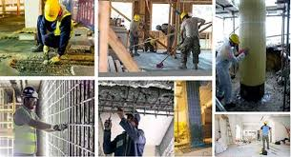

3.5 HOW TO DEVELOP NEW PRODUCT AND IMPROVING THE EXISTING ONES
THE STAGES OF NEW PRODUCT DEVELOPMENT
- Idea generation. Idea generation involves brainstorming for new product ideas or ways to improve an existing product
- Idea screening
- Concept development and testing
- Marketing strategy and business analysis
- Product development
- Test marketing
- Product launch

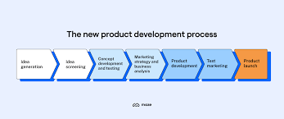
HOW TO IMPROVE AN EXISTING PRODUCT
To improve an existing product, gather customer feedback to identify pain points, analyze user behavior, and then implement changes by adding new features, enhancing usability, adapting to changing needs, and conducting thorough testing to validate improvements; essentially, listen to your customers, understand their frustrations, and make targeted adjustments to address them while keeping market trends in mind.

CHAPTER FOUR
4.1 INTRODUCTION TO MANAGEMENT AND STRATEGY
Management and strategy" refers to the practice of planning, organizing, leading, and controlling an organization's activities to achieve its goals, by developing and implementing strategic plans that position the company favorably within its market, considering internal strengths and weaknesses alongside external opportunities and threats to gain a competitive advantage; essentially, it's about making informed decisions to navigate the business landscape and reach desired outcomes.

KEY ASPECTS OF MANAGEMENT AND STRATEGY
- Strategic Planning:
Analyzing the current situation through SWOT analysis (Strengths, Weaknesses, Opportunities, Threats) to develop a long-term vision and set clear objectives for the organization.
- Strategy Formulation:
Creating a roadmap to achieve the goals by identifying the best course of action, including market positioning, product development, resource allocation, and competitive strategies.
- Implementation:
Putting the chosen strategy into action by assigning tasks, mobilizing teams, and managing resources effectively.
- Evaluation and Control:
Regularly monitoring performance against strategic goals, identifying deviations, and making necessary adjustments to stay on track.

HOW TO SET COMPANY GOALS AND OBJECTIVES
- Establish a clear vision and mission:
Understand the long-term direction of the company and what you want to achieve to guide goal setting.
- Perform a SWOT analysis:
Assess your company's internal strengths and weaknesses, along with external opportunities and threats, to inform goal setting.
- Use the SMART framework:
Ensure your goals are Specific, Measurable, Achievable, Relevant, and Time-bound.
- Identify key areas for focus:
Determine the most important aspects of your business to prioritize goals in areas like sales, market share, customer satisfaction, or operational efficiency.
- Break down large goals into smaller objectives:
Divide major goals into manageable steps with clear deadlines to track progress.
- Involve stakeholders:
Get input from different departments and levels within the company to ensure alignment and buy-in.
- Prioritize objectives:
Decide which goals are most critical and allocate resources accordingly.
- Develop action plans:
Create detailed plans with specific actions and responsible individuals for each objective.
- Communicate goals clearly:
Ensure all employees understand the company goals, their individual roles, and the expected outcomes.
- Regularly review and adjust:
Monitor progress towards goals, identify areas needing improvement, and make adjustments as needed.
Example of a SMART goal:
- Goal: Increase market share in the local region.
- SMART objective: "Increase market share by 10% in the next fiscal year by launching a targeted marketing campaign focused on new customer acquisition."

4.2 HOW TO RECORD PRODUCTION AND SALES DATA
STEPS FOR RECORDING PRODUCTION DATA
- Identify relevant metrics:
Determine which production details are critical to track, such as raw materials used, labor hours, machine downtime, units produced, and defects.
- Data collection method:
Choose a method to capture data, like manual entry on a production log sheet, using a dedicated production data collection terminal, or integrating with machinery to automatically record data.
- Record details consistently:
For each production run, log the date, time, product code, quantity produced, materials used, labor hours, any quality issues, and machine performance.

STEPS FOR RECORDING SALES DATA
- Utilize POS system:
If applicable, use a POS system to automatically record sales transactions, including product details, quantity sold, price, customer information, and payment method.
- Manual recording:
If not using a POS, maintain a sales log to record each sale, including product details, customer information, price, and payment method.
- Sales channel tracking:
Differentiate sales based on sales channels like online store, physical store, or wholesale accounts.

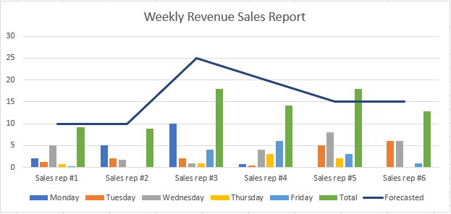

4.3 WHAT PLASTIC IS USED TO PRODUCE
Many different types of plastic are used to produce a wide variety of products, including bottles, containers, and packaging.

COMMON PLASTICS
- Polyethylene terephthalate (PET): A strong, lightweight, water-resistant plastic that's often used for food and drink containers. PET is recyclable and is the most produced synthetic plastic.
- High-density polyethylene (HDPE): A resistant resin used for grocery bags, milk jugs, and more.
- Polypropylene (PP): A heat-resistant plastic used for plastic bottles containing spices.
- Polyvinyl chloride (PVC): A toxic plastic that contains chloride, a carcinogen.
- Acrylic or Polymethyl Methacrylate (PMMA): A commonly used plastic.
- Polycarbonate (PC): A commonly used plastic.
- Acrylonitrile-Butadiene-Styrene (ABS): A commonly used plastic.

PLASTIC PRODUCTION
Plastics can be synthetic or biobased. Synthetic plastics are derived from crude oil, natural gas, or coal. Biobased plastics come from renewable products such as carbohydrates, starch, vegetable fats and oils.

PLASTIC USES
Plastics are used in many aspects of daily life, including packaging, healthcare, mobility and transport, electronics, clothing, and footwear.

4.4 SIX SIGMA
Six Sigma is a quality management process that aims to reduce defects and improve the production of products and services. It's a statistical measurement of how far a process is from perfection.

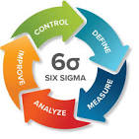

How it works
- Motorola developed Six Sigma in the 1980s.
- It's used in many industries, including manufacturing, healthcare, finance, and service.
- Six Sigma uses a step-by-step approach called DMAIC, which stands for define, measure, analyze, improve, and control.
- Lean Six Sigma combines Lean manufacturing principles with Six Sigma techniques.

Benefits
- Six Sigma can help improve customer satisfaction, reduce costs, and increase profits.
- It can help eliminate inefficiencies in a company's process flow.
- It can help identify the causes of waste or redundancy and develop solutions to address them.

Certifications
- Six Sigma Black Belt Certification provides knowledge of Six Sigma philosophies and principles.
- Six Sigma Green Belt Certification provides problem-solving skills, with an emphasis on the DMAIC model.

CHAPTER FIVE
5.1 CONCLUSION
The student industrial work experience scheme (SIWES) helps students to expand their knowledge and experience in their field of study. It will also help student whenever they come across it in future career.

5.2 RECOMMENDATION
The following are the suggested recommendation for the program
- The company should remain friendly and accommodating to future IT student.
- The SIWES coordinator and school should where organized enlightenment program for IT student in order to know the important of SIWES.
- The school (Polytechnics) should consider the four months mandatory SIWES while drafting the calendar for a successive session in a way that will affect the returning IT Student.

