CHAPTER ONE

1.1 INTRODUCTION TO SIWES
The Student Industrial Work Experience Scheme (SIWES) is designed to provide students with practical exposure in industries related to their field of study. It serves as a link between theoretical knowledge gained in classrooms and the real-world application of those concepts in industries. Through this program, students acquire hands-on experience, develop essential technical skills, and understand workplace ethics, industrial operations, and organizational structures.
SIWES plays a crucial role in preparing students for the challenges of professional careers by enabling them to apply engineering and technical principles in practical situations. It helps bridge the skill gap between academic learning and industry demands, ensuring that students become competent and job-ready. Additionally, the program fosters creativity and innovation, allowing students to engage in real-life technical tasks and problem-solving activities.
The scheme is coordinated by the Industrial Training Fund (ITF) in collaboration with tertiary institutions and various industries to enhance students' learning experiences and improve their employability upon graduation.

1.2 OBJECTIVES OF SIWES
SIWES aims to provide students with practical experience and industrial exposure relevant to their field of study. It helps students apply theoretical knowledge in real-world situations while developing essential technical and professional skills. The scheme also enhances employability by familiarizing students with industry standards, safety regulations, and workplace ethics. Additionally, it bridges the gap between academia and industry, fostering creativity, problem-solving abilities, and collaboration between institutions and industries.
- To provide students with practical experience and industrial exposure.
- To help students apply theoretical knowledge in real-world situations.
- To develop technical and professional skills required in the industry.
- To enhance employability by familiarizing students with industry standards.
- To expose students to workplace ethics, safety regulations, and operations.
- To bridge the gap between academic learning and industrial practices.
- To foster creativity, innovation, and problem-solving abilities.
- To promote collaboration between educational institutions and industries.

CHAPTER TWO

2.0 DESCRIPTION OF THE ORGANIZATION OLADIMEJI TECH
2.1 HISTORY AND STRUCTURE OF OLADIMEJI TECH
Oladimeji Tech is a technology and engineering company located in Ilorin, Kwara State. It specializes in electrical installations, wiring, circuit design, and electronic simulations. The company was established to provide quality technical services, offering expertise in both residential and industrial electrical projects. Over the years, Oladimeji Tech has built a reputation for excellence in electrical and mechanical engineering solutions.

2.2 VISION OF THE COMPANY
Oladimeji Tech envisions becoming a leading provider of innovative and reliable electrical and electronic engineering solutions in Nigeria. The company aims to set industry standards through excellence in service delivery, cutting-edge technology, and customer satisfaction. Its goal is to expand its impact by providing sustainable and efficient engineering solutions while fostering skill development and technological advancement in the industry. Some of Oladimeji Tech vision include:
- To be a leading provider of electrical and electronic engineering solutions in Nigeria.
- To deliver innovative, reliable, and high-quality technical services.
- To set industry standards through excellence and customer satisfaction.
- To promote sustainable and efficient engineering solutions.
- To foster skill development and technological advancement.

2.3 SCOPE OF WORK
Oladimeji Tech specializes in a wide range of electrical and electronic engineering services. The company’s operations cover:
- Electrical Installations – Wiring, lighting, and power system setups.
- Circuit Design and Simulation – Developing and testing electronic circuits.
- Wiring and Maintenance – Installation and repair of electrical systems.
- Socket and Switch Fixing – Installation and troubleshooting of electrical outlets.
- Fan and Appliance Installation – Mounting and connecting electrical appliances.
- Industrial and Residential Services – Providing solutions for homes and businesses.
The company ensures quality service delivery through the use of modern tools, adherence to safety standards, and skilled professionals.

2.4 OBJECTIVES OF THE COMPANY
- To provide high-quality electrical and electronic engineering services.
- To ensure safe and efficient wiring and installation solutions.
- To deliver reliable circuit design and simulation services.
- To maintain high industry standards in service delivery.
- To enhance customer satisfaction through professionalism and innovation.
- To promote skill development and technical expertise.
- To expand operations and become a leading name in the industry.
2.5 ORGANIZATION CHART
Chief Executive Officer (CEO)
General Manager (CEO)
Administrative Manager

Head of Electrical Electronics
Head of Engineering Design

Customer Support

Technical Staff Manager (Engineers, Technicians)

Support Staff

Support Staff

CHAPTER THREE

3.0 DESCRIPTION OF ACTIVITIES UNDERTAKEN
During my SIWES training at Oladimeji Tech, I was engaged in various practical activities related to electrical and electronic engineering. These activities provided hands-on experience and improved my technical skills.

3.1 WIRING INSTALLATION
During my SIWES training at Oladimeji Tech, I was actively involved in wiring installation for residential and commercial buildings. This process included laying electrical cables, connecting circuits, and ensuring proper insulation to prevent electrical hazards.
The installation process followed key steps:
- Planning and Layout: Determining cable routes and positioning electrical components.
- Cable Installation: Running wires through conduits and ensuring proper connections.
- Connection to Distribution Board: Linking circuits to the main power supply with appropriate circuit breakers.
- Testing and Safety Checks: Using multimeters and testers to verify continuity and ensure safe operation.
Strict adherence to safety measures was maintained to prevent electric shocks and short circuits. Tools used in this process included pliers, screwdrivers, electrical testers, and insulation tape.

3.2 CIRCUIT DESIGN AND SIMULATION
During my SIWES training at Oladimeji Tech, I was involved in designing and simulating electronic circuits using circuit analysis software. This process helped in testing circuit functionality before physical implementation, reducing errors and improving efficiency.
The steps involved in circuit design and simulation included:
- Selecting Circuit Components: Choosing resistors, capacitors, diodes, transistors, and other electronic components.
- Drawing Circuit Diagrams: Using software like Proteus and Multisim to create schematic representations of circuits.
- Simulating Circuit Performance: Running simulations to analyze voltage, current, and signal flow within the circuit.
- Troubleshooting and Modifications: Identifying and correcting design errors before practical implementation.
This activity improved my understanding of electronic components, circuit behavior, and problem-solving techniques in electrical engineering.

3.3 FIXING SOCKETS AND SWITCHES
I assisted in the installation and repair of electrical sockets and switches, ensuring proper connections and adherence to safety standards. This task was crucial in providing stable power distribution within buildings.

The process involved:
- Identifying Power Sources – Locating the appropriate circuit for socket or switch installation.
- Wiring Connections – Connecting live, neutral, and earth wires correctly to prevent faults.
- Mounting and Securing – Fixing sockets and switches firmly onto walls or panels.
- Testing for Functionality – Using testers and multimeters to ensure proper operation.
Safety precautions were strictly followed to avoid electric shocks or wiring errors.
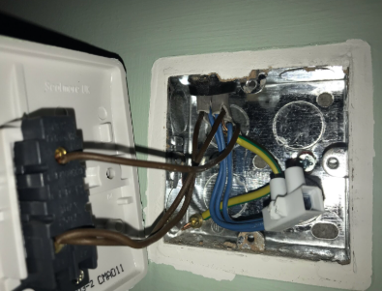
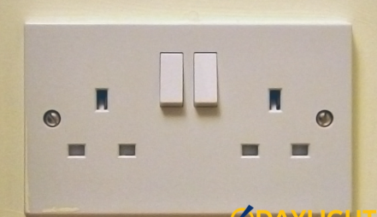
Figure 1: Installed Electrical Socket

Figure 2: Wiring Process for a Switch

3.4 FAN AND ELECTRICAL APPLIANCE INSTALLATION
I assisted in mounting ceiling fans and installing other electrical appliances, ensuring proper wiring and secure fittings.
The process involved:
- Identifying Installation Points – Selecting suitable locations for mounting fans and appliances.
- Wiring and Connection – Connecting power supply wires, ensuring correct phase alignment.
- Mounting and Securing – Fixing fans and appliances firmly to avoid loose fittings.
- Testing for Functionality – Checking proper operation and balancing of ceiling fans.
Safety precautions were taken to prevent electrical hazards and ensure durability.
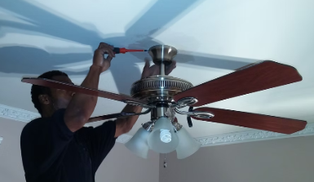
Figure 3: Installation Ceiling Fans

3.5 TROUBLESHOOTING AND MAINTENANCE
During my SIWES training at Oladimeji Tech, I was actively involved in troubleshooting and maintenance of electrical systems. This process involved identifying and fixing electrical faults to ensure proper system functionality.
3.5.1 STEPS INVOLVED IN TROUBLESHOOTING AND MAINTENANCE
- Fault Detection: Identified common electrical issues such as short circuits, loose connections, and power fluctuations.
- Testing and Diagnosis: Used tools like multimeters and electrical testers to analyze voltage, current, and circuit continuity.
- Repair and Replacement: Fixed damaged wiring, faulty sockets, switches, and electrical components.
- Final Testing and Verification: Conducted safety tests to ensure the system was operating correctly and efficiently.

3.6 USE OF ELECTRICAL TOOLS
3.61 COMMON ELECTRICAL TOOLS USED:
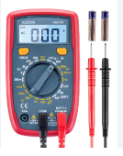
- Multimeter: Measures voltage, current, and resistance in electrical circuits. It helps in diagnosing faults, checking circuit continuity, and ensuring proper connections.
Multimeter
- Screwdrivers: Used for tightening and loosening screws in electrical components such as sockets, switches, and circuit boards. Different types include flathead and Phillips screwdrivers, depending on the screw type.
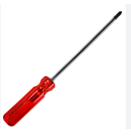

Screwdrivers
- Pliers: Essential for gripping, bending, cutting, and stripping electrical wires. Types include combination pliers, long-nose pliers, and cutting pliers, each serving a specific function in electrical work.
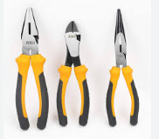

Pliers
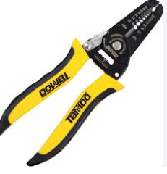
- Wire Stripper: Removes insulation from electrical wires without damaging the conductor. It ensures a clean and accurate wire connection for efficient electrical conductivity.
Wire Stripper
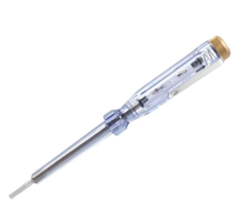
- Electrical Tester: Detects the presence of voltage in a circuit. It is used to ensure wires are live or dead before working on them, preventing electrical hazards.

Electrical Tester

- Insulation Tape: Used to cover exposed wires and insulate electrical connections. It prevents short circuits, electric shocks, and accidental contact with live wires.
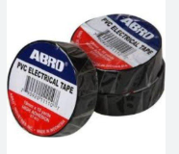

Insulation Tape
These tools were essential for performing safe and accurate electrical tasks.

CHAPTER FOUR
4.0 CHALLENGES, LESSONS LEARNED, AND RECOMMENDATIONS
4.1 CHALLENGES FACED
Several challenges were encountered during the SIWES training, which impacted the learning process and work efficiency.
- Limited Resources: Some essential tools and materials were not always available, making certain tasks difficult to complete efficiently. In some cases, alternative tools had to be used, which affected precision.
- Electrical Hazards: Exposure to potential dangers such as electric shocks, short circuits, and fire risks required extra caution. Strict adherence to safety measures was necessary to prevent accidents.
- Technical Difficulties: Some electrical faults were complex to troubleshoot, requiring advanced knowledge and experience. Diagnosing the root causes of failures in circuits and components was sometimes challenging.
- Time Constraints: Tasks needed to be completed within a limited time while maintaining accuracy. Some activities, such as wiring and testing, required more time for proper execution.
- Environmental Challenges: Working in different locations exposed me to issues such as poor lighting, space limitations, and unfavorable weather conditions, which sometimes slowed down progress.
4.2 LESSONS LEARNED
The SIWES training provided valuable hands-on experience that enhanced my technical and problem-solving skills.
- Practical Application of Theories: The training bridged the gap between theoretical knowledge from the classroom and real-world applications. I understood how electrical principles work in practice.
- Problem-Solving Skills: Electrical faults and malfunctions required logical thinking and analytical skills to diagnose and fix issues. I developed a structured approach to troubleshooting.
- Safety Awareness: I learned the importance of electrical safety measures, such as proper insulation, circuit testing, and the use of protective equipment to prevent accidents.
- Teamwork and Communication: Effective communication and teamwork were essential in coordinating tasks with colleagues and supervisors. Collaboration helped in sharing knowledge and improving efficiency.
- Time Management: Prioritizing tasks and managing time effectively was crucial in completing assignments within deadlines without compromising quality.
- Use of Modern Tools and Equipment: I became familiar with various electrical tools and testing devices, improving my efficiency in installations, repairs, and maintenance.
4.3 RECOMMENDATIONS
To improve the SIWES experience for future participants, the following recommendations should be considered:
- Provision of More Tools and Equipment: Ensuring an adequate supply of necessary tools and materials will enhance hands-on learning and improve efficiency.
- Enhanced Safety Measures: Regular training on workplace safety, including first aid procedures and the use of protective gear, should be emphasized to minimize risks.
- Extended Training Duration: A longer training period will allow students to gain deeper practical experience and handle more complex tasks.
- Advanced Training on Modern Technologies: Exposure to modern electrical and automation systems, such as smart home wiring and renewable energy technologies, will improve technical skills.
- Better Supervision and Mentorship: Assigning experienced professionals as mentors will help students gain industry-specific knowledge and improve their learning experience.
- Improvement in Working Conditions: Providing better lighting, adequate workspace, and proper ventilation in work areas will create a more conducive environment for learning and productivity.

CHAPTER FIVE
5.0 CONCLUSION AND RECOMMENDATION
5.1 CONCLUSION
The SIWES training at Oladimeji Tech provided valuable hands-on experience in electrical installations, circuit design, troubleshooting, and maintenance. It bridged the gap between theoretical knowledge and practical applications, enhancing my technical skills and problem-solving abilities. The challenges encountered, such as limited resources and technical difficulties, further strengthened my adaptability and teamwork. Overall, the training significantly improved my understanding of electrical systems and prepared me for real-world industry applications.
5.2 RECOMMENDATION
To improve the effectiveness of SIWES, the following recommendations should be considered:
- Provision of Adequate Tools and Equipment: Ensuring the availability of essential tools will enhance the learning experience.
- Enhanced Safety Training: Regular safety workshops should be conducted to minimize workplace hazards.
- Extended Training Duration: A longer training period will allow interns to gain more in-depth practical knowledge.
- Exposure to Modern Technologies: Introducing students to advanced electrical systems, automation, and renewable energy will expand their expertise.

