A

TECHNICAL REPORT ON STUDENT INDUSTRIAL WORK EXPERIENCE SCHEME (SIWES)

HELD AT

HASBUNALLAH ELECTRICAL & ELECTRONIC NIGERIA LIMITED

COMPILED BY
YAKUB FARUQ OLAMILEKAN
ND/23/EEE/FT/0048

IN PARTIAL FULFILMENT OF THE REQUIREMENT FOR THE AWARD OF NATIONAL DIPLOMA (ND) IN ELECTRICAL ELECTRONIC ENGINEERING

SUBMITTED TO:
DEPARTMENT OF ELECTRICAL ELECTRONIC ENGINEERING INSTITUTE OF TECHNOLOGY KWARA STATE POLYTECHNIC, ILORIN

2024/2025

DEDICATION
The report is dedicated to the almighty Allah and my parent Mr. & Mrs. Yakub

ACKNOWLEDGMENT
All thanks and adoration to almighty Allah for making this write up a successful one. I acknowledge the effort of my parent Mr and Mrs Yakub who provided me the opportunity of passing through this third stage of education in my life, may you live long to eat the fruit of your labour.
I also acknowledge the effort of my supervisor Mr Jerry Joe. He had always been with me beginning of this four month program to the end, He put me through many things, encourage me to be bold and vocal, He let me know all qualities of a good instructor. Ma, only God can repay you for this kind gesture.

PREFACE
The Student Industrial Work Experience Scheme (SIWES) was introduced into the nation's tertiary education curricular because of the belief that there is value in putting into practice what has been learned beforehand. There was also the belief that SIWES would help students to acquire on understanding of the society and meet to interaction with different people outside their institution.
It is in this light that the Student Industrial Work Experience Scheme for Polytechnics in Nigeria as stated in the National Board for Technical Education Syllabus aims to produce citizenry conscious of its role in a wider world, proud of its antecedent and prepared for effective leadership role in diversified or society, thereby, ensuring a positive contribution on interaction, greatness and trying or becoming effective in their field of studies or field of specialization.
TABLE OF CONTENT
Title page
Dedication
Acknowledgment
Abstract
Preface
Table of content
CHAPTER ONE
1.1 Introduction to SIWES
1.2 History of SIWES
1.3 Aims and Objectives of SIWES
CHAPTER TWO
2.1 Historical Background of the Organization
2.2 Major Activities of the Organization
2.3 Vision and Mission Statement
2.4 Department In The Organization
2.5 Organization Organogram
CHAPTER THREE
3.1 Experience Gained
CHAPTER FOUR
4.1 Work actually carried out
4.2 Executive Summary
CHAPTER FIVE
5.1 Challenges Faced
5.2 Conclusion
5.3 Recommendation
CHAPTER ONE
1.1 DEFINITION OF SIWES
The Student Industrial Work Experience Scheme (SIWES) of the Nigeria Polytechnic and colleges of technologies is an arrangement in which practical is integrated with theory.
The Students Industrial Work Experience Scheme (SIWES) is a unit under the Vice-Chancellor’s Office. It was established in 2006. The Students Industrial Work Experience Scheme (SIWES) is a skills training programme designed to expose and prepare students of universities and other tertiary institutions for the Industrial Work situation they are likely to meet after graduation.
The Students Industrial Work Experience Scheme (SIWES), is the accepted training programme, which is part of the approved Minimum Academic Standard in the various degree programmes for all Nigerian Universities. The scheme is aimed at bridging the existing gap between theory and practice of Sciences, Agriculture, Medical Sciences (including Nursing), Engineering and Technology, Management, Information and Communication Technology, and other professional educational programmes in the Nigerian tertiary institutions. It is aimed at exposing students to machines and equipment, professional work methods, and ways of safeguarding the work areas and workers in industries, offices, laboratories, hospitals, and other organizations.
It is a cooperative industrial internship program that involves institutions of higher learning, industries, the Federal Government of Nigeria, the Industrial Training Fund (ITF), and the Nigerian Universities Commission (NUC).
It is also established by the Industrial Training Fund (ITF) in 1974 to bridge the gap between theory and practical. The programme has a nice focus on the development of industrial students in the world of work. Also how theory and practical are social skills -and insight in the world of work to create awareness and prospect are the challenges the programme tries to tackle to cope with the development process of the student.
1.2 HISTORY OF SIWES
SIWES was founded in 1973 by ITF (Industrial Training Funds) to address the problem of tertiary institution graduates' lack of appropriate skills for employment in Nigerian industries. The Students' Industrial Work Experience Scheme (SIWES) was founded to be a skill training programme to help expose and prepare students of universities, Polytechnics and colleges of education for the industrial work situation to be met after graduation.
This system facilitates the transfer from the classroom to the workplace and aids in the application of knowledge. The program allows students to become acquainted with and exposed to the experience required in handling and operating equipment and machinery that are typically not available at their schools.
Prior to the establishment of this scheme, there was a rising concern and trend among industrialists that graduates from higher education institutions lacked appropriate practical experience for employment. Students who entered Nigerian universities to study science and technology were not previously trained in the practical aspects of their chosen fields. As a result of their lack of work experience, they had difficulty finding work.
As a result, employers believed that theoretical education in higher education was unresponsive to the needs of labor employers. Thousands of Nigerians faced this difficulty till 1973. The fund's main motivation for establishing and designing the scheme in 1973/74 was launched against this context.
The ITF (Industrial Training Fund) organization decided to aid all interested Nigerian students and created the SIWES program. The federal government officially approved and presented it in 1974. During its early years, the scheme was entirely supported by the ITF, but as the financial commitment became too much for the fund, it withdrew in 1978. The National Universities Commission (NUC) and the National Board for Technical Education (NBTE) were given control of the scheme by the federal government in 1979. The federal government handed over supervision and implementation of the scheme to ITF in November 1984. It was taken over by the Industrial Training Fund (ITF) in July 1985, with the federal government bearing entire responsibility for funding.
1.3 AIMS AND OBJECTIVE OF SIWES
The Industrial Training Fund’s Policy Document No. 1 of 1973 which established SIWES outlined the objectives of the scheme as:
- Provide an avenue for students in Institutions of higher learning to acquire industrial skills and experience in their respective courses of study.
- Prepare students for the Industrial Work situation they are likely to experience after graduation.
- Expose students to work methods and techniques of handling equipment and machinery that may not be available in their Institutions.
- Make the transition from school to the world of work easier; and enhance students’ networks for later job placements.
- Provide students with an opportunity to apply their knowledge to real work situations, thereby bridging the gap between theory and practice; and
- Enlist and strengthen Employers’ involvement in the entire educational process; thereby preparing the students for employment in Industry and Commerce.

COMPANY PROFILE

ABOUT UMEME LIMITED
Umeme Limited is electricity distribution company, listed on the local community in Kwara State Exchange. The Company operates a 20-year electricity distribution concession effective 1st March 2005, from the Government of Uganda. After the electricity sector reforms in 1999, Uganda adopted a single buyer electricity sector model, where Uganda Electricity Transmission Company Limited (UETCL) is the System Operator, responsible for the purchase of electricity from all Independent Power Producers, import and export of electricity and being Umeme’s sole supplier.
As an electricity distributor, Umeme is licensed to distribute and supply electricity to customers. This mandate involves; operation, maintenance and upgrade of electricity distribution infrastructure, electricity retail and provision of related services. The sector is regulated by the Electricity Regulatory Authority, whose mandate includes setting operating standards and appropriate end user tariffs.
The registered offices of the company are located at Rwenzori House, 1 Lumumba Avenue, in the central business district of Kampala, the capital and largest city of Uganda.

New structure/organogram under Network Operations
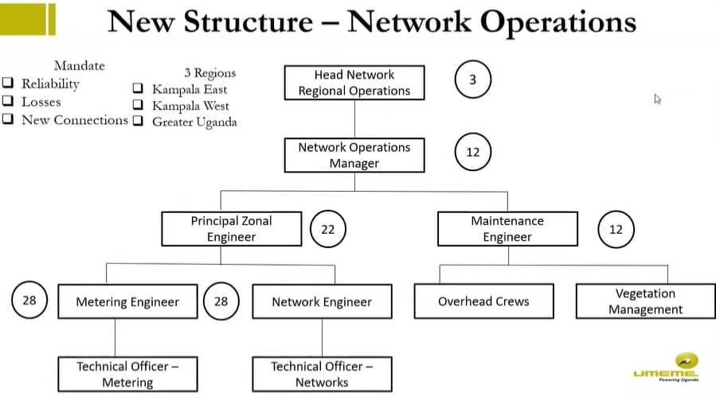
Figure 1 Reporting structure under Network Operations/Technical office

CHAPTER TWO: ELECTRICITY GRID SYSTEM.

HOW ELECTRICITY REACHES OUR HOMES

Electricity is a form of energy resulting from the existence of charged particles (such as electrons or protons), either statically as an accumulation of charge or dynamically as a current.
In Uganda, as in many other countries, electricity reaches homes through a multi-step process involving Generation, Transmission, and Distribution.

Here's how electricity typically reaches our homes:
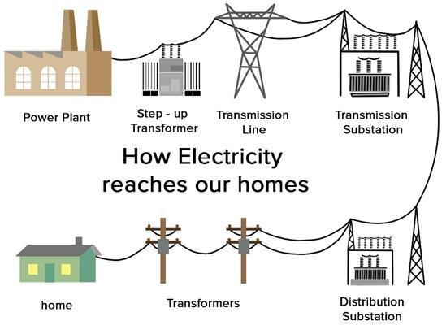

Figure 2: Figure 2 How electricity reaches our homes

Electricity Generation.
Electricity in Uganda is primarily generated at a low voltage (say 11kV) from various sources, with a focus on hydroelectric power due to the country's numerous rivers and lakes. Other sources include thermal (fossil fuels) and renewable energy (solar and wind).
Uganda Electricity Generation Company Limited (UEGCL) and other independent power producers operate power plants to generate electricity.

Electricity Transmission.
The generated voltage is then stepped up for transmission over long distances from power plants to regional substations through a network of high-voltage transmission lines.

Reasons for transmitting at a higher voltage include:
      - Reducing Energy Losses: When electric current flows through a conductor, such as a power line, it encounters resistance. This resistance causes some of the electrical energy to be converted into heat, which is wasted energy. The amount of energy lost as heat is directly proportional to the square of the current (I) and the resistance (R) in the transmission line.
This relationship is described by the formula P (power loss) = I²R.
By increasing the voltage (V) in the transmission lines while keeping the power (P) constant, according to the formula P = VI, the current (I) is reduced. Since power is conserved, a higher voltage allows for the same amount of power to be transmitted with a lower current. Lower current results in less resistive heating of the transmission lines, reducing energy losses. This effect is known as the I²R loss reduction.
      - Efficient Long-Distance Transmission: High-voltage transmission lines are more efficient for carrying electricity over long distances. This is because, with high voltage, the electric field strength is greater. A stronger electric field can push electrons through the conductor more effectively, overcoming the resistance encountered along the transmission line.
Additionally, high-voltage lines allow for thinner conductors (wires or cables) to be used compared to lower voltage lines for the same amount of power transmission. This reduces the material and construction costs of the transmission infrastructure.
These transmission lines are owned and operated by the Uganda Electricity Transmission Company Limited (UETCL).
Voltage levels in these lines are quite high (usually in the range of 66kV to 400kV) to minimize energy losses during transmission.

Substations.
At regional substations, the voltage is reduced from the high transmission levels to lower levels suitable for distribution within the local communities. This is done through transformers. The substations are essential for ensuring that the electricity can be safely distributed to homes and businesses.

Electricity Distribution.
After leaving the substations, the electricity is carried through a network of medium- voltage distribution lines. These distribution lines are often overhead wires or underground cables, depending on the local infrastructure. The distribution network is operated and maintained by the Uganda Electricity Distribution Company Limited (UEDCL) and other private distribution companies including Umeme limited.

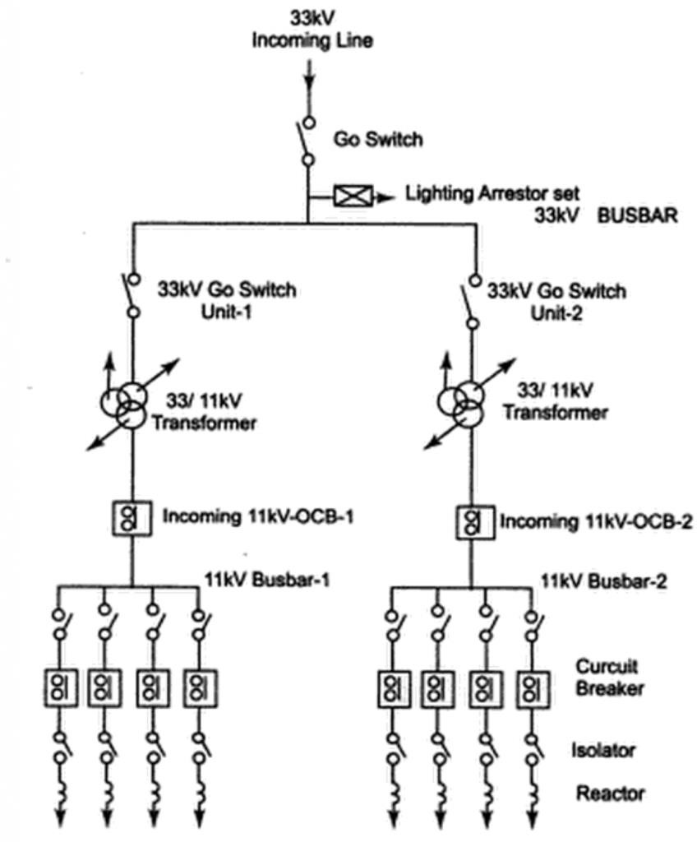
Figure 3: Single line diagram of a distribution substation

Transformers.
At this stage, the voltage is further reduced using distribution transformers to levels suitable for residential and commercial use. In Uganda, this voltage is commonly stepped down to 415/240V volts for homes, small businesses and small industrial customers. Voltage tolerance for low voltage lines are usually ±6%.
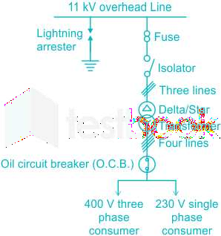
Figure 4: Single line diagram of 11kV/0.4V substation

Energy meters and Service Lines
Finally after the energy meters, service lines, also known as service drops or service cables, connect individual homes and businesses to the local distribution network.
These service lines are typically overhead wires that run from utility poles to buildings, or they may be underground cables in some areas.
Once the electricity enters a home, it is typically routed through a main distribution board or consumer unit (commonly known as Main Switch). From there, it is divided into various circuits that power different parts of the house, including lighting, outlets, and appliances. Residents can control and use electricity for various purposes within their homes.
It's worth noting that access to electricity in Uganda has been a focus of government initiatives and international development efforts to increase electrification rates, especially in rural areas. As a result, there has been an expansion of the electricity distribution network to reach more homes and communities across the country.

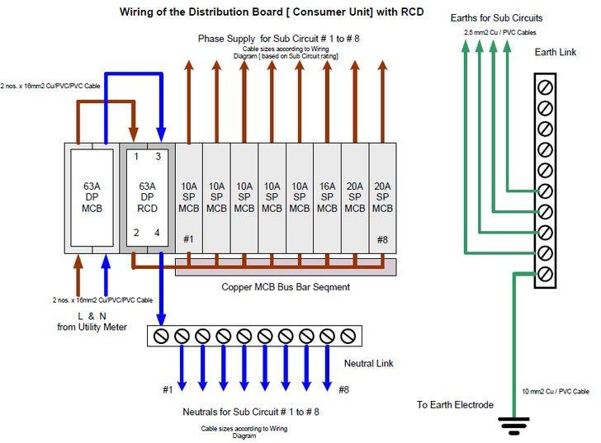

Figure 5 Wiring diagram of single-phase distribution board

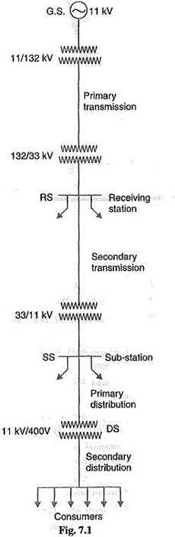

Figure 6 How electricity reaches final consumers from a generating plant

Nominal voltages and their tolerances in Uganda

- High voltage (HV) levels
Nominal voltages: 66kV, 132kV, 220kV and 400kV Tolerances: ±10%

- Medium voltage (MV) levels Nominal voltages: 11kV and 33kV Tolerances: ±10%

Low voltage (LV) levels
Nominal voltages: 240V (for single phase consumers) and 415V (for three phase customers)
Tolerances: ±6%

CHAPTER THREE: ACTIVITIES CARRIED OUT DURING THE TRAINING

DISTRIBUTION TRANSFORMER INSPECTION AND MAINTENANCE
Transformer Is a static device which transforms ac electrical power from one voltage to another, keeping frequency the same by electromagnetic induction.
Distribution transformers are special transformers that provide final transformation in the electrical power distribution system. They step down the voltage in the distribution lines to be used by the final consumers.
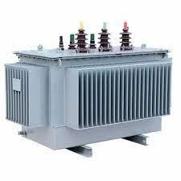
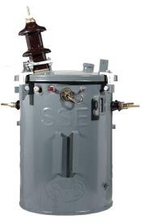
UMEME distribution transformers transform from 33kV or 11Kv to usable voltages of 415V or 240V.

Figure 7: Distribution transformers

Reasons for Transformer inspection and maintenance
Transformer inspection and maintenance are very essential because:
- Transformer is an expensive asset.
- It creates a bigger outage in case of fault.
- About 54% of outages originate from transformers.
- Safety and Compliance: Regular maintenance ensures that transformers meet safety standards and comply with regulations. It helps identify and rectify any safety hazards, such as loose connections, oil leakage, or insulation deterioration, preventing accidents or environmental hazards.

Activities performed during distribution transformer inspection:
- Visual Inspection: to determine any signs of physical damage, oil leakage, loose connections, condition of silica gel, status of transformer structure, its wiring, its temperature while on load and any other visible abnormalities.
- Insulation Resistance Testing: is conducted to measure the insulation resistance of the transformer windings. This test helps identify any insulation breakdown or deterioration.
- Earth Resistance Testing: Earth resistance values should not exceed 5Ω

- Electrical Connections: all electrical connections are checked and tightened, ensuring they are secure and free from any loose or corroded contacts.
- Protective Device Testing: The operation and settings of protective devices, such as MCCBs, Surge arrestors, overcurrent relays and differential relays, are checked. These devices provide protection against various faults and abnormal operating conditions.
- Bushings and Tap Changers: The condition of bushings and tap changers is examined. Insulation integrity, oil leakage, and proper operation of tap changers are checked. Repairs or replacements are carried out if necessary.
- Load Testing: Load testing is conducted to verify the transformer's performance under normal operating conditions. It helps ensure that the transformer can handle the expected load without issues.
- Oil Sampling and laboratory Analysis: The analysis helps in determining the condition of the transformer insulation, detecting any contaminants or moisture, and assessing the overall health of the transformer.
- Cooling System Inspection: Cooling systems, such as fans or radiators, are inspected and cleaned to ensure efficient heat dissipation from the transformer. Any obstructions or blockages are cleared to maintain optimal cooling.
- Buchholz Relay Inspection: If the transformer is equipped with a Buchholz relay, it is inspected for proper functioning. The relay detects internal faults, such as short circuits and gas accumulation in the transformer oil.
- Documentation and Record Keeping: Detailed records of maintenance activities, test results, and observations are documented for future reference. This helps in tracking the transformer's maintenance history and identifying any recurring issues.

TRANSFORMER INSPECTION SCHEDULE
No | DATE | FEEDER NAME | TX NAME | RATING(kVA) | ACTIVITIES | REMARKS
Table 4 Sample of transformer inspection schedule

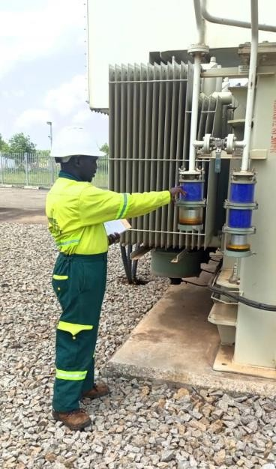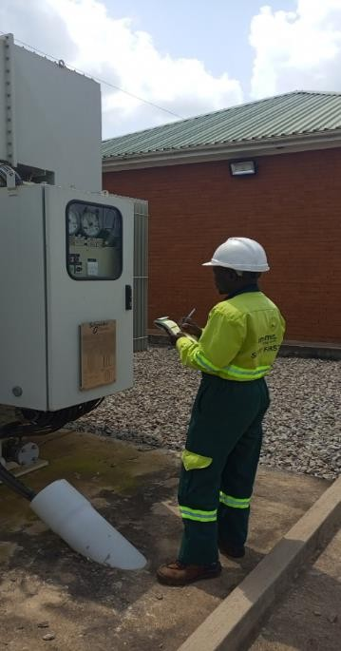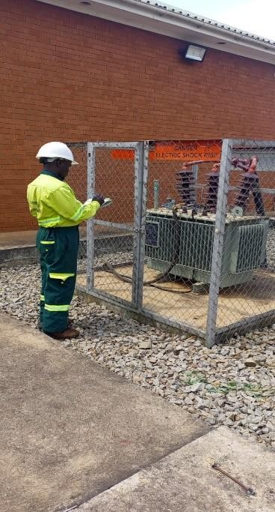
Figure 8 Transformer inspection at Nyakesi substation.

Activities performed during distribution transformer maintenance:
The common activities we performed during distribution transformer maintenance include:
- Earthing improvement.
- Oil top up (in case of low oil level).
- Replacement of rotten/broken transformer structures.
- Replumbing of leaning transformer structures.
- Replacement of damaged/faulty components such as burnt transformer wiring, faulty MCCB, faulty surge arrestors, broken lugs, PG clamps, blown HT links, etc.
- Carrying load balancing.
- Carrying out load transfer to a nearby transformer in case of overload.
- Improvement of both MV and LV networks such as conductor re-sagging, replumbing of leaning poles and so on, to avoid circumstances that may cause short-circuits.
- Tightening any loose connections on the transformer.
- Etc.

DISTRIBUTION TRANSFORMER COMMISIONING
This refers to putting a distribution transformer in to service or energizing the distribution transformer.
Commissioning a transformer involves a series of steps to ensure that it is installed correctly, operates safely and meets its performance specifications.

Steps involved in transformer commissioning
Here are the typical steps involved in commissioning a transformer:

Pre-Installation Inspection:
  - Verify that the transformer received matches the specifications and ratings required for the application.
  - Inspect the transformer for any visible damage during transportation.

Site Preparation:
  - Prepare the location where the transformer will be installed, ensuring that it is level, stable, and meets the required safety standards.
  - Provide proper ventilation and clearance around the transformer as per the manufacturer's guidelines.

Installation:
  - Carefully position the transformer on its foundation or mounting structure.
  - Connect the transformer to the electrical system, including the primary and secondary windings and grounding connections.

Fluid Filling:
  - If the transformer is an oil-filled type, it will need to be filled with transformer oil to the appropriate level, ensuring that it covers all windings.

Insulation Resistance Test:
  - Perform insulation resistance tests to check the integrity of the insulation between windings and ground.

Transformer Ratio Test:
  - Conduct a transformer turns ratio test to verify that the turns ratio of the primary and secondary windings is within the specified limits.

Polarity Check:
  - Verify the polarity of the transformer's windings to ensure that they match the specified configuration.

Oil Quality Test (for oil-filled transformers):

  - Test the quality of the transformer oil to ensure it meets the required standards for dielectric strength and other properties.

Electrical Tests:
  - Perform a series of electrical tests, including no-load and load tests, to assess the transformer's performance under different conditions.

Protection Testing:
  - Check the functioning of protective devices, such as relays and circuit breakers, to ensure that the transformer is adequately protected from faults.

Temperature Rise Test:
  - Conduct a temperature rise test to assess the transformer's ability to dissipate heat under normal operating conditions.

Final Inspection:
  - Conduct a thorough inspection of all connections, accessories, and components to ensure they are secure and functioning correctly.

Documentation:
  - Prepare comprehensive documentation, including test reports, operation manuals, and as- built drawings, to record the commissioning process and provide reference for future maintenance.

Commissioning Report:
  - Compile a commissioning report that summarizes the entire process, including test results, observations and any necessary recommendations. Finally, the transformer is handed over to the owner or operator.
It's important to note that the commissioning process may vary depending on the type, size, and complexity of the transformer, as well as any specific requirements from the manufacturer or local regulations.

During the training the Umeme, commissioning a distribution transformer majorly involved both Visual and Machine testing;

Under Visual Checks:
  - Check status of transformer wiring
  - Check alignment of transformer platform
  - Check for any loose connections.
  - Check for oil level
  - Check to ensure no foreign materials such as spanners, plies, etc. are left on the transformer
  - Check on oil leakage.
  - Check for any damage e.g., cracks on the transformer bushings, cooling fins, etc.

Under Machine Tests:
  - Test for Earth Resistance i.e., MV and LV earths using Earth
Resistance Tester. The Earth Resistance value should not exceed 5Ω.
  - Test for Insulation Resistance using Insulation Resistance Tester. The
value should be ≤500MΩ.
  - Test for phase sequence using Phase Sequence Tester.
  - Test the voltage on no load (240±6% between each phase and earth/neutral or 415±6% between two phases).

NB. Transformer is soaked for at least a day:
- To realize any anomalies/faults before loading.
- For transformer oil to settle.

Distribution Transformer protection
All new Transformers must be Completely Self Protected (CSP) transformers. Low Voltage will be protected by internal Circuit Breakers, and MV will be protected with internal Fuses.
Overhead fuse links must also be used for isolation and additional protection.

Rated surge arresters must be installed on the transformer tank on the HV side. Brackets must be available on the transformer. Surge arrester earth connections must be individually connected to earth and not combined.
For transformer installations which are not CSP, the Transformer will be protected by means of a rated main LV circuit breaker with 10kA rupturing capacity installed below the transformer. Feeder circuits shall also be individually protected by rated circuit breakers.

Power | Phases | LV braker | MV fuse (11kV) | MV fuse (33kV)
6kVA | Single Phase | 30 | 5A | 5A
16kVA | Single Phase | 60 | 5A | 5A
25kVA | Single Phase | 100 | 5A | 5A
25kVA | Three-phase | 35 | 5A | 5A
50kVA | Three-phase | 70 | 5A | 5A
100kVA | Three-phase | 140 | 5A | 5A
200kVA | Three-phase | 250 | 10A | 5A
315kVA | Three-phase | 400 | 20A | 10A
500kVA | Three-phase | 600 | 30A | 10A
630kVA | Three-phase | 800 | 40A | 20A
Table 5:Transformer LV and MV protection

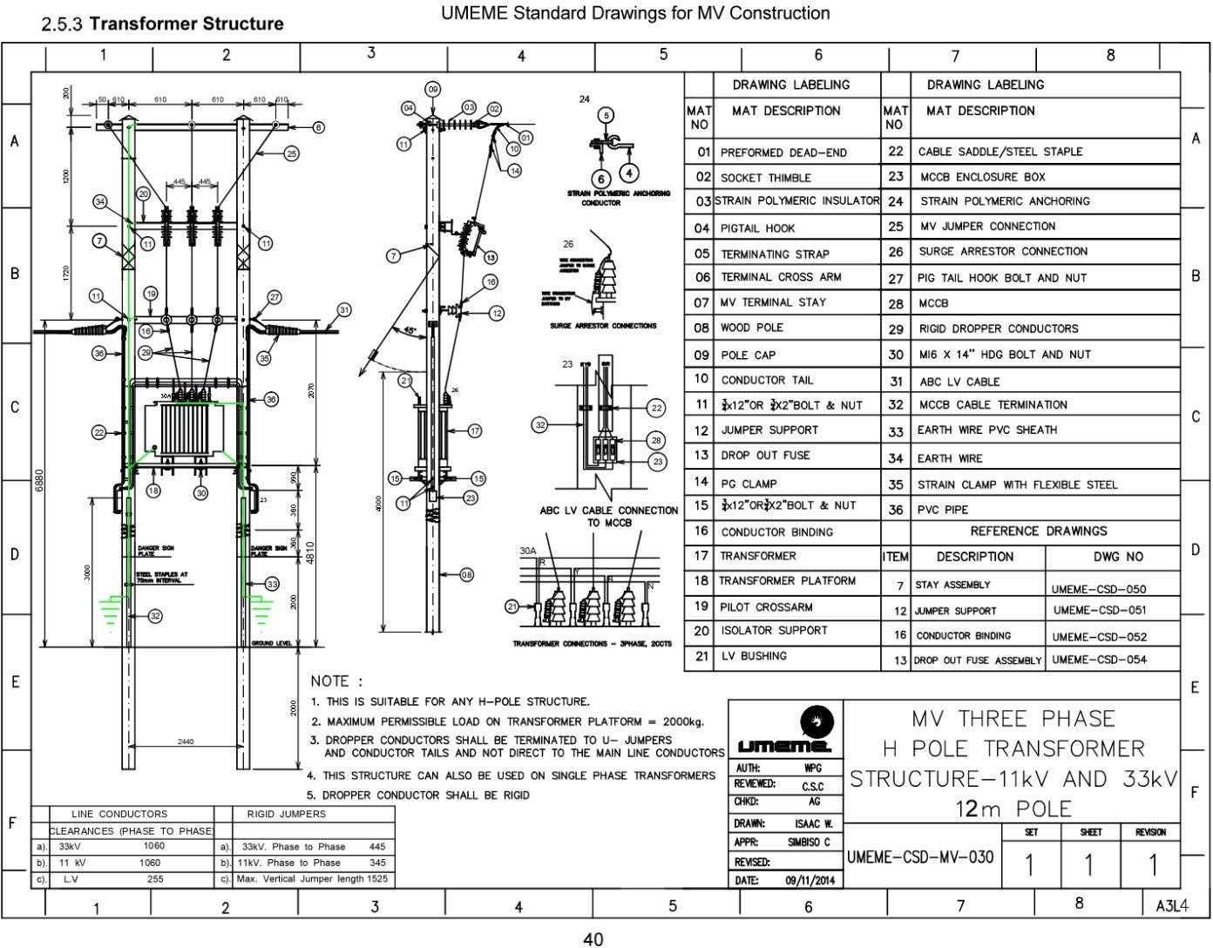

Figure 9: Typical pole mounted transformer structure

SUBSTATION MAINTENANCE
Substation maintenance refers to the regular and planned activities undertaken to ensure the reliable and safe operation of electrical substations.
Substations are essential components of the power grid that help in the transmission and distribution of electricity from power plants to end-users. Proper maintenance is crucial to prevent breakdowns, optimize performance, and extend the lifespan of substation equipment.
This particular activity was done at Tororo Rock and Nagongera Substations.

Activities carried out during substation maintenance
During the substation maintenance, the following activities are carried out to ensure the reliable and efficient operations:
- Visual Inspection: Conducting a visual inspection of the substation equipment, including circuit breakers, transformers, disconnect switches, relays, meters, and control panels, to identify any signs of damage, overheating, corrosion, or loose connections.
- Cleaning: Removing dust, debris, and contaminants from the equipment. This helps to prevent insulation deterioration, reduce the risk of arcing, and maintain optimal performance.
- Lubrication: Applying lubricants to moving parts, such as hinges, bearings, and linkages, to ensure smooth operation and minimize frictional losses.
- Testing and Calibration: Performing tests and calibrations on protective relays, meters, and other monitoring devices to verify their accuracy and functionality. This helps to ensure proper operation and timely response in case of faults or abnormal conditions.
- Insulation Testing: Conducting insulation resistance tests on cables, transformers, and other insulation systems to assess their integrity and identify any potential insulation breakdown or leakage.
- Circuit Breaker Maintenance: Inspecting, cleaning, and lubricating circuit breakers, as well as conducting mechanical and electrical tests to verify their operating parameters, contact resistance, and trip/reset functions.
- Transformer Maintenance: Inspecting transformer oil levels, checking for leaks, performing insulation tests, checking functionality of tap changer and conducting electrical and thermal imaging inspections to detect any potential issues and ensure optimal performance.
- Grounding System Inspection: Checking the integrity of grounding systems, such as ground electrodes, connections, and conductors, to ensure effective grounding and protection against electrical faults and lightning.

- Battery Maintenance: Testing and maintaining the backup battery systems used for supplying power to control and protective devices during outages or emergencies. This includes checking battery voltage, electrolyte levels, and conducting load tests.
- Records and Documentation: Updating maintenance logs, recording observations, test results, and any repairs or replacements performed during the maintenance activities. Proper documentation helps in tracking the maintenance history, identifying trends, and planning future maintenance tasks.

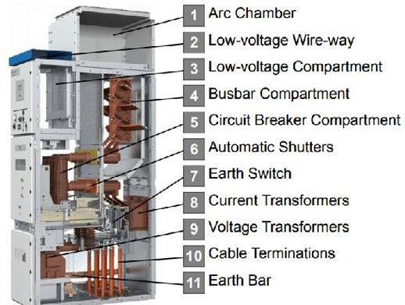
Figure 10 11kV switchgear

VEGETATION CLEARANCE
Vegetation clearance in electricity distribution lines refers to the process of removing or managing trees, shrubs, and other vegetation that grows near or around the infrastructure of power distribution lines.
It involves the regular removal of trees, shrubs, and other vegetation that could potentially interfere with the distribution infrastructure. Trees and vegetation growing near power lines can pose several risks.

Reasons for vegetation clearance
Here are some of the reasons why vegetation clearance in electricity distribution lines is a crucial aspect of maintaining a reliable and safe power supply:
- Electrical safety: When branches or foliage come into contact with power lines, it can cause electrical arcing, short circuits, and power outages. This not only disrupts the electricity supply but also poses a significant safety hazard to people in the vicinity.
- Fire hazard: Dry or overgrown vegetation near power lines can become fuel for fires that can damage electricity infrastructure. Regular clearance helps reduce this risk.
- Equipment damage: When trees or branches fall onto power lines due to wind, storms, or heavy snow, they can cause damage to the equipment, either physical or through short circuit. This damage can be costly to repair and may lead to prolonged power outages.
- Reliability: Vegetation interference is a common cause of power outages. By clearing the vegetation in a proactive manner, a utility company like Umeme Ltd can minimize the occurrence of outages and enhance the reliability of the electricity distribution system.
To address these risks, Umeme has introduced Vegetation Clearance Team that operates under maintenance department. They are responsible for regular inspections and maintenance activities to identify and remove vegetation that poses a threat to power lines.

Activities carried out during vegetation clearance
Here are the common activities carried out during vegetation clearance:
- Pruning: Trimming trees and shrubs in a manner that maintains a safe clearance distance from power lines. This could involve removing branches that are in close proximity to the lines or those that have the potential to grow into them.
- Tree removal: In cases where trees pose a significant risk to power lines or are likely to cause major disruptions if they were to fall, utility companies may decide to remove them entirely.

- Herbicide application: In some instances, utility companies may use approved herbicides to manage vegetation growth within electrical infrastructure, e.g., in substations. This is done selectively and with proper environmental considerations.
- Regular inspections: Routine inspections of power line corridors help identify potential issues and prioritize clearance efforts. This proactive approach helps prevent vegetation-related incidents before they occur.
- Relocation of bees from electricity infrastructure: Done by experts.

It's worth noting that vegetation clearance activities must adhere to environmental regulations and guidelines to ensure responsible management. In regards to this, Umeme Ltd has established ESG (Environmental, Social, and Governance) department that works closely with environmental authorities and follow best practices to strike a balance between maintaining power system reliability and preserving the natural environment.

UMEME GUIDELINES FOR LINE CLEARANCE WORKS
All Line Clearance shall be executed in accordance with the guidelines outlined below.
      - CLEARENCE IN AGRICULTURAL, GRASS AND SCRUB COUNTRY

11kV and LV lines
All trees and shrubs etc., will be felled, or lopped 3m either side of center line only. Trees will not be cleared to falling distance. See drawing 01
Notwithstanding this general instruction, any tree, which is obviously rotten, and a danger to the line will be felled.

33 kV Lines
33 kV lines will be graded class I or II. This grading will be clearly stated in the line specification.

Class I
All trees, which are within falling distance of the line, will be cleared, allowing a safety distance of 3.6 m from either side of the centerline. See drawing 01.
All trees and branches that are within 45 degrees when measured at a distance of 3.6 m from the base of the pole will also be cleared as shown in drawing 01.

Class II
The clearance of class II 33 kV lines will be the same as for 11 kV lines. See drawing 02.

      - CLEARANCE IN NATURAL AND RESERVE FORESTS

11kV and LV lines
All trees and scrub within 4.5 m of radius either side of centerline will be cleared. See drawing 03.

33 kV Lines and Class I
All Scrub will be cleared for a distance of 4.5 m on both sides of centerline.
All trees will be cleared for a distance of 7.5 m on both sides of the center line. All trees within falling distance will be felled. See drawing 03.
- 33 kV Lines Class II
The clearance of class II 33 kV lines will be the same as for 11 kV and lv lines. See drawing 03.

IN FOREST PLANTATIONS:
The minimum clearance in forest plantation is 6 m either side of clearance lines. In the case of 11 kV and class I and II 33 kV lines, the width of clearance will be stated in the line specification.

POLES WEEDING
The contractor is advised that there are on average 10 poles per kilometer and they will be required to weed around each pole structure to a radius of one (1) meter and also submit a report of all rotten poles (with GPS reference) found on the line.

DRAWINGS FOR LINE CLEARANCE FOR SCOPE OF WORK

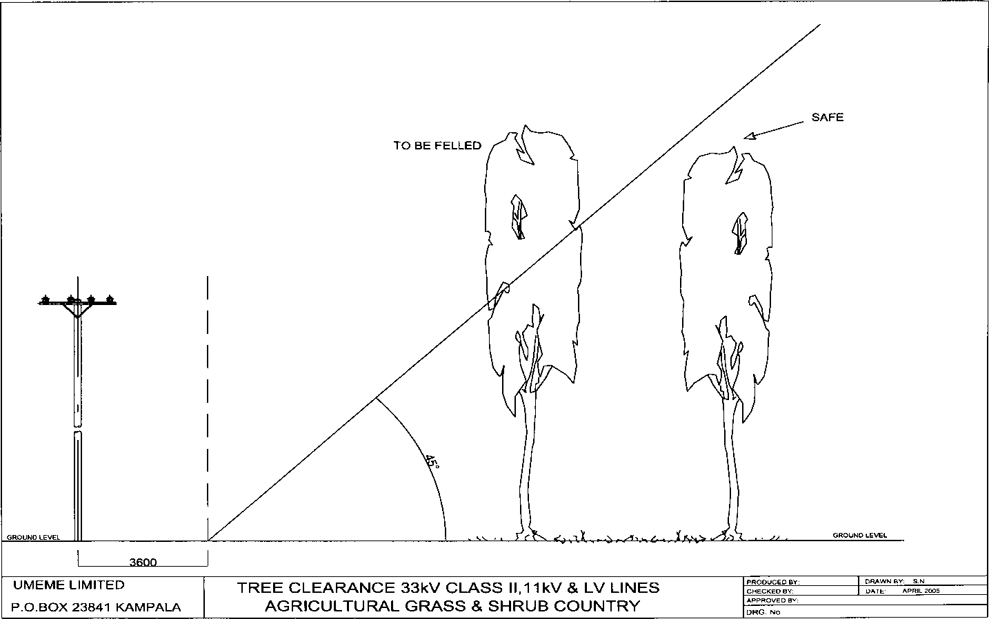

Figure 11 Vegetation clearance in agricultural grass and shrub country 1

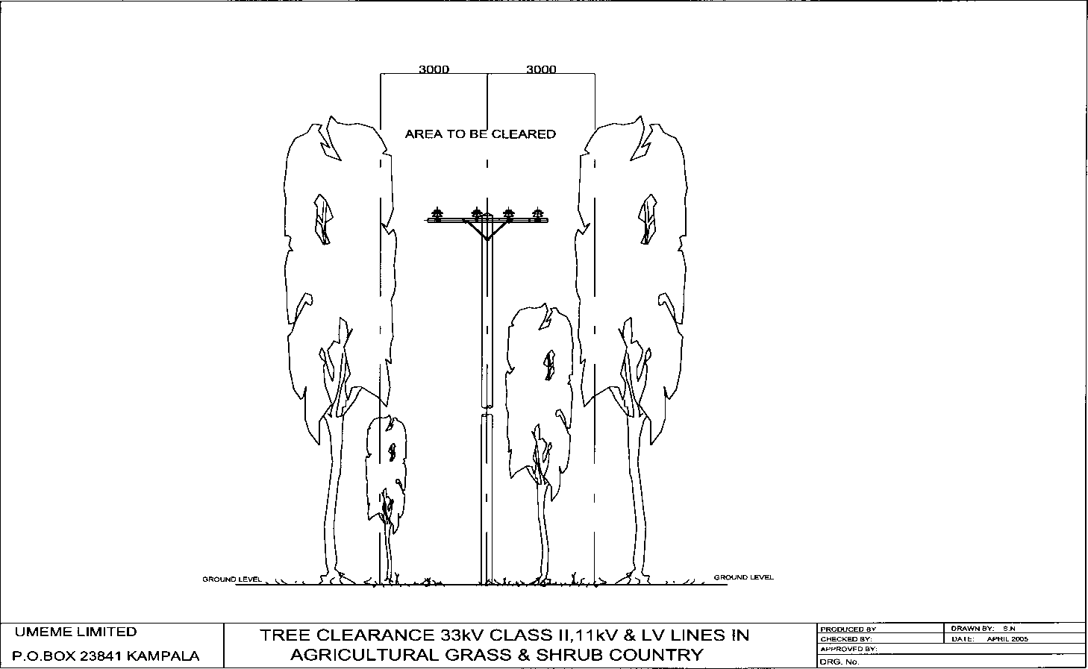
Drawing 02:
Figure 12: Vegetation clearance in agricultural grass and shrub country 2

Drawing 03:
33kV CLASS I LV,11kV &33kV CLASS II

OF O H


LINE

C
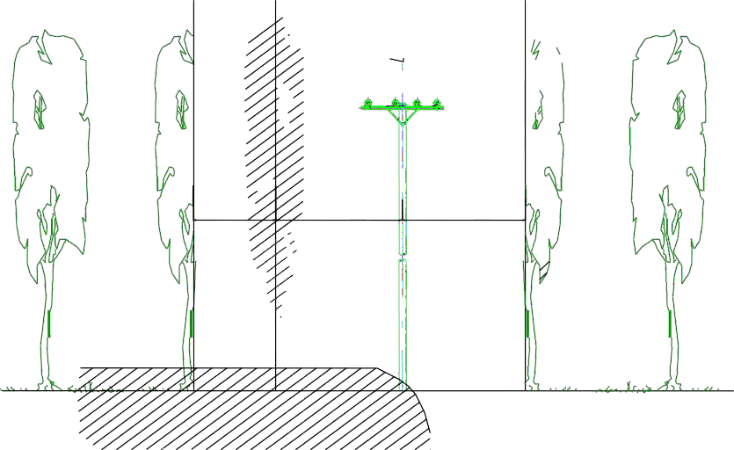
TREES IN FALLING
DISTANCE TO BE FELLED

CLEAR ALL TREES IN THIS 3M

3000 4500 4500

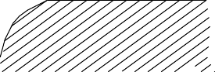
CLEAR SCRUB CLEAR SCRUB
AND ALL TREES AND ALL TREES
UMEME LIMITED IN THIS 4.5M IN THIS 4.5M
P.O.BOX 23841 KAMPALA
 | TREE CLEARANCE 33kV CLASS I, II  & 11kV LINES IN NATURAL & RESERVE FOREST | PRODUCED BY: | DRAWN BY: S.N
 |  | CHECKED BY: | DATE: APRIL 2005
 |  | APPROVED BY:
 |  | DRG. No.

Figure 13: Vegetation clearance in forest reserve

GUIDELINES, PROCEDURE AND SCOPE FOR LINE CLEARANCE

TASK PROCEDURE / OBSERVATION FORM
1. SCOPE:

This procedure is developed to inform persons of the hazards attached to the activity of bush or line clearance. It is the responsibility of every supervisor and individual to follow these steps in order to
minimize the probability of injuries. Trained competent / responsible persons should carry out the activity of bush or line clearance.
- APPLICABLE LEGISLATION:
  - ELECTRICITY ACT OF 1999
  - OPERATING REGULATION FOR HIGH VOLTAGE SYSTEM
  - ELECTRICITY (SAFETY CODE) REGULATIONS 2002
- PPE REQUIREMENTS:
  - WORKING GLOVES (LEATHER)
  - OVERALL/OVERCOAT
  - SAFETY SHOES
  - SAFETY GUM BOOTS (SWAMP AREAS)
  - EYE PROTECTION (USING OF CHAIN SAWS)
  - SAFETY HELMET (HARD HAT)
  - SAFETY BELT (WORKING ON HEIGHTS OR LEAVING GROUND LEVEL >2M)
  - BEE SUITS(BEE INFESTED TREES)
- TOOLS AND EQUIPMENT:
  - Operating stick and key (s)
  - Proximity tester
  - Motor vehicle
  - Earthing leads and working earths.
  - Chainsaw, pangas, ropes, tirffor, climbing irons, chain saw, ladders, axes, bow saws etc.
  - Bucket truck (a must have)
5. PRECAUTIONS:
- Ensure that the working earths are applied on either side of the work area, where theline can only be worked on when isolated (dense areas)
- Ensure maximum concentration from all the members, avoiding horseplay, which can be very dangerous.
- When working on road sides the required warning signs and cones must be placed
- Ensure that all members understand the risks involved in carrying out the task ofbush/line clearance. (Explained in the workers register)
- Proper judgement and assessments to be made of tree heights to prevent line contacts
- SCOPE AND AUTHORITY:

  - Only Authorized Persons shall operate the HV system.
  - The supervisor of bush clearing activities must be a competent person.
  - A work permit must be issued and worker’s registers duly completed to all contract workers.
  - Where HV operation is required, all HV operating instructions shall be communicated to Control and the controller confirms the operation via radio and/or telephone.
  - Only competent persons to use motorized equipment (chain saws)
Table 6: Guidelines, procedures and scope of work for line clearance

DEFECT LIABILITY PERIOD (DLP) INSPECTION / LINE INSPECTION
This activity was carried on new networks constructed by C$G ANDIJES GROUP LTD under REA SCHEMES. It involved assessment and verification of the network's construction and installation during the specified defect liability period.
This inspection ensures that the newly built network meets the required standards, specifications, and contractual obligations.

Activities involved during DLP inspection
Here is how DLP inspection may be conducted on a newly constructed electricity distribution network:
- Construction Compliance Review: The inspector reviews the construction plans, specifications, and contractual agreements to understand the scope of work and the expected quality standards for the network.
- Visual Inspection: A comprehensive visual inspection of the newly constructed network infrastructure, including power lines, poles, transformers, switchgear, substations, and associated equipment, is performed. The inspector examines for any visible defects, installation errors, improper connections, or non-compliance with design requirements.
- Equipment Testing: Various tests are conducted on the newly installed equipment and components to ensure they are functioning correctly and meet the required performance specifications. This may include tests for transformers, switchgear, protection relays, meters, and other critical equipment.
- Safety Verification: The inspector verifies that the newly constructed network complies with safety standards and regulations. This involves assessing the effectiveness of safety measures, grounding systems, earthing arrangements, insulation requirements, and adherence to electrical codes.
- System Performance Assessment: The inspector evaluates the performance of the newly constructed network by analyzing voltage levels, power quality parameters, system losses, and load distribution. This assessment helps identify any inefficiencies, imbalances, or performance issues that need to be addressed.
- Compliance with Standards: The inspector checks if the newly constructed electricity distribution network meets the applicable industry standards, local regulations, and best practices. This includes assessing compliance with electrical codes, network design guidelines, and quality assurance requirements.
- Documentation Review: The inspector reviews documentation related to the construction and installation of the network, such as construction records, equipment certificates, test reports, and as-built drawings. This helps ensure that the constructed network aligns with the approved plans and specifications.
- Defect Identification and Rectification: Any defects, deficiencies, or non-compliance issues identified during the inspection are documented in a comprehensive report. The

report serves as a basis for the contractor to rectify the identified issues within the defect liability period.

Parameters checked during DLP inspection
The parameters to be checked are listed in the table below:

ITEM CHECK | TX  No 1 | TX  No 2 | TX  No3 | TX  No 4
Overhead Line Parameters
Check for T-off protection (DOFI installed).
Check for alignment of DOFI.
Condition of cross arms (alignment, bents, rusts, etc.)
Condition of conductors (joints, kinks, etc.)
Cable armour earthed on only one end.
Condition of the cable armour earthing
No of PG clamps on each HV jumper.
Condition of the jumper
No of missing pole caps on HV and LV poles.
Danger Plates mounted on HV poles
Condition of the danger signs (faded, etc.)
Pole tags available on MV poles
In adequate clearance between LV pole and HV conductors
Inadequate clearance between HV conductors (11&33) kV
Clearance of HV conductor from ground.
Tree(s) under, close or touching HV line.
No of sections with missing insulator supports
Long HV spans (Above 100m)
Backfilling of HV poles not to required standard.
Stays correctly installed, tensioned, stay wire tails cut and locked.
Leaning Structures e.g. (T-off, Transformer, 3 members, H Pole)
Combined earth point for both LV and TX body
Inadequate clearance between stay and conductor (LV or HV)
Broken HV insulators
Surge arrestors on terminal structure(s)

Earth Test Point Provided
Earth wire PVC Sheath used
Conductor firmly bound on insulators.
No of long LV spans
Transformer Structure
Transformer Replaced (Y/N)
Transformer Make.
Transformer Rating.
Transformer Serial number.
Year of manufacture.
Tap Position.
Impedance.
Check HV and LV bushings if lugged.
Condition of HV and LV Termination on the distribution transformer.
Condition of the lugged Tx earth tank
Check jumpers to arrestors if connected using PG. clamps.
Condition of arrestors on Tx
Condition of terminal line arrestors
Condition of the LV breakers.
Condition of the LV breaker termination
Rating of LV breaker
No of LV circuits.
Condition of the saddles.
Load Voltage Values
R-B Phase values
R-Y Phase values
B-Y Phase values
Red Values
Yellow Values
Blue Values
Current Values Circuit 1 & 2
Circuit A | Red Phase
Circuit A | Yellow Phase
Circuit A | Blue Phase
Circuit B | Red Phase
Circuit B | Yellow Phase
Circuit B | Blue Phase
Conclusions and Recommendation(s)
Table 7: Parameters checked during inspections of newly constructed lines

POLE REPLACEMENT
Electrical pole replacement is the process of replacing utility poles that are used to carry overhead power lines in an electricity distribution system.
Most utility poles under distribution network in Uganda are typically made of wood, concrete or steel and play a crucial role in transmitting electricity from power plants to homes, businesses, and other facilities.

Reasons for Electrical Pole Replacement:
- Age and Deterioration: Over time, utility poles can become structurally weakened due to natural aging, exposure to the elements, and environmental factors like wind, rain, and extreme temperatures. This can lead to a decreased ability to support the weight of power lines, posing safety hazards and increasing the risk of pole failure.
- Storm Damage and Accidents: Severe weather events, such as storms, hurricanes, or tornadoes, can cause significant damage to utility poles. Additionally, accidents involving vehicles colliding with poles can result in damage that necessitates replacement.
- Improvement of Infrastructure: Utility companies might choose to replace older poles with newer, more robust ones to improve the overall infrastructure and ensure reliable electricity distribution.
- Safety Concerns: When utility poles show signs of severe damage or structural instability, it is essential to replace them promptly to prevent potential hazards to the public and electrical workers.

Activities involved in pole replacement
Pole replacement involves a number of processes that include:
- Inspection and Assessment: Regular inspections of power lines are always done to identify any signs of deterioration or damage. Or at times broken poles are reported, calling for assessment.
- Planning and Scheduling: Based on the inspection and assessment results, utility companies plan and prioritize the replacement of poles that pose the greatest risks. A schedule for replacement activities is created to ensure that critical poles are addressed promptly.
- Temporary Power Shutdown: Before replacing a pole, the electrical power in the area served by that pole may need to be temporarily shut down for safety reasons. Affected customers are notified in advance to minimize inconvenience.
- Removal of Old Pole: Crews use specialized equipment and machinery such as cranes to remove the old pole carefully. In some cases, they may need to dig around the base of the pole to detach it from the ground.
- Installation of New Pole: The new utility pole is installed, anchored securely into the ground, and aligned properly to support the power lines effectively.

- Reconnection and Testing: After the new pole is in place, the power lines are reconnected, and the electricity supply is restored. Utility crews then conduct tests to ensure that the electrical system is functioning correctly.
Electrical pole replacement is an essential maintenance activity for power distribution systems, ensuring the reliability and safety of electricity delivery to consumers.

NB:
  - Wooden poles must be treated with Creosote or CCA to UMEME standards and specifications. This specification is available from UMEME on request.

  - Anti-climbing devices must be installed on MV strut poles only.

  - Pole numbering must be done as a standard on both MV and LV poles

  - Each MV pole must be equipped with a “danger” warning sign in local Language and
  - English.

Pole sizes and their applications

Size | Pole length | Min pole base (mm) | Min pole top (mm) | Planting depth (m) | Application/construction
Light | 10 | 210 | 150 | 2 | Intermediate poles LV ABC
Light | 12 | 240 | 180 | 2 | Intermediate MV on rural lines
Medium | 10 | 240 | 180 | 2 | Angle pole LV supported
Medium | 12 | 260 | 197 | 2 | Angle pole MV supported
Medium | 14 | 280 | 210 | 2.2 | Special use MV (Long span, etc)
Stout | 10 | 295 | 190 | 2 | Unsupported LV
Stout | 12 | 320 | 200 | 2 | Unsupported MV
Stout | 14 | 340 | 220 | 2.3 | Special use MV (long span, etc)
Table 8: Pole sizes and their applications

Stays and Assemblies

Stay wire
The stay support shall be planted at an angle of 45˚ from the pole. Outrigger brackets shall be used where space is limited. The stay rod should not be closer than 2.5m from the pole base.
A guideline for stay wire for medium Voltage and low Voltage installations will be as per Table below:

Application | Strands/diameter
LV | 7/2.5mm
11kV | 7/3.35mm
33kV | 7/3.35mm
Table 9: Standard stay wire

Stay rod
Stay rods shall comply with BS 183 Grade 700and shall be 1100 MPA for both LV and MV stays. Table below gives a guideline for the standard stay rod sizes to be used.
Application | Diameter | Adjustment
LV | 16mm | Adjustable
11/33kV | 20mm | Adjustable
Table 10:Standard stay rod

Base plate/Stub pole
A Stub pole or kicker block will be used as an anchor. The stub pole shall be 1m long, fully treated on both ends as per UMEME specification. Un-treated cut-offs are not allowed.

Stay Insulator
Rated Stay Insulators must be used as per UMEME specification. The vertical height of the stay insulator from the ground should be a minimum of 4m.

FAULT FINDING
The tools used to analyze distribution faults include a feeder monitoring system (FMS), an automated outage management system (OMS), a distribution SCADA system (DSCADA), and several Excel spreadsheet applications. The latest fault detection system involves an integration of FMS, OMS, and DSCADA systems to provide distribution dispatchers with a graphical display of possible locations for faults that have locked out feeder circuit breakers.

Umeme distribution network majorly uses SCADA (Supervisory Control and Data Acquisition) system. This can be achieved by ensuring that the system is properly set up and configured to monitor the distribution line.
It includes deploying remote terminal units (RTUs) or intelligent electronic devices (IEDs) to collect real-time data.
The SCADA system should continuously collect data from the RTUs or IEDs placed strategically along the distribution line. This data typically includes voltage, current, power factor, and other relevant parameters.
SCADA system's graphical interface help monitor the distribution line in real-time. You can view voltage profiles, current flows, and the status of switches and circuit breakers.
The SCADA system should have algorithms and rules in place to detect abnormal conditions on the distribution line, such as voltage sags, current spikes, or abnormal frequency. When a fault occurs, the system should raise an alarm or notification. All these events are logged.

Sectionalization;
Sectionalization, in the context of electrical distribution systems, refers to the practice of dividing a larger electrical network or circuit into smaller sections or segments. Each section can be isolated independently from the rest of the network using switches or sectionalizers. The primary purpose of sectionalization is to improve the reliability, efficiency, and ease of maintenance of the electrical distribution system.
When a fault alarm is triggered, field technicians are dispatched to the affected feeder indicated by the SCADA system to operate the sectionalizer switches (such as Air break switches, Load break switches, Drop out fuse isolators, Auto reclosers, etc.), isolating the suspected faulted section. This action effectively disconnects the faulted section from the rest of the distribution line.
Once the fault location is confirmed, field technicians can then proceed with the necessary repairs, which might involve replacing damaged equipment, fixing insulation issues, or addressing other specific faults.
After repairs are completed, the isolated section can be reconnected to the distribution line, and power can be restored to the affected customers.

SWITCH GEAR OPERATING
Operating an electrical switchgear involves performing a series of actions and procedures to control, manage, and maintain electrical power distribution systems.
Switchgear is a collection of devices, including switches, circuit breakers, fuses, and other protective equipment, used to control the flow of electrical power in industrial, commercial, and utility settings. The primary goals of operating switchgear are to ensure the safe, reliable, and efficient distribution of electrical energy.

Correct sequence/order of operating:
Switching, Linking, Safety testing and Earthing

Situations under which electrical switchgear may be operated
Electrical switchgear is operated in various situations and scenarios to control, manage, and maintain electrical power distribution systems. Here are common situations when electrical switchgear is operated:
- During the startup and shutdown of electrical systems to energize or de-energize circuits and equipment as needed.
- During routine maintenance activities. For example, during scheduled inspections or equipment servicing.
- When electrical faults occur in the system, such as short circuits or overloads, switchgear is operated to detect the fault location and isolate the affected section of the electrical network.

During Load Shedding.
- During testing and troubleshooting to check the functionality of circuit breakers, switches, and protective relays.

During emergency Response.
- Switching for Maintenance Work. The switchgear is operated to isolate the equipment from the power source. This is done to ensure the safety of maintenance personnel.
- During grid Reconfiguration. In utility-scale power distribution, grid reconfiguration involves changing the network's topology to enhance reliability or improve power quality. Switchgear is used to implement these changes.
- Etc.

Note: Operating electrical switchgear should always be done by trained and authorized personnel who are familiar with the equipment and safety procedures. Safety is paramount in switchgear operations to prevent electrical accidents and ensure the reliable operation of the electrical system.
According to Umeme ORHVS (Operating Regulations for High Voltage Systems), No person shall be authorized to perform specific tasks without having been suitably selected, trained, assessed and found competent to do the work.
Only authorized persons shall carry out switching, linking, safety testing and earthing activities to the extent of their authorization, except where persons are being trained for operating authority.
These trainees shall operate under the supervision of an authorized person, provided that the control officer has been duly informed of such an arrangement.

When a high voltage electrical apparatus is to be worked on, it must be Opened, Isolated, Safety- tested and earthed. Here, the person authorized for operating physically carries out the switching, linking, safety testing and earthing in order to make the apparatus safe to work on.
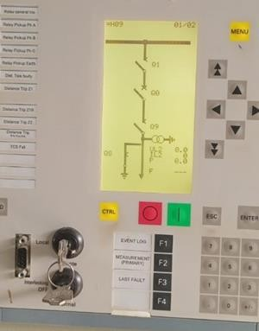
Figure 14: Figure 13: SLD showing that an apparatus is Opened, Isolated and Earthed.

The regulations are based on the following principles:
  - Control must be exercised over system conditions and operating procedures at all times
  - Access to high voltage conductors and apparatus must be strictly controlled
  - No person shall carry out work of any description, on any part of high voltage apparatus, unless those parts are:

- Opened (Opening of breakers or switches)
- Isolated and all practical steps are taken to lock such apparatus where possible from all live conductors

Safety tested,
- earthed, bonded and insulated so that an equipotential zone is created
- Handover taken; workings earths applied where applicable in order to create an equipotential zone.
- Barricaded (screened off) from danger where required - warning notices affixed
- A work permit issued where required
- The persons who are to work on the apparatus are made fully aware of the nature and extent of the work to be done. The risk assessment and workers register has been completed

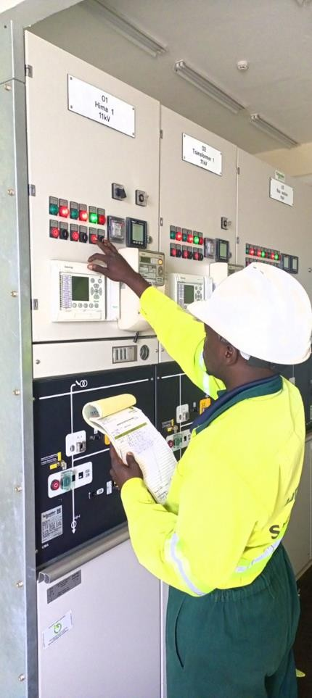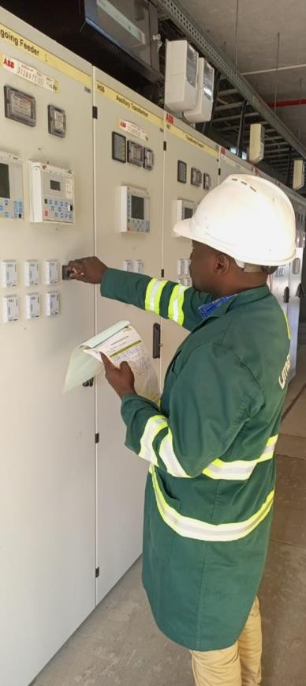
Figure 15: Carrying out switching on Hima 1 11kV feeder and Busia 33kV feeder at Nyakesi and Tororo main substations respectively.

Why unearthed disconnected overhead line is not regarded dead
An overhead line disconnected from all sources of supply, but not earthed, cannot be regarded as being dead because:
- It can acquire a static charge
- It can retain a static charge
- It can accidentally be made alive
- Nearby energized lines continuously induce voltages in them (electrical and electromagnetic induction).

Ways in which isolated apparatus can acquire a static charge:
Electrical apparatus and, in particular, overhead lines may become charged due to:
- Direct lightning strikes
- Electromagnetically induced currents from a lightning strike in the immediate vicinity of the line.
- Electro-statically induced charges on the lines, due to the presence of thunderclouds and
- Electrostatic charges imparted to the line by the friction of dust or snow blowing past the conductors.

Way in which Isolated and earthed apparatus can be accidentally energized:
- From the power system due to operating errors/unauthorized operating– e.g., closing the wrong isolators/breaker.
- Through a live conductor breaking and falling onto the isolated and earthed apparatus.
- By means of back-feeding from a customer’s generator set
- By means of stray voltages.
- Broken insulators between different systems.

Reasons for earthing isolated lines and apparatus
The purpose of earthing isolated lines and apparatus, including bonding all conductive material together on the worksite, is to:
- Provide protection to workers against static charges
- Provide protect to workers against residual voltages
- Protect the workers if the line or apparatus is accidentally made alive whilst persons are working on them
- Discharge induced voltages continuously and safely.
The only safe way to ensure that the apparatus is made safe, and will remain safe while working on it, is by earthing it in such a way that an equipotential zone is created.

Types of earthing devices
There are three different types of earthing devices found on the Umeme network system, namely:
- Portable earths
- Fixed earths
- Earthing switches

Dangers of inadequate or improper earthing and properties of safe earth connection

Dangers of inadequate or improper earthing
      - Electrocution
      - Burns from arcing
      - Electric shock leading to falls

Properties of safe earth connection
      - Earths must be mechanically and electrically in a good condition
      - There should be no broken strands
      - Clamps should be rigid and without defect
      - They should make intimate contact with conductors and earth
      - Earthing leads should be as short as possible

Important: Each authorized person who has taken over the line (or an apparatus) will apply working earths on all sides of, visible and as close as possible to his point of work in such a manner that an equipotential zone is created.

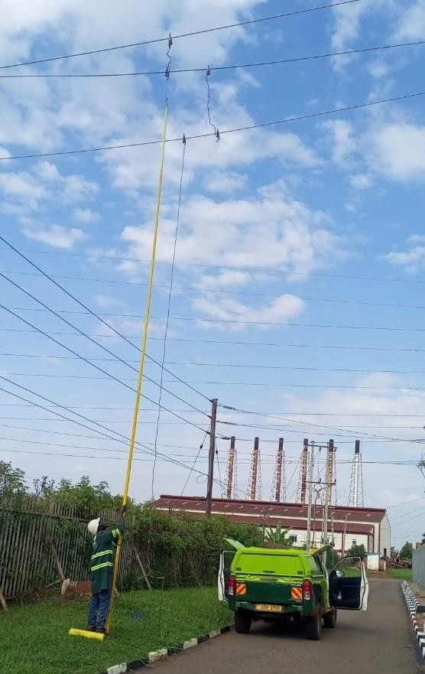
Figure 16: Applying working earthing for works on a cable structure at Tororo main substation.

PRECAUTIONS TO TAKE WHEN OPERATING ELECTRICAL SWITCHGEAR

Pre-Operation Checks:
  - Ensure you are properly trained and authorized to operate the switchgear.
  - Put on appropriate personal protective equipment (PPE) such as gloves, safety glasses, and arc flash protection gear.
  - Ensure that you are in the right and intended apparatus to operate.
  - Verify that the switchgear is in the correct operating position, and all interlocks are in place.
  - Confirm that the equipment is properly grounded to minimize the risk of electrical faults.

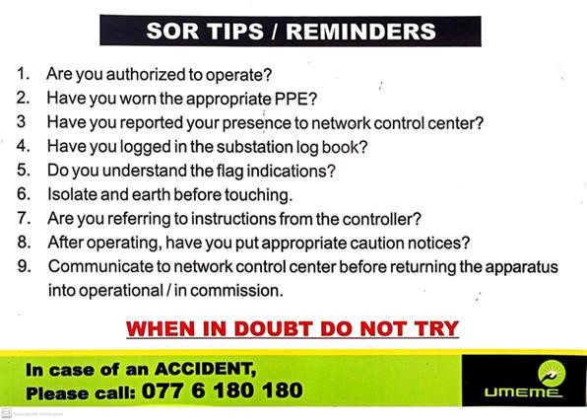
Figure 17: Safety reminder for operating at the substation

Visual Inspection:
  - Conduct a visual inspection of the switchgear to check for any signs of damage, loose connections, or foreign objects inside the enclosure.
  - Verify that all warning labels and nameplates are legible and up-to-date.

Verify Isolation and Lockout/Tagout:
  - Ensure that the circuit you intend to work on is isolated from the power source.
  - Use lockout/tagout procedures to secure the switches or circuit breakers in the off position to prevent accidental energization.
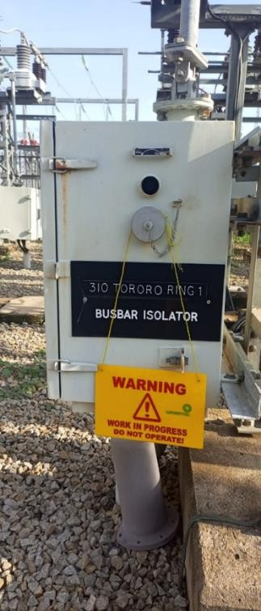
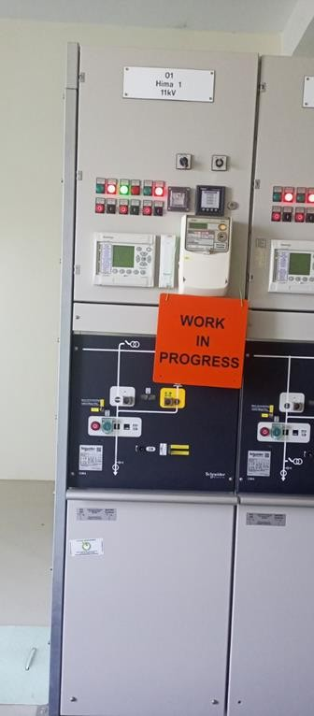

Figure 18:Prohibitory signs placed at isolation points to prevent accidental operating

Review Operating Procedures:
  - Familiarize yourself with the specific operating procedures for the switchgear, which may include manufacturer instructions and facility-specific guidelines. It is advisable to have a written instruction during operating.
  - Understand the sequence of operations required for your task.
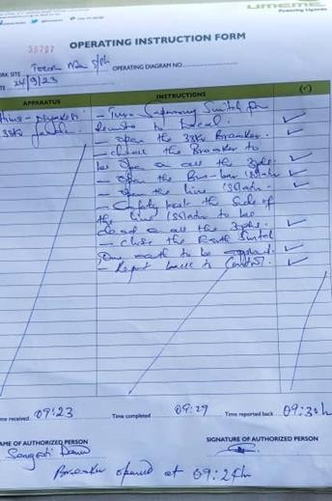
Figure 19: Sample of an operating instruction form
Experience has proved that relying on memory can be fatal. Any abnormal occurrence could distract the authorized person’s attention, which could cause errors or accidents. The written instruction provides a quick reference and eliminates guesswork.

Advantages of using operating instruction form
    - It abolishes the need for relying on memory.
    - It reduces the chances of error as operations are set down in sequence.
    - Tick off each step when completed

Energize the Control Circuit:
  - If the switchgear has a control circuit, energize it according to the manufacturer's instructions to enable remote operation if necessary.

Manual Operation:
  - If your task requires manual operation, use the appropriate tools or handles to open or close the switches or circuit breakers.
  - Follow the correct sequence of operations to prevent electrical faults.

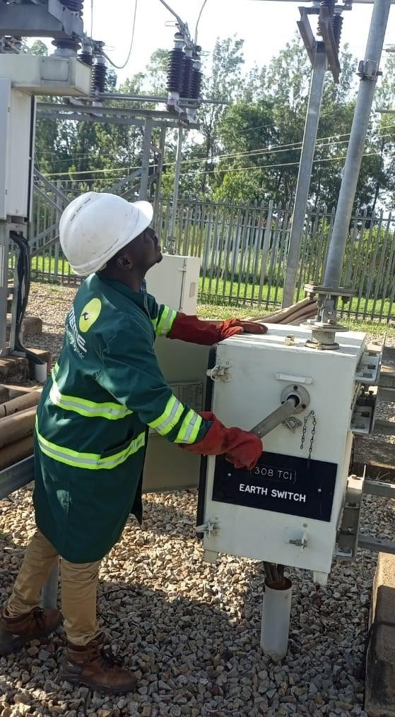

Figure 20:Closing an earth switch manually on TCI 1 33Kv feeder at Tororo main substation

Monitoring:
  - Continuously monitor the switchgear while it is in operation to ensure that it performs as expected.
  - Look for any abnormal conditions, such as excessive heat, unusual sounds, or flashing lights.

Record Keeping:
  - Maintain a record of your switchgear operations, including the date, time, and details of the task performed in the operating instructions book.
  - Document any abnormalities or observations made during the operation.

De-Energization:
  - When your task is completed, de-energize the switchgear by opening the switches or circuit breakers.
  - Confirm that all equipment is in the safe and off position.

Lockout/Tagout Removal:
  - Remove any locks and tags that were placed on the switches or circuit breakers during the isolation process.

Post-Operation Checks:

  - Conduct a post-operation visual inspection to ensure that the switchgear and the surrounding area are in good condition and free from hazards.

Reporting:
  - Report any issues, abnormalities, or equipment malfunctions to the appropriate personnel, and follow your facility's incident reporting procedures.

Exit Procedure:
  - Leave the switchgear area, ensuring that all tools and equipment are accounted for and that the area is safe and secure.

CHAPTER FOUR: FAULTS IN ELECTRCAL SYTEM

FAULTS
In an electric power system, a fault or fault current is any abnormal electric current.
It can also be defined as any abnormal condition of the system that involves the electrical failure of the equipment, such as, transformers, generators, busbars, etc.
Electrical networks, machines and equipment are often subjected to various types of faults while they are in operation. When a fault occurs, the characteristic values (such as impedance) of the machines may change from existing values to different values till the fault is cleared.
There may be lot of probabilities of faults to appear in the power system network, including lightning, wind, tree falling on lines, apparatus failure, etc.

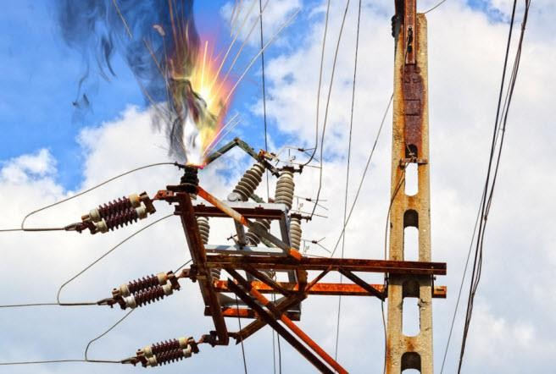
Figure 21: Impact of an electrical fault

Types of Faults
Electrical faults in three-phase power system mainly classified into two types, namely open and short circuit faults. Further, these faults can be symmetrical or unsymmetrical faults as discussed here in detail.

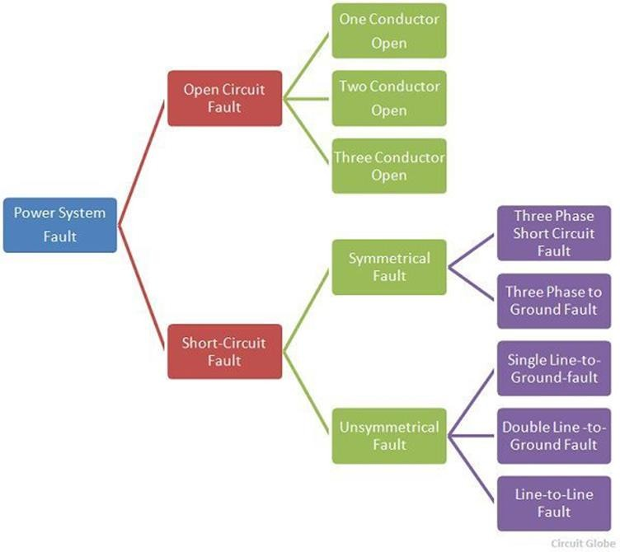
Figure 22: Types and categories of electrical faults

Open Circuit Fault
The open circuit fault mainly occurs because of the failure of one or two conductors. The open circuit fault takes place in series with the line, and because of this, it is also called the series fault. The most common causes of these faults include broken jumper(s) or joint failures of cables and overhead lines, and failure of one or more phases of circuit breaker and also due to melting of a fuse or conductor in one or more phases.

The open circuit fault is categorized as
  - Open Conductor Fault
  - Two open conductors Fault
  - Three open conductors Fault.

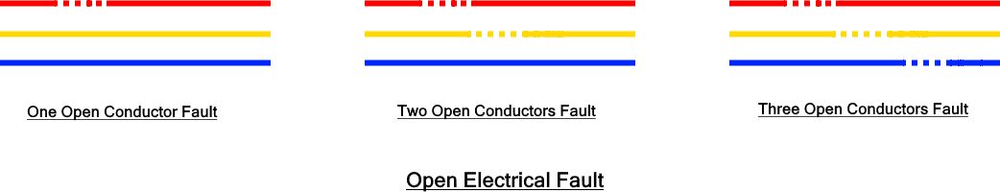
Figure 23: Open electrical fault

Short-Circuit Fault
In this type of fault, the conductors of the different phases come into contact with each other with a power line, power transformer or any other circuit element due to which the large current flow in one or two phases of the system.
It can be defined as an abnormal connection of very low impedance between two points of different potential, whether made intentionally or accidentally. Short circuit faults are also called as shunt faults.
The short-circuit fault is divided into the symmetrical and unsymmetrical/ asymmetrical Fault.

Symmetrical Fault
This fault occurs when all the three phases are simultaneously short circuited. Symmetrical fault is also called as balanced fault. In other words, the electrical system remains balanced during such faults i.e. the fault current has a similar magnitude and has 120° phase difference. The fault affects each phase equally.
These faults rarely occur in practice as compared with unsymmetrical faults.

There are two types of symmetrical faults
  - Line – line – line(L-L-L) Fault
  - Line – line – line – ground (L-L-L-G) Fault

Line – Line – Line (L-L-L) Fault
Such symmetrical fault occurs when all three phases are shorted together. They physically touch each other with zero impedance between them. The fault current is similar in all three phases.
Thus known as symmetrical it balanced fault.

Line – Line – Line to Ground (L-L-L-G) Fault
Such fault occurs when all three phases are shorted together with the ground of the system. The chance of occurrence of such fault is 2 – 3%.

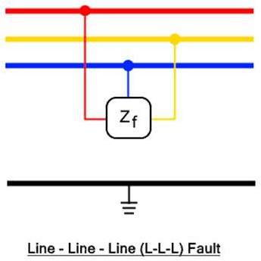
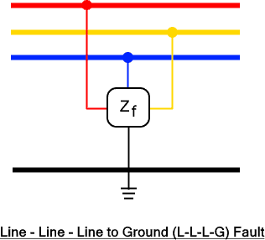

Figure 24: Symmetrical faults

Unsymmetrical/ Asymmetrical Fault
An asymmetrical fault is such a type of fault that causes an imbalance in the power system.
Such fault creates asymmetrical currents in the circuit (having different magnitudes with unequal phase displacement). These faults are also called as unbalanced faults as it causes unbalanced currents in the system. Such fault occurs in a three-phase power system.
Asymmetrical faults are the most common type of faults in three-phase power systems which are relatively less severe as compared to a symmetrical fault.
There are three types of asymmetrical faults
  - L-G Fault
  - L-L Fault
  - L-L-G Fault

Single Line to Ground (L-G) Fault
Such fault occurs when any one of the three phases is short-circuited or comes into contact with the ground. There is a very small impedance between them called the fault impedance Zf.
These faults are the most occurring type of fault in the phase power system with a 70 – 80% chance of occurrence. And they are less severe as compared to other faults. This fault occurs due to extreme weather conduction such as lightning, storms, and trees coming into contact with the power lines creating a short circuit with the ground.

Line to Line (L-L) Fault
A line-to-line fault occurs when two phase conductors come into contact with each other by any means accidentally or intentionally. The impedance between the shorted phase conductors is zero. The fault current is larger as compared to the L-G fault due to the high potential difference between phases.
Therefore, L-L fault is more severe than the L-G fault but less severe than other faults. The probability of occurrence of L-L fault is about 15 – 20%

Double Line to Ground (L-L-G) Fault
Such fault occurs when any of the two phases come in contact with the ground. The phase conductors are also shorted together as well as with the ground. It is the most severe kind of asymmetrical fault with a very less chance of occurrence about 5 – 10%.
Asymmetrical fault creates an imbalance in the system as they are unbalanced fault. This is because the impedance of each phase is dissimilar causing an unbalanced current. They are very difficult to analyze.
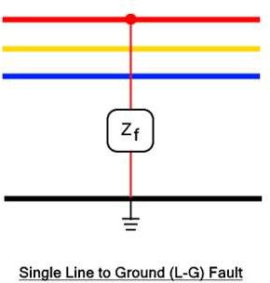
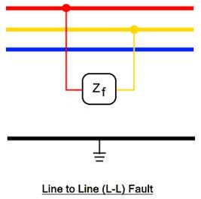
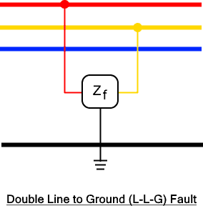
Figure 25: Unsymmetrical faults

Causes of Faults in Electrical Power System
      - Weather Condition
Extreme weather conditions affect the power lines in many ways that lead to electrical faults. These causes include:
        - Lightning strike hitting the power lines.
        - Heavy rain
        - Storm, heavy wind and trees falling on the power lines
        - Earthquake
        - Flood
        - Snowfall forms ice over the power lines.
        - Fire
Such weather conditions can damage the generation, transmission, and appliances connected to a power system.

Equipment Failure
Any kind of abnormality in any equipment, transmission cables, generation station, appliances, or loads connected in an electrical system can cause an electrical fault due to the following reasons.
        - Insulation failure of cables and windings in the motor
        - Aging and degradation of conductor
        - Malfunctioning
        - Physical damage

Human Error
There are certain safety rules and regulations that must be followed when installing any power system. However, human error can still cause faults due to.
        - Installing devices and components of improper ratings.
        - Improper maintenance
        - Switching circuit during its maintenance
Human error can be reduced to a great extent by following electrical codes and allowing professionals to do their job.

Miscellaneous
Here are some miscellaneous causes for the electrical fault:
        - The air ionizes due to the particles in the smoke of fire surrounding the overhead lines. The ions create a conducting path between the lines creating sparks between them. The flashover is a very common failure in insulators where it loses its insulating capacity.
        - Stress on power lines: the mechanical stress such as bending, flexing, and thermal stress acting on power lines causes electrical failure.
        - Switching surges: Due to sudden switching of a circuit breaker, voltage surges are created in the circuit that causes overvoltage
        - Accidents: any accidents involving vehicles hitting the utility pole
        - Birds shorting the power lines
        - Strings and snakes shorting the power lines
        - Chemical pollution corrodes and reduces the life of conductors.

Severity and Occurrence of Faults
The severity and occurrence are described in the table below

S. No | Fault Type | Fault Name | Short Name | Occurrence of fault | Severity of fault
1 | Asymmetrical | Line to Ground | L – G | 70 – 80% | Lowest
2 | Asymmetrical | Line to Line | L – L | 15 – 20% | >>
3 | Asymmetrical | Line to Line to Ground | L – L – G | 10% | >>
4 | Symmetrical | Line to Line to Line | L – L – L | 1% | >>
5 | Symmetrical | Line to Line to Line to Ground | L – L – L – G | 2 – 3% | Highest
Table 11: Severity and Occurrence of electrical Faults

Effects of Electrical Faults
Different kinds of faults, their duration, and location affect the electrical system differently.

Effect of Open Circuit Fault
- The Open Circuit faults are less severe and it causes in reduction of load at the alternator. In turn, it results in the acceleration of the alternator causing over frequency.

- It also causes an imbalance in the load. The intact phases take the load current of the broken phases. This affects the life span of the connected load.

Effects of Short Circuit Fault
- Over-current: short circuit fault creates very low impedance causing a huge fault current (over-current) that can damage the insulation and equipment connected to the circuit.
- Under voltage: In a short circuit fault, the large current flow also causes the reduction in the supply voltage.
- Danger to personnel: Electrical fault can pose danger to personnel working at the site of fault. It can even become fatal depending on the level and duration of the fault.
- Electrical fire: short circuit fault can lead to electrical fire caused by the arcing and sparks at the fault location that can spread to any adjacent objects and eventually the whole building.

Fault Protection Devices

There are different types of fault protection devices used in electrical power systems to minimize the damage caused by an electrical fault. Some of these devices are mentioned below.
- Fuse; A fuse is a safety device made from a thin wire or strip that melts when a heavy current pass through it. The wire is placed between two copper terminals and the remaining body is made of insulating and non-combustible material.
The fault current heats up the wire and melts it causing it to break the power supply to the circuit. The size and material of the wire determines the ratings of the fuse. A broken fuse must be replaced manually. But the fault must be located and removed first.

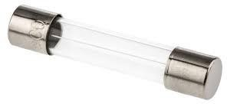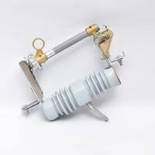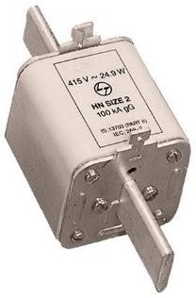
Figure 26: Fuses

- Circuit Breaker; A circuit breaker is another safety device used for protection against electrical fault. It automatically breaks the circuit when the current flowing through it exceeds a certain limit. CB has a fast response time and it can be reset manually by triggering it. There are different types of circuit breakers used but their basic operation is discussed below.
A circuit breaker can interrupt short circuit current instantly thanks to its electromagnetic coil that pulls the lever and separate the contacts. In case of overcurrent, it provides a delay in case the fault clears on its own using a bimetallic strip. The bimetallic strip bends due to the heating of the overcurrent which then releases the level to break the circuit.
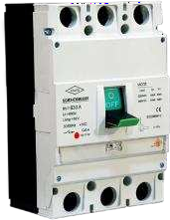
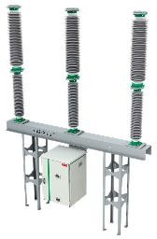
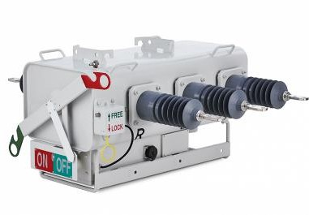
Figure 27: Circuit breakers

- Protective Relay; Relays are devices that are able to detect any abnormal activity or parameters on a power system and initiate corrective actions such as commanding a circuit breaker to trip the circuit.
There are four generations of relay technology which include: Electromagnetic Relays, Static relays, Digital/Numerical Relays and IEDs relays (smart relays).
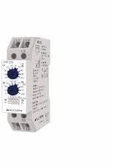
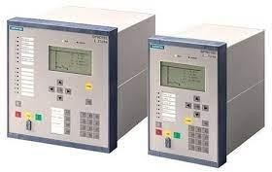

Figure 28: Protection relays

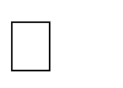
Various relays perform different power system protection functions and they include; Distance relay
Over current and earth fault relay Restricted earth fault relay Buchholz relay
Pressure release relay Line differential relay
Transformer differential relay Under frequency relay, etc.
- Lightning and Surge Arrestor; Lightning is a high voltage surge that is diverted using a lightning rod/conductor connected directly to the ground. The lightning arrestor rod is highly conductive that provides a low impedance path for the lightning straight to the ground and protects the connected power system.

CHAPTER FIVE: SUBSTATION

ELECTRICAL SUBSTATION
Electrical Substation is a network of electrical equipment which is connected in a structured way in order to supply electricity to end consumers.
The electricity substation designs are purely dependent on the need, for instance, a single bus or complex bus system etc. Moreover, the design is also dependent on the application as well, for instance, indoor substations, generation substations, transmission substations, pole substations, outdoor substation, converter substation, and switching substation etc.

LIST OF ELECTRICAL SUBSTATION EQUIPMENT

Power transformer
Transformer is a device that transfers electrical energy from one circuit to another through mutual induction. It has two coils i.e., primary & secondary that are magnetically coupled & electrical isolated. They are used for increasing or decreasing the voltage & current levels without changing their frequency.
Power transformers are usually of the two-winding type. The capacity of the transformers is usually decided by system requirements. Transformers may be designed with all three phases in common tank or as three separate single-phase units.
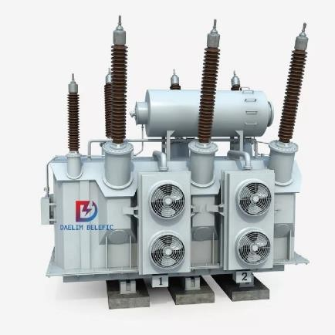
Figure 29: Power transformer

Instrument Transformers:
Instrument transformers are categorized into:
  - Current Transformer (CT) and
  - Voltage/Potential transformer (VT/PT)
The instrument transformer is a static device utilized for reduction of higher currents and voltages for safe and practical usage which are measurable with traditional instruments such as digital multi-meter etc.
The value range is from 1A to 5A and voltages such as 110V etc. The transformers are also used for actuation of AC protective relay through supporting voltage and current. Instrument transformers are shown in the figure below and its two types are also discussed underneath.

Current Transformer:
A current transformer is a device that is used for the transformation of current from a higher value into a proportionate current to a lower value. It transforms the high voltage current into the low voltage current due to which the heavy current flows through the transmission lines is safely monitored by the ammeter.
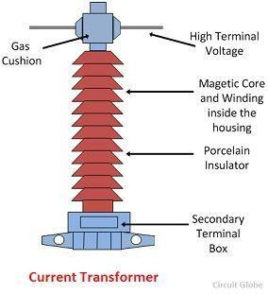
Figure 30: Current transformer (CT)

Potential/Voltage Transformer:
A potential transformer (also known as voltage transformer) is a type of instrument transformer. It is a step-down voltage transformer that reduces the high-level voltage to safer low levels. The output voltage of the potential transformer can be measured by connecting an ordinary
voltmeter.
Furthermore, it also provides isolation between the high voltage power circuit & the low voltage measuring circuit.
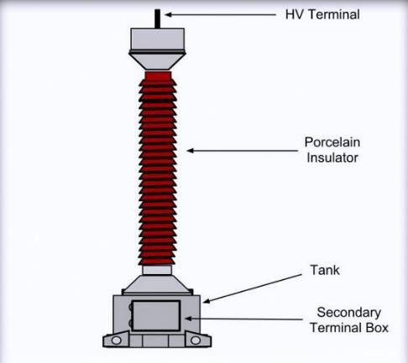
Figure 31: Voltage transformer (VT/PT)

Conductors:
Conductors are the materials which permit flow of electrons through it. The best conductors are copper and aluminum etc. The conductors are utilized for transmission of energy from place to place over substations.

Insulators:

The insulators are the materials which do not permit flow of electrons through it. Insulators are resisting electric property. There are numerous types of insulators such as shackle, strain type, suspension type, and stray type etc. Insulators are used in substations for avoiding contact with humans or short circuit.
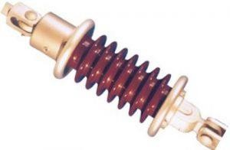
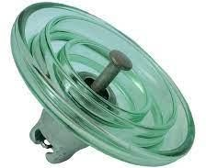
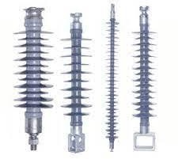
Figure 32: Insulators.

Isolators/Disconnectors and Earth switches
The isolators in substations are mechanical switches which are deployed for isolation of circuits when there is an interruption of current.
They are generally operated off-load to provide isolation of main plant items for maintenance, or to isolate faulted equipment from other live equipment.
These are also known with the name of disconnected switches operation under no-load conditions and are not fortified with arc-quenching devices. These switches have no specific current breaking value neither these have current making value. These are mechanically operated switches.
Disconnectors are usually interlocked with the associated circuit breaker to prevent any attempt being made to interrupt load current.

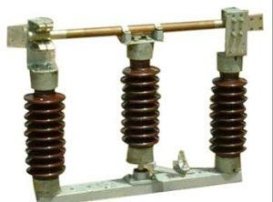
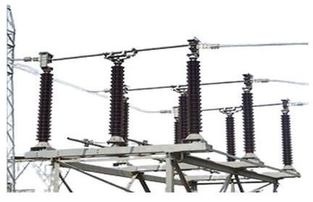

Figure 33: Disconnect switches/Isolators/Earth switches

Earth switches are usually associated and interlocked with disconnectors and mounted on the same base frame. They are driven by a separate, but similar mechanism to that used for the disconnector. This arrangement avoids the need for separate post insulators for the earth switch and often simplifies interlocking. Earth switches are designed to be applied to
dead and isolated circuits and do not have a fault making capability, however special designs are available with fault making capability if required.

Busbars:
A busbar is among the most important elements of a substation and is a conductor which carries current to a point having numerous connections with it. The busbar is a kind of electrical junction which has outgoing and incoming current paths. Whenever a fault occurs in the busbar, entire

components connected to that specific section should be tripped for giving thorough isolation in a small time, for instance, 60ms for avoiding danger rising due to conductor’s heat. These are of different types such as ring bus, double bus, and single bus etc.
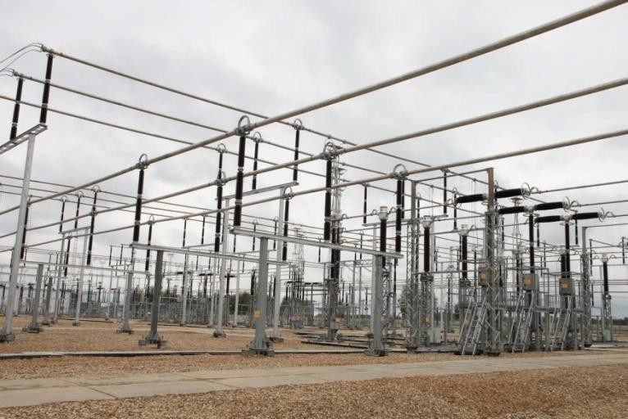
Figure 34: Busbars in a substation

Lightning/Surge Arresters:
A surge arrester, as the name suggests, is a device that protects other electrical equipment by “arresting” or discharging surge currents brought about by external (e.g., lightning) or internal (switching events) forces. It is also called a surge protection device (acronym: SPD), or less commonly, a voltage surge suppressor (TVSS).
Surge arresters can be considered as the first ever components of a substation. These are having a function of protecting equipment of substation from high voltages and are also limiting the amplitude and duration of the current’s flow. These are connected amid earth and line i.e. connected in line with equipment in the substation. These are meant for diversion of current to earth if any current surge appears hence by protecting insulation as well as conductor from damages. These are of various types and are distinguished based on duties.

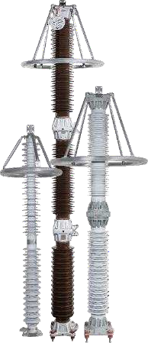
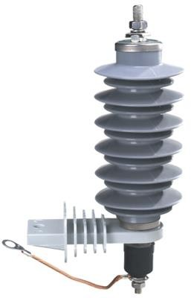
Figure 35: Surge arrestors

Circuit Breakers:
This is a switching device capable of making and breaking currents under normal and abnormal (fault) circuit conditions.

It can also be defined as a switching device that can be operated manually or automatically for controlling and protecting an electrical power system. It consists of two main contacts: a fixed contact and a moving contact. The contacts are normally closed and allow current to flow through the circuit. When a fault occurs, such as a short circuit or an overload, the contacts are separated by a mechanism that releases stored potential energy. This mechanism can be spring-operated, pneumatic, hydraulic, or magnetic.
The separation of contacts creates an arc between them, which is a highly ionized and conductive plasma. The arc can damage the contacts and the surrounding equipment if not extinguished quickly.
Therefore, circuit breakers use various methods to quench the arc, such as cooling, compressing, or replacing the ionized medium with fresh gas. The choice of arc quenching medium depends on the voltage level and current rating of the circuit breaker.
Circuit breakers protect electrical circuits from damage caused by overcurrent, short circuits, or overload. They interrupt the flow of current when a fault occurs and restores it when the fault is cleared. Unlike a fuse, which needs to be replaced after one operation, a circuit breaker can be reset and reused multiple times.
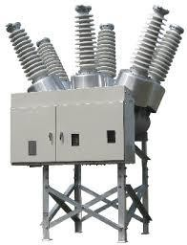
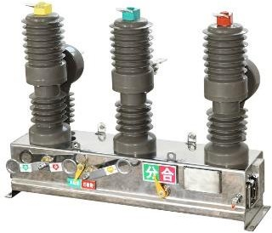

Figure 36: Circuit breakers

Relays:
A relay is automatic device which senses an abnormal condition of electrical circuit and closes its contacts. These contacts in turns close and complete the circuit breaker trip coil circuit hence make the circuit breaker tripped for disconnecting the faulty portion of the electrical circuit from rest of the healthy circuit.
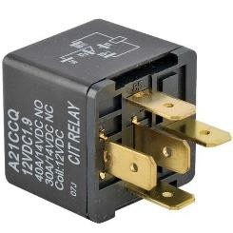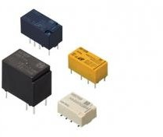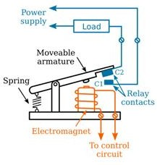
Figure 37: Relays

Batteries:

Some of the important substation parts such as emergency lighting, relay system, and automated control circuitry are operated through batteries. The size of the battery bank depends on the voltage required for operation of the DC circuit.
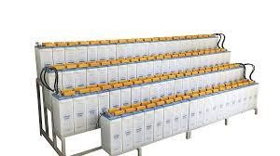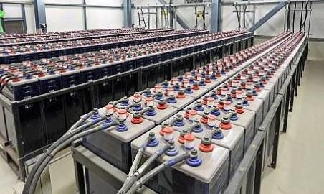
Figure 38: Substation batteries

Wave Trapper:
The wave trapper is one of the substation components which is placed on the incoming lines for trapping of high-frequency waves. The high-frequency waves which are coming from nearby substations or other localities are disturbing the current and voltages, hence its trapping is of great importance. The wave trapper is basically tripping high-frequency waves and is then diverting the waves into telecom panel.
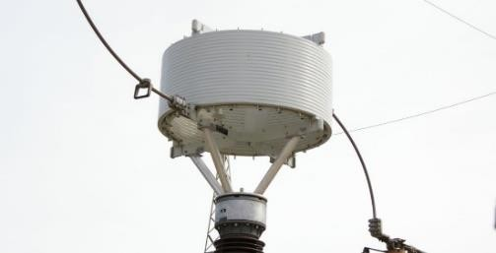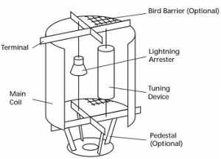
Figure 39: Wave trapper

Capacitor Banks:
Capacitor bank is defined as a set of numerous identical capacitors which are connected either in parallel or series inside an enclosure and are utilized for the correction of power factor as well as protection of circuitry of the substation. These are acting like the source of reactive power and are thus reducing phase difference amid current and voltage. These are increasing the capacity of ripple current of supply and avoid unwanted selves in the substation system. The use of capacitor banks is an economical technique for power factor maintenance and for correction of problems related to power lag.

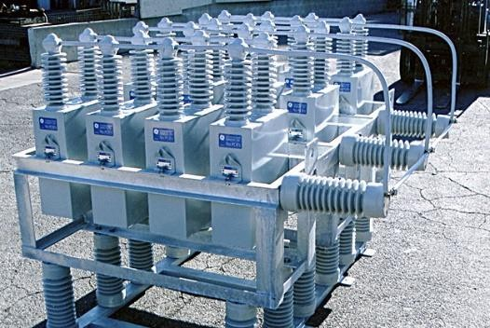
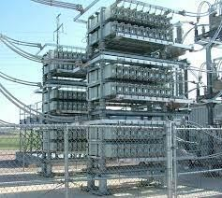
Figure 40: Capacitor banks

Other substation components include:
Switch yard
Metering and Indication Instruments Equipment for Carrier Current
The Outgoing Feeders Security fence Grounding System Control room
Auxiliary Power Supply; such as auxiliary transformer, generator, batteries Supporting structures such as poles, towers, etc.
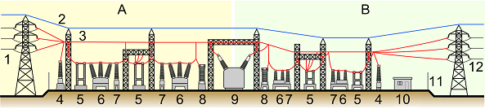
Figure 41: Elements of a substation

Elements of a substation A: Primary power lines’ side B: Secondary power lines’ side
- Primary power lines
- Ground wire
- Overhead lines
- Transformer for measurement of electric voltage
- Disconnect switch
- Circuit breaker
- Current transformer
- Lightning arrester
- Main transformer
- Control building
- Security fence
- Secondary power lines

SUBSTATIONS IN TORORO UNDER UMEME LIMITED

There are four substations operated by Umeme-Tororo branch. These include:
- Tororo Rock Substation
- Nyakesi Substation
- Nagongera Substation
- Tororo Main Substation (33kV side)

Tororo Rock Substation
Tororo Rock Substation is located along Jinja road, about one kilometer away from Tororo town. It is fed by Tororo Ring 1 33kV feeder from Tororo main substation.
It comprises two power transformers (5MVA and 2.5MVA) coupled together, one auxiliary transformer of 200kVA and four feeders: Town Ring, Town Via Quarry, Petrol Station and Rubongi (currently in operational) 1lkV feeders.
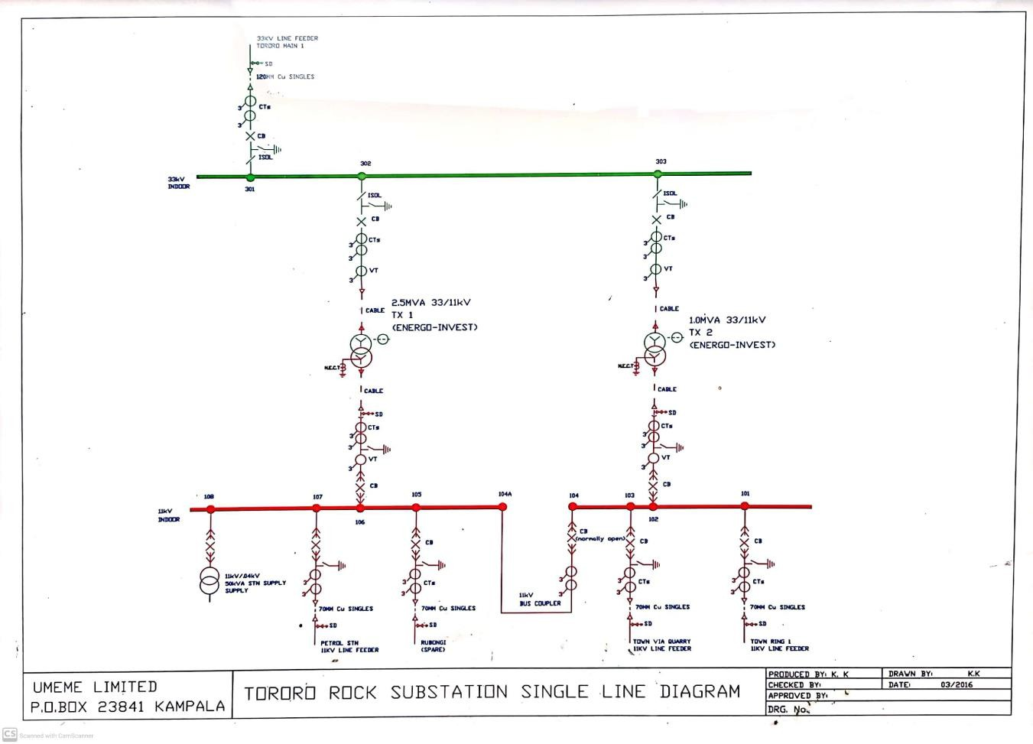
Figure 42: Single line diagram of Tororo Rock Substation

Nyakesi Substation
Nyakesi Substation is located along Mbale road, four kilometers away from Tororo town. It is fed by Nyakesi 33kV feeder from Tororo main substation.
It comprises two power transformers of 15/20 MVA coupled together, two auxiliary transformers of 100kVA each and three feeders; Simba cement 33kV feeder, Hima 1 11kV feeder and Hima 2 11kV feeder.

Nagongera Substation
Located along Butaleja road, 17 kilometers away from Tororo town. It is fed by Mbale 2 33kV feeder from Tororo main substation.
It comprises one power transformers of 5 MVA, one auxiliary transformer of 100kVA and two feeders: Butaleja and Tororo town 11kV feeders.

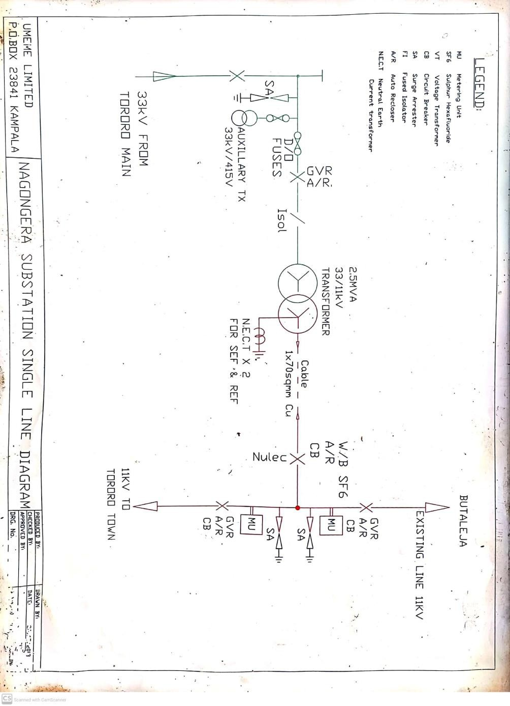
Figure 43: SLD of Nagongera substation

Tororo Main Substation (33kV side)

Tororo Main Substation is located along Jinja road, six kilometers away from Tororo town. It is fed by Iganga 1 and 2 132kV lines from Iganga substation.
It comprises two power transformers of 15/20 MVA and 80MVA, one auxiliary transformer of 200kVA and a standby generator. The two power transformers are not coupled, each serving a separate busbar. There are two busbars (busbar 1 and 2) separated by bus coupler which is normally open.

The feeders on the 33kV side of Tororo main substation include: Tororo Ring 1, Tororo cement 1, Tororo cement 2, Mbale 1, Bugiri, Mbale 2, Nyakesi, Busia, and Mbale Industrial Park 33kV feeders.

PARALLEL OPERATION OF TRANSFORMERS

In most parallel operation of transformers are implemented and it offers several advantages and serves specific purposes in power distribution and management.

Reasons for parallel operation of transformers
Here are some of the key reasons for coupling two transformers in parallel:

      - Load Sharing: One of the primary reasons for connecting transformers in parallel is to share the load. When a single transformer is insufficient to meet the load demand, multiple transformers can be paralleled to distribute the load among them. This ensures that each transformer operates within its rated capacity, preventing overload and enhancing system reliability.

      - Redundancy and Reliability: Parallel transformers provide redundancy in case one of them fails or requires maintenance. If one transformer goes out of service, the remaining transformers can continue to supply power, reducing the risk of downtime and ensuring uninterrupted power supply. This redundancy improves system reliability.

      - Increased Capacity: Paralleling transformers allows for an increase in overall capacity without the need to replace a single, larger transformer. This can be cost-effective when the load requirements grow over time, as it allows for incremental capacity expansion by adding more transformers as needed.

      - Voltage Regulation: In some cases, parallel transformers can help improve voltage regulation in the distribution system. Transformers with different voltage ratios or tap settings can be connected in parallel to achieve more precise voltage control at different points in the network.

      - Flexibility and Load Balancing: Parallel transformers provide flexibility in managing the load distribution within a network. By adjusting the tap settings or adding/removing transformers, it becomes easier to balance loads and optimize the utilization of transformers in the system.

      - Efficiency Improvement: Operating transformers closer to their rated capacity can result in better efficiency. Paralleling transformers can help achieve this by distributing the load more evenly among them, reducing losses and improving the overall energy efficiency of the system.

      - Emergency Backup: Parallel transformers can serve as emergency backup units. In case of a fault or failure in the primary transformer, the secondary transformer can be switched to supply power to critical loads, ensuring continuity of service.

Conditions for parallel operation of transformer
For parallel connection of transformers, primary windings of the Transformers are connected to source bus-bars and secondary windings are connected to the load bus-bars.
Various conditions must be fulfilled for successful operation of transformers. Some of these conditions are convenient and some are mandatory:

Convenient conditions include:
        - Same voltage ratio and turns ratio
        - Same percentage impedance
        - Same kVA rating
        - Same position of tap changer
Mandatory conditions include:
        - Same phase angle shift
        - Same polarity
        - Same frequency
When the convenient conditions are not met, parallel operation is possible but not optimal.

CHALLENGES
The following are the challenges during my training:

Understanding the overall Grid Network was challenging for a new comer and required more time.

Complex Technical Knowledge: The distribution of electrical power involves complex technical knowledge related to electrical engineering and power systems. Gaining a deep understanding of concepts like voltage regulation, fault analysis, load balancing, and power factor correction within the short period of training was challenging.

Hands-On Training: Gaining hands-on experience was difficult, especially in situations where safety concerns limited access to live equipment. Finding opportunities to apply theoretical knowledge in practical situations can be a challenge.

Dealing with Outages and Emergencies: Responding to power outages and emergencies requires quick thinking and the ability to troubleshoot and restore power promptly. Handling these situations effectively was very challenging, especially during extreme weather conditions.

Customer Interactions: Working with customers, addressing their concerns, and explaining technical issues in a clear and understandable manner was a big challenge, as it requires strong communication and customer service skills, especially when explaining technical issues to a lay person.

RECOMMENDATIONS
Based on my experiences and observations during the internship, I would like to offer the following recommendations:
Invest in Advanced Technologies: Given the evolving energy landscape, consider investing in advanced technologies such as smart grid solutions, grid automation, and predictive maintenance tools. These technologies can improve grid reliability, efficiency, and customer service.

Expand Hands-On Training Opportunities: Provide interns with more opportunities for hands- on training, especially in areas where safety considerations can be addressed. Practical experience is invaluable for interns to apply theoretical knowledge effectively.

Work-Life Balance: Continue to promote work-life balance among employees by implementing flexible work arrangements, offering employee wellness programs, and addressing any work- related stressors.

CONCLUSION

In conclusion, my internship experience with Umeme ltd has been a valuable and enlightening journey into the world of energy distribution and electrical engineering. Throughout the course of my internship, I encountered various challenges and opportunities for growth that have significantly contributed to my professional development.
I gained a deeper understanding of the intricate distribution grid network, its components, and the critical role they play in ensuring the reliable supply of electrical power to consumers. The emphasis on safety protocols and the need for constant vigilance when working with high-voltage equipment have instilled in me a strong commitment to safety in the workplace.

REFERENCES
SUBSTATION DESIGN / APPLICATION GUIDE BY V AYADURAI BSC, C.Eng., FIEE
Engineering Expert

https://www.electronicshub.org/types-of-faults-in-electrical-power-systems/

https://circuitglobe.com/types-of-faults-in-power-system.html

https://www.electricaltechnology.org/2022/09/faults-in-electrical-power-system.html

https://www.watelectrical.com/electrical-substation-components/

https://ieeexplore.ieee.org/document/1002288/citations#citations
Umeme ORHVS guide book. Umeme construction standards book

