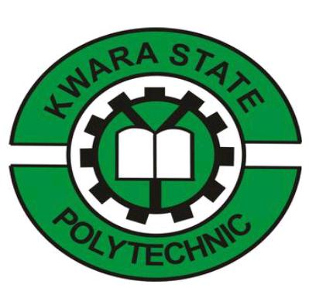
KWARA STATE POLYTECHNIC, ILORIN
TECHNICAL REPORT
ON
STUDENT INDUSTRIALS WORK EXPERIENCE SCHEME
(S.I.W.E.S)
HELD AT
AIT LAGOS (DAAR COOMUNICATION).
AIT ROAD OFF LAGOS/ABEOKUTA EXPRESS ROAD ILAPO VILLAGE, LAGOS STATE.
BY
TIJANI KEHINDE ZAINAB
ND/23/MAC/FT/0091
SUBMITTED TO:
THE DEPARTMENT OF MASS COMMUNICATION, INSTITUTEOF INFORMATION AND COMMUNICATION TECHNOLOGY, KWARA STATE POLYTECHNIC,
KWARA STATE. INPARTIAL FULFILMENT OF THE REQUIREMENT FOR THE AWARD OF NATIONAL DIPLOMA (ND)
IN
MASS COMMUNICATION.

DEDICATION
I dedicate this technical report as a thanks to the almighty Allah, Whom who give me the most grateful opportunity and Understanding to begin my siwes programm and end it up successfully. I give thanks to the almighty Allah once again. The giver of knowledge, wisdom and custodian of life.
I equally dedicate this siwes report to my my dearly parents Mr.and Mrs. TIJANI for their caring and love May almighty Allah continue to lift up and shower you more blessing.
Also not forgotten my lecturer's in school may almighty God be with you and your family

PREFACE
The report is about the knowledge and experience acquired during the Industrial training program known as Student Industrial Work Experience Scheme (SIWES).
As a mass communication student, this program was introduced by the federal government and under control or coordinating by INDUSTRIAL TRAINING FUND (I.T.F).
This enhance students to acquire necessary practical skill in their course of study and also to help student to gain extra and valuable knowledge by physical practices during their siwes. Which they can't learnt in theory class. This increase student knowledge and understanding.
In a physical aspect such as practical. This our brain assimilate very fast than hearing, because the brain and eye works together the moment the eye captured it, it will transfer it to the brain and that will be difficult to forget
The technical report comprises of daily activities undertaken during my siwes. In my place of attachment at AIT LAGOS (DAAR COMMUNICATION)

ACKNOWLEDGEMENT
All thanks and adoration goes to almighty God for giving me the opportunity to begin my siwes and ended it successfully
Am also using this opportunity to thank my siwes coordinator Held At AIT LAGOS (DAAR COMMUNICATION)for their support and advice during my program.
Mostly. My gratitude goes to my lovely parent ,may Almighty Allah will let you eat the fruits of your labour and my parent Mr. and Mrs. TIJANI for your support financially and spiritually Finally, my appreciation goes to my friends in Mass communication department and also member of the class.
MAY ALMIGHTY GOD GRANT US ALL OUR REQUEST.

CERTIFICATION
I here by certify that this report of Student Industrial Work Experience (SIWES) was prepared and compiled by TIJANI KEHINDE ZAINAB with the matriculation number ND/23/MAC/FT/0091 from the department of Mass Communication, kwara State Polytechnic ,Ilorin, Kwara State for the successful completion of SIWES undertaken at AFRAS fm,

H.O.D Signature and Date

SIWES Supervisor. Signature and Date

TABLE OF CONTENT
- Title page i
- Preface ii
- Dedication iii
- Acknowledgement iv
- CHAPTER ONE
1.1 Definition, goals and objectives of (SIWES) 6
1.2 Aims and Objectives of SIWES 6
1.3 Historical background of the organization 7
1.4 Organizational chart 8
1.5 Major activities of the organization 9
2.0 CHAPTER TWO
2.1 Marketing Terms 10
2.2 What is news 10
2.3 Types of Journalism 11
2.4 Qualities of a good journalist 12
3.0 CHAPTER THREE
3.1 Report 14
3.2 Relevance of experience gained to my field of study 15
4.0 CHAPTER FOUR
4.1 Some pictures/sketches taken during my siwes 16
4.2 Interpersonal relation within the organization 17
5.0 CHAPTER FIVE
5.1 Challenges encountered during my program 18
5.2 Solutions 18
5.3 Recommendation 18

CHAPTER ONE
  - BACKGROUND AND SCOPE OF SIWES
- 1.2 ABOUT STUDENT INDUSTRIAL WORK EXPERIENCE (SIWES)
Students’ Industrial Work Experience Scheme(SIWES) is a programme designed to expose and prepare students of Universities, Polytechnics, Colleges of Technology, Colleges of Agriculture and Education for Industrial Work situation which they are likely to meet after graduation. It is a skills training programme which affords students the opportunity of familiarizing, acquiring and exposing themselves with the needed experience in handling industrial equipment and machinery that are not usually available in their institutions.
Students’ Industrial Work Experience Scheme (SIWES) is a human capital formation programme through industrial attachment for which students are expected to have a practical experience on the basis of theories and principles acquired in the teaching-learning process. However, the prevalence of the inability of participants of SIWES to secure employment after the programme casts doubt on the continuing relevance of SIWES to the contemporary industrial development drive in Nigeria. Human resource development constitutes the most critical factor in the development process and the quality must therefore be inherent in the productive capacity of people. Human societies in the quest for development have identified and developed institutional as well as structured training and educational programmes as major avenues for processing human beings to acquire the necessary skills and technical competence for their roles in the development of the society. In this context ,it is observed that, it is not only in advanced nations that science and technology are spreading, but that, they are increasingly valued whenever people value their nation’s independence, prosperity, power and prestige, and also, where nations seek a high standard of living, improved health or better education. In most discussions on human resource management, training and development represents the most significant. SIWES was established by ITF (industrial training fund) in the year 1973 to solve the problem of lack of adequate proper skills for employment of tertiary institution graduates by Nigeria (SIWES) was founded to be a skill training programme to help expose and prepare students of University, polytechnic and college of education for the industrial work situation to be met after graduation, this scheme serve as a smooth transition from the class room to the world of work and further help in the application of knowledge the scheme provide students with the opportunity of acquiring and exposing themselves to the experience required in handling and managing of equipment and machinery that are usually not made available in their institution. In Nigeria, SIWES was introduced in 1973 to enable undergraduate students in Science and engineering acquire practical skills needed to function satisfactorily in work-settings. Industrial training commenced in the country due to the reliance of companies or industries on technical proficiencies, for production process and preservation of company resources. In practice, it is said to originated from the then Yaba Technical Institute, now Yabba College of Technology. At that point, students were being sponsored by various government owned institutions and other private firms. The practice permitted student store turn to work with their employers during long vacations. Through this, students were having work-related experience and the training available in companies then must have been responsible for the quality of graduates in organizations in those early days. However, it could be observed that the quality of the Nigerian graduates began to diminish afterwards due to the dearth of faculties to impart quality education on students in tertiary institutions. Asmilitary imperialists began to unleash terror on social critics ,most of which were faculty members, they decided to find greener pastures abroad. To fill the vacuum, unqualified faculty members’ were recruited into the academics. To worsen the situation, most of the expatriates left Nigeria for their countries of origin; the vacuum created could not be filled satisfactorily with the skill so fresh graduates from the nation’s educational systems. Given this, multinational companies in Nigeria such as Flour Mill Nigeria Plc, Bag co Plc, Nigerite, Nigerian Breweries Plc, Unilever Nigeria Plc, Texaco Overseas (TO), Chevron Nigeria Limited (CNL) established training schools: Also, Shell Petroleum Intensive Training Programme was established in 1998 for technical skill acquisition through hands-on experience. Since independence, the issue that has attracted the interest of succeeding Governments in Nigeria has been that of human resource development. From the beginning of Nigeria’s nation hood, it was imminent that the pace of national development through technological advancement devolved not so much on the availability of means or resources, rather, on theart culation and effectiveutilizationofthevasthumanandmaterialresources.Itisonthisbasisthatinvestmentontrainingofthehumanfactorbecomesaseriouschallengeasscience and technology related courses are requisite for national development. Therefore, it is observed that, initial efforts aimed at achieving rapid national development were concentrated on the expansion of formal educational institutions, though these considerably increased in number, yet did not and were not expected to have acquired the skilled, knowledge and varied technological expertise required to meet the needs of special and vital sectors of the economy. However, the fundamental role of education in human resource development Is a matter of priority for any developing country to evolve a functional education policy. This is necessary because, only through such priority can a country lay a solid foundation for a future, stable andresult-oriented human resource development. Thus, growt hand development, which will result from effective organizational change, depend on a well-educated and adequately skilled human capital that is capable of applying vision, knowledge and creativity to their economic activities. Thus, industrial education which can be achieved through the formalor / and informal educational approach (es) attracted theat tention of Government and individuals, in contemporary development environment.
1.2 Aims and Objectives of SIWES
Students Industrials Work Experience Scheme (SIWES) Program designed to expose and prepare students of universities, Polytechnic, colleges of technology, colleges of agriculture and Education for Industrial Work situation which they are likely to meet after graduation. It is a skills training program that affords students the opportunity of familiarizing, acquiring and exposing themselves to the needed experiencing in handling industrial equipment and machinery that are not usually available in their institutions. Considering all the facts of production, the human factors of production, management, distribution, marketing and supervision among others the objectives for which industrial policy has been drawn become unachievable. The aim SIWES plan to achieve as follows:
- To expose and each students to work methods and technique in handling equipment that may not be available in the university of institution.
- To make students have a smooth transition from the university to the workforce of the world.
- To give students the ability to try and apply the given knowledge and experience in any industry they find themselves in.
- To afford student of tertiary institution the opportunity of being familiarized and exposed of the needed experience in handling Machinery, Equipment and Measuring which are usually not available in the educational institution.
- To improve the technology development in the country.
- To expose the student and broaden their knowledge on the practical aspect of the course they are pursuing in their various schools ahead of their future.
- To enlarge student performance when he/she graduated from school for the world to be proud of his/her school in life time.
1.3 HISTORICAL BACKGROUND OF THE ORGANIZATION
HISTORY OF ORGANISATION
Africa Independent Television, also known by its acronym AIT, is a privately owned television broadcaster in Nigeria. It operates Free To Air in Nigeria as the largest privately operated terrestrial television network with stations in twenty-four out of thirty-six states in Nigeria. AIT is also broadcast via satellite television from its operational headquarters in Abuja. AIT is a subsidiary of DAAR Communications plc, available throughout Africa, and via Dish Network to North America.
Satellite broadcasts started on 3 November 1997.
In the early 2000s, it was one of the many affiliates that relayed TVAfrica's output in Nigeria.
In the United Kingdom and Ireland, it was available on Sky channel 454 as a free-to-air channel (originally a subscription channel until 1 August 2016). An additional channel called AIT Movistar, formerly on Sky channel 330, ceased broadcasting on 28 July 2009. AIT International ceased broadcasting in the United Kingdom and Ireland on 15 October 2019.
1.4 ORGANIZATION CHART
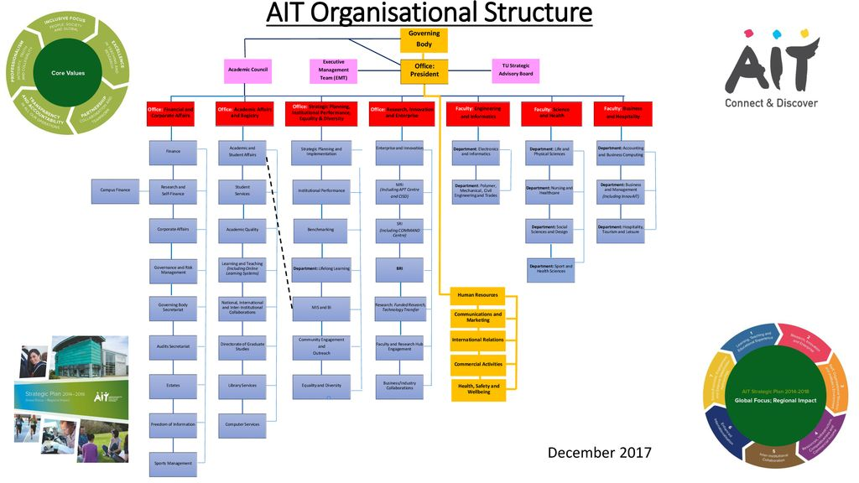

1.5 MAJOR ACTIVITIES OF THE ORGANIZATION
Africa Independent Television (AIT) Lagos State is a leading independent broadcaster providing news and entertainment in Nigeria. Here are some of the major activities of AIT Lagos State:
- News Broadcasting: AIT provides up-to-date news coverage on local and national events, keeping viewers informed about current happenings .
- Entertainment Programming: AIT offers a range of entertainment programs, including music, movies, and cultural shows, catering to diverse viewer interests .
- Documentary and Current Affairs: AIT produces and airs documentaries and current affairs programs, focusing on social, economic, and political issues affecting Nigeria and Africa .
- Advertising and Sponsorship: AIT offers advertising and sponsorship opportunities for businesses and organizations, providing a platform to reach a wide audience .
- Community Engagement: AIT engages with the local community through events, sponsorships, and partnerships, promoting social responsibility and development .
Overall, AIT Lagos State plays a significant role in providing information, entertainment, and education to the Nigerian public.

CHAPTHER TWO
2.1 WHAT IS NEWS
News is information about current events. This may be provided through many different media: word of mouth, printing, postal systems, broad casting, electronic communication, or through the testimony of observers and witnesses to events. News is sometimes called "hard news" to differentiate it from soft media.
Report writing is a formal style of writing elaborately on a topic. The tone of are port and report writing format is always formal. The important section of occasion is the target audience. For example – report writing about as school event, report writing about a business case, etc.
2.2 TYPES OF JOURNALISM
- Political Journalism. The news in political journalism is provided in formats like 'national', 'local', and 'international', political news. ...
- Investigative Journalism. ...
- Business Journalism. ...
- International News. ...
- Crime Journalism. ...
- Lifestyle Journalism. ...
- Entertainment Journalism. ...
- Sports journalism
- Scientific Journalism

2.3 QUALITIES OF A GOOD JOURNALIST
Do you get inspired by famous journalists and the righteous persona the represent? What are those qualities that make them stand out of the crowd? From courage to honesty, integrity to determination, there are some essential qualities that a professional journalist possesses. If you are aspiring to make a career in journalism, you should have these qualities.
A Way with Words
How do you distinguish between an average news story and an enthralling news piece? Effective writing skills can make all the difference. A writer should know how to play with words and should be able to produce an error-free, grammatically correct and concise article with factual information that would pique the interest of the audience.
Thorough Knowledge
For being a good journalist, you need to be aware of the current events. Read a wide range of both print and digital medium of news sources to stay updated on the happening events. Also, you need to have some background knowledge before you go out to cover a story and write on it. Your ability to research to find out the important details of a story is quite helpful.
2.4 STUDIO MICROPHONE
A microphone is a device that converts sound waves into electrical signals. There are many types of microphones, including dynamic, condenser, ribbon, and shotgun microphones.
Types of microphones
Dynamic microphones
Also known as moving coil microphones, these are inexpensive, durable, and have low background noise. They are often used for public speaking.
Condenser microphones
These microphones are often used in studios because they produce high quality sound. They are good for recording vocals, acoustic guitars, and other instruments.
Ribbon microphones
These microphones are often used in studios because they produce a smooth, natural sound. They are less susceptible to electronic noise than condenser microphones.
- Shotgun microphones
These microphones are often used in video production because they can capture sound from a specific direction. They are often mounted to high-end video cameras.
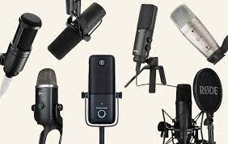
TELEVISION STUDIO
A television studio, also called a television production studio, is an installation room in which video productions take place, either for the production of live television and its recording onto video tape or other media such as SSDs, or for the acquisition of raw footage for post-production. The design of a studio is similar to, and derived from, movie studios, with a few amendments for the special requirements of television production. A professional television studio generally has several rooms, which are kept separate for noise and practicality reasons. These rooms are connected via 'talkback' or an intercom, and personnel will be divided among these workplaces.
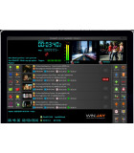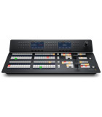Broadcast Video Mixer
Broadcast Video Route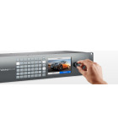
Broadcast-Tv-And-Video- Playout- Automation-Software
STUDIO FLOOR
The studio floor is the actual stage on which the actions that will be recorded and viewed take place. A typical studio floor has the following characteristics and installations:
decoration and/or sets
professional video camera (sometimes one, usually several), typically mounted on pedestals
microphones and fold back speakers
stage lighting rigs and the associated Lighting control console, although it is often located in the production control room (PCR)
Several video monitors for visual feedback from the PCR
a small public address system for communication
a glass window between the PCR and studio floor for direct visual contact is often desired, but not always possible
While a production is in progress, people composing a television crew work on the studio floor.
the on-screen presenters themselves, and any guests - the subjects of the television show.
a floor manager, who has overall charge of the studio area stage management, and who relays timing and other information from the television director.
one or more camera operators who operate the cameras, though in some instances these can also be operated from the PCR using remotely controlled robotic pan tilt zoom camera (PTZ) heads.
possibly a teleprompter operator, especially if this is a live television news broadcast
PRODUCTION CONTROL ROOM
The production control room is the place in a television studio in which the composition of the outgoing program takes place. The production control room is occasionally also called a studio control room (SCR) or a "gallery" – the latter name comes from the original placement of the director on an ornately carved bridge spanning the BBC's first studio at Alexandra Palace, which was once referred to as like a minstrels' gallery.
The vast majority of devices in a PCR are interfaces for rack-mounted equipment that is located in the Central Apparatus Room (CAR).

CHAPTER THREE
3.1 CENTRAL APPARATUS ROOM
The central apparatus room (CAR) houses equipment that is too noisy or runs too hot to be located in the production control room (PCR). It also makes sure that coax cable, SDI cable, Fibre optic cable or other wire lengths and installation requirements keep within manageable lengths, since most high-quality wiring runs only between devices in this room. This can include the actual circuitry and connections between:
character generator (CG)
camera control units (CCU)
digital video effects (DVE)
video routers
video servers
vision mixer (video switcher)
VTRs
patch panels
MASTER CONTROL
Master control is the technical hub of a broadcast operation common among most over-the-air television stations and television networks. Master control is distinct from a PCR in television studios where the activities such as switching from camera to camera are coordinated. A transmission control room (TCR) is usually smaller in size and is a scaled-down version of central casting.
The master control room in a US television station is the place where the on-air signal is controlled. It may include controls to play out pre-recorded television programs and television commercials, switch local or television network feeds, record satellite feeds and monitor the transmitter(s), or these items may be in an adjacent equipment rack room. If the program is broadcast live, the signal goes from the PCR to MCR and then out to the transmitter.
3.2 QUALITIES OF A GOOD PRESENTER
- Know the audience. ...
- Know the material. ...
- Make it a conversation. ...
- Adjust course as necessary. ...
- Be empathetic

CHAPTER FOUR
*4.1 REPORT
A REPORT ON AIT LAGOS PRESENTATIONS
I learnt how to put the system for recording the program
I learnt how to copy file into the hardwire
I learnt how to keep and record the information that are already edited
I learnt how to operate the equipment in the library
  - RELEVANCE OF EXPIREINCE GAINED TO MY FIELD OF STUDY
As matter of fact, the scheme has indeed created an opportunity of exposure for me in my field of study (Mass communication), which I also judiciously utilized because the course is all about practice. Being among the SIWES student for 2024 throughout the scheme. I have been practically oriented for future challenges at least to an extent as far as Mass communication is concerned, especially in inspecting News casting and some other programs. The scheme has given me an opportunity to identify an event work on presenter on which I know quite well that I may never have such opportunity to work on until I leave the school if not for the SIWES program.
The program is really an eye opener for all students participating in it. As the program enabled the student to know the best option for him/her to specialize on after going through the practical aspect of the field.

CHAPTER FIVE
  - PROBLEMS ENCOUNTERED DURING MY SIWES
During my siwes I did not face a lot of challenges just few which are
1 .High cost of transportation.
2. lack of chairs, we will stand from morning till afternoon 8:00 to 3:30
5.2 SOLUTIONS
- They should be able to afford transport fare for the siwes student if they won't pay us
- And they should also try and provide chairs for their siwes student,is not easy to stand for an hours.
5.3 RECOMMENDATION
The following are the suggested recommendation for the program
- The company should remain friendly and accommodating to future IT student.
- The SIWES coordinator and school should where organized enlightenment program for IT student in order to know the important of SIWES.
- The school (Polytechnics) should consider the four months mandatory SIWES while drafting the calendar for a successive session in a way that will affect the returning IT Student.

