
#
A TECHNICAL REPORT
ON
STUDENT INDUSTRIAL WORK EXPERIENCE SCHEME (SIWES)

HELD AT
BRIGHTERSUN SOLAR DEPOT
OPPOSITE SYSTEM.G SUPERMARKET OFFA GARAGE ROAD ILORIN

WRITTEN BY
AJIBADE SAMUEL BLESSING
ND/23/EEE/PT/0166

SUBMITTED TO

DEPARTMENT OF ELECTRICAL / ELECTRONICS ENGINEERING, INSTITUTE OF TECHNOLOGY (I.O.T) KWARA STATE POLYTECHNIC, P.M.B 1375, ILORIN

INPARTIAL FULFILLMENT FOR THE REQUIREMENTS FOR THE AWARD OF NATIONAL DIPLOMA (ND) IN ELECTRICAL/ELECTRONICS ENGINEERING

AUGUST TO NOVEMBER, 2023

DEDICATION
This report is dedicated to Almighty Allah, who strengthens me and also spear my life to complete my SIWES program in BRIGHTERSUN SOLAR DEPOT
. I also praise my parents Mr & Mrs Ajibade. May Almighty Allah continue to enrich their pocket. (Amin).

ACKNOWLEDGEMENT

I give thanks to Almighty Allah for making my dream a reality. I am also using this medium to express my profound gratitude also to my family, and to my supervisor at BRIGHTERSUN SOLAR DEPOT , and friends and my lecturer’s at Kwara State polytechnic for their encouragement.
Thank you all, may Almighty Allah reward you abundantly (AMIN).

TABLE OF CONTENT
Title page
Dedication
Acknowledgement
Table of Content
CHAPTER ONE
1.0 Introduction
1.1 Definition of SIWES
1.2 Goals and Objectives of SIWES
CHAPTER TWO
2.0 Brief History of the company
2.1 Vision
2.2 Mission statement
CHAPTER THREE
3.0 Safety in Electrical Installation
3.1 Electrical / Electronics Tools and their uses
3.2 Uses of the above tools
3.3 Types of wire used
3.4 Uses of the Wire stated above in Electrical Installation
3.5 Pictures of the tools used in electrical workshop
CHAPTER FOUR
4.0 Wiring system
4.1 Types of wiring system
4.2 Different between surface and conduit wiring System
4.3 Electrical Accessories needed in surface wiring system
4.4 Wire joint
4.5 Types of wire joint
4.6 Electrical accessories needed in conduit wiring system
4.7 When choosing a system of wiring for a building, the following point must
be put into consideration
4.8 Quotation of a two bedroom flat
CHAPTER FIVE
5.0 Conclusion and Recommendations
5.1 Conclusion
5.2 Recommendation

CHAPTER ONE
- INTRODUCTION
The practical background of the engineering student industrial work is purposely set up in practical fulfillment of the award of National Diploma (ND) in Electrical / Electronics Engineering. I fulfilled my compulsory four months industrials training at D-ONE ABDUL ELECTRICAL WORKSHOP . The report is all about my experience, knowledge and my involvement in the job description during the course of my SIWES.
1.1 DEFINITION OF SIWES
SIWES means Student Industrial Work Experience Scheme. It is a course by which students are exposed to practical training in their respective field of study. SIWES is the acceptable skill training programme set up as the requirement for the award of National Diploma (ND) certificate for student studying engineering and applied science.
Its effort is to bridge the gap existing between theory and practical aspect of engineering and some applied science.
1.2 GOALS AND OBJECTIVES OF SIWES
1. To enable students to be practicable oriented
2. To enable students to handle equipment and machine in their field of study
3. To expose students to challenges to be face in their course of study and their fields after graduation.

CHAPTER TWO
2.0 BRIEF HISTORY OF THE COMPANY
The company took it mandates since 2000 opposite system.g supermarket offa garage road ilorin . The company was registered with CAC in the 2005, since then the operation of the company started in full.
2.1 Vision
The vision of the company is to provide the immediate community with optimum service in the electrical works.
2.2 Mission
To provide customer friendly innovative service in which everyone counts and every staff member manage one-point agenda.
2.3 Organization structure chart
DIRECTOR

STAFF

SECURITY
APPRENTICE
CLEANER

2.4 Two connection of two ways Switch with one lighting point
On the first switch the live wire there will be connected to the (common) on the switch and the two black wires will be connected to the L1 and L2 on the switch there. O on second switch the two black wires will be connected to the L1 and L2 and the last wire is called branch, it will be connected to the (common) on the switch. Finally we have branch and neutral at the lighting point which will be connected to the lamp holder
2.5. Wiring network of one ways switch with one lighten point
The supply of the wire is red(the mains) and black(the branch) while the mains of the supply goes into a label c in the switch while the neural enter the lighting and a branch came out from the light point back to the switch to the label L1
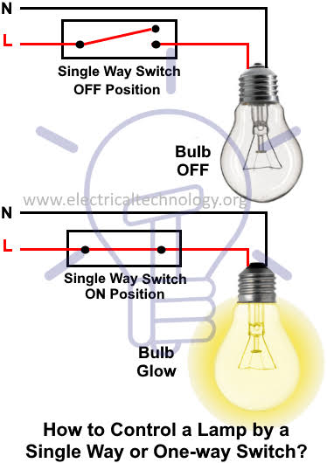
2.6 ELECTRICAL LOOPING
It is created between two light with a single wire connected to multiple fitting. Usually looping is done for neutral wire. Neutral wire is a return wire for the current in an electrical circuit.
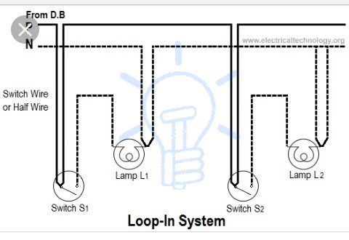
2.7. How to connect a socket
The socket has three terminals which are the L (life), N (neutral) E (earth). The red wire which is the life enters into the L terminal and the black which is the neutral enters into the N terminal while the yellow wire which is the earth enters the E terminal.
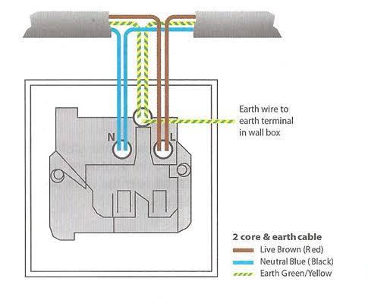

CHAPTER THREE
3.0 POWER INVERTER
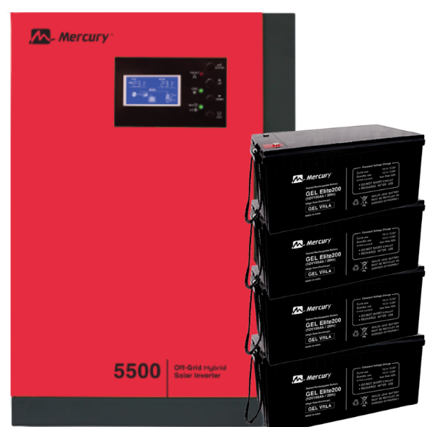
A power inverter, inverter, or invertor is a power electronic device or circuitry that changes direct current (DC) to alternating current (AC). The resulting AC frequency obtained depends on the particular device employed.

Does an inverter store power?
Inverters do not generate electricity or store it. Its primary function is to convert the AC power from power stations into DC power and store it in the batteries.
Can we run AC on inverter?
Can you run your inverter AC on an inverter? Yes, simply put, an AC can run on an inverter in the event of a power cut. Whether you have a normal AC or an inverter AC , they both can be powered by an inverter. But, it all depends on whether your inverter is powerful enough to take the load of your AC.
Inverters do not generate electricity or store it. Its primary function is to convert the AC power from power stations into DC power and store it in the batteries. You may ask why we can’t store electricity in its available AC form?
The simple answer is that while household appliances run on AC power, inverter batteries can only be charged with DC power. Therefore, the inverter must convert the AC power into DC power and store it in a battery.
In addition to the various types, inverters also come in different capacities. One of the main factors to consider when buying inverters in Nigeria is the power requirement at home. The first thing you should do is calculate the load you intend to provide power for. The table below gives a general energy consumption of common everyday appliances.
Fan = 70 Watts Normal bulbs = 60 Tube light = 18 CFL bulb = 25 LED bulbs = 30 LCD/LED TV (< 42") = 150
‍Suppose you want to power 2 Fans, 3 Tube lights, 1 CFL, 2 Normal bulbs, 2 LED bulbs, and 1 Television.
(2*70 + 3*18 + 1*25 + 2*60 + 2*30 + 150) = 549 watts.
The total power consumed would be 549 watts.
Now, let us calculate the required capacity of the inverter. In an ideal condition, an inverter would operate with 100% efficiency. But in fact, inverters have an efficiency of between 60% and 80%. This efficiency can also be referred to as the power factor of an inverter. We would use a power factor of 0.8 for our calculation. The formula for calculating the required inverter capacity is;
Inverter Required Capacity = Total Power Consumed / Power Factor Recall our example above where we calculated the Total Power Consumed as 549W Power factor = 0.8.
Thus, the Inverter Required Capacity = 549/0.8 = 686.25VA
We would advise using a 0.9kVA inverter considering surge power and the likelihood of you adding other appliances to the system. Inverters provide a cost-effective power backup solution that is convenient to use and easy to maintain. And at Genus, our products are designed to deliver consistent and reliable power every time. Explore our wide range of high-capacity and smart inverters when you visit The Simba Den.

3.1 MOSFET : MOSFET stands for metal-oxide-semiconductor field-effect transistor. It is a field-effect transistor with a MOS structure. Typically, the MOSFET is a three-terminal device with gate (G), drain (D) and source (S) terminals.
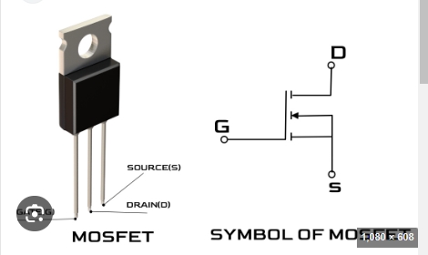

3.2 SAFETY IN ELECTRICAL INSTALLATION
- PERSONAL SAFETY
- Wear safety equipment like protective shoe, goggle etc.
- Wear gloves when handling rough materials
- Keep hair short or wear a cap
- SAFETY TOOLS
- Use the correct tools for the job
- Use a tools box for carrying the tools
- Keep tools in boxes when not in use

3.3 ELECTRICAL / ELECTRONICS TOOLS AND THEIR USES
The company has an Electrical Technician that makes use of the following instrument in performing their operations:
- Fishing Tape
- Pliers
- Screwdriver
- Electrical insulator tape
- Hammer
- Measuring tape
- Hacksaw
- Insulator or Rubber Glove
- Bending Spring
- Drawing wire
- Chisel
3.4 USES OF THE ABOVE TOOLS
- Fishing Tape: Is a tool used by electrical technicians to draw wire inside a
pipe conduit wiring
- Pliers: Is a hand tool used to hold objects firmly and at this same time used to peel and cut wire to a desire length
- Screwdriver: Is a tool for driving screw (to open electrical object like
garden light, fence light, outside light when fixing)
- Electrical Insulator: Is a type of tape used to insulate electrical wires and
other materials when wiring installation.
- Hammer : Is some aspect in an electrical field; Hammer is use to nail some
electrical equipment that cannot stand or hang on their own.
- Measuring tape: Is used to measure height and length of switch and outlet.
- Hacksaw: Is used to cut pipe and other strong electrical materials that need
to be cut.
- Tester: It is used to know if current is in a particular junction when wiring a
building.
- Ladder: It is used to climb electrical poles and high places to fix any faulty
electrical accessories i.e droplight, spotlight (POP light) etc.
- Drilling Machine: It is used to drill hole or make a hole in a work piece
where needed.
- Line: It is known as draw wire which is to draw wire inside the pipe or tube
3.5 TYPE OF WIRE USED
- 1.5MM
- 2.5MM
- 4MM
- 6MM
- 16MM
3.6 USES OF THE WIRE STATED ABOVE IN ELECTRICAL INSTALLATION
- 1.5MM – Lighting
- 2.5mm – lighting sockets
- 4mm – Cooker control Unit
- 6mm – Air conditioner (A.C), Cooker control Unit
- 16mm – House servicing
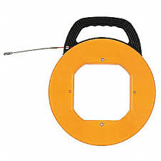
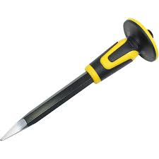
3.7 Pictures of the tools used in Electrical Workshop

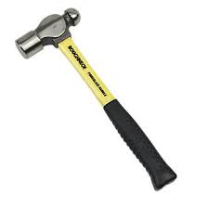
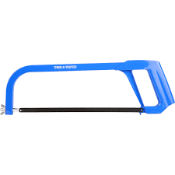
Chisel Fish Tape

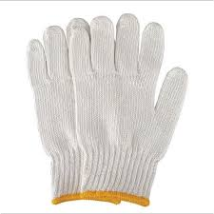
Hammer hacksaw
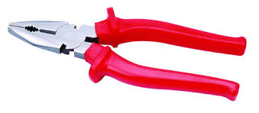

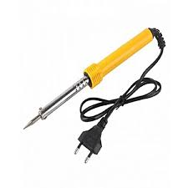
Hand Glove Combination Plier

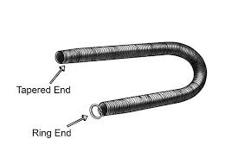
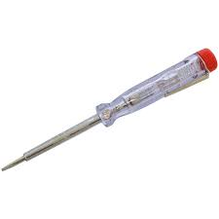
Screw driver Soldering Iron

Multi-Tester Bending Spring
3.8 DISTRIBUTION BOARD
It is [also called panel board or breaker panel] a component of an electricity supply system which divides an electrical power feed into subsidiary circuit while providing a protective fuse or circuit breaker for each circuit in a common enclosure.
Other names of distribution boards are:
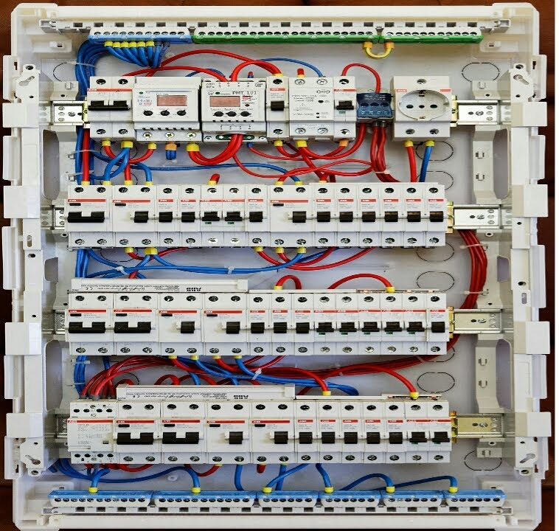
- Breaker panel
- Circuit breaker panel
- Consumer unit
- Electrical panel
- Fused board
- Breaker box e.t.c

3.9 TYPES OF DISTRIBUTION BOARD
- Single phase
- Double phase e.t.c
3.9.1 SAFETY IN ELECTRICAL BUILDING
- Wear safety equipment like protective shoe, goggle e.t.c
- Wear gloves when handling rough materials
- Keep hair short or wear a cap
3.9.2 SAFETY TOOLS
- Use the correct tools for the job
- Use a tools box for carrying tools or bag
- Keep tools in boxes when not use

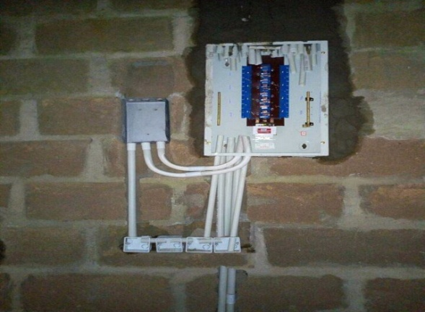

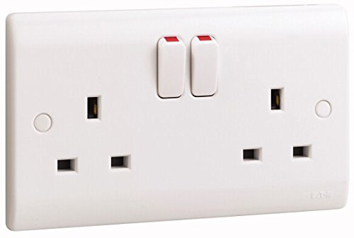
3.9.3 SOCKET: It connect electric equipment to the alternating current power supply in buildings and at other sites.

CHAPTER FOUR
4.0 Actual Work done
Adding of Electrolyte to cell battery 220AH solar battery put 12voltage
Connection of street light, Separation of wire’s positive and negative to different part.
Fixing of solar camera 360⁰ with a full installation of 10 pack of it, Adding of electrolyte Lithium battery to gain back the capacity of the battery Lifespan
Adding of electrolyte of four turbular battery to increase the lifespan of the battery
D.C installation with one panel battery deep cycling, Installation of ceiling ceiling fan
Full installation 20panel with 8 battery connected in series and parallel 10KVA inverter. Adding of AVS is to regulate the amount of current entry the inverter
4.1 How to install an inverter: inverter is electronic device that convert DC current to AC current for appliances usage. When the inverter is 2kva by 24v that means the inverter will used 24v dc input to generate 220v ac output, in this sense the inverter will use two 12v battery connected in series to give out 24v.
4.2 How to install solar panel with an inverter: solar panel is a device that absorbed heat or ray of the sun and generate electricity ,the solar panel produced dc output with the help of diode attached to the device.
4.3 How to connect batteries in series: connection of battery in series (100amp by 12v), positive terminal of the batteries are connected to the negative terminals or vice versa. This is done to yield increase in voltage and ampere remains constant.
4.4. Connection of battery in parallel (100amp by 12v), positive terminal of the battery is connected to the positive of the other battery, so also all negative are connected together. This is done to give increase in ampere and voltage remains constant.
4.5 Series and parallel connection (100amp by 12v): when the number batteries used are four, two are connected in parallel and two are connected in series. The main reason for series and parallel connection of batteries is to increase the working stability i.e. it reduce the rate at which the battery drop low compare to other connection

Uses Of Solar Power
Solar energy has long been used directly as a source of thermal energy. Beginning in the 20th century, technological advances have increased the number of uses and applications of the Sun’s thermal energy and opened the doors for the generation of solar power.

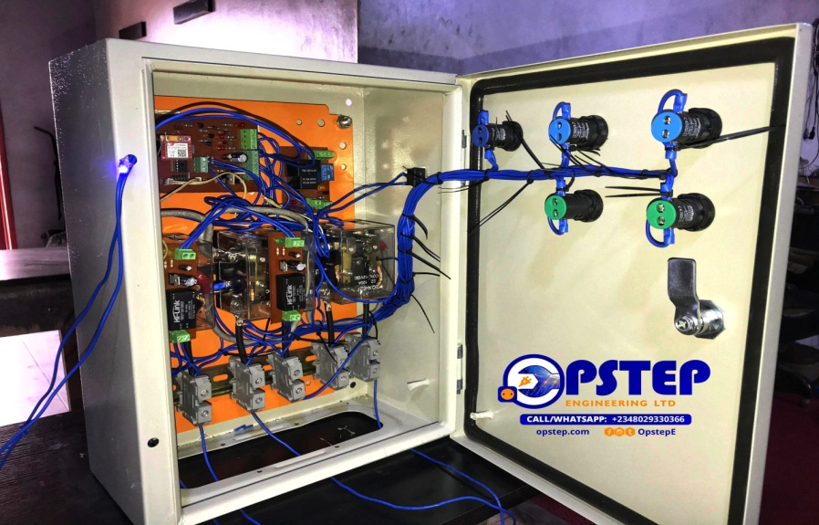
CHANGE OVER SWITCH: A changeover switch is designed to transfer a house (or business) electricity from the commercial power grid to a local generator when an outage occurs.

4.9 Problem Encountered and Proffer Solution
- Transport fare – payment of Student’s Allowance to assist in transportation during the period of training
- Technicality – Most trainers, instructors are not all registered engineers, local description instead of technical description.
- Further reading and Make consultation with expert in the field of wiring.

CHAPTER FIVE
5.0 CONCLUSION AND RECOMMENDATION
5.1 CONCLLUSION
The student industrial work experience scheme (SIWES) has been a great opportunity to expose and intending architects to all kind of building practice in order to upgrade their knowledge practically. It has also given student the privilege to be self employed or re-employed by the firm of management with which he/ she carried his SIWES training programme.
5.2 RECOMMENDATION
Base on the experience in the areas and section company’s the following recommendation is made;
i. They should organize seminars or workshop practice as related area of
discipline of trainees for better understanding of his job.
ii. The Management should oversee the welfare of the trainee and safe guards him against any industrial hazard.

