A TECHNICAL REPORT
ON
STUDENT INDUSTRIAL WORK EXPERIENCE SCHEME (SIWES)

HELD AT

ASO TAB-BIO NIGERIA. LIMITED.
12 AKOWONJO ROAD, DOPEMU BUS-STOP, LAGOS STATE.

WRITTEN BY
ABDUL-KABIRU FADILAHT KEHINDE
ND/23/PSM/FT/0097

SUBMITTED TO
DEPARTMENT OF PROCUREMENT AND SUPPLY CHAIN MANAGEMENT, INSTITUTE OF FINANCE AND MANAGEMENT STUDIES, KWARA STATE POLYTECHNIC ILORIN

IN PARTIAL FULFILLMENT OF THE REQUIREMENT FOR THE AWARD OF NATIONAL DIPLOMA (ND) IN PROCUREMENT AND SUPPLY CHAIN MANAGEMENT

AUGUST TO NOVEMBER 2024
DEDICATION

This report is dedicated to almighty God for his love, mercy and protection over my life, my parent Mr. and Mrs. Abdul-Kabiru and my family.

ACKNOWLEDGEMENT
I give all praises, honor and glory to almighty God for his blessing and protection over me; also for the strength he has given me throughout this programme and the opportunity to produce this SIWES report. My special thanks go to my parent who has been very supportive throughout my programme and for their valuable contribution both morally and financially towards the success of this report. May God in His own mercy grant them all their heart desire and let them reap the fruit of their hard labor.

PREFACE
The student industrial working experience (SIWES) is a program organized by the National Board of Technical Education (NABTE) to allow student to have practical experience which is very important to the student for the Award of their National Diploma and also to solid foundation toward the upcoming challenges.
This technical report contains the various activities and experience undergone during my four months Student Industrial Working experience program, which was held at ASO TAB-BIO NIG. LTD., Dopemu Bus-stop Lagos State.

TABLE OF CONTENT
Title Page
Dedication ii
Acknowledgement iii
Preface iv
Table of Content v-vi
CHAPTER ONE
Introduction to SIWES 1
Definition of SIWES 1
Aims and Objectives 2

CHAPTER TWO

DESCRIPTION OF THE ESTABLISHMENT OF ATTACHMENT

2.1 Location and Brief History of Establishment 3

2.2 Objectives of the Establishment 3

2.3 Organization Structure 3

2.4 Various Departments/Units and Their Functions 4

CHAPTER THREE

3.1 Work Actually Carried Out 5

CHAPTER FOUR

4.1 Experiences Gained 10

CHAPTER FIVE

5.0 Summary, Conclusion, and Recommendations 11

5.1 Summary of Attachment Activities 11

5.2 Problems Encountered During the Program 11

5.3 Suggestions for the Improvement of the Scheme 11

CHAPTER ONE
- INTRODUCTION
The student industrial works experience scheme (SIWES) was established by the industrial training fund (I.T.F) in 1973 and control by the national board for technical education (NBTE). The aims and objectives is to develop student skill and to expose students in the school of engineering, technology, environment, science and agriculture and medical science to the working experience in which they will found themselves in future.
It is integral part of degree and National Diploma programme institute of higher learning in Nigeria. This privilege programme would definitely broaden student chance of learning and would empower his/her academic efficiency.
1.1 DEFINITION OF SIWES
Student industrial Working Experience (SIWES) is a skill acquisition training programme set up by the Federal and State government across the Nation in collaboration with the body known as Industrial Training Fund (I.T.F) for student to have a working experience and a feel of what it takes to be genius in one discipline before challenges ahead.
1.2 AIMS AND OBJECTIVES OF SIWES
1. It exposes the prepare students of higher institution for the industrial working situation they can likely to meet in the future.
2. It enables student to apply what they have learn theoretically in class into practice in the real world.
3. It makes student to understand the technical implication of their profession.
4. It helps student to express their initiatives, competence and standard in task they have chosen.
5. It enable student to be technically and morally oriented
6. It helps to make transition from school to the working environment easier and to enhance students contact for later job placement

CHAPTER TWO

DESCRIPTION OF THE ESTABLISHMENT OF ATTACHMENT

2.1 Location and Brief History of Establishment
ASO TAB-BIO NIG. LTD is located at 12 Kowonjo Road, Dopemu Bus-stop Lagos State. and specializes in the design, manufacturing, and supply of aluminum windows and doors. ASO TAB-BIO NIG. LTD was established in 2001, the company has built a reputation for quality and efficiency in the aluminum industry.

2.2 Objectives of the Establishment
- To provide high-quality aluminium windows and doors.
- To optimize production and procurement processes.
- To maintain efficient supply chain operations.
- To ensure customer satisfaction through timely delivery of products.

2.3 Organization Structure
The company has a well-structured organization with the following key departments:
- Procurement and Supply Chain Department
- Production Unit
- Sales and Marketing
- Logistics and Distribution
- Finance and Administration
ORGANIZATION CHART
Managing Director
Supervisors

Student Workers Apprentice

2.4 Various Departments/Units and Their Functions
- Procurement Department: Handles supplier selection, sourcing of materials, and purchase negotiations.
- Production Unit: Responsible for manufacturing aluminium doors and windows.
- Logistics and Distribution: Manages transportation, inventory, and warehousing.
- Finance and Administration: Oversees budgeting, cost control, and financial transactions.
- Sales and Marketing: Promotes company products and manages customer relationships.

CHAPTER THREE

3.1 WORK ACTUALLY CARRIED OUT
During my industrial training, I was involved in various activities related to procurement and supply chain management, including:
- Supplier Evaluation and Selection: Assisted in identifying reliable suppliers for aluminium materials.
- Purchase Order Processing: Participated in the preparation and management of purchase orders.
- Inventory Management: Monitored stock levels and ensured proper storage of materials.
- Logistics Coordination: Observed the transportation and delivery process of finished products.
- Cost Analysis and Budgeting: Assisted in cost estimation and analysis for procurement activities.

MATERIALS NEEDED IN ALUMINUM DOORS AND WINDOWS
- Lock Style – The vertical section of a door or window where the locking mechanism is installed, providing security.
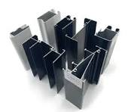
Lock Style
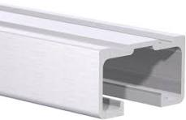
- Top Rail – The horizontal section at the top of a window or door frame, providing structural support.

Top Rail
- Interlock – A structural component where two sliding panels overlap and engage with each other to enhance security and minimize air leakage.
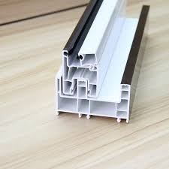
Interlock
- Double Jamb – A door or window frame with two vertical sections (jambs) to accommodate double-track or sliding systems.
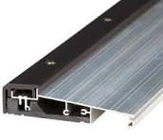
Double Jamb
- Single Jamb – A door or window frame with a single vertical section, usually for hinged or single-track sliding systems.
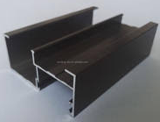
Single Jamb
- Single Track – A sliding window or door system with only one track, allowing a single panel to slide.
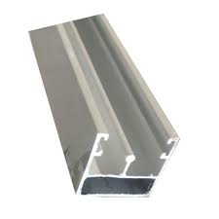
Single Track

- Three Track Aluminium – A sliding system with three tracks, allowing multiple sliding panels to move independently or stack behind each other for greater opening space.
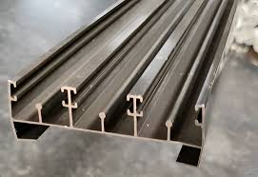

Three Track

CHAPTER FOUR

4.1 EXPERIENCES GAINED
In summary, this program has exposed me to some practical aspect in relation to my course of study and I benefitted greatly from the grogram.
What I learnt from the organization includes:
- Understanding of supplier relationship management.
- Knowledge of procurement documentation and processes.
- Exposure to inventory control techniques.
- Improved negotiation and communication skills.
- Hands-on experience in logistics planning and management.

CHAPTER FIVE

5.0 SUMMARY, CONCLUSION, AND RECOMMENDATIONS

5.1 Summary of Attachment Activities
My SIWES program at Aso Tab-Bio Nig. Ltd provided practical exposure to procurement and supply chain operations. I was actively involved in procurement planning, supplier engagement, and logistics coordination. The training enhanced my ability to analyze procurement data, manage inventory, and understand the flow of materials from suppliers to production.

Problems Encountered During the Program
- Limited access to supplier negotiations due to confidentiality policies.
- Challenges in understanding complex procurement contracts.
- High demand fluctuations affecting inventory levels.
- Delays in supply chain due to logistics constraints.

Suggestions for the Improvement of the Scheme
More involvement in supplier negotiations to gain negotiation skills, the training sessions on procurement software and tools, improved communication between departments to ensure efficiency and also regular evaluation of logistics and distribution strategies to prevent delays.

