

TECHNICAL REPORT

ON

STUDENT INDUSTRIAL WORK EXPERIENCE SCHEME (S.I.W.E.S)

HELD AT

MMTECH GLOBAL MULTI SERVICES ENTERPRISES
182, Ibrahim Taiwo Road, Beside Eco-bank, Ilorin

WRITTEN BY

AREMU VICTORIA AYOMIDE
ND/23/COM/PT/0080

SUBMITTED TO:

DEPARTMENT OF COMPUTER SCIENCE
INSTITUTE OF INFORMATION & COMMUNICATION TECHNOLOGY
KWARA STATE POLYTECHNIC, ILORIN, KWARA STATE.

IN PARTIAL FULFILMENT OF THE REQUIREMENT FOR THE AWARD OF NATIONAL DIPLOMA IN COMPUTER SCIENCE.

AUGUST-DECEMBER, 2024

CERTIFICATION
This is to certify that the report was compiled by AREMU VICTORIA AYOMIDE with Matric Number ND/23/COM/PT/0080 a student of Computer Science Department, Institute of Information and Communication Technology (I.I.C.T) Kwara State Polytechnic Ilorin, Kwara State on the completion of the Student Industrial Work Experience Scheme (SIWES)

_______________________ _________________
SIWES COORDINATOR DATE

______________________ _____________________
HEAD OF DEPARTMENT DATE

DEDICATION
This report is dedicated to God almighty, who guided me and made the programme a successful one for me.
It also goes to my loving Parent, in person of Mr. and Mrs. Aremu and to my wonderful mentors and friends, for their advice, encouragement and support both financially and morally. May God continue to bless you. (Amen)

ACKNOWLEDGEMENT
As such praise due to Almighty God for sparing my invincible life during my stay at Kwara State Polytechnic, Ilorin.
To the surprise of my one and only, my next point on call will definitely be my parent for their effort which upholds my success, in this regard, BIG THANKS to them Mr. and Mrs. Oyedeji, what will I? If not for their financial moral, spiritual and parental support, my success would have been delayed. I will say vividly "Oh God, have mercy on them even as they nourished me in my childhood.
My appreciation goes to my noble SIWES based supervisor, for their support and impartation of knowledge.
It is mandated on me that the effort of the following toward my success must duly be recognized from lecturers within the institution; May the blessing of God continue to shower you all for contributing immensely on this programme.

TABLE OF CONTENT

Cover Page
Title Page
Dedication
Acknowledgement
Table of Content
Chapter One
Introduction
Purpose of training.
Objectives and vision of REFRESH COMPUTER CONSULT
Company’s area of specialization
Departments in the company
Chapter Two
Industrial Experience
Web design department
Definition of terms
HTML and its properties
CSS and its properties
Website design using HTML and CSS
JavaScript and its properties
JavaScript work using HTML, CSS and JavaScript
Chapter Three
Skills acquired and challenges encountered
Technical skills acquired
Social and functional skills acquired
Personal input to the company MMTECH GLOBAL ENTERPRISES SERVICES)
Challenges encountered
Chapter Four
Conclusion and Recommendations
Conclusion
Recommendations
Reference
CHAPTER ONE
INTRODUCTION

- PURPOSE OF TRAINING:
The student industrial work experience scheme (SIWES) popularly called Industrial Training (IT) by Nigerian students is a yearly program design by the institution in collaboration with the industries to give students the opportunity to gain practical working experience in their various field of study or area of specialization. It is an effort to bridge the existing gap between classroom theories and practical’s in engineering, management and other professional programs in the Nigerian tertiary institutions.
Training is a key factor in changing expertise of a workforce. The world is passing through one of the worst economic crisis in recent time. Both the developed and developing economics are experiencing serious economic downturns.
Globalization has turned the world into one big village and whatever happens in one economy will have effects in other economics, and the growing concern among our industrialist is that graduates of our institutions of higher learning, lack adequate practical background studies, so as to help in the industries led to the formation of Student Industrial Work Experience Scheme (SIWES) by ITF 1993/1994.
It is through this Industrial Training that the educational systems aims at helping students acquire appropriate skills, abilities and competencies, both mental and physical, as well as equip the individuals to live in society. The focus of the Industrial Training Fund (ITF) is for the industries of our countries to succeed in the face of the current economic meltdown.

1.2 OBJECTIVES AND VISION OF MMTECH GLOBAL ENTERPRISES
- To serve as a catalyst for both individual and collective development through the provision of cutting-edge technological server’s solution, resources and guidance.
- To produce professionals in this era of global technologies.
- To offer a wide range of automated and integrated solution in broad spectrum of computer and telecommunication.
- To build bridges between need and the solution.
- MMTECH GLOBAL ENTERRISES is position to offer unique and innovative solution to client in terms of technologies.
- Our vision is to become the leading full-service information and communication technology.
1.3 COMPANY’S AREA OF SPECIALIZATION
With a team of seasoned computer Engineers and Programmers with proven track records in computer and communication business, the company offers the following wide areas of specialization
- Software Development and Maintenance
- Computer Networking and Maintenance
- VSAT Installation and Maintenance, Radio and other communication equipment
- Web Development
- Internet and E-mail Services
- Training Services
1.4 DEPARTMENTS IN THE COMPANY
- Computer repair and maintenances department
- Networking department
- Software development department
- Sales department
- Internet café
- Web design department
- Computer appreciation department
- Desktop Publishing department

CHAPTER TWO
INDUSTRIAL EXPERIENCE

2.0 WEB DESIGN DEPARTMENT
This department was where my Industrial Training took place where i was grounded and expose to the website world especially the creation of websites taking me step by step with practical all through the process.

2.1 DEFINITION OF TERMS
The following are terms that were made use of, in this department
WEBSITE:
A website is a set of related webpages containing content such as texts, images, videos, audios, etc. A website is hosted on at least one web server, accessible via a network such as the internet or a private LAN through an internet address known as a URL (Universal Resource Locator). A publicly accessible websites collectively constitutes the World Wide Web (WWW).
WEBPAGE:
A webpage is a document, typically written in plain text interspersed with formatting instructions of hypertext nark up language (HTML, XHTML). A webpage may incorporate elements from other websites with suitable anchors. Webpages are accessed and transported with the hypertext transfer protocol (HTTP), which may occasionally employ encryption (HTTP secure, HTTPS) to provide security and privacy for the use of the webpage content. The user’s application often a web browser renders the page content according to its HTML mark-up instructions into a display terminal.

HTTP:
This stands for Hyper Text Transfer Protocol which is the set of rules for transferring files (text, graphic, images, sound, video, and other multimedia files) on the World Wide Web.
URL:
This stands for Uniform Resource Locator and as the name suggests, it provides a way to locate a resource on the web, the hypertext system that operates over the internet.

2.2 HTML AND ITS PROPERTIES
HTML stands for Hypertext Mark-up Language, and it is the most widely used language to write Web Pages.
- Hypertext refers to the way in which Web pages (HTML documents) are linked together. Thus, the link available on a webpage is called Hypertext.
- As its name suggests, HTML is a Markup Language which means you use HTML to simply "mark-up" a text document with tags that tell a Web browser how to structure it to display.
Originally, HTML was developed with the intent of defining the structure of documents like headings, paragraphs, lists, and so forth to facilitate the sharing of scientific information between researchers.
Now, HTML is being widely used to format web pages with the help of different tags available in HTML language.
2.2.1 HTML TAGS:
As told earlier, HTML is a markup language and makes use of various tags to format the content. These tags are enclosed within angle braces <Tag Name>. Except few tags, most of the tags have their corresponding closing tags. For example, <html>has its closing tag</html>and <body>tag has its closing tag </body>tag etc.
The following are the names of tags and their description.
Tag | Description
<html> | This tag encloses the complete HTML document and mainly comprises of document header which is represented by <head>...</head> and document body which is represented by <body>...</body> tags.
<head> | This tag represents the document's header which can keep other HTML tags like <title>, <link>, <script language =”javascript”> etc.
<title> | The <title> tag is used inside the <head> tag to mention the document title.
<body> | This tag represents the document's body which keeps other HTML tags like <h1>, <div>, <p>, <table> etc.
<h1> | This tag represents a heading
<p> | This tag represents a paragraph.
<b>, <i>, <li>, <ul> | Bold, italic, list, unordered list

2.2.2 HTML TABLE:
The HTML table model allows web designers to arrange data –text, preformatted text, images, links, forms, form fields, other tables, etc. into rows and columns of cells. It is defined with the <table> tag.
Table are divided into table rows with the <tr> tag. Table rows are divided into table data with the <td> tag. A table row can also be divided into table headings with the <th> tag.
Table data <td> are the data containers of the table. They can contain all sorts of HTML elements like text, images, lists, other tables.
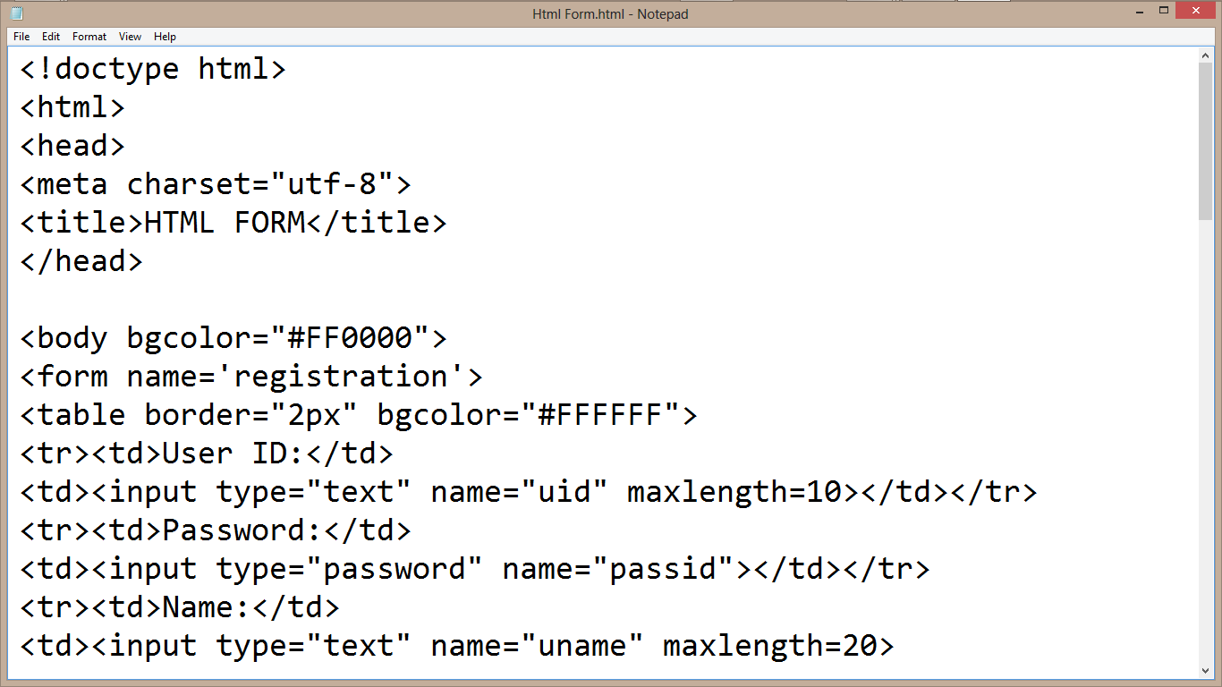
CODE VIEW
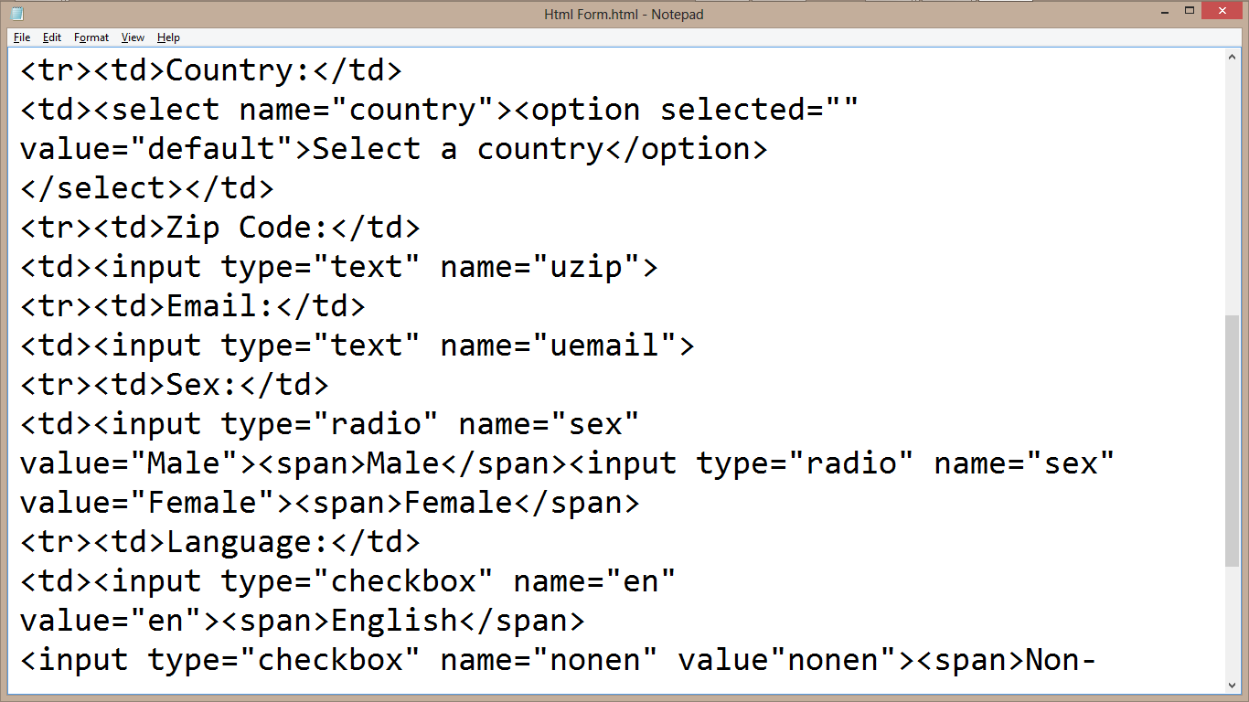

2.3 CSS AND ITS PROPERTIES
CSS stands for Cascading Style Sheet used for formatting html document. It is a style sheet language used for describing the presentation of a document written in a mark-up language.
Note: CSS code is not written the same way as HTML code is. This makes sense because css is not HTML, but rather a way of manipulating existing HTML.

2.3.1 REASONS FOR CSS
The following are reasons why CSS is better
- It saves time
- It eradicate the idea of using repeating codes
- It provides efficiency in design and updates: with css, we are able to create rules, and apply those rules to many elements within the website.
- It can lead to faster page downloads: since rules are only downloaded once by the browser, then are the cached and used for each page load, the use of css can lead to lighter page loads, and improved performance. This contributes to lighter server loads and lower requirements, which overall saves money for our clients.
- It creates external file (server side) for managing html content

2.3.2 METHOD USED BY CSS IN FORMATTING HTML DOCUMENT
- Inline Style: It is used to apply a unique style to a single HTML element. An inline CSS uses the style attribute of an HTML element.
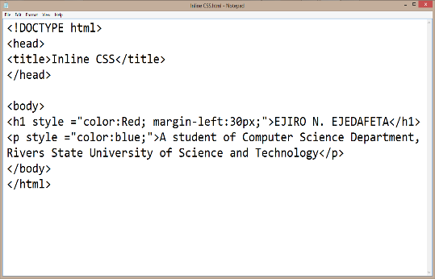
CODE VIEW DESIGN VIEW

- Embedded / Internal Style: It is used if one single page has a unique style. Internal styles are defined within the <style> element, inside the <head> section of an HTML page.

CODE VIEW
DESIGN VIEW
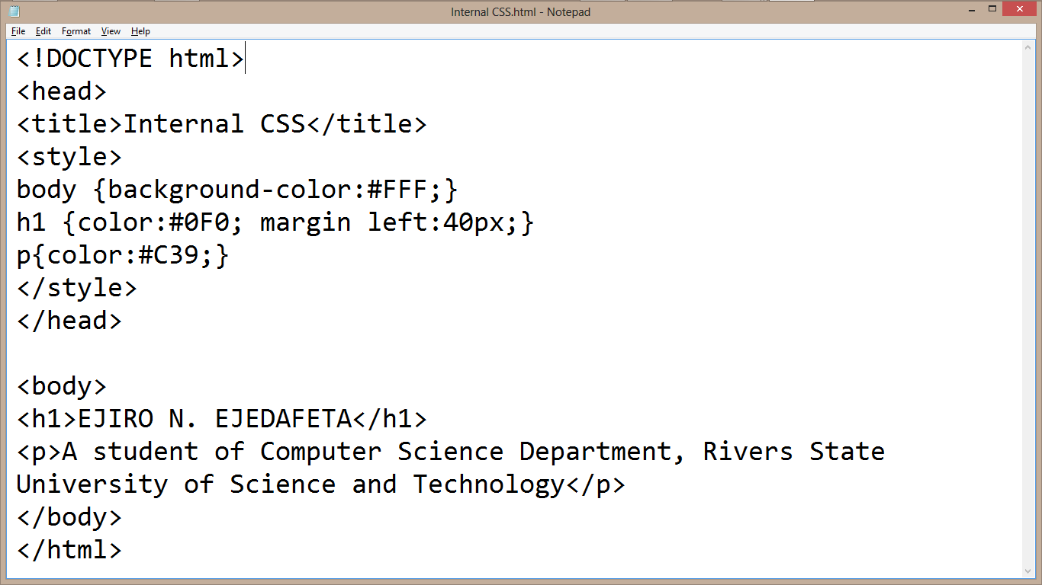

- External Style: With an external style sheet, you can change the look of an entire website by changing just one file. Each page must include a reference to the external style sheet file inside the <link> element. The <link> element goes inside the <head> section. Also when using external css it is preferable to keep the css separate from your HTML. Placing CSS in a separate file allows the web designer to completely differentiate between content (HTML) and design (CSS). External CSS is a file that contains only CSS code and is saved with a “.css” file extension. This CSS is then referenced in your HTML using the <link> instead of <style> as earlier stated.
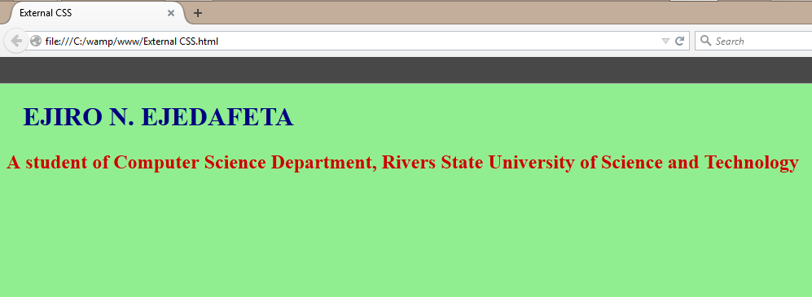
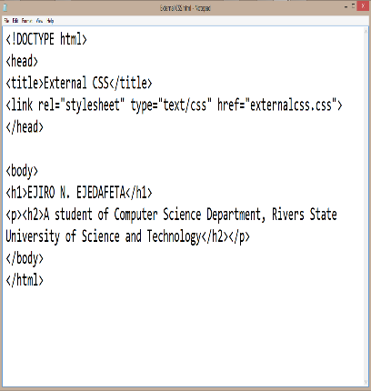
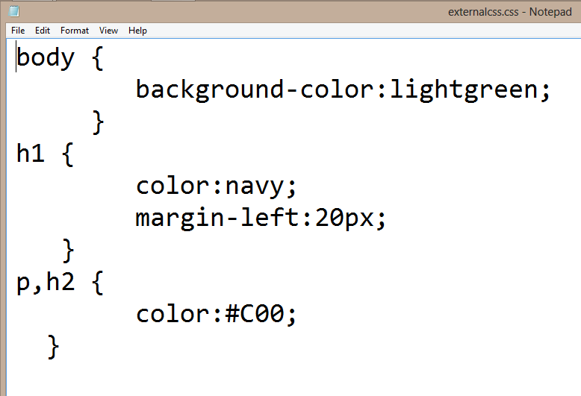
EXTERNAL CSS FILE HTML CODE DESIGN VIEW

2.3.3 CSS SELECTORS AND HOW THEY CAN BE USED
CSS selectors are used to find or select HTML elements based on their element name, id or class
- Element Selector: The element selector selects elements based on the element name.
- Id Selector: The id selector uses the id attribute of an HTML element to select a specific element. The id of an element should be unique within a page, so the id selector is used to select one unique element. e.g. id=”hello” css #hello { color;red;}
- Class Selector: The class selector selects elements with specific class attribute. To select elements with a specific class, write a period (.) character followed by the name of the class. e.g. .center {text-align:center;}
2.3.4 CSS RULES OVERRIDING
- Any inline style sheet takes the highest priority, so it will override any rule defined in <style>……</style> tags.
- Any rule defined in <style>………</style> tags will override the rules defined in any external style sheet file.

2.3.5 CSS COMMENTS
To simply put comment inside a style sheet you use /*………..*/, you can use it to comment multi-line blocks in similar way as you do in c and c++ programming language.

2.3.6 BACKGROUND AND FONT OF VARIOUS HTML ELEMENTS
You can set the following background properties of an element.
- The background-color: Is a property used to set the color background of an element.
- The background-image property: is used to set the background image of an element.
- The background repeat: Is used to control the repetition of an image in the background.
- The background position: Is used to control the position of an image in the background.
- The background attachment: Is used to control the scrolling of an image in the background.
- The background property: Is used as a short hand to specify a number of other background properties.

FONT WHICH ARE;
- The Font-family property: This is used to change the face of a font
- The Font-style property: This is used to make a font italic or oblique.
- The Font-weight property: This is used to increase or decrease how bold or light a font appears.
- The Font-size property: This is used to increase or decrease the size of a font.

2.3.7 TEXT DECORATION:
This demonstrate how to decorate a text in css, the values are none, underline, over line, line through and blink.

2.3.8 PROPERTIES OF HYPERLINK USING CSS
- The link signifies unvisited hyperlinks
- The link visited signifies visited hyperlinks
- The link hovered signifies an element that currently has the user’s mouse pointer hovering over it.
- The link active signifies an element on which the user is currently clicking.

2.4 WEBSITE DESIGN USING HTML AND CSS
HTML CODING VIEW
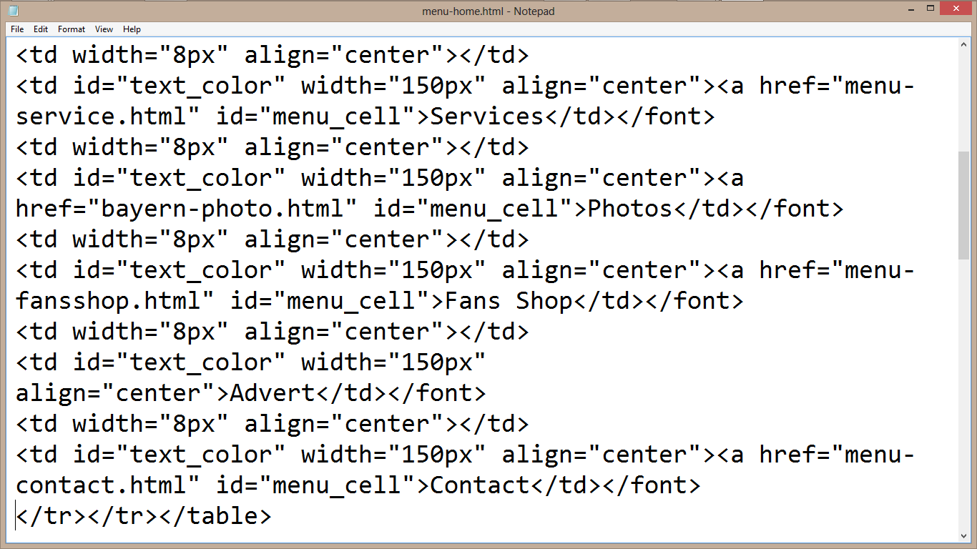
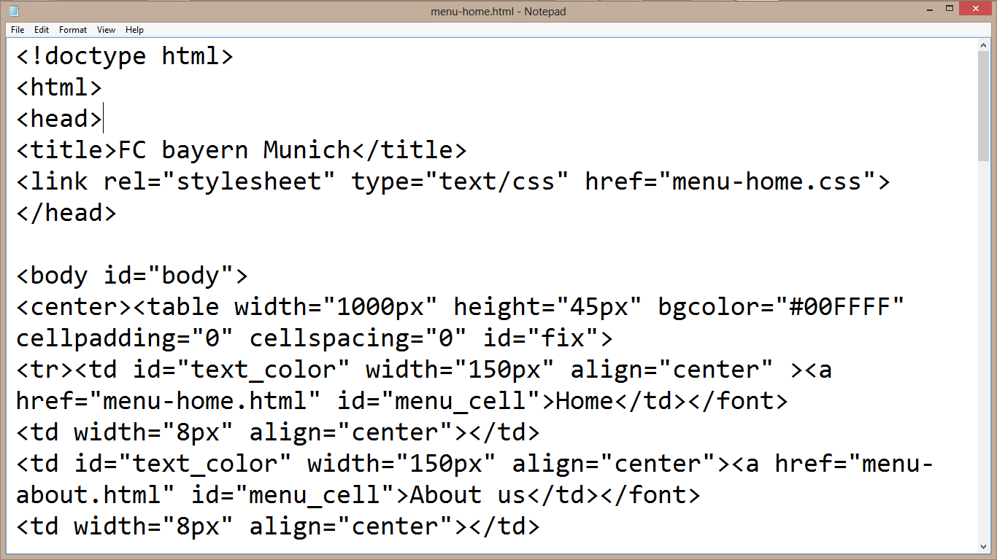
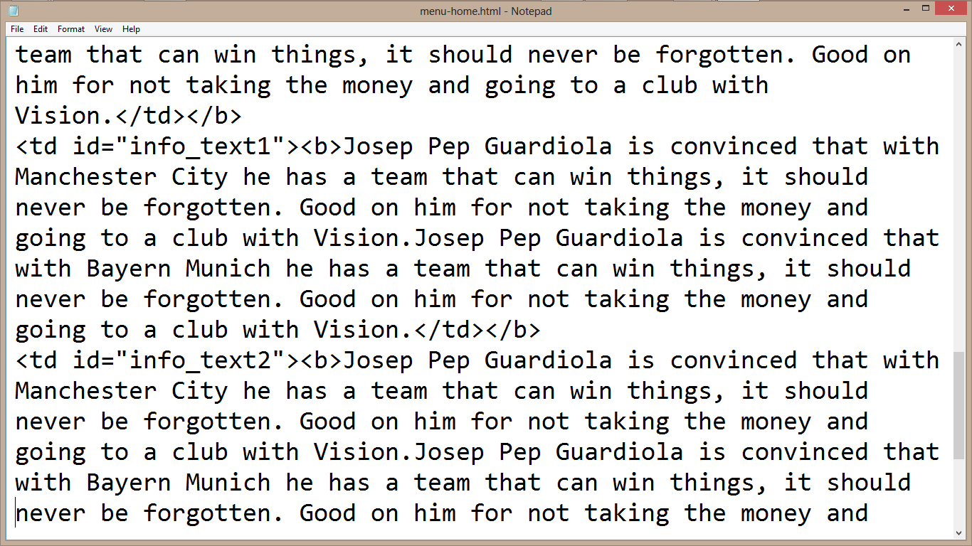
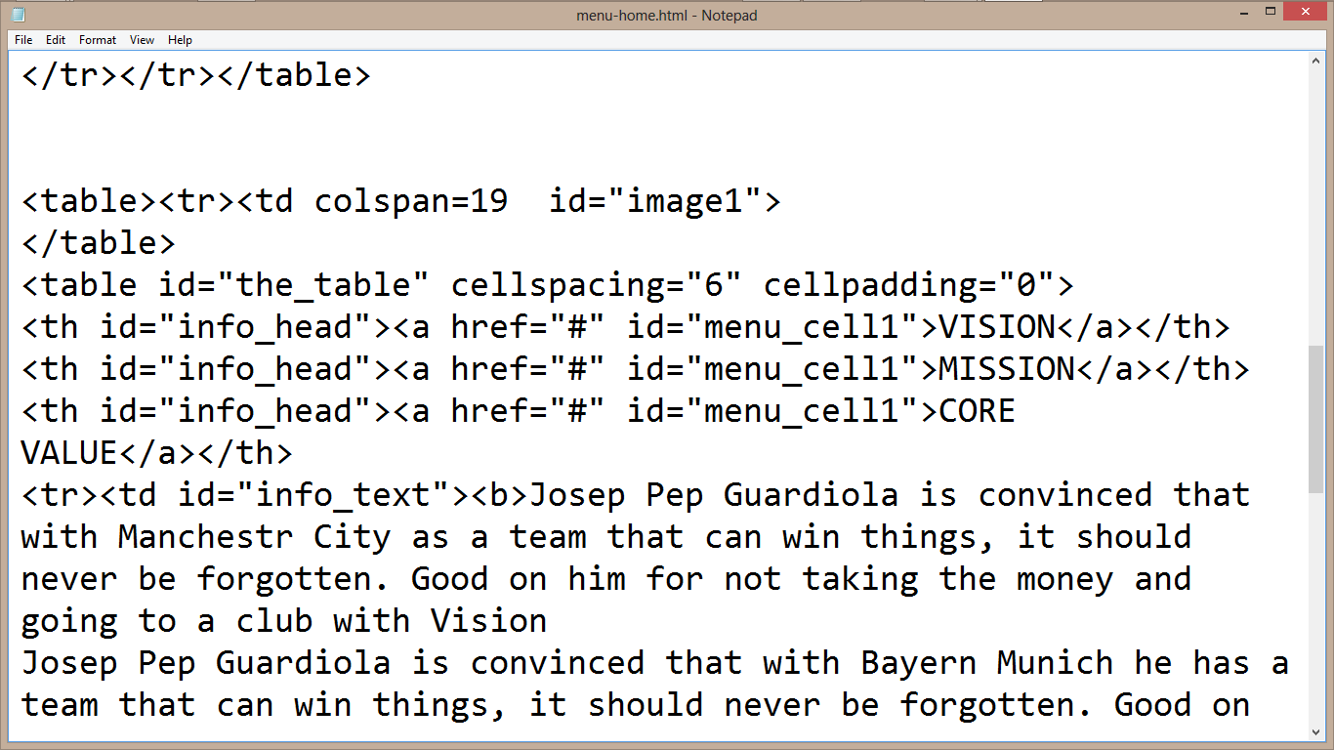

2.5 JAVASCRIPT AND ITS PROPERTIES
JavaScript is a dynamic computer programming language. It is lightweight and most commonly used as a part of web pages, whose implementations allows client side script to interact with the user and make dynamic pages. It is an interpreted programming language with object oriented capabilities. It was developed by Brenan Eich 1995-1996; it is an implementation of ECMA Script (European Computer Manufacturers Association). It was also known as livescript later change to javascript. It is use for client side web form validation. Javascript cannot run with been embedded in the HTML.

2.5.1 FUNCTIONS OF JAVASCRIPT
- It is most commonly used as a client side scripting language, which implies that JavaScript is written into an HTML page and when a user request an HTML page with JavaScript in it, the script is sent to the browser.
- It used for form validation.

CHAPTER THREE
SKILLS ACQUIRED AND CHALLENGES ENCOUNTERD

3.0 TECHNICAL SKILLS ACQUIRED
Below is list of skills I acquired during my Industrial Training at MMTECH GLOBAL ENTERPRISES SERVICES
- Deep knowledge in understanding web design and database maintenance.
- Ability to create websites with the help of HTML.
- Ability to create websites with the help of HTML and CSS.
- Ability to create a standardize websites with the help of HTML, CSS, JAVASCRIPT, and PHP.
- Debugging errors and been creative in arrangement of codes.
- Installing Database (Wamp) and linking PHP to the Database.
- Installing several developmental tools like Adobe CS6 which contain Dreamweaver, and Fireworks, knowing how to use them effectively.
- Learning how to work with designed Templates and creating Templates.
- Ability to Insert, Update, Select, Delete records in the Database and Importing, Exporting database file from one local server to another.

3.1 SOCIAL AND FUNCTIONAL SKILLS ACQUIRED
- Enhanced communication skills.
- Ability to identify and solve problems relating to web design .
- Decision making, critical thinking, organizing and planning.
- Ability to work with team.
- Enhanced teaching and effective learning skills
- Good customers services orientation skill

3.2 PERSONAL INPUT TO THE COMPANY (DUPE PHOTOS AND MULTIMEDIA)
- Teaching and assisting students (Clients) through their lessons.
- Assist students with their codes when not running.
- Running of errands to boost activities in the workplace.
- Check and work on colleague’s systems when challenge with an error code.
- Help in installing various development applications to colleagues and client.
3.3 CHALLENGES ENCOUNTERD
- Difficulty in seeking for IT attachment.
- Lack of transportation fee.
- Lack of good facilities for web design.
- I was not paid either by SIWES or the place of my attachment.
- There are no standard equipment’s for learning and practical.
- The company lacks proper SIWES orientation on how to train student.

CHAPTER FOUR
CONCLUSION AND RECOMMENDATIONS

4.0 CONCLUSION
My Three (3) months Industrial Training at Probity Hub was a huge success and a great time of acquisition of knowledge and skills. Through my training i was able to appreciate my chosen course of study even more, because i had the opportunity to blend the theoretical knowledge acquired from school with the practical hands-on application of knowledge gained here to perform very important tasks that contributed in a way to my productivity in the company. My training here has given me a broader view to the importance and relevance of Computer Science (Web Design Development) in the immediate society and the world as a whole, as i now look forward to impacting it positively after graduation. I have also been able to improve my communication and presentation skills and thereby developed good relationship with my fellow colleagues at work. I have also been able to appreciate the connection between my course of study and other disciplines in producing a successful result.

4.1 RECOMMENDATIONS:
- School should provide a place of attachment for student.
- Allowances should be paid to students during their programme just like NYSC and not after. This would help them a great deal to handle some financial problems during their training course.
- Supervisor should always visit student monthly in their various places of attachment.

REFERENCE
PAPER
- Student industrial work experienced scheme 2022/2023 handbook
- Web design manual by industrial supervisor
- Web design and Advance Manual by Industrial based supervisor

LINK
- http://www.w3schools.com
- http://www.tutorialpoint.com
- http://www.tizag.com/CSS
- http://www.CSS/HTML/116583/article.com

