
A TECHNICAL REPORT

ON

STUDENT INDUSTRIAL WORK EXPERIENCE SCHEME (SIWES)

HELD AT

OPBAS COMPUTER SERVICE,
Tidibodo Complex Akingble Moniya, Ibadan

PRESENTED BY

YUSUF AZEEZ OLAMIDE
MATRIC N0: ND/23/COM/PT/0108

SUBMITTED TO THE

DEPARTMENT OF COMPUTER SCIENCE
INSTITUTE OF INFORMATION AND COMMUNICATION TECHNOLOGY,
KWARA STATE POLYTECHNIC, ILORIN

SEPTEMBER - DECEMBER, 2024
DEDICATION
This project is dedicated to Almighty God. It is also dedicated to my parents Mr. And Mrs. Yusuf. May the God peace continue to keep them.

ACKNOLEDGEMENTS
My acknowledgement goes to Almighty God (The most beneficent, the merciful). For sparing my live throughout the duration of this course. My sincere and profound gratitude goes to my loving and caring parents for their parental advice, caring and also for their financial support which have added to the success of this project.
My heartily gratitude goes to this set of people Mr. Ayodele, and others of my friend you are all wonderful.
I cannot but mention the effort of lecturers as well as the entire staff in computer science department for their support in one way or the other.

TABLE OF CONTENTS
TITLE PAGE
DEDICATION
ACKNOWLEDGEMENTS
TABLE OF CONTENTS
CHAPTER ONE
1.1 Introduction
1.2 Definition of the Student Industrial Work Experience Scheme (SIWES)
1.3 Aims and Objectives
CHAPTER TWO
2.1 Historical Background of the Organization
2.2 Organizational Chart
2.3 Major Activities of the Organization

2.4 Section and Unit of the Organization and their Specific Function
CHAPTER THREE
3.1 Introduction to Microsoft Word
CHAPTER FOUR
4.1 Attribute Indicator
CHAPTER FIVE
5.1 Personal Impression about the Organization
5.2 Recommendation to the Organization
5.3 To the Polytechnic

CHAPTER ONE
1.1 INTRODUCTION
Student industrial work experience scheme (SIWES) started in some years back organize by the Industrial Training Fund (ITF) which is a committee set aside for the enlightenment of student on the advantage of SIWES and some other review.
1.2 DEFINITION OF THE STUDENT INDUSTRIAL WORK EXPERIENCE SCHEME (SIWES)
The student industrial work-Experience scheme (SIWES) was initiated in 1973 by the Industrial Training Fund (ITF)
The report of the National Needs Assessment Survey conducted by the National Universities Commition (NUC) in 2004 titled “labour market”. Expectations of Nigeria Graduate showed that “employers believe graduates bring sufficient theoretical knowledge to the job but that they generally lack hands on or practical skills that would make them productive”. It was in the face of such criticism in the past that the student industrial work experience scheme (SIWES) was established with the aim of bringing gap between the skills which the labour market requires and those that graduate bring to the job.
It is relevant that SIWES, an important component of the curricula of science, engineering and the technology programs of Nigeria Tertiary Institutions, by Government policy, should attract a minimum of two credit units in colleges of education, four credit units in polytechnic and six credit units in the universities.

1.3 AIMS AND OBJECTIVES
- Expose students to work methods and techniques in handling equipment and machinery that may not be available in their institution.
- Make the transition from school to the work of school easier and enhance students’ contacts for later job placement.
- Provide students with the opportunities to apply their educational knowledge in real work situations, thereby bringing the gap between theory and practice.
- Provide an avenue for students in institutions of higher learning to acquire industrial skills and experience during their courses of study.
- Prepare students for industrial work situation that they are likely to meet after graduation.

CHAPTER TWO
2.1 HISTORICAL BACKGROUND OF THE ORGANIZATION
OPBAS Computer Service was established by Mr. Adeniran M.A on the 27th of June 2009 and it became registered under auspices of Companies and Allied Matters Act (CAMA) 2010 in collaboration with Corporate Affairs Commission (CAC).The institute contribute to the technology expansion and also training people to have basic knowledge about the computer system thereby contributing to the development of this country.
2.2 ORGANIZATIONAL CHART
DIRECTOR

MANAGER

BUSINESS SECTION
CYBER CAFE
TRAINING SECTION

2.3 MAJOR ACTIVITIES OF THE ORGANIZATION

The major activities of the organization are: -
- People are trained to be a computer literate and also to be computer operator
- People are also allows to be trained at the cyber café section.

2.4 SECTION AND UNIT OF THE ORGANISATION AND THEIR SPECIFIC FUNCTION
In the organization there are three different sections which are:
- Cyber café
- Training section
- Business center
Cyber Café: This section are meant for browsing, where people are allow to browse the web
Training Section: people are trained on different application packages e.g. ms word Corel draw etc.
Business Center: This is where people purchase their ticket to have access to the net, and also photocopies, lamination, scanning are also made.

CHAPTER THREE
3.1 INTRODUCTION TO MICROSOFT WORD
Microsoft Word is a word-processing application that can be part of the Microsoft Office suite or a stand-alone program installed on to your computer.
The program can be used to write letters and different types of documents that can include graphics and pictures. This guide explains how to open Microsoft Word and start a new document, using the Windows 7 operating system.
It will feature Word 2013 for PCs, and is slightly different to earlier versions of Word. A word processor included free with the Windows operating system is WordPad, which doesn’t have all the features of Word but does have some formatting features.
It can be found in the ‘Start’ menu under ‘Accessories’. Click on ‘All programs’ and then scroll to ‘Accessories’ folder
- A computer with Microsoft Word installed.
Follow these step-by-step instructions to start a document in Microsoft Word
Step 1: From the desktop or from your ‘Start’ menu, open Microsoft Word.

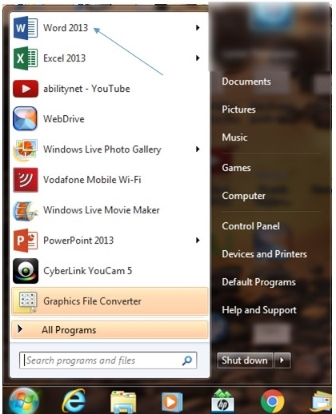
If the Word 2013 icon does not appear you can search for it, using the ‘Search programs and files’ box in the picture above.
Step 2: Microsoft Word will open up and present you with an option to select a document template, or a blank document.

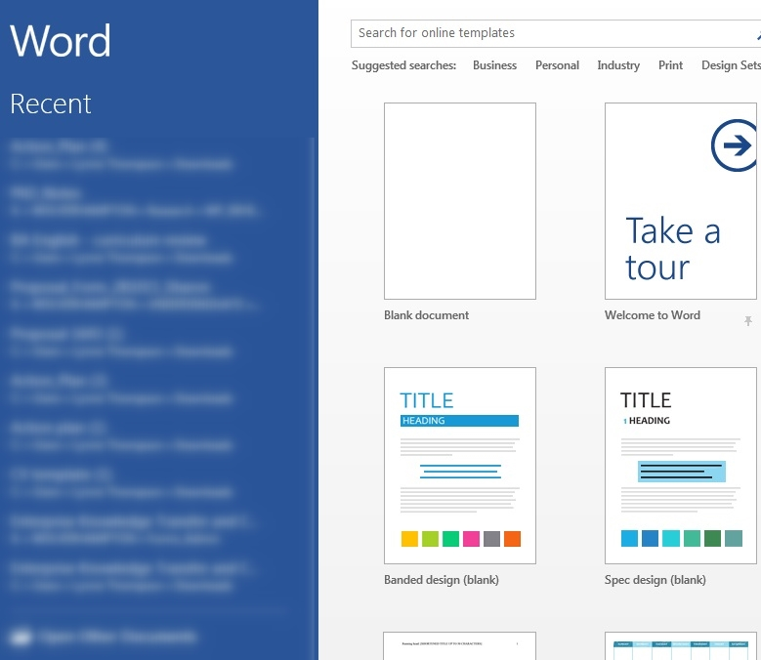

Step 3: If you don’t want to use any of the templates on display, click on the blank document.

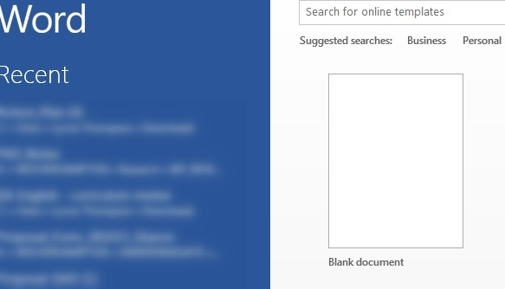

Step 4: A new blank document will open up ready for you to start typing.
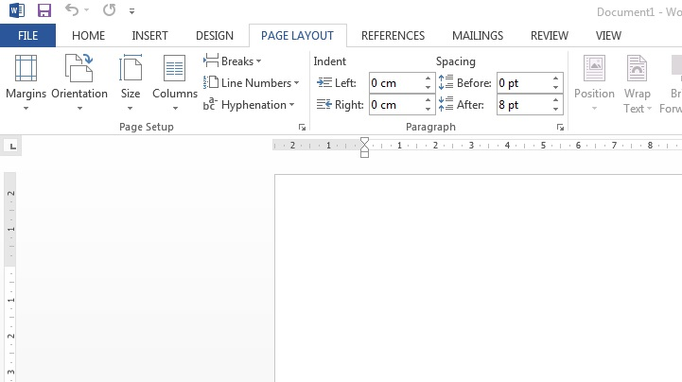
CHAPTER FOUR
4.1 ATTRIBUTE INDICATOR
BOLD FACING: This is used to make a text thicker and darker than the normal text.
Highlight the text
Go to the format bar
Click on B symbol
UNDERLINING: These features enable you to underline a specified aspect of your document.
Highlight the text
Go to the format bar
Click on U symbol
CENTERING:
Highlight the text
Go to the format bar OR FORMAT MENU
Click on paragraph
Click on align center under alignment.
SPELL CHECKING:
It enables you to check spelling in the active document, including the text in the headers, footers, endnotes and annotations. When word check spelling automatically as you type, a wavy red line appears under each word that does not appear in any open dictionary. in the same way for grammar mistakes, a green wavy line appears.

STEP
Click on tool menu
Click on spelling and grammar
Select and correct word and click on change
Click on ignore if the spelling is correct.
BULLETS AND NUMBERING
This type of formatting is applied to a list. We can also apply this type of formatting to selected text paragraphs, in which cases the paragraphs, in which case the paragraphs are numbered or bulleted.
TO APPLY BULLETS OR NUMBERING FORMATTING
Select the list to which you wish to apply either bullets or numbering
Click on the Bullets or Numbering icons in the formatting toolbar or select format menu---- bullets and numbering.
To stop bullets or numbering from generating further, click on the bullets and numbering icon
To remove a single bullet or number, click before the bullet or number or press the backspace key
INDENTATION
Indentation is the process of moving your line of text to the work area e.g. Paragraph.
Go to your format menu
Click on tabs
A dialog box appear on the screen
Type any figure you want for your paragraph, it may be 0.2,0.4
CHANGING LINE SPACING
Highlight your text
Go to your format menu
Click on paragraph (a dialog box appear on the screen)
Click on any type of line spacing you want, either single or double.
JUSTIFICATION
This is the process in which the text is properly aligned i.e. balanced. To justify
Highlight your text
Click on format
Click on paragraph
Click on alignment

MICROSOFT KEYBOARD SHORTCUT
Ctrl V | Paste
Ctrl Z | Undo
Alt F4 | Close Window
Ctrl Y | Undo
Ctrl E | Centralize
Ctrl X | Cut
Ctrl C | Copy
Shift F3 | Change Case
Ctrl J | Justification
Ctrl O | Open
CHAPTER FIVE
5.1 PERSONAL IMPRESSION ABOUT THE ORGANIZATION
The interpersonal relation I had with the organization was deep. The director and staff of the organization were so familiar. I was treated like their staff. I have access to work on any available computer system and department. Due to the deep relation I had with the organization, it give me a great privilege to go there any period of time am on holiday. With my knowledge have gained in this organization, am been given the organization ID card to be able to work with any company.
According to the document signed between I and the management, they will be of help if I need their assistant.
It is an organization where unit and love exist within the manager, all staff and the students. These make the company to grow and expand.
This organization is a nice company which I can recommend for any student to go and achieve knowledge about computer engineer.
5.2 RECOMMENDATION TO THE ORGANIZATION
My recommendation to the organization is that they should improve on their facilities. They should get more systems for their cyber Café department and other tools that are needed for system maintenance.
I’m appealing to the organization that have opportunity to seek any student on the SIWES program as an helping hand to them because the students is there to learn the practical aspect of what they have been taught in school and the organization can also gain from the student anyway.
5.3 TO THE POLYTECHNIC
I’m also appealing to all the institutions that they should get their students involves in the SIWES program because I believe that they can be able to know practical about their study and also be able to relate with people anywhere they go for their program. So the management should make it mandatory for the student to go for training.

