REPORT ON STUDENT INDUSTRIAL
WORK EXPERIENCE SCHEME (SIWES)
UNDERTAKEN AT

MOUNT OLIVE QUARRY, NIGERIAN LIMITED

BY

OLUWADAMILARE KEHINDE PETER
ND/23/COM/PT/0323

Computer Science,
Institute of Information and Communication Technology,
Kwara State Polytechnic, Ilorin.

Being a report submitted to the SIWES unit, Kwara State Polytechnic, Ilorin, Nigeria, in partial fulfillment of the requirements for the Student Industrial Work Experience Scheme (SIWES)

AUGUST-NOVEMBER, 2024

DEDICATION
To my wonderful parents, who taught me that the largest task can be accomplished if one can work hard and remain committed to one’s trueself

ACKNOWLEDGEMENT
All praise and adoration are to God Almighty my creator, my strong pillar, my source of inspiration, wisdom, knowledge and understanding. He has been the source of my strength throughout this program.
I owe thanks to my parents for their unstinting support, co-operation, encouragement and understanding throughout the span of this program and many other close friends and family members.
I have taken effort in this report. However, it would not have been possible without the kind of roles played by all the technical staffs of MOUNT OLIVE QUARRY, for their relentless supports, guidance, constant supervision, and explanation of work(s) done even though the work was so hectic. Other members of staff of PC MOUNT OLIVE QUARRY, who contributed to one form or the other are deeply appreciated and to the people who have willingly helped me out with their abilities.

DECLARATION
I hereby declare that I, Oluwadamilare kehinde peter from Computer Science Department, Institute of Information and Communication Technology, Kwara State Polytechnic, Ilorin, Nigeria underwent the four months Students Industrial Work Experience Scheme (SIWES) at MOUNT OLIVE QUARRY, KWARA STATE, from 12th of August to November 2024. I also declare that to the best of my knowledge, all sources of knowledge used have been duly acknowledged.

---------------------------------------
Oluwadamilare kehinde peter
ND/23/COM/PT/0323

TABLE OF CONTENT

TITLE PAGE i
DEDICATION ii
ABSTRACT iii
ACKNOWLEDGEMENTS iv
DECLARATION v

1. CHAPTER ONE: THE SIWES 1
1.1 Introduction 1
1.2 Objectives of SIWES Error! Bookmark not defined.2
1.3 Importance of SIWES 1
2 CHAPTER TWO: PC AID COMPUTER ENGINEERING 2
2.1 Computer Repair Services in Nigeria 2
2.2 About PC AID COMPUTER ENGINEERING 2
2.2.1 PC AID Computer Engineering Products and Services 3
2.3 Organizational structures of PC AID COMPUTER ENGINEERING 3
2.4 The Department in PC AID Computer engineering company and Their Functions 3
3 CHAPTER THREE: WORK DONE & EXPERIENCE GAINED 9
3.1 Introduction 9
3.2 Training department 9
3.2.5 Equipment and Machine used in the Training Department 9
3.2.6 Experienced Gained And Work Done In The Training Department 10
3.3 Operation and Procurement Department 10
3.3.1 Introduction 10
3.3.4 Experienced Gained and Work Done In The Operation Department……………………...11
3.4 Marketing and Logistics Department 11
4 CHAPTER FOUR: THE EQUIPMENTS 12
4.1 Introduction 12
4.2 DC Power Supply 12
5 CHAPTER FIVE: SUMMARY, CONCLUSIONS AND RECOMMENDATIONS 13
5.1 Summary and Conclusions: 13
5.2 Problem Faced During SIWES Program 13
5.3 Recommendations 13
REFRENCE

CHAPTER ONE

Introduction
The Students Industrial Work Experience Scheme (SIWES) is the accepted skills training program, which forms part of the approved minimum Academic Standards in the various degree program for all the Nigerian Universities. It is funded by the Federal Government of Nigeria and jointly co-ordinate by the Industrial Training Fund (ITF) and the National Universities Commission (NUC).
It is also designed to expose and prepare students at Universities, Polytechnics, Colleges of Technology, Colleges of Agriculture and Colleges of Education for the industrial work situation they are likely to meet after graduation. The scheme also affords students the opportunity of familiarizing and exposing themselves to the needed experience in handling equipment and machinery that are usually not available in their Institutions. Before the establishment of the scheme, there was a growing concern among our industrialists that graduates of our Institutions of higher learning lacked adequate practical background studies preparatory for employment in Industries. Thus, the employers believed the theoretical education going on in higher institutions was not responsive to the needs of the employers of labor. It is against this background that the rationale for initiating and designing the scheme by the Industrial Training Fund (ITF) during its formative years – 1973/74 was introduced to acquaint students with the skills of handling employers’ equipment and machinery. The ITF solely funded the scheme during its formative years. But as the financial involvement became unbearable to the Fund, it withdrew from the Scheme in 1978. Later the Federal Government in November 1984 revert the management and implementation of the SIWES Programmed to ITF.
Importance of SIWES
- It provides students with an opportunity to apply their theoretical knowledge in real life situations.
- It strengthens links between the employers, universities, and industrial training fund (ITF).
- It also prepares the students for the labor market after graduation (Hameed, 2019).
- It helps in increasing self-confidence and identifying their own proficiency.
- The industrial training program improves students’ awareness in single technology.

CHAPTER TWO

2.1.0 MOUNT OLIVE QUARRY

2.2.2 Computer Repair Services in Nigeria
The profession of computer repairing is relatively new. The industry is characterized by an extremely fast turnover of knowledge and skills. This is due to the rapid technological advancements. The history of computer repairs is therefore inextricably interwoven with the history of computers. This is particularly true for the personal computer. There are however certain defining factors that have made the computer repair profession what it is today.
Prior to 1980, Apple, Commodore and Tandy Corporation (Radio Shack) manufactured majority of microcomputers. As computer parts became cheaper, more and more companies entered the industry. As a result, more affordable computers were produced. The increased usage of computers brought about the need for a growing number of skilled technicians.
In the times before there was a computer (or two) in every household, personal computer users often had only the most basic of computer skills. Computer technicians would regularly encounter customers with simple computer problems.
Correspondingly, the various workplaces in which a computer technician has had to negotiate have also expanded. With every market and industry recognizing the advantages that computers can bring, technicians are often needed on site.

2.2.3 ABOUT PC AID COMPUTER ENGINEERING
PC AID computer engineering is a certified computer engineering company headquartered at Dugbe in Ibadan, Nigeria. It was established and registered by the Corporate Affairs Commission in 2018, it is primarily involved in the sales, repair and maintenance of Computers and its accessories with services rendered to Private Organizations and individuals with a robust and extensive supply and services network. PC AID contributes to the smooth running of different organizations in Nigeria. The company has in the past 4 years gone mainstream due to the display of integrity with respect to quality products and professional service.

2.2.3 Organizational Structures of MOUNT OLIVE QUARRY
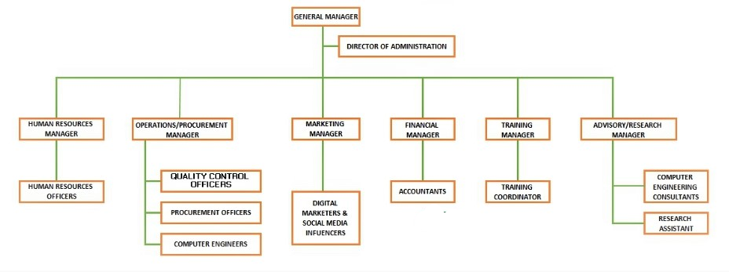
Fig ‎0.1. Organogram of YEMTECH CYBER WORLD COMPUTER ENGINEERING

2.2.4 MOUNT OLIVE QUARR, Products and Services
MOUNT OLIVE QUARRY, has a wide variety of services being rendered across the country. The type of service being provided in any location in Nigeria is dependent on customers’ demand in that location. MOUNT OLIVE QUARRY, computer engineering classified their services broadly into hardware repair and complete installation of computer systems (any brand), local and international buying and selling of laptop computers (any brand) and accessories, I.T consultancy, data recovery, software engineering and ICT training. The Department in PC AID Computer engineering company and their functions
The various departments in YEMTECH CYBER WORLD located in Ibadan and their various functions are stated below:

2.2.5 Human Resources Department
The human resources department is responsible for activities spanning a wide variety of core functions. In a nutshell, the human resources department performs the staffing, development, compensation and employee and labor relation functions in the company.

2.2.6 Health Safety and Environment Department
This department is responsible for the encouragement and regulation, regulation and enforcement of workplace health, safety, and welfare of the staff. It also looks into the occupational risks involved in the use of each machinery and equipment at the different working levels in the organization.

2.2.7 Operation and Procurement Department
The operation and procurement unit of the organization is responsible for the day-to-day activities of the organization. The department also deals with the procurement of laptops and their hardware parts both locally and internationally.

Training Department
Training of students who intend to learn about computer engineering and repairs.

Advisory on Research Department
This department makes research on new technological trends, conducts feasibility tests and writes reports on the research and tests conducted. It also advises the organization on what to do to progress due to the research that had been carried out based on previous records.

Admin Department
The department is saddled with the responsibility of keeping records and data important to the organization.

Audit Department
This department makes sure that the other department complies with policies and procedures. They also assess the quality of internal controls and evaluate risk managements.

Logistic Department
The role of the logistic department includes the delivery and storage of products and goods. They ensure that the right products are delivered to the right location at the time. They are also involved in transportation, stock control, warehousing and monitoring the flow of goods.

Marketing Department
This department is responsible for brand representation. They analyze the market and conduct campaigns for marketing initiatives.

Finance Department
Their duties include financial planning, management of the financial capitals of the organization. Their activities include disbursement of funds, keeping of the company’s daily transactions details etc., reporting and controls short- and long-term business strategies including investments, hedging, mergers and acquisitions.

CHAPTER THREE

3.0 WORK DONE AND EXPERIENCE GAINED

3.1 Introduction
This chapter covers the information on experience gained from various departments. We were advised and lectured that the importance of safety cannot be overemphasized in any company or establishment. So, we were drilled on the safety procedures, processes, and the use personal protection equipment by the HSE department in our first few weeks of internship. Before any activities are carried out in any department, we were evaluated on our knowledge of the safety procedures and processes.
3.2 Safety

3.3 Introduction
In our first few days in the training department, we were made to understand the design and working principles of computers’ components, it is important to have the design knowledge of both laptop and desktop computers before proceeding into their hardware repair and software installations. The manufacturer of computers must know what brand of computer to produce for a targeted market. We were made to understand that there are three components of a computer, These are:
i. Hardware
ii. Software
iii. Human ware

3.4 COMPUTER HARDWARE
The hardware refers to the physical components and the devices which make up the visible computer. It can be divided into two: Central Processing Unit (CPU) and the Peripherals. The CPU is responsible for all processing that the computer does while the peripherals are responsible for feeding data into the system and for collecting information from the system. The CPU consists of Main Storage, Arithmetic and Logic Unit (ALU) and Control Unit. The main storage is used for storing data to be processed as well as the instructions for processing them. The ALU is the unit for arithmetic and logical operations. The control unit ensures the smooth operation of the other hardware units.
The Peripherals are in three Categories: Input devices, Output devices and Auxiliary storage devices. The input device is used for supplying data and instructions to the computer. Examples are terminal Keyboard, Mouse, Joystick, Microphone, Scanner, Webcam, and so on. Output device is used for obtaining result (information) from the computer. Examples are Printers, Video Display Unit (VDU), loudspeaker, projector, and so on. Auxiliary Storage Devices are used for storing information on a long-term basis. Examples are hard disk, flash disk, magnetic tape, memory card, and so on (Babatunde, 2019).
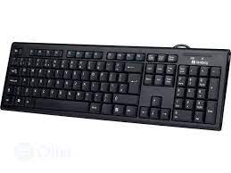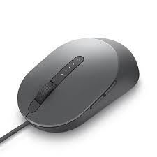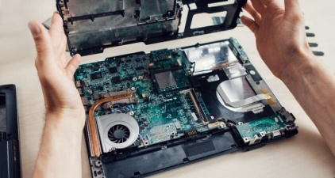
Fig. 3.1 computer keyboard, mouse, and motherboard

3.5 COMPUTER SOFTWARE
Software basically refers to programs written to control the operations of computer hardware. A program consists of sequence of coded instructions showing the logical steps required to accomplish a well-defined task. It also refers to the instructions, programs, data, and protocols which run on top of hardware(Alfred, 2021). Examples of such tasks include:
- Finding the average score of a student
- Computing the net pay of an employee
- Solving a set of simultaneous linear equations
It is the software that enables the hardware to be put into effective use; i. e the software that makes the computer versatile. There are two main categories of software – System software and Application software.
- System software are programs commonly written by computer manufacturers, which have direct effect on the control, performance and ease of usage of the computer system. Examples are Operating System, Language Translators, and System Utilities Programs.
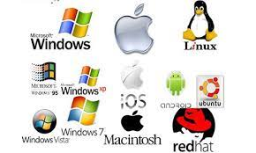
Fig. 3.2 System software (operating systems)
ii. Application Software: are programs written by a user to solve his/her own application problem. They do not have any effect on the efficiency of the computer system. An example is a program to calculate the grade point average of all the 100L students. Application software can be divided into two namely: Application Package and User’s Application Program. When application programs are written in a very generalized and standardized nature such that they can be adopted by several different organizations or persons to solve similar problem, they are called Application Packages. These include word processors (such as MS-word, WordPerfect, WordStar); Database packages (such as Oracle, MS-access, Sybase and Informix); Spreadsheet packages (such as Lotus 1-2-3 and MS-Excel); Graphic packages (such as CorelDraw, Fireworks, Photoshop etc.), and Statistical packages (such as SPSS). User’s Application Program is a program written by the user to solve specific problem which is not generalized in nature. Examples include writing a program to find the roots of quadratic equation and program to computer students’ results (Babatunde, 2019).

Fig. 3.3 computer application packages

A Microprocessor
A Microprocessor is any of a type of miniature electronic device that contains the arithmetic, logic, and control circuitry necessary to perform the functions of a digital computer’s central processing unit. In effect, this kind of integrated circuit can interpret and execute program instructions as well as handle arithmetic operations.
The first microprocessor was the Intel 2004, which was introduced in 1971. During the early 1980s very large-scale integration (VLSI) vastly increased the circuit density of microprocessors. Microprocessor consists of an Arithmetic and Logic unit (ALU), flag register, register array, instruction decoding unit, a control unit and PC/IP. ALU performs arithmetical and logical operations on the data received from the memory or an input device.

Programming a laptop BIOS (EEPROM) chip with an external programmer
A BIOS chip is a piece of Read-Only Memory (ROM), located on the surface of a computer motherboard, which contains the information necessary to boot up the computer. Reprogramming a BIOS chip means changing its settings, It is pertinent to note that certain BIOS changes can undermine the stability of a system, one need to be careful when reprogramming a BIOS chip.
Guide – Part 1: Prepare the motherboard.
1. Open the computer case, take a picture of the connections so you do not get lost later when you will have to reconnect everything.
2. Disconnect the power supply from the PC,
3. Disconnect all devices,
4. Remove the graphics card,
5. Remove the memory modules,
6. Remove the CPU cooler (you will need thermal paste later),
7. Remove the processor,
8. Disconnect all other connectors (USB, PS/2, SW Power, Reset SW, P Led +/-),
9. Take the motherboard out of the computer,
10. Put it near another working computer (whether it’s a laptop or a desktop computer).
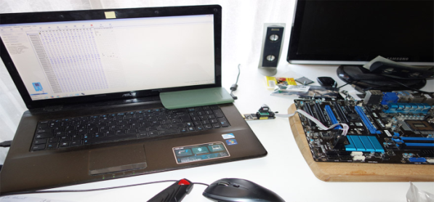
Fig. 3.22 Bios Programming
Necessary Material:
1. Hot air welding station
2. Soldering kit with a fine head, including a desoldering wick, tin wire .
– a soldering kit with a fine head, including a desoldering wick, tin wire.
Equipment and machines used in the training unit
The training department of the organization consists of different machines and equipment which are used to achieve the training aims and objectives.
I. EPROM Programmer
II. Soldering Iron
III. Hard Drive (HDD) external connector
IV. Multimeter
Soldering iron: A soldering iron is a hand tool used in soldering. It supplies heat to melt solder so that it can flow into the joint between two work pieces.
A soldering iron is composed of a heated metal tip and an insulated handle. Heating is often achieved electrically, by passing an electric current (supplied through an electrical cord or battery cables) through a resistive heating element.
Soldering lead is a fusible metal alloy used to create a permanent bond between metal work pieces. It must be melted to adhere to and connect the pieces together.
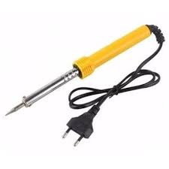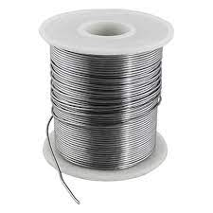
Fig. 3.26 Soldering iron Fig. 3.27 soldering lead
SATA connector: It is used for connecting an external hard drive with a computer for data sharing.
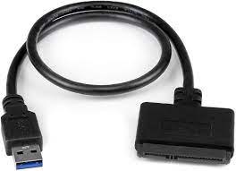
Fig. 3.28 SATA connector
Multimeter: A multimeter is a measuring instrument that can measure multiple electrical properties. A typical multimeter can measure voltage, resistance, and current, in which case it is also known as a volt-ohm-millimmeter (VOM), as the unit is equipped with voltmeter, Experience Gained and Work Done in the Training Department
- I was introduced to the parts of computer system, internal structure of a computer system, the motherboard architecture, and peripherals.
- I was taught some computer engineering’s project and resources management strategies, negotiation.
- I participated actively in a team of interns that procured hardware components of some laptop computers for replacement and fixings.

3.6 Computer Networking
A computer network is a system in which multiple computers are connected to each other to share information and resources.
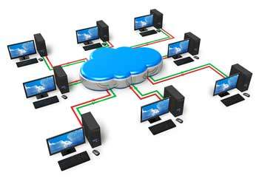
Fig. 3.31Computer networking
Characteristics of a Computer Network
- Share resources from one computer to another.
- Create files and store them in one computer, access those files from the other computer(s) connected over the network.
- Connect a printer, scanner, or a fax machine to one computer within the network and let other computers of the network use the machines available over the network.

3.7 Disassembling and Assembling A Laptop Computer
The computer system is made up of following external devices:
- CPU cabinet
- Monitor
- Keyboard
- Mouse
- Printer/scanner (if attached)
However, the techniques of assembling and disassembling a computer system differ from a computer’s type and model to the other. I was taught how to disassemble and assemble both laptop and desktop computer of any model, but some techniques that are peculiar to laptop computers only are explained here.

3.6 Computer Motherboard
A motherboard (also called main board, main circuit board, or mobo) is the main printed circuit board (PCB) in general-purpose computers and other expandable systems. It holds and allows communication between many of the crucial electronic components of a system, such as the central processing unit (CPU) and memory, and provides connectors for other peripherals. Unlike a backplane, a motherboard usually contains significant sub-systems, such as the central processor, the chipset's input/output and memory controllers, interface connectors, and other components integrated for general use.
MOTHERBOARD AND MICROPROCESSOR DIAGNOSTIC TESTS
The motherboard and processor are two of the most important hardware components inside the computer. The various pieces of hardware inside the PC communicate with one another through the circuits on the motherboard, while the CPU stores and executes programming instructions. However, they can malfunction at any point in time. Diagnosing a defective motherboard or CPU isn't an exact science, however, as most hardware components exhibit similar symptoms when failing. The following are simple techniques in diagnosing a computer motherboard for faults:
- Turn off the computer
Turn off the computer. Disconnect the power cable from the back of the PC. Unscrew and remove the cover from the case.
- Touch a bare metal surface
Touch a bare metal surface, such as the computer chassis, to ground yourself.
- Turn on the computer
Reconnect the power cable and then turn on the computer. Listen to the internal speaker for a sequence of beeps (call beep codes) that the motherboard produces when the system detects a problem with a critical hardware component.
- Navigate to motherboard manufacture’s website
Open a browser and navigate to the motherboard manufacturer's website. Look up the motherboard model and review the documentation for the component to find out which device is responsible for the beep code, if applicable.
Turn off the computer
Power off the computer if the PC fails to emit a beep code. Disconnect the power cable and all peripheral components connected to the rear of the PC.
- Uninstall hardware
Uninstall all hardware from the computer except for the motherboard, CPU, power supply, hard drive and video card.

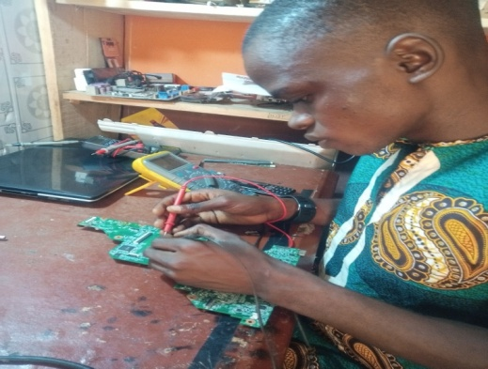

Fig. 3.40image of an intern troubleshooting a laptop motherboard

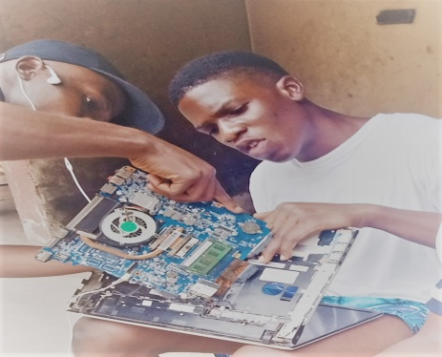
Fig. 3.42 Image of Interns disassembling a laptop computer system

Experience Gained and Work Done in the Training Department
- I actively participated in troubleshooting, and repair faults on laptop motherboards. This involves the tracing faults on a motherboard with the aid of the motherboard architectural diagram using a digital multimeter, DC power supply etc.,
- RAM module, keyboard, mouse pad, battery etc. of any model of a computer system, formatting and installing operating systems and fundamental software and rectification of software glitches on both laptop and desktop computers.
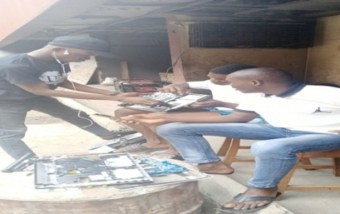
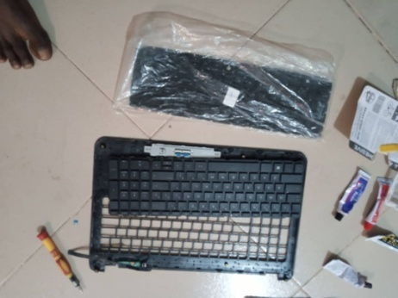
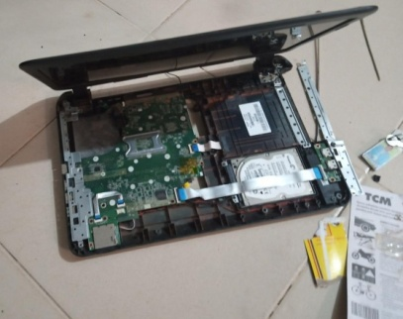
Fig ‎0.43 Image of internsassembling a laptop computer system

Replacement and fixing of hardware components of a laptop computer system Image of a laptop keyboard replaced

CHAPTER FOUR

THE EQUIPMENT

4.1 Introduction
This chapter entails the equipment used, the functions of the equipment used and the descriptions of their usage while this attachment at YEMTECH CYBER WORLD, Ibadan. The equipment used are as follow.
1. Oscilloscope
2. DC power supply
3. Rework station
4. Personal protective equipment (PPE)
5. Multi-meters and Clamp meters
6. Operating system (OS) Installation Flash drive and Hard drives
7. Allen key and a set of screw drivers
8. Light testers

4.2 DC power supply
ADC power supply, also known as a bench power supply, is a type of power supply that gives direct current (DC) voltage to power a device. A DC power supply management subsystem can use AC, DC, battery, or ultralow voltage as inputs. They generate the output power by converting an input signal into an output signal (in this case, a DC output).
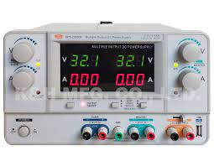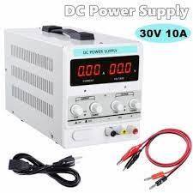
‎0.1DC power supply

CHAPTER FIVE

SUMMARY, CONCLUSIONS AND RECOMMENDATIONS

5.1 Summary and Conclusions
The whole experience gained during the attachment at PC AID was very enlightening. The practical skills we were exposed to and the opportunity to relate with typical situations relating to computer engineering industry. These experiences have successfully broadened my understanding and interest in Electrical and Electronics Engineering as a profession especially in the field of Control and Automation engineering.
The training was worthwhile, has it accorded me the privilege of gaining insight into job preparation as well as what it meant to carry out proper inspection and also working condition under stress which in a way prepares undergraduates for the outside world after school.

5.2 Problem Faced During SIWES Program
Some the problems experienced during the SIWES program. These are as stated below;
1. Limited orientation before starting the program.
2. There is also difficulty in getting a placement since placement letter was not issued on time.

3. The workload is too broad to the extent that engineers were unable to explain the importance of work done on particular equipment to me as well as how it relates to the theoretical knowledge gathered.

