

TECHNICAL REPORT ON
THE STUDENT INDUSTRIALWORKS EXPERIENCE SCHEME (SIWES)

HELD AT

OLOHUNWA ELECTRICAL CONTRACTOR
PRESENTED BY
TIJANI ABDULMUIZ
ND/23/EEE/PT/0062

SUBMITTED TO:
DEPARTMENT OF ELECTRICAL /ELECTRONIC ENGINEERING,
INSTITUTE OF TECHNOLOGY [I.O.T.]
KWARA STATE POLYTECHNIC, ILORIN.

IN PARTIAL FULFILLMENT OF THE REQUIREMENT FOR AWARD OF NATIONAL DIPLOMA (ND) CERTIFICATE IN ELECTRICAL/ELECTRONICS ENGINEERING

AUGUST TO NOVEMBER 2023

DEDICATION
This report is dedicated to allah Almighty for His boundless grace, consistent love, immeasurable faithfulness, and for sparing my life throughout the duration of my SIWES program. It is also dedicated to my parents, Mr. and Mrs.TIJANI, for their unwavering support and immeasurable assistance throughout the entire exercise, as well as to my beloved friends who always trigger me to be strong.

ACKNOWLEDGEMENT

I wish to register to my profound gratitude to allah Almighty for the guidance and grace throughout my life.
I'm appreciative to olohunwa electrical contractor
complete crew for making my industrial training exciting, instructive, and beneficial.
My special gratitude goes to my boss and mentor, Engr. bashir., for his effort to see that this work saw the light of day. I appreciate my supervisor, and also my amazing lecturers for their seasoned lectures. To them all, I say thank you.
As a final note, I'd like to extend a special thank you to a few of my many friends, I want to thank everyone for their concern, financial assistance, and words of support during my program. I love you everyone, and I hope you live long and fulfill your desires.

PREFACE
The student industrial work Experience scheme (SIWES) helps in exposing students to the practical application of their course and to get used to equipment and machine that are utilize in the factory. The SIWES was established to promote student ability and skill in industrial Practice and pre-expose them to working experience in industrial settings.
The SIWES program covered a period of four month from September to December 2023 and it is a partial fulfillment of a two year academic program to obtain an OND certificate in Engineering. The report explains the description of the work here.

TABLE OF CONTENT
TITLE PAGE i
DEDICATION ii
ACKNOWLEDGEMENT iii
PREFACE iv
TABLE OF CONTENT
CHAPTER ONE
  - INTRODUCTION 1
  - BACKGROUND 1
  - OBJECTIVE 1
CHAPTER TWO
2.0 LOCATION AND BRIEF HISTORY OF THE ESTABLISHED 2
CHAPTER THREE
3.0 ELECTRICAL TOOLS AND INSTRUMENT 3
3.1 USES OF THE TOOLS AND INSTRUMENT 3
3.2 MAINTENANCE OF THE TOOLS 5
3.3 SOME SAFETY PRECAUTIONS IN ELECTRICAL 5
3.4 WIRING SYSTEM 5
3.5 MATERIAL NEEDEDFOR ELECTRICAL INSTALLATION 6
3.6 TYPES OF WIRINGSYSTEM. 7
3.7 SURFACE WIRING SYSTEM 8
3.8 CONDUIT WIRING SYSTEM 8
3.9 TYPES OF CONDUIT WIRING SYSTEM 8
3.9.1 HALF CONDUIT WIRING SYSTEM 8
3.9.2 FULL CONDUIT WIRING SYSTEM 8
3.10 LAYING OF CONDUIT PIPE. 9
CHAPTER FOUR
4.0 RELEVANCE OF THE EXPERIENCE GAIN AT STUDENT FIELD OF STUDY 11
CHAPTER FIVE
5.0 CONCLUSION AND RECOMMENDATION 12
5.1 CONCLUSION 12
5.2 RECOMMENDATION 12

CHAPTER ONE
- INTRODUCTION
Student industrial work experience (SIWES) is a program organized by industrial training found (ITF) purposely to improve practical knowledge of the students in an institution. Also to expose them to a various equipment and their uses in their field of studies. Due to the fact that only theory aspect of their course are covered throughout the semester. Meanwhile, SIWES program is brought to the student in other to expose them to different type of machine and tools as well as their uses in their respective field of studies.
1.1 BACKGROUND
The Student’s Industrial Work Experience Scheme (SIWES), was introduced in 1973 by the Industrial Training Fund (ITF), and the institution established federal government of Nigerian to carry training programmed for students in institution the country.
Student’s Industrial Work Experience Scheme (SIWES) is under the National Board for Technical Education (NBTE). It was established by ITF (Industrial Training Fund) to solve the problem of lack of adequate skills preparatory for employment in industries by Nigerian graduate of tertiary institution.
1.2 AIMS AND OBJECTIVE OF SIWES
The program, Student’s Industrial Work Experience Scheme (SIWES) is designed for student’s most especially technical student to expose them to the industrial technical require in their various field of study’s.
- To facilitate the students towards a full potential.
- To prepare students for future ambition.
- To enable students to be self-employed.
- To make students to practically oriented.
- To enhance qualified education in all tertiary institution.
- To enable students to have more knowledge in their area of specialization.
- To help students to put theoretical aspect of knowledge gained in their various course in practical.
- To contribute immensely to the attribute of qualified students.

CHAPTER 2
1.1 LOCATION AND BRIEF HISTORY OF ESTABLISHMENT
olohunwa electrical contractor (registered on 31" October 2012) was fully incorporate with Corporate Affairs Commission (CAC) in Nigeria on 18th day of May, 2015 to carry on business as Engineers whether Electrical, Mechanical, Information Technology, Building Contractors, General Contractors and in other areas as specified in the Memorandum of the Association.
A Nigerian Company committed to excellent professional practices olohunwa electrical contractor is noted for timely and quality job delivery. This is made possible by the caliber of staff engaged in the services of the company and also by the belief of the company in continuous staff development which has also made the company relevant in time and trends in today's technology. Our results speak for us.
So far, olohunwa electrical contractor has achieved a good measure of success in the Manufacturing and Construction Industries and have several projects to her credit. Some of these projects were executed in the areas of: Industrial Distribution panels design and construction for Private, Hotel and Hospital Buildings, Electrical/Mechanical Services Design and Supervision, Vehicle Tracking Installation for both private and official vehicles.

CHAPTER THREE
3.0 ELECTRICAL TOOLS AND INSTRUMENTS
Electrical Engineering make use it different instrument in performing different operations.
Some of the instruments used are listed below:
- Screw driver
- Meter Reading
- Bender spring
- Cooker control unit
- Gloves
- Pliers
- Hammer
- Neo Tester
- Fishing tape
- Hack saw
- Center punch
- Bench vice
- Spanner
- Soldering iron
- Safety belt
- Cutting pliers
- Multi meter
3.1 USES OF ABOVE TOOLS AND INSTRUMENTS
- Screw Driver: it is used for loosing and tightening screw.
- Meter Reading: A Meter Reader has many responsibilities, such as inspecting meters, collecting and documenting meter readings, and communicating with customers when needed to gain access to thei r meters.

- Bending spring: it is made up of spring, it is used in Bending PVC pipe when working von conduit wiring system.
- Cooker control unit: The cooker control unit serves several important purposes in a kitchen or any environment where an electric cooker is installed
- Gloves: it is used to guide against Electrical and mechanical damages to hands.
- Pliers: it is used for cutting, disconnecting or removing installation material like rubber from a conductor. It is also used to hold material firmly in order to couple the material.
- Hammer: it is used for clipping cable to a surface.
- Tester: it is used to check whether a conductor is live. It is also used to detect the flow of current in a conductor
- Fishing tape: it is used in passing wire into PVC pipe when working on conduit wiring system.
- Hacksaw: it is used for Cutting metal and PVC pipe when working on conduit wiring system.
- Center punch: it is used for making point on metal or concrete blocking before drilling.
- Spanner: for tightening and losing hexagonal headed bolt ad nuts.
- Soldering iron: for soldering cable conductor joints.
- Water heater: Water heaters serve the primary purpose of heating water for various domestic and commercial applications..
- Cutting pliers: for Cutting conductors
- Voltmeter: it is used for measuring the amount of voltage that passes through a cable.
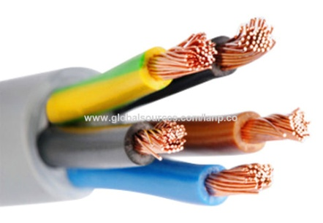
- Multi meter: is an instrument designed to measure electric current, voltage and usually resistance, typically over several range of value.

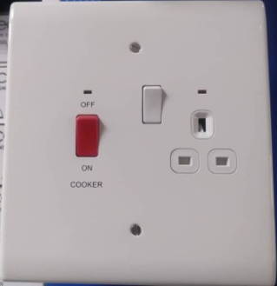
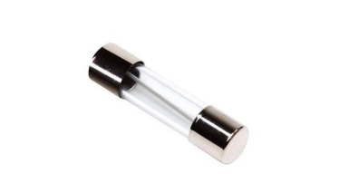

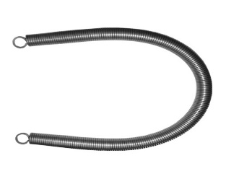
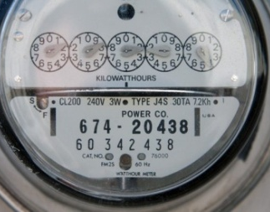
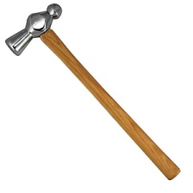

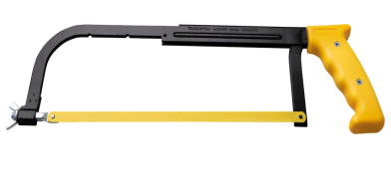

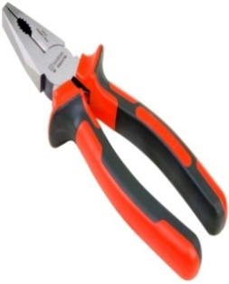
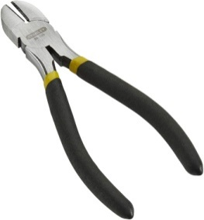
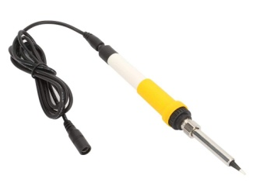

3.2 MAINTENANCE OF THE TOOLS.
The maintenance are listed below.
- It should be check regularly.
- It should not be exposed to rain.
- Store the tools in a cool, dry area both before and after use.
- Make use of the right tool for the right Job
3.3 SOME SAFETY PRECAUTIONS IN ELECTRICAL INSTALLATION.
- Instead of contacting the conductor directly, use a tester to check its polarity.
- Operating electrical equipment you are unfamiliar with can be dangerous.
- When installing on live cable, always remove the fuse first.
- Always utilize the proper tools for the work at hand. Since using the wrong tools could cause an accident.
- When using a ladder, make sure it is positioned correctly to prevent it from collapsing.
3.4 WIRING SYSTEM.
When choosing a system of wiring from a building, the following point must be put into consideration:
- Neatness of the final work: To determine whether a building's preferred wiring system will work for it.
- Cost of installation: is an important factor to take into account when selecting a wiring system because a client may want to wire his or her building in fill conduit because of the neat appearance but may not be able to afford the cost by the time he or she sees the estimated cost of the wiring.
- The installation's durability: if a certain wiring choice was made considering the risk of usage or whether it would survive as long as anticipated. A surface PVC encased wire, for instance, poses a risk to a metalworking business.
- Future augmentation and modification: A wiring system must support growth in the future. Concealed conduit wiring is not a viable choice for factory installation, which is regularly expanded.
- Future addition and modification: One must make sure that a wiring system will allow for future expansion. For factory installation, which is frequently extended, concealed conduit wiring is not a good option.
- Time required to finish the wiring: if, for this reason, the time allotted for completion does not fail, specific urgent jobs are being awarded by the government.

3.5 MATERIAL NEEDED FOR ELECTRICAL INSTALLATION
- Cable: A length of insulated single conductor (solid or stranded) or of two or more such conductor, each provided with its own insulation, which are laid up together.
- PVC sheathed cable: A cable of which the conductor Insulation and mechanical protection is of polyvinyl- chloride.
- Cable trunking: A cast for cables constructed of metal sheet, wood or insulating materials and may be of rectangular or square cross section of which one side is removable or binged for the whole of its length for the purpose of laying cable there in.
- Circuit breaker: a mechanical device use for making and breaking a circuit both under normal and abnormal condition, such as those of a short circuit being broken automatically.
- Consumers control unit: it is a distribution board inco-operating a main switch or main circuit breaker within it sunit.
- Distribution board: is a component of an electricity supply system that divides an electrical power feed into subsidiary circuits while providing a protective fuse or circuit breaker for each circuit in a common enclosure
- Earth continuity conductor: this is the earth wire that connect the earth terminal on a apparatus to the earth rod.
- Earth electrode: a metal rod or rods metal plate or may having effectual connection with the general mass of the earth.
- Fuse: it is a device for opening a circuit by means of a conductor designed to melt when an excessive current flows. It consists of two part, the base and the bridge.
- Installation of conductor: it is a suitable non-conductor material enclose surrounding or supporting a conductor.

MATERIAL USED IN ELECTRICAL INSTALLATION
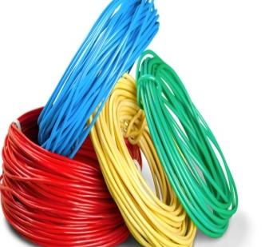
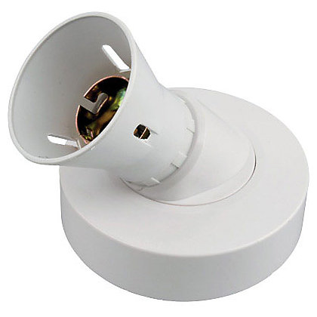

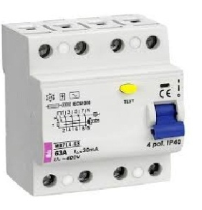
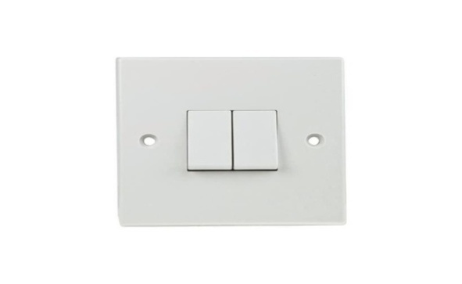

3.6 TYPES OF WIRING SYSTEM
1. Surface wiring system
2. Trunking wiring system
3. Conduit wiring system

3.7 SURFACE WIRING SYSTEM
PVC encased wiring on surface is a method of wiring that uses PVC insulated cable put out in a flat arrangement with a tight covering of PVC to provide mechanical protection since there is no metal sheath. To act as the conductor for the earth continuity, a bare conductor will be used as the twin and an earth wire will be covered in PVC.
SOME OF THE MATERIALS USED FOR SURFACE WIRING SYSTEM
- Plastic box (3x3, 3x6)
- Joint box
- Ceilings rows
- Lamb holder
- Cable
- Clip and nails
3.8 CONDUIT WIRING SYSTEM
It is laying of PVC pipe inside the block for passing wire and cables to the load.
SOME OF THE MATERIALS USED FOR CONDUI WIRING SYSTEM
- Iron box ( 3x3, 3x6)
- Pipe (20mm, 25mm)
- Wall bracket box (“U” way, “Y” way, and “four” way)
3.9 TYPES OF CONDUIT WIRING SYSTEM.
- Half conduit system wiring.
- Full conduit system wiring.
3.9.1 HALF CONDUIT WIRING SYSTEM.
This wiring scheme calls for putting PVC tubing within the block and on the ground, which uses less money and resources.
3.9.2 FULL CONDUIT WIRING SYSTEM.
This wiring technique calls for the installation of PVC pipe inside concrete blocks, on the floor, and even inside the ceiling, so that no cable will protrude or be visible from the outside. It requires more resources than a half conduit, but it looks better for clients who are well-informed.
3.10 LAYING OF CONDUIT PIPE
Good conduit work can only be achieved when there is good PVC pipe laying.
The following point will assist Electricians in this field.
- PLANNING THE LAYOUT: The following point should be considered before starting the actual layout:
- i. The structure should be carefully examined (to determine if it is a shop or cottage).
- Draw your layout.
iii. Verify that the consumer's requirements are stated properly in the architect's drawing.
- MARKING OUT: During the marking out, the following procedure should be taking.
- Position of the distribution board.
- Position of the boxes for switches, sockets, cookers, etc. should be clearly marked.
The marking out can be done by using chalk to mark
Channel and cutting bricks or concrete: After the marking out of the building, the next thing is to use chisel or hammer to cut or channel the bricks in order to put conduit pipes inside the bricks.
- Preparing the conduit: conduit pipes comes in length, they should be cut to size with hacksaw having a fine tooth blade. It should be cut in a pipe vice. Preparing the conduit pipes will also involve bending of the conduit pipes depend on the type of conduit being installed which may be heavy or light gauge conduit, full or half PVC pipe laying system.
Size and cable used in an Electrical installation:
S/N | SIZE OF CABLE | USES
i. | 1.5mm | For lighting
ii. | 2.5mm | For socket of 13Amps and 15A
iii. | 4mm | For AC and Cooker control unit

GRADE AND CABLE IN AN ELECTRICAL INSTALLATION
S/N | SIZE OF CABLE | CURRENT RATING E
 | 1.mm² | 10A
 | 1.5mm² | 13A
 | 2.5mm² | 18A
 | 4mm² | 24A
 | 6mm² | 30A
 | 10mm² | 40A
 | 16mm² | 55A
 | 25mm² | 70A
 | 35mm² | 900A
 | 50mm² | 140A

TYPES OF SWITCHS THAT WE HAVE:
- One Gang switch.
- Two Gang switch.
- Three Gang switch.
- Four Gang switch.
TYPE OF SOCKETS THAT WE HAVE:
- 13A (3x3 for single socket and 3x6 for double socket).
- 15A (3x3 for single socket and 3x6 for double socket).

CHAPTER FOUR

4.0 RELEVANCE OF THE EXPERIENCE GAIN AT STUDENT FIED OF STUDY.
In summary, this program has exposed me to some practical aspect in relation to my course of study (Electrical Engineering) and I benefited greatly in the program. What I learnt at various sites involves the following
- Wiring installation system.
- Type of work suitable for installation
- Typed of wiring system
- Tools suitable for electrical installation

CHAPTER FIVE
5.0 CONCLUSION AND RECOMMENDATION
5.1 CONCLUSION
My exposure to and training in the field of electrical and electronic engineering have both benefited from the SIWES program. It has also aided me in applying the new information I have learned in the classroom to real-world professional experience. A critical and practical attitude to problems and their solutions in the electrical area should also be developed.
5.2 RECOMMENDATION
All students at the polytechnic should be required to take it, as the curriculum involves both practical and theoretical experience. SIWES program is such a program that exposes student to the practical aspect of what he/she had been taught theoretically at school.

