

TECHNICAL REPORT ON STUDENT INDUSTRIAL WORK EXPERIENCE SCHEME (SIWES)

HELD AT:

SHERIFF ELECTRICAL ELECTRONIC WORKS
NO. 1, EMIR’S ROAD NIGER JUNCTION ILORIN KWARA STATE

BY

ISMAIL FARUK UMAR
MATRIC NO: ND/23/EEE/FT/0037

SUBMITTED TO:

DEPARTMENT OF ELECTRICAL/ELECTRONIC ENGINEERING
INSTITUTE OF TECHNOLOGY (I.O.T)
KWARA STATE POLYTECHNIC, ILORIN
P.M.B. 1375 ILORIN, KWARA STATE

IN PARTIAL FULFILLMENT OF THE REQUIREMENT FOR THE AWARD OF NATIONAL DIPLOMA (ND) CERTIFICATE IN ELECTRICAL AND ELECTRONIC ENGINEERING

AUGUST – DECEMBER, 2024.
DEDICATION
This report work is dedicated to the Almighty Allah, the Most beneficent and Most merciful. The one who make me whom I am today, also to all the staff of Sheriff Electrical Electronic Works.

ACKNOWLEDGMENT
What I am now is by the grace of the Almighty God, who is able to do all things and make me to excel abundantly above in all I ask and think, according to the power that works in me unto him the glory and domination.
The success of this report however would not have been possible without the invaluable support, assistance and encouragement of a large number of people who are too numerous to mention.

PREFACE
Student industrial work experience scheme is geared towards educating and giving the participant i.e. the student to the practical aspect of the academic discipline and course he or she is pursuing.
This technical report is based on all the training acquired by me during the course of my industrial attachment the attachment lasted for four months (August – December, 2024)
This program is organized for all engineering and technological students of higher institution of leaning, is a sure way of achieving the guest for technological and self reliance in a country like ours where the need for technological advancement cannot be over emphasized.
My acquired experience on this industrial work which I did at Sheriff Electrical Electronic Works has given me insight into the course of my study. It has exposed me and given me the knowledge about the various types of electrical and inverter installation and some work techniques, whose operational techniques work only, but theoretically explained in our lectures in class. I want to appreciate the national board of technical education for the introduction of the student industrial work experience scheme programme to the higher institution to prepare us for a better future.

ABSTRACT
This report cover the systems of electrical installation the types of electrical installation system, such as surface wiring system, trunking wiring system and conduit wiring system, the tools and instruments used and their uses, various types of materials used in electrical installation including the cable to be use and various things to consider before the electrical installation of a building. Inverter installation and all the materials needed for the installation

TABLE OF CONTENTS
Title i
Dedication ii
Acknowledgment iii
Preface iv
Abstract v

CHAPTER ONE
1.0 Introduction 1
1.1 Definition of SIWES 1
1.2 Specific Aims of SIWES 1
1.3 Objective 2

CHAPTER TWO
2.0 Brief History of the organization 3
2.1 Organization chart 3

CHAPTER THREE
3.1 Electrical Tools and Instruments 4
3.2 Uses of the above tools and instruments 5
3.3 Maintenance of the tools 7
3.3 Some safety precaution in the electrical installation 7
3.5 Definition of electrical terms used in electrical installation 8
3.6 Wiring system 12
3.7 Types of wiring system 13
3.8 Surface wiring system 14
3.9 Conduit wiring system 15
3.10 Types of conduit wiring system 15
3.11 Half conduit system wiring 15
3.12 Full conduit system wiring 15
3.13 Laying of conduit pipe 15
3.14 Trunking wiring type 18

CHAPTER FOUR
4.0 Relevance of the experience gained at students field of study 19
4.1 Interpersonal Relationship with the organization 19

CHAPTER FIVE
5.0 Conclusion and Recommendation 20
5.1 Conclusion 20
5.2 Recommendation 20

CHAPTER ONE
1.0 INTRODUCTION
Student industrial work experience scheme (SIWES) programmed, it was establish in year 1973 by Federal Government of Nigeria through the Industrial Training Fund (ITF) under the NTBE (National Board for Technical Examination). It has it’s headquarter in Jos Plateau State. The major reason behind the establishment of SIWES programmed and the importance of the student to display their talents and also learn the practical aspects of their fields of study. After their graduation, they will have something valuable to contribute to the society. They will also be able to face future challenges in their respective field of study.
1.1 DEFINITION OF SIWES
SIWES, means student industrial training work experience scheme, it is a course by which student are expose to practical training in their respective field of study. SIWES is the acceptable skill training program set up as the requirement for the award of national diploma ( N. D ) certification for studying engineering and applied science. Its efforts is to bridge the gap existing between theory and practical aspect of engineering and some applied science.

1.2 SPECIFIC AIMS OF SIWES.
- It enable the industrial to be able to recruit graduates to the post appropriate to their background, training and the orientation during the change over from student to work status.
- To be introduced to as wide a range of industrial skills as much as possible.
- To enable trainee student become familiar with the organization and control of the industries similar to where they are likely to work after graduation.
1.3 OBJECTIVES
Specifically, the objectives of the students industrial Work Experience Scheme are to provide an avenue for students in Nigeria Tertiary Institutions to acquire industrial skills and experience in their course of study.
- it prepares student towards the challenge they might likely encounter in their field of study
- it prepares student about the future work themselves
- it gives the experience and additional opportunity about their filed of study
- it makes student to be practically oriented

CHAPTER TWO
2.0 BRIEF HISTORY OF THE ORGANIZATION
Sheriff Electrical Electronic Works has experience in electrical wiring installation and Electronics repairs especially in house and office. He has been a Technician for many years, he has many apprentice under his company he trained many SIWES/IT students.
2.1 ORGANIZATION PROFILE
Managing Director
Supervisor

Student Workers SIWES

CHAPTER THREE
3.0 WORKDONE
3.1 ELECTRICAL TOOLS
Electrical Engineering makes use of different instrument in performing different operations.
Some of the tools used are listed below:
- Screw driver
- Bending spring
- Gloves
- Pliers
- Hammer
- Tester
- Fixing tape
- Hack saw
- Centre punch
- Bench vice
- Spanner
- Soldering iron
- Safety belt

3.2 USES OF THE ABOVE TOOLS
- Screw Driver - it is used for loosing and tightening screw.
- Bending Spring – it is made up of spring, it is used in bending PVC pipe when working on conduit wiring system.
- Gloves –it is used to guide against electrical and mechanical damages to the hands.
- Pliers – it is used for cutting, disconnecting or removing installation material like rubber from a conductor. It is also used to hold material firmly in order to couple the material.
- Hammer – it is used for clipping cable to a surface.
- Tester – it is used to check whether a conductor is live. It is also used to detect the flow of current in a conductor.
- Fixing Tape – it is used in passing wire into PVC pipe when working on conduit system wiring.
- Hacksaw – it is used for cutting metal and PVC pipe when working on conduit wiring system.
- Center Punch – it is used for making point in metal or concrete blocks before drilling.
- Bench Vice -for Viking metals for the purpose of cutting or threading.
- Spanner – for tightening and losing hexagonal headed bolt and nuts.
- Soldering Iron – for soldering cable conductor joints.
- Safety Belt – for prevention and holding the body when climbing concrete poles.
- Cutting Pliers – for cutting conductors
- Raw plug Drill – for forming holes inside the block or concrete.






Hack Saw
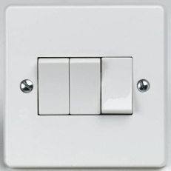
Clipping Hammer
Nose pliar

Screw driver
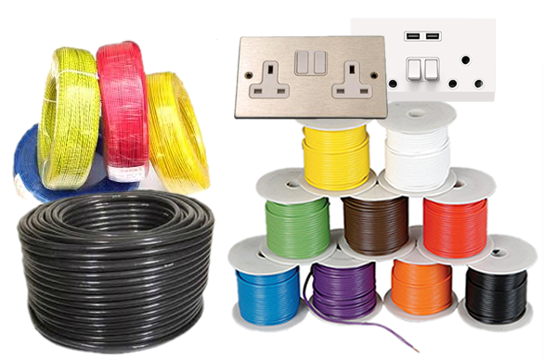
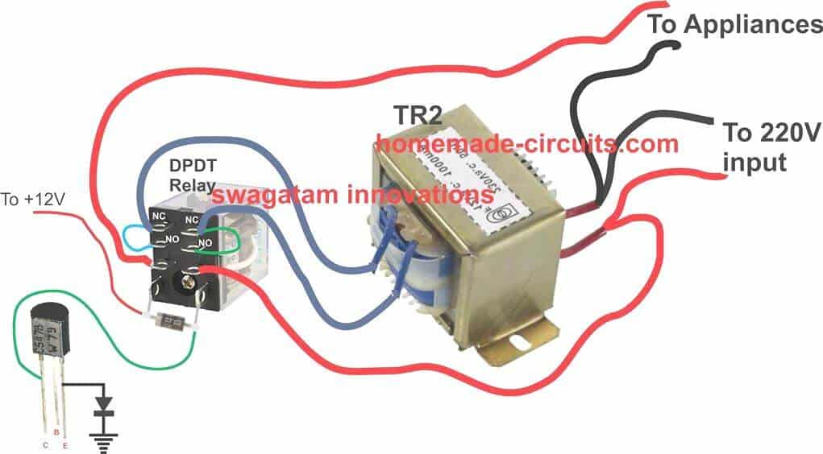



3.3 MAINTENANCE OF THE TOOLS.
The maintenance are listed below.
- Keep the tools in cool and dry place.
- It should be check regularly.
- It should be kept away from rain.
- It should be taking away from in sting.
3.4 SOME SAFETY PRECAUTION IN ELECTRICAL INSTALATION.
- Always put on your overall when in workshop or any place of work.
- Always remove the fuse when carrying out installation on live cable.
- Test the conductor polarity by means of tester not by touching it ordinarily.
- It is dangerous to operate electrical machine you are not familiars with.
- Spark from switch cause serious burns.
- Always use correct tools for all jobs. Since incorrect tools used can result in accident.
- When using ladder, ensured that it is placed properly to avoid it from falling down.
- When working on concrete pole with ladder, ensure safety belt is used to hold the body when working.
3.5 DEFINITION OF MAJOR TERMS USED IN ELECTRICAL INSTALLATION
- Accessory:- Any device, other than a lighting fittings associated with the wiring and current using appliance of an installation for example a switch, a Fuse, a Lamp holder, or a plug.
- Apparatus:- This include all machines, Electric fitting that use conductors for connections. For Example Electric motor, Fluorescent fittings; Television.
- Appliance:- Any device which use Electricity for particular purpose, excluding fighting fitting or independent motor, for Example, Radio, Cooker, or Electric Iron.
- Cable:- A Length of insulated single conductor (Solid or stranded), or of two or more such conductor, each provided with its own insulation, which are laid up together.
- Circuit Breakers:- A mechanical device for making and breaking a circuit both under normal and abnormal condition, such as those of a short circuit being broken automatically.
- Consumers Control Unit:- It is a distribution board incorporation a main switch or main circuit breaker within its unit.
- Consumer Terminals:- This is the point of a consumers installation where the services of the supply is connected.
- Fuse:- It is a device for opening a circuit by means of a conductor designed to melt when an excessive current flows. Its consists of two parts, the base and the bridge.
- Installation of Conductor:-It is a suitable non-conductor material enclosing surrounding or supporting a conductor.
- Joint Box:-A Box forming part of wiring of an installation (usually surface) provided to contain joints in the conductor.
- Junction Box:-A box connecting two or more length of conductor or trunking appliance.
- Length of Run:- For the purpose of the table of current rating and volt drop, the length of run is the point -to- point distance measured along the route taken by the cable.

3.6 WIRING SYSTEM.
When choosing a system of wiring from a building, the following point must be put into consideration:
- Neatness of the finished jobs:-To see if a particular wiring system if choosing a for a building will not be eyes sure.
- Time required to complete the wiring:- That is, if therefore length of time that is allocated for the completion will not fail, particularly urgent jobs being allocated by government .
- The durability of the installation:- If a particular wiring chosen withstanding the hazard condition of usage or will last long as expected of the installation. For Example, a surface PVC. Sheathed wiring will prove hazardous to a metal workshop.
- Future Extension and Alteration:- One must ensure that a system of wiring will give room for future addition. For Example, a concealed conduct wiring will not be suitable for factory installation which is often subjected to extension.
- Drainage to the fabric of the building by cut away:- For Example, it will be better to wire a completed multi-storey building in surface wiring than concealed conduct which may weaken the wall and pillars when chiseled to form channel.
3.7 TYPES OF WIRING SYSTEM
- Surface Wiring
- Conduit wiring
- Trunking Wiring
During the course of my Siwes programme, I was fully taught about surface wiring, PVC pipe laying, and trunking wiring system. Based on this report, I will explain widely on the three.
3.8 SURFACE WIRING SYSTEM
This is the system of wiring by which is called PVC sheathed wiring on surface, this involve the use of PVC insulated laid up in flat formation with a close covering of thought PVC as mechanical protection since there is no metal sheet. A bare conductor as in twin and earth cable will be enclosed in PVC sheet to serve as the earth continuity conductor.
It is the most commonly used cable in Nigeria for domestic wiring. It can be used for surface wiring without further mechanical protection.
It should not be installed where it can come in contact with gas pipe, water pipe or other metal work.
The accessories used for this type of wiring are joint boxes, tumbler switch or way gang switch with pattresses, clips, wire, nails, wood screws, to mention a few. The cable for this wiring can be run over ceiling and under flour but because the temperature limitation is 650c, it should be run over ceiling desert area as the cable sheath may melt.
3.9 PVC PIPE LAYING SYSTEM
It is laying of PVC pipe inside the blocks for passing cables for conduit wiring.
3.10 TYPES OF PVC PIPE LAYING SYSTEM.
- Half conduit system wiring.
- Full conduit system wiring.
3.11 HALF CONDUIT SYSTEM WIRING
This system of wiring it require laying for PVC pipe inside the block and on the ground, it require less cost and less materials.

3.12 FULL CONDUIT SYSTEM WIRING.
This is the system of wiring by which it require laying of PVC pipe inside concrete blocks, on the ground and including the inside of the ceiling such as that there won’t be a space for cable to be showing or to be seen outside. It require more cost than the half conduit system of wiring, it is require more materials than the half conduit, its more well presentable for the well wise customers.
3.13 LAYING OF PVC PIPE
Good conduit work can only be achieved when there is good PVC pipe laying.
The following points will assist Electricians in this field.
- PLANING THE LAYOUT:-The following point should be considered before starting the actual layout.
- The Building should be studied property (e.g if it is bungalow).Draw your layout.
- Make sure the consumer has a requirement clearly before started in the architects drawing.
- MARKING OUT:-During the marking out, the following procedure should be taking.
- Position of the boxes for Switches, Sockets, Cooker, etc. should be clearly marked.
- Position of the Distribution Board.
The laying cannot be done by using chalk to make marks and lines as following.
- Channeling and cutting bricks or concrete: After the marking out of the building, the next thing is to use chisel or hammer to cut or channel the bricks in order to put conduit pipes inside the bricks.
- Preparing the conduit:- Conduit comes in length, length should be cut to size with hacksaw having a fine tooth blade. It should be cut in a pipe vice. Preparing the conduit will also involve bending of the conduit depending on the type of conduit being installed which may heavy or light gauge conduit, full or half pvc pipe laying system.
- Piping of the channeled Bricks:- After the cutting and bending of conduit to desire length, the next thing is to put the conduit pipe inside the channeled bricks, floor or concrete.
- Gumming and Dressing of the Channeled Bricks:- After the piping of the channeled brick and dress it to it normal position.
Size and Cable Used in an Electrical Installation:

S/N | SIZE OF CABLE | USES
i. | 1.5mm | For lighting
ii. | 2.5mm | For Socket of 13Amps and 15A
iii. | 4mm | For AC and Cooker Control unit
iv. | 6mm | For Cooker Unit
v. | 10mm | For meter and distribution board
vi. | 16mm | For Servicing Building

TYPE OF SWITCH THAT WE HAVE:-
We have different type of switch as follow:
- We have One Gang Switch.
- We have Two Gang Switch.
- We have Three Gang Switch.
- And we also have Four Gang Switch.
HOW TO CONNECT INDICATOR RING.
Indicator ring is the system of a ring that we use to detect an Electricity using mechanical motor machine, Such as (GENERETOR).

3.14 SOLAR POWER SYSTEM.
Solar power system is the process by which we can generate heart of any solar photovoltaic system, is the solar of the photovoltaic module which transfers light energy to electricity. A standard module has a number of Silicone Crystalline/or amorphous cells connected in series/parallel configuration to get the required voltage/current.
A number of such modules are connected in series/parallel combination to get the required power out-put.
Photovoltaic systems use high efficiency modules for the best performance and value of money.
The uses of solar power system involve in used of dip charge battery through a charge control unit and the battery drive an inverter which acts as a centralized power generating unit, capacities range from 0.5KVA to 5KVA and above.
TYPE OF SOLAR SYSTEM
- Series solar system. * Parallel solar system.

CHAPTER FOUR
4.0 RELEVANCE OF SIWES TO MY COURSE OF STUDY.
Electrical installation of building in electrical engineering deals with some basic practical knowledge which is hidden to student since they are not taught in school. I was opportune to impose and acquire practical knowledge during any training.
SHERIF ELECTRICAL ELECTRONIC WORKS has really tried for me in impacting knowledge in electrical accessories, pronunciation of accessories and apparatus, identification and cleaning of faults in building and general installation and wiring of building.
4.1INTERPERSONAL RELATIONSHIP WITH THE ORGANIZATION
We all behave as one family at Sheriff Electrical Electronic Works. This relationship helped us to carryout project works without any stress. Division of labour is also admitted in the organization to eliminate fatigues of one group than the other.
The managing director, behave like father to everyone including IT and SIWES Students.
The staffs are always trying to impact knowledge on the trainee, with the trainee wiring to at regular interval. They also appreciate trainee asking Questions.
Sheriff Electrical Electronic Works is the best and better place for acquiring electrical installation knowledge with adequate and modern equipment and tools.
CHAPTER FIVE
- CONCLUSION AND RECOMMENDATION
5.1 CONCLUSION
The SIWES programmed had contribution positively to my exposure and training in the field of electrical and electronics engineering.It has also helped me to put practice the knowledge gained in classroom with the actual industrial experience. Also to develop a critical and realistic approach to problems with their solution in the electrical field.
5.2 RECOMMENDATION
The polytechnics should make it compulsory for all students, since the programmed goes way in improving student’s practical and theoretical experience.
SIWES programmed is such a program that exposes student to the practical aspects of what he/she has been taught theoretically in the school. A body also should be setup to give penalties to any student who refuses to go give him/her SIWES programmes.

