
REPORT ON
STUDENT INDUSTRIAL WORK EXPERIENCE SCHEME (SIWES)

HELD AT;
MICHAEL IMOUDU NATIONAL INSTITUTE FOR LABOUR STUDIES, KM 7, AJASE IPO ROAD, ILORIN KWARA STATE.

BY
EKUNDAYO AYOMIDE OLUWASEYI
ND/23/STA/FT/0060

SUBMITED TO
DEPARTMENT OF STATISTICS,
INSTITUTE OF APPLIED SCIENCES,
KWARA STATE POLYTECHNIC, ILORIN.

IN PARTIAL FULFILMENT OF THE REQUIREMENTS
FOR THE AWARD OF NATIONAL DIPLOMA (ND) IN STATISTICS.

August – November, 2024

DEDICATION
This report is dedicated to almighty God, the Supreme Being, the beneficent, the merciful, and the foundation of wisdom, knowledge and understanding to the prudent.

OUTLINE
Title Page 1
Dedication 2
Outline 3
Introduction to SIWES 4
Definition of SIWES 4
Aim and Objectives of SIWES 4
Introduction of Industrial Placement 5
Organization structure 5
Departments and their function 6
Statistical Work Done 6
Experiences Gained in the Industrial Place 10
Conclusion 11
Recommendation 11

INTRODUCTION TO SIWES
Student industrial work experience scheme (SIWES) was established by Industrial Training Fund (ITF) in 1973/1974 to solve the problem of lack of adequate practical skills preparatory for employment in industries by Nigerian graduate of tertiary institutions.
Prior to the establishment of the schemes, there was a concern among our institution of higher learning lacked practical background studies preparation for employment in the industries.
The student industrial work experience scheme (SIWES) is a skill training program designed to expose and prepare student of agriculture technology, environmental science, medical science and pure & applied science for the industrial work situation one is likely to meet after graduation.
The program was established with various coordinating agencies respect to each tertiary institution in the country. These agencies are:
- NBTE (National Broad for Technical Education)
- NUC (National University Commission) for University
- NCCE (National Commission of College of Education) for colleges of education.
DEFINITION OF SIWES
Student industrial work experience which is a program established by I.T.F (Industrial Training Fund) in 1976 to bridge the gap between theory and practical aspect of learning in a tertiary institutions in Nigeria.
SIWES was established in Nigeria to help student develop on their practical aspect of learning expose them to various techniques in the industry and also help them to know the ways of handling equipment and machineries.
AIM AND OBJECTIVES OF SIWES
The aim and objectives of SIWES are as follows;
- Provide an avenue for students in institution of higher learning to acquire industrial skills and experience in their approved courses of study.
- Prepare students for the industrial work situation which they are likely to meet after graduation.
- Expose students to work methods and techniques in handling equipment and machinery not available in their institution.
- Provide students which they are likely to meet after graduation.
- Expose students to work methods and techniques in handling equipment and machinery not available in their various institutions.

INTRODUCTION OF INDUSTRIAL PLACEMENT
The Michael Imoudu National Institute for Labour Studies (MINILS) was established in 1983 as a specialized institution dedicated to labour education, research, and training in Nigeria. Located in Ilorin, Kwara State, the institute was named after Michael Imoudu, a renowned Nigerian labour activist known for his contributions to workers' rights and trade unionism.
MINILS was created to promote industrial harmony, workers' education, and labour relations through training programs, workshops, and research initiatives. The institute serves as a key resource for trade unions, employers, government agencies, and workers, equipping them with knowledge on labour laws, dispute resolution, workplace safety, and productivity enhancement.
Over the years, MINILS has played a crucial role in shaping Nigeria's labour policies and industrial relations, fostering dialogue between employees and employers, and strengthening the nation's workforce.

ORGANIZATIONAL STRUCTURE

DEPARTMENT IN THE PLACEMENT AND THEIR FUNCTION
The Michael Imoudu National Institute for Labour Studies (MINILS) has several departments that focus on labor education, training, research, and consultancy. Below are some key departments and their functions:
- Faculty of Social & Management Sciences
  - Industrial and Labour Relations: This department focuses on labor relations, trade unionism, and industrial conflict resolution.
- Training and Research Department
  - Provides training programs for workers, trade union leaders, and employers in both public and private sectors.
  - Conducts research on labor policies, industrial relations, and socio-economic development.
- Education and Publication Department
  - Develops and delivers educational materials, workshops, and seminars on labor issues.
  - Publishes journals, research reports, and educational resources on labor studies.
- Consultancy Services Department
  - Offers expert advice to government agencies, trade unions, and businesses on labor laws, manpower development, and industrial relations.
- Library and Resource Center
  - Serves as a national reference point for materials related to industrial relations, labor laws, and employment studies.
  - Houses historical records and memorabilia related to Nigeria’s labor movement, including those of Michael Imoudu, a prominent labor leader.
These departments help MINILS fulfill its mandate of enhancing the role of trade unions, promoting industrial harmony, and improving labor policies in Nigeria
STATISTICAL WORK-DONE
Statistics can be said to be about collecting, organizing, summarizing, presenting and analysis of data. There are various method or techniques in which data can be analyze to make a valid conclusion or interpretation of the analyzed data. During my stay at the institution, I was placed in the data bank and I was able to carry-out some statistical work using Statistical Package for Social Sciences (SPSS).
Below is the sample of Institute appraisal use for gathering data
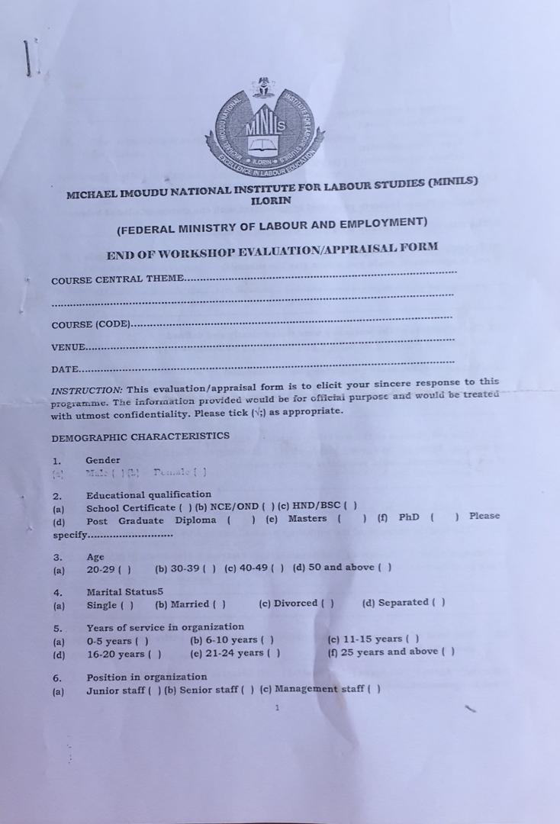
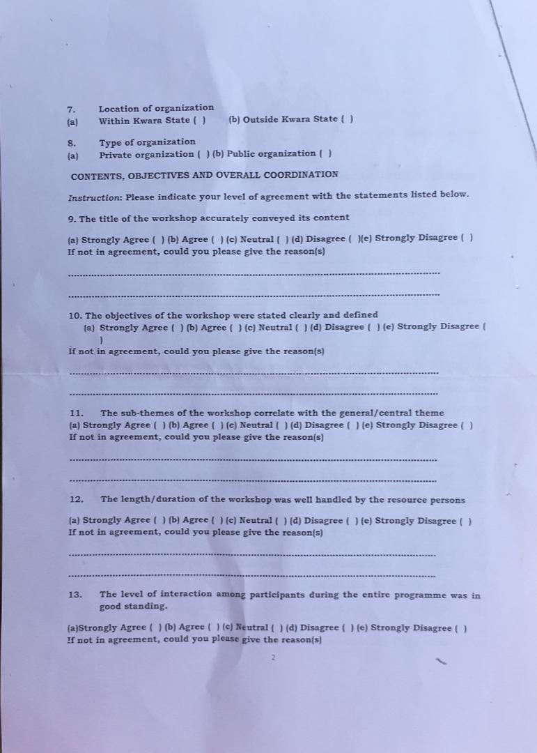

Employment & Unemployment Statistics
Quarter | Labour Force (millions) | Employment Rate (%) | Unemployment Rate (%) | Underemployment Rate (%)
Q1 (Jan-Mar) | 80.5 | 64.5% | 22.5% | 13.0%
Q2 (Apr-Jun) | 81.2 | 65.2% | 21.8% | 13.0%
Q3 (Jul-Sep) | 81.8 | 66.0% | 21.2% | 12.8%
Q4 (Oct-Dec) | 82.1 | 66.8% | 20.5% | 12.5%

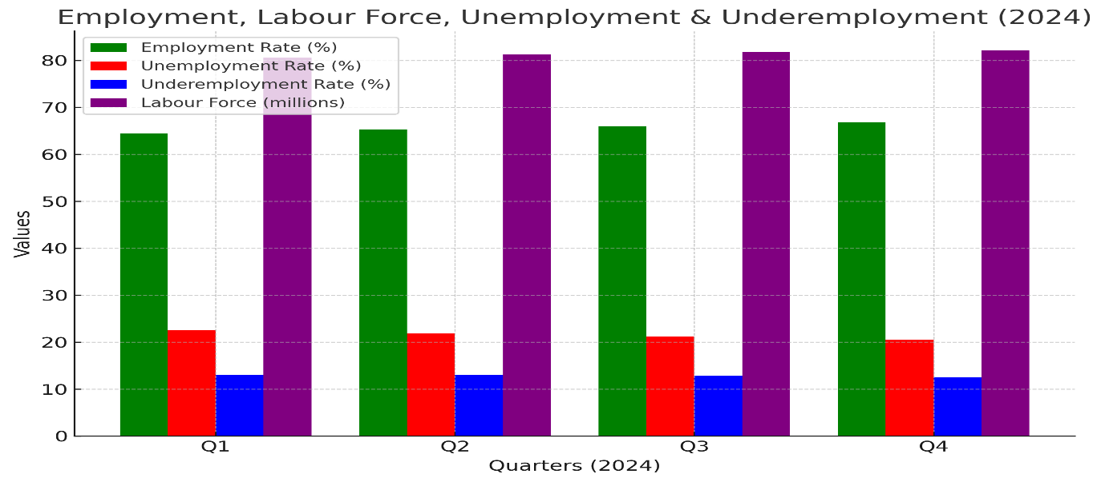

INTERPRETATION

Employment Rate (Green Bars)
- Steady Growth: The employment rate increased from 64.5% in Q1 to 66.8% in Q4.
- Positive Job Market Trend: This suggests more people found jobs over the year.
- Largest Growth: The biggest increase occurred in Q3 and Q4, likely due to year-end economic activities.

Labour Force (Purple Bars)
- Gradual Expansion: The total labor force grew from 80.5 million in Q1 to 82.1 million in Q4.
- Implication: More people entered the workforce, possibly due to population growth or fresh graduates joining the job market.

Unemployment Rate (Red Bars)
- Consistent Decline: The unemployment rate dropped from 22.5% in Q1 to 20.5% in Q4.
- Economic Recovery Sign: This reduction indicates increased job opportunities, likely driven by government policies or business expansions.
- Key Improvement: The biggest drop occurred in Q4, suggesting higher job creation towards year-end.

Underemployment Rate (Blue Bars)
- Slight Decrease: The underemployment rate declined from 13.0% in Q1 to 12.5% in Q4.
- Positive Indicator: Fewer people were engaged in low-paying or part-time jobs, meaning more individuals got full-time or well-matched jobs.
- Stable Change: The rate remained relatively constant in the first half of the year before improving in Q3 and Q4.

Overall Summary
- Employment is rising, showing an improved job market.
- Unemployment is decreasing, suggesting better job creation.
- Labour force is expanding, meaning more people are seeking jobs.
- Underemployment is slightly reducing, indicating better job quality.
EXPERIENCE GAINED IN SIWES PLACEMENT
Week 1: Introduction
Week 2: Explanation of how the institution operate and their functions
Week 3: How to construct and administer an appraisal within the institution.
Week 4: Explanation on the importance of appraisal and it uses within the institution.
Week 5: Administration of the institute appraisal/evaluation form to the participants that came for training.
Week 6: Inputting of responses gathered from the appraisal form into (SPSS).
Week 7: I was taught different statistical analysis like, T-test, ANOVA, Correlation etc.
Week 8: Practical aspect on one sample T-test on SPSS.
Week 9: Updating the institute data bank on daily basis into Microsoft access.
Week 10: Administration and retrieval of the institute appraisal forms from various department in the institute.
CONCLUSION
After my stay at the SIWES placement, which I was placed in the records department in which I input the daily record in the system, and I was able to carry-out some statistical work by practical, I understand that solving the problem of skill acquisition by graduates of Nigerian technical / vocational education is a reason for the establishment of SIWES. It was planned to be a bridge between educational institutions and industrial employers with the latter providing general and specific occupational skills and knowledge. If the scheme is not adequately implemented it becomes difficult for graduates of the system to secure proper understanding of their choice of study and implementing into occupations or make smooth transition to the labor market world.
Incompetence in workplace is related to the kind or quality of training in the school. To improve on the scheme’s implementation students should be placed in industries relevant to their field s of study. There is need for greater cooperation between industries and educational institutions on how best to implement SIWES programme. It can thus be concluded that SIWES offers the students learning experiences which cannot be directly gained in the class room.
RECOMMENDATION
- All the institutions involved should be organizing orientation courses in collaboration with the ITF for their students prior to their attachment with the attendance made mandatory for the students accepted for SIWES and ITF staff.
- ITF should ensure the regular visitation of the ITF officers to supervising Agencies institutions, employers and students on attachment.
- ITF should be providing insurance cover to students on attachment and improve on paying students and supervisors allowances for motivation.
- The Banks should speed up their action at clearing of cheque issued to avoid unnecessary delay.

