KWARA STATE POLYTECHNIC, ILORIN


A TECHNICAL REPORT ON
STUDENT INDUSTRIAL WORK EXPERIENCE SCHEME
(SIWES)

HELD AT:

GLOBAL FM, 92.5 ONIWAYA OFF
OLUSANYA STREET AGEGE, LAGOS STATE

BY

ASHIPA FATHIA AJOKE
MATRIC NO: ND/23/MAC/PT/0725

SUBMITTED TO

DEPARTMENT OF MASS COMMUNICATION
INSTITUTE OF COMMUNICATION
KWARA STATE POLYTECHNIC, ILORIN

IN PARTIAL FULFILLMENT OF THE REQUIREMENTS
FOR THE AWARD OF NATIONAL DIPLOMA (ND)

FEBRUARY,2025
ACKNOWLEDGMENT

I express my sincere gratitude to Almighty God for His guidance throughout my SIWES training. My appreciation goes to my SIWES Supervisor, Mr Oluwadamilare, for his mentorship and support.

I also extend my thanks to the management and staff of Global Fm Broadcasting Corporation, AGEGE, Lagos, for their warm reception and for providing a platform to learn and grow. Lastly, I appreciate my family, lecturers, and colleagues for their encouragement.

DEDICATION

I dedicate this report to my family, who have been my source of inspiration, and to my lecturers at Kwara State Polytechnic for their guidance in my academic journey.

TABLE OF CONTENTS

1. CHAPTER ONE: INTRODUCTION

1.1 Background of SIWES 1

1.2 Objectives of SIWES 1

1.3 Organizational Profile (Lagos State Broadcasting Corporation) 2

1.4 Organizational Structure 2

2. CHAPTER TWO

2.1 Overview of Broadcasting 3

2.2 News Writing and Editing in Broadcasting 3

2.3 Role of a Journalist in News Production 3
2.4 Organization Organogram 4

3. CHAPTER THREE: SIWES ACTIVITIES

3.1 Tasks Performed 5

3.2 Equipment and Tools Used 6

3.3 Skills Gained 7-10

4. CHAPTER FOUR: CHALLENGES AND SOLUTION
4.1 Challenges Encountered 11

4.2 Solutions and Adaptation 11

5. CHAPTER FIVE: CONCLUSION AND RECOMMENDATIONS

5.1 Summary of Experience 12

5.2 Recommendations 12

CHAPTER ONE

INTRODUCTION

1.1 Background of SIWES

The Student Industrial Work Experience Scheme (SIWES) was established to bridge the gap between classroom learning and practical industry exposure. The program enables students to gain hands-on experience in their field of study.

The programme (SIWES) came to existence through the establishment of Industrial Training Fund (ITF) under decree 47 of 1971 in bid to boost professionalism in the construction industries. The fund in its policy statement NO.1 published in 1973 inserted a clause, dealing with the issue of practical skill. The fund will seek to look out co-operative machinery with industry, where students in institutions of higher learning may rewrite industrial training or mid-career attachment by contribution to the allowance payable to the students.
SIWES is therefore a skill training programme designed to expose and prepare students of the universities, polytechnics and colleges of education to practical works on site. This scheme is for students of engineering and technology including environmental, technical and business studies. Recently, students in the medical field are also made to undertake this programme for higher learning in Nigeria.
However, in 1979, ITF withdrew the funding enjoyed by polytechnics and colleges of education, technical and went ahead to notify all universities that it would withdraw the funding of SIWES as from January 1980. In view of this, the National University Commission (NUC) took up the responsibility of funding the programme for engineering and technology students of Nigerian Universities, while the National Body for the Technical Education (NBTE) assumed financial responsibilities for the programme in the polytechnics and colleges of education.
The administration of the programme was still a Herculean task and was not without a myriad of operational problem. So, the Federal Government agreed on the funding of the scheme in 1985. In 1985, ITF assured the administration of SIWES programme and these are some of the parastatals of government that are involved in the management of SIWES programme the federal government, industrial training fund (ITF), institutions of higher learning, employers of students and coordinating agencies, the National University Commission (NUC), the National Board for Technical Education
(NBTE) and the National Council for Colleges of Education (NCCE).

1.2 Objectives of SIWES

- To expose students to real-life broadcasting operations.

- To help students apply theoretical knowledge in a practical setting.

- To enhance students’ technical and communication skills.

1.3 Background of Global FM
Global FM is a reputable radio station located in Agege, Lagos State. It is known for its news accuracy, diverse programming, and engaging talk shows. The station operates through different units, including news and editorial, audio production, marketing, and technical broadcasting.

1.4 Significance of the Training at Global FM
My training at Global FM provided me with valuable insights into the media industry. I gained practical experience in news editing, advertisement production, and live program coordination. The experience also helped me understand the importance of teamwork, accuracy, and timeliness in broadcasting

Organizational Structure

The station consists of different departments, including:

News and Current Affairs

Production Unit

Engineering and Technical Unit

Marketing and Advertisement

CHAPTER TWO

DESCRIPTION OF THE ORGANIZATION

2.1 Overview of Broadcasting

Broadcasting involves the transmission of information via radio waves to a wide audience. It plays a significant role in news dissemination and public engagement.

2.2 News Writing and Editing in Broadcasting

News editing ensures that news reports are concise, clear, and factual before broadcast. Editors remove errors and structure stories to maintain professionalism.

2.3 Role of a Journalist in News Production

A journalist is responsible for news gathering, verification, editing, and presentation to ensure credible reporting.

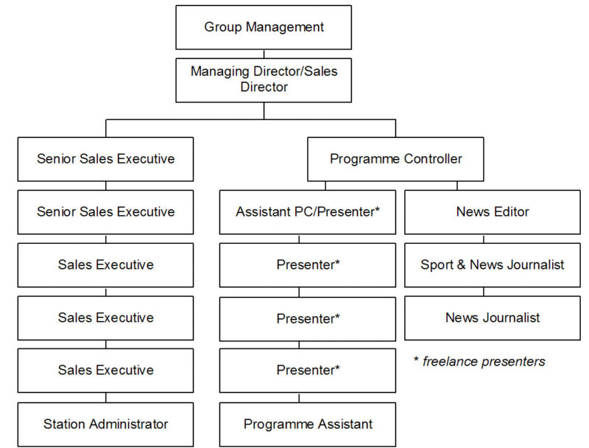

ORGANOGRAME OF THE ORGANIZATION

CHAPTER THREE

SIWES ACTIVITIES AND LEARNING EXPERIENCE

3.1 Tasks Performed
During my training at Global FM, I actively participated in various aspects of news broadcasting, production, and advertisement. My key responsibilities included
My major responsibilities included:

1. Writing News on Sanitation Day

Researched and gathered information about sanitation efforts, policies, and public reactions.

Structured the report to include government initiatives, environmental impact, and community participation.

Ensured that the news complied with broadcasting ethics and language clarity before it was aired.

2. News Editing

Edited raw news reports to ensure accuracy, clarity, and conciseness.

Removed unverified information and grammatical errors from news stories.

Reformatted scripts to follow the standard broadcasting structure.

3. Writing Stories from News

Rewrote complex reports into simpler and engaging formats for better audience understanding.

Adapted breaking news stories into feature reports.

Assisted in structuring headlines and summaries for news bulletins.

4. Handling Broadcasting Instruments

Learned how to operate studio microphones, sound consoles, and audio mixers.

Assisted in setting up headphones, speakers, and transmission equipment for live broadcasts.

Understood how to adjust sound levels for clear and noise-free news broadcasts.

5. Visitation to FM Station

Observed the daily operations of FM broadcasting.

Learned about radio frequency modulation, live program scheduling, and transmission procedures.

Engaged with FM station personnel to understand their roles in radio journalism.

6. Obituary Press Release

Learned the format for preparing obituary announcements.

Ensured that names, dates, and messages were properly verified before being aired.

Assisted in recording, editing, and broadcasting obituary announcements.

3.2 Equipment and Tools Used

I had the opportunity to work with various broadcasting equipment and tools during my SIWES training. These included:

1. Studio Microphone

Used for recording news, advertisements, and interviews.

Ensured high-quality audio output for clear transmission.

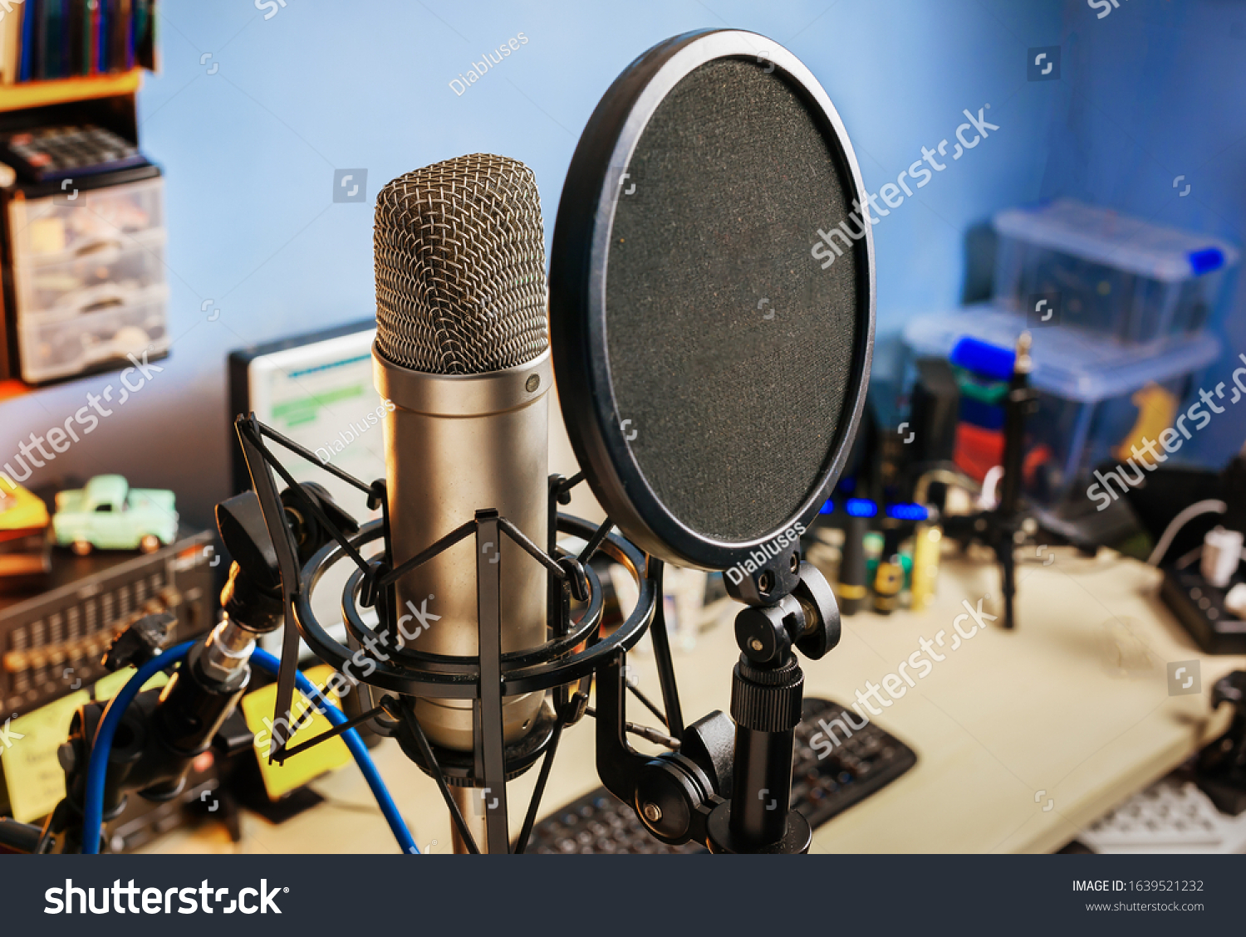

2. Digital Audio Mixer

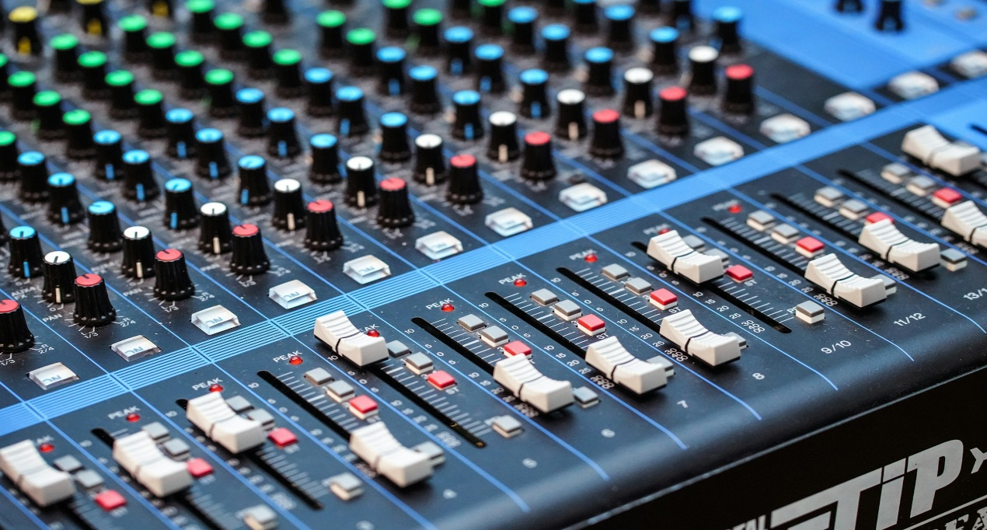

Adjusted audio levels for live news broadcasting.

Balanced background sound and voice clarity.

3. Headphones and Earphones

Monitored sound clarity during live broadcasts and recordings.

Helped detect background noise and transmission issues.

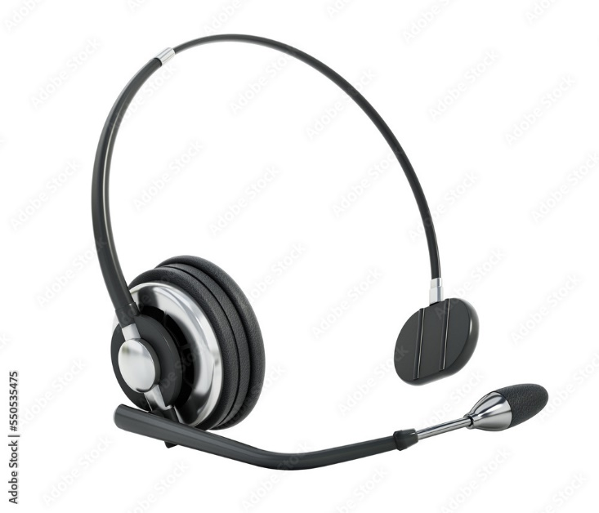

4. Speakers

Used to playback pre-recorded news reports before airing.

Allowed for proper sound verification and quality control.

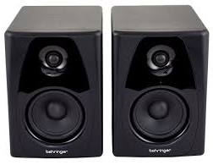

5. Editing Software (Adobe Audition, Audacity)

Used for audio editing, noise reduction, and sound effects enhancement.

Assisted in news reformatting and background music synchronization.

3.3 Skills Gained During SIWES Training

Throughout my SIWES program, I developed essential skills in broadcasting and journalism. These skills include:

A. News Writing and Editing Skills

Developed proficiency in structuring news reports for radio broadcast.

Learned headline writing, script formatting, and summary creation.

Enhanced my ability to edit and proofread news content for accuracy.

B. Technical and Broadcasting Skills

Understood how to operate and adjust studio microphones, mixers, and sound systems.

Gained experience in handling live radio equipment and managing audio levels.

Developed basic troubleshooting skills for broadcasting equipment issues.

C. Communication and Research Skills

Improved my oral presentation and voice modulation for news reading.

Learned how to research and gather credible information for news stories.

Developed confidence in writing and delivering reports professionally.

CHAPTER FOUR

CHALLENGES AND SOLUTIONS

4.1 Challenges Encountered

During my SIWES training, I faced some challenges, including:

Adapting to the fast-paced newsroom environment, which required quick thinking and decision-making.

Understanding complex broadcasting equipment within a short training period.

Ensuring accuracy in news writing and editing under tight deadlines.

4.2 Solutions and Adaptation

To overcome these challenges, I:

Observed and learned from experienced news editors and broadcasters.

Practiced using broadcasting equipment daily to improve my technical skills.

Asked questions and engaged in research to understand industry standards.

CHAPTER FIVE

CONCLUSION AND RECOMMENDATIONS

5.1 Summary of Experience

My SIWES training at GLOBA FM Broadcasting Corporation provided me with practical exposure to broadcasting and journalism. I gained firsthand experience in news writing, editing, production, and the use of broadcasting equipment. This training enhanced my skills in communication, technical operations, and problem-solving.

5.2 Recommendations

- The broadcasting corporation should provide more hands-on training sessions for interns.

- Students should be given access to more advanced broadcasting software for skill improvement.

- Future interns should undergo technical workshops to familiarize themselves with studio operations before SIWES begins.

