

A TECHNICAL REPORT
ON
STUDENT INDUSTRIAL WORKING EXPERIENCE SCHEME (SIWES)
HELD AT
MOSCOW SWIFT CONCERT
NO. 37 Mercy Cresent Odogunyan, Ikorodu Lagos State

By
Olonade Johnson oluwadamilare
ND/23/EEE/PT/0088

SUBMITTED TO
DEPARTMENT OF ELECTRICAL/ELECTRONICS ENGINEERING, INSTITUTE OF TECHNOLOGY (I.O.T), KWARA STATE POLYTECHNIC, ILORIN
IN PARTIAL FULFILMENT OF THE REQUIREMENT FOR THE AWARD OF NATIONAL DIPLOMA (ND) IN ELECRICAL/ELECTRONICS ENGINEERING
AUGUST-DECEMBER, 2024
DEDICATION
I am delight to dedicate this report to Almighty God who gave me the grace and opportunity to complete this program. I also dedicate this report to my parents Mr. and Mrs. OLONADE may Almighty God be with you forever.

ACKNOWLEDGEMENT
The dignity of human is not the ability to shape the destiny but to complete and tolerate each prevailing circumstances, in this regard am profusely thankful to God Almighty for helping and guiding through my program (SIWES).
I wish to express my acknowledge the effort of my parents Mr. and Mrs. OLONADE for support throughout my studies.

ABSTRACT
The main body of this report contains details on how my industrial training attached was spent at Moscow Swift Concert.

TABLE OF CONTENT
Title page i
Dedication ii
Acknowledgement iii
Abstract iv
Table of Content v

CHAPTER ONE
- Introduction 1
1.1 Organization of SIWES program and their Role 2
  - Objective of SIWES 4

CHAPTER TWO
2.0 Brief history of the organization 5
  - Aims and objectives of the organization 5
2.2 Organization Chart 6

CHAPTER THREE
3.0 Work done 7
  - Activities performs by the organization 7
  - Introduction to electrical work 7
  - Safety measure in electrical work 8
  - Winding of 3 phase A.C induction motor 9
  - Transformer winding 12
  - Single phase A.C induction motor 13
  - Electric standing fan 14
  - Introduction to wiring 14
  - Introduction to generator 15

CHAPTER FOUR
4.0 Relevance of the experience gained at students field of study 17

CHAPTER FIVE
5.0 Conclusion 18
5.1 Recommendation 18
CHAPTER ONE
1.0 INTRODUCTION
Student industrial work experience scheme (SIWES) is a program designed by the polytechnic to expose the student to the practical aspects of his/her course of study that can provide the training and experience required in the industry, as these experience and training cannot be obtained in lecture rooms but the theoretical knowledge taught in lecture rooms shall be applied by the student in real industrial situation.
This training/work experience, is an essential component in the development of the practical and professional skills required of each student by their respective course of study and also stand as an aid to prospective employment.
As a student of electrical/electronic I have been able to obtain the relevant and effective practical industrial training and experience in a duration of four months I have been to practical and activities from in the industries I was attached principle area of operation include, rewind, maintenance and servicing.
  - ORGANISATION INVOLVED IN THE MANAGING SIWES PROGRAM AND THEIR RULES.
The Federal Government, the industrial training fund (ITF) The supervising Agency, National University Commission (NUC), employers of labour and institutions have specific rules to play in management of siwes. The rules are;
The Federal Government
- To provide adequate fund to the ITF through the federal ministry of industry for scheme.
- To make it mandatory for all ministries, companies and parastatals to offer place to students in accordance with the provision of decree No 4 of 1971 as amended in 1990.
- Formulate policies to guide the running of scheme nationally.
Industrial Training Fund (ITF)
- Formulate policies and guideline on SIWES of distribution to all the SIWES participating bodies.
- Provide logistic material needed to administer the scheme.
- Organize orientation programs for students prior to attachment.
- Provide information on companies for attachment and assist in industrial placement of students.
- Supervise on industrial attachment.
- Accept and process master and placement list from institution and supervising agencies.
- Vet and process students logbook and ITF form 8.
The supervising Agencies (NUCC, NABTEB) etc. NUCC is to;
- Ensure the establishment and accreditation of SIWES until directorate in institution under their jurisdiction.
- To vet and approve master and placement list of student from participating institution and forward same to ITF. Fund SIWES Directorate adequately in participating institutions.
- To direct for the appointment of full time SIWES coordinator/director.
- Review program qualified from SIWES regularly.
- Participate in the behind SIWES conference and seminars in conjunction with ITF.
1.2 OBJECTIVE OF SIWES
The industrial training fund policy Document No 1 of 1973 which established SIWES outlined the objectives of the scheme, the objectives of SIWES are:
- To provide an avenue for students in Nigerian Tertiary Institution to acquire industrial skills and experience during the course of study.
- To prepare students for the work situation they are likely to meet after graduation.
- To expose the students for work method and techniques in handling equipment and machinery that may not be available in their polytechnic.
- To allow the transition phase from school to their theoretical knowledge in real work and practice.
- Enlist and strengthen employer’s involvement in the entire educational through SIWES.

CHAPTER TWO
2.0 BRIEF HISTORY OF THE ORGANISATION
MOSCOW SWIFT CONCERT was established in year 2005 and it is compose of the highly technical.
The chairman of the company has experience in electrical winding installation especially in transformer winding he has worked in many company. He has been an electrician since 2003, he has many apprentice under his company he trained many SIWES students the company has done many electrical winding in different places many more.
2.1 AIMS AND OBJECTIVE OF THE ORGANIZATION
- To provide a solid foundation in the electrical engineering work
- To develop the concept of professional practices innovation and enterprise
- To train workers for the dynamic and rapidly changing market for computing and information system and product
- To satisfy the customer in any given time jobs
- To brings about the knowledge of new technical aspect of engineering
2.2 ORGANIZATION CHART
MANAGER

ELECTRICAL SECTION

SECRETARY

ENGINEERS

STUDENTS

STORE MANAGER

CHAPTER THREE
3.0 WORKDONE
3.1 ACTIVITIES PERFORM BY THE ORGANIZATION
- Wiring
- Installation of electrical machine and accessory
- Rewinding of AC and DC induction motors
- Rewinding of Coils
- Rewinding of transformer
- Repairing and service of generator
- Electrical maintenance service
3.2 INTRODUCTION TO ELECTRICAL WORK
Electrical Engineering [sometimes referred to as electrical and electronic engineering] is a professional engineering discipline that deals with the study and application of electronic and electromagnetism. The field became an identifiable occupation in the late nineteenth century with the commercialization of the electrical supply.
The field now covers a range of sup-description including those that deals with power, digital electronics, analog electronics, computer science, artificial intelligence, control system electronic, signal processing and telecommunications. Where a distinction is made electrical engineering is considered to deal with the problems associated with large scale electrical system such as power transmission and motor control , where as electronic engineering deals with the small scale electronic system including computers and integrated circuit or another way of look at the distinction is that electrical engineers are usually concerned with using electricity to transmit energy while electronic engineers are concerned with using electricity to transmit information.
3.3 SAFETY MEASURE IN ELECTRICAL WORKS
It’s very important to take safety precaution when working with electricity. Safety must not be compromised and some ground rules need to be followed first.
Some of them are;
- Avoid water at all times when working with electricity, never touch or try repairing any electrical equipment or circuit with wet hands. It increases the conductivity of electric current.
- Always use insulated materials while working.
- If working on any receptacle at home, then always turn off the mains, it is also good idea to indicate a sign on the service panel so that nobody turn the main switch on by accident.
- Always use appropriate insulated rubble glove and goggles while working on any branch circuit or any other electrical circuit.
- Always use a circuit breaker or fuse with the appropriate current rating.
- Always tape or put cap on a life or hot wire.
- Take care while removing capacitor from the circuit to avoid electric shock because capacitor stores charges.
- Always take care while soldering, keep the soldering iron in its stand when not use.
- Always careful while using aluminum or steel ladder because of electrical surge will ground you and hole electric current will pass through you, use a wooden ladder instead.
- Always use a right tool for the job.

3.4 WINDING OF 3 PHASE A.C INDUCTION MOTOR
Introduction to 3 phase induction motor is a generalized transformer, the difference is that, transformer is an alternating flux machine, rotating flues is possible only when 3 phase voltage which is 120 degree apart in time is applied to a 3 phase wiring then magnetic flux is produced whose magnitude is constant direction keep changing, in transformer the flux produced is alternating and not changing.
There is no air gap between the primary and secondary of transformer, whereas there is air gap between the stator and rotor which give mechanical movability to motor. An induction synchronous motor is an AC electric motor in which the electric current in the rotor needed to produce torque is obtained by electromagnetic induction from the magnetic field of the stator.
PART OF INDUCTION MOTOR
- Bearing
- Stator
- Rotor
- Shaft
- Air Gap
- Fan Blade
- Wiring Cover
- Motor Frame
- Stator Slot
- Rotor Slot
- Stator Core
MATERIAL REQUIRE FOR CONSTRUCTION
- Copper wire
- Leather rod paper
- Marking tape
- Copper oil or varnishes
An induction or synchronous motor is an AC electric motor in which the electric current in the rotor needed to produce torque is obtained by electromagnetic induction from the magnetic field of the stator.

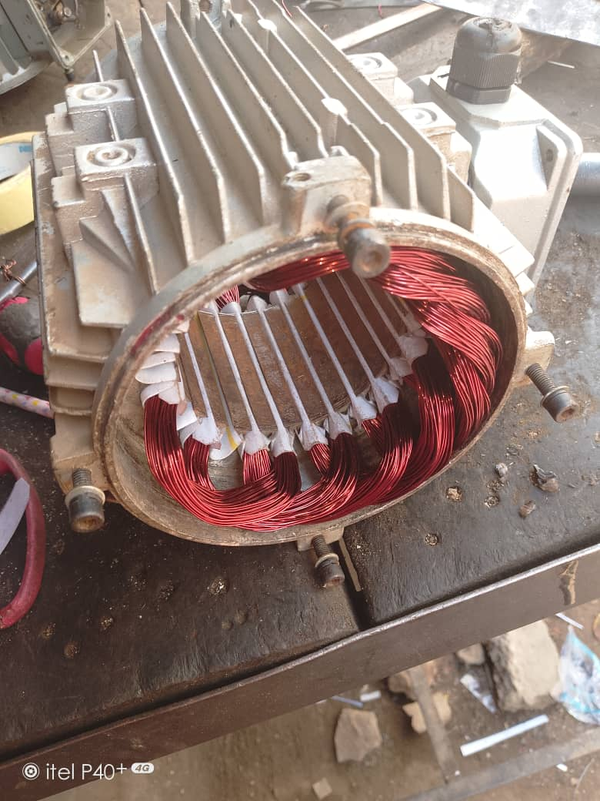
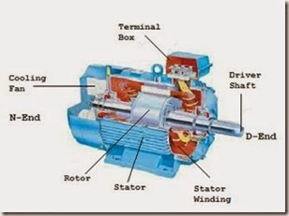
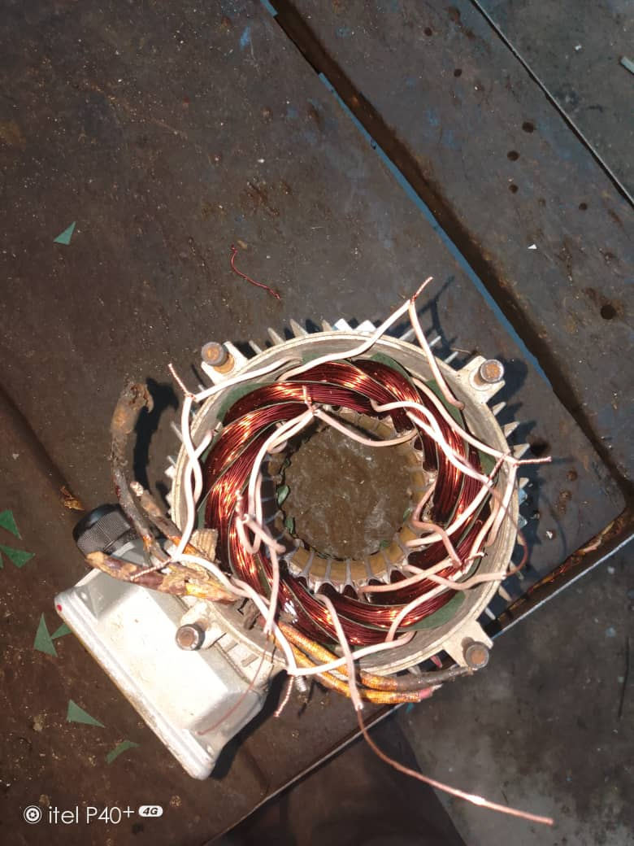

3.5 TRANSFORMER WINDING
Transformer is an electric device used to increase or decrease the voltage of alternating current in electric power applications.

TRANSFORMER
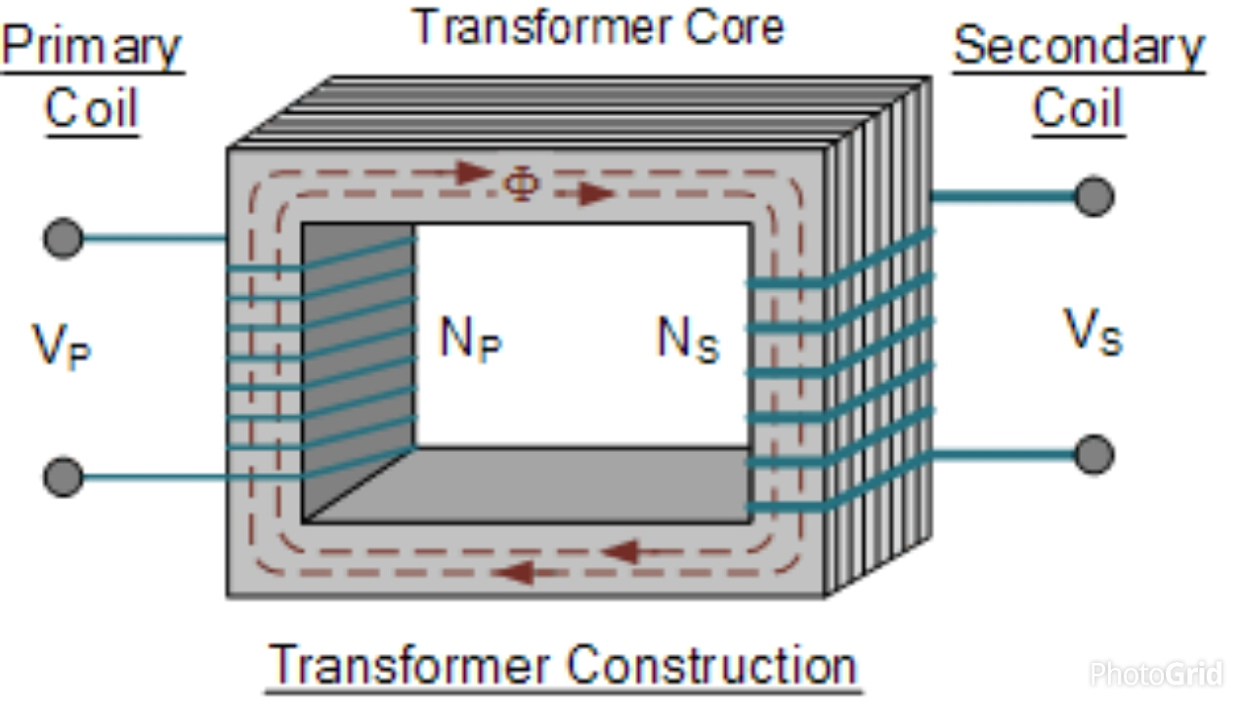

COMPONENTS OF TRANSFORMER
- Laminated steel core: are used to support the winding in the transformer.
- Insulating materials and cardboard paper are used to separate the primary and secondary winding from each other
- Winding: this is the main part of the transformer it has the input (primary coil) and output (secondary coil) which are separately connected without any direct interconnection.

CLASSIFICATION OF TRANSFORMER WINDING
It can be classify into two form
Base on the input and output
- Primary
- Secondary
Base on the voltage range
- High voltage winding
- Low voltage winding
High voltage winding are made up of copper coil, the number of turns in it is more than the number of turn in the low voltage winding.
Low voltage winding has lesser number of turns than that of the high voltage winding. It is made up of thick copper conduction.
3.6 SINGLE PHASE A.C INDUCTION MOTOR
- Single phase induction motors require one power phase for their operation.
- The main component of single phase are Rotor, Stator, Winding
- Single phase induction motor is also called a capacitor start motor.
Connection: the main winding which is running is connected in series with capacitor. The start of the running is a lead (Red) while the ends which is the finishing which connect with capacitor in series is a neutral (Black)
3.7 ELECTRIC STANDING FAN
Electric standing fan required one power phase for their operator. It is also a capacitor start motor , capacitor are connected in series with the main coil which has speed one, two, three depending on their connections. It has running, starting and regulator which are connected together to form a close mash or circuit.

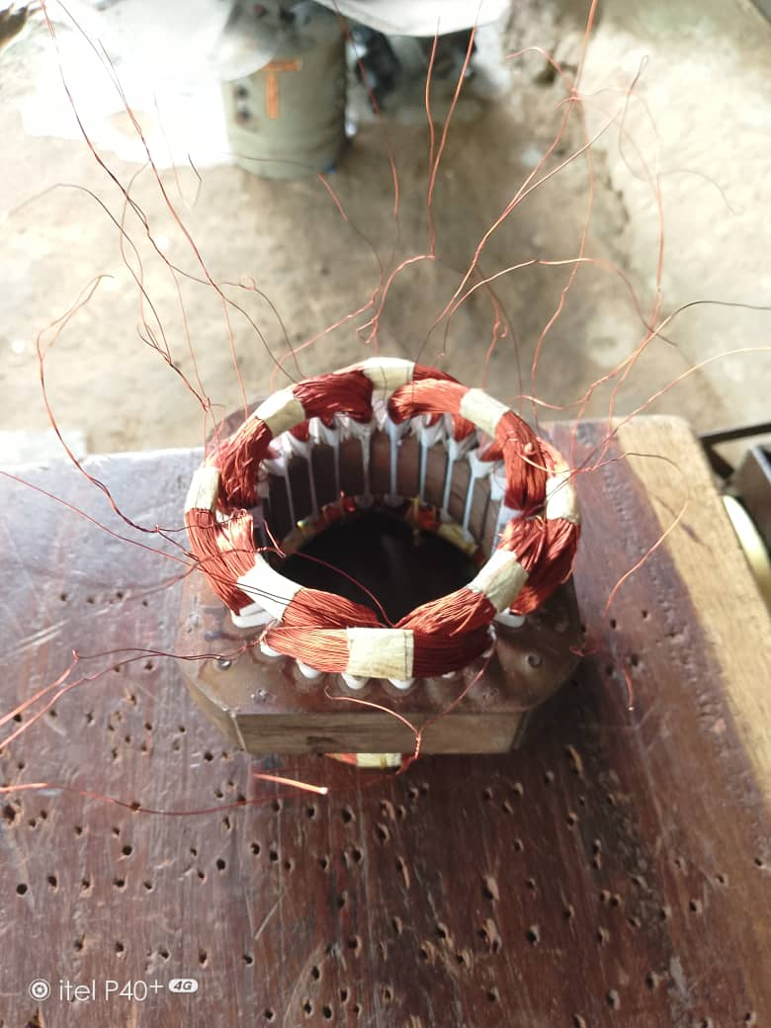

3.8 INTRODUCTION TO WIRING
Building wiring is the electrical wiring and associated device such as switches, meters and light fittings used in building or other structures.
Wire and cables are related by the circuit voltage, temperature and environmental condition moisture, sunlight, oil, chemical in which they can be used.
A wiring can be a surface or conduit mostly depend on how he or she like.
Understanding of wiring and installation must be gained or acquire before starting the work chosen of cable sizes and appropriate accessory for the right job is very important, and chosen an appropriate location for the accessory to be installed is very important.
Wiring work must be straight and clean, all connection must be properly connected and all joining wires must be tape or caps, all mistakes must be corrected before testing.

3.9 INTRODUCTION TO GENERATOR
Generator is a machine that converts mechanical energy to electrical energy by using the principle of magnetic induction, which state that whenever a conductor is moved within a magnetic field in such a way that the conductor cuts across magnetic lines of flux or force voltage is produced or generated in the conductor.
D.C Generator can be classify into:
1. Brush Generator
2. Brushless Generator
MAINTENANCE SERVICE
In this service and maintenance one has to have the experience and have ability to replace a damage accessory or appliance. A person must have time for his/her client because at your inconvenience time, client may call you to come and check or detect fault on machine.
One may have the following skill
- Ability to use multi-meter to read current and voltage
- Ability to use meter to trace wire
- Ability to use testing materials

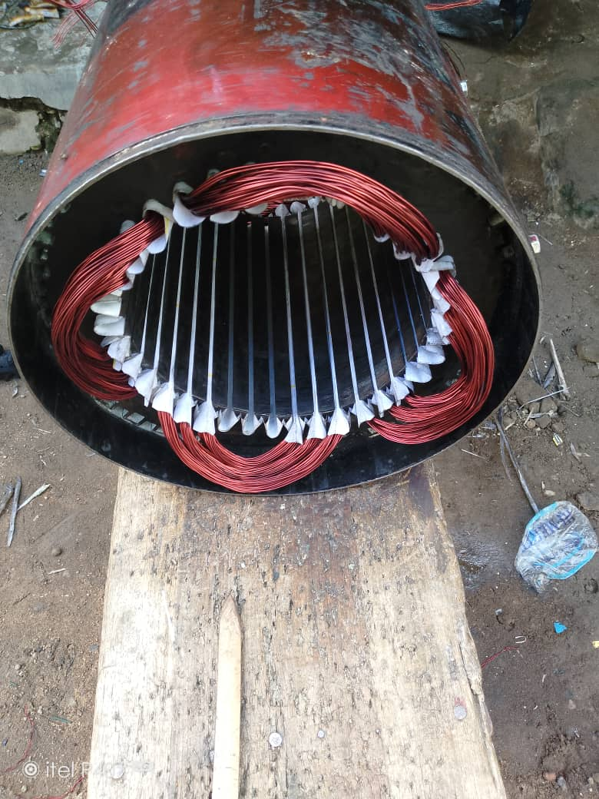
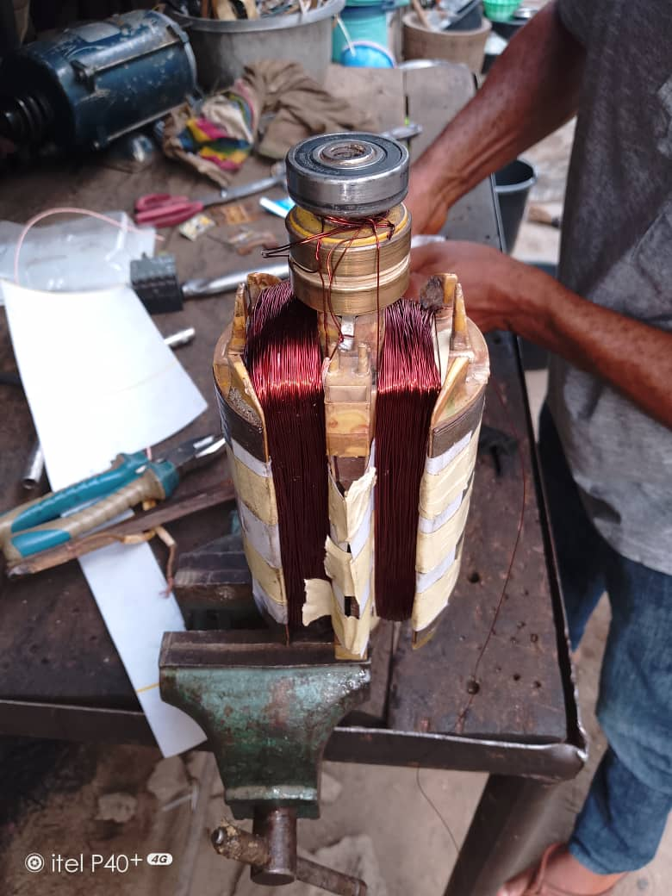
CHAPTER FOUR
- RELEVANCE OF THE EXPERIENCE GAINED AT STUDENTS FIELD OF STUDY
In summary, this program has exposed me to some practical aspect in relation to my course of study (Electrical/Electronics Engineering) and I benefitted greatly from the program. What I learnt at various site involves the following.
- Winding of three phase A.C induction motor
- Transformer winding
- Single phase A.C induction motor
- Winding of electric fan
- Wiring
- Repairing and servicing of generator
- Maintenance service

CHAPTER FIVE
- CONCLUSION
In conclusion, as a student of electrical/electronic engineering, I have been able to obtain the most relevant and effective practical industrial training and experience in a duration of four month, having been exposed to practical on winding, wiring, generator, maintenance e.t.c.
Furthermore, an awareness of the general workplace has been developed in me and I acquired important behavior and interpersonal skills with the opportunity giving me to get feel of the work environment and exposure as a student to the electrical responsibilities and ethics.
Finally, I will like to stat that the SIWES program is a very relevant and necessary program for all students that must be taken advantage of.
5.1 RECOMMENDATION
I would recommend that industrial training fund committee should orientate organization, firms, ministries on the need to get students attachment to them and engage them in their activities of which they are attached there for.
Also regular visits should be made by the appropriate authority to check if really the knowledge is being impacted to the students.
Furthermore, the industrial training fund (ITF) zonal office should ensure that payment is been made to the SIWES students as an allowance at their place of attachment.

