

A TECHNICAL REPORT ON
STUDENT INDUSTRIAL WORK EXPERIENCE SCHEME (SIWES)

HELD AT
WORK OF GOD MULTIBIZ RESOURCES VENTURE
LINE 3, ISELE AGBARA AREA STREET, ILE-IFE, OSUN STATE

PRESENTED BY:
OLAYINKA QUADRI OLAMIDE
ND/23/MET/FT/039

SUBMITTED TO
DEPARTMENT OF METALLURGICAL ENGINEERING, INSTITUTE OF TECHNOLOGY, KWARA STATE POLYTECHNIC, ILORIN, KWARA STATE

IN PARTIAL FULFILLMENT OF THE REQUIREMENT FOR THE AWARD OF NATIONAL DIPLOMA CERTIFICATE IN METALLURGICAL ENGINEERING TECHNOLOGY.
AUGUST – NOVEMBER, 2024

DEDICATION
I dedicate this work to my dearest parents Mr. and Mrs. Olayinka whom through their advices, love, care and financial assistance have made me to be where I am today. I pray the good God will continue to keep and guide them for me. Amen.

ACKNOWLEDGEMENTS
I cannot but express my unquenchable and eternal gratitude to HIM “The Alpha and Omega who has proved his tremendous works in my life and has not cut short my expectations throughout the course of this programme.
My heartfelt appreciation goes to my loving parents; Mr. and Mrs. Olayinka, for their financial, spiritual and moral contributions through my academic course.
I am deeply indebted to our SIWES coordinator for his excellent advice, efficient supervisions, to my able HOD; Engr. Alagbe and to the entire staff of metallurgical engineering Department, Kwara State Polytechnic, Ilorin .My eagle could not have flown wings to my loyal allies for their words of encouragement and for believing in my dreams.
And to all the entire Metallurgical Engineering ND II Students, if there is anything my soul love best it is you. My profound gratitude also goes to the management of Work of God Multibiz Resources Venture. To those whom I omit to mention, pardon my inadvertence, the pressure of the season has impressed upon my fallible mind. Thank you.

Preface
This report is a summary of the experience I acquired during my Four Months Student’s Industrial Work Experience Scheme (SIWES) at Work of God, Multibiz Resources Ventures, Line 3, Isele Agbara, Agbara Area, Ile-Ife, Osun State. With highlight majorly Foundry (casting of items), giving a full enlightenment on equipment used during the course of the work as well the various component and processes, giving a clear idea of the student involvement in an operational activities carried out in the firm.

Table of Contents
Title Page i
Dedication ii
Acknowledgements iii
Preface iv
Table of Contents v
CHAPTER ONE 1
1.0 Introduction 1
1.1 Definition of SIWES 2
1.2 Aim and Objectives of SIWES 3
1.3 Ola-Iya Foundry Workshop 4
1.3.1 Brief History of Ola-Iya 4
1.3.2 Vision 4
1.4 Major Activities of the Organization/Company 4
1.5 Organization Chart Of Ola-Iya 5
CHAPTER TWO 6
2.0 Section of the Organization and Specific Function 6
2.1 The Workshop Section 6
2.2 Functions of the Section/Unit 6
CHAPTER THREE 8
3.1 Introduction to Foundry 8
3.2 Some Tools Used in the Workshop and their Uses 8
3.3 Diagrammatical Representation of Tools Listed Above 9
3.4 Safety Precautions and Their Reasons 9
3.5 Casting 10
3.5.1 Factors to Consider when Casting 10
3.5.2 Types of Casting 10
3.6 Some Work done in the Foundry Section 12
3.7 Qualities of Good Moulding Sand 12
CHAPTER FOUR 14
4.1 Production of Aluminium Pot (Size E4) 14
4.2 Finishing 18
CHAPTER FIVE 21
5.1 My Personal Impression About the Organization 21
5.2 Experience Gained 21
5.3 Recommendation to the Organization and to the Polytechnic Concerning the SIWES Program 22
5.4 Interpersonal Relationship 23
5.5 Conclusion 23

CHAPTER ONE

1.0 Introduction
The Students Industrial Work Experience Scheme (SIWES) is a skills Training Programme designed to expose and prepare students of Universities, Polytechnics/Colleges of Technology/Colleges of Agriculture and Colleges of Education for the Industrial Work situation they are likely to meet after graduation. The scheme also affords students the opportunity of familiarizing and exposing themselves to the needed experience in handling equipment and machinery that are usually not available in their Institutions.
Before the establishment of the scheme, there was a growing concern among our Industrialists that graduates of our Institutions of Higher learning lacked adequate practical background studies preparatory for employment in Industries. Thus, the employers were of the opinion that the theoretical education going on in higher institutions was not responsive to the needs of the employers of labour.
The organization responsible for student industrial work experience scheme (SIWES) is Industrial Training Fund (ITF) and was established on October 1971. The student industrial work experience scheme (SIWES) is the accepted skills training programme which form part of the approved minimum academic standards in the various programme.
The practical knowledge and skilled acquired in Nigeria Tertiary Institution are no longer sufficient to provide adequate required skills in construction technology it is regarded as a part of the course requirement (curriculum) for engineering and some other professional courses offered in higher institution of learning, it was established in 1973 by the Industrial Training Fund in collaboration with the National Board for Technical Education which has it headquarter at Kaduna to solve the problem or adequate practice skill required for employment in industries by Nigeria Graduates of Tertiary Institution.
The main operators in the SIWES programme are the ITF and the Government agencies are NBTE. It is funded by the Federal Government of Nigeria and beneficiaries of the programme include Undergraduate student of Agriculture Engineering, Environment Science Education, Medical Science and Pure and Applied Science.

1.1 Definition of SIWES
Student Industrial Work Experience (SIWES) is a programme established by government and introduced to every higher institution in order for student to have practical experience of the work done.

1.2 Aim and Objectives of SIWES
Specifically, the objectives of the Students Industrial Work Experience Scheme (SIWES) are to:
- Provide an avenue for students in institutions of higher learning to acquire industrial skills and experience in their course of study, which are restricted to Engineering and Technology including Environmental studies and other courses that may be approved. Courses of NCE (Technical), NCE Agriculture, NCE (Business), NCE (Fine and Applied Arts) and NCE (Home Economics) in Colleges of Education are also included.
- Prepare students for the industrial work situation they are to meet after graduation;
- Expose students to work methods and techniques in handling equipment and machinery that may not be available in their institutions.
- Make the transition from school to the world of work easier, and enhance students contacts for later job placement;
- Provide students with an opportunity to apply their knowledge in real work situation thereby bridging the gap between theory and practice; and
- Enlist and strengthen employers, involvement in the entire educational process and prepare students for employment in Industry and Commerce.

1.3 Work of God Multibiz Resources

1.3.1 Brief History of Work of God
Work of God, Multibiz Resources was established in the year 2007, which is situated at Orita Globe Street, Garage Olode, Osun State. The Industry is made up of five of Departments and chaired by the General manager/Chief Executive Officer, who is responsible for the day to day running of the organization. It was charged with the broad function of generating and catalyzing industrialization by carrying out the production of Modern Aluminum Pots, popcorn spoon, gate designs and correction of defective castings, etc.

1.3.2 Vision
To make Nigeria one of the acknowledged leaders of the scientifically and technologically developed nations of the world.

1.4 Major Activities of the Organization/Company
Work of God Multibiz was majorly established to stimulate modern production of aluminum pot, gate designs, arrows, pot covers, correction of defects, popcorn spoon and bowl etc.

1.5 Organization Chart of Ola-Iya Foundry

CHAPTER TWO

2.0 Section of the Organization and Specific Function
The organization has a little amount of workers, whom are divided into units. The sectional unit can also be sub-divided into different section there are

2.1 The Workshop Section
i. Moulding Section
ii. Casting Section
iii. Finishing Section

2.2 Functions of the Section/Unit
1. Moulding Section: This section of the workshop where all mixture of sand and moulding of sand is being done and equipment used in this section are the moulding box or flask, the rammer, the sprue pin, riser pin rammer etc.
2. Casting Section: This is another section of the workshop where the melting of molten metal is being done, also this section ensure that the molten metal is well melted and all slags are removed to prevent defect, equipment used in this section are crucible, ladle, charcoal etc.
3. Finishing Section: This is the final section of the workshop where all inspection and correction are made on the material produced. Also, this section are also set aside for the correction of defect and materials used by this section are hand file, ring, grinding machine, hand file etc. and a pomade substances used for correction such as hardener and filler.

CHAPTER THREE

3.1 Introduction to Foundry
Foundry is a branch of metal work or metallurgy which deals with the moulding of metal in a specific/special furnace and thereby producing a specified pattern. Pattern is said to be define as the replica of what is being cast.

3.2 Some Tools Used in the Workshop and their Uses
- Rammer: Used in pounding of sand to fit in the moulding box or used in ramming of sand.
- Strike-Off Bar: Used in the production or making of bed and for smothering the surface of mould
- Spoon: Used in the production of core and also used in drawing of mould to prevent defect
- Slick: Used in the production of the line of co-ordination
- Moulding Box: Used for moulding during sand casting
- Trowel: Used in smoothing of the surface of mould and also in the smoothing of sand to produce the line or co-ordination
- Spring: It is used for tightening of flask together i.e the cope and the drag
- Crucible: It is used in melting of molten metal in the workshop
- Hoe: Used in the mixture of sand or separation of sand or breaking of solidified sand
- Flask: A type of moulding box containing the drag and cope

3.3 Diagrammatical Representation of Tools Listed Above
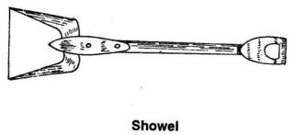
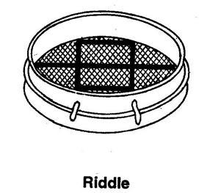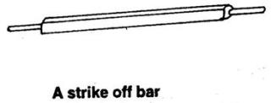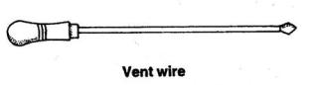

3.4 Safety Precautions and Their Reasons
- Do not run in the workshop, because running in the workshop can lead to damaging of the mould prepared.
- Do not wear shoe from outside to the workshop, because the shoe might have other constituents aside sand that can lead to defect
- Always wear workshop boot when working or walking in the workshop, because walking in the workshop barefooted in the workshop can lead to injury as a result of stepping on molten metal.
- Ensure the mould is well dress before application of molten metal to prevent defect
- Ensure the mould is well fixed to the bed to prevent molten metal from getting outside the moulding box
- Be careful when imprinting alphabets on the mould to prevent defect
- Ensure the parting sand is well filtered so as to prevent defect
- Avoid water or any liquid substance from penetrating molten metal so as to prevent bubble blast which can cause injury.

3.5 Casting
Casting can be define as a manufacturing process in which liquid material is poured into a mould, which contains a hollow cavity of desired shape, and then allowed to solidified. The solidified part is known as casting, which is ejected or broken down out of the mold to complete the process.

3.5.1 Factors to Consider when Casting
1. Geometric complexity
2. Type of metal to be casted
3. Dimensional allowance or tolerances
4. Cast surface finish
5. Quality requirement and assurance i.e. properties of metal soundness of casting smoothness to finish

3.5.2 Types of Casting
- Sand Casting
- Die Casing
- Centrifugal Casting
Sand Casting
Sand casting also known as sand molded casting is a metal casting process characterized by using sand as mold material. The term “sand casting” can also refer to an object produced using the sand casting. It is produced in specialized foundry industry.
Furnace
A furnace is a device used for high-temperature heating. It was coined out from the Greek Word “Fornax” which means OVEN. The heat energy fuel a furnace may be supplied directly by fuel combustion by electricity such as the electric arc furnace, or through induction heating in induction furnace.
Types of Furnace
- Blast furnace
- Rotary furnace
- Crucible furnace
- Induction furnace
- Jet stream furnace
- Electric arc furnace
- Open health furnace
- Cupola furnace

3.6 Some Work done in the Foundry Section
1. Moulding
2. Casting
3. Patching of worn out pot/spoon or Aluminium product
4. Production of the following: Aluminium pot, Gate covers, Aluminium spoon, arrows etc.
Mould
A mould is the cavity or impression of a pattern left in a box of sand into which amolten metal is poured.
Types of Sand Used for Foundry Mould
Fine sand
Medium sand
Coarse sand

3.7 Qualities of Good Moulding Sand
Compatibility: The sand must be able to change its shape into the shape of the pattern and retain that shape when the pattern has been removed and up to the time the molten is poured and has solidified.
Permeability: the sand must be porous enough to allow escape of gas generated when the molten metal gets into contact with the moist.
Refractoriness: the sand must be able to withstand the air generated by the molten metal.

CHAPTER FOUR

4.1 Production of Aluminium Pot (Size E4)
The production of this pot (Aluminium pot) commonly known as E4 follow a sequential process i.e having a heap of sand and a hoe, then The sand will be filled into the pot until it is full, then it will be rammed with the use of rammer and the surface will be smoothened with a strike off bar as in the figure below.
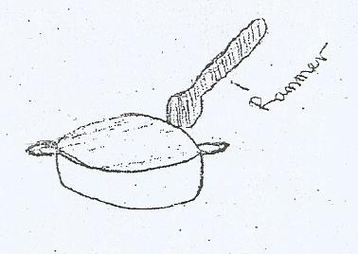
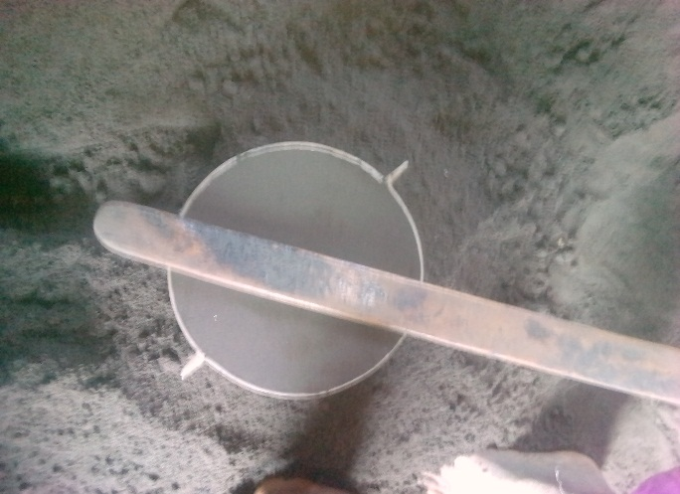
OR
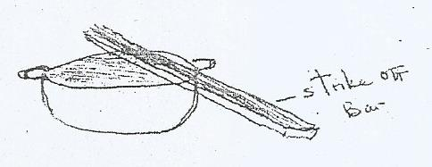
Then a bed will be prepared with the use of strike off bar and sand as shown below
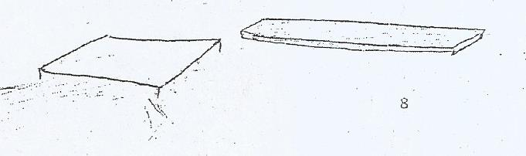
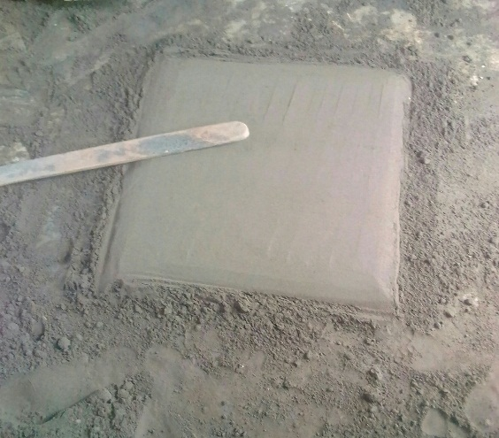 OR
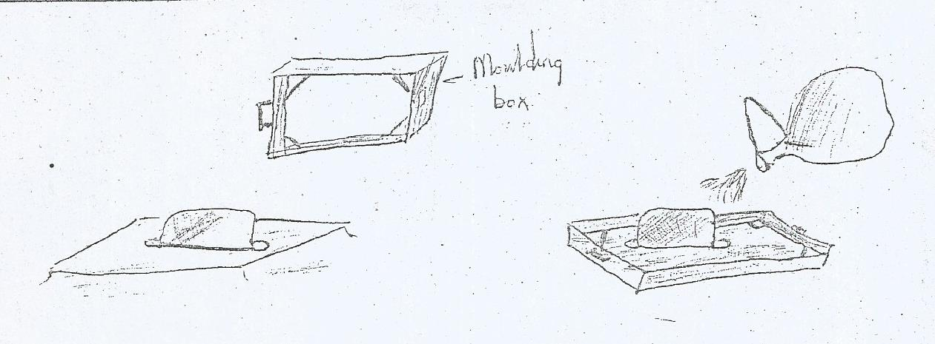
After, then the pattern with sand will be placed on the prepared bed, then a moulding box will placed on it after which a parting sand will be applied on both the pattern and the bed. Thin wet sand will be added to cover the pattern inside the moulding box as shown below.
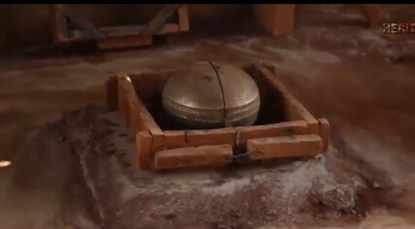
Then it is filled with the moulding sand and pounded using the rammer as indicated in the picture below.
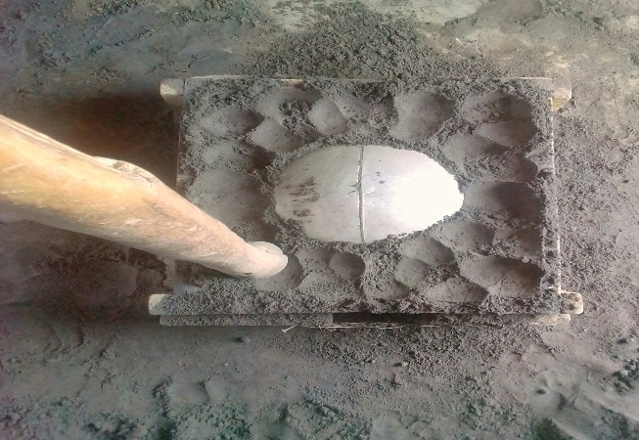
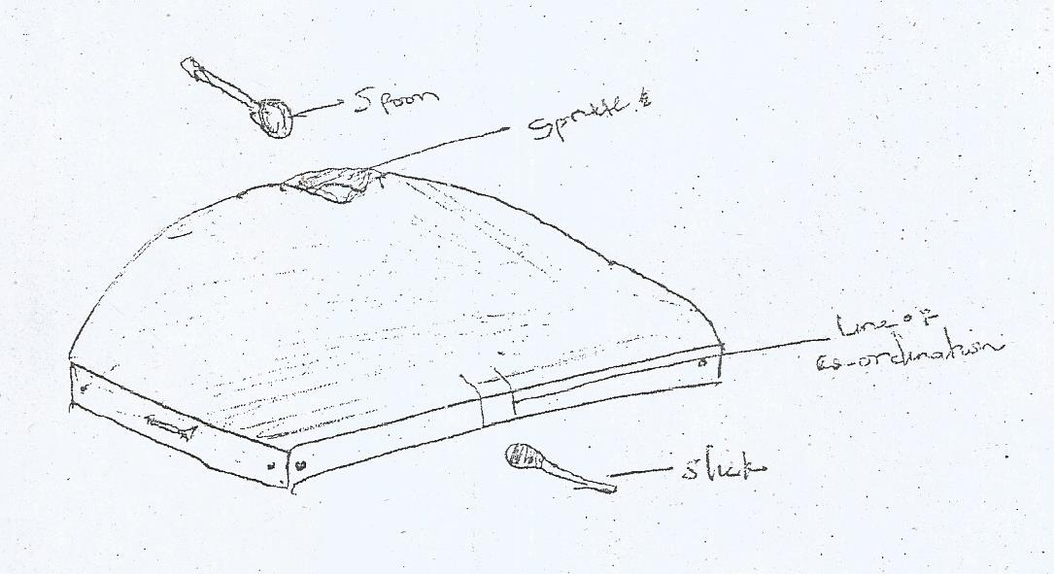
A core is the opening at the middle of the mould where molten metal is being poured. After the production of the core, the mould will be raised carefully up-ward so as to remove the pattern. And after the removal of the pattern the mould will be dressed properly and then it will be carefully placed back with the correspondence of the line of co-ordination.
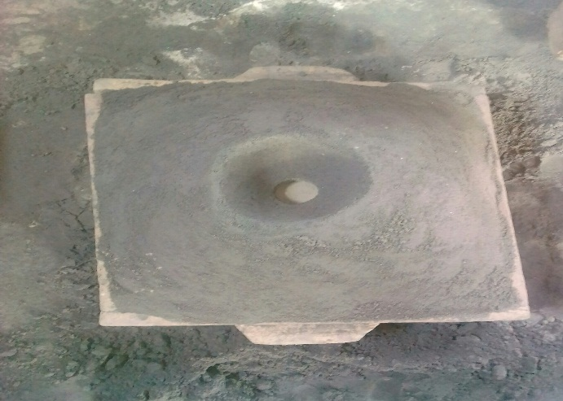

After the core for pouring has been made, then the pattern is remove by lifting up the moulding box. Then the mould is dressed properly by blowing off the loss sand as indicated below.
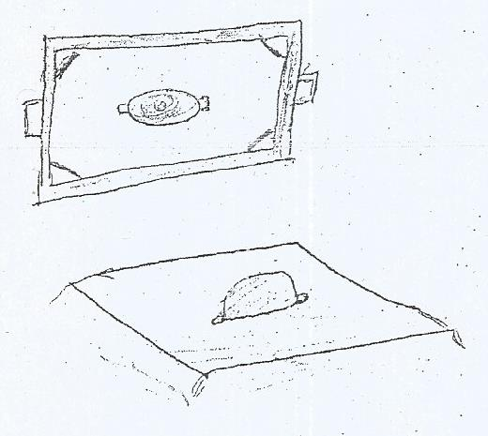
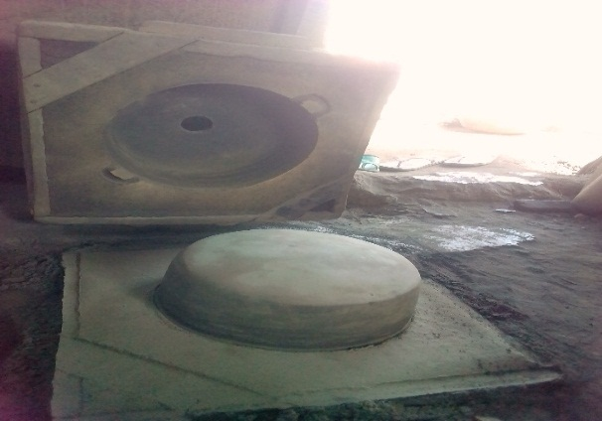OR

After all these processes are being carried out successfully then molten metal will be poured and the mould will be opened after 10-15 seconds. The molten metal will be transferred from the furnace to the workshop through the use of a crucible ladle and mind you, the molten metal will be poured through the core.
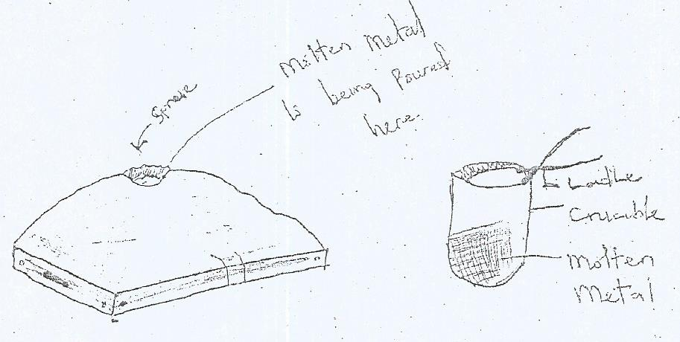
After which the Aluminium pot is produced.
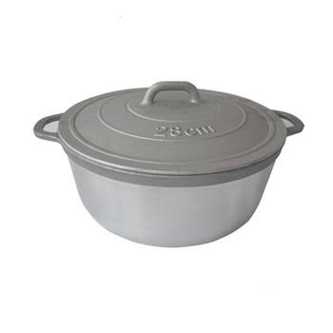

4.2 Finishing
Substances used in the finishing section are:
- Filler
- Hardner and
- Petrol
In foundry, finishing is the final stage in the workshop where all completion of casting is carried out. In this process correction of minor defect is being done by patching through the process of hammering a metallic scrap towards the point of defect as shown in the diagram below.
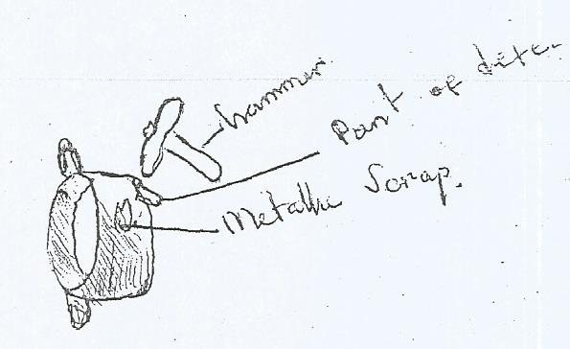


Also defect sometimes are correct with the use of pomade like substance called body filler and a white gelatinous substance called hardener mixed thoroughly together and rubbed on the point of defect. Also, rough parts at the edge of the Aluminum product produced are being smoothened with the use of hand file.
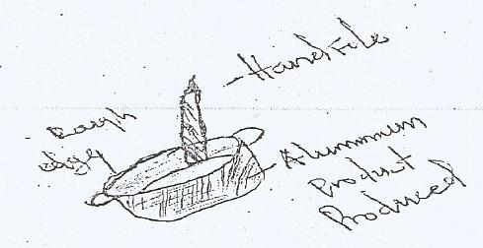
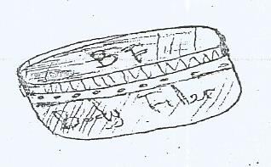
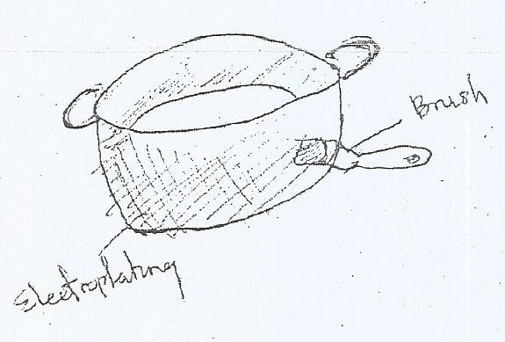
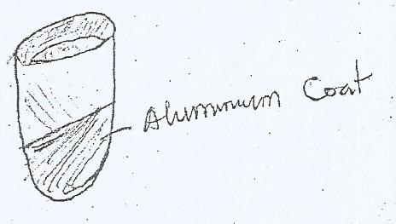
Also, the final aspect of finishing is the polishing i.e the product being produced is polished with an Aluminium coat or the process of electroplating the product with an Aluminium coat.

CHAPTER FIVE

5.1 My Personal Impression About the Organization
Work of God Multibiz, a very friendly organization which addresses issues in a polite manner and equally encourages both the SIWES students and apprentices to be self-dependent and motivated. I can say that the organization as a bright/promising future if she will not change the way she operates.

5.2 Experience Gained
Working as a student Trainee at Work of God Multibiz Workshop has given me the opportunity of getting a firsthand appreciation of Foundry, learning its fundamentals, learning to work with the various equipment used. I was able to apply some of the theoretical knowledge gained during my study at the Polytechnic to real work situations thereby bridging the gap between school work and actual practice.
My general experiences concerning Metallurgical Engineers are as follow:
- I was able to understand what Foundry generally was all about.
- I was made to understand how to use some foundry equipment and their general maintenances
- I learnt how to form mould.
- I learnt how to use different pattern types of pattern i.e single pattern and split pattern.
- Finally, I learnt how difficult tasks are handled to ensure smooth progress of a project work in conjunction to the time frame for a given project.

5.3 Recommendation to the Organization and to the Polytechnic Concerning the SIWES Program
In view of the relevance of the SIWES program, it is important that it is sustained by the government through the industrial training fund (ITF) as it exposes the student to work tools, facilities and equipment that may not be available in their respective institutions in relation to their course of study.
- To this end, I recommend that the following under-listed points should be implemented.
- Students’ Industrial work Experience Scheme (SIWES) needs to be strengthened by all concerned stakeholders in order for its objective to be full realized.
- Regular monthly allowances for students on attachment should be paid promptly.
- Organizations should always accept students for SIWES and subsequently assign them to relevant jobs.
- It will be of great benefit if the institution can create a platform whereby student can obtain Pre-SIWES knowledge or excursion programs, before the student embark for general 4-Months Industrial Training Programme.

5.4 Interpersonal Relationship
My four (4) month SIWES programme at Ola-Iya Foundry was much educational because their staff was always ready to entertain every question and to provide reasonable answers to them. In other words, the workers there were hard working, reasonable and also good at clearing doubt.

5.5 Conclusion
This report has been able to X-ray an account of the entire work-experience garnered by me during my SIWES program at OLA-IYA Foundry Workshop which is a core scheme in ITF and which is saddled with the responsibility of strengthening the effective teaching and learning skill-based course such as Metallurgical Engineering. I therefore concluded that SIWES is of great benefit to students in tertiary institutions. It therefore implies that the proper and effective administration of SIWES will go a long way in boosting and enhancing the competencies of the workforce of the country. I also that SIWES is confronted with series of challenges and this may have hindered the realization of the goals and objectives of the scheme and it therefore needs to be given attention by all concerned stakeholders.

