

A TECHNICAL REPORT
STUDENT INDUSTRIAL WORKING EXPERIENCE SCHEME
(SIWES)

Held at

ILORIN MICRO FINANCE BANK L.TD, BABOKO MARKET, OJA TUNTUN, KWARA STATE
Prepared by:
ABDULKAREEM RASHEEDAT AYOOLA
ND/23/BFN/FT/0020

SUBMITTED TO

DEPARTMENT OF BANKING AND FINANCE
INSTITUTE OF FINANCE AND MANAGEMENT STUDIES
KWARA STATE POLYTECHNIC, ILORIN

INPARTIAL FULFILLMENT OF THE AWARD OF THE REQUIREMENT OF THE AWARD OF NATIONAL DIPLOMA IN BANKING AND FINANCE

DEDICATION
I dedicate this technical report to the Almighty GOD, the giver of knowledge, wisdom and who is rich in mercy.

ACKNOWLEDGEMENT
I take this opportunity to express my profound gratitude and deep regards to the creator of heaven and earth, the one who knows the beginning and the end, the alpha and the omega, the Almighty Allah and also to my guides (MR & MRS ABDULKAREEM and to all those who has helped me during my SIWES programme. The blessings, help and guidance given by them, time to time has carry me so this far and shall carry on the journey of life on which I am about to embark. I also take this opportunity to express a deep sense of gratitude to compliment my mentor for his cordial support valuable information and guidance which helped me in completing my SIWES through various stages.
Lastly my deep regard to the best and most inspiring brother and sister in person of …...
A big thanks goes to my friends ….., May Almighty GOD bless, protect, keep, nourish and guide you through all your life’s entire journey. And also my regard to the school board of trustees and the staff a very big thank you to all and sundry.

TABLE OF CONTENT
Title page i
Table of content ii
Dedication iii
Acknowledgements iv
TABLE OF CONTENTS
CHAPTER ONE
  - Background of SIWES 1
  - History of SIWES 1
  - Objectives of SIWES 2
  - Objectives of Establishment 3
CHAPTER TWO
2.1. INTRODUCTION TO THE COMPANY 4
2.2. WHAT IS OPERATE" SYSTEM SOFTWARE 4
2.3 WHAT IS A LOAN
CHAPTER THREE
3.1 SYSTEM CONFIGURATION MANAGEMENT (SCM) 6
3.2 ACCOUNTING POSTING MANAGEMENT 6
3.3 CASHIER POINT"
CHAPTER FOUR
4.0 CONCLUSION AND RECOMMENDATIONS
4.1 CONCLUSION
4.2 RECOMMENDATIONS

CHAPTER ONE
  - INTRODUCTION TO SIWES
Students Industrial Work Experience Scheme (SIWES) is a Skills Training Program designed to prepare and expose Students of Universities, Polytechnics, Colleges of Technology, Colleges of Agriculture and Colleges of Education for the Industrial Work situation they are likely to meet after graduation. The Scheme affords Students the opportunity of familiarizing and exposing themselves handling equipment and machinery that are usually not available in their institutions.

1.2 HISTORY OF SIWES
The Students’ Industrial Work Experience Scheme (SIWES) was initiated in 1973 by the Federal Government of Nigeria under the Industrial Training Fund (ITF) to bridge the gap between theory and practice among products of our tertiary Institutions. It was designed to provide practical training that will expose and prepare students of Universities, Polytechnics, and Colleges of Education for work situation they are likely to meet after graduation.
Before the establishment of the scheme, there was a growing concern among the industrialists that graduates of institutions of higher learning lacked adequate practical background studies preparatory for employment in industries. Thus the employers were of the opinion that the theoretical education going on in higher institutions was not responsive to the needs of the employers of labour.
As a result of the increasing number of students’ enrolment in higher institutions of learning, the administration of this function of funding the scheme became enormous, hence ITF withdrew from the scheme in 1978 and was taken over by the Federal Government and handed to National Universities commission (NUC), National Board for Technical Education (NBTE) and National Commission for Colleges of Education (NCCE). In 1984, the Federal Government reverted back to ITF which took over the scheme officially in 1985 with funding provided by the Federal Government.

1.3 OBJECTIVES OF THE PROGRAMME
The specific objectives of SIWES are to:
- Provide placements in industries for students of higher institutions of learning approved by relevant regulatory authorities (NUC, NBTE, NCCE) to acquire work experience and skills relevant to their course of study
- Prepare students for real work situation they will meet after graduation.
- Expose students to work methods and techniques in the handling of equipment and machinery that may not be available in schools.
- Make transition from school to the labour market smooth and enhance students’ conduct for later job placement
- Provide students with the opportunity to apply their knowledge in real life work situation thereby bridging the gap between theory and practice
- Strengthen employer involvement in the entire educational process and prepare students for employment in industry
Promote the desired technological knowhow required for the advancement of the nation.
1.4 OBJECTIVES OF ESTABLISHMENT
- Network security
Protecting the network and infrastructure from unauthorized access, disruptions, and other abuses. Companies can use centralized sign-on security systems to prevent unauthorized devices from joining the network.
- Reduce downtime and improve network availability
A well-documented network configuration can help simplify the process of identifying and resolving issues, reducing downtime, and maintaining business continuity
- Performance
Ensuring that the network is delivering by establishing metrics to measure performance. Continuous analysis of performance helps ensure that policies are being followed and business objectives are being met.

- Communication and collaboration
Computer networking services can facilitate communication and collaboration among employees, regardless of their physical location.

CHAPTER TWO
2.1. INTRODUCTION TO THE COMPANY
- I was introduce to each department in microfinance bank and some other departments
- I was introduced to organization structure, office and their functions
An organizational structure is a system that defines how a company operates, including how employees are grouped, their roles, and how they communicate. It also outlines how tasks are delegated to achieve the company's goals.
Organization Structure
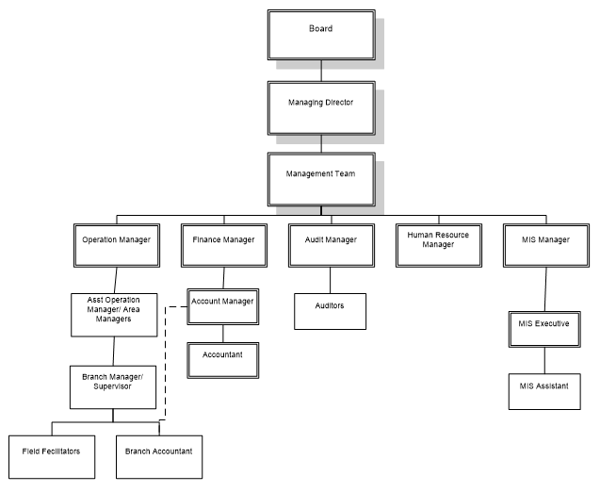

2.2 WHAT IS OPERATE" SYSTEM SOFTWARE?
operate" system software, essentially means to use your computer's operating system (OS) by interacting with its graphical user interface (GUI) through your mouse and keyboard, which allows you to open applications, manage files, access settings, and perform basic computer functions; you don't directly control the system software itself as it runs in the background managing your hardware and other applications seamlessly.
Key points about operating system usage:
- Turning on your computer:
When you power on your computer, the system software (OS) automatically loads and starts running, displaying the desktop interface.
- Navigating the interface:
Use your mouse to click on icons and menus to open applications, access settings, and manage files within folders on your computer.
- Opening applications:
Double-clicking on an application icon on the desktop launches the program.
- File management:
Use the file explorer to browse, create, delete, rename, and move files within your storage.
- System settings:
Access settings panels to adjust various aspects like display resolution, network connections, sound volume, date and time, etc.
- Using keyboard shortcuts:
Many common functions can be performed with keyboard shortcuts for faster navigation and efficiency.
Important aspects of system software operation:
- Updates:
Regularly updating your operating system ensures you have the latest security patches and features.
- Driver management:
The OS automatically installs and updates drivers for connected hardware like printers, scanners, and webcams.
- User accounts:
Create separate user accounts for different users on the computer to manage access and privacy.
2.3 WHAT IS A LOAN
What is a Loan? A loan is a sum of money that one or more individuals or companies borrow from banks or other financial institutions so as to financially manage planned or unplanned events. In doing so, the borrower incurs a debt, which he has to pay back with interest and within a given period of time.
OVERDRAFT
An overdraft is when you withdraw more money than you have in your bank account. This can happen when you use your account to pay for something, even though you don't have enough money in your account to cover the cost.
How do overdrafts work?
- The bank lends you the money to cover the transaction
- You pay back the loan plus interest
- You may be charged fees
When might I use an overdraft?
- To cover unexpected expenses, like a last-minute bill
- To pay for short-term needs, like equipment or operating expenses
What are the risks of an overdraft?
- Overdrafts can lead to higher interest rates
- The bank can change your overdraft limit or ask you to pay back the overdraft at any time
- If you don't manage overdrafts carefully, you could get into financial trouble
Overdrafts vs. loans
Overdrafts are more flexible than loans because you can borrow money as needed, but loans have fixed repayment schedules

CHAPTER THREE
3.1 SYSTEM CONFIGURATION MANAGEMENT (SCM)
System Configuration Management (Scm) refers to the practice of systematically tracking, controlling, and managing the settings and components of a system, ensuring consistency across different environments and versions, often used in software engineering to maintain the integrity of a software application by tracking changes to its configuration files and components throughout the development lifecycle.
Key points about system configuration management:
- Purpose:
To maintain a consistent and documented state of a system, allowing for easy identification and resolution of configuration issues.
- Key functions:
  - Configuration identification: Recognizing and documenting all system components and their settings.
  - Change management: Controlling modifications to the system configuration, including approvals and impact analysis.
  - Configuration status accounting: Maintaining a record of the current system configuration and its changes.
  - Configuration verification and audit: Regularly checking if the system configuration aligns with the documented baseline.
- Tools and techniques:
  - Configuration management tools: Specialized software that automates configuration tasks like deploying updates, managing baselines, and auditing system states.
  - Version control systems: Tracking different versions of configuration files and allowing rollbacks if needed.
  - Configuration as code: Storing system configurations in text files, enabling easier management and automation.

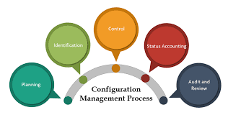

3.2 ACCOUNTING POSTING MANAGEMENT
Accounting posting management is the process of moving entries from a journal to a general ledger. It's a key step in the accounting cycle that helps ensure accurate financial records.
How it works
- Accountants record transactions in a journal in chronological order
- Accountants post the transactions from the journal to the general ledger
- Accountants use the general ledger to create financial statements
Why it's important
- Posting ensures that all transactions are accounted for
- Posting helps keep the accounting equation in balance (Assets = Liabilities + Equity)
- Posting makes it easier to see the overall status of an account
- Posting helps maintain organized and accurate financial records
Posting frequency
- Posting frequency can vary from once a day to once a month
- Posting is only necessary for larger-volume transaction situations
- For low-volume transaction situations, entries are made directly into the general ledger
Automation
Automation has made the posting process more efficient in modern accounting practices.

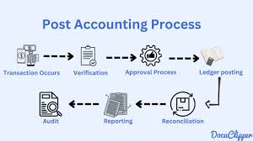

3.3 CASHIER POINT"
A "cashier point" refers to the physical location where a cashier processes customer payments, essentially the "point of sale" (POS) in a store, typically including a cash register, where a customer completes their purchase by paying for goods or services; it's the place where the transaction is finalized.
Key points about "cashier point":
- Synonym with POS: "Cashier point" is essentially another way to say "point of sale".
- Function: This is where a cashier scans items, calculates the total cost, and accepts payment from the customer.
- Hardware involved: A typical cashier point includes a cash register, credit card reader, barcode scanner, and a cash drawer.
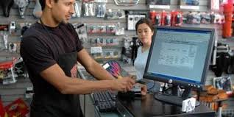

There are several types of accounts, including savings accounts, equity accounts, and fixed deposit accounts.
Savings accounts
- A type of account for people who want to save money, such as those who receive salaries or work as laborers
- Can be opened with a minimum initial deposit that varies by bank
Equity accounts
- Also known as owner's equity, equity accounts are a reflection of a company's overall worth
- Are included on the balance sheet, along with assets and liabilities accounts
- Retained earnings are a common equity account
Fixed deposit accounts
- A type of savings account where a specific amount of money is deposited for a fixed period
Other types of accounts
- Real accounts, which are classified as tangible or intangible
- Personal accounts, which are classified as natural, representative, or artificial
- Cash management accounts (CMAs), which are offered by non-bank financial institutions such as brokerages and robo-advisor platforms
- Natural personal accounts, which include accounts belonging to human beings, such as debtors, creditors, capital accounts, and drawings accounts
Accounting account types Asset accounts, Expense accounts, Income accounts, and Liability accounts.

CHAPTER FOUR
4.0 CONCLUSION AND RECOMMENDATIONS
4.1 CONCLUSION
Having passed through the SIWES training, have been able to discover and explore different things about the microbial world; therefore, its usefulness cannot be over – emphasized. The interesting part of this is that the field of microbiology has gotten answer to most of the infection and disease affecting the world. For the few infections that has not been diagnosed, precautionary measures that can be taken against it has been discovered. The only section left is for people should come out of their ignorance and go for medical check – up instead of relying on self – medication and visiting unqualified practitioners, if people could visit hospitals or health – centers frequently and follow the treatments given to them, mortality rate will drastically be reduced and the health status of the nation will be promoted.
More importantly I have been able to see the various prospects available in the field and also the various challenges that call for quick attention. Indeed, the industrial training program has been impactful; it was never a waste of time and energy.
4.2 RECOMMENDATIONS
The effort of the industrial training fund (ITF) was recommended for bringing up this programme known as student industrial work scheme (SIWES). This has paved way for self practice of the theoretical works that have been taught during lectures.

