
A TECHNICAL REPORT ON
STUDENTS INDUSTRIAL WORK EXPERIENCE SCHEME [SIWES]
Held at
UNIVERSITY OF ILORIN TEACHING HOSPITAL
Prepared by:
AYANDO FAITH ROSELINE
ND/23/NAD/FT/0009
SUBMITTED TO
DEPARTMENT OF NUTRITION AND DIETETICS
INSTITUTE OF APPLIED SCIENCE
KWARA STATE POLYTECHNIC, ILORIN
IN PARTIAL FULFILMENT OF THE REQUIREMENT FOR THE AWARD OF NATIONAL DIPLOMA (ND), IN NUTRITION AND DIETETICS

Sept., – Dec., 2024

DEDICATION
I dedicate this technical report to the Almighty God, the giver of knowledge, wisdom and who is rich in mercy.

ACKNOWLEDGEMENT
I take this opportunity to express my profound gratitude and deep regards to the creator of heaven and earth, the one who knows the beginning and the end, the alpha and the omega, the Almighty God and also to my guides Mr and Mrs AYANDO, and to all those who has helped me during my SIWES programme. The blessings, help and guidance given by them, time to time has carry me so this far and shall carry on the journey of life on which I am about to embark. I also take this opportunity to express a deep sense of gratitude to compliment my mentor for his cordial support valuable information and guidance which helped me in completing my SIWES through various stages.
Lastly my deep regard to the best and most inspiring brothers, sisters and friends may Almigthy God continue to bless you all.

TABLE OF CONTENT
Title page
Table of content
Dedication
Acknowledgements
TABLE OF CONTENTS
CHAPTER ONE
  - Background of SIWES
  - History of SIWES
  - Objectives of SIWES
  - Objectives of Establishment
CHAPTER TWO
2.1 Location And Brief History Of University Of Ilorin Teaching Hospital
2.2 Objective Of University Of Ilorin Teaching Hospital
2.3 Organization Structure
CHAPTER THREE
3.1 Nutrition in Pregnancy And Lactation
3.2 Physiology Of Pregnancy
3.3 Nutrients Requirement Before Pregnancy
3.4 Nutrients Requirement During Pregnancy
3.5 Vitamins And Minerals Needed During Pregnancy
3.5 Nutrients Requirement During Postpartum
CHAPTER FOUR
4.1 The Nutrition Care Process (NCP)
4.2 Preparation Of Fortified Pap With Standard Measurements
4.3 Preparation Methods
CHAPTER FIVE
5.1 Summary, Challenges Encountered, And Conclusion Recommendation
5.2 Challenges Encountered
5.3 Conclusion
5.4 Recommendation
CHAPTER ONE
  - INTRODUCTION TO SIWES
Students Industrial Work Experience Scheme (SIWES) is a Skills Training Program designed to prepare and expose Students of Universities, Polytechnics, Colleges of Technology, Colleges of Agriculture and Colleges of Education for the Industrial Work situation they are likely to meet after graduation. The Scheme affords Students the opportunity of familiarizing and exposing themselves handling equipment and machinery that are usually not available in their institutions.

1.2 HISTORY OF SIWES
The Students’ Industrial Work Experience Scheme (SIWES) was initiated in 1973 by the Federal Government of Nigeria under the Industrial Training Fund (ITF) to bridge the gap between theory and practice among products of our tertiary Institutions. It was designed to provide practical training that will expose and prepare students of Universities, Polytechnics, and Colleges of Education for work situation they are likely to meet after graduation.
Before the establishment of the scheme, there was a growing concern among the industrialists that graduates of institutions of higher learning lacked adequate practical background studies preparatory for employment in industries. Thus the employers were of the opinion that the theoretical education going on in higher institutions was not responsive to the needs of the employers of labour.
As a result of the increasing number of students’ enrolment in higher institutions of learning, the administration of this function of funding the scheme became enormous, hence ITF withdrew from the scheme in 1978 and was taken over by the Federal Government and handed to National Universities commission (NUC), National Board for Technical Education (NBTE) and National Commission for Colleges of Education (NCCE). In 1984, the Federal Government reverted back to ITF which took over the scheme officially in 1985 with funding provided by the Federal Government.

1.3 OBJECTIVES OF THE PROGRAMME
The specific objectives of SIWES are to:
- Provide placements in industries for students of higher institutions of learning approved by relevant regulatory authorities (NUC, NBTE, NCCE) to acquire work experience and skills relevant to their course of study
- Prepare students for real work situation they will meet after graduation.
- Expose students to work methods and techniques in the handling of equipment and machinery that may not be available in schools.
- Make transition from school to the labour market smooth and enhance students’ conduct for later job placement
- Provide students with the opportunity to apply their knowledge in real life work situation thereby bridging the gap between theory and practice
- Strengthen employer involvement in the entire educational process and prepare students for employment in industry
Promote the desired technological know how required for the advancement of the nation.
1.4 OBJECTIVES OF ESTABLISHMENT
- To provide optimum and individual care to patients.
- To develop recognition for patients needs for privacy and preservation of dignity.
- To maintain good relationship with patients, relations and the community through health education.
- To carry out diagnosis and intervention.
- To provide training for students.
- To maintain sufficient hospital supply of equipment and promote their utilization and maintenance.
To treat and control diseases.

CHAPTER TWO
2.1 LOCATION AND BRIEF HISTORY OF UNIVERSITY OF ILORIN TEACHING HOSPITAL
The University of Ilorin Teaching Hospital belongs to the second (2nd) generation of Teaching Hospitals in the country. The Hospital came into existence on 2nd of May 1980 along with five other hospitals located in Jos, Calabar, Sokoto, Maiduguri and Port Harcourt. Temporary Site and Lease Agreement The University of Ilorin Teaching Hospital took off in July 1980 and started its operations using as its temporary site, the Ilorin General and Maternity hospitals, which were owned by the Kwara State Government. The formal release of the two hospitals to the Management Board of this Teaching Hospital was done on 1st September 1981 when a lease agreement was signed between the Federal Ministry of Health and the Kwara State Government. The University of Ilorin Teaching Hospital remained in these two old sites (General Wing was built in 1955 and Maternity Hospital Wing was built in 1937) till early 2009 when gradual relocation to the Permanent Site commenced. Full movement to the Permanent site from the General Hospital Wing was completed in mid 2010. However the training Schools of the Hospital are presently occupying the Maternity wing.
PERMANENT SITE OF THE HOSPITAL The contract for the construction of the 13 phased Permanent Site of the hospital was awarded by the Federal Government in 1981. The contract commenced on the 13th of April 1981 but the project was abandoned when it reached only 33% completion stage on 20th December 1985. In August 2000, construction work resumed at the Permanent Site and Building One (1) was constructed then. This Hospital is privileged to be one of the 8 Teaching Hospitals in the country to have benefitted from $8 million VAMED Engineering Co. Ltd. Medical Equipment supply which was a key health project of the Obasanjo Administration. To this end, building six (6) comprising the Radiology Department and the main Theatre became the next priority. This is because the VAMED project required that physical infrastructures should be put in place before the installation of various equipment. The Federal Government also, approved contracts for the pre-installation works to be carried out at the Permanent Site of the Hospital. This involved the completion of the space required and the provision of mechanical and electrical services for Building six built to house Radiology complex, 8 operating theatres, and an ICU. Through the VAMED Project, UITH became a recipient of state-of- the-art Radio-diagnostic, Surgical, Medical and laboratory equipment.
2.2 Objective Of University Of Ilorin Teaching Hospital
The objectives for which the Hospital was set up are:
i. To Train Medical and Paramedical Personnel
ii. To deliver Health Care Services
iii.To serve as referral Centre for other Hospitals around and
iv.To conduct researches
2.3 Organization Structure

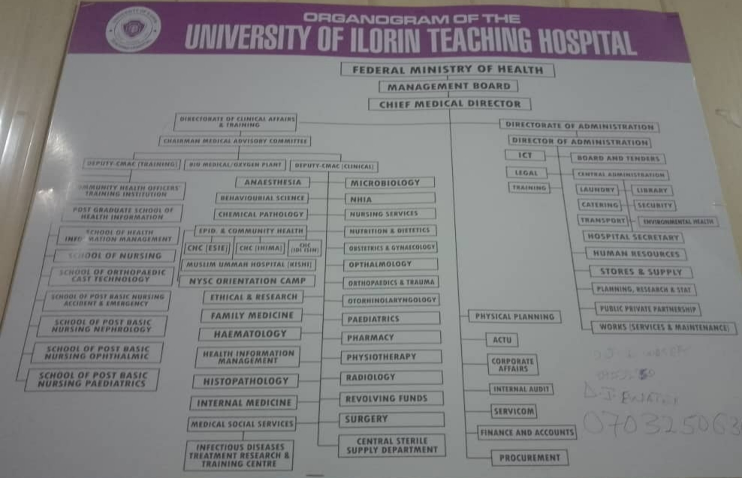

CHAPTER THREE
3.1 Nutrition in Pregnancy And Lactation
Nutrition in pregnancy and lactation is crucial for both the mother and the baby’s health. Throughout pregnancy and infancy, a new human grows and develops, and this feat is made possible in large part because of the nutrients that the mother provides. Nutrient requirements are greater in pregnancy and lactation to support maternal health, the healthy growth and development of the fetus, and the production of milk to nourish the infant.
3.2 Physiology Of Pregnancy
Human pregnancy lasts for approximately 40 weeks (when counted from the first day of a woman’s last menstrual period) and is roughly divided into thirds, or trimesters. Pregnancy begins when the sperm fertilizes the egg, and the single cell formed from this union begins to divide and differentiate. During the first few weeks of development, the cells of the uterine lining provide nutrients to the developing embryo. Between the 4th and 12th weeks, the developing placenta gradually takes over the role of feeding the embryo, which is called a fetus beginning in the 9th week of pregnancy. The placenta forms from tissues deriving from both the fetus and the mother, and this new organ becomes the interface between the two. The placenta provides nutrition and respiration, handles waste from the fetus, and produces hormones important to maintaining the pregnancy. The blood of the fetus and mother do not mix in the placenta, but they come close enough that nutrients (including glucose, amino acids, fatty acids, vitamins, and minerals) and oxygen can pass from the mother’s blood to the fetus, and carbon dioxide and waste products can be passed from the fetus to the mother.
The first trimester is a key period for the formation of embryonic and fetal organs. During the second and third trimesters, the fetus continues to grow and develop, with final development of organs such as the brain, lungs, and liver continuing in the last few weeks of pregnancy.
Infants born before 37 weeks of pregnancy are considered preterm, and because they have not completed fetal development, are at increased risk for a range of health problems.
3.3 Nutrients Requirement Before Pregnancy
Before pregnancy, women needs nutritious and safe diets to establish sufficient reserves for energy and other nutrients. Therefore, adequate nutrition is vital for women who are trying to conceive or may become pregnant. In addition, women who are either underweight or obese before becoming pregnant can find it more difficult to get pregnant and face greater risks of pregnancy complications. Therefore, it’s recommended to establish healthy eating and exercise habits and work towards a healthy weight before pregnancy.

3.4 Nutrients Requirement During Pregnancy
Pregnant women need more calories, macronutrients, and micronutrients than they did before pregnancy. A dietary pattern focused on vegetables, fruits, whole grains, nuts, legumes, fish, and vegetable oils, and lower in red and processed meats, refined grains, and added sugars is associated with a reduced risk of pregnancy complications such as gestational diabetes and hypertension. During pregnancy, poor nutrition can cause preeclampsia, hemorrhage, stillbirth, low birth weight and developmental delays in children.
The following recommendations should be followed for a healthy lifestyle during pregnancy according to My pregnancy plate:
- Choose large portions of a variety of non-starchy vegetables such as leafy greens, broccoli, carrots, bell peppers, tomatoes, mushrooms, and cabbage.
- Choose a variety of whole fruits, limiting juice and dried fruit.
- Aim for 2 to 3 servings of nonfat or 1 percent milk or yogurt (unsweetened or slightly sweetened).
- Choose protein sources like poultry, beans, nuts, eggs, tofu, and cheese. Aim for 8 to 12 ounces of low-mercury seafood each week.
- Choose fiber-rich sources of carbohydrates, including whole grains, legumes, and starchy vegetables such as sweet potatoes and squash.
- Drink mainly water, decaf coffee, or tea.

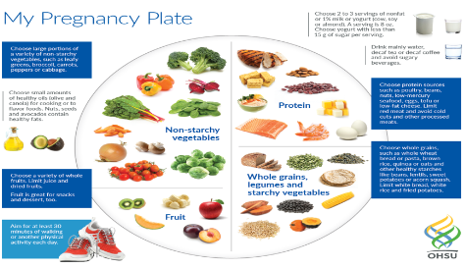
3.5 Vitamins And Minerals Needed During Pregnancy
S/N | NUTRIENTS | RDA | IMPORTANCE | SOURCES
1 | Vitamin A | 770mcg | Forms healthy skin  and eyesight; helps  with bone growth | Carrot, spinach,  oil, potato,  tomato
2 | Vitamin B6 | 1.9mg | Helps form red  bloodcells; helps  the body  metabolize  macronutrients | Oat, milk,  poultry, fish
3 | Vitamin B12 | 2.6mcg | Maintains nervous  system; helps form  red blood cells | Soy milk, yogurt,  egg
4 | Vitamin C  i | 85mg | Promotes healthy  gums, teeth, and  bones | Citrus fruit,  pepper,broccol
5 | Calcium | 1000mg | Builds strong bones  and teeth | Dairy products, leafy greens,fish,  nut and seeds,

3.5 Nutrients Requirement During Postpartum
Postpartum nutrition is crucial for a new mother's recovery and overall health, as well as for supporting breastfeeding. Here are some important postpartum foods and their benefits:
- Leafy Greens: Spinach, kale, and other leafy greens are rich in iron, calcium, and vitamins A and C, helping replenish nutrients lost during childbirth and support overall health.
- Lean Proteins: Chicken, turkey, lean beef, eggs, and legumes provide essential amino acids necessary for healing tissues and maintaining muscle strength.
- Whole Grains: Brown rice, quinoa, oats, and whole wheat bread offer complex carbohydrates for sustained energy and help maintain blood sugar levels.
- Dairy Products: Milk, cheese, and yogurt are excellent sources of calcium and vitamin D, which are important for bone health, especially if breastfeeding.
- Fruits: Berries, oranges, bananas, and apples provide vitamins, minerals, and antioxidants that support immune function and overall health.
- Nuts and Seeds:Almonds, walnuts, flaxseeds, and chia seeds are packed with healthy fats, protein, and omega-3 fatty acids, supporting brain health and reducing inflammation.
- Fish:Fatty fish like salmon, sardines, and trout provide omega-3 fatty acids, which are crucial for brain health and may help reduce postpartum depression.
- Hydrating Foods: Water-rich fruits and vegetables, such as cucumbers, watermelon, and celery, help maintain hydration levels, which is important for overall health and breastfeeding.
- Legumes: Lentils, chickpeas, and beans are excellent sources of iron, protein, and fiber, supporting energy levels and digestive health.
- Herbal Teas: Certain herbal teas like fenugreek and fennel can support lactation, while
others like chamomile can promote relaxation and better sleep.

CHAPTER FOUR
4.1 The Nutrition Care Process (NCP)
The NCP is a framework that guides registered dietitians (RDs) and other healthcare professionals in providing high-quality, patient-centered nutrition care. It's a systematic approach to:
1. Assess patients' nutritional needs
2. Diagnose nutrition-related problems
3. Develop personalized nutrition care plans
4. Implement and monitor those plans
5. Evaluate the effectiveness of care
Here's a detailed overview of the NCP:
Step 1: Nutrition Assessment
- Collect relevant data on patients' medical history, dietary habits, lifestyle, and anthropometric measurements
- Identify potential nutrition-related problems
Step 2: Nutrition Diagnosis
- Analyze assessment data to identify specific nutrition-related problems
- Use standardized language to document diagnoses (e.g., "inadequate energy intake")

Step 3: Nutrition Care Planning
- Develop personalized care plans addressing diagnosed nutrition problems
- Consider patients' cultural, social, and economic factors
Step 4: Nutrition Intervention
- Implement care plans through education, counseling, and support
- Provide ongoing monitoring and adjustments as needed
Step 5: Nutrition Monitoring and Evaluation
- Regularly assess patients' progress toward goals
- Evaluate the effectiveness of care plans
- Revise plans as necessary to ensure optimal outcomes
By following the Nutrition Care Process, healthcare professionals can deliver comprehensive, patient-centered care that addresses the complex relationships between nutrition, health, and well-being
4.2 Preparation Of Fortified Pap With Standard Measurements
INGREDIENTS; soya beans,guinea-corn paste,palm oil,Egg, sugar
QUANTITY;
- Soybeans-200g
- Egg - 1 egg most time is 60g
- Sugar-30g
- palm oil -15mls
- Water- 750mls or 75cl
- fish paste- 45g (optional)
- groundnut paste -20g (optional)
- Guineacorn /millet paste /250g
4.3 PREPARATION METHODS
- Soaking of the soybean in hot water for an hour
- Removing of the shaft
- Wash and soaked for 1-2hrs in water
- Mill it into smooth paste kept cover
- Measure of 750mls or 75cl in to clean pot
- Sieve the soy paste to extract soy milk from it
- Put the milk on fire and let it be covered
- Break your egg in to a clean cup or bowl and whisk it very well or thoroughly till it becomes whitish in color
- Add abt four table spoon of pap paste and mixed it together
- Check the soy milk on fire,stir it continuously to avoid coagulation
- When the soy milk is cooked it will not bubble again
- Pure the mixed well egg with pap paste in to the cooked soy milk
- Stir it to prevent coagulation
- Leave for abt 10-15min
- Add the remaining grams of pap paste
- Add 1 table spoon of palm oil
- Add 30g of sugar stir it together
- Leave it on fire for 1mins then serve
CHAPTER FIVE
5.1 SUMMARY, CHALLENGES ENCOUNTERED, AND CONCLUSION RECOMMENDATION
5.2 CHALLENGES ENCOUNTERED
The main problems encountered were getting placement and transportation. It was quite challenging for me that live in far place to get to the organisation every working day. I was not given any remuneration or allowance, other problems encountered during the training was attending to different people with different personalities at the reception.
5.3 CONCLUSION
My four months industrial attachment with University of Ilorin Teaching Hospital has been one of the most interesting , productive, instructive and educative experience in my life. Through this training, I have gained new insight and more comprehensive understanding about the real industrial working condition and practice and also improved my soft and functional skills.
All these valuable experiences and knowledge that I have gained were not only acquired through the direct involvement in task but also through other aspects of the training such as: work observation, supervision, interaction with colleagues, supervisors, superior and other people related to the field. It also exposed me to some certain things about medical environment. And from what I have undergone, I am sure that the industrial training programme has achieved its primary objective.
As a result of the programme, I am now more confident to build my future career which I have already started with University of Ilorin Teaching Hospital .
5.4 RECOMMENDATION
I recommend that all institutions or bodies involve in Student Industrial Working Experience Scheme, should provide places for industrial attachment for Student Industrial Training Fund and also pay some allowances to students and the company should provide more safety equipments to prevent further environmental and health hazards.
Also, to students that are to undergo the training, I recommend that they should take it very seriously, because it is one of the most important parts of their studies which will help them build a very significant and effective meaning in their career pursuit.

