

TECHNICAL REPORT ON STUDENT INDUSTRIAL WORK
EXPERIENCE SCHEME {SIWES}

HELD AT
FOREVER GRACE VENTURES LTD.
N0 5 FACTORY STREET MEDINA IGBESA OGUN STATE

WRITTEN BY
OKEBUNMI AYOMIDE OLAITAN
ND/23/EEE/PT/0106

SUBMITTED TO

DEPARTMENT OF ELECTRICAL AND ELECTRONIC ENGINEERING, INSTITUTE OF TECHNOLOGY, KWARA STATE POLYTECHNIC
IN PARTIAL FULFILLMENT FOR THE AWARD OF NATIONAL DIPLOMA (OND) IN ELECTRICAL AND ELECTRONIC ENGINEERING, KWARA STATE POLYTECHNIC, ILORIN, NIGERIA.
SEPTEMBER – DECEMBER 2024

DEDICATION
I dedicated this report to Almighty God for his love, grace, mercy and divine protection over me.
And also to my parent for their moral and financial support and my lovely siblings; May God continue to be with you and satisfy you with long life and good state of health.
Finally, to my family members, friends and well wishers whom as always been there for me, May God reward them abundantly in life and hereafter.

ACKNOWLEDGEMENT
I give thanks to Almighty God that makes it possible for me to go through safely and for counting me worthy to be among the living souls. My appreciation goes to my parent MR & MRS OKEBUNMI for their prayer, support and love for me. I also acknowledge my supervisor, HOD of the department and all the lecturers who has in one way or the other imparted in me, I pray may you all never work in vain and may God reward you all for imparting knowledge into me .God bless you all.
I also thank all the people who have contributed immensely to the successful completion of the program.

PREFACE
SIWES is a program design by the industrial training fund (ITF) WHICH ALLOW THE STUDENT to acquire more knowledge and skills by applying the theories learnt in class room into practical in their respective field of study.

TABLE OF CONTENTS
TITLE PAGE
DEDICATION
ACKNOWLEDGEMENT
PREFACE
TABLE OF CONTENTS
CHAPTER ONE
1.0 INTRODUCTION OF SIWES
1.1 AIMS AND OBJECTIVES OF SIWES
1.2 ORGANIZATION CHART
1.3 EXPECTED CONTRIBUTION TO KNOWLEDGE
CHAPTER TWO
2.0 INTRODUCTION TO TOOLS AND THEIR USES
2.1 SOME DIAGRAM OF ELECRICAL TOOLS
2.3 ELECTRICAL ASSESSORIES
CHAPTER THREE
3.0 WIRING SAFTY CODES
3.1 COLOR CODES/NUMERICAL CODES
3.2 WIRING SYSTEM
CHAPTER FOUR
4.0 MAINTENANCE OF TOOLS
4.1 BASIC RULES FOR MAINTAINACE
4.2 IMPORTANCE OF TOOLS
4.3 WORKSHOP SAFET
CHAPTER FIVE
5.0 EXPERIENCEAQUIREDINTHEORGANIZATION
5.1 RECOMMENDATION
5.2 CONCLUSION

CHAPTER ONE

INTRODUCTION
This report is based on the knowledge acquired during my four month student industrial work experience scheme (SIWES) is an integral part of degree in National Diploma program in the institution of higher learning in Nigeria established in year 1973 by federal government. The scheme is designed to expose the student in the tertiary institution to have more experience in the working environment in which they will likely proud themselves after completing their chosen course of study in the institution. It also prepares the student to have courage and discipline by merging the analytical power with self radiance and social interaction.
AIMS AND OBJECTIVES OF SIWES
The aims and objectives of the student industrial work experience scheme (SIWES) are:
- To enable the student to apply their academic knowledge in real practical.
- It expose student to some machines and instrument used in a particular field.
- To establish a link between the school and the outside environment and to install discipline advance of safety rules and regulations.
- Make the transition from school to the word of work easier and reliance student’s contact for placement.
- It expose student to industrial challenges.

ABOUT ORGANIZATION CHART
MANAGING DIRECTOR
SECRETARY

WORKERS/JOINMAN

IT STUDENT/SIWES
APPRENTICES

EXPECTED CONTRIBUTION TO KNOWLEDGE
It is expected that SIWES program should prepare student for the industrial work situation to meet after graduation. It should also enable the student to apply their academic knowledge in real practical. At the end of the program, the student should have accessed important working equipment that is not available in the school environment but more available institution.

CHAPTER TWO
COMMON TOOLS AND HAND TOOLS WITH THEIR USES
There are various tools used in electrical installation either in surface wiring or in conduit wiring, they are highlighted below:
- Plier : it is use to cut, loose and tie cable.
- Tester: it is use to test the flowing of electric current.
- Hammer: it is use for nailing clip into the wall in surface wiring.
- Screw driver: it is use to loose and tightening of screw.
- Bending spring: it is use to bend PVC pipes.
- Insulated hand gloves: it prevents electric shock.
- Multimeter: it is used to take reading and also used to detect faulty wires.

SOME DIAGRAM OF ELECTRICAL TOOLS
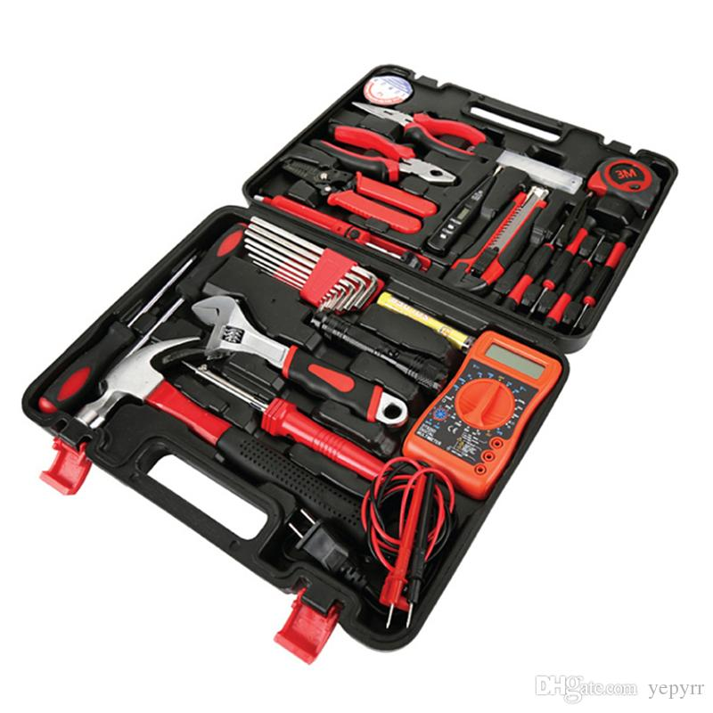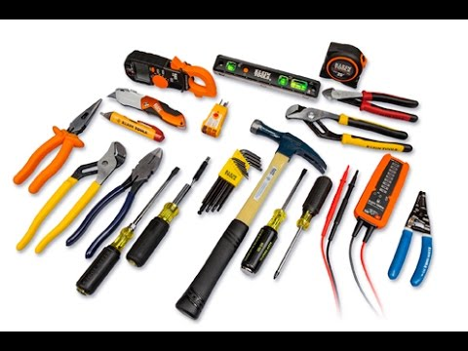

ELECTRICAL ASSESSORIES
There are so many electrical accessories in wiring installation of the building, they are;
*SWITCH: this is of difference gang and can be use for putting on and off the electrical appliance
* PATRESS: this serve as the base for switchs and wall sockets
* CLIP &NAIL: this is use to hold firmly the wire with the wall
* LAMP HOLDER: this is use to hold bulb
* ENERGY METER: this measure the amount of energy that is entering a particular house
* CHANGE OVER: this is use to change the source of electricity whether it is government owned electricity, (e.g Ibadan Electricity Distribution Company) private source (e.g A.C Generator, Solar)
*BUSBAR:foreveryheavycurrentsinelectricalapparatus,andforheavycurrentsdistributedthroughabuilding,busbarcanbeused.Eachliveconductorsuchasystemisarigidpieceofcopperoraluminium,usuallyinflatbars(butsometimesastubingorothershapes).
* EARTHED ELECTRODE: a metal rod or rods, metal plate or mat having effectual connection with the general mass of the earth.

* DISTRIBUTION BOARDS: this is an assemblage of parts, including one or more fuses or miniature circuit breaker, arrange for the purpose of distribution of electrical energy to the final sub-circuit and too their distribution boards.
TYPES OF DISTRIBUTION BOARDS
*Single phase
* Double phase
* Three phase
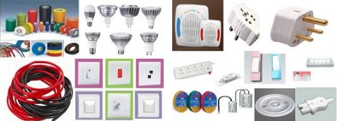

CHAPER THREE
WIRING SAFETY CODES
Wiring safety codes vary by country, Wiring and cables are rated by the circuit voltage, temperature, and environmental conditions (moisture, sunlight, oil, chemicals) in which they can be used. Colour codes are used to distinguish, neutral and ground (earth) wires, while some uses numerical numberings.
COLOUR CODES
To enable wires to be easily and safely identified, the common colour safety codes are:
1. Red/Brown (this is used to identity the live )
2. Black/Blue (this is used to identity the neutral)
3. Yellow/Green (this is used to identity the earth/ground)
NUMERICAL CODES
Most of this kind of wires are not commonly used, and most of this wires are mostly black insulated wires, it is always a strand type of wire ,its numbering ranks 1,2,3,4,5,6,7,8,9 .....
TYPES OF WIRE AND THIER USES
1. TRIPLEX WIRE
Triplex is an aerial cable that the utility company uses to feed power pole . This wire ties to the wires sticking out of the weather head.
2. MAIN FEEDER WIRES
These wire are usually type THHN wire and are rated for 125% of the load required. These are usually black insulated wires coming out of the service weather head.\

3. PANEL FEED WIRES
These wires are also type THHN, like the main feeders. A typical 100-amps service would have a #2THHN SET OF WIRES. They would then be rated at 125amps. This would protect the wires if the amperage was full 100 amps.
4. Non - metallic sheathed wire (NM)
This wire, are commonly called Romex, is a plastic coated wire that has either two or three conductors and a bare ground wire. This is the typical wiring used in most home s. The rating for this wire is either 15amps, 20 amps,or 30 amps, depending on the installation.
5. SINGLE STRAND WIRE
When your home is piped, you'll have another type of wire. Single strand wire is insulated and many of these can be pulled into the same pipe. Normally, you'll be using THHN wire for installation.
SIZES OF WIRES
Wires are also breakdown into sizes depending on the purpose it will be used go for we have :
1mm,1.5mm,2.5mm,4mm,6mm,10mm,16mm......
WIRINGSYSTEM
BUILDINGWIRINGistheelectricalwiringandassociateddevicesuchasswitches,meter sand light fittings used in buildings or other structures. Electrical wiring us s insulated conductors
Point considered for wiring system of a building are as follows :
* Neatness of the finished job : to see if a particular wiring systemic choosing for a building will not be an eye sure.
* Time required to complete the wiring : that is if the length of time that is allocated for completion will not fail, particularly urgent jobs being allocated by government.
* Durability of the installation : if a particular wiring chosen will withstand the hazard conditions of usage or will last long as expected of the installation. Eg. A surface PVC sheared wiring will prove hazardous to a metal workshop.
* Future extension and alteration : one must ensure that a system of wiring will give room for future addition and alteration. E.g. A concealed conduit wiring will not be suitable for factory installation which is often subject to extension.
* cost of installation : this is one important aspect to be considered when deciding on a wiring system because a client may want wire his/her building in full conduit because of the neat appearance but by the time he/she sees the estimated cost of the wiring he/she may not be able to afford the cost.
* Special consideration like dampness, flammable : in situations which is either permanently damp or temporarily damp, damp proof fittings and wiring materials must be used to prevent ingress of moisture to the wiring, and if inflammable situation all accessories and apparatus to be used must be of flameproof type.
* Damage to the fabric of the building by cut away : eg. It will be better to wire a complete multistory building in surface wiring than in concealed conduit which may weaken the walls and pillar when chiselled to form a channel.
TYPES OF WIRING SYSTEM IN NIGERIA
(1) PVC sheathed cable wiring on surface (surface wiring): this can be described as a system of running cables outside the wall and fixed with a buckle clip.
In surface wiring the following are essential for a correct connection of wires at the joint box, which states that :
• The red/brown wire of the switch should be connected to the supply coming from the main source (its called the supply).
• The black/blue wire of the lighting point should be connected to the supply coming from the main source (its called the neutral).
• The red/brown wire of the lighting point should be connected to the black/blue coming out from the switch (its called the branch).
• All sockets are connected connected directly.
• All the water heater wires meets at the switch I.e the load and the supply.
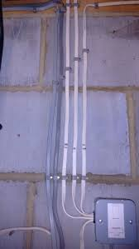
(2) conduit system of wiring: it uses metals conduit or plastic conduit pipes which are buried in walls or underground which wires are run into to provide mechanical protection on the insulated cables. The most common form of conduit used in Nigeria for electrical installation in residential or office building is insulated or plastic conduit(sizes of pipes : 20mm,25mm....).
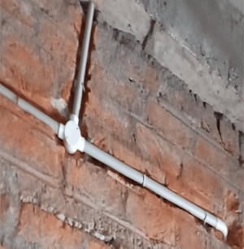

(3) Trucking system of wiring :this kind of wiring systems is similar to the surface
wiring ,the only difference in this kind of wiring is dat it also has metals or plastic pipes which run outside the wall to provide mechanical protection on the insulated cables (sizes of trucking pipes:16mm,20mm,25mm....).

CHAPTER FOUR
MAINTENANCE
This is the process of preserving a condition or situation technically; maintenance involves various activities such as functional checks, inspection, servicing, repair, replacement, fault detection, cleaning and adjustment, e.t.c. We all know that if we dont take care of our body it tend to break down likewise the machines also. It is a must for every Engineer to know how to take care of the machine he uses and also how to maintain them.
There are three type of maintenance listed below:
- Corrective maintenance
- Predictive maintenance
- preventive maintenance

Corrective Maintenance: Equipment is repaired or replaced after wear, malfunction or break down. It is often most expensive which usually lead to multiple damage, and consequently brings about significant losses of revenues due to down time during overhauling.
PredictiveMaintenance:itusessensordatatomonitorasystem,thencontinuouslyevaluateitagainsthistoricaltrendstopredictfailurebeforeitoccurs.Thisstrategyallowsmaintenancetobeperformedmoreefficiently,sincemoreuptodatedataisobtainedabouthowclosetheproductistofailure.
PreventiveMaintenance:EquipmentorFacilitiesareinspectedmaintainedandbeforebreakdown.Itisperformedwiththeintentofavoidingfailures,safetyviolations,unnecessarylosses,andtoconserveoriginalmaterialsoffabrication.

BASIC RULES FOR MAINTENANCE
There are five basic rules that should be followed;
°Maintenanceshouldstartwithproperplanning.Consultingworkersandkeepingtheminformedisvitalthroughouttheplanningstageincludinginvolvementinpreparingriskassessments.
°The work are need stop be secured by prevent in gun authorized access.
°Employersmustprovidetherighttoolsandequipmentforthejobinappropriateconditionandsuitablefortheworkenvironment.
°Theworkshouldbemonitoredbythesupervisorinchargesothattheagreedsafesystemsofworkandsitesrulesareobserved.
°All must be check and declare safe to complete the maintenance tools.
IMPORTANCEOF TOOL
* It makes work easier and faster to do.
* It helps in saving mans effort.
* It makes the work done perfectly and neat.
WORK SHOP SAFETY
Safety is an important factor that should be put in place in the workshop to reduce accidents.
Theworkshopputanumberofsafetyprecautionintheworkshopwhichallthestudentsmustdullyobeyandtheyarelistedbelow:

* Students must put on their overall and safety shoes
* There must be noun necessary movement or running in the workshop.
* Fatal accidents should be reported to the workshop supervisor.
*Student must use insulated plier.
* Student must avoid peeling wire with their teeth.

CHAPTER FIVE
EXPERIENCE AQUIRED IN THE ORGANIZATION
It was a great opportunity for one to have training in AIP Electrical and Electronics because I was so fortunate to acquire some experience that will help me in future. I learnt many things some can be stated and some cannot be stated.
° How to maintain electrical equipment
° How to do wiring installation of a building
° Types/codes of wires
° Types of wiring system
RECOMMENDATION
I humble recommend that all the student of this great institution should not get themselves in irrelevant matters, with the few months I spent during my student industrial experience scheme (SIWES) I wish this opportunity should also be granted to the student who are to come after us so as to enable them to acquire more knowledge and to carryout some practical by their selves to have experience as I do.
CONCLUSION
Conclusively, the student industrial work experience scheme (SIWES) has exposed me to many useful training which are relevant to my course of study.
During the four month industrial training it has broad knowledge in the practical aspect of my course of study.

