

TECHNICAL REPORT ON
STUDENTS INDUSTRIAL WORKS EXPERIENCE SCHEMES (SIWES)

HELD AT

KWARA STATE BROADCASTING CORPORATION RADIO STATION
2, Police Road GRA Kwara State Ilorin

PRESENTED BY:

OJO ZAINAB ADUKE
ND/23/MAC/PT/0666

SUBMITTED TO:

THE DEPARTMENT OF MASS COMMUNICATION, INSTITUTE OF INFORMATION AND COMMUNICATION TECHNOLOGY, KWARA STATE POLYTECHNIC, ILORIN.
IN PARTIAL FULFILMENT OF THE REQUIREMENT FOR THE
AWARD OF NATIONAL DIPLOMA (ND) IN MASS COMMUNICATION.

AUGUST - NOVERMBER 2024

DEDICATION
I am delight to dedicate this report to Almighty God who gave me the grace and opportunity to complete this programme.

ACKNOWLEDGEMENT
I thank God Almighty for his mercy and grace that kept me all through my SIWES period.
I am greatly indebted to my parents, Mr. & Mrs. Ojo for their morally, spiritually and financially, word of encouragement and prayer given to me, who make my SIWES programme successful and also my relatives and siblings.
I also want to thank my friend and everyone that contributed to the success of my SIWES program my Industrial supervisors, my colleagues and co-workers for the tremendous moral assistance throughout the period of my attachment.

REPORT OVERVIEW
The report comprises the background of SIWES, the description of the organization, its aims and objectives, the experiences gained as an industrial training student and the summary, conclusions and recommendations.
It has a total of 5 chapters with sub-chapters. It also has the preliminary pages, such as the title page, report overview and table of contents and recommendations on the improvement of scheme.

TABLE OF CONTENT
Title Page i
Dedication ii
Acknowledgement iii
Report Overview iv
Table of Contents v

CHAPTER ONE
1.0 Introduction 1
1.1 Definition of SIWES 1
1.2 Aim and Objectives 1
CHAPTER TWO
2.1 Brief history of the organization 3
2.2 Organization chart 4

CHAPTER THREE
3.0 Workdone 5
3.1 How do you structure a radio program 4
3.2 What is news casting 4
3.3 What is news writing 4
3.4 How to write news 4
3.5 What are the rules of press reporters 5
3.6 Broadcasting 7
3.7 Types of Broadcasting 7
3.8 Studio Broadcasting Equipment 8
3.9 Jingle 11
3.10 How to write an effective jingle 11
3.11 How do you write a jingle script 11
3.12 What is the use of content with caption 12
3.13 Video Editing 12
3.14 Video Downloading 12
3.15 The difference between streaming and downloading media 13

CHAPTER FOUR
4.0 Experience gain 15

CHAPTER FIVE
5.0 Conclusion 16
5.1 Suggestion and Recommendation to the organization and polytechnic concerning the siwes program 16

CHAPTER ONE
- INTRODUCTION
SIWES program was established in year 1973 by the federal Government of Nigeria through the industrial Training Fund (ITF) under the National Board of Technical Education (N.B.T.E) and it has its head quarters in Jos, plateau state.
There are other reasons behind the establishment of SIWES program, but the major reason is to learn the practical aspect of their field of study while still in course of study, which will help to face the future challenges in their respective field of study.
1.1 DEFINITION OF SIWES
Student Industrial Work Experience Scheme (SIWES) can simply be defined as a course by which student are exposed to practical training in their respective field of study. Its aim is to expose students to work practically in their respective disciplines. However, the scheme therefore was introduce to enable students match theoretical classroom knowledge with related practical knowledge in the industrial environment.
1.2 AIM AND OBJECTIVES OF SIWES
- SIWES helps the student to have experience and develop during industrial training.
- To improve students in the practical aspect of their field.
- It helps to improve quality of student in the level of their technology.
- It makes student to find their interests in the various fields of study.
- To prepare student for the future.

CHAPTER TWO
2.0 BRIEF HISTORY OF THE ORGANIZATION
Ilorin was the first location in Kwara State where broadcasting services were provided by the Kwara State Broadcasting Corporation (also known as “Radio Kwara”). These services began in 1956 as a relay station. In those days, people referred to it as the provincial broadcasting house.
The one quarter kilowatt (kW) medium wave transmitter that was employed at the time could only reach an area within an eight kilometer radius of Ilorin.
However, the Kwara State Broadcasting Corporation as it is now was not one of the beneficial byproducts of the first state to be created in Nigeria. It did not come into existence until the adoption of the Kwara Edict No. 3 of 1979, but it took effect back on April 10th, 1978.
Due to the state of Kwara’s topography, it was decided that it should be covered with both medium and shirt wave transmitters when it was created in 1967. This was part of a larger master plan that was developed and approved for the entire nation at the same time. This plan was based on the number and capacity of transmitters as well as the mode of transmission that were to be sited in each new state.
These facilities wave put into use is from 19th December, 1976; however, as a result of a directive from the federal government, the short wave transmitter was shut down in 1976. Instruction work began in 1974 in the modern studio/broadcasting house at the 10kw short wave and 20kw medium wave transmitting station sites. On April 1st, 1978, a decree was issued in camphene with the federal government that transfers all radio Nigeria stations on the state to their respective host states. On September 5, 1978, Mr. Horation Agedoti of radio corporation in Lagos reframed the formal handing over of the station by the NBA to the Kwara state government. At that time, all of the existing staff members were given the option of either continuing to work for corporation or moving on to work for Federal Radio Corporation. Those employees who made the decision to remain on staff were kept.
At the time of the takeover by the state government, the state already possessed a broadcasting house and a transmitting station that were located at their current locations. The two inherited ten kW transmitters were both very old; in fact, by the time the station was taken over in 1978, only one of the transmitters was functioning adequately.
The decree that transferred the federal radio station in Ilorin to the government of the state of Kwara in 1978 allowed the federal government to boost the transmitting capacity of Radio Kwara, which was a service of the Kwara state government. After then, the station emitted two medium-wave signals of 50 kilowatts each at Budo Eko. As a result of this turn of events, the state government gave its stamp of approval to a suggestion made by the corporation to build four imported 10 kW medium wave transmitters in the periphery area of what was then the state of Kwara in order to ensure adequate coverage. The Egba title was bestowed to two of them. One of them was located at Okike, close to Okene (both of which are now in Kogi State), and the other was located at Koro, in New Bussa (which is now in Nigeria Skew). Each of the three stations that had been reserved was eventually built and put into operation.
Despite the enormous progress, the transmitting stations at Bin Do Eko suffered a major setback in 1991 when the 840-foot tower mast was damaged by a lightning strike. This occurred despite the fact that the stations had made enormous achievements. When you take into consideration that the transmitting station had by that point become an essential component of radio kwara and a reliable ally in the fulfillment of its statutory obligation, this situation became a significant obstacle that needed to be addressed immediately.
Between the years 2000 and 2002, efforts were made to resurrect the station. As a result of these efforts, a new tower mast and a 50 kW thom cast transmitter were installed so that normal broadcast could resume. In spite of the efforts made by the administration of Alhaji Mohammed Lawal, there was still an insufficient amount of transmitter. On the other hand, the government of Dr. Bukola Saraki, who took office in May 2003 and immediately began renovating the station, awarded a contract for the provision of contemporary studio equipment and an additional 50Kw Harris transmission, bringing the total cost to nearly #300,000,000.
Due to this one-of-a-kind breakthrough, “Radio Kwara” has become not only one of the few radio stations in Nigeria with digital studios installed, but also one of the first stations in Nigeria to comply with the global directive in converting from analogue to digital broadcasting.

2.1 ORGANIZATION CHART
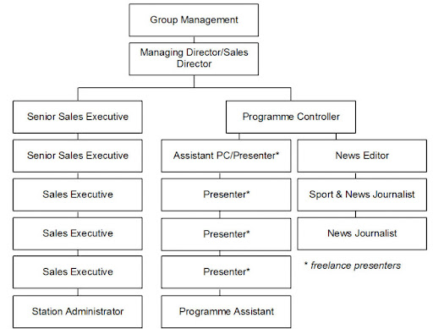

CHAPTER THREE
3.0 WORKDONE
3.1 HOW DO YOU STRUCTURE A RADIO PROGRAM?
Start with an Intro, End with an outro. It's not a bad idea to start with some kind of open or intro that explains what people are about to hear and who they are listening to. Intros make a great slot for thanking program sponsors, too. Likewise, end the show with a close or an outro.
3.2 WHAT IS NEWS CASTING?
A newscast is a news programme that is broadcast on the radio or on television.
3.3 WHAT IS NEWS WRITING?
Journalism or news writing is a prose style used for reporting in newspapers, radio, and television. When writing journalistically, one has to take into account not only one's audience, but also the tone in which the piece is delivered, as well as the ABCs of news writing: Accuracy, Brevity, and Clarity.
3.4 HOW TO WRITE NEWS
A news report should include the following,
- Headline: It tells what the story is about.
- Byline: It tells about the writer of the story.
- Lead: Covers the most important facts.
- Body: Includes a detailed account of the event/occurrence.
- Ending: Talks about the solution or something to think about.
RULES GUIDING NEWS WRITING
- Organization (the Inverted Pyramid) People have a tendency to tell stories chronologically
- Lead. The start of a news story should present the most compelling information.
- Fact (Not Opinion) and Attribution
- Identification
- Short Paragraphs
- Person
- Headlines
3.5 WHAT ARE THE RULES OF PRESS REPORTERS?
- Accuracy is the first rule of reporting.
- Be fair. It is not sufficient for an article to be libel-proof. Try to get the other side of the story and tell it.
- Observe the laws of good taste, something which is impossible of exact definition, but which most civilized and educated people know by instinct.
- Rarely is there such a thing as too much of a good story.
- Important stories need not be long.
- Sentences and paragraphs should be short.
- The lead should always be clear, provocative and simple. It should promise things to come, and the promise should be fulfilled.
- News accounts are improved by quotes. Speech should be quoted exactly as spoken.
- Select adjectives as you would lovers. Too many are dangerous.
- Do not be overly impressed when you get an important assignment. If you do, it will show in your copy.
- Go directly to the source on every story. Use your legs. Most so-called Big Shots are ever bit as approachable as a peasant and much more inclined to articulate their views.
- Leave no reasonable questions unanswered.
- Do not assume that the reader knows the background of the story.
- Get everything, including the last small details. If the speaker wears button shoes, that’s news. So is a wig. When you start the writing process you may kick yourself if you’re missing a detail you could have gotten when you were out doing the reporting.
- Be polite, but do not be servile.
- Don’t avoid writing facts on the assumption that "everybody knows that."
- Most stories are improved by a time element. That doesn’t mean you should say an accident occurred at 2:18.5 p.m., but it is laziness to say it occurred "yesterday."
- Never despise the homely, the familiar, the sweaty. The average reader should be able to identify with the story, and sometimes say, "This could have happened to me."
- Never insult or stereotype a race. You can mention race when it is necessary to the story, but otherwise be colorblind.
- Don’t abuse the weapons of your trade.
3.6 BROADCASTING
Broadcasting is the distribution of content, either audio or video, to a large dispersed audience by means of any medium of electronic mass communications. Typically, the mass communications medium is one that uses the electromagnetic spectrum, i.e. radio waves, in a one-to-many model.
3.7 TYPES OF BROADCASTING
- Radio broadcasting
- Television broadcasting
- Satellite broadcasting
- Cable broadcasting:
3.8 STUDIO BROADCASTING EQUIPMENT
- HEADPHONES
- MICROPHONES
- MIXER
- ON AIR LIGHT
- SPEAKERS
- AUDIO
- MIC ARM
- MONITOR
- MICROPHONE PROCESSOR
- RDS ENCODER
- VIDEO TRANSMITTER
- BROADCAST DESK
- CABLE
- CAMERAS
- CD PLAYER
- GSM INTERFACE
- RADIO AUTOMATED SOFTWARE
- TALENT PANEL
- TELEPHONE
- AMPLIFIERS
- ANTENNA
- AUDIO SWITCHER
- BROADCASTING SOFTWARE
- COMPUTER





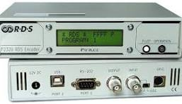
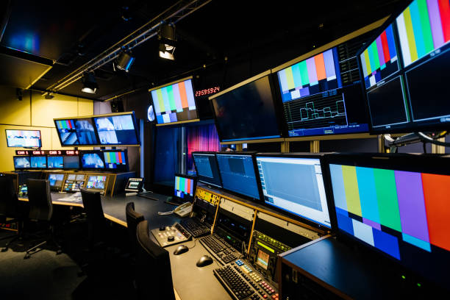

HEADPHONES MICROPHONES SPEAKER

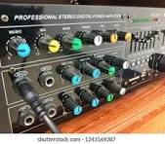
MIXER MONITOR RDS ENCODER
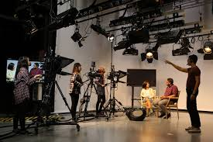
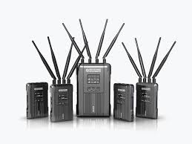
VIDEO TRANSMITTER CAMERAS AMPLIFIER

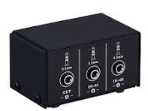
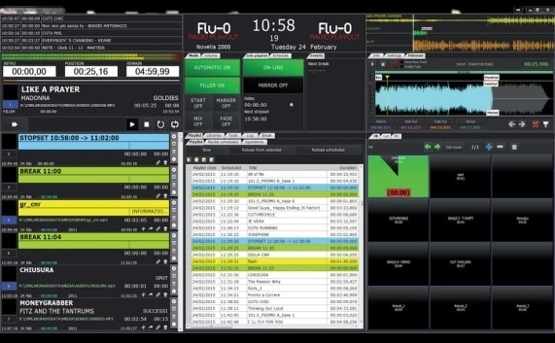
RADIO AUTOMATED SOFTWARE AUDIO SWITCHER COMPUTER
3.9 JINGLE
A jingle is a radio or TV advertising slogan set to a (hopefully) memorable melody. Jingles are written explicitly about a product, they can be original works designed to describe a product or service, or to help consumers remember information about a product.
3.10 HOW TO WRITE AN EFFECTIVE JINGLE
- Get to know your client. Once we get a client, we try to find out who they are and who they're trying to reach.
- Anticipate your audience. You have to develop a sense of who is going to hear the advertisement.
- Make your own music.
- Be evocative.
- Give it time.
3.11 HOW DO YOU WRITE A JINGLE SCRIPT?
Here's our step-by-step breakdown of how to write a script for a radio ad:
- Understand Your Audience
- Define a Clear Objective
- Write a Strong Opening
- Keep the Message Simple and Focused
- Create a Sense of Urgency
- Use Powerful and Descriptive Language
- Include a Clear Call to Action
- Add a Memorable Jingle or Sound Effect.
3.12 WHAT IS THE USE OF CONTENT WITH CAPTION?
A caption on social media is a text or written explanation that accompanies a photo, video, or reel. It provides context or additional information about the content being shared. Captions are commonly used on social media platforms. They can also be used to add hashtags or tag other users in the post.
3.13 VIDEO EDITING
Video editing is the post-production and arrangement of video shots. To showcase perfect video editing to the public, video editors must be reasonable and ensure they have a superior understanding of film, television, and other sorts of videography.
3.14 VIDEO DOWNLOADING
It means the electronic or other non-tangible transmission of a single motion picture (including bonus features and/or other added-value audio visual materials) to a device in the home or other place of dwelling for storage on such device (or at the recipient’s election, outside such dwelling in a so-called “digital locker”)
3.15 THE DIFFERENCE BETWEEN STREAMING AND DOWNLOADING MEDIA
What's the difference between streaming and downloading programmes? When you watch a programme online, either live or on demand, this is known as streaming. Downloading is saving the programme to your device temporarily and watching it when you're not connected to the internet.
LIVE STREAMING
Live streaming is the streaming of video or audio in real time or near real time. While often referred to simply as streaming, the real time nature of livestreaming differentiates it from other forms of streamed media, such as video-on-demand, vlogs, and YouTube videos. Live streaming technology lets you watch, create and share videos in real time, a bit like live TV. All you need to be able to live stream is an internet enabled device, like a smart phone or tablet, and a platform (such as a website or app) to live stream from.
HOW TO START LIVE STREAMING
Create & schedule a mobile live stream
- On your phone or tablet, open the YouTube app.
- At the bottom, tap Create. Go live.
- Follow the steps to create a live stream. For users aged 13 through 17 on YouTube, your default mobile live stream privacy setting is set to unlisted.
- Tap Go live.
- To end your stream, tap Finish.
HOW DOES LIVE STREAMS WORK?
With a live stream, the content gets uploaded by the host in small chunks and distributed to the viewer in real time (as it happens). The smaller/shorter the video chunk, the closer to real-time the viewer is.

CHAPTER FOUR
4.0 EXPERIENCE GAIN
In summary, this program has exposed me to some practical aspect in relation to my course of study (Mass communication) and I benefitted greatly from the program. What I learnt at various department involves the following.
- How to write news
- How to source for news
- How to cast news
- How to organize programs
- How to make a jingle

CHAPTER FIVE
5.0 CONCLUSION
The student industrial work experience scheme (SIWES) in an interesting and programmed that adds more value to students view and objectives of their field of studies.
More so, it adds advancement to the student experience on the theoretical aspect of their course, since they are exposed to the real practical aspect during the programmed.
Furthermore, it widens the horizon of students, because it makes them understand the rules and regulations governing their field of studies. This would guide them when they establish on their own.
5.1 SUGGESTION AND RECOMMENDATION TO THE ORGANIZATION AND POLYTECHNIC CONCERNING THE SIWES PROGRAM
SIWES coordinator and the polytechnic authority should try to stop the habit of rejecting students for SIWES program by the industry. The institution supervisor should make it a priority to visit their designated students in the various organizations to update the student’s log book.
Finally, they should resist the habit of staying in school and wait for their wards to finish the SIWES program only for them to sign their training log book and award them grade of the choices without checking the performance of the student in the field.

