

TECHNICAL REPORT ON STUDENT INDUSTRIAL WORK
EXPERIENCE SCHEME {SIWES}

HELD AT

TUNDEX ELECTRICAL SERVICES
N0 31,Baba Ijebu Street Along Hopeful School Agaye Juction, Ijeododo Ijegun Laos
EX
Prepared BY
JIMOH ISAAC TOBILOBA
ND/23/EEE/PT/0090

SUBMITTED TO

THE DEPARTMENT OF ELECTRICAL AND ELECTRONIC ENGINEERING, INSTITUTE OF TECHNOLOGY, KWARA STATE POLYTECHNIC, ILORIN

IN PARTIAL FULFILLMENT FOR THE AWARD OF NATIONAL DIPLOMA (OND) IN ELECTRICAL AND ELECTRONIC ENGINEERING

SEPTEMBER-NOVEMBER2024

DEDICATION
I thank almighty Allah for his protection and guardian in my life and having carried me this far.
I also, appreciate my parents Mr. and Mrs. JIMOH and all my siblings for their direction, protection and financial support.

ACKNOWLEDGEMENT
All praises and adoration be to almighty Allah for his endless mercies and wisdom during the interval.
I also, acknowledge my parents Mr. and Mrs. JIMOH and, my sister and all my brothers for the fully Corporation and undivided support.
My special thanks goes to the students industrial work experience scheme (SIWES). They have helped a lot in assisting students acquire the applicable practical on job experience.

TABLE OF CONTENTS
Title Page
Dedication
Acknowledgement
Table Contents
CHAPTER ONE
1.0 Introduction of SIWES
1.1 General objectives of SIWES
1.2 Brief Description of Place of Attachment
1.3 The establishment structure (organogram)
1.4 Workshop Safety
CHAPTER TWO
2.0 Introduction to Common Hand Tools In Electrical and Their Uses
2.1 Some Diagrams of Electrical Tools
2.2 Report On Coil Winding Processes
2.3 Prelude
2.4Definition of Coil winding
2.5 Types of Wire That Can Be Use To Wind Coil
2.6ExplanationOn Essential Sectarian of Coil Winding
2.7Winding of Standing Fan Coil
2.8 List of Materials Used With Their Function
2.9 List of Instruments Used And Their Function
2.10 Procedures
2.11 Precaution
CHAPTER THREE
3.0 Problem Encountered
3.1 Conclusion
3.2 Report on the Construction of Conduit Installation System of Wiring
3.3 Introduction
3.4 List of Instruments and Their Function
3.5 List of Conduit Devices
3.6 Diagrams to Elucidate Above List
3.7 Problem Encountered
3.8 Conclusion
CHAPTER FOUR
4.0 Achievement
4.1 Recommendation
4.2 Conclusion

CHAPTER ONE
INTRODUCTION
BRIEF HISTORY OF SIWES
The Students’ Industrial Work Experience Scheme (SIWES) is a skill training programme designed to expose and prepare students of universities, polytechnics and Colleges of Education for the industrial work situation they are likely to meet after graduation. The scheme also affords students the opportunity of familiarizing and exposing themselves to the needed experience in handling equipment and machinery that are usually not available in their institutions.
Before establishment of the scheme, there was a growing concern among our industrialists that graduates of institutions of higher learning lacked adequate practical background studies preparatory for employment industries.
Thus the employers were of the opinion that the theoretical education going on in higher institutions was not responsive to the needs of the employers of labour.
General Objectives of SIWES
SIWES is strategized for skill acquisition. It is in fact designed to prepare and expose students of universities polytechnics and colleges of education to the real-life work situation they would encounter after graduation.
Therefore, SIWES is key factor required to inject and engender industrialization and economic development in our nation through the induction of scientific and technological skills on students.

BRIEF DESCRIPTION OF PLACE OF ATTACHMENT
ABS de-valiant Electrical and Electronic Technology was established in year 2003, it is highly technical and the chairman the of organization have experienced in electrical wiring installations on both house and company.
the organization had done electrical wiring installations in many different building such as duplex, flat, mosques ,churches, hotels and so on.
The organization has many apprentice and they are also, training the SEWIS students.
ESTABLISHMENT STRUCTURE (ORGANOGRAM)
Managing director

Assistant managing director

Supervisors

Apprentice
Workers
Student

WORKSHOP SAFETY
Safety is an important factor that should be put in place in the workshop to reduce accidents.
The workshop put a number of safety precaution in the workshop which all the students must dully obey and they are listed below:
- Students must put on their overall and safety shoes
- There must be no unnecessary movement or running in the workshop.
- Fatal accidents should be reported to the workshop supervisor.
- Student must use insulated plier
- Student must avoid peeling wire with their teeth

CHAPTER TWO
INTRODUCTION TO COMMON HAND TOOLS IN ELECTRICAL AND THEIR USES
There are many kinds of tools used by electrical and electronic engineering to carry out the installation and other processes, below is the list of view of them:
- Plier: it is use to cut, loose and tie cable
- Tester: it is use to test the flowing of electric current
- Hack saw: it is use to cut metal,pipe and other materials
- Files: these are of various types which are use to reduce and for surface smoothing
- Hammer: it is use for nailing clip into the wall in surface wiring
- Screw driver: it is use to loose and tightening of screw
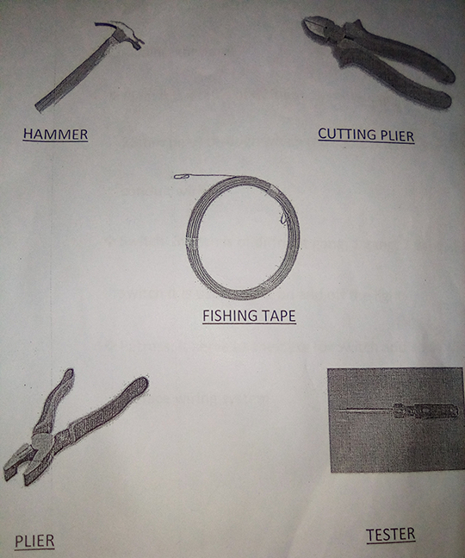
Some Diagram of Electrical tools
REPORT ON COIL WINDING
PRELUDE
ABS de-valiant electrical and electronic technology was told to rewind the coil of standing fan by one of their customers, in which I was opportune to accomplish practical idea in coil rewinding processing.
DEFINITION OF COIL WINDING
In electrical engineering, coil winding is the manufacture of electromagnetic coils. Coils are used as components of circuits, and to provide the magnetic field of electrical machines such as motors and generators, and in the manufacture of
Loudspeakers and microphones. The shape and dimensions of a winding are designed to fulfill the particular purpose. Parameters such as inductance,
Q factor, insulation strength, and strength of the desired magnetic field greatly influence the design of coil windings. Coil winding can be structured into several groups regarding the type and geometry of the wound coil. Mass production of electromagnetic coils relies on automated machinery.
TYPES OF WIRE USED TO REWIND COIL
The most common kinds of wire that are conducive for rewindprocessing are two, which are :
* Copper wire
* Aluminum wire

BRIEF EXPLANATION ON ESSENTIAL SECTARIANOF COIL WINDING
There are two most very important sections in coil winding process, namely
Primary winding : this is also know as main or running winding
Secondary winding :this can also called start or auxiliary winding
WINDING OF STANDING FAN COIL
These are processes which involved in rewind the inner grooved stator of standing fan coil with sixteen poles.
Before we started rewinding, engineer Taofeek have counted the numbers of turn that
is present in each coil. Below is the list of materials and instrument used with their function and procedures
LIST OF MATERIALS USED WITH THEIR FUNCTIONS
1. Leather rod: it is use to protect coil from damages that may cause by rotor and to ensure drift free of rotor
2. Copper wire : this is material use to wind coil and it is a conductor that allow free flow of current.
3. Varnish : this is also a protective gum that will be painted on the surface of wire to serve as insulator
INSTRUMENT AND THEIR FUNCTIONS
Claw hammer : it is used for removal of the nail
Combination Plier : it is used to cut wire and other routine job like that
Peg : it is made from bamboo or from dry stick and it is use to insert the coil into the slot
Blade or scissors : it is also use for peeling
Nails : are used incase of former
Screw driver : it is for tightening and loosing of the screw
PROCEDURES
We make the arrangement of nails and we used the slot mode of (1-4) to wind 700 turns of copper wire in four different places for main winding (I. E means or primary part) and the same approached was applied to secondary winding (I. E auxiliary or starting winding) with some little different .After all these the lead wires was connected and one start hand from the main winding was connected to the red hand of capacitor and another hand from auxiliary winding was connected to the second hand of capacitor out of these two the main winding part was connected straight to the power supply while the auxiliary winding part was tape and connected to no supply while the second hand of power supply was connected to the fan speed regulator.
Precaution
In testing the coil when the varnish have not applied to the surface of the coil. to avoid electrical shock ,hand must be keep away from the coil because some part might have peeled during the installations.
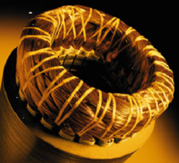
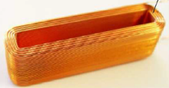
DIAGRAM OF WOUNDED COILS
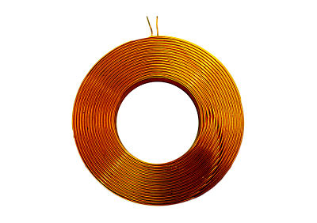

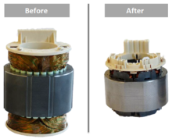

CHAPTER THREE
PROBLEM ENCOUNTERED
As a new experiment to me, it took me to understand the processes and the procedures to be followed in the execution of coil winding.
CONCLUSION
The standing fan coil winding was successfully executed and it's working system was accepted by the owner.
Report on the construction of conduit installation system of wiring
INTRODUCTION
ABS de-valiant was contracted to carry out conduit installation system of two bedroom with a parlour around Oko Olowo Area In Ilorin Kwara State.
Two out of senior I met their were then sent to carry it out in which I was directed to follow them so as to achieve one or two things in conduit construction system.
List of instruments and their function
These are the list of instruments used to execute the installatio :
1. Hammer: is used to hammered
2. Chisel: it is use for pointing hole
3. Bending spring : this is use for pipe bendings
4. Hack saw : it is to cut pipes

LIST OF CONDUIT DEVICES
Below are the list of materials utilized to carry out conduit construction system
1. Pipes: 25mm and 20mm
2. Lockout box (partress ):3/3 and 3/6
3. Cooker box
4. Adaptable box: 20mm and 25mm
5. ELCB box
6. Distribution board box
7. Stop end box : difference shapes
8. Male bush: 20mm and 25mm
9. Coupler join
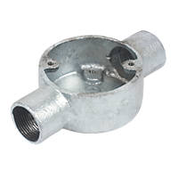
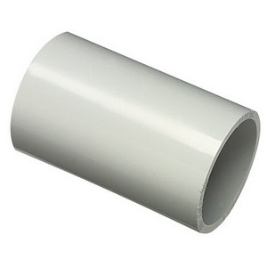
DIAGRAM TO ELUCIDATE ABOVE LIST
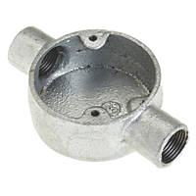
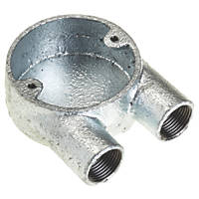
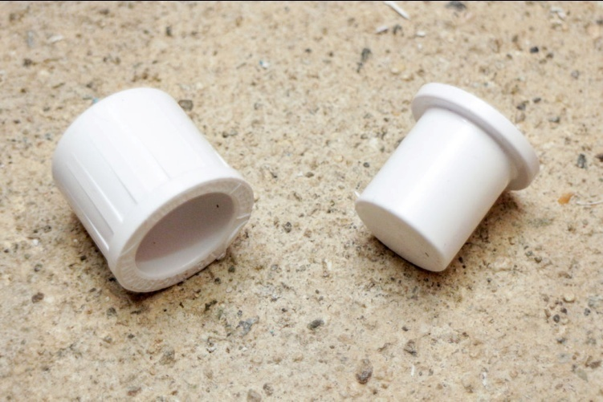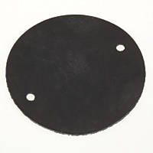
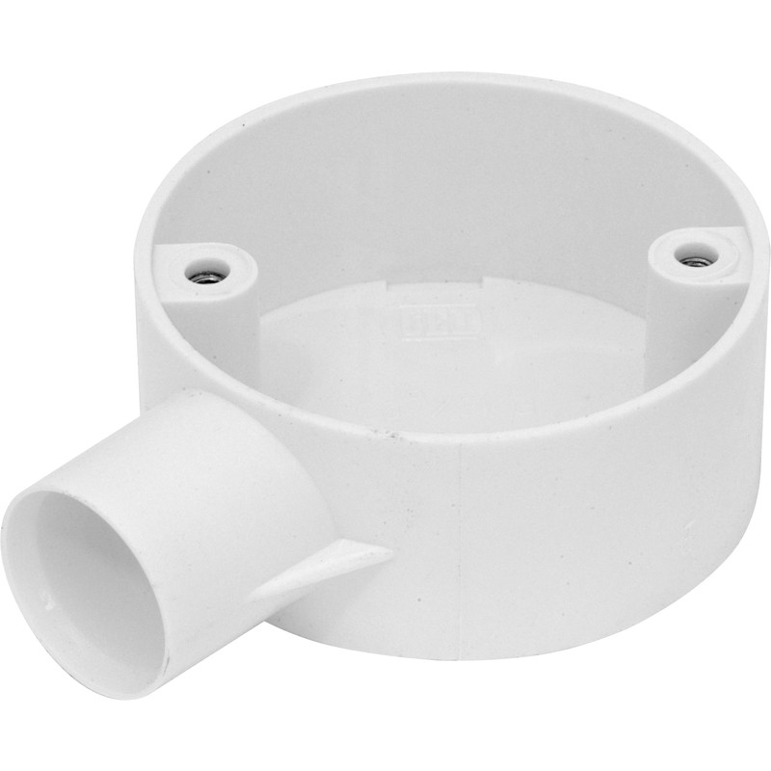
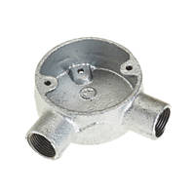

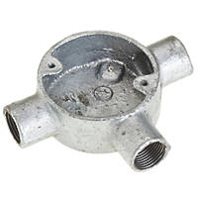
PROBLEM ENCOUNTERED
After I understood the laying of lockout box(partress)I was still delayed by the instrument since the instrument we mobilized to execute the installation were not many.

CHAPTER FOUR
ACHIEVEMENTS
For the few practical I had undergo through out the four months of my SIWES program, I can boost accomplish the like experiment.
RECOMMENDATION
I am selecting this space to commend to the SIWES coordinator to be help in attaching students to the various establishment of their (SIWES coordinator) own choice. So as to enable all students achieve much experience from choose establishment. I am saying this because majority of students were experienced some stresses before getting a place to attach.
CONCLUSION
I am delighted to be exposed to organization of ABS de-valiant to be educated in both practical and managerial aspect of electrical and electronic engineering profession within the period of four months.
My profound gratitude goes to federal government for the introduction of this program and all the involved in this program.
I also, thanks the SIWES and the polytechnic for not relent in the coordination of this program since and it had been helped in numerous way to produce expert in different fields of study. I therefore extol the scheme.
Thank you for the understanding.

