
TECHNICAL REPORT ON THE STUDENT INDUSTRIAL WORK EXPERIENCE
SCHEME (SIWES)

UNDERTAKEN AT
OLAAK ELECTRICAL WORK
ABDULQODIRI ALIYU
ND/23/EEE/PT/0029

SUBMITTED TO
THE DEPAERTMENT OF ELECTRICAL/ELECTRONICS ENGINEERING,
INSTITUTION OF TECHNOLOGY (IOT) KWARA STATE POLYTECHNIC, PMB 1375 ILORIN KWARA STATE.
IN PARTIAL FULFILMENT OF THE REQUIREMENT FOR THE AWARD OF NATIONAL DIPLOMA (ND) CERTIFICATE

AUGUST – NOVEMBER, 2024.

DEDICATION
This report is dedicated to the Almighty God for His guidance and protection throughout my industrial training. I also dedicate it to my parents, lecturers, and everyone who has contributed to my academic and professional growth.

ACKNOWLEDGEMENT
I sincerely appreciate the management and staff of Olaak Electrical Works for their warm reception, support, and mentorship throughout my industrial training. My gratitude also goes to my institution, lecturers, and SIWES coordinators for providing me with the opportunity to gain practical knowledge. Special thanks to my family and friends for their encouragement and support during this period.

PREFACE
This report details my Student Industrial Work Experience Scheme (SIWES) undertaken at Olaak Electrical Works. It provides insights into the various tasks and responsibilities I handled, the knowledge gained, and the challenges encountered during the training. The report also outlines recommendations for future industrial trainees.

TABLE OF CONTENTS
Chapter One: Introduction
1.1 Background of SIWES
1.2 Objectives of SIWES
1.3 Benefits of SIWES
1.4 Scope of the Report
Chapter Two: Description of the Organization
2.1 History and Background of Olaak Electrical Works
2.2 Organizational Structure
2.3 Services Rendered
2.4 Equipment and Tools Used
Chapter Three: Training Activities and Experiences
3.1 Overview of Tasks Assigned
3.2 Electrical Installations and Maintenance
3.3 Wiring and Circuit Design
3.4 Safety Measures and Regulations
3.5 Challenges Encountered
3.6 APPENDIX

Chapter Four: Observations and Findings
4.1 Technical Skills Acquired
4.2 Work Environment and Professionalism
4.3 Strengths and Weaknesses of the Organization
4.4 Problem-Solving Approaches
Chapter Five: Conclusion and Recommendations
5.1 Summary of Experience
5.2 Recommendations for Future SIWES Participants
5.3 Recommendations for Olaak Electrical Works
5.4 Conclusion

CHAPTER ONE
INTRODUCTION
1.1 Background of SIWES
The Student Industrial Work Experience Scheme (SIWES) was established to bridge the gap between theoretical knowledge and practical applications. It allows students to gain hands-on experience in their respective fields of study.
It is a programme required to be undertaken by all students of tertiary institutions in Nigeria pursuing courses in specialized engineering, technical, business, applied sciences and applied arts and Mass Communication".
The Federal Government on 8th October 1971 established the industrial training (ITF) to acquaint the students on the industrial work method. The SIWES which is a subsidiary formed in 1973 was initiated to improve the students technical abilities to expose them to industrial culture thereby getting the acquainted with the role to play towards the technological advancement of the nation.
It creates an avenue on environment in which the students are exposed to areas of their various disciplines to enhance their mental and creative minds in the aspects of Practical.
It is therefore a practical aspect of the academic work; which students may not have opportunity to carry out throughout their stay in the higher institutions.
1.2 Objectives of SIWES
- To expose students to the industrial work environment.
- To enhance students’ technical and practical skills.
- To enable students to apply classroom knowledge to real-world situations.
- To prepare students for the challenges of professional work life.

1.3 Benefits of SIWES
- Improved understanding of industry operations.
- Development of problem-solving skills.
- Enhancement of employability and technical competence.
- Exposure to professional ethics and safety regulations.
1.4 Scope of the Report
This report covers my experience at Olaak Electrical Works, detailing the activities I participated in, the skills acquired, and the lessons learned during the training.

CHAPTER TWO
DESCRIPTION OF THE ORGANIZATION
2.1 History and Background of Olaak Electrical Works
Olaak Electrical Works is a reputable electrical services company specializing in electrical installations, maintenance, and repairs for residential, commercial, and industrial clients.
The company started as a small-scale electrical workshop and has since expanded into a reputable organization recognized for its excellence in electrical engineering services. Over the years, Olaak Electrical Works has built a strong reputation based on reliability, efficiency, and adherence to safety standards.
The company has successfully executed numerous projects, ranging from small household electrical repairs to large-scale industrial installations. Its commitment to continuous improvement and the adoption of modern technology has positioned it as a trusted name in the electrical industry. Olaak Electrical Works also invests in training and capacity-building programs to ensure its workforce remains updated with the latest advancements in electrical engineering.

2.2 Organizational Structure
The organization comprises various departments, including technical, administrative, and customer service teams, working together to deliver quality electrical services.
2.3 Services Rendered
- Electrical wiring and installations
- Power system maintenance
- Transformer and generator repairs
- Electrical consultancy and troubleshooting
2.4 Equipment and Tools Used
- Multimeter
- Insulation tester
- Circuit breakers and relays
- Conduit bending tools
- Safety gear (gloves, helmets, safety boots)

- Multimeter:
A device used to measure electrical properties such as voltage, current, and resistance. It is an essential tool for diagnosing electrical faults and ensuring proper circuit functionality.
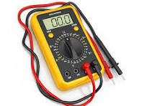 Multimeter

- Instulation Tester:
Devices used to check the insulation resistance of electrical systems, ensuring that wiring and equipment are properly insulated to prevent electrical hazards such as short circuits and leakage currents.

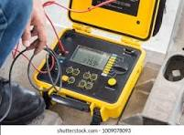
Instulation Tester

- CIRCUIT BREAKER ANALYZER
A circuit breaker analyzer is used to test the performance of circuit breakers by evaluating their timing, contact resistance, and insulation resistance. It ensures the reliability of breakers in electrical systems.
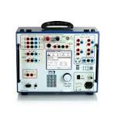Circuit Breaker Analyzer
- Conduit Bending Tools
Conduit bending tools are specialized equipment used to shape electrical conduits to the desired angles and configurations for proper cable routing. These tools help electricians bend metal or PVC conduits without causing damage or flattening, ensuring smooth wire passage. Some common conduit bending tools include:
- Hand Benders – Used for small-diameter conduits and manual bending.
- Hydraulic Benders – Used for larger and thicker conduits, offering more precise and effortless bending.
- Electric Conduit Benders – Motorized machines used for high-volume or industrial bending needs.
- Offset and Hickey Benders – Designed for creating offsets and tighter bends.

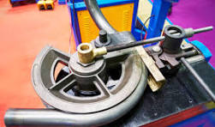
- Conduit Bending Tools

- Safety Gear (Gloves, Helmets, Safety Boots)
Safety gear is essential for protecting electricians from electrical hazards, physical injuries, and environmental dangers. Some key safety gear includes:
- Gloves – Insulated gloves protect against electric shocks, burns, and cuts from sharp materials.
- Helmets – Hard hats shield the head from falling objects, accidental bumps, and electric arcs.
- Safety Boots – Electrically insulated and slip-resistant boots protect against electrical hazards, sharp objects, and impact injuries.
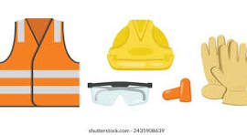

CHAPTER THREE
TRAINING ACTIVITIES AND EXPERIENCES
3.1 Overview of Tasks Assigned
During my training, I was involved in various electrical works, including installations, maintenance, and troubleshooting.
3.2 Electrical Installations and Maintenance
I participated in electrical wiring, circuit designs, and system maintenance for residential and commercial buildings.
3.3 Wiring and Circuit Design
I gained experience in reading electrical diagrams, designing circuits, and installing electrical panels and components.
3.4 Safety Measures and Regulations
I learned about electrical safety protocols, including proper handling of electrical tools and emergency response procedures.
3.5 Challenges Encountered
Some challenges included adapting to fieldwork, handling complex electrical faults, and working under pressure to meet deadlines.

3.6 APPENDIX
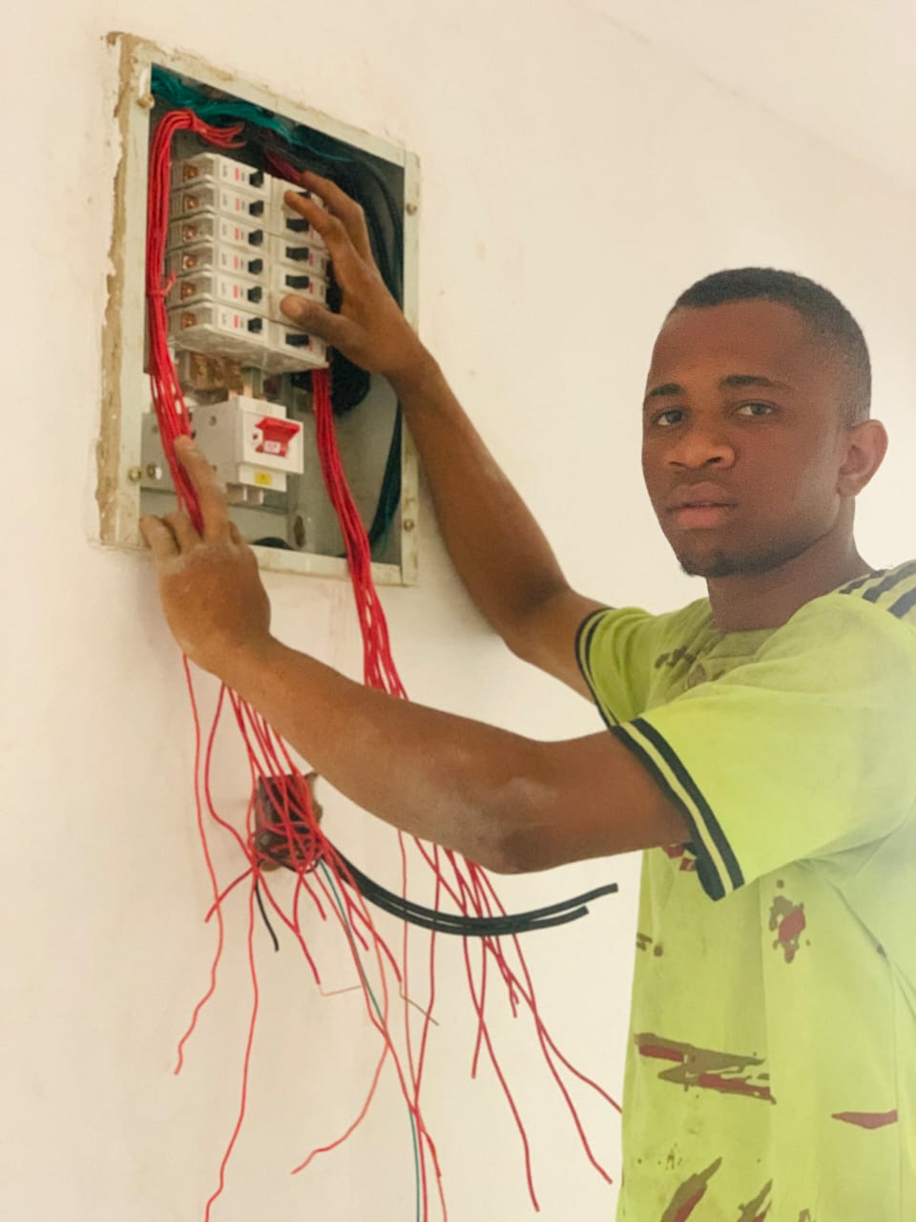

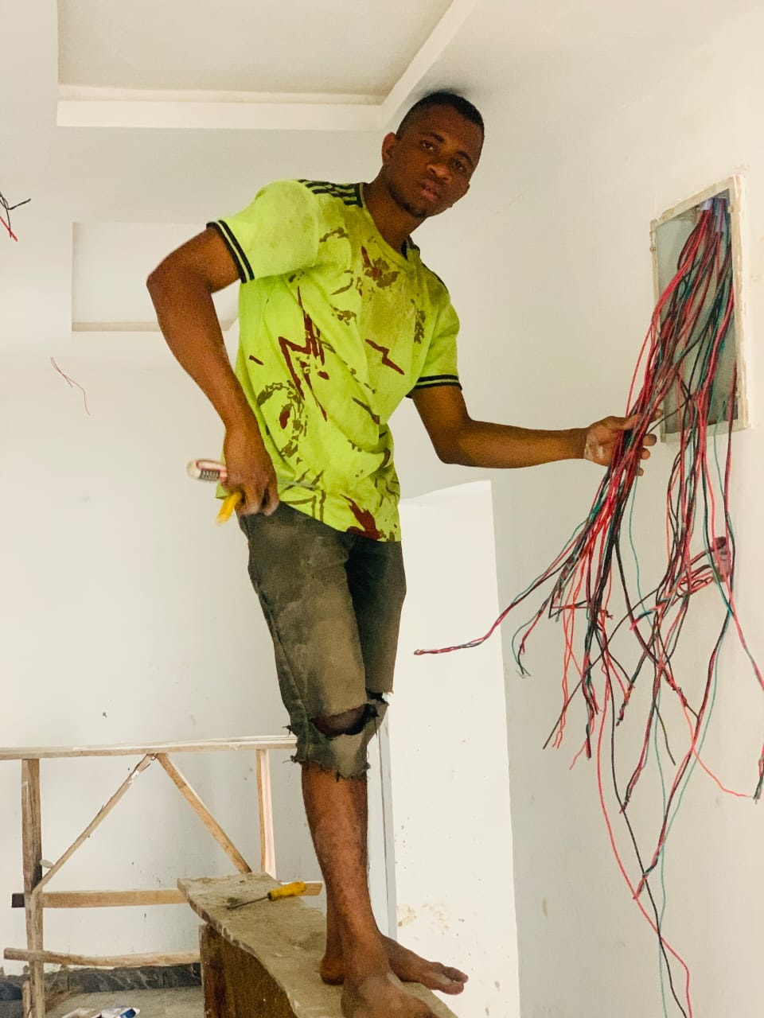
CHAPTER FOUR
OBSERVATIONS AND FINDINGS
4.1 Technical Skills Acquired
I acquired hands-on skills in wiring, troubleshooting, and maintaining electrical systems.
4.2 Work Environment and Professionalism
The work environment was professional, emphasizing teamwork, time management, and safety.
4.3 Strengths and Weaknesses of the Organization
Strengths: Skilled workforce, adherence to safety standards, and use of modern tools. Weaknesses: Limited access to advanced technology and need for more structured training for interns.
4.4 Problem-Solving Approaches
I learned to diagnose and resolve electrical faults efficiently using technical and logical approaches.

CHAPTER FIVE
CONCLUSION AND RECOMMENDATIONS
5.1 Summary of Experience
My industrial training at Olaak Electrical Works was insightful, providing me with valuable technical and professional skills.
5.2 Recommendations for Future SIWES Participants
- Be proactive and willing to learn.
- Follow safety procedures strictly.
- Engage in practical tasks to gain hands-on experience.
5.3 Recommendations for Olaak Electrical Works
- Invest in advanced electrical tools and technologies.
- Develop a structured internship program for better training outcomes.
5.4 Conclusion
The SIWES program at Olaak Electrical Works provided me with a strong foundation in electrical engineering practices, which will be beneficial for my future career.

