

TECHNICAL REPORT ON

STUDENT INDUSTRIAL WORK EXPERIENCE SCHEME (SIWES)

HELD AT

PRIME BUSINESS CENTER
(WESTEND HOSTEL AREA, KWARA POLY ILORIN)
BETWEEN
September – November, 2024

BY:

EDUNFUNKE EMMANUEL IYANUOLUWA
ND/23/BAM/PT/0168

SUBMITTED TO:

THE DEPARTMENT OF BUSINESS ADMINISTRATION AND MANAGEMENT,
INSTITUTE OF INFORMATION COMMUNICATION TECHNOLOGY (IICT) KWARA STATE POLYTECHNIC, ILORIN.

IN PARTIAL FULFILMENT FOR THE AWARD OF NATIONAL DIPLOMA (ND) IN BUSINESS ADMINISTRATION AND MANAGEMENT, KWARA STATE POLYTECHNIC, ILORIN

2024/2025 Academic Session

PREFACE
The Student Industrial Work Experience Scheme (SIWES) was established by the Industrial Training Fund (ITF) to enable student of tertiary institution to have basic technical knowledge of industrial work basic on their courses of study before the completion of their program in their various institutions.
In the early stage, student are graduating into institution without any technical knowledge of working experience, this make them to undergo further training after servicing an employment with the reason.
I did my Siwes programme at PRIME BUSINESS CENTER enterprise, located at Westend Hostel Area, Kwara Poly Ilorin within the period of September – November, 2024.
In the course of my SIWES programme, I was exposed and I learnt how to run Microsoft Office Programs i.e. MSWord, MS-PowerPoint, MS-Excel and physical document/departmental record, invoice preparation and payroll, report taken and many more.

DEDICATION
This report is dedicated to God Almighty for His blessings, and mercies bestowed on me right from womb till this very moment and for always been there for me and got my back always and ever. And special thanks to my parent and departmental lecturers as well.

ACKNOWLEDGEMENT
I really thank God Almighty for making this vision a reality. The foundation of everything in life is of utmost importance. Therefore, I give credit and kudos to all Mentors at PRIME BUSINESS CENTER. I also thank the Director of the center for his leadership attitude which provides a conducive and uninterrupted academic Centre for which students can acquire knowledge in different kind of field of study.
A report of this magnitude definitely involved more than just my hand work alone. In consequence to that, it is important that effort of my people who contributed to the success of this programme should be acknowledge.
I sincerely appreciate the effort of all the lecturers of Business administration and management Department and also to the non-teaching staffs, who have contributed in one way or the other towards the successful completion of this programme, may the Lord give them his infinite mercy and blessing. Bless you and your entire family. (Amen).
TABLE OF CONTENTS
Title page i
Preface ii
Dedication iii
Acknowledgement iv
Table of contents v
CHAPTER ONE
  - Introduction 1
  - Objectives of SIWES (Definition of SIWES) 2
  - Location and brief history background of the organization 3
  - Aims and objective of establishment 3
  - Organization chart 4
CHAPTER TWO
- Work done 5
  - Introduction to Microsoft Offices (MS-Word) 5
    - Steps require to activate Microsoft word 5
    - Creating a document 5
    - Formatting a text 5
    - How to save a document 6
    - Zooming in and out 7
    - Printing of file 7
    - Spelling and grammar checking 7
    - Creating table 8
    - Exiting Ms-word 8
    - Insert word art 8
    - Insert symbol 9
  - Microsoft Excel 13
CHAPTER THREE
- Experience gained 16
CHAPTER FOUR
  - Conclusion 17
  - Personal impression about the organization 17
  - Suggestions/recommendation 17

CHAPTER ONE
1.1 INTRODUCTION
SIWES was established by ITF in 1973 to solve the problem of lack of adequate practical skills preparatory for employment in industries by Nigerian graduates of tertiary institutions.
The Scheme exposes students to industry-based skills necessary for a smooth transition from the classroom to the world of work. It affords students of tertiary institutions the opportunity of being familiarized and exposed to the needed experience in handling machinery and equipment which are usually not available in the educational institutions.
Participation in Industrial Training is a well-known educational strategy. Classroom studies are integrated with learning through hands-on work experiences in a field related to the student’s academic major and career goals. Successful internships foster an experiential learning process that not only promotes career preparation but provides opportunities for learners to develop skills necessary to become leaders in their chosen professions.
One of the primary goals of the SIWES is to help students integrate leadership development into the experiential learning process. Students are expected to learn and develop basic non-profit leadership skills through a mentoring relationship with innovative non-profit leaders.
By integrating leadership development activities into the Industrial Training experience, we hope to encourage students to actively engage in non-profit management as a professional career objective. However, the effectiveness of the SIWES experience will have varying outcomes based upon the individual student, the work assignment, and the supervisor/mentor requirements. It is vital that each internship position description includes specific, written learning objectives to ensure leadership skill development is incorporated.
Participation in SIWES has become a necessary pre-condition for the award of Diploma and Degree certificates in specific disciplines in most institutions of higher learning in the country, in accordance with the education policy of government.
Operators - The ITF, the coordinating agencies (NUC, NCCE, NBTE), employers of labour and the institutions.
Funding - The Federal Government of Nigeria
Beneficiaries - Undergraduate students of the following: Agriculture, Engineering, Technology, Environmental, Science, Education, Medical Science and Pure and Applied Sciences.
Duration - Four months for Polytechnics and Colleges of Education, and Six months for the Universities.
1.2 OBJECTIVES OF SIWES
The following are some of the objectives of SIWES:
- SIWES will provide students the opportunity to test their interest in a particular career before permanent commitments are made.
- SIWES students will develop skills in the application of theory to practical work situations.
- SIWES will provide students the opportunity to test their aptitude for a particular career before permanent commitments are made.
- SIWES students will develop skills and techniques directly applicable to their careers.
- SIWES will aid students in adjusting from college to full-time employment.
- SIWES will provide students the opportunity to develop attitudes conducive to effective interpersonal relationships.
- SIWES will increase a student's sense of responsibility.
- SIWES students will be prepared to enter into full-time employment in their area of specialization upon graduation.
- SIWES students will acquire good work habits.
- SIWES students will develop employment records/references that will enhance employment opportunities.
- SIWES will provide students the opportunity to understand informal organizational interrelationships.
- SIWES will reduce student dropouts.
1.3 LOCATION AND BRIEF HISTORY OF ESTABLISHMENT
Prime Business Center world is a fast growing enterprise that strives to provide its clients with the prime solutions when it comes to their automation needs, project solutions of varies and it was founded and has been in operation since in 2017 by its Co-founder MR. PRIME.
1.4 AIMS AND OBJECTIVES
Mission
- To provide the world with the most advanced, easy to use information and communications technology products, services and solutions.
Vision
- To become a world-class ICT corporation, empowering Nigeria and the world
Core Values
- Team work, Honesty and Integrity,
- Excellence, Efficiency and Effectiveness,
- Services and Delivery,
- Customer and Customization,
- Vendor Neutrality.

1.5 ORGANIZATION CHART

Figure 1.1: Organogram of the Company

CHAPTER TWO
2.0 WORK DONE
2.1 INTRODUCTION TO MICROSOFT WORD
The chapter include information about how to boot the system, formatting of text, what we can find when we start our window and some other important things in word processor. Microsoft word is the word processing software which can be use in writing of text, placing of text in column inserting of clip art, creating of text.
2.1.1 STEPS REQUIRE TO ACTIVATE MICROSOFT WORD
- Step 1 Boot the system
- Step 2 Click start button ( or press window on keyboard)
- Step 3 Click on all program
- Step 4 Click on Microsoft office ( from the program submenus)
- Step 5 point Microsoft word
2.1.2 CREATING A DOCUMENT
When Microsoft word is started, a basic sheet of electronic paper is displayed on which you can type and text appear in the document and editing occurs.
2.1.3 HOW TO FORMAT A TEXT
Formatting is when you want to change the characters of your text such a font type, size and the thickness. Color or the position which could be superscript or subscript does as following.
- Step 1 Highlight the, it is compulsory to highlight the text you want to modify either by the mouse or keyboard before the operation.
- Step 2 click format
- Step 3 click font
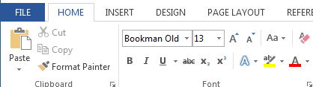
2.1.4 HOW TO SAVE A DOCUMENT
Saving a document can be done in two ways:
To save a new document
- Click file from menu bar
- Click save as
- Type a file your document
- Click on save
To save subsequent document after the first saving
- Then Click file the menu bar
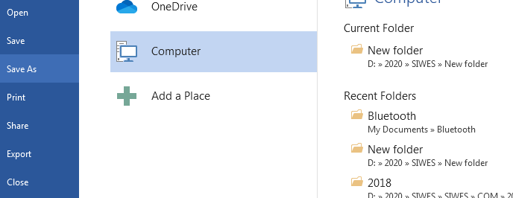
- Click save or use shortcut key from keyboard “Ctrl + S”

2.1.5 ZOOMING IN AND OUT
- Select zoom tool from the tool-box
- Hold the mouse button down to access to zoom fly –out, and then select the first option
- Move your cursor, which has changed ‘above or below of the object, press the mouse button.
- Release the mouse button, the object will now take up most the screen
2.1.6 PRINTING OF FILE
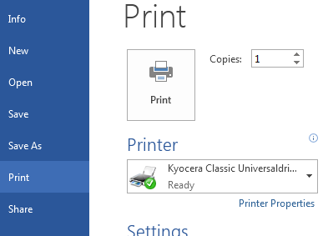
- Open the file you want to print
- Click file from the menu bar
- Select print from the file menu
- Click print.
2.1.7 SPELLING AND GRAMMER CHECKING

- At the beginning of the document click review tab
- Select spelling and grammar from the proofing
- Select the correct word from the suggestion list bar
- Click change.

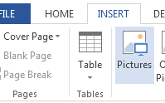
2.1.8 TO CREATE TABLE
- Position the cursor to where you want the table
- Click insert tab and click table button
- Select insert table from the dialog box.
- Type the number of column in the column box and the number of rows in the rows box
- Select the desired width for each column or select auto
- Click ok.
2.1.9 EXITING MICROSOFT WORD
- Select the file command from the main menu
- Select exit and click it take you back to the window menu
2.1.10 TO INSERT WORD ART
- From the menu, click insert.
- Highlight function and click word art from the sub menu
- Select the desire word art and click it
- Type the text using the desired font and click ok.
2.1.11 TO INSERT SYMBOL
- Select insert from the main menu
- Select symbol from the sub menu
- Click the desired symbol
- Select close
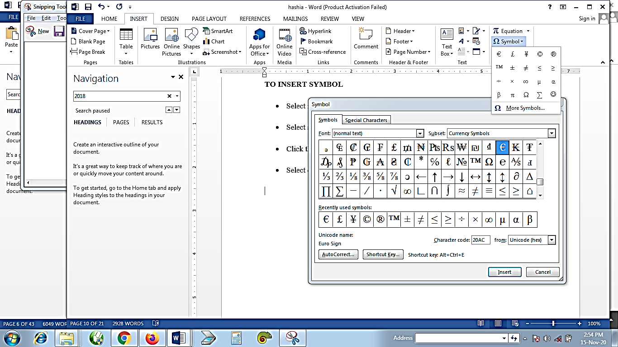

2.2 MICROSOFT EXCEL 2010
Excel Microsoft office also known as spreadsheet or worksheet program is used to store and retrieved numerical data in a grid format of rows and columns. It is also used for entering calculation and analyzing data.
- To Start or Launch the Program: <>Click the start button <>Select all programs <>Select Microsoft office <>Click on Microsoft Excel.
2.2.1 Microsoft Excel Tools
- Title Bar: Displays the name of the current program and worksheet you are working on in the computer system.
- Menu Bar: Displays the name of the excel menu.
- Standard Bar: Displays the buttons of the most frequently used functions.
- Name Box: Displays the coordinates of the active cell.
- Formula Bar: Displays the contents of the active cell.
- Status Bar: Displays information about a selected command as well as the status of certain keys. Example: cap-lock, number lock.
- Scroll Bar: Used to move through the worksheet.
- Selected All Button: This selects every cell in a worksheet.
- Sheet Tabs: Displays the names of the worksheet within a workbook.
- Tab Scrolling Button: Used to scroll through the worksheet in a workshops.
- Worksheet: This is a single page in a workbook, which is divided into rows and columns.
- Active Cells: This is the cell surrounded by a border where you enter and edit data.
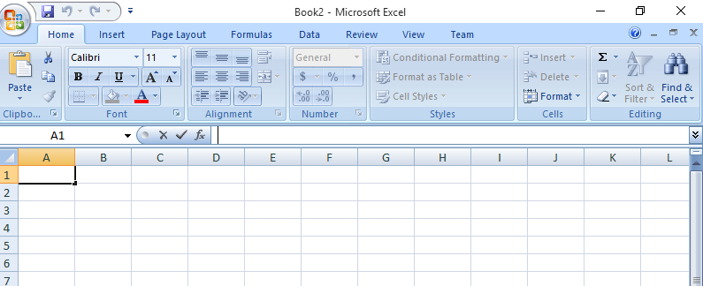
- Creating A Worksheet
- Entering Data:<>Select a cell<>Enter the data <>Click on Ok.
- Entering a Range of Data: <>Select the cell <>Enter the data<>Click on enter <>Continue until the entire cell is filled.
- Editing Data: <>Double click on the cell or click on it.
- Saving A Document on Microsoft Excel: <>Click on the file menu <>Click on save as <>Click on the save in drop down list to select the specific drive <>Name your document <>Select “MS-Excel workbook from the file type <>Click on OK.
- Inserting, Deleting and Merging of Cells
- Inserting Cell: <>Select the cell <>Click on the insert menu <>Click on cells <>Click on OK.
- Inserting Rows and Columns: <>Select the cell <>Click on the insert menu <>Click on columns and rows.
- Deleting Cells: <>Select cells to delete <>Click on edit <>Click on delete <>Click on OK.
- Deleting Rows and Columns: <>Select at least on cell <>Click on the edit menu <>Click on delete <>Click on OK.
- Merging Cells: <>Select the cells you want to merge <>Click on merger and center button on the tools bar.
- Adding Header and Footer: <>Click on the view menu <>Click on header and footer <>Click on OK.
- Changing Margin: <>Click on the file <>Click on page set-up <>Click on margin tab, change it to your preferred choice <>Click on OK.
- Printing Worksheet and Workbook
- Printing: <>Click on the file menu<>Click on print, a dialogue box will appear<>Select the option you wish to change (i.e. page name, name of printer etc)<>Select the number of copies<>Click on OK.
2.3.2 HOW TO CREATE A PAYROLL
Open a New Excel Spreadsheet
The first step in making payroll in Excel is to open a new Excel sheet. For this:
- Go to the “Search Box” at the bottom-left end of the Windows desktop screen.
- Type “Excel”
- Click the Excel icon to open a new blank Excel spreadsheet.
Note: We have included screenshots of Excel for each step, making it simple for you to follow along with the process.
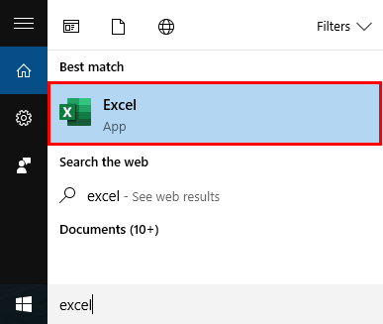
Step #2: Save the File
Save the file in a preferred location so you can easily access the file whenever you need.
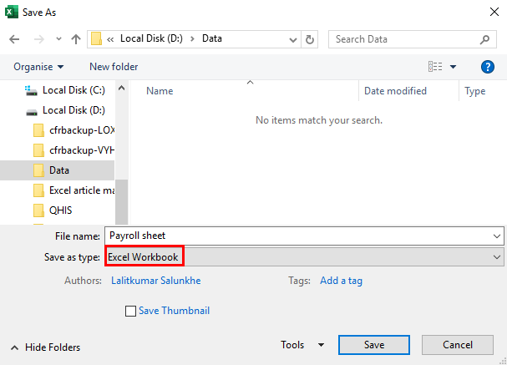
Step #3: Add Columns
Next, add some columns in the sheet to add data like employee name, pay/hour, total hours worked, etc., for the payroll calculation. Enter the column names in the following hierarchy:
Sr. No. | Payroll Parameters | Add in Column | Details
1 | Employee Name | A | Contains the employee names.
2 | Pay/Hour | B | Total money an employee earns for one hour of work.
3 | Total Hours Worked | C | Total hours the employee worked in a month or a particular pay period.
4 | Overtime Pay/Hour | D | Pay an employee earns for working beyond the regular working hours.
5 | Total Overtime Hours | E | Total hours the employee worked overtime in a month or a particular pay period.
6 | Gross Pay | F | The amount you have to pay the employee (before deductions)
7 | Income Tax | G | Tax payable on Gross pay.
8 | Other Deductibles  (If Any) | H | Deductibles other than income tax like TDS, EPF, PT, etc.
9 | Net Pay | I | In-hand salary of the employee.
The above data in Excel will look like this:
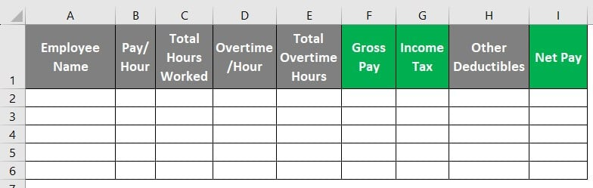
Step #4: Enter Employee Data
After creating columns, enter the necessary details in the appropriate columns like the employee’s name in column A, the total no. of hours worked by an employee in column C, and so on.
Note: Total Hours Worked and Total Overtime Hours data is for a month. Moreover, Pay/Hour and Overtime/Hour are in USD.
Step #5: Calculate Gross Pay
Now, we will calculate the Gross pay in column F. We will use the following formula to calculate gross pay.
Gross Pay = (Pay per Hour x Total Hours Worked) + (Overtime Pay per Hour x Total Overtime Hours)
In Excel, we can write the above formula as follows:
=(B2*C2)+(D2*E2)
- Select “Cell F2” and enter the above formula.
- Press “Enter”. Excel will calculate the gross salary and display 3500 in Cell F2.
- Similarly, to calculate the gross pay for all employees, drag the cell downwards to apply the same formula to Cell F3 to Cell F6.

CHAPTER THREE
3.1 EXPERIENCE GAINED
I learnt how to create and work with Excel spreadsheet
I was able to practice all the theoretical aspect have been learning from class before
I was able to develop research using online and apply different effect
I was able to use MS-Word in report collection
I was able to learn how I can apply formula to excel spreadsheet with different forms of calculations
I can now use and print data of varies from both MS word and excel
I was able to add and develop my typing skills

CHAPTER FOUR
4.1 CONCLUSION
SIWES (Student Industrial Work Experience Scheme) is design to show student greatly equipped with technical knowledge based work experience scheme in each student scheme of work. As a student who has pass through this program, I have acquired more knowledge on computer operating and the different why operating system varies. The program has been an avenue of multiplication to my knowledge in the field of Business administration and management.
4.2 PERSONAL IMPRESSION ABOUT THE ORGANIZATION
I was highly impressed with the performance of the entire staffs of the company. The environment are so conducive and close to my place, their staffs are friendly and ready to listen to any complaint from their customer. And the way they conduct their meeting every Monday before any service at the company.
4.3 SUGGESTIONS/RECOMMENDATION TO THE ORGANIZATION AND THE POLYTECHNIC CONCERNING THE SIWES PROGRAMME
To the numerous and immensely contributions of SIWES to my personal life and my career in computer, I hereby suggested that, this great opportunity should be given to generation yet unborn. Every technical school and polytechnic in Nigeria should re strength their effort with the federal government to make sure that, this great opportunity should have a lifespan. Henceforth, the school should be orienting the student on what they are likely to face and experience they are likely to acquired during the program. So as to prepare their mind for the great challenge.
Finally, the organization should understand the important of this program, they should have it at back of their mind that, this is an opportunity for them to contribute to the development of this country by building manpower and developing human resource. So their interest should be taken aside. They should stop requesting for some amount before admitting student for the program.

